ARCHITECTURE VERSION 2

A) FRONT END

* Login page

Features:- sign in , sign up , forgot password.

This page is used to sign in , sign up and change password.

Buttons will redirect you to the respective pages.

* Home page

Features:- time-table,attendance,hall-ticket, marks,course-content.

This page is used to display time-table,attendance,hall-ticket,marks , course-content of the respective student.

Buttons will redirect you to the respective pages.

* Time-Table

Features:- Regular or supplementry dropdown selection,back.

Drop down will give you regular or supplementary selection

Button will redirect you to the respective page.

* Attendance

Features:- semester selection,back.

Drop down will give you semester selection.

Buttons will redirect you to the respective page.

* Hall-ticket

Features:- download ,back.

Buttons will redirect you to the respective page.

* Marks

Features:- semester selection,avg calculation,back.

Drop down will give you semester selection.

Button will redirect you to the respective page.

* Course-content

Features:- semester,back.

Drop down will give you semester selection.

Button will redirect you to the respective page.

* Sign-up

Features:- submit,back.

Submit will create a new user back takes you back to the home screen.

* Resetpassword

Features:- cancel,continue.

Cancel will cancel the change password process continue will proceed forward.

* Forgotpassword

Features:- cancel , continue.

Cancel will cancel the change password process continue will proceed forward.

B) BACK END

Directly connected to each frames so there is no requirement for backend.

C) Databases

Name:- user_info (privacy)

Table- data(id(primary key)(unique),password,phno);

Name:- student

Table- student ( id-varchar(unique) , name-varchar , email-varchar , branch-varchar , semester-int); (id primary key)

Table- create table attendance(id varchar(20),semester_1 int,semester_2 int,semester_3 int,semester_4 int,semester_5 int);

(id primarykey)

Table- course_content(branch varchar(20)unique,semester_1 varchar(50),semester_2 varchar(50),semester_3 varchar(50),semester_4 varchar(50),semester_5 varchar(50),semester_6 varchar(50),semester_7 varchar(50),semester_8 varchar(50)); (branch primary key)

Table- ce_1(id varchar(20),ma_101 varchar(10),ch_101 varchar(10),es_101 varchar(10),es_102 varchar(10),es_103 varchar(10),es_104 varchar(10),se_101 varchar(10),hs_101 varchar(10),fl_101 varchar(10));

table ee_1(id varchar(20),ma_101 varchar(10),ch_101 varchar(10),es_101 varchar(10),es_102 varchar(10),es_103 varchar(10),es_104 varchar(10),se_101 varchar(10),hs_101 varchar(10),fl_101 varchar(10));

table me_1(id varchar(20),ma_101 varchar(10),ch_101 varchar(10),es_101 varchar(10),es_102 varchar(10),es_103 varchar(10),es_104 varchar(10),se_101 varchar(10),hs_101 varchar(10),fl_101 varchar(10));

table cs_1(id varchar(20),ma_101 varchar(10),ch_101 varchar(10),es_101 varchar(10),es_102 varchar(10),es_103 varchar(10),es_104 varchar(10),se_101 varchar(10),hs_101 varchar(10),fl_101 varchar(10));

table ce_2(id varchar(20),ma_102 varchar(10),ch_102 varchar(10),ph_101 varchar(10),es_105 varchar(10),es_106 varchar(10),es_107 varchar(10),se_102 varchar(10),hs_102 varchar(10),fl_102 varchar(10));

table ee_2(id varchar(20),ma_102 varchar(10),ch_102 varchar(10),ph_101 varchar(10),es_105 varchar(10),es_106 varchar(10),es_107 varchar(10),se_102 varchar(10),hs_102 varchar(10),fl_102 varchar(10));

table me_2(id varchar(20),ma_102 varchar(10),ch_102 varchar(10),ph_101 varchar(10),es_105 varchar(10),es_106 varchar(10),es_107 varchar(10),se_102 varchar(10),hs_102 varchar(10),fl_102 varchar(10));

table cs_2(id varchar(20),ma_102 varchar(10),ch_102 varchar(10),ph_101 varchar(10),es_105 varchar(10),es_106 varchar(10),es_107 varchar(10),se_102 varchar(10),hs_102 varchar(10),fl_102 varchar(10));

table ce_3(id varchar(20),ma_203 varchar(10),ph_202 varchar(10),es_208 varchar(10),es_209 varchar(10),es_210 varchar(10),ce_201 varchar(10),fl_203 varchar(10));

table ee_3(id varchar(20),ma_203 varchar(10),ph_202 varchar(10),es_208 varchar(10),es_209 varchar(10),es_210 varchar(10),ee_201 varchar(10),fl_203 varchar(10));

table me_3(id varchar(20),ma_203 varchar(10),ph_202 varchar(10),es_208 varchar(10),es_209 varchar(10),es_210 varchar(10),me_201 varchar(10),fl_203 varchar(10));

table cs_3(id varchar(20),ma_203 varchar(10),ph_202 varchar(10),es_208 varchar(10),es_209 varchar(10),es_210 varchar(10),cs_201 varchar(10),fl_203 varchar(10));

table ce_4(id varchar(20),es_211 varchar(10),ce_202 varchar(10),ce_203 varchar(10),ce_204 varchar(10),ce_205 varchar(10),ce_206 varchar(10),se_203 varchar(10),fl_204 varchar(10));

table ee_4(id varchar(20),es_211 varchar(10),ee_202 varchar(10),ee_203 varchar(10),ee_204 varchar(10),ee_205 varchar(10),ee_206 varchar(10),se_203 varchar(10),fl_204 varchar(10));

table me_4(id varchar(20),es_211 varchar(10),me_202 varchar(10),me_203 varchar(10),me_204 varchar(10),me_205 varchar(10),me_206 varchar(10),se_203 varchar(10),fl_204 varchar(10));

table cs_4(id varchar(20),es_211 varchar(10),cs_202 varchar(10),cs_203 varchar(10),cs_204 varchar(10),cs_205 varchar(10),cs_206 varchar(10),se_203 varchar(10),fl_204 varchar(10));

D) OVERVIEW

It is a tool that helps students access information about exams and otherstuff.

Students can:

* Access their Hall tickets
* View their Time-table
* View their Grades and CGPA
* View their Course Content
* Check if they are eligible to write exams i.e check their attendance

B)

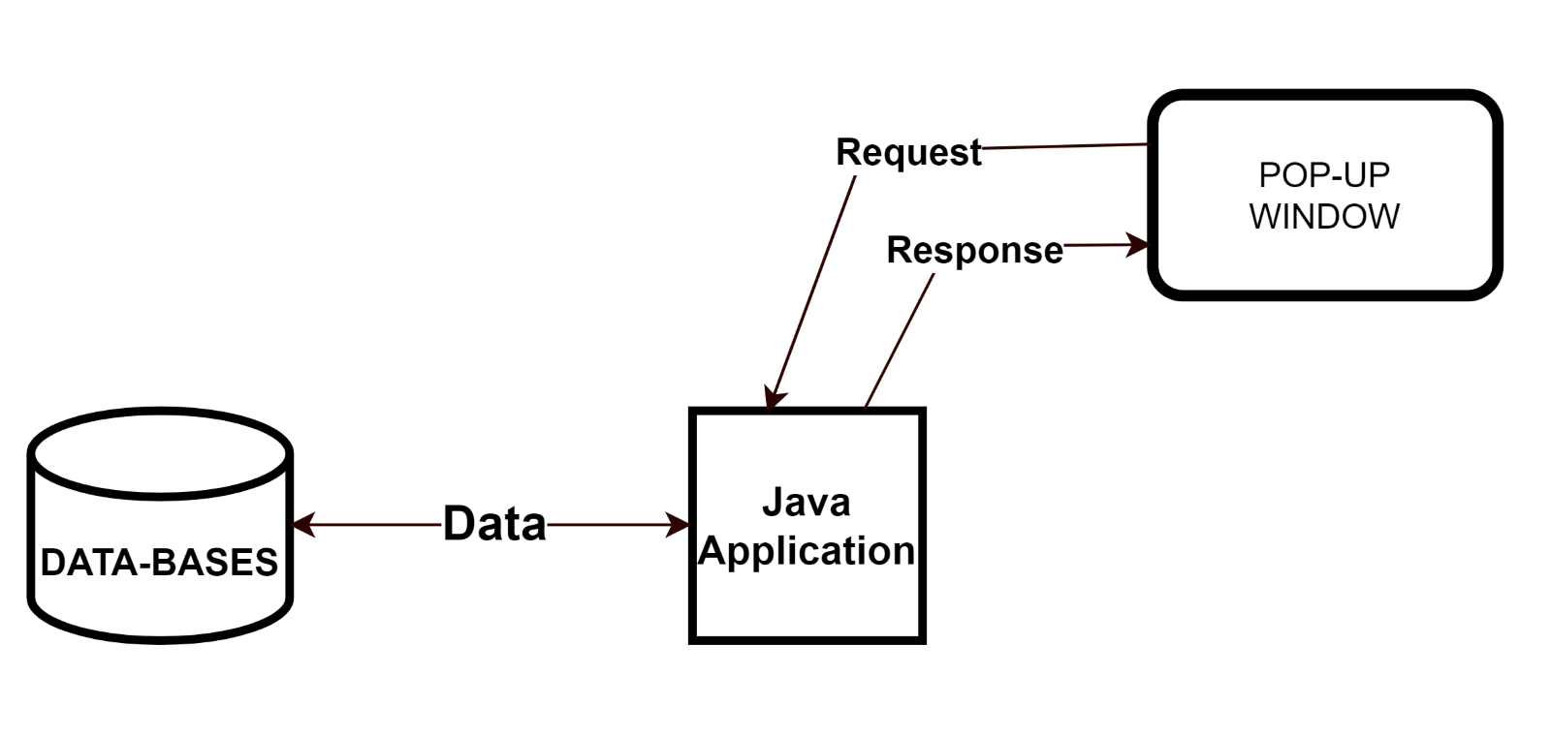

C)

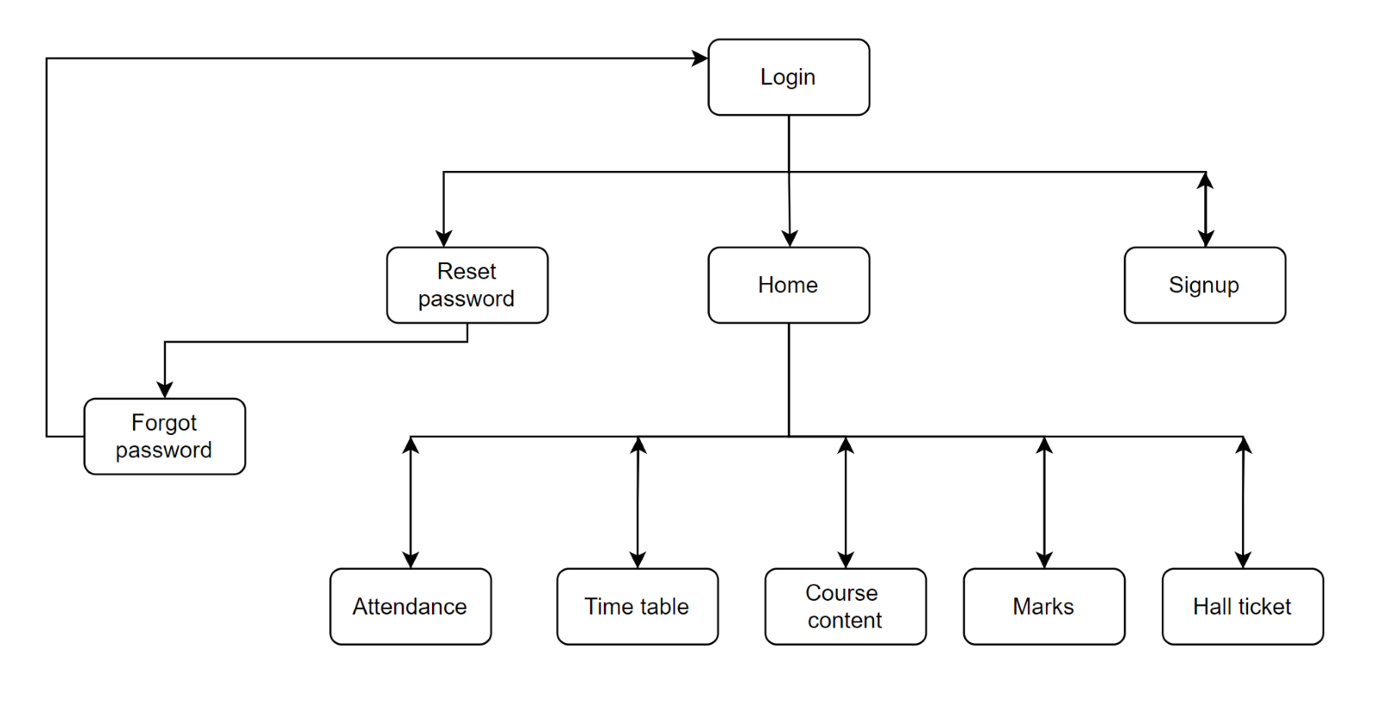

D) ER – Diagram.

