The collection of your information is for the purpose of processing the application and acceptance of our student in your company/office. By filling out this form, you certify that all information are true and correct, and that you are authorizing the UE OJT Office to process your information.  The accomplished form will be kept in a secured place and will be disposed of after five years.

**OFFICE OF THE CHANCELLOR**

**ON-THE-JOB TRAINING**

Date : _______________________

**Dear OJT Industry Partner:**

**We would like to express our heartfelt gratitude to your company / institution for accommodating our student/s for the On-the-Job Trainee / Intern post.** It has been our pleasure with your organization to jointly develop future leaders/ professionals and citizens of this country.

With this, we request your authorized representative to fill-out the following information below as a validation/ authentication from your company/institution:

1. Student’s acceptance for OJT and Confirmation of Assumption of Duty; and
2. Formal partnership through OJT Memorandum of Agreement (MOA). As mandated by **CMO No. 104 Series of 2017, Annex B and Annex E.**

Again, our warmest appreciation to your company / institutions for accepting our student/s, for other concerns, please free to contact us through any of the following: telefax: 8567 -4794, email: **ojt.manila@ue.edu.ph**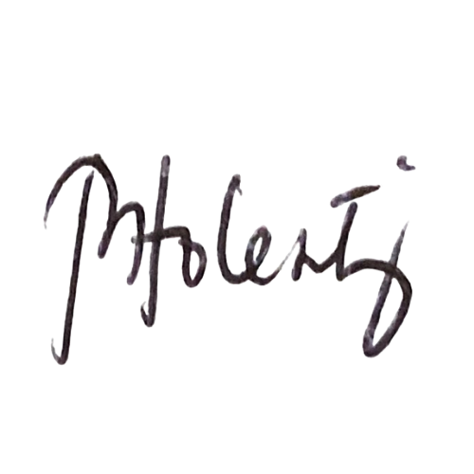

Very truly yours,

**MARITA N. TOLENTINO**

**OJT Coordinator**

**Dear UE OJT Office:**

This is to formally inform your institution that your student Mr./Ms.

has been accepted as trainee/intern in our company/institution:

with address at:

We also attest the details related to his/her On-the-Job Training with us follows:

Date of first day of duty: Mobile Number:

Assigned OJT Supervisor/s:

Attached is the photocopy of my company ID for your validation and you may contact us at:

Company Landline Number: Mobile Number:

Email address: website:

Attested by Department head/ Authorized Signatory:

**Dear UE OJT Office:**

We would like to have partnership through OJT MOA with the University of the East. With it, please email the copy of your OJT MOA to ________________________________ for our own review and evaluation. Please coordinate with Mr./Ms.________________________________________ on this matter.

Attested by Department Head / Authorized Signatory: ___________________________________ _________

Signature over Printed Name and Designation Date Signed