**NCP2209: OPERATING SYSTEMS (LABORATORY)**

2nd Semester, School Year 2020 - 2021

**Introduction to GIT Versioning Control System**

Module 1- Machine 1

Submitted by:

**NEIL RENDELL T. REGLOS**

20190146613

**ROZS RAVEN G. TIO**

20190163894

**NAIF G. JADOON**

20180149386

Submitted to:

**ERROL JOHN M. ANTONIO, MEng’g-CpE**

Assistant Professor, DCpE

February 01, 2021

**Introduction to GIT Versioning Control System**

**Module 1 - Machine 1**

**Instructions:**

Perform the following tasks / machine problems.

1. Perform the following Git operations within your team.
2. Create an account on **GitHub**.
3. Team Leader (TL) shall invite the Team Members (TM) using the UE official e-mail addresses. (Go to "**Settings**" and navigate to "**Manage Access**")
4. TL shall create a project folder (with a dummy source file named **SampleCode.txt**) and a repository named "**DemoProject".**
5. Perform the following operations.        
   4.1 TL shall push all changes to the repository.  
   4.2 TMs shall **clone** the project        
   4.3 TMs shall modify the sample source code by adding few lines of codes and **push** the changes to the repository.        
   4.4 TL shall **pull** all the changes made on the repository.        
   4.5 Then, TL **modify** the sample source code by adding few lines of code and **push** the changes to the repository.         
   4.6 TMs shall make modifications again before pushing new changes and **pull** the changes made by the TL to their local machines.
6. Provide a screenshot of the **commits** of the contributors. (Go to "Insights" and navigate to "Contributors"). See Canvas Assignment for instructions.

**Contributors:**

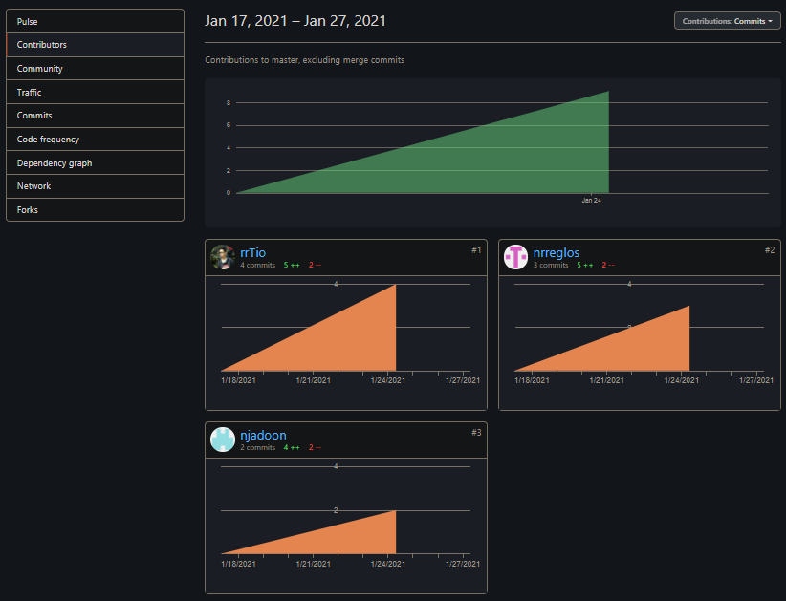

**Figure 1: Contributors**

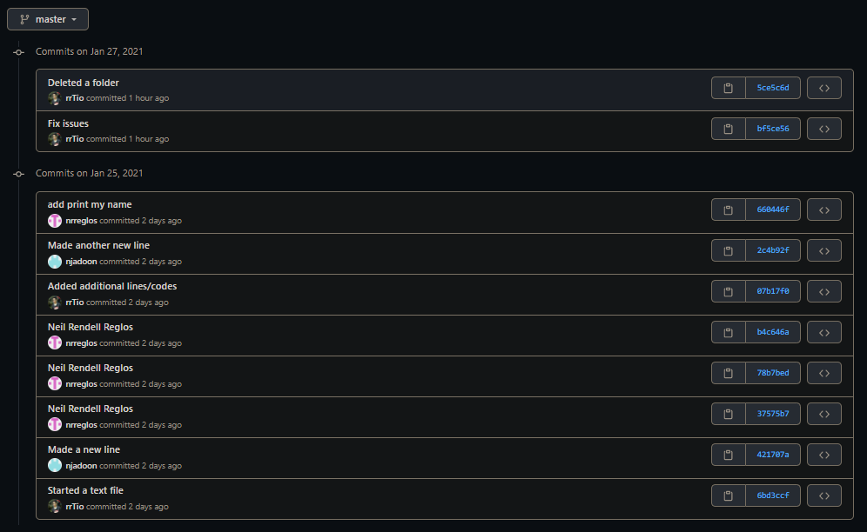**Commits:**

**Figure 2: Commits**

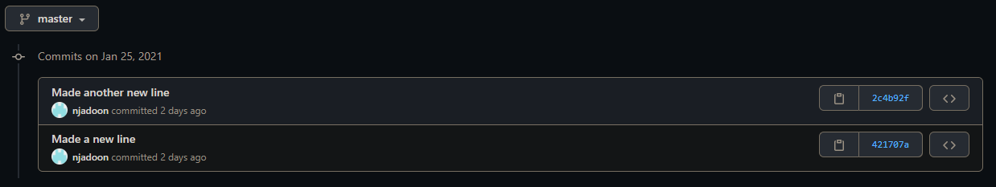

**Figure 3: Commits (Naix Jadoon)**

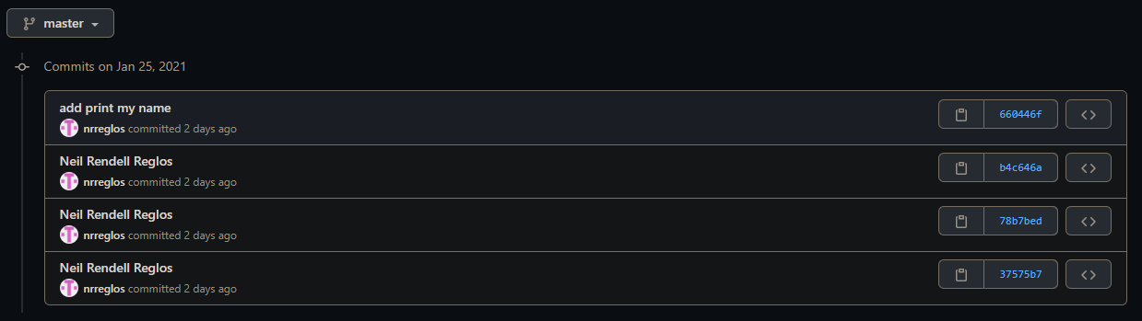

**Figure 4: Commits (Neil Rendell Reglos)**

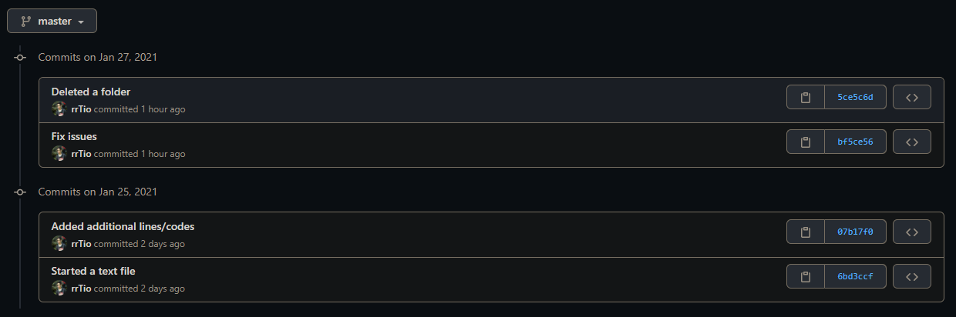

**Figure 5: Commits (Rozs Raven Tio)**