**NCP2209: OPERATING SYSTEMS (LABORATORY)**

2nd Semester, School Year 2020 - 2021

**GIT - BRANCHING**

Module 1 - Machine Problem No. 2

Submitted by:

**NEIL RENDELL T. REGLOS**

20190146613

**ROZS RAVEN G. TIO**

20190163894

**NAIF G. JADOON**

20180149386

Submitted to:

**ERROL JOHN M. ANTONIO, MEng’g-CpE**

Assistant Professor, DCpE

February 01, 2021

**Git - Branching**

**Module 1 – Machine Problem No. 2**

**Instructions:**

Perform the following Git operations within your team.

1. Use the existing repository used in the previous MP.
2. TL and TMs shall create a new folder (with demo image and sample code) on their local machines assuming that these folders are their assigned features to develop -- name your folder as **feature-surname** (e.g. feature-antonio)
3. Now, each member so the team shall create a new branch name **feature-surname** (e.g. feature-antonio) and push all changes to the newly created branch.
4. One member of the team shall create a new branch names **merged-features.**
5. Merge all branches in **merged-features** branch.
6. All other members shall pull the contents of the merged-feature branch.
7. Verify that you fetched all the required files by checking out to different branches (**git checkout branch-name**). You shall observe that the content of the folder in your machine changes depending on which branch you checked out.
8. Provide a screen capture of the commits and copy of the files in each branch (through GitHub). See sample screenshot below for branches.

**Contributors:**

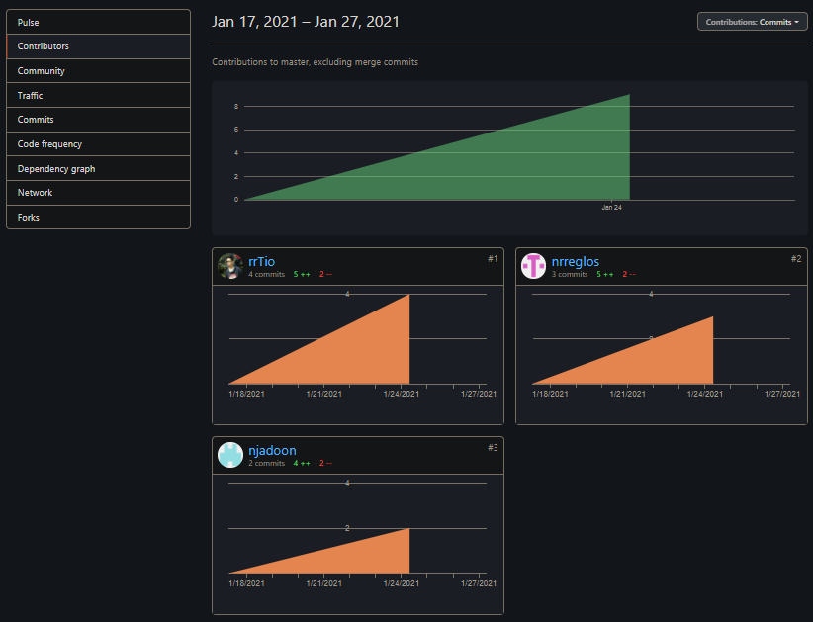

**Figure 1: Contributors**

**Merged Branch:**

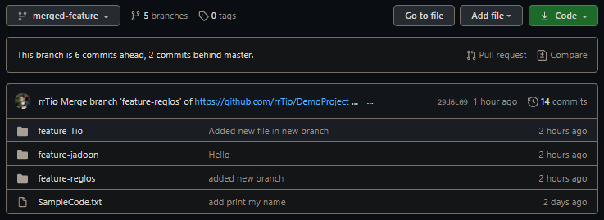

**Figure 2: Merged Branches**

**Commits:**

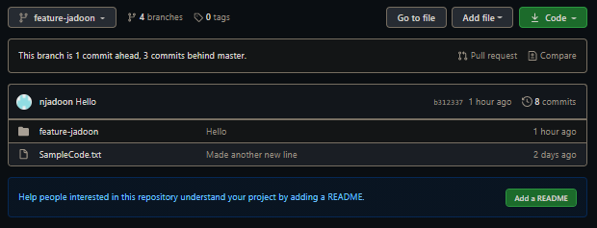

**Figure 3: Commits (Naix Jadoon)**

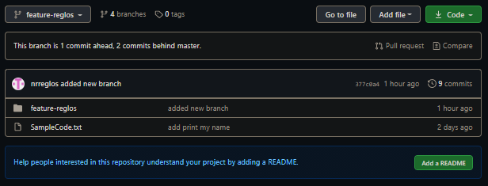

**Figure 4: Commits (Neil Rendell Reglos)**

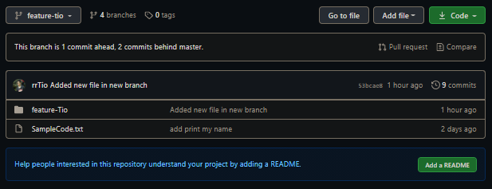

**Figure 5: Commits (Rozs Raven Tio)**