
Department of Computing

Software Architecture and Design
(55-608809-AF-20245)

Software Design Document
Task 1.1(Group)

Project: Advanced Library Management System (AML)
Group #: 33
Group Members:
Name | ID
Flinn Hancock | C2029156
Raf Shahid | C0042249
Veronica | C4022377

Date: 26/08/2024

Table of Contents
Introduction 2
Overview 3
Scope of Work 3
Functional Requirements 3
- User Registration & Management 3
- Media Search & Discovery 3
- Media Borrowing & Issue Reporting 4
- Inventory Procurement & Management 4
- Role Based Control 4
Non-Functional Requirements 4
- Scalability 5
- Availability & Reliability 5
- Performance 5
- Security 5
- Accessibility 5
- Maintainability 5
- Extensibility 5
- Backup & Recovery 5
- Data Consistency & Integrity 5
- Compliance & Legal Requirements 5
- Usability 6
Use Cases 7
User Interface Design 13
First design: 14
API endpoints 14
System Architecture 15
C4 Context Diagram (level 1) 15
C4 Container Diagram (level 2) 15
C4 Component Diagram (level 3) 15
C4 Code Diagrams (level 4) 15
Data Design 15
Architecture Decision Records 15
Security 16
Team reflection 16
Incorporation of Formative Feedback 17
Appendix 1: Tasks Completed 17
Appendix 2: GitHub Repository 18
References 20

Scope of Work
The proposed solution addresses the Advanced Media Library's (AML) need for an improved media management system by implementing a headless content management system (CMS). This CMS will feature an admin panel that allows non-technical stakeholders to manage media inventory across multiple branches. The scope of this proof of concept focuses on inventory management, enabling staff to add and update media records easily. Features like user authentication, payment handling, and media reservation are outside the scope of this phase. Instead, the proof of concept will demonstrate core functionalities for managing library resources while ensuring scalability and compliance with AML's accessibility requirements.

Functional Requirements
Functional requirements provided as bullet points with explanations
The proof of concept will address core functional requirements such as media inventory management and content updates by non-technical staff, while details on additional functional requirements can be found in the case study.

Non-Functional Requirements
Overview and explanation of several non-functional requirements for the system

Scalability
The system must support a growing user base, with an expected 10% yearly increase. It must also scale when it comes to system aspects such as the database and content management system itself.
- Performance
The system should maintain a fast response time for key transactions such as a search or borrowing action.
Batch processing should be handled to keep a smooth experience under heavy user load
- Maintainability
The system should be modular to allow for easy updates and maintenance, maintenance could include thigs like new features being implemented or bug fixes.
- Backup & Recovery
Regular backups of user data, media records and transactions should be performed. And the system should have a disaster recovery plan to restore operations quickly in case of failure.
Use Cases
Table 1 – Tabular Use Case template
UC-001 | Semantic Search
Description | This use case outlines the process of a library member conducting a semantic search to find books based on natural language queries.
Actor/s | Library member, System
Data | Search Query, Book Title, Author, Genre, Availability Status
Trigger | Member initiates a search using natural language or keywords
Pre-Condition | - The library member must be logged into their account.  - The system must have access to the book inventory.
Post-Condition | - The system returns relevant search results based on the query.  - The member can view book details and availability.
Primary Scenario | - The member enters a natural language query (e.g., “Find books on sustainable energy”). ￼  - The system analyses the query using semantic processing to understand context and intent.  - Relevant book results are retrieved from the inventory, considering synonyms and related topics.  - The system displays a list of books, including titles, authors, and brief descriptions, sorted by relevance.  - The member applies filters (e.g., by availability or genre) to refine search results.  - The member selects a book to view detailed information, including its availability and a summary.  - The system offers options to check out or reserve the book.
Alternative Scenario | - The member inputs a query that yields no results (e.g., “Books on quantum mechanics in everyday life”).  - The system informs the member that no matches are found. ￼  - The system suggests alternative search terms or related topics (e.g., “Books on quantum physics”).  - If the member’s query is ambiguous (e.g., “Java”), the system prompts the member to clarify their search intent.  - If the member’s account has restrictions (e.g., overdue fines), the system informs them and restricts checkout options.

UC-002 | Borrow Item
Description | This use case outlines the process through which a user searches for and borrows an item.
Actor/s | Library member (user)
Data | User’s search query (title, author, genre, etc.).  User’s membership status and borrowing history.  Item availability data (physical stock or digital access).
Trigger | - The user searches for and selects a media item they wish to borrow, triggering the borrowing process upon pressing the borrow button.
Pre-Condition | - The item must be available in stock and not already borrowed.
Post-Condition | - Success: The item is successfully borrowed by the user.  - Failure: The user is informed if the item is unavailable and other branches are checked for availability
Primary Scenario | - User Searches for Item: The user logs into the AML system and searches for an item using the search bar.  - Availability Check: The system checks the availability of the item across all branches and digital platforms.  - If the item is available at the user’s current branch, the system displays the option to borrow it.  - If the item is only available at another branch, the user is notified of that.  - Select Borrow: The user selects the option to borrow the item.  - Update Records: The system updates the user’s borrowing history and adjusts the item’s availability in the system.
Alternative Scenario | - Item Unavailable: If the item is currently unavailable at the user’s preferred branch. Check availability from another branch.  - System Failure: The system proce eds gracefully.

UC-003 | Notify of Item Availability at Other Branches
Description | This use case describes the system functionality where users are notified if an item they wish to borrow (book, journal, or multimedia) is unavailable at their current AML branch but is available at another AML branch in a different city. The system will provide details on availability and offer options to reserve or request the item from the other branch.
Actor/s | Library member
Data | - User’s current AML branch and the desired media (e.g., book, journal, multimedia).  - Stock information from other branches (availability, location).
Trigger | The user searches for or selects a media item that is unavailable at their current AML branch.
Pre-Condition | - The user must have an active library membership and be able to access media from multiple AML branches.  - The AML system must have real-time access to stock information across all branches.  - The system must have the ability to notify users of item availability at other branches and allow cross-branch reservations or transfers.
Post-Condition | - Success: The system notifies the user of the item’s availability at another AML branch, providing options to reserve or request a transfer.  - Failure: The system cannot find the item at any other branch, and the user is informed that the media is currently unavailable across all branches.
Primary Scenario | - User Searches for Item: The user searches for a specific book, journal, or multimedia in the AML system.  - Availability Check: The system checks the availability of the item at the user’s current branch.  - Item Unavailable Locally: The system determines that the item is unavailable at the current branch.  - Search Other Branches: The system automatically checks availability at other AML branches in different cities.  - Stock Found Elsewhere: The system identifies that the item is available at one or more other branches.  - Notify User: The user is notified of the item's availability at another branch, with details such as the branch location and estimated time for pickup or delivery.  - User Action: The user is given the option to either:  - Reserve the item at the other branch for personal pickup.  - Request a transfer of the item to their current branch for local pickup.  - Confirmation: The system confirms the user's reservation or transfer request and provides the estimated time for availability at the chosen branch.
Alternative Scenario | - Item Unavailable Across All Branches: The system notifies the user that the item is unavailable across all branches.  - Branch Transfer Not Possible: The user can choose to reserve the item for pickup at the other branch or continue searching for alternatives.

UC-004 | Branch Manager Adds, Manages, or Removes Media Items from Stock
Description | This use case describes how a branch manager uses the admin panel to add a newly stocked item (book, journal, or multimedia) to the system, manage its availability (increase or decrease stock), or remove it if the item is no longer available for borrowing or for sale.
Actor/s | Branch Manager (Admin)
Data | - Details about the media item being added (title, author, ISBN, genre, media type, etc.).  - Stock quantity or availability status (e.g., available, out of stock).  - Media removal information (reason for removal sold, damaged, outdated, etc.).
Trigger | - The branch manager adds a new item to the library’s stock.  - The branch manager updates stock levels or removes an item from availability.
Pre-Condition | - The branch manager must have access to the admin panel with permissions to manage media stock.  - The system must be connected to the media database and the inventory system for real-time updates.  - The system should ensure proper stock tracking, preventing duplication or discrepancies between branches.
Post-Condition | - Success: The item is successfully added to the system, stock levels are updated, or the item is removed from the system.  - Failure: If an error occurs (e.g., missing required data or a system issue), the media item is not added, updated, or removed, and the manager is notified of the error.
Primary Scenario | - Access Admin Panel: The branch manager logs into the admin panel using their credentials.  - Select Add New Media Item: The manager selects the option to add a new media item to the branch's stock.  - Enter Media Details: The manager inputs the necessary details about the media (e.g., title, author, ISBN, media type, quantity).  - Add Item to Inventory: The system adds the item to the branch's inventory and updates the central media database with availability information.  - Stock Management: After the item is added, the manager can view the stock levels for that item, increasing or decreasing the quantity as necessary based on new arrivals or withdrawals (e.g., sales, damages).  - Remove Item: If the item is no longer available (e.g., sold out or damaged), the manager can remove it from stock by selecting the item in the admin panel and marking it as unavailable or permanently removing it from the system.  - Confirmation: The system confirms that the item has been successfully added, updated, or removed and reflects this in the media inventory system for all branches.
Alternative Scenario | - Invalid Media Details: The system displays an error message asking the manager to fill in the missing data.  - Item Already Exists: The manager can update the stock quantity instead of adding a new entry.  - System Error: The system displays an error message, and the manager is unable to complete the action.

UC-005 | User Returns Borrowed Item and Receives Royal Mail Return QR Code
Description | This use case describes the process where a user who has borrowed an item from AML can initiate its return directly from the item view in the AML system. Upon confirming the return, the system generates and displays a free Royal Mail return QR code for the user to ship the item back.
Actor/s | Library Member (User)
Data | - User's borrowed items (title, media type, return status).  - User’s preferred return method (Royal Mail in this case).  - Royal Mail return request data (shipping address, package details).
Trigger | The user views the borrowed item in their account and selects the option to return the item.
Pre-Condition | - The user must have an active AML account and currently own (borrowed) at least one item.  - The AML system must be integrated with the Royal Mail API for generating QR codes.  - The item must be eligible for return through Royal Mail.
Post-Condition | - Success: The user successfully receives a Royal Mail QR code for returning the item, and the return is registered in the system.  - Failure: If the system or Royal Mail integration fails, the user is informed, and no QR code is generated.
Primary Scenario | - User Views Borrowed Item: The user logs into the AML system, navigates to their account, and views a list of currently borrowed items.  - Select Return Option: The user selects the borrowed item they wish to return and chooses the option to return it.  - Return Confirmation: The system confirms the return process and informs the user that the item will be shipped back via Royal Mail.  - Generate QR Code: The AML system communicates with the Royal Mail API to generate a free return QR code specific to the user and item.  - Display QR Code: The system displays the Royal Mail QR code to the user along with packaging instructions.  - User Action: The user packages the item, takes the package to a Royal Mail location, and shows the QR code for a free return.  - Update Return Status: The AML system updates the item’s status as “Returned” once the return process is initiated.
Alternative Scenario | - Item Not Eligible for Return: The user is provided with instructions for returning the item directly to an AML branch with a reimbursement guarantee.  - Royal Mail API Failure: Displays an error message and offers the user an alternative method for returning the item, such as manual return at a branch.

UC-006 | Read Page Content Aloud for Users with Accessibility Features Enabled
Description | This use case describes how the system automatically reads aloud all page content for users who have enabled accessibility features, such as screen reading. This ensures users with visual impairments or other accessibility needs can access the content without requiring additional manual interaction.
Actor/s | Library Member (User with Accessibility Needs)
Data | - User’s accessibility preferences (e.g., text-to-speech enabled).  - Page content (text, links, buttons, etc.).
Trigger | The user enters a page in the AML system, and the system detects that accessibility features (such as screen reading) are enabled.
Pre-Condition | - The user must have accessibility features, such as screen reading, enabled in their profile or device settings.  - The AML system must have support for text-to-speech technology and be able to read content aloud.  - The page content must be structured in a way that the system can parse for reading (i.e., properly labeled headings, paragraphs, buttons).
Post-Condition | - Success: The page content is read aloud to the user, allowing them to interact with the page based on the spoken feedback.  - Failure: If an error occurs or the system cannot access the content, the user is notified, and no content is read aloud.
Primary Scenario | - User Enters Page: The user navigates to a new page within the AML system.  - Accessibility Check: The system detects that the user has enabled accessibility features, specifically screen reading or text-to-speech.  - Content Parsing: The system parses the page content, identifying headings, paragraphs, links, buttons, and other interactive elements.  - Begin Reading Aloud: The system begins reading the page content aloud, starting with the title or heading, followed by descriptive text and any interactive elements.  - User Interaction: As the system reads the page content, the user can listen and interact with elements (e.g., selecting a link or confirming an action) based on voice commands or manual input.  - Completion: The system continues reading until all the content on the page has been vocalized, or the user interrupts or navigates away from the page.
Alternative Scenario | - User Disables Accessibility Features: The system immediately stops reading aloud and resumes normal functionality.  - Unsupported Content: The system skips the unsupported content and notifies the user that some elements may not be accessible.  - System Error or Accessibility API Failure: Alert the user that the page could not be read aloud.

User Interface Design
In this section you should include Wireframes for the identified use case descriptions demonstrating personas impact. The UI design must be consistent with F/NF requirements

Mockplus link - https://rp.mockplus.com/team/invitation/rowN4RnA4/phfqpllsrd
(my email looks weird because past me used 10 minute mail to sign up to this)

First design:
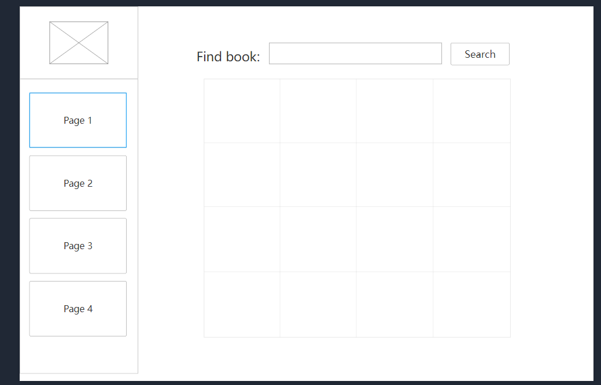The above is the first prototype wireframe that our group made, a very basic overview of how the library system should be structured. The left of the screen will allow you to navigate through the website, whilst most of the screen is taken up by a table with search functionality. Future designs will begin to populate that table with the relevant books.

API endpoints
Document your APIs here.

System Architecture

C4 Context Diagram (level 1)
Temp, make something better
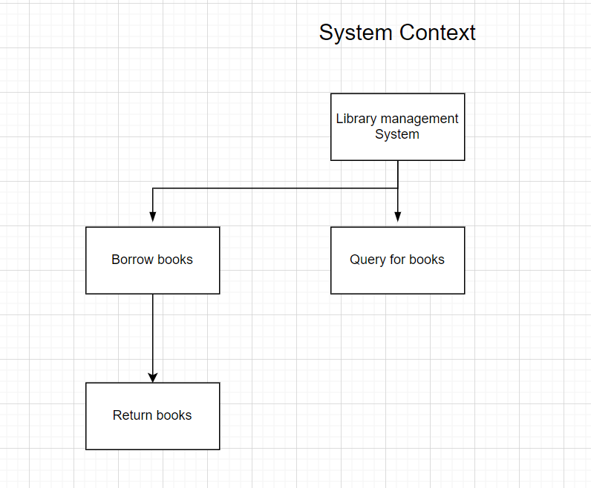

C4 Container Diagram (level 2)

C4 Component Diagram (level 3)

C4 Code Diagrams (level 4)
- Structural diagram
- Behavioural diagram

Data Design
Include diagrams and description of the project data design.

Architecture Decision Records
Include one key ADR example here.
https://github.com/rraafays/2024-oftware_architecture_and_design_architectural_decision_records

Security
In terms of security measures, each user will be using their own account with a unique username and password. Their name must be unique to avoid impersonation and prevent someone withdrawing many books in their name fraudulently.
Since AML will be storing a large amount of information from across the UK, it is important to ensure their databases are properly secure, as weak security may compromise hundreds of thousands of their users in the UK.

Team reflection
The team can briefly reflect here on pros, cons, challenges faced, and lesson learned in relation to working as a team on the architecture and design. Avoid repeating points mentioned in the individual reports.

Incorporation of Formative Feedback
Write here about evaluation of Formative Feedback and Actions Taken in Response to Feedback.
Table 2 - Weekly Feedback
Week # | Feedback | Response
1 | Essam: due to the scope of this proof of concept, an external api responsible for generating recommendations for search terms would be acceptable | We will use an external api to generate recommendations from a search query if we cannot implement it internally
2
3
4
5
6
7
8
9
10
11
12

Appendix 1: Tasks Completed

Table 3-Tasks Completed by each Member:
Name: | Tasks Completed:

Appendix 2: GitHub Repository
Add here a public link to GitHub Repository.
Include screenshots of commits and insights.

Table 4 - GitHub Usernames
Student name | GitHub name

References

Medvidovic, N., & Taylor, R. N. (2010, May). Software architecture: foundations, theory, and practice. In Proceedings of the 32nd ACM/IEEE International Conference on Software Engineering-Volume 2 (pp. 471-472).

Van Vliet, H., Van Vliet, H., & Van Vliet, J. C. (2008). Software engineering: principles and practice (Vol. 13). Hoboken, NJ: John Wiley & Sons.
Tofan, D., Galster, M., Avgeriou, P., & Schuitema, W. (2014). Past and future of software architectural decisions–A systematic mapping study. Information and Software Technology, 56(8), 850-872.

Nadareishvili, I., Mitra, R., McLarty, M., & Amundsen, M. (2016). Microservice architecture: aligning principles, practices, and culture. " O'Reilly Media, Inc.".

Yang, C., Liang, P., & Avgeriou, P. (2016). A systematic mapping study on the combination of software architecture and agile development. Journal of Systems and Software, 111, 157-184.

