
Department of Computing

Software Architecture and Design
(55-608809-AF-20245)

Software Design Document
Task 1.1 (Group)

Project: Advanced Library Management System (AML)
Group #:33
Group Members:
Name | ID
Raf Shahid | C0042249
Veronica | C4022377

Date: 26/08/2024

Table of Contents
Introduction 3
Overview 4
Scope of Work 4
Functional Requirements 4
Non-Functional Requirements 4
Use Cases 5
User Interface Design 13
First Design (Low Fidelity): 14
Home Page 14
Item view 14
Search 15
All Items 16
API endpoints 17
System Architecture 18
C4 Context Diagram (level 1) 18
C4 Container Diagram (level 2) 18
C4 Component Diagram (level 3) 19
C4 Code Diagrams (level 4) 20
Data Design 21
Architecture Decision Records 22
Security 23
Team reflection 23
Incorporation of Formative Feedback 24
Appendix 1: Tasks Completed 24
Appendix 2: GitHub Repository 25
Appendix 3: Sequence Diagram 26
References 28

Introduction

Overview

This portfolio is designed to outline the system specifications and use cases for an expansion of Advanced Media Library (AML) systems across England. With a large, expected influx of new users, AML requires us to develop a proof of concept of what an expansion to their system may look like, with a particular focus on ensuring scalability and reliability.

Scope of Work
The scope of this proof of concept is to address the core functionality of AML’s systems, as illustrated through the case study. These core functionalities include searching, item recommendations and item availability checking as well as an admin panel for librarians and accessibility features. While a fair amount of the system s

Functional Requirements

Functional requirements provided as bullet points with explanations
- User Registration & Management: Users can register as library members online or in branch. Librarian accounts must be created through administrator privilege, though they have heightened control over the system (including administrator privilege). The personal data of members, such as their contact detail, is something only they can change.
- Media Search and Discovery: Users can search for AML media, such as books, movies, journals, video games and various other AML media. This can be sorted by title, author, genre or through natural language queries.
- Media Borrowing and Issue Reporting: Users can borrow AML media for a limited amount of time. Users can report any issues with this system by the “Report Issue” button.
- Inventory Procurement and Management: Librarians can manage the quantity of items in the AML system, adding new media to the stock whenever necessary beyond the automated borrowing process.

Non-Functional Requirements

Overview and explanation of several non-functional requirements for the system
- Scalability: The system must scale support a growing user base, with an expected 10% yearly increase in users.
- Availability: The system must provide 24-hour availability for online services
- Reliability: The system must work reliably, and any downtime should be minimized to be as least disruptive as possible. All transactions should ensure ACID compliance when updating inventory or user data.
- Performance: The system should maintain a fast user response time for all processes, even under heavy user load.
- Accessibility: The system must comply with WCAG 2 accessibility standards, ensuring that all features are useable to individuals with disabilities. Such features may include (but are not limited to) screen readers, keyboard navigators and colour-blind settings.
- Maintainability: The system should be easy to update and maintain.
- Extensibility: The system should be able to grow and expand to get bigger without complications.
- Data Backup: User data should be regularly backed up off-server to be reverted to in the event of any complications.

Use Cases

Table 1 – Tabular Use Case template
UC-001 | Library Member Registration
Description | Procedure of a Guest browsing content offered by Advanced Media Library and then becoming a Library Member
Actor/s | Guest
Data | User name, password, email, branch
Trigger | Guest selects the register option from the top right corner of AMLs customer facing website header
Pre-Condition | N/A
Post-Condition | - The Guest is now a Library Member with all prior viewing abilities as well as the ability to purchase, borrow and return
Primary Scenario | - The Guest views content offered by Advanced Media Library via the frontpage or collection view  - Guest decides they would like to start purchasing or borrowing items from AML  - They select the option to register  - The necessary fields are filled out and they confirm  Library Member account is created and they are automatically forwarded to login
Alternative Scenario | - The Guest is viewing an item offered by Advanced Media Library which they would like to purchase or borrow  - They proceed by pressing the borrow or purchase button despite not actually owning an account or the item  - They are forwarded to the registration menu  - An account is created once they have filled out and confirmed their details  - The new Library Member is forwarded to the continue the checkout or borrowing process of the item they were originally viewing

UC-002 | Library Member uses Responsive Search
Description | Search which prioritises and autocompletes with the Library Member’s currently selected branch’s stock
Actor/s | Library Member
Data | User’s selected branch  Metadata of the returned items
Trigger | - Library Member is in the process of searching
Pre-Condition | - The user must be logged in  - Search reflects items currently in AML’s possession
Post-Condition | - Success: The system provides relevant Search results and autocompletion queries  - Failure: Search yields nothing and user is prompted to search something else which may yield results
Primary Scenario | - The system retrieves the relevant items by matching against titles, genres, media types.  - Item availability is checked, prioritising their branch and then descending in priority until the furthest branch  - The system displays the results to the user, who can interact with the items quickly or view and proceed as usual from the item view
Alternative Scenario | - Insufficient Data: User is informed that the search yields no results  - System Failure: The system proceeds gracefully.

UC-003 | Librarian Manages their branch’s stock
Description | In addition to the automatic management of stock levels of individual items which happens upon Library Member purchases or borrows. Items at an individual branch can be manually managed by the Librarian (or group of Librarians if the branch is big enough to warrant multiple Librarians) for the purpose of processing stock deliveries to that particular branch.
Actor/s | Librarian
Data | - All item information  - Individual item stock levels
Trigger | Librarian searches through items via the Admin Panel
Pre-Condition | - Librarian must be signed into the Admin Panel  - Item must exist already (authored by a Branch Manager and approved by a System Admin)  - Item must itself be available (not assigned the Do Not Restock tag by a Branch Manager or System Admin)
Post-Condition | - Success: The stock levels of the desired item are manipulated according to the Librarians requests and changes are committed to AML’s database  - Failure: Changes are not made, the Librarian is warned and no changes are committed to AML’s database
Primary Scenario | - Librarian searches for an item via the Admin Panel  - Item stock levels are changed by the Librarian according to what stock they have received from a delivery to their branch  - The stock change is committed by the Librarian and processed by the system  - If the change is possible then it is committed and the change is reflected by the database
Alternative Scenario | - Librarian searches for an item via the Admin Panel  - Item stock levels are changed by the Librarian according to what stock they have received from a delivery to their branch  - The stock change is committed by the Librarian and processed by the system  - If the change is not possible then it is not committed and the change is not reflected by the database and the Librarian is notified of the failure

UC-004 | Branch Manager creates new items for approval
Description | Items new to Advanced Media Library’s collection may be created by a Branch Manager however they cannot be served to customers, purchased or borrowed until a System Admin approves the new item
Actor/s | Branch Manager
Data | - Details of a new item which may have been requested for delivery to a branch by the Branch Manager or System Admin
Trigger | - Save button is pressed proceeding the Add Item button on the admin panel under a selected branch
Pre-Condition | - Item matching the title must not exist  - Branch Manager must be signed in  - Branch must not be flagged for Refurbishment
Post-Condition | - Success: The item is added but not published and all System Admins are notified of the new Item for them to review and potentially publish  - Failure: Item is not created and the Branch Manager is prompted which fields are violated
Primary Scenario | - Branch Manager enters all relevant fields  - Item creation view’s save button is pressed  - Title is used to check for duplicates  - If no duplicates are found, then the new item is saved  - System Admins are notified of the new item ready for them to review
Alternative Scenario | - Item is a duplicate of an already existing item  - The new item is not saved  - Branch Manager is notified of the duplicate  - Fields which are invalid are highlighted  - Branch Manager may try again

UC-005 | System Admin approves and publishes items
Description | Items can be viewied either under each individual branch sorted by stock count or under the grand item view. New unapproved items created by Branch Managers are at the top of the grand item list with a notifier showing that they are awaiting approval. These items can be opened and approved and now become available to all customers
Actor/s | System Admin
Data | - All items  - All branches  - New unapproved items
Trigger | The System Admin views unapproved items, reviews, potentially approves and then publishes the item for all users to access.
Pre-Condition | - Unapproved items are awaiting review under the grand view
Post-Condition | - Success: The System Admin successfully reviews, approves and publishes the item, making it accessible to all Library Members and Guests of Advanced Media  - Failure: Item to be approved and the System Admin is warned and returned to the grand item view
Primary Scenario | - System Admin views all items  - Items which are awaiting approval are listed first  - System Admin selects an item  - If no changes or minimal changes are needed then they can either proceed or make the according changes  - System Admin can then publish the changes
Alternative Scenario | - System Admin is unhappy with the item awaiting approval  - The item is declined  - The item is deleted

UC-006 | System Admin promotes or demotes users
Description | When a new branch is created or an internal staff of Advanced Media Library leaves or joins the company, the System Admins may exercise the ability to change the role or even theunderlying access levels of the specified user’s role.
Actor/s | System Admin
Data | - All users of Advanced Media Library
Trigger | System Admin is on the Roles or Users menu within the Admin Panel and decides to make changes to an indivdual role a User is at or the very individual access rights a specific Role has
Pre-Condition | - Role must have been initated upon implementation of the new system
Post-Condition | - Success: Role access rights are manipulated or an individual user’s roles are changed.  - Failure: The Role or indivdual user is left unchanged
Primary Scenario | - System Admin enters the Roles view  - Role is selected from the Roles view  - Access rights of the specified Role are changed  - Users can be selected and have a Role applied
Alternative Scenario | - Role does not exist  - The Role cannot be manipulated  - The Role’s access rights cannot be changed

User Interface Design

First Design (Low Fidelity):

Home Page

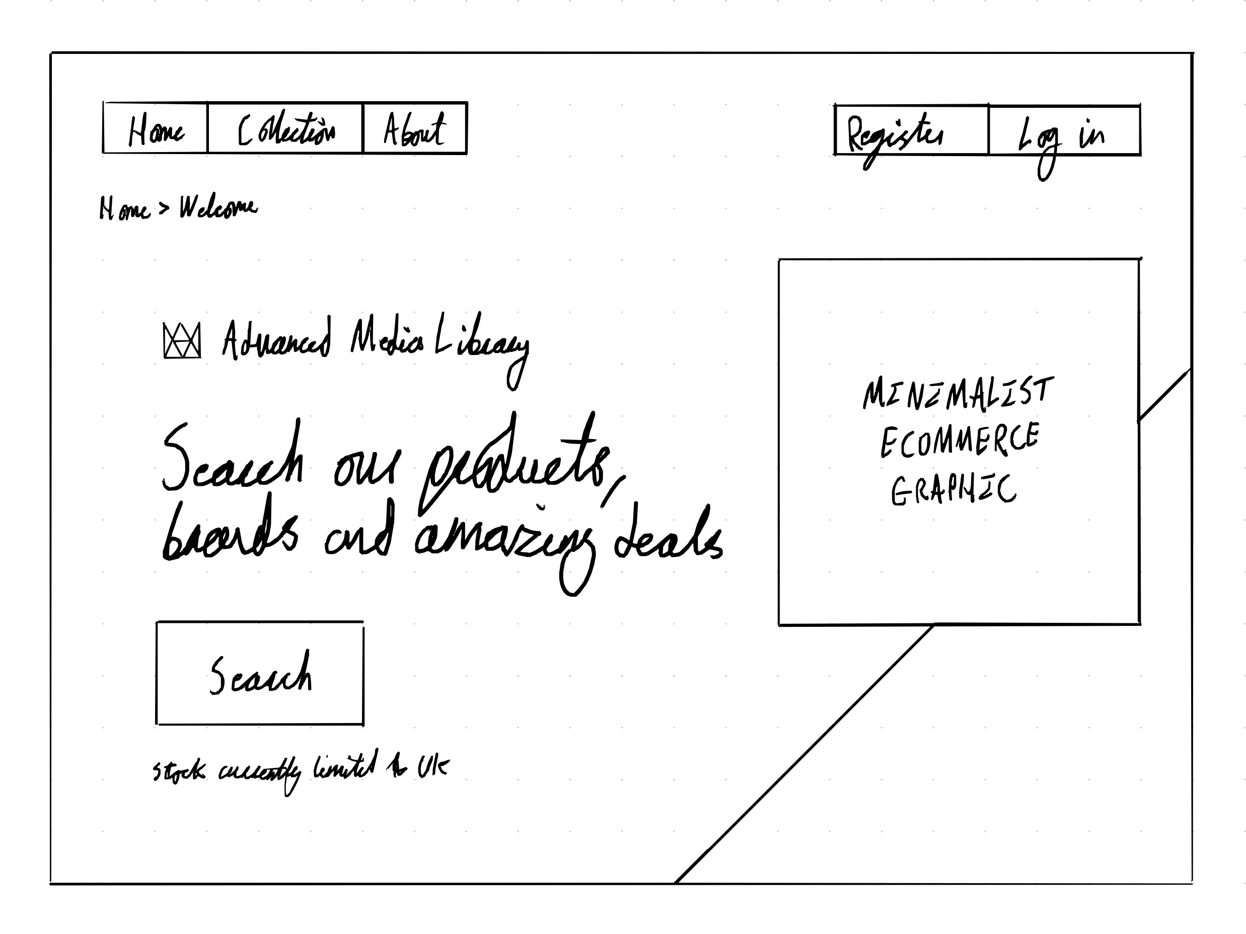

Item view

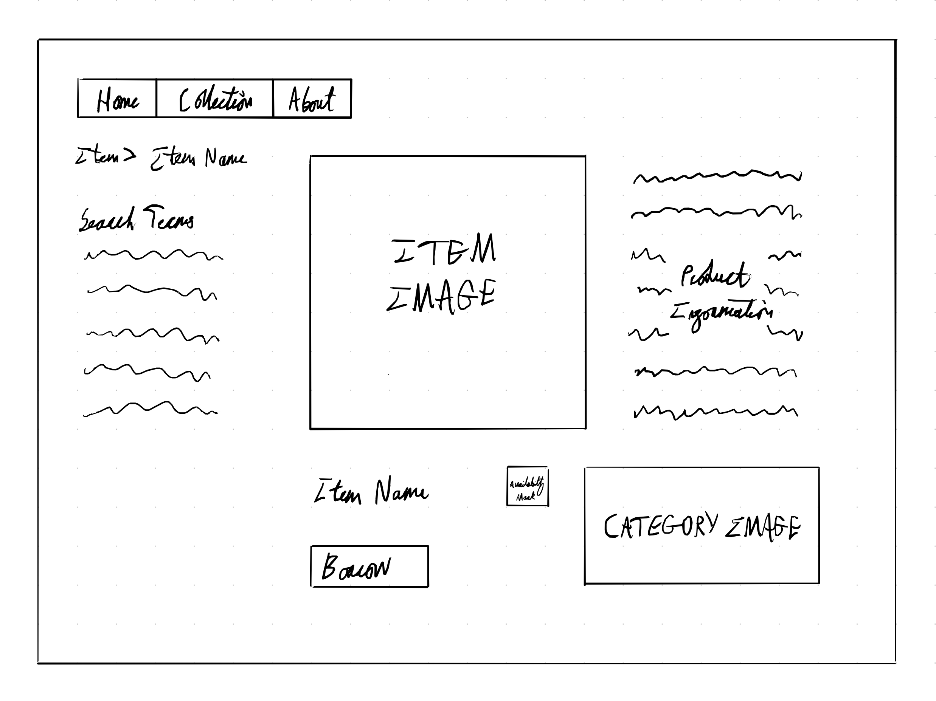

Search

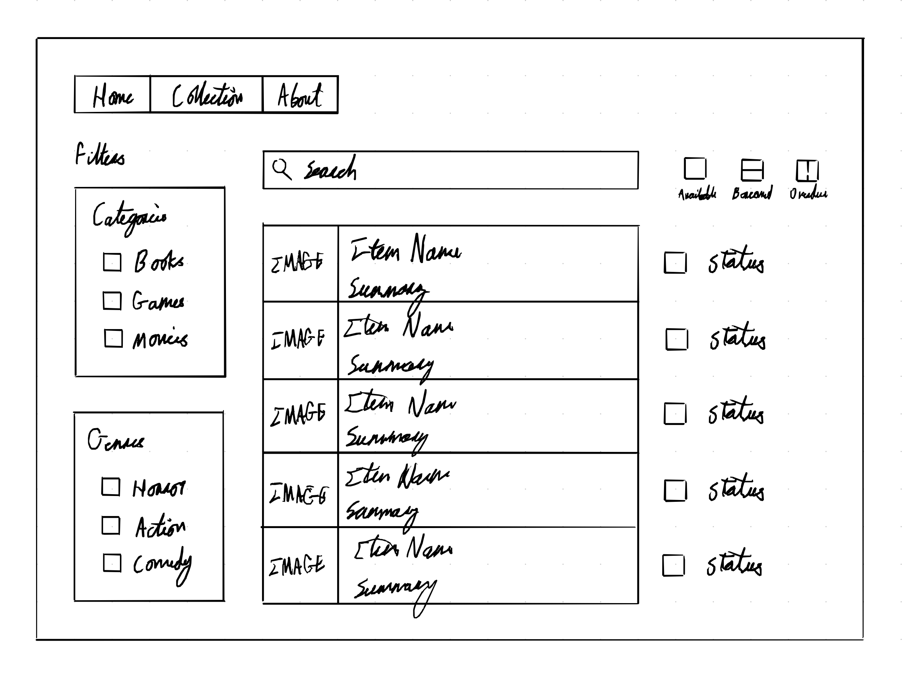

All Items

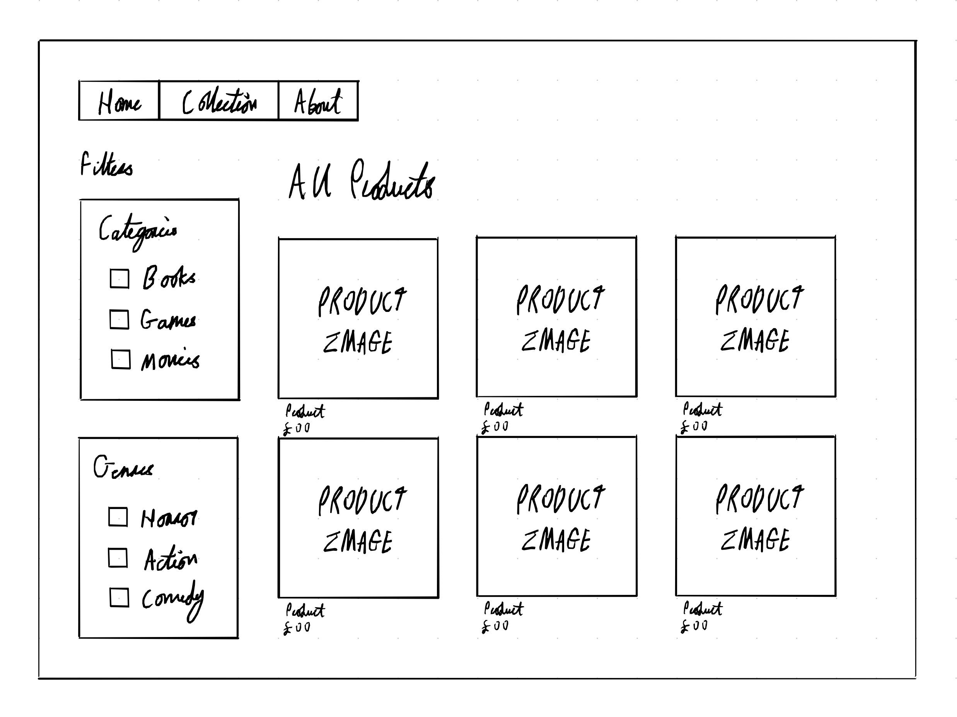

Second Design (High Fidelity):

API endpoints

Document your APIs here. (FILL THIS IN WHEN WE START SPRINT)

System Architecture

C4 Context Diagram (level 1)

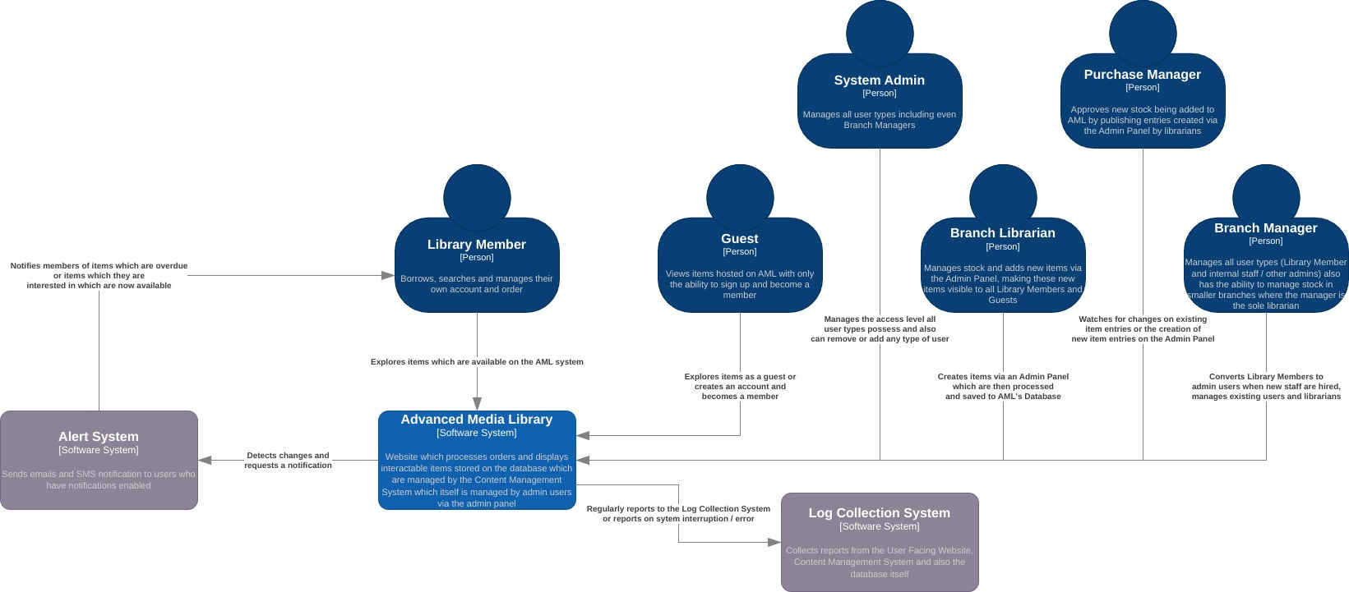
add more roles

C4 Container Diagram (level 2)
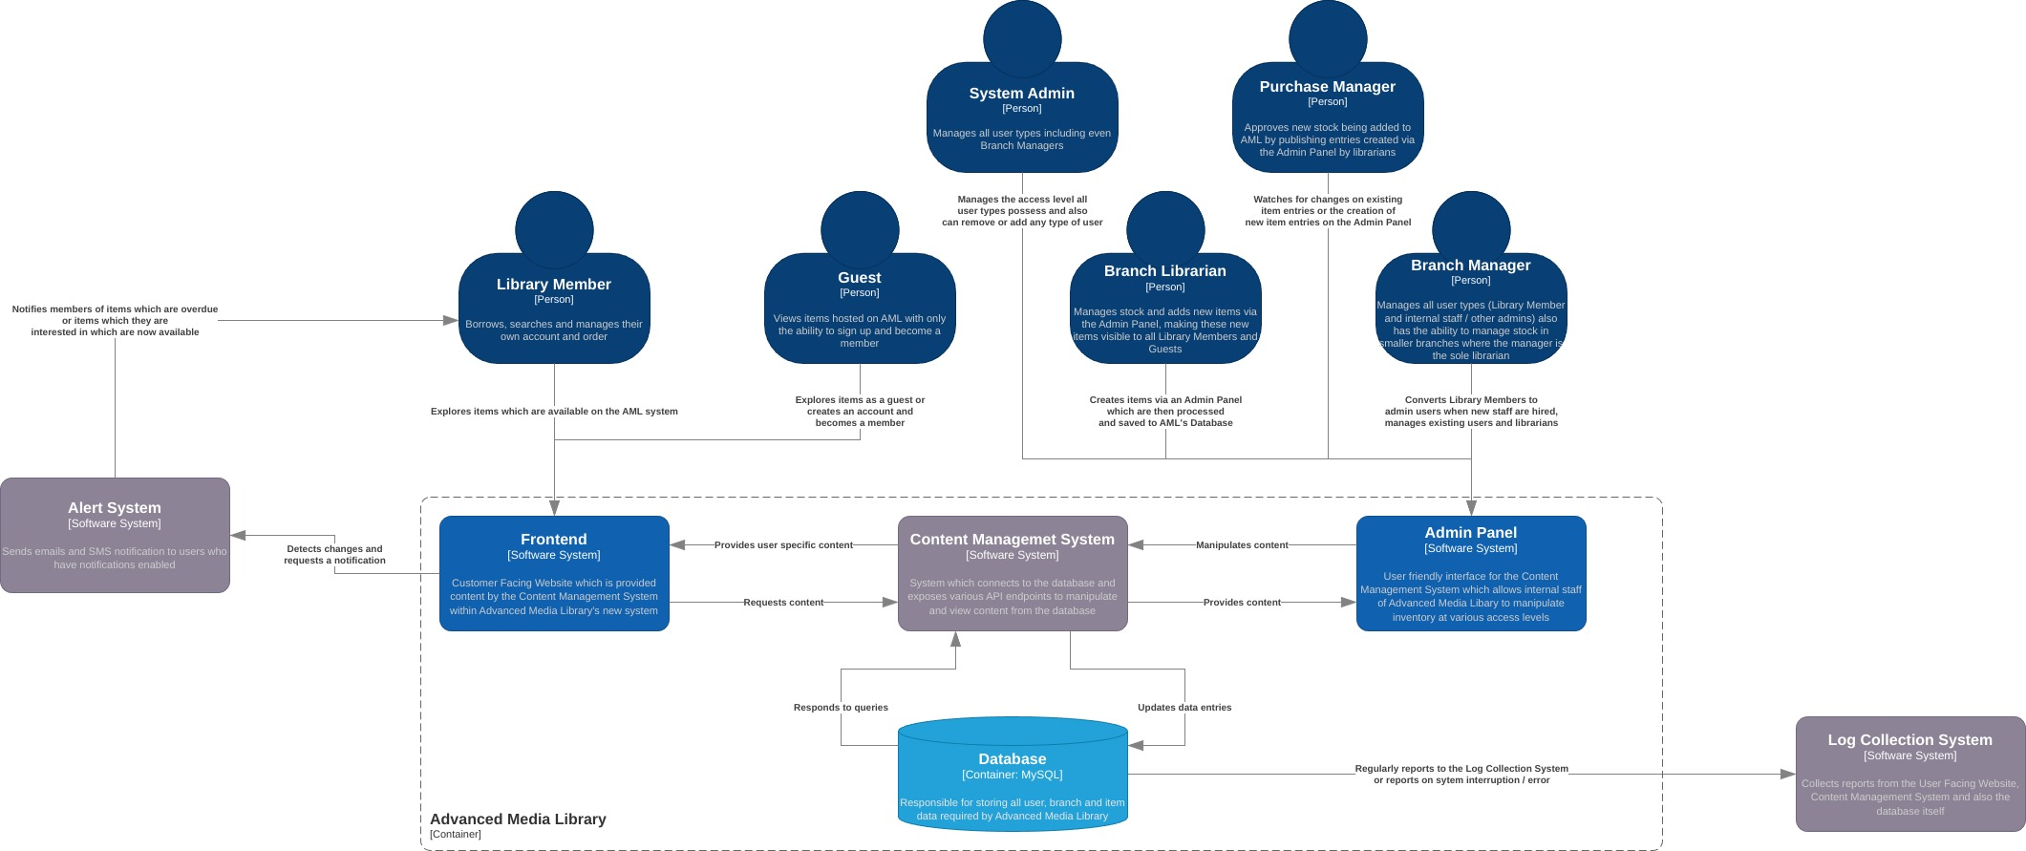

C4 Component Diagram (level 3)

C4 Code Diagrams (level 4)
- Structural diagram
- Behavioural diagram

class diagram
sequence diagram

Data Design
Include diagrams and description of the project data design.

In terms of the data design of the project, both the data of the users and the data of the media need to be stored and represented in a way that allows other functionality to work. For instance, to allow the user to search for books written by an author, each book will need to have that data attached. Users must also be represented to give them these priviliges.

(make an ERD here)

Architecture Decision Records

Include one key ADR example here:
ADRs are important to determine how exactly to best improve the systems of AML, and one of their most important systems worthy of improvement is their CMS, or Content Management System.
Add Link to GitHub repository that includes all project ADRs.
8

Security

In terms of security measures, each user will be using their own account with a unique username and password. Their name must be unique to avoid impersonation and prevent someone withdrawing many books in their name fraudulently.
Since AML will be storing a large amount of information from across the UK, it is important to ensure their databases are properly secure, as weak security may compromise hundreds of thousands of their users in the UK.

Team reflection

Incorporation of Formative Feedback

Table 2 - Weekly Feedback
Week # | Feedback | Response
1 | Essam: must provide recommendations through an external api and not internally | I will use an external api to provide recommendations
2
3
4
5
6
7
8
9
10
11
12

Appendix 1: Tasks Completed

Table 3-Tasks Completed by each Member:
Name: | Tasks Completed:

Appendix 2: GitHub Repository

Add here a public link to GitHub Repository.
Include screenshots of commits and insights.

Table 4 - GitHub Usernames
Student name | GitHub name

Appendix 3: Sequence Diagram

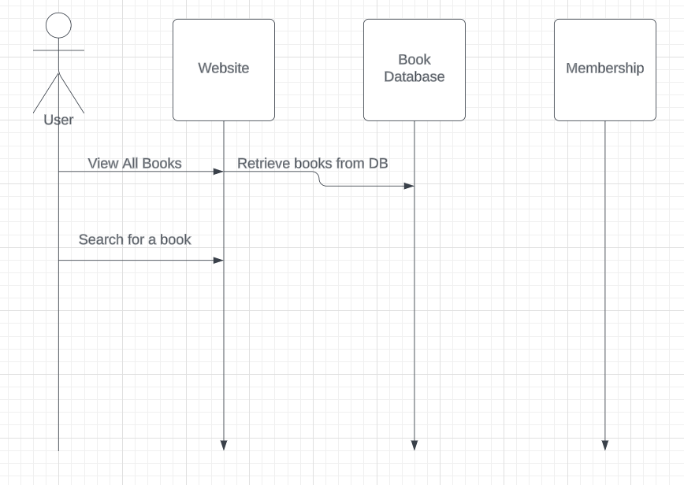

￼
￼

References

