SAV (Select-A-Vistion) Eyewear: Tri Focus Readers / Blue Light

<https://www.saveyewear.com/reading-glasses/tri-focus-readers.html>

Okay, so I am at a point where I find it difficult to go through the day without grabbing a pair of reading glasses somewhere along the way. My regular vision is alright, so all I need for now are reading glasses.

In the past I have used them for fine print instructions or ingredients (or the ludicrously small labels on laundry detergents and softeners that tell you which is which – what’s with that?), and that has been enough. I can still see the computer screen fine, so long as I am sitting back in my chair, but lately working with up close details on my screen could benefit from a boost. The problem is the power needed for reading or writing notes is higher than what is needed for my computer screen.

Therefore, when I came across these tri-focus reading glasses, I thought they were worth a try. They are just like prescription progressive lens, but do not attempt to correct for distance, and are not customized beyond coming in assorted styles and powers (1.00 to 3.00). They are also about $50 instead of several hundred dollars.

I have now been using them for several months, and I am very pleased with them. In fact, I now have a couple of them, so they are wherever I need them. They do have an additional feature I wasn’t looking for, which is blue light blocking for computer use. That has been a health trend for a few years now, but other than the glasses making objects a bit dimmer than usual, I can’t really tell how much difference this makes. They also come with a soft carrying case.

The progressive lenses have three zones, the lower portion for paperwork at 100% power, a computer portion for screens at roughly 80% power, and an interacting zone at the top for looking across the desk at 50%. In practice, I find this works very well, and there is no detectable edge between zones. They are also quite comfortable to wear for long periods (without headphones), and when you put them on or take then off, the spring in the hinges allows some give without putting added stress on the arms. The hook for the ears is plenty to keep them on at my desk, but little enough to slide on and off easily. A picture containing chart

They don’t attract extra dirt, so light cleaning as needed is all they require. The lens case is effective at protecting the lens and keeping the arms from getting bent when they go in a pocket or bag. Since the case is not hard, they could still get broken if sat on, mistreated, or spend the day in a jeans pocket, rather than a jacket or vest pocket.

The frames come in slightly different shapes, but I like that the lenses in mine are low enough for reading a book, though for reading a book or phone in bed, they could go a bit deeper. For me, the Interacting zone would be better as clear glass with no magnification, so I could just wear them without removal when I walk somewhere else.

Basically, I like the progressive concept and for me it would be best with no magnification at the top, or a fully prescription version at far higher cost, but this is an excellent substitute. It is well made, with small extras like the springy hinges, is comfortable (for me), and does its job well. A hard case, or slightly thinner fold would make nice improvements, but for the price these are very effective.

The following YouTube reviews were about all I could find beyond those left on their own site. The EpicReviewGuys’ thoughts were very similar to my own. He did also note that normally he would get a headache using regular reading glasses to look across the room, which he did not using the upper (Interacting) portion of these. The Gad Wmixs review is not very complete, though they did not like the sewed-in version of lens cleaning cloth theirs came with.

EpicReviewGuys, (March 16th, 2017). Tri Focus Reading Glasses Review. [Video] YouTube. Retrieved online June 11th, 2022 from <https://www.youtube.com/watch?v=Bs2bD941EMA>

Gad Wmixs, (November 9th, 2020). SAV Eyewear Tri Focus Select-A-Vision Glasses Review. [Video] YouTube. Retrieved online June 11th, 2022 from <https://www.youtube.com/watch?v=4jv7EyFkiW0>

Discussion – week 8: My Scottevest

**Scottevest Travel Vest**

[**https://www.scottevest.com/products/rfid-travel-vest-for-men**](https://www.scottevest.com/products/rfid-travel-vest-for-men)

Scottevest clothes provide lots of customized pockets for modern electronics and conveniences. I have had a version of this vest for over ten years and use it often. It has about 26 pockets which hold cameras, glasses, wallets, phones, and so on. Oversized pockets are specifically designed for common bulky items like a full-sized water bottle (with elastic strap to keep it from moving around), tablet or notebook, and laptop. All pockets have zippers, and some have multiple tiers of inner pockets, held shut from one another by magnets sewn into the material.

Here are some pros and cons from my experience:

|  |  |
| --- | --- |
| **Pros** | **Cons** |
| Comfortable weight distribution | Phone pocket cover material did not hold up well (see-through and touch-through) |
| Ability to carry large items | Very easy to lose track of items that don’t have a permanent home |
| Ability to carry and organize many items | Very difficult to clean everything out for washing |
| Water bottle pocket can also hold a micro umbrella | Small items or loose change can disappear into the headphone wire channels if not held in an appropriate small pocket and vest is tossed around (going upside down) |
| Frequent use with regular items turns the vest into the equivalent of a briefcase or backpack with everything ready to go, in its place | Regular use makes it difficult to switch over to something else when you don’t want to wear a vest |
| Airport security: everything in vest goes through screening tray and back on, quickly | Very expensive |
| Glasses pocket has attached cleaning cloth |  |

A brief evaluation, using Quesenbery’s 5Es:

|  |  |
| --- | --- |
| **Quesenbery’s 5Es** |  |
| Effective | The vest carries a lot of stuff, and it blends into the look quite easily. |
| Efficient | It is very easy to access each pocket to retrieve and store items. The small and large pockets cover most portable items. |
| Engaging | It is satisfying to have access to all your stuff, without awkwardness or a heavy bag. |
| Error tolerant | So long as you close zippers after using them, you won’t likely lose anything, though if you don’t and you frequently set your vest down, it is possible to lose something. It is also possible to lose track of where you have stored items, which can get frustrating when you need them and must search. |
| Easy to learn | The vest is easy to use, but without referring to the pocket diagrams, it takes a while to remember all the pocket options, and to settle on where you’d like to store each item. |

Evaluation using the Quesenbery’s 5Es suggests the vest is successful in its mission to carry around the things you need with little effort, easy retrieval, and while not feeling the weight.

**References**

Barnum, C. (2021). Usability Testing Essentials. (2nd edition). New York. Morgan Kaufmann Publishers.

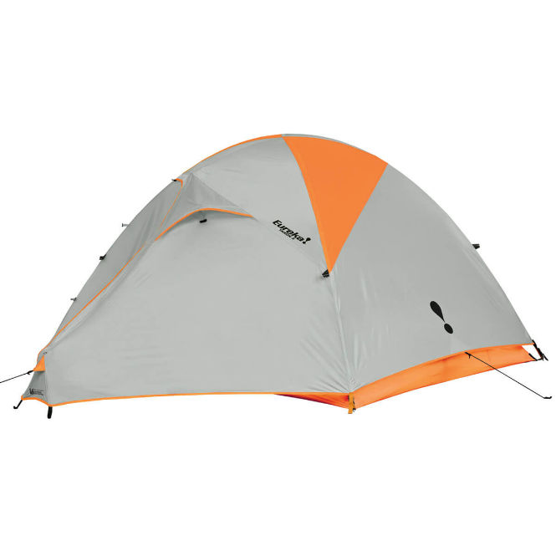

**Eureka Taron 3 Tent**

https://eurekatentscanada.com/

I have a few tents, and they each have a purpose with pros and cons. This Taron 3 tent from Eureka is the one I use most for group campouts without much hiking or canoeing.

The Taron is “three-man” based on the standard of how many sleeping bags actually fit, but that would be tight. I primarily use it on my own and it provides tons of space for me, my regular gear, and the extra group gear I often need to drag along. I will use this tent with one other person, but rarely with three. There is more room under the vestibule outside the tent for further gear that does not need to come inside. There is a gear loft at the top, and plenty of pockets to hold quick grab items like flashlights and sunglasses.

It is a three-season tent with very good waterproofing and a bathtub floor. It has endured multiple days and nights of downpours without actual leaking, though at that point you do need to avoid touching the walls, wicking water through. The tent’s structure is reasonably strong and holds up well to wind but I wouldn’t recommend it for very high wind conditions. It does have enough extra guy line attachment points for quite secure anchoring, but only if you are carrying enough extra string.

While its ventilation is great for the summer, this tent is horrible when the weather turns cold. In fairness, it is rated as a three-season tent, not a winter tent, but in the late fall sometimes there are unexpected cold snaps, and it makes for a difficult night. When snow does appear, it weighs down the fly rather than shedding easily. The frost contributes to the fly sagging and without extra tarps, guy lines, pegs, and preparation, it can be difficult to either pack up or get the tent ready for another night.

The tent is very easy to pitch and take down, even for one person. There are two lightweight shock-corded poles which clip to the tent body and are easily assembled. The fly system connects to the tent body with clips and a fly rod provides extra head space in the vestibule.

The Taron 3 is fairly large and heavy to carry for hiking but is reasonable for two people on a canoe trip. For hiking or a trip without excessive gear, I would rather use a “one-man” tent. For the late fall and winter months, I would use a winter tent. A quinzee (above…far warmer at -40C out than the tent at -10C) is far more effective in the winter than this tent would be.

Here are some pros and cons from my experience:

|  |  |
| --- | --- |
| **Pros** | **Cons** |
| Easy to setup & take down | Fairly large and heavy for hiking |
| Good ventilation in the heat | Limited seasonal use (gets too cold) |
| Good waterproofing | Limited high wind resistance |
| Quality zippers and materials | Could use more ventilation closure options |
| Lots of head room | Harsh ground requires a footprint |
| Both foul and fair-weather entryways |  |
| Large vestibule for extra gear and entry space |  |

A brief evaluation, using Quesenbery’s 5Es:

|  |  |
| --- | --- |
| **Quesenbery’s 5Es** |  |
| Effective | Within the seasons it’s rated for, it provides good shelter in warm and stormy conditions. |
| Efficient | It sets up and takes down quickly, and pockets help with interior organization. |
| Engaging | With colour-coded fly to tent body clips, and vestibule options for staying dry while watching the outside during regular storms, a lot of potential frustrations are avoided and there are opportunities to be engaged with the outdoors. |
| Error tolerant | Mistakes can be made in setup, but unless there are high winds or torrential rains, they do not affect usability or livability very much. |
| Easy to learn | The instructions and tent are straight-forward and intuitive a couple exceptions: preparation for serious weather require more knowledge than is provided, and the fly pole assembly could be clearer. Using the entryways and ventilation options are simple. |

Overall, the Eureka Taron 3 is very usable within limits. It is best limited to trips in the late spring to early fall, where it won’t have to be carried for long distances. It is very suitable supporting two people on a canoe or car camping trip, even if rainy weather is expected.

A smaller, lighter tent would be more suitable for long hiking trips, and a winter tent should definitely be used in colder months of the year. Otherwise, as a reasonably priced mid-range tent, it provides very good value and assurance as a reliable shelter.

°

**References**

Barnum, C. (2021). Usability Testing Essentials. (2nd edition). New York. Morgan Kaufmann Publishers.