**ASIAN COLLEGE OF HIGHER STUDIES**

**(Affiliated to Tribhuvan University)**

**Dhobidhara, Kathmandu**



**Assignment**

**Of**

**“Web Technology”**

**Submitted by**

**Rabina Rana (cs180825)**

**Fifth Semester**

**Submitted to**

**Subit Timalsina**

**ACHS, Kathmandu**

**Abstract**

My report Portfolio's goal and scope are to show potential employers how to choose the ideal applicant by highlighting experience, talents, and accomplishments. It comprises an overview of my schooling, accomplishments, and professional experience in order to convey a breadth and depth of knowledge that employers will value.

**Table of Contents**

|  |  |  |
| --- | --- | --- |
| **S.N** | **Topic** | **Page No.** |
| 1 | INTRODUCTION   * + PORTFOLIO INTRODUCTION   + IDE5 | 4-5 |
| 2 | SCREEN SHOTS | 6-7 |
| 3 | CONCLUSION | 8 |

1. **INTRODUCTION**
   1. **PORTFOLIO INTRODUCTION**

The ultimate goal of a portfolio website is to help to gain more clients, whether that means freelance work, new clients for your agency, or job opportunities. Before we start adding material to your website, we need figure out what we want to achieve.At its most basic form, a portfolio website provides **professional information about an individual or a company**and presents a **showcase of their work.**

**In this "Portfolio", HTML is used to design text as headers and headings, organize illustrations on the portfolio site, connect to other pages within a site, and connect to many locations, CSS is used** to change the style of the portfolio and user interfaces and JavaScript is used to change theme of portfolio by using event listener.

* 1. **IDE**

There are many IDEs available on the internet for a particular language. An IDE is an environment that has features which support the writing of language, runs it and produces the desired result. They are different for different language like Visual Studio Code if you want to write program in HTML, CSS. For this we are going to use Visual Studio Code as IDE.

Visual Studio Code is a lightweight but powerful source code editor which runs on your desktop and is available for Windows, macOS and Linux. It comes with built-in support for JavaScript, TypeScript and Node.js and has a rich ecosystem of extensions for other languages (such as C++, C#, Java, Python, PHP, Go) and runtimes (such as .NET and Unity).

1. **SCREEN SHOTS**

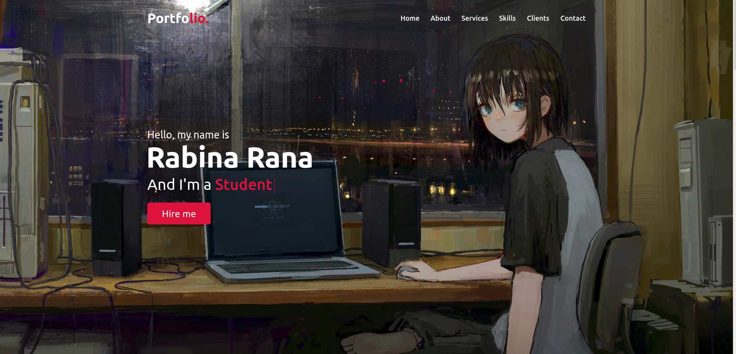

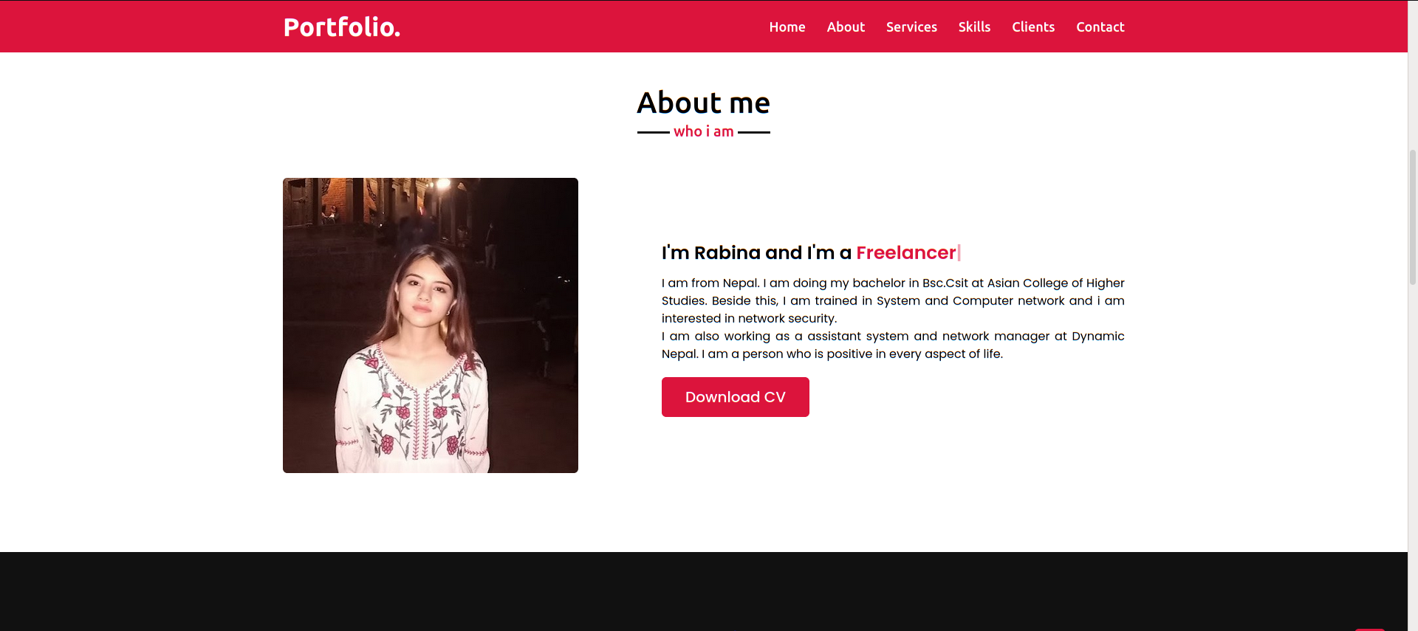

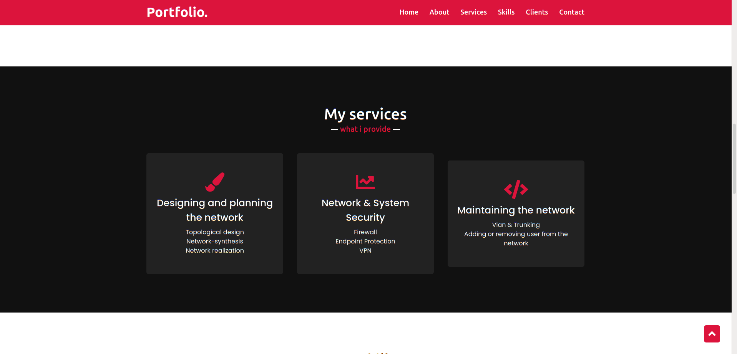

**Figure: Homepage**

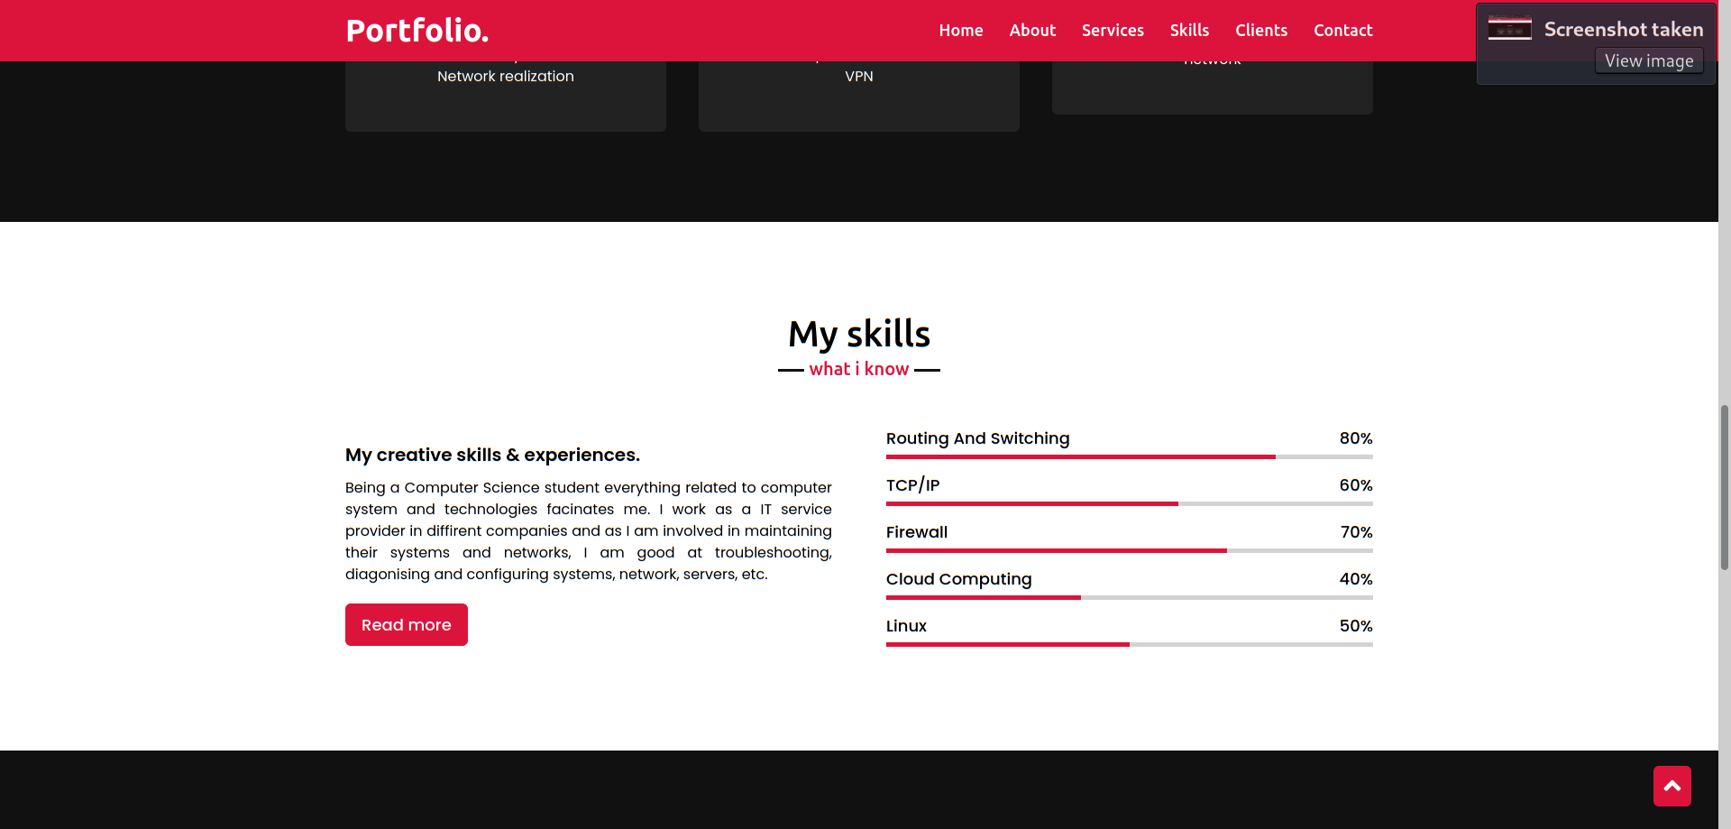

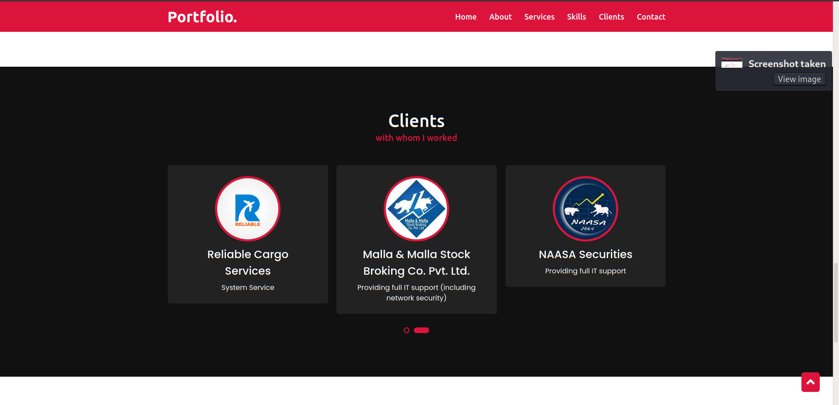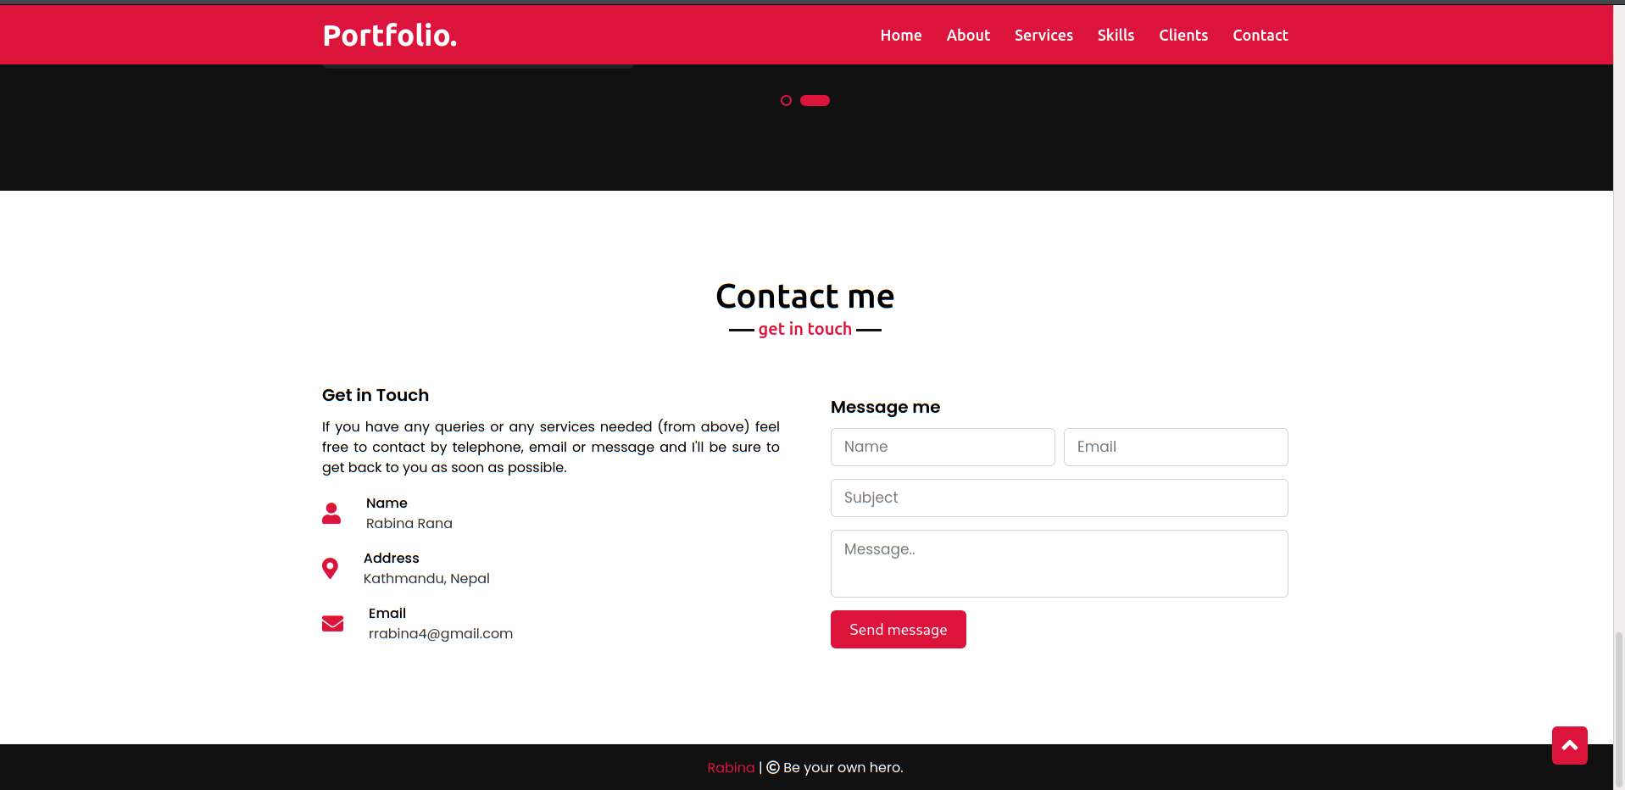

1. Conclusion

To conclude, Portfolio is a website is the ultimate way to showcase your work and let others reach out for you. Through this portfolio, any coding we’ve done for it is work potential employers might be paying attention to and analyzing, and this presents an opportunity for you to show off skills you might not have been able to in the projects you link to.

I learned how to use CSS to style web pages, how to make web sites responsive, and how to deal with HTML, CSS, and Java Script as a result of my project.