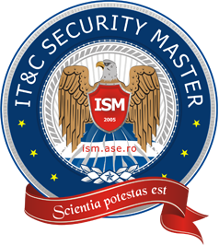

Bucharest University of Economic Studies

Faculty of Cybernetics, Statistics and Economic Informatics

IT&C Security Master Program

Steganography Mobile Application

Dissertation thesis

Scientific coordinator

Assoc. Prof. Popa Marius Emanuel Ph.D.

Master student

Ionescu Radu Ștefan

Bucharest 2020