**Assignment-1**

Q.1. Install Power BI Desktop and share the final screenshot of the report view page which appears when power desktop starts.

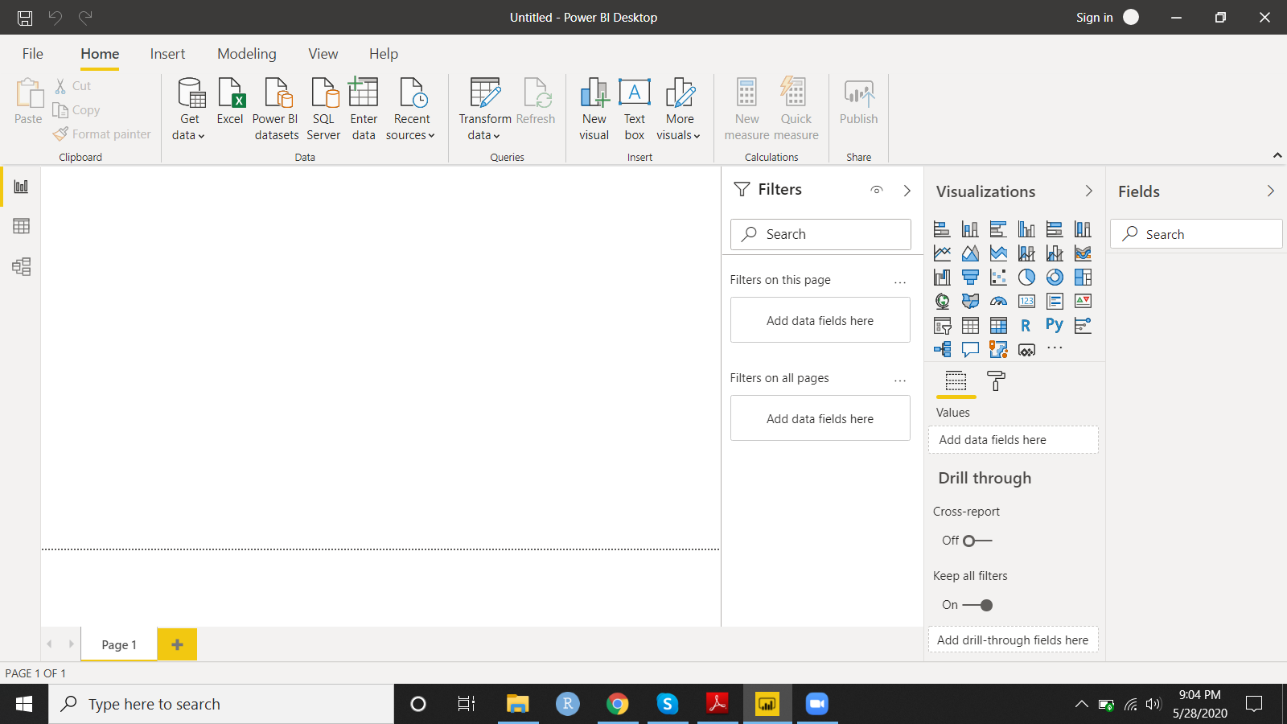

Q2. Prepare a document and with the following screenshot

* Report View
* Data View
* Model View
* Power Query Editor
* Advance Editor

Ans: 1.Report View

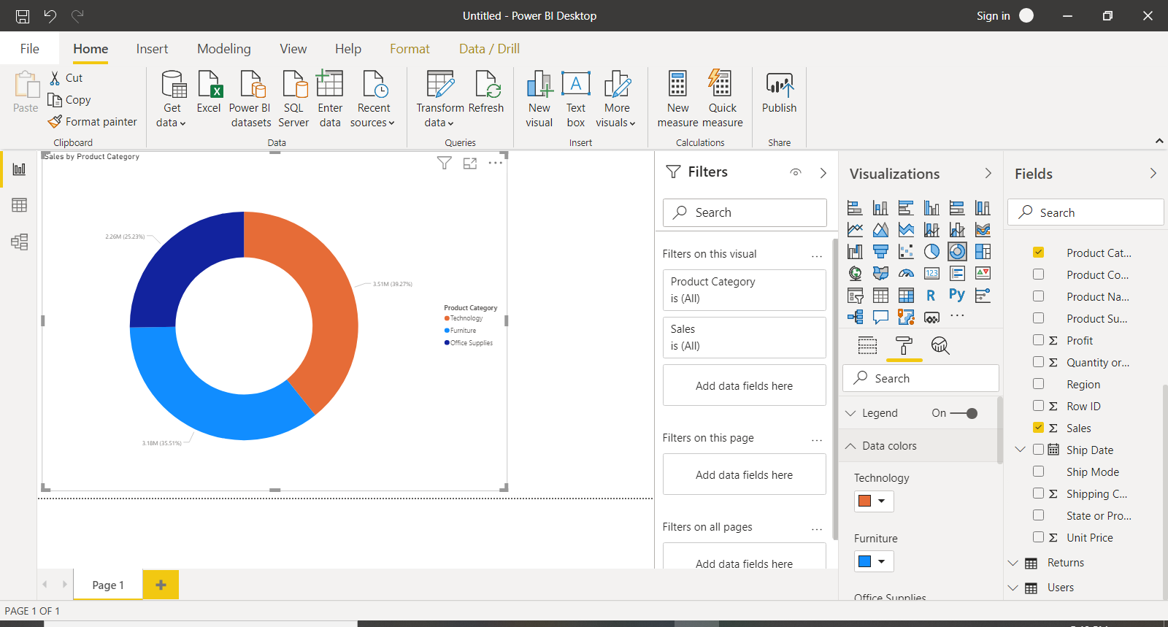

2. Data View:

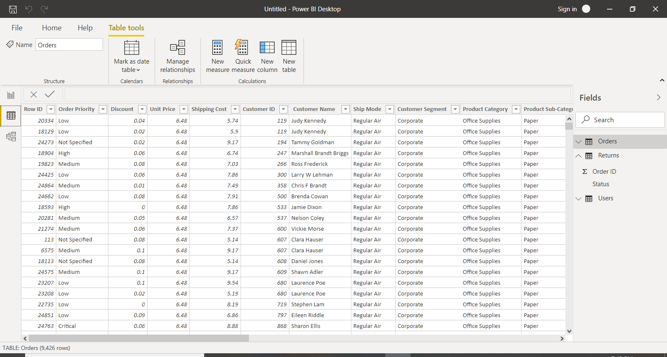

3. Model View:

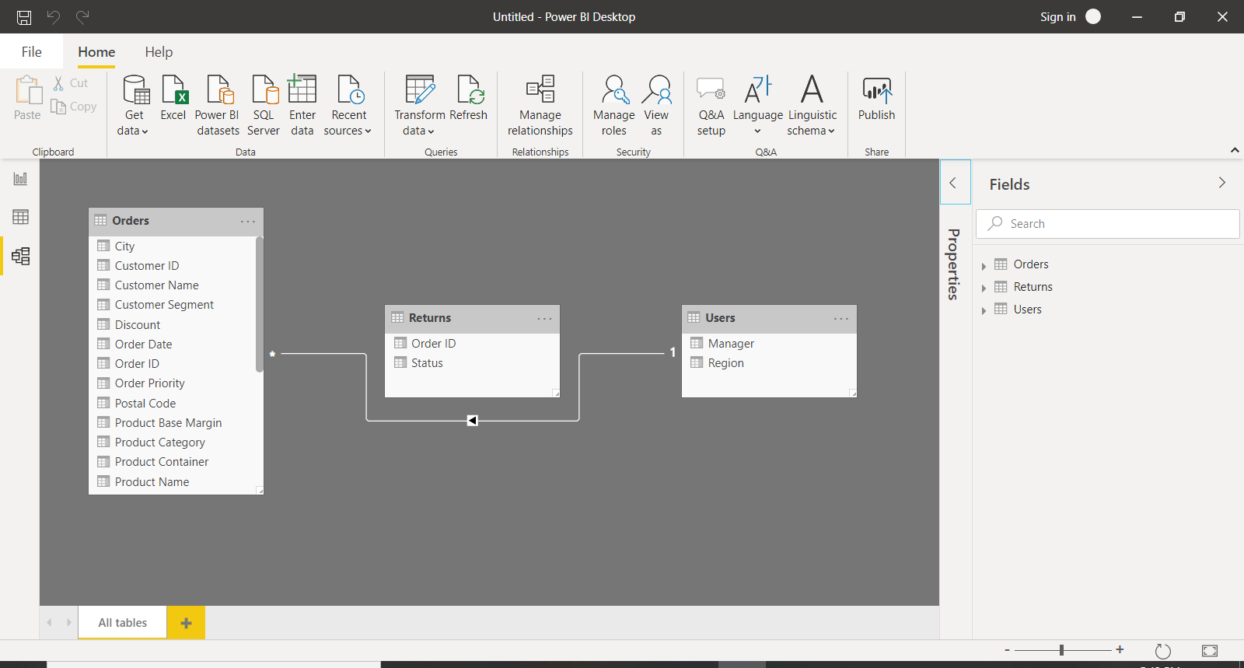

4. Power Query Editor:

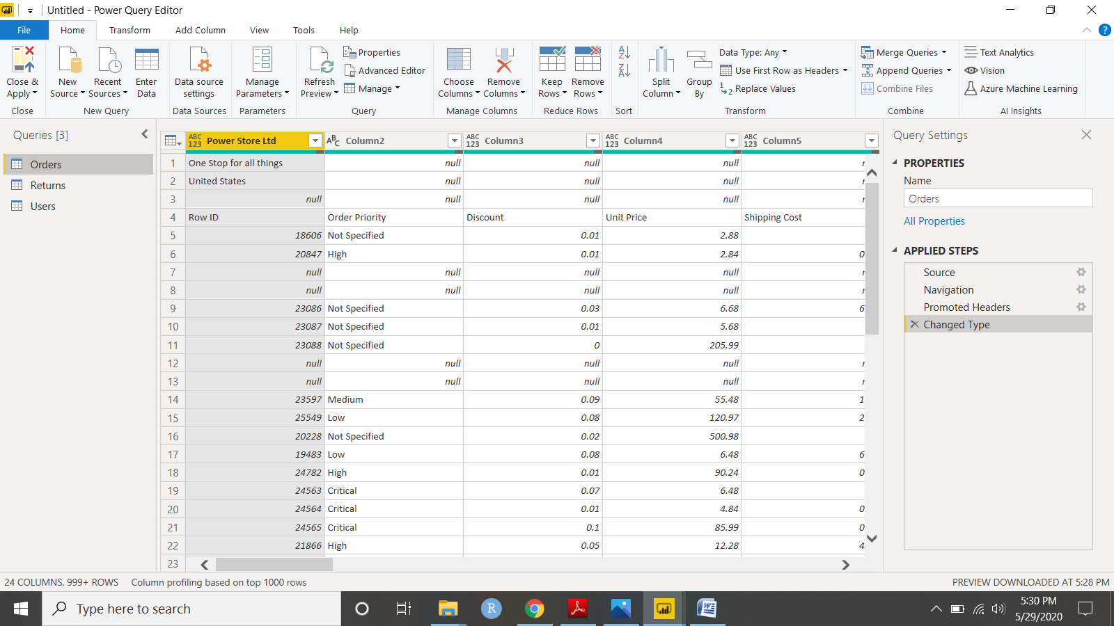

4. Advance Editor:

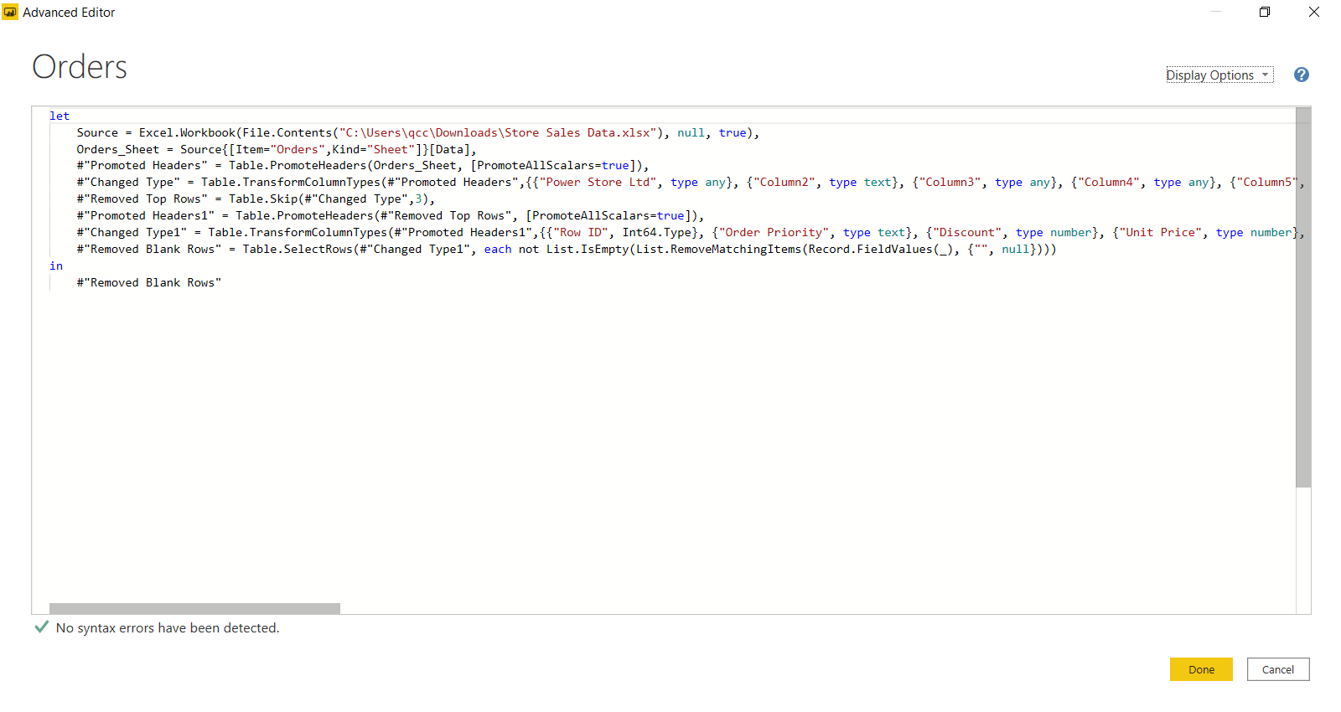

Q3. Prepare a document with details of the following along with their price

* Power BI Desktop
* Power BI Pro
* Power BI Premium

Ans:

**Power BI Desktop:** It is a free version available to any single user and includes data cleaning and preparation, custom visualizations and the ability to publish to the Power BI service.

**Power BI Pro:** Pro subscription starts with $9.99 per user per month. It offers features like data governance, content packaging and distribution. We can also try it for 60 days before purchasing the subscription.

**Power BI Premium:** The premium plan starts at $ 4,995 a month per dedicated cloud compute and storage resource.