**Assignment – 3**

Use the Employee Details dataset and perform the following activities.

Q.1.Split the column CITY and separate the code associate with each city like – Allahabad [AL2] should be only Allahabad and [A2] will be separate.

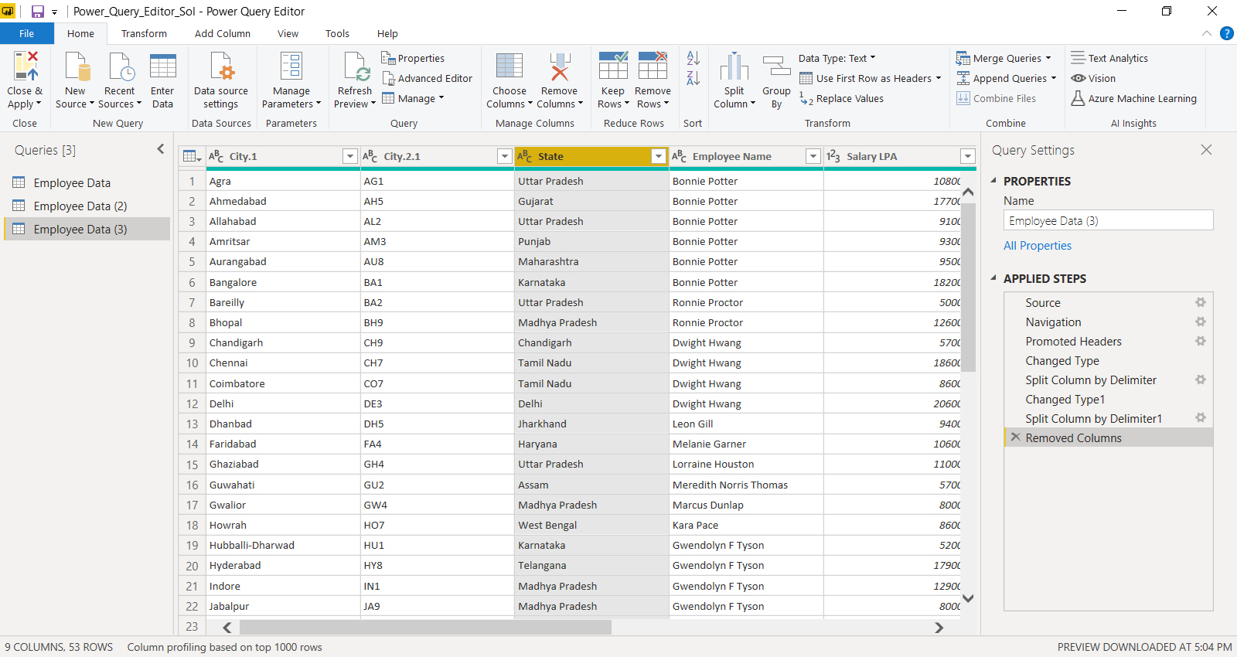

Q2. Extract the first name from EMPLOYEE NAME column and transform the column.

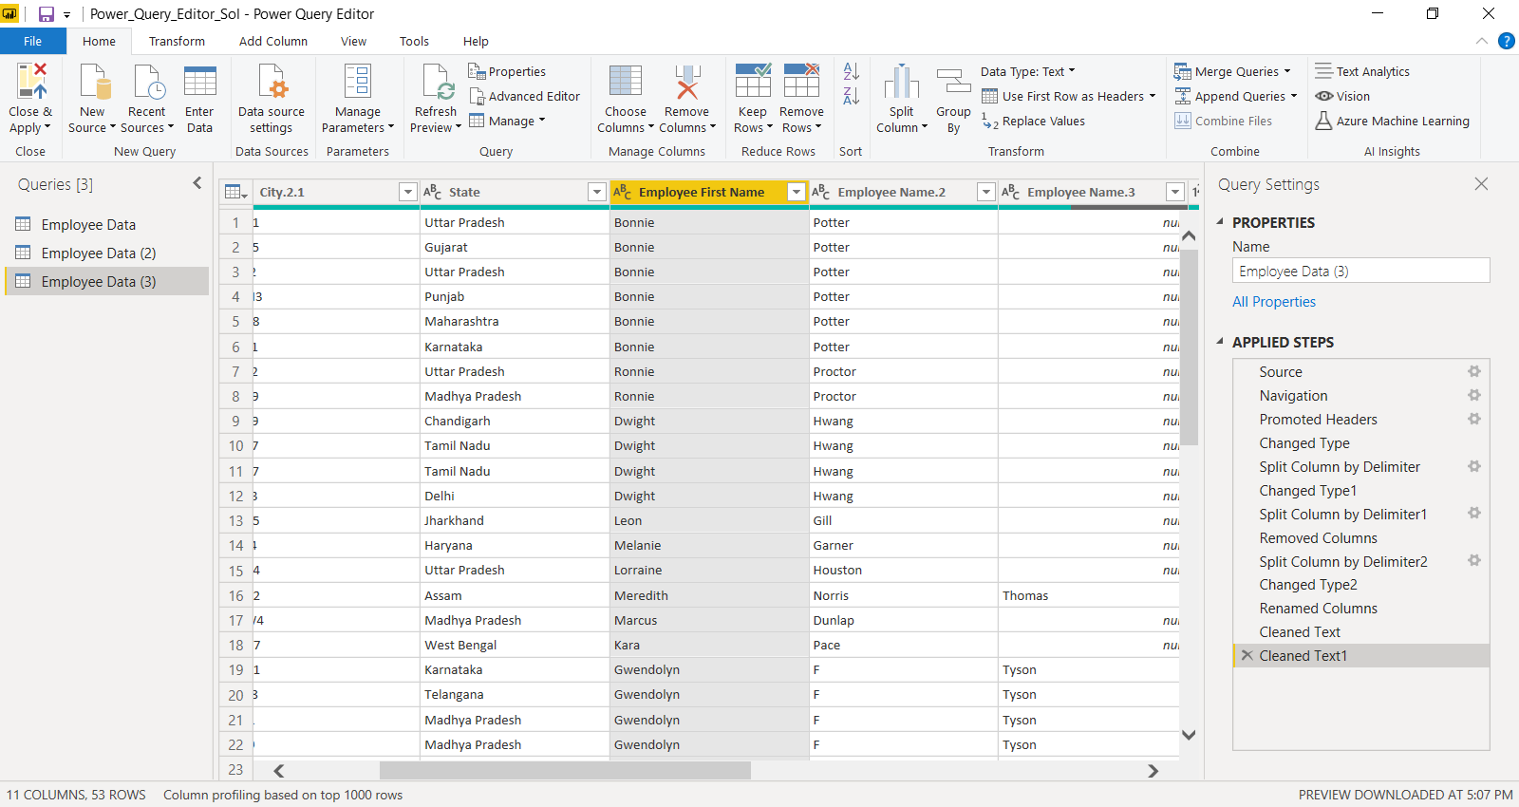

Q3.Using the JOINING DATE column extract the Year and no. of days for that month.

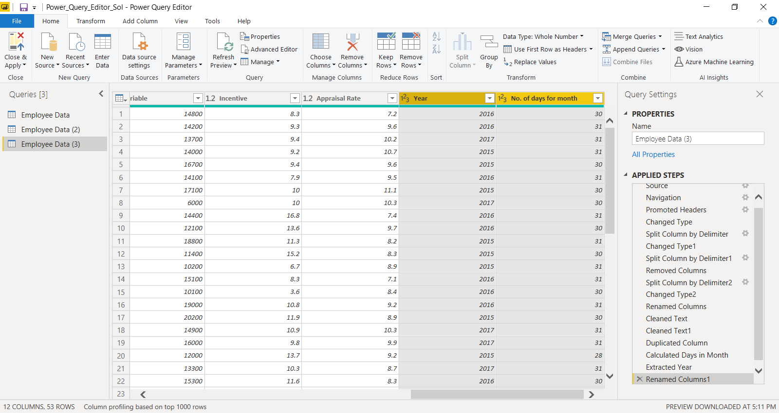

Q4.Create a visual of your choice and show the how much salary has been paid to each state and which state has lowest payout.

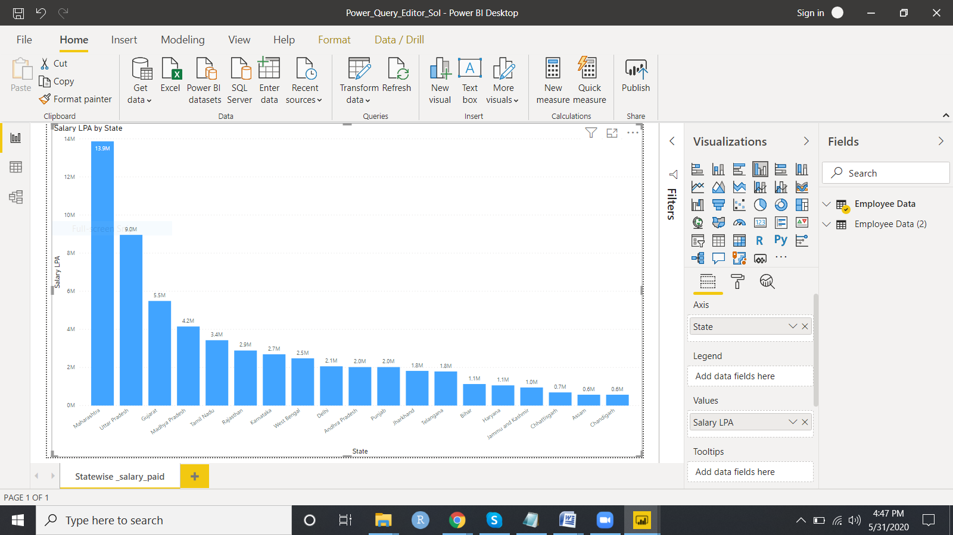

ss

Ans : Assam and Chandigarh has the lowest payout.