## horizontal line

## **Visit Pipelines problems**

# **Problem Statements :**

Consider the shape of pictures given below :

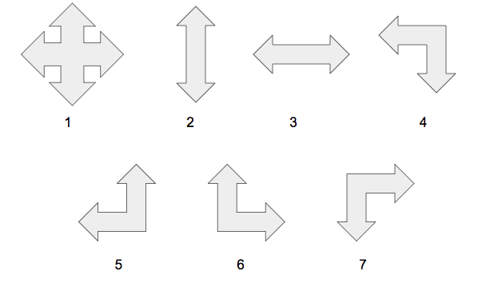

All the above given shapes represents the shape of pipelines. The arrow points represents that you can either enter into that pipelines or can leave that pipelines from that point. Pipeline 1 has four entry points and leaving points and other six pipelines have two entry points and leaving points.

**Examples :** For pipeline 1st, you can enter or leave that pipelines from all four points.

A robot is moving into a tunnel. The tunnel is represented in the shape of matrix and each indices of that matrix represents one of the shape of above given pipelines. See the below figures.

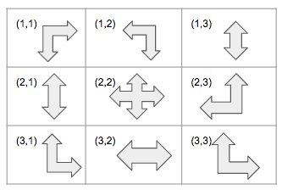

**Tunnel in the form of matrix**

Suppose that Robot is initially at pipeline (2,2) . So it can able to leave that pipelines in four directions (Left, Right, Up , Down) i.e into the pipeline (2,1), (2,3), (1,2) and (3, 2). Robot will move in a particular pipeline only when there is a leaving point into current pipeline and an entry point in the next pipeline where it wants to move.

**Examples :**  From pipeline (2, 2) , robot can move into pipeline (2,3) and (1,2) only but can’t move into the pipeline (2,1) and (3,2) although it can able to leave the cell (2,2) into left and down directions.

**Problem :** You are provided a such kind of above tunnel of pipelines in the form of matrix. Initially Robot has provided a fixed pipeline (x,y) and an integer L. Integer L represents that robot can move to that pipeline which is at most (L-1) distance away from the current pipeline. The index of matrix would be an integer p (1<=p<=7) and the value of p represents the shape pipelines which is given in the 1st picture.

You work is to find how many of pipelines it can visit starting from the pipelines with index (x,y).

# **Input Format :**

First line contains integer t which is number of test case.

For each test case, it contains following lines.

1st line of each test case contains five integers n, m, x, y, L. n*m is the dimension of the matrix and (x,y) is starting index of the robot and L is the maximum number of pipelines it can visit.

Next n lines contains m space separated integers which is the value of index of the matrix.

**Constraints :**

1<=t<=100

1<=n,m,<=50

1<=L<=2500

**Output Format :**

Print the maximum number of pipelines that robot can visit.

# **Sample Input :**

1

3 3 2 2 5

7 4 2

2 1 5

6 3 6

**Sample Output :**

7

**Explanation :**

Robot can start from pipelines (2,2) and visit the other pipelines which upto 4 (L-1) distance away from the pipelines at index (2,2).

(2,2) -> (2,3) and (1,2) , (2, 3) ->(1,3), (1,2) -> (1,1) -> (2,1) -> (3,1)

Total visited pipelines = (2,2), (2,3), (1,2), (1,3), (1,1), (2,1), (3,1)

**Time Limit :**

none