ZoTok
User Manual
Home Dashboard & Threads
──────────────────────────────────────────────────
Version 1.0 • July 2026
A Complete Walkthrough for New Users

Hd Agencies
Powered by ZoTok

Table of Contents
1. Introduction
1.1 About This Manual
1.2 Logging In
2. Home Dashboard
2.1 Navigation Sidebar
2.2 KPI Cards
2.3 Customer Data Table
3. Settings & Configurations
3.1 Sales View Settings
3.2 Payment View Settings
4. Product Module
4.1 Product KPIs
4.2 Empty State & Adding Products
5. Threads
5.1 Threads Interface
5.2 Thread Types
5.3 Empty Conversation State
6. Queries Management
6.1 Queries List
6.2 Query Type Details
6.3 Adding a New Query Type
6.4 Complete Query Type Reference
7. Appendix
7.1 Click Flow Diagram
7.2 Tips & Shortcuts
7.3 Document Information

1. Introduction
ZoTok is a comprehensive field operations and distributor management platform designed to streamline communication, sales tracking, inventory management, and payment reconciliation for businesses. This user manual covers two core modules: the Home Dashboard and the Threads (conversation/query management) feature.

1.1 About This Manual
This manual is structured to follow the natural workflow of a ZoTok user. Each chapter corresponds to a screen or feature demonstrated in the walkthrough, providing descriptions of UI elements, configuration options, and actionable steps.

1.2 Logging In
After successful authentication, users are greeted with the Home Dashboard displaying the firm name (e.g., "Hello, Hd Agencies") and a welcome message. The navigation sidebar provides access to all core modules.
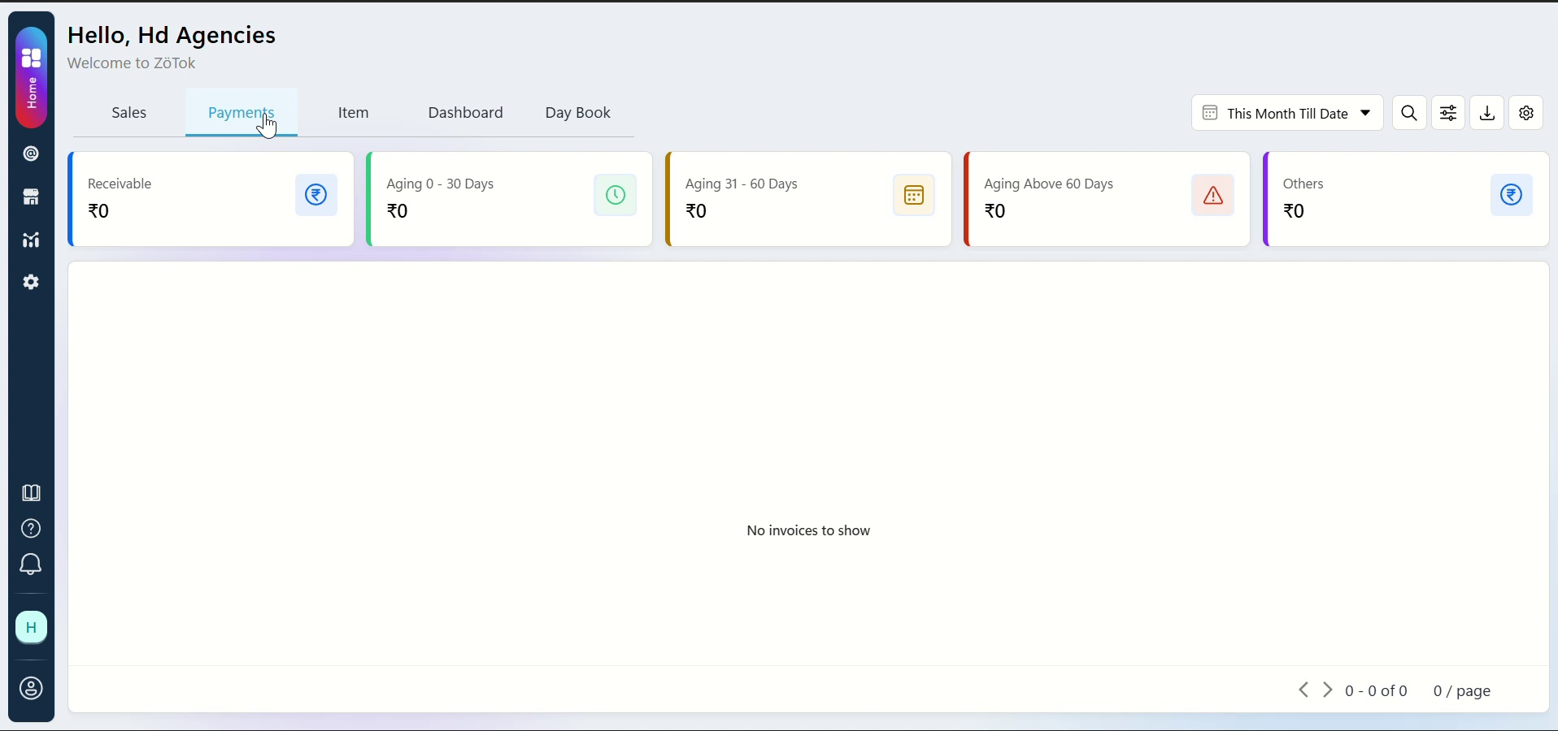

💡 Tip: The Home Dashboard is your command center — all modules are accessible from the left sidebar.

2. Home Dashboard
The Home Dashboard serves as the landing page after login. It provides a high-level overview of key business metrics and quick access to all ZoTok modules.

2.1 Navigation Sidebar
The left sidebar contains the following navigation items:
Module | Icon | Description
Home | 🏠 | Dashboard overview with KPI cards, receivables ageing, top customer data
Sales | 💰 | Sales transactions, charts, column configuration
Payments | 💳 | Payment tracking, age-wise receivables, ageing configuration
Item | 📦 | Product catalog, inventory tracking, stock management
Dashboard | 📊 | Advanced analytics and charts
Day Book | 📖 | Daily transaction register
Threads | 💬 | Customer conversations, queries, and signal inbox

Click any navigation item to switch to the corresponding module.

2.2 KPI Cards
The top of the dashboard displays key performance indicators for "This Month Till Date":
- Receivable — Total outstanding receivables
- Ageing Buckets — 0-30 Days, 31-60 Days, Above 60 Days
- Total Sales — Aggregated month-to-date sales figure

2.3 Customer Data Table
The main content area displays a sortable data table with columns including:
- Customer / Firm Name and Customer Name
- District, State, Customer Code, Phone, GSTIN
- Total Sales, Category Name/Code, Average Sales
- Total Invoices, Total Cgst

💡 Tip: Click column headers to sort. Use the settings overlay to toggle visible columns.

3. Settings & Configurations
ZoTok provides per-module configuration panels that can be opened by clicking on navigation items. These overlays allow users to customize their view.

3.1 Sales View Settings
Triggered by clicking the Sales nav item, this overlay provides:
- Chart Configuration — Chart 1 & 2 selection, Donut Chart toggle
- Table Columns — Check/uncheck columns (customerFirmName, customerName, District, State, customerCode, phone, gstin, Total Sales, Category, Average Sales, Total Invoices, Total Cgst)
- Data Filters — Type, Customer, Category
A state-wise summary table shows aggregated sales (e.g., Telangana: ₹900+).
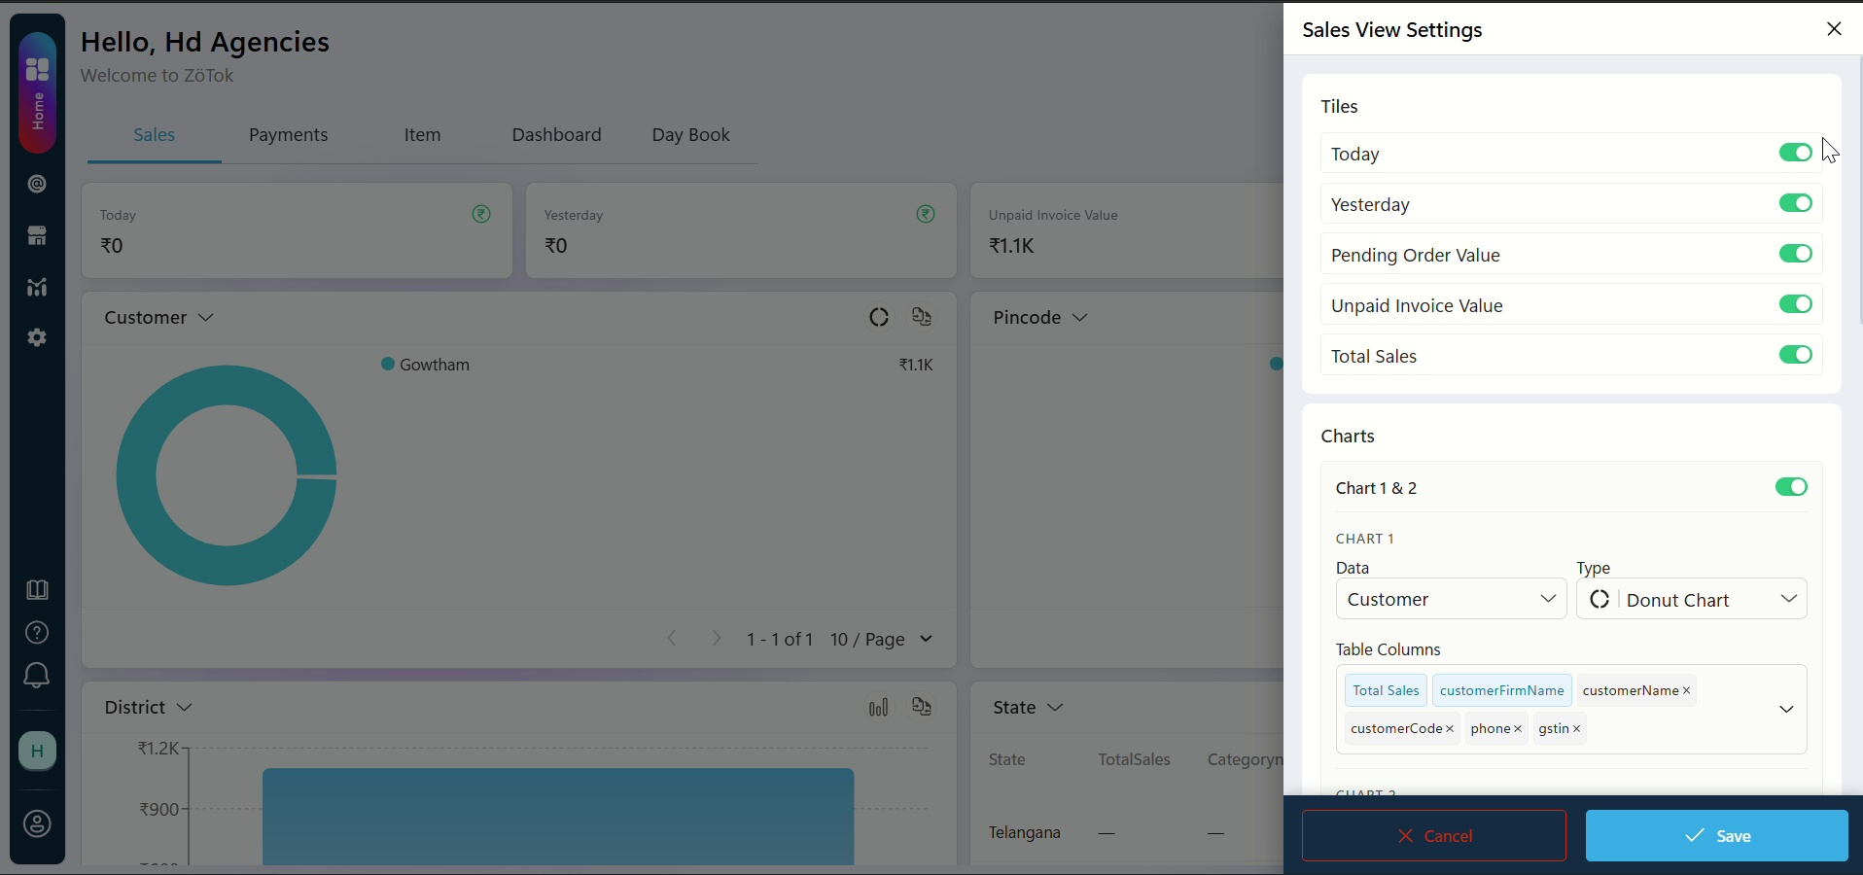

3.2 Payment View Settings
Triggered by clicking the Payments nav item, this overlay configures receivable ageing:
- Ageing By — Choose Due Date or Bill Date
Ageing Bucket Ranges:
Bucket | Range | Description
1 | 0 - 10 Days | Current / near-term receivables
2 | 11 - 20 Days | Early overdue
3 | 21 - 30 Days | Moderate overdue
4 | 31 - 40 Days | Attention required
5 | 41 - 50 Days | Escalation needed
6 | Over 50 Days | Critical — immediate follow-up

When no invoices exist, the system displays: "No invoices to show".

4. Product Module
The Product (Item) module allows businesses to manage their product catalog and track inventory, revenue, and sales performance.

4.1 Product KPIs
Upon entering the Product module, these KPI cards are displayed:
- Current Stock — Total units currently in stock
- Inventory Value — Monetary value of current inventory (₹)
- Total Revenue — Revenue generated from product sales
- Units Sold — Total units sold

4.2 Empty State & Adding Products
If no products have been added yet, the system shows:
"No products added yet. Add products to start tracking sales insights."
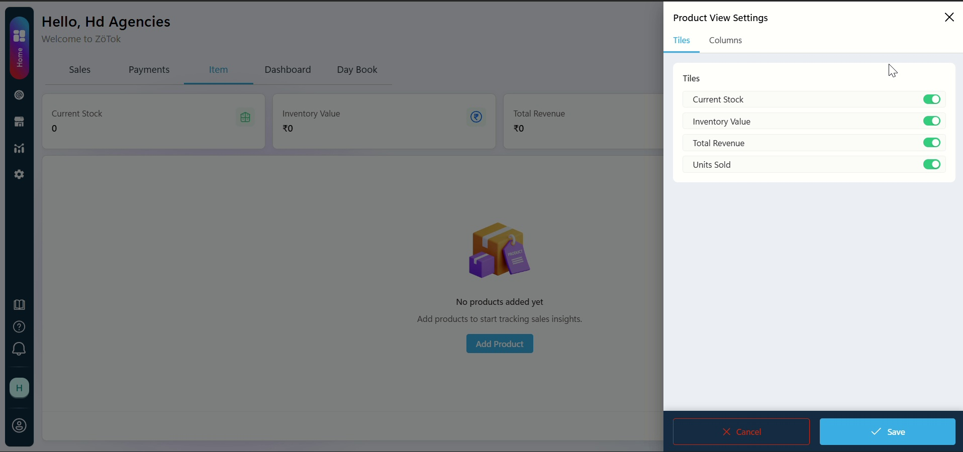
Click the "Add Product" button to populate your catalog.

💡 Tip: Add all products before tracking sales to ensure accurate KPI calculations.

5. Threads
The Threads module is ZoTok's conversation management system. It organizes all customer interactions — queries, follow-ups, issues, and signals — in a unified inbox.

5.1 Threads Interface
Upon navigating to Threads, the interface displays:
- Header showing 'Threads' with customer count (e.g., 8 Customers)
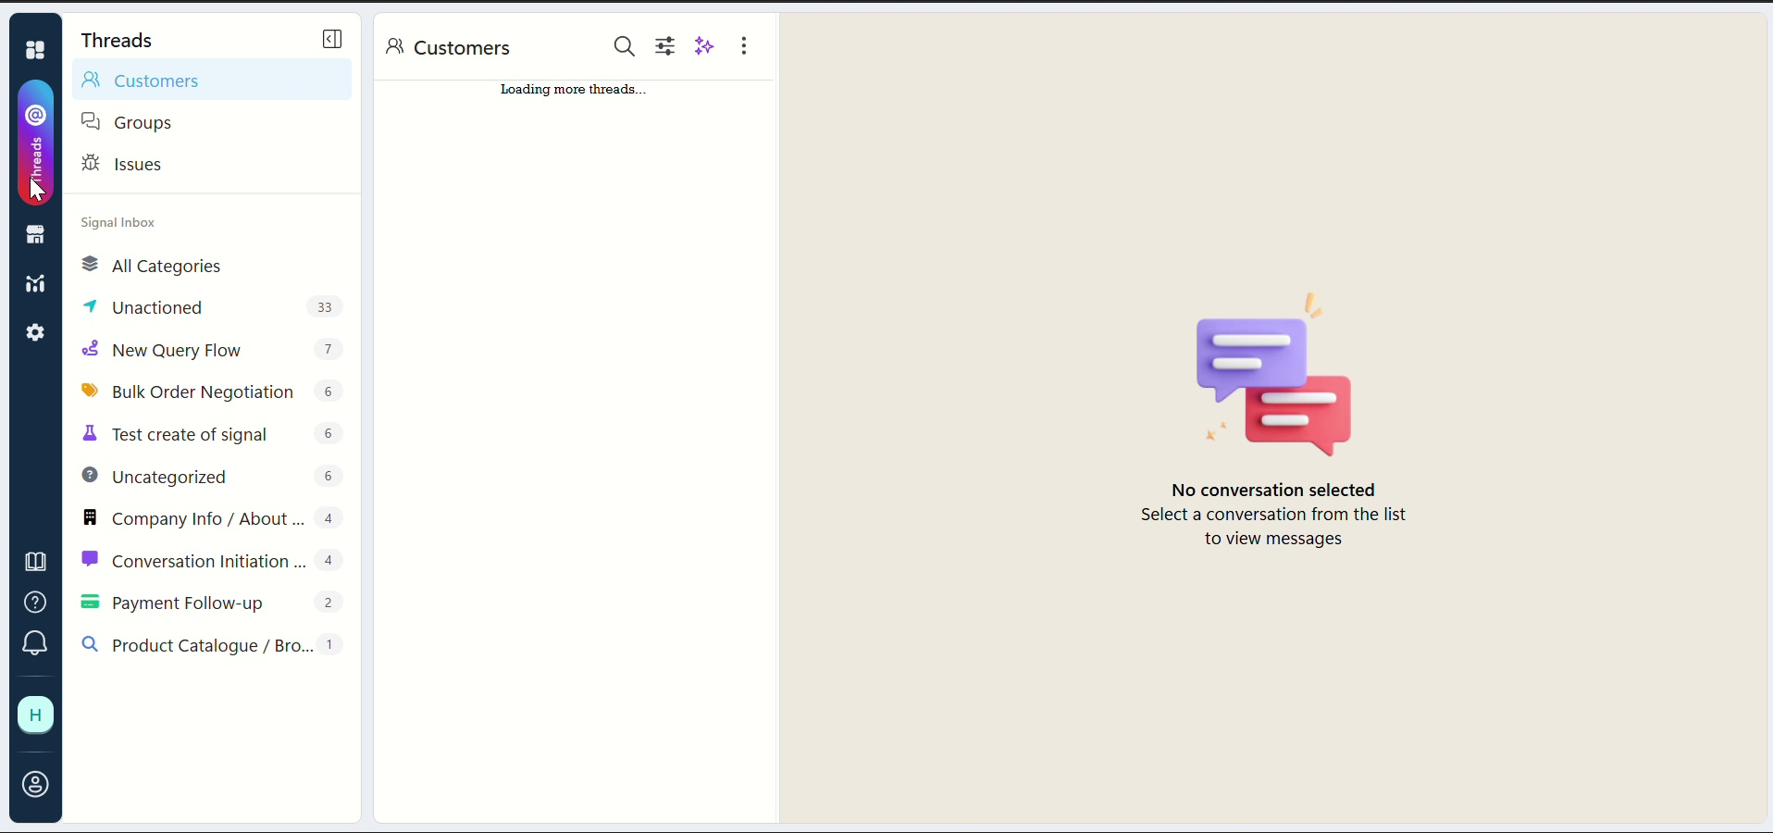
Tabbed navigation:
Tab | Purpose
Groups | Group conversations (broadcast to multiple customers)
Threads | Individual conversation threads with customers
Issues | Escalated tickets and problem reports
Signal Inbox | Incoming automated signals and alerts

Category filters:
- All Categories — Show all conversation types
- Unactioned — Show only conversations requiring action

5.2 Thread Types
Common conversation categories include:
- New Query Flow — First-time customer inquiries
- Bulk Order Negotiation — Large order discussions
- Payment Follow-up — Outstanding payment reminders
- Product Catalogue / Browsing Request — Catalog sharing
- Company Info / About Request — Business information queries
- Conversation Initiation — Simple greeting / onboarding

5.3 Empty Conversation State
When no conversation is selected, the system displays:
"Select a conversation from the list to view messages"

💡 Tip: Conversations are automatically categorized. Ensure query types are configured for accurate routing.

6. Queries Management
The Queries Management section provides a comprehensive list of all configured query types. Each query type defines a conversation category and its associated action items.

6.1 Queries List
The queries table displays configured queries (45 total, paginated 20 per page):
S.No | Query Name & Description | Action Items | Last Used | Updated On | Actions
1 | Bulk Order Negotiation | Create Order | 19 min ago | 6 Jul 2026 | ✏️
2 | Conversation Initiation — Simple Greeting | Request Payment | 19 min ago | 6 Jul 2026 | ✏️
3 | Create Order | Upload Invoice, Create Order, Send Order Receipt | 19 min ago | 6 Jul 2026 | ✏️
4 | Payment Follow-up | Send Payment Receipt | 22 hrs ago | 5 Jul 2026 | ✏️
5 | Product Catalogue / Browsing Request | N.A. | 1 hr ago | 6 Jul 2026 | ✏️

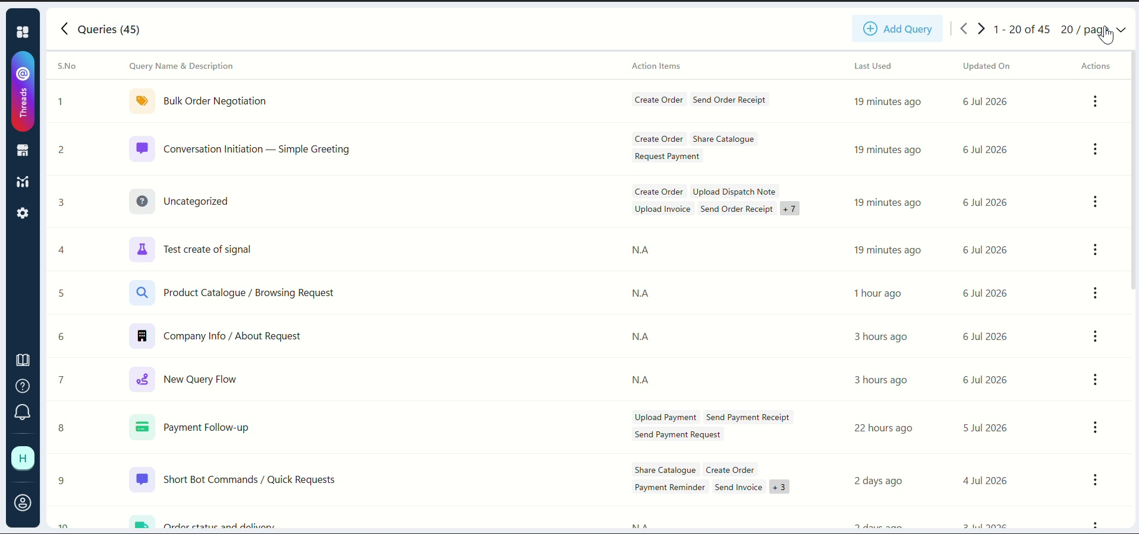

6.2 Query Type Details Overlay
Clicking a query row opens details showing:
- Query Name — The category name
- Description — What this query type covers
- Action Items — Available actions (Create Order, Send Invoice, Request Payment, etc.)

6.3 Adding a New Query Type
Click the "Add Query" button to open the creation form.
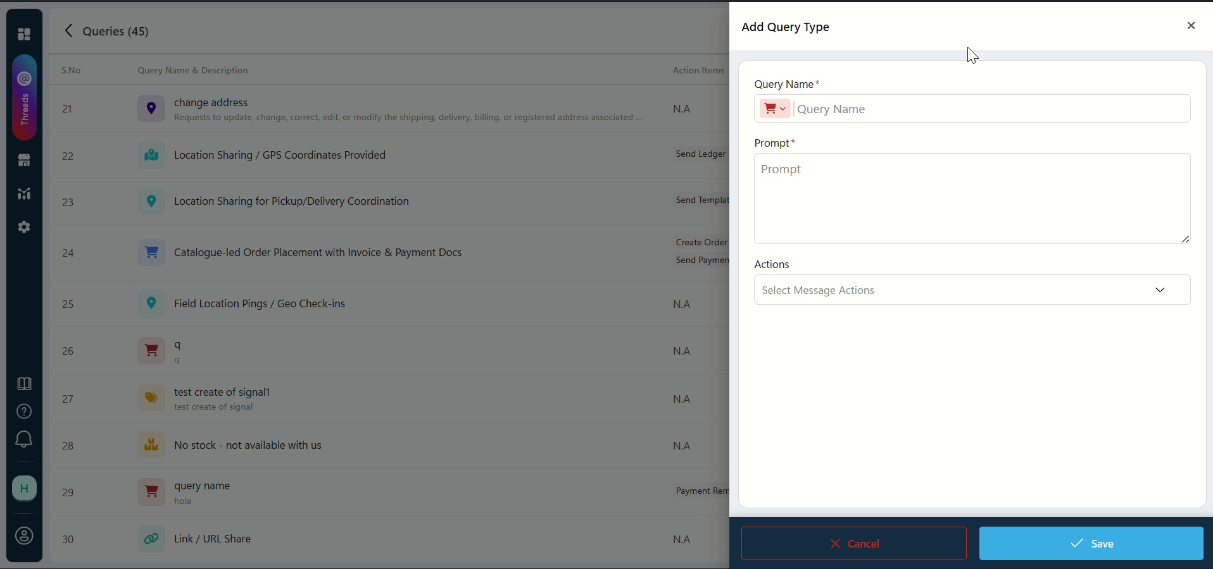
Form Fields:
Field | Required | Description
Query Name * | Yes | A unique name for the query type
Prompt * | Yes | Instruction/prompt associated with this query
Actions | Optional | Select from available message actions

Buttons: XCancel (discard) | Save (add query)

6.4 Complete Query Type Reference
Pre-configured query types in the system:
# | Query Name | Action Items | Status
1 | Bulk Order Negotiation | Create Order | Active
2 | Conversation Initiation — Simple Greeting | Request Payment | Active
3 | Create Order | Upload Invoice, Create Order, Send Order Receipt | Active
4 | Test create of signal | N.A. | Active
5 | Product Catalogue / Browsing Request | N.A. | Active
6 | Company Info / About Request | N.A. | Active
7 | New Query Flow | N.A. | Active
8 | Payment Follow-up | Send Payment Receipt | Active
9 | Location Sharing / GPS Coordinates | Send Ledger, Send Invoices | Active
10 | Location Sharing for Pickup/Delivery | Send Template | Active
11 | Catalogue-led Order Placement | Send Payment Receipt | Active
12 | Field Location Pings / Geo Check-ins | N.A. | Active
13 | No stock — not available with us | N.A. | Active
14 | Link/URL Share | N.A. | Active
15 | Short Bot Commands / Quick Requests | Payment Reminder, Send Invoice | Active
16 | Change Address | N.A. | Active
17 | Share Catalog | Create Order | Active

7. Appendix

7.1 Click Flow Diagram
Complete navigation flow from the walkthrough video:
Step | Action
1 | Login → Home Dashboard (Hello, Hd Agencies)
2 | Click Sales → Sales View Settings overlay (charts, columns)
3 | Save/Cancel → Return to Home Dashboard
4 | Click Payments → Payment View Settings (ageing config)
5 | Save/Cancel → Return to Home Dashboard
6 | Click Item → Product View Settings → Products Home
7 | Click Add Product → Product creation flow
8 | Navigate to Threads → Threads interface (8 Customers)
9 | Select thread → Conversation view or empty state
10 | Open Queries → Queries list (45 types, 2 pages)
11 | Click Add Query → Query Type form (Name + Prompt)
12 | Save → Query added to list

Flow Diagram:
Home Dashboard
├── Sales View Settings → Save/Cancel → Home
├── Payments → Payment View Settings → Save/Cancel → Home
├── Item → Product View Settings → Products Home → Add Product
└── Threads → Threads Interface (8 Customers, tabs)
├── Select Thread → Queries List (45 queries)
└── Add Query → Query Type Form → Save

7.2 Tips & Shortcuts
- Use sidebar navigation to switch between modules instantly
- Settings overlays can be dismissed by clicking Cancel or pressing Escape
- Tables support sorting by clicking column headers
- Use category filters in Threads to narrow down conversation types
- Pagination controls at bottom of lists allow page navigation
- Configure query types upfront for automatic conversation routing
- Regularly review Unactioned threads to avoid missing customer queries

7.3 Document Information
Field | Value
Product | ZoTok (Field Operations & Distributor Management)
Module | Home Dashboard & Threads
Document Version | 1.0 (July 2026)
Source Video | Home and Threads.mp4 (4 min, 213 MB)
Video Resolution | 1916 × 900 px, 30 fps, H.264
Firm (Demo) | Hd Agencies
Frame Extraction Tool | OpenCV + RapidOCR
Document Format | Microsoft Word (.docx)

