EchoSphere v2.2: Complete Project Master Documentation Manual
Exhaustive Engineering Reference of Entire System: Project Overview, Architecture, ERD, Methodology, AI Subsystem & IoT Hardware Speaker Integration
─────────────────────────────────────────────────────────────────

1. Executive Summary & Entire Project Overview
EchoSphere v2.2 is an intelligent multi-tiered campus announcement management ecosystem engineered to replace traditional physical notice boards, unregulated instant messaging channels, and bloated legacy ERP suites in higher education institutions.
The platform incorporates direct Departmental IoT Hardware Speaker Integration, deploying smart audio nodes across every academic department (CSE, ECE, ME, Civil, EEE, AI/ML, Basic Sciences, Admin Block). Approved announcements are automatically synthesized into natural voice audio and broadcast live in department corridors while updating cross-platform Flutter app feeds and dispatching push notifications.

2. System Architecture & Diagram

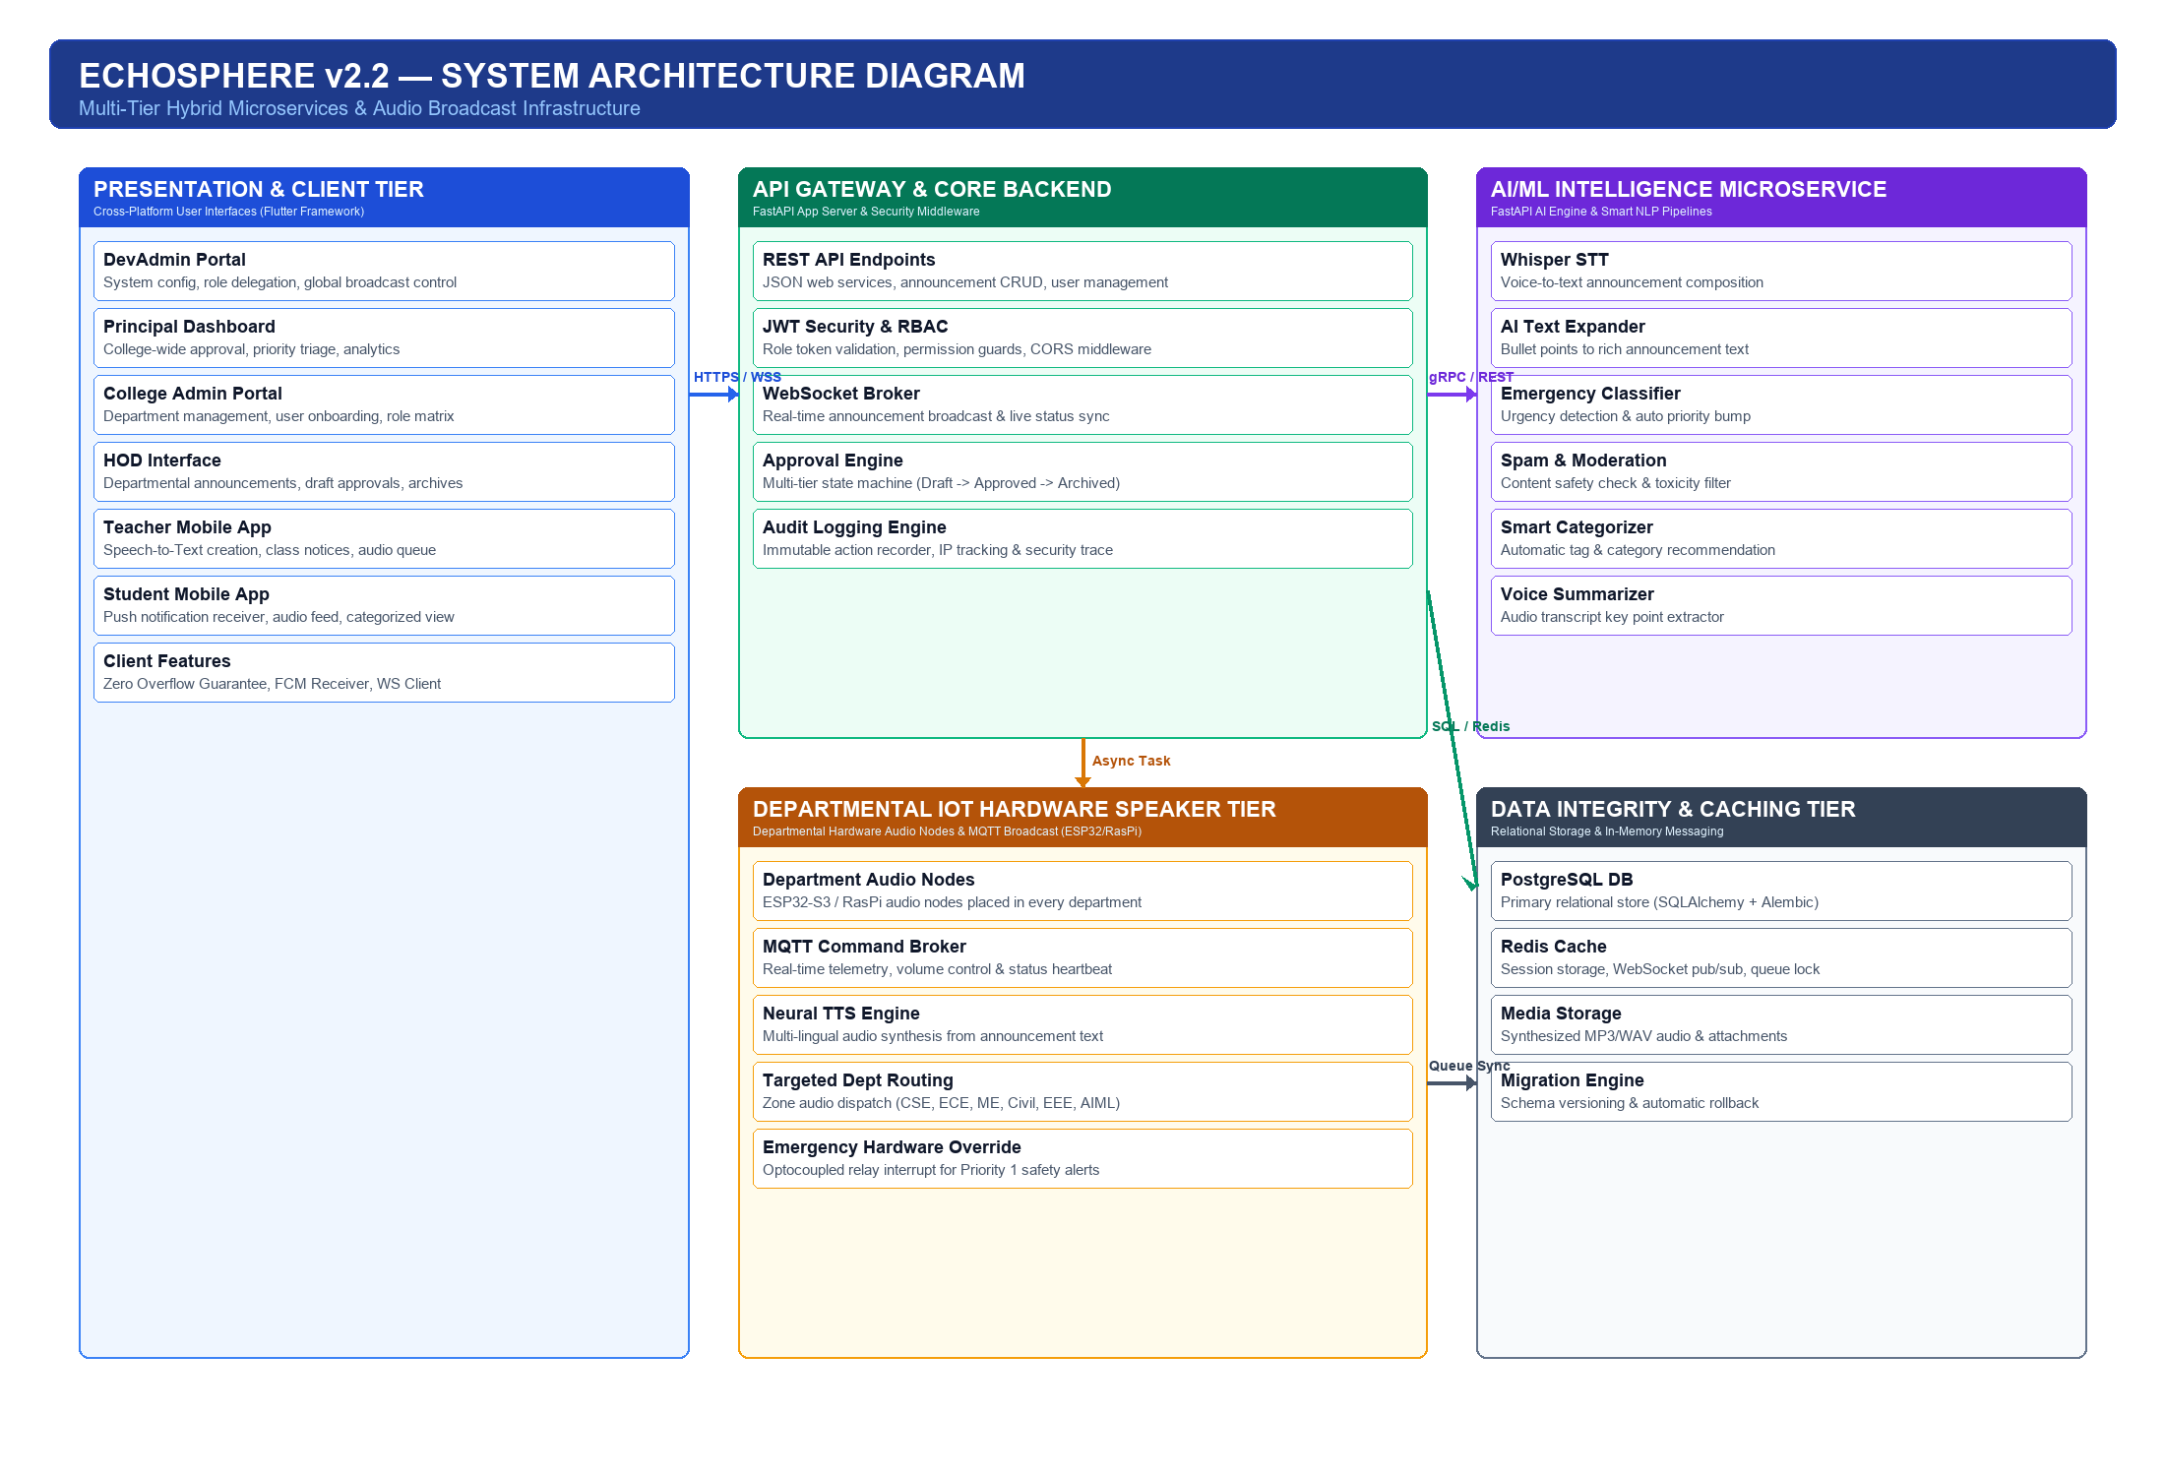

3. Entity Relationship Diagram (ERD) & Database Schema

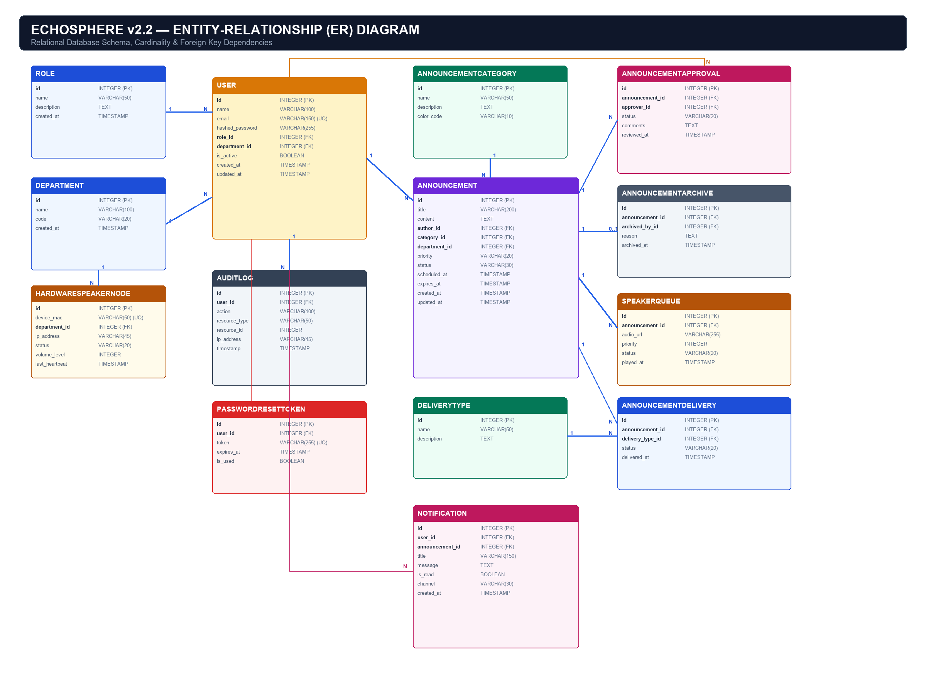

4. System Methodology & Announcement Lifecycle
Every notice progresses through a strict 6-stage lifecycle state machine:
DRAFT -> PENDING_APPROVAL -> APPROVED -> SPEAKER_QUEUE / FCM -> ARCHIVED
1. DRAFT: Created by Teacher/Admin.
2. PENDING_APPROVAL: Submitted for HoD/Admin review.
3. APPROVED: Verified and dispatched to app feed, push notification, and departmental speakers.
4. REJECTED: Returned to author with mandatory feedback.
5. SCHEDULED: Timed release for future broadcast.
6. ARCHIVED: Historical audit record.

5. Departmental IoT Hardware Speaker Subsystem
• Microcontroller: ESP32-S3 Dual-Core / Raspberry Pi Zero 2 W.
• Audio DAC: PCM5102A 32-Bit / 384kHz I2S Audio DAC.
• Power Amplifier: TPA3116D2 50W Class-D Amplifier.
• Emergency Relay: Optocoupled 5V Relay forcing 100 dB SPL volume during Priority Level 1 broadcasts.

