ASP.NET Core Web API .NET 8 2024 -1. Create Project + Install

I have already downloaded and installed Visual Studio Community with ASP.NET and Azure Development.

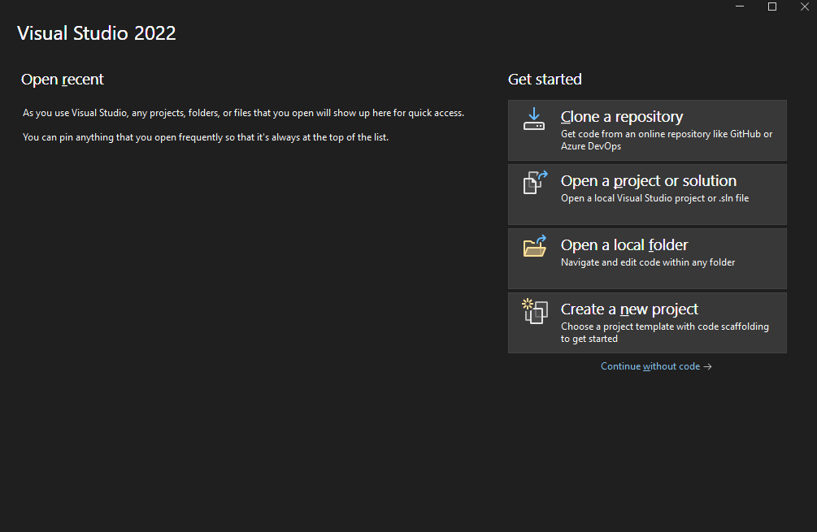

Downloading and Installing SQL Server Express Edition

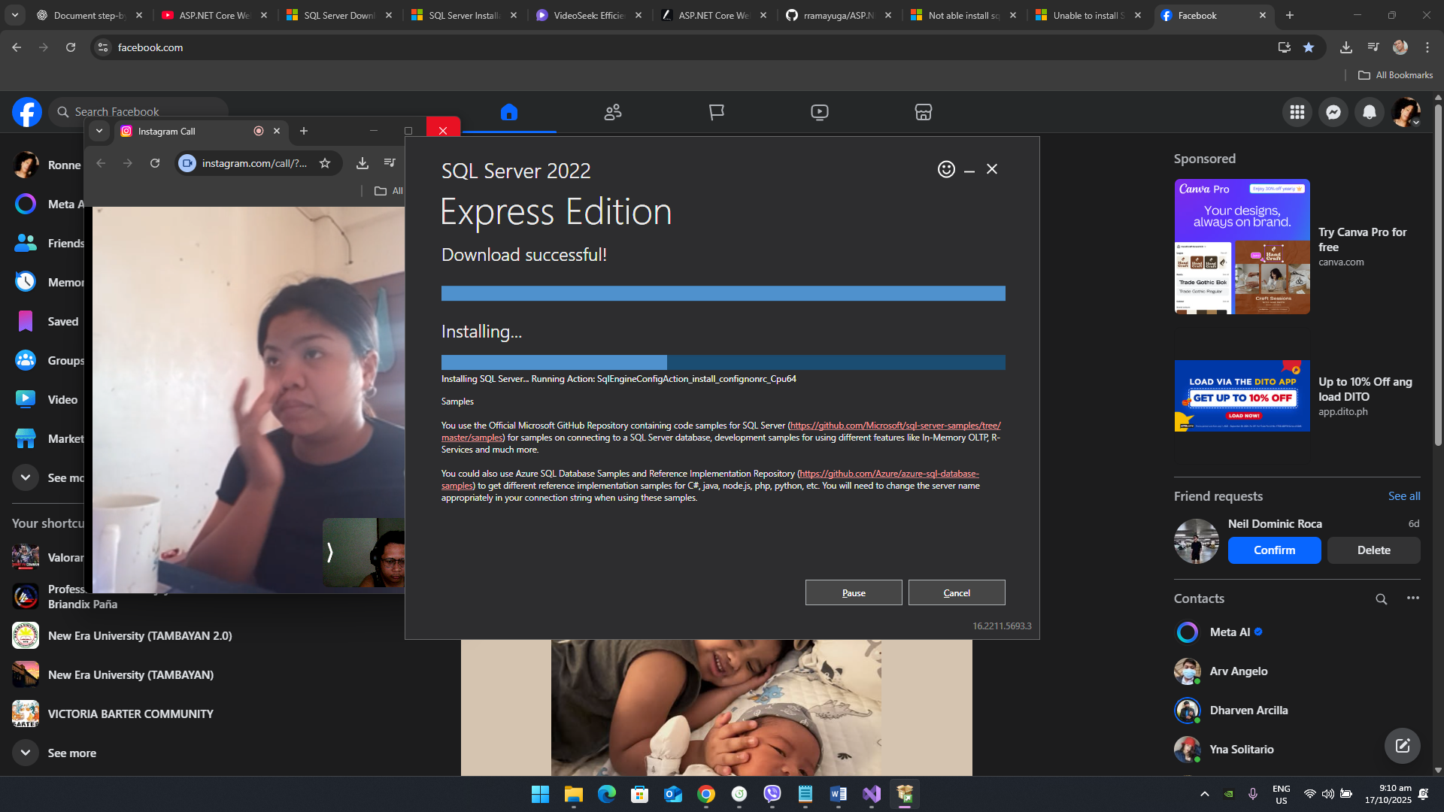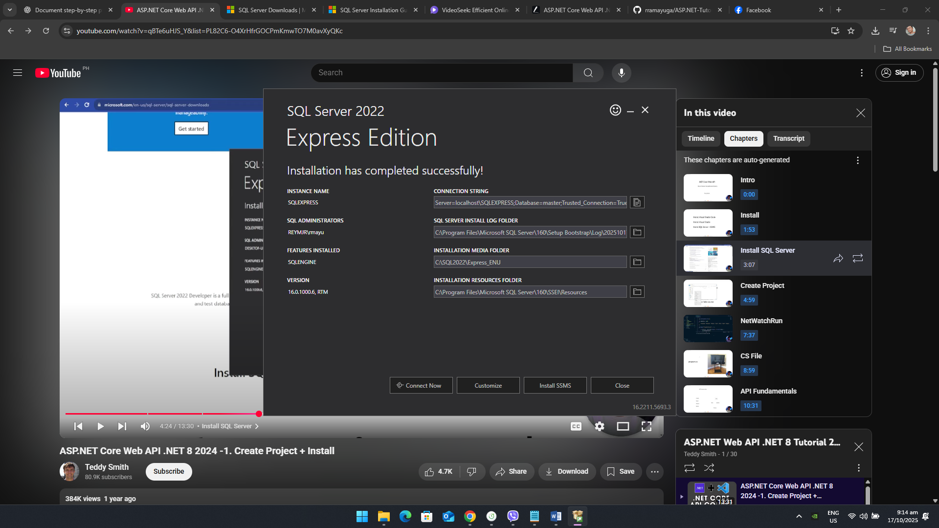

I’ve got some error while installation because of an older version of SQL Server.

Installing SSMS  
