Module Design Document

Arithmetic

**Revision History**

|  |  |  |
| --- | --- | --- |
| **Version** | **Author** | **Notes** |
| 1.1 | Raymundo Ramirez | Initial Version of the Document |
|  |  |  |
|  |  |  |
|  |  |  |

Table of Contents

1. Module Purpose 4

2. Requirements 4

3. Module Diagrams 4

4. Detailed design 6

4.1. Arithmetic.c 6

# Module Purpose

This module purpose is to provide the arithmetic operations for the project

# Requirements

|  |  |
| --- | --- |
| **No.** | **Requirements** |
| 1 | "Buzz" when F(n) is divisible by 3. |
| 2 | "Fizz" when F(n) is divisible by 5. |
| 3 | "FizzBuzz" when F(n) is divisible by 15. |
| 4 | "BuzzFizz" when F(n) is prime. |

# Module Diagrams

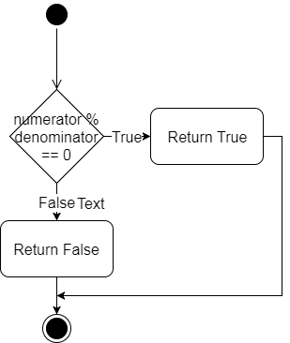

Activity Diagram 1

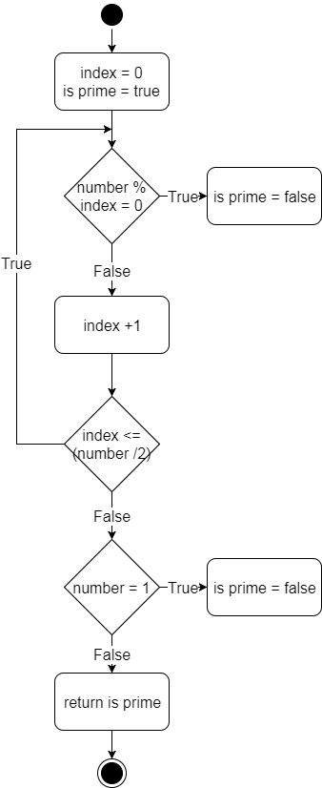

Activity Diagram 2

# Detailed design

## Arithmetic.c

**bool** DivisibleBy (**numerator, denominator**)

|  |  |  |
| --- | --- | --- |
| **Description** | Determine if a number is divisible by another If numerator%denominator = 0 returns true else false | |
| **Return type** | boolean | |
| **Return value** | True/false | |
| **Arguments** | | |
| **type/name** | | **Description/range** |
| int numerator | | the number to be evaluated |
| int denominator | | number by which numerator should be divisible |

**bool** PrimeEvaluation (**number**)

|  |  |  |
| --- | --- | --- |
| **Description** | Determine if a number is prime | |
| **Return type** | boolean | |
| **Return value** | True/false | |
| **Arguments** | | |
| **type/name** | | **Description/range** |
| int number | | the number to be evaluated |