Module Design Document

BuzzFizz

**Revision History**

|  |  |  |
| --- | --- | --- |
| **Version** | **Author** | **Notes** |
| 1.1 | Raymundo Ramirez | Initial Version of the Document |
|  |  |  |
|  |  |  |
|  |  |  |

Table of Contents

1. Module Purpose 4

2. Requirements 4

3. Module Diagrams 5

4. Detailed design 7

4.1. Buzzfizz.c 7

# Module Purpose

This module purpose is to evaluate the numbers with the BuzzFizz trigger conditions.

# Requirements

|  |  |
| --- | --- |
| **No.** | **Requirements** |
| 1 | "Buzz" when F(n) is divisible by 3. |
| 2 | "Fizz" when F(n) is divisible by 5. |
| 3 | "FizzBuzz" when F(n) is divisible by 15. |
| 4 | "BuzzFizz" when F(n) is prime. |
| 5 | The value F(n) otherwise. |

# Module Diagrams

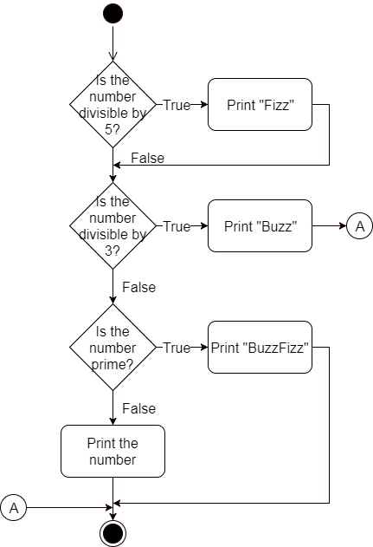

Activity Diagram

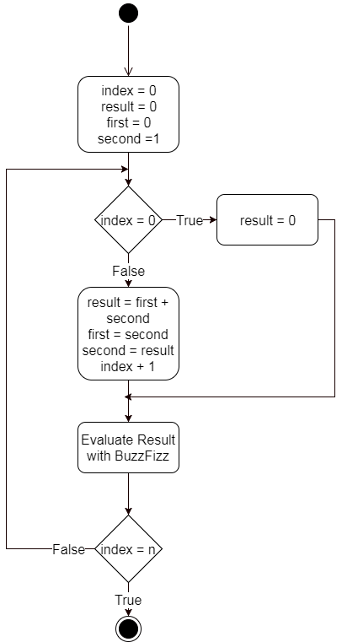

Activity Diagram

# Detailed design

## Buzzfizz.c

**void** BuzzFizzEvaluation(**number, fizz, buzz**)

|  |  |  |
| --- | --- | --- |
| **Description** | Evaluate the BuzzFizz conditions, print a different result depending on the trigger, Fizz if divisible by FIZZ, Buzz if divisible by BUZZ. BuzzFizz if the number is prime, just print the number if the otherwise. | |
| **Return type** | Void | |
| **Return value** | N/A | |
| **Arguments** | | |
| **type/name** | | **Description/range** |
| int number | | the number to be evaluated |
| int fizz | | Fizz trigger |
| int buzz | | Buzz rigger |

**void** FibonacciBuzzFizz(**number, fizz, buzz**)

|  |  |  |
| --- | --- | --- |
| **Description** | Creates a Fibonacci series evaluated by BuzzFizz | |
| **Return type** | Void | |
| **Return value** | N/A | |
| **Arguments** | | |
| **type/name** | | **Description/range** |
| int number | | the number to be evaluated |
| int fizz | | Fizz trigger |
| int buzz | | Buzz rigger |