**PS 3 Repo**: <https://github.com/rramnauth2220/cpsc-572-webots/tree/master/RAMNAUTH-572-PS3>  
  
**Question 4 World**: <https://github.com/rramnauth2220/cpsc-572-webots/blob/master/RAMNAUTH-572-PS3/src/worlds/rectangle_room_tracer.wbt>

**Question 4 Controller**: <https://github.com/rramnauth2220/cpsc-572-webots/tree/master/RAMNAUTH-572-PS3/src/controllers/e-puck_trace_walls-c> **(C)**

**Question 4 Video:** <https://youtu.be/enroE2xqd_w> **(C)**

**Tutorial 1 Screenshots:**

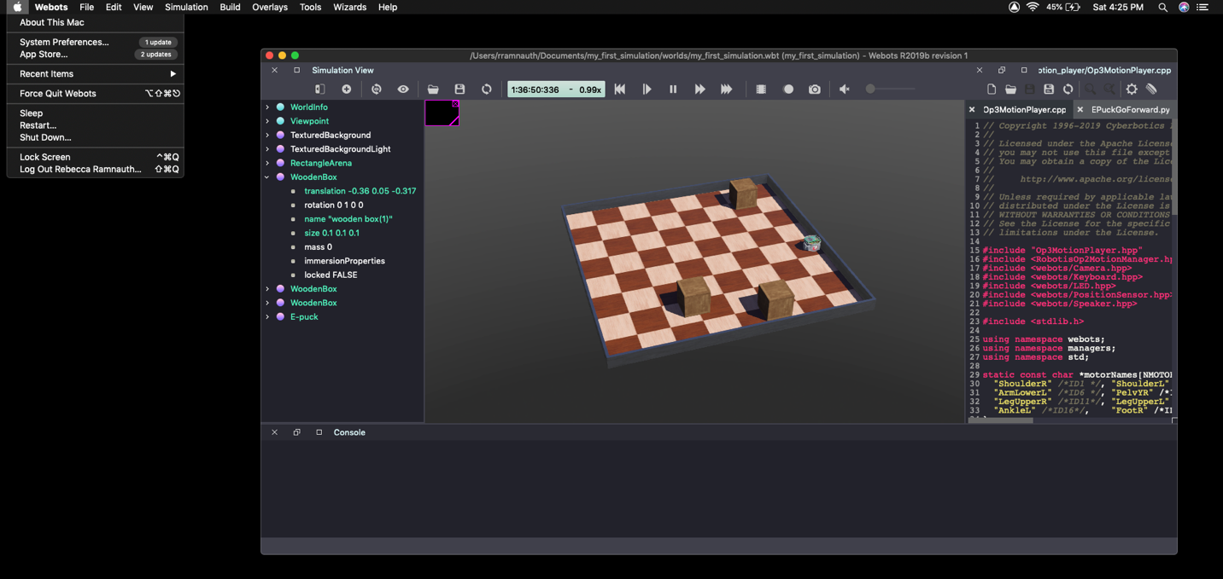

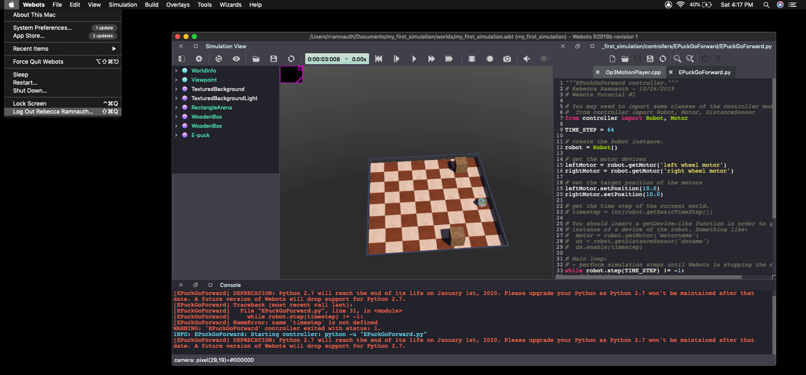*Figure 1.* Screenshot of Tutorial 1, Adding Objects

*Figure 2.* Screenshot of Tutorial 1, Creating a Controller

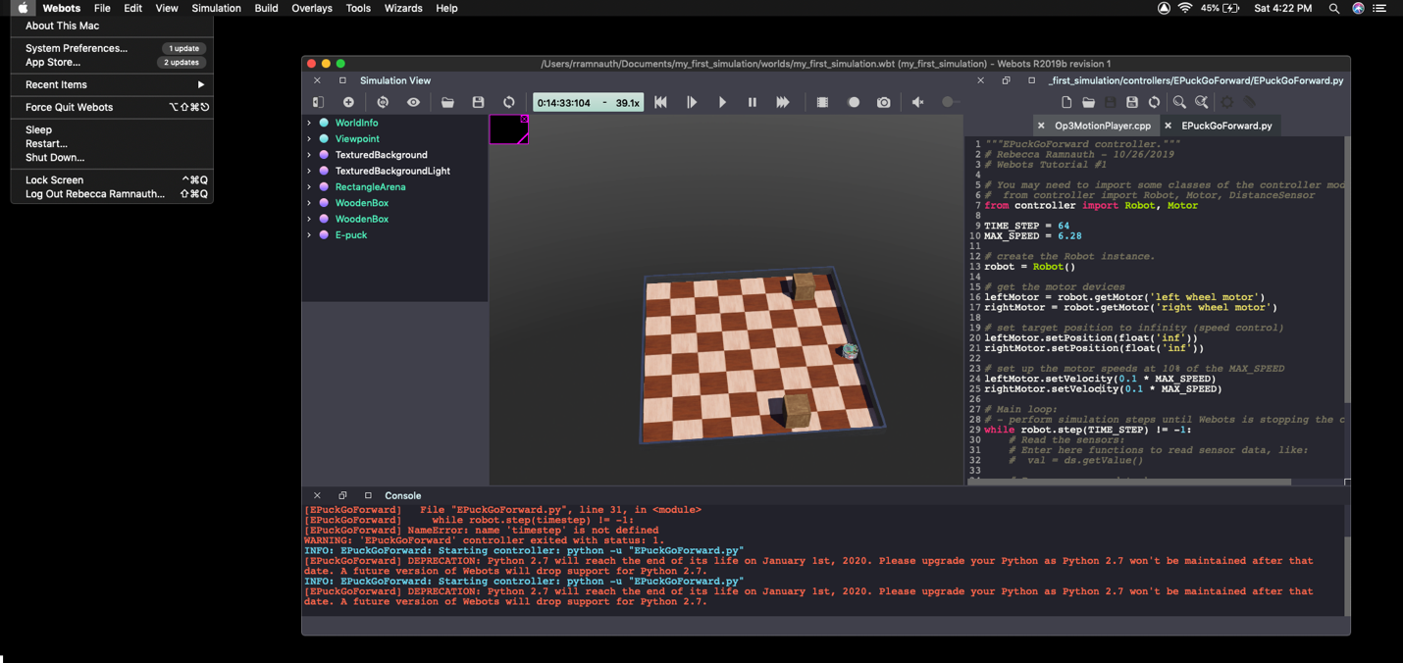

*Figure 3.* Screenshot of Tutorial 1, Extending a Controller

**Tutorial 4 Screenshots:**

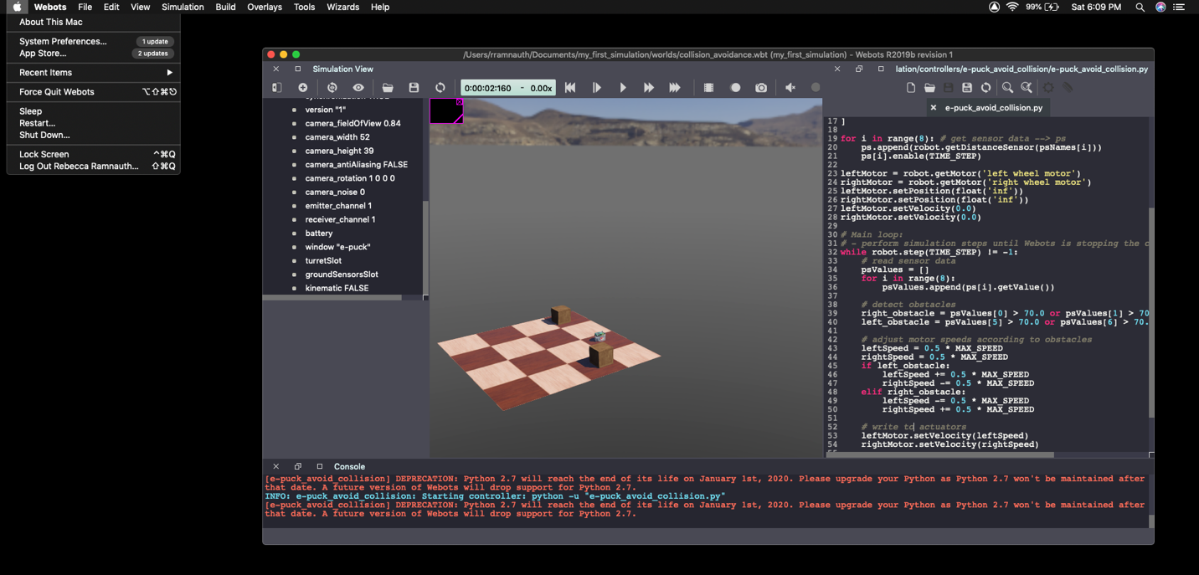

*Figure 4.* Screenshot of Tutorial 4, View Tree & Controller

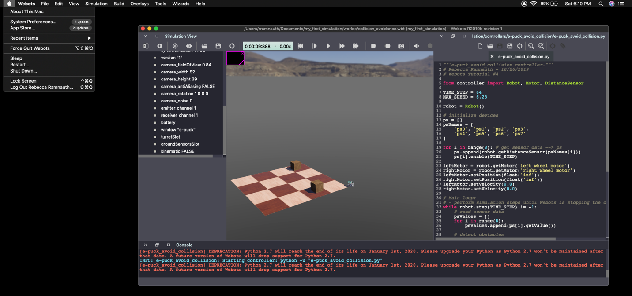

*Figure 5.* Screenshot of Tutorial 4, View Tree & Controller (continued)

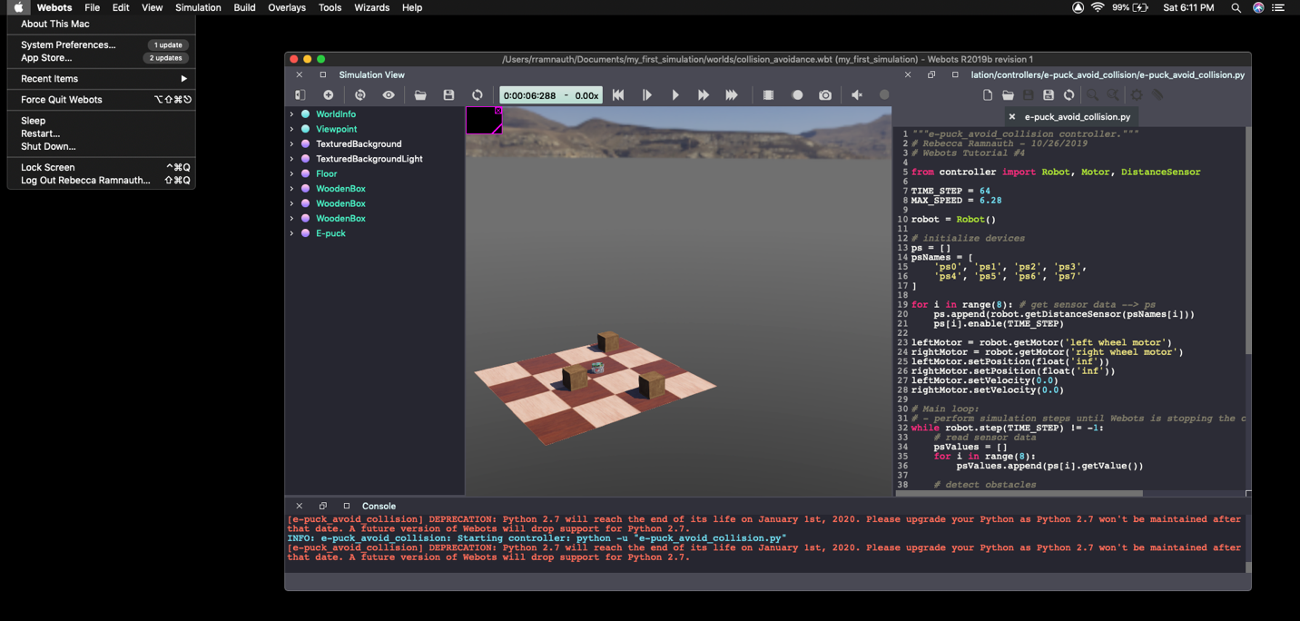

*Figure 6.* Screenshot of Tutorial 4, Completed Controller