ClaimSphere
Technical Design & Implementation Report
Senior Application Engineer (Senior UI Developer) — Case Study Submission · Reference 139644
A claims-adjudication workspace for ABC Insurance: a 25,000-record claims grid with role-based access, and a document workspace that opens, edits, splits, merges, comments on and annotates documents of 100 MB to 1 GB.

Item | Details
Candidate | Rangaprasad
Date | 9 November 2026
Source code | https://github.com/rranga/claimsphere
Live demo | https://rranga.github.io/claimsphere/ (GitHub Pages)
Stack | React 19 · TypeScript (strict) · Vite · Tailwind CSS v4 · TanStack Query · Redux Toolkit · TanStack Virtual · pdf.js · Radix UI · MSW · Vitest · Playwright · axe-core

Contents
1. Executive summary 3
Key results 3
2. Scope, inputs and assumptions 4
2.1 Inputs 4
2.2 Assumptions 4
2.3 Requirements traceability 4
3. The solution at a glance 6
4. Architecture 9
4.1 System context 9
4.2 Technology choices 9
4.3 Code organisation and boundaries 10
4.4 State management 10
4.5 Backend API contract 11
5. Key flows 12
5.1 Grid data flow 12
5.2 Grid to document workspace 12
5.3 Loading very large documents 12
5.4 Editing and saving documents 13
6. Design patterns used 14
7. Performance optimisation 15
Trade-offs considered 15
8. Security and role-based access 16
8.1 Personas 16
8.2 Where enforcement lives 16
8.3 Further safeguards 16
9. Accessibility (WCAG 2.1 AA) 17
9.1 Verification 17
9.2 What was implemented 17
10. Coding standards and best practices 18
11. Testing and continuous integration 18
12. Running the project 19
Suggested five-minute walkthrough 19
13. Limitations and roadmap 19

1. Executive summary
ABC Insurance is replacing a legacy claims-processing system. Claims arrive by email, SFTP, portal and API, and each claim carries large documents that adjusters must review and reorganise. The case study asked for a scalable, high-performance web application covering a large data grid, role-based access, very large documents and document operations, together with a discussion of architecture, performance and trade-offs.
ClaimSphere is a working implementation of that brief, not a mock-up. Every functional and non-functional requirement is implemented and covered by automated tests. The highlights:
- 25,000 claims, instant scrolling. Only about 20–35 rows exist on the page at any time, however many claims match. Sorting, filtering and search run on the server.
- 1 GB documents open in under 2 seconds. The browser downloads only the parts of the file it needs: 6.6 MB (0.7%) to show the first page of a 1 GB document.
- Security decided by the server. Each role (Adjuster, Supervisor, Auditor, Admin) sees different records and actions. The interface adapts, but every request is checked again on the server.
- Safe document editing. Split, merge, reorder, rotate and delete with undo/redo. Saving is all-or-nothing, with progress, cancel and safe retry. Unsaved work survives a browser refresh.
- Quality evidence. 45 unit/integration tests, 10 end-to-end browser tests, zero lint warnings, and an automated WCAG 2.1 AA accessibility audit with no violations on every main screen.

Key results
Measure | Result
Claims in the grid | 25,000 (server-side sort, filter, search)
Rows in the page at any scroll position | ~20–35 (virtualized)
1 GB document: time to first page | < 2 s, 6.6 MB downloaded
Jump to page 900 of 1,500 | +9.8 MB (1.6% of the file in total)
Initial JavaScript (app code, gzipped) | ~74 KB; the PDF engine (123 KB) loads only when a document is opened
Automated tests | 45 unit/integration + 10 end-to-end (incl. 3 accessibility audits) — all passing
Accessibility | WCAG 2.1 A/AA automated audit (axe-core): 0 violations on sign-in, grid and workspace
Static analysis | TypeScript strict mode, ESLint with zero warnings, Prettier enforced in CI and pre-commit

2. Scope, inputs and assumptions

2.1 Inputs
- Job description: Senior Application Engineer / Senior UI Developer, Swiss Re L&H Reinsurance Engineering.
- Case study: “Senior UI Engineering Use Case — Problem Statement” (functional, non-functional and discussion requirements).
- Figma: “CRM Dashboard – Customers List” (layout, typography, colour palette, KPI cards, table and pagination styling).

2.2 Assumptions
Topic | Assumption and rationale
Document size | The brief shows “1500 MB” corrected to “100 MB” (strike-through). The design targets 100 MB–1 GB, and because nothing scales with file size it also holds beyond 1.5 GB.
Backend | No backend was provided. A mock server (Mock Service Worker) implements a realistic REST contract — authentication, authorization, versions, validation and asynchronous jobs — so the UI is built exactly as it would be against a real API.
Figma | The CRM “Customers” screen was adapted to the claims domain: KPI cards became claim statistics; the customer table became the claims grid; the visual language (Poppins, #5932EA, status pills, pagination) is preserved.
Document format | PDF, the de-facto format after ingestion and OCR. Other formats would be normalised to PDF at ingestion.
Devices | Desktop-first (adjuster workstations, ≥1280 px). Side panels collapse on smaller screens.
Test data | 25,000 claims generated deterministically (same data on every load). Sample PDFs are committed; 250 MB and 1 GB PDFs are generated by a script.

2.3 Requirements traceability
Each requirement from the case study, how it is met, and where it is verified.
Requirement | Implementation | Verified by
Grid: 20,000+ records, sort, filter, row actions (Edit / Delete / Assign) | Server-side sort/filter/search; virtualized grid with on-demand loading in 100-row blocks; Figma-style pagination as an alternative mode; Edit, Assign and Delete dialogs | E2E: grid, pagination, filter. API tests: server-side sort/filter
Pagination vs alternative, justified | Virtualization as default, pagination as toggle; decision record ADR-0001 | docs/adr/0001
RBAC: backend is the source of truth | Server policy checks every request; data scoped by region; per-row allowedActions; 401/403/404 responses | API tests: scoping, 403 on UI bypass, 404 no-leak
RBAC: frontend for UX (show / hide / disable) | Hide when the role can never act; disable with an explanation when this record blocks it; route guard | Component test (RowActions); E2E per persona
Row → document: smooth transition | Prefetch on hover intent (code, document list, first page); instant header; skeletons; animated route transition; Back restores the grid | Manual + E2E navigation
View 100 MB–1 GB documents | pdf.js in a Web Worker; custom HTTP Range loader; only visible pages rendered | Measured: 6.6 MB for first page of 1 GB
Edit, split, merge, delete; page comments; annotations | Command log with undo/redo; same rules on client and server; comments and annotations bound to stable page ids | Unit: operation engine, Redux slice. E2E: split + save, annotate, comment
Performance: minimal re-renders and memory | Memoized rows, structural sharing, selector subscriptions, canvas release, LRU caches, code splitting | Section 6 measurements
Scalability: records, document size, users | Server row model; size-independent document loading; stateless API with version tokens | Architecture (section 3)
UX: progress, errors, cancel / retry | Job progress bar, cooperative cancel, idempotent retry, per-region error boundaries, toasts, skeletons | E2E: failure → retry
Reliability: consistent state, partial failures | Atomic commit, optimistic concurrency (409), idempotency keys, draft persistence, orphan cleanup | API tests: atomicity, idempotency, 409

3. The solution at a glance
The screenshots below are taken from the production build of the application, driven by the same automated browser used for end-to-end testing.
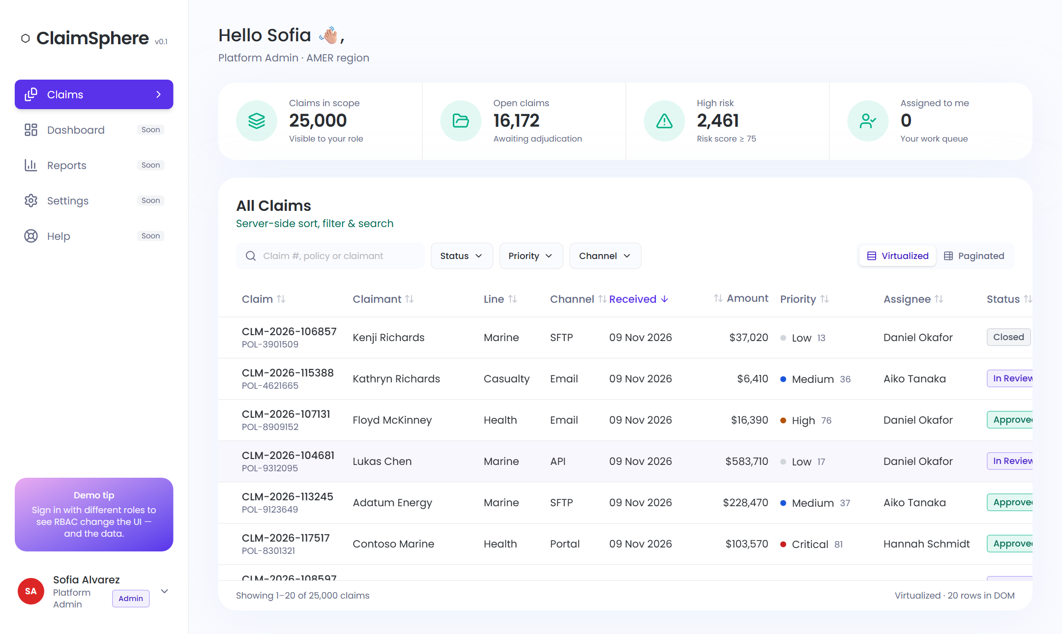
Figure 1 — Claims grid (Admin): KPI cards, server-side filters, virtualized grid of 25,000 claims; footer confirms only 22 rows are in the page.
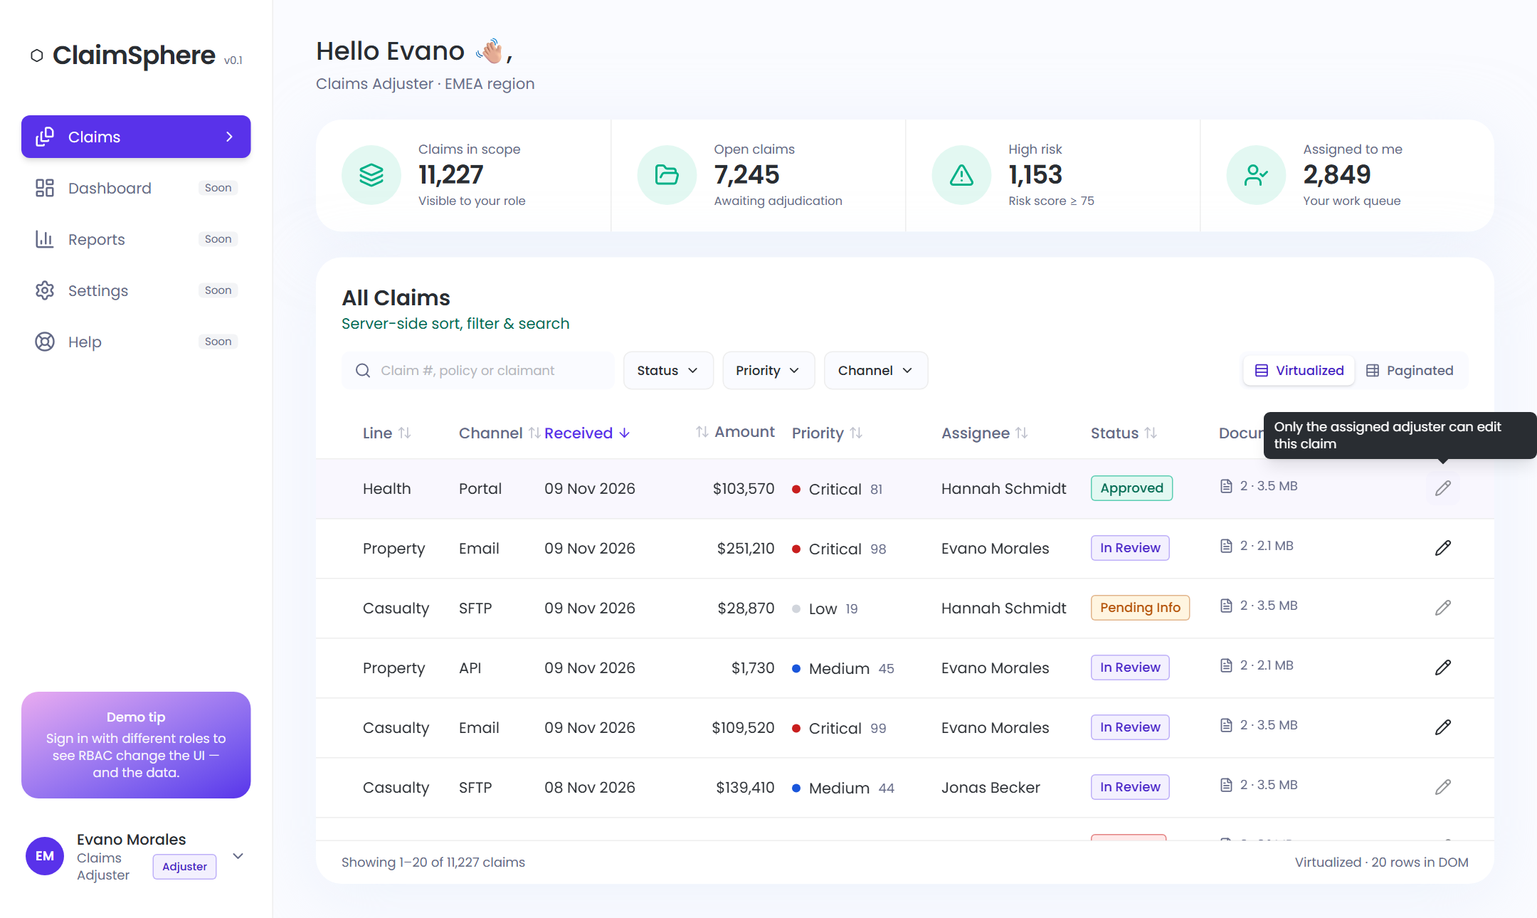
Figure 2 — Role-based UX (Adjuster, EMEA only): Edit is available on own claims and disabled with an explanation on colleagues’ claims; Assign and Delete are hidden for this role.
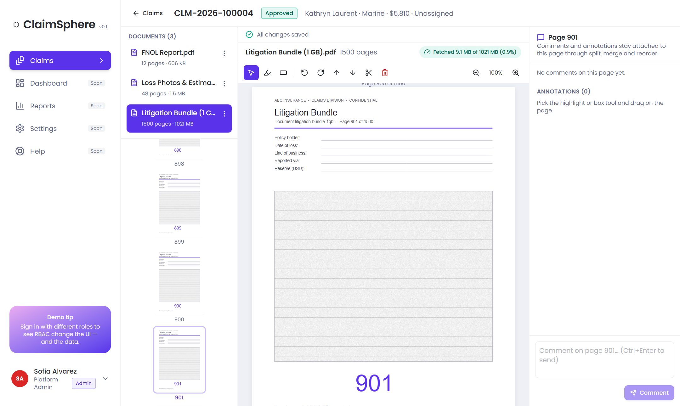
Figure 3 — 1 GB, 1,500-page document opened at page 901: only 9.1 MB (0.9%) has been downloaded (green badge).
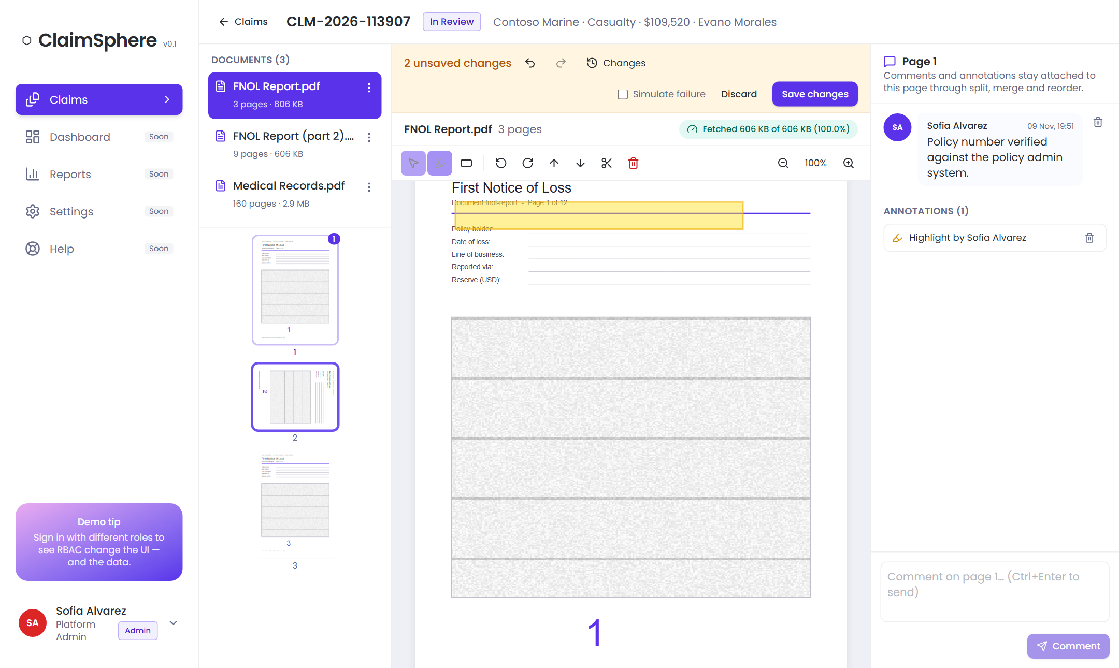
Figure 4 — Editing: document split into two, page rotated (draft with undo/redo), highlight annotation and a page comment.
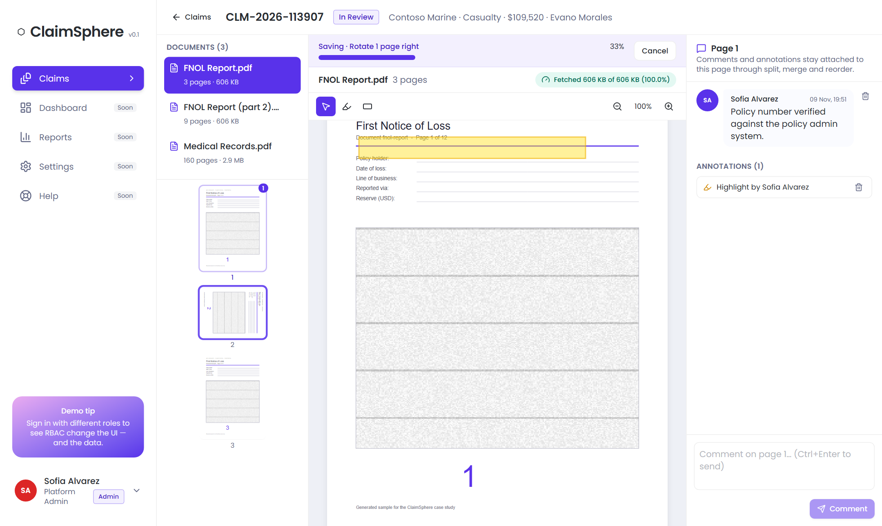
Figure 5 — Saving runs as a server job with live progress and Cancel; nothing is applied until the final atomic step.

4. Architecture

4.1 System context
The browser never downloads a whole document. It calls the API for data and commands, and fetches byte ranges of immutable source files directly from document storage (in production: object storage behind a CDN with short-lived signed URLs).
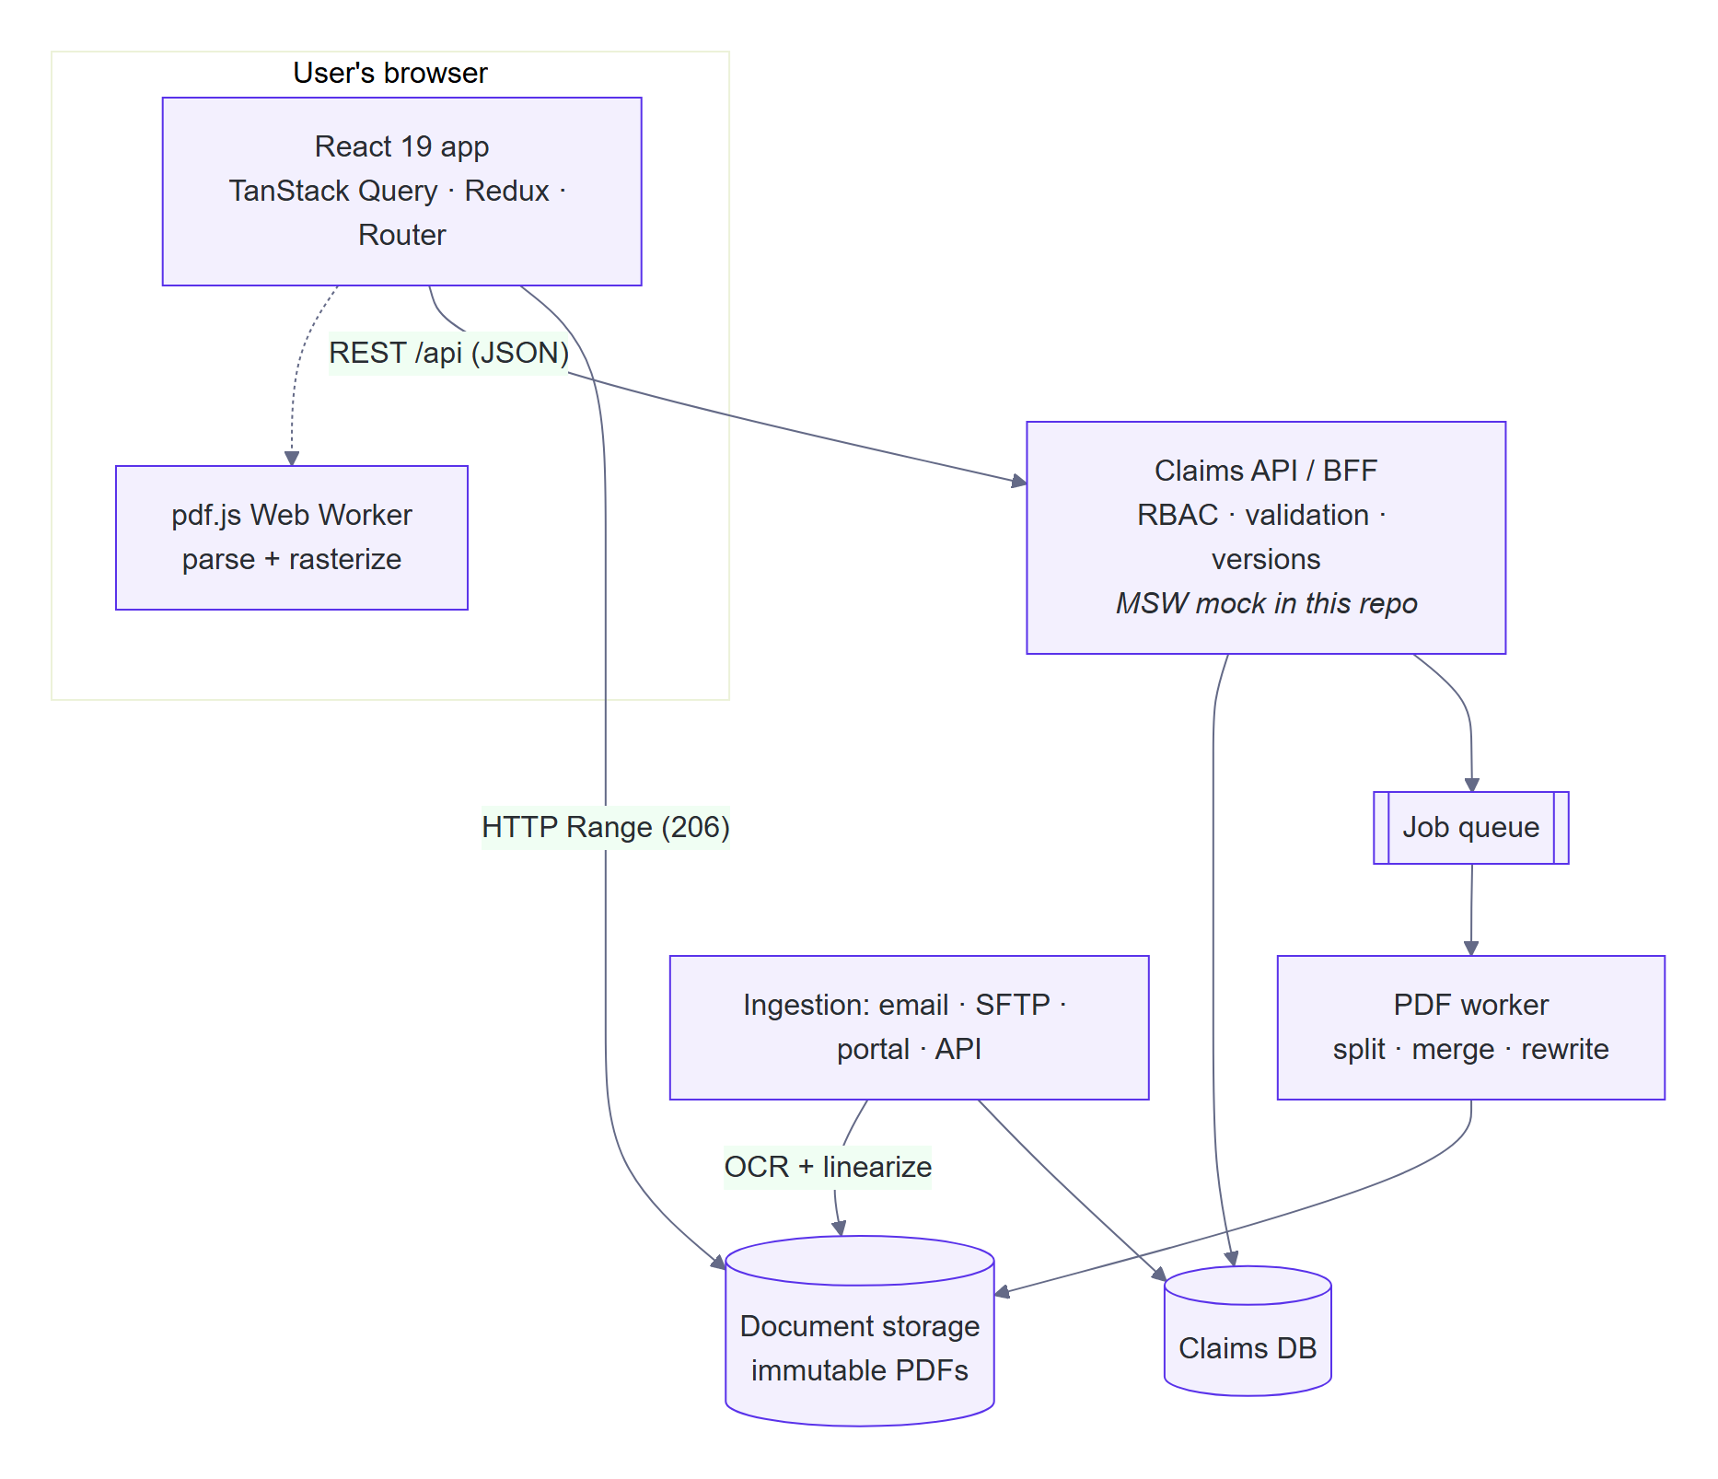
Figure 6 — System context

4.2 Technology choices
Concern | Choice | Why
UI framework | React 19 + TypeScript (strict) | Preferred in the job description; strict typing catches errors at build time
Build | Vite 7 | Fast development server, native ES modules, simple code splitting
Styling | Tailwind CSS v4 with design tokens | Figma colours/typography defined once as tokens; consistent, small CSS (7 KB gzipped)
Accessible primitives | Radix UI (dialog, menu, tooltip) | Keyboard support, focus management and ARIA handled correctly
Server state | TanStack Query | Caching, request de-duplication, cancellation, prefetch, garbage collection
Client state | Redux Toolkit | Complex document-editing session with undo/redo
Virtualization | TanStack Virtual | Headless, works for both the grid and the page viewer
PDF rendering | pdf.js (Mozilla) | Industry-standard, renders in a Web Worker, supports partial loading
Mock backend | Mock Service Worker (MSW) | Real HTTP semantics in the browser and in tests; deployable as a static demo
Testing | Vitest, React Testing Library, Playwright, axe-core | Unit, component, API-contract, end-to-end and accessibility

4.3 Code organisation and boundaries
The code is organised by feature, not by file type. Pages compose features; features never import each other’s internals; shared code never depends on features. These rules are enforced by ESLint, so they cannot erode over time.
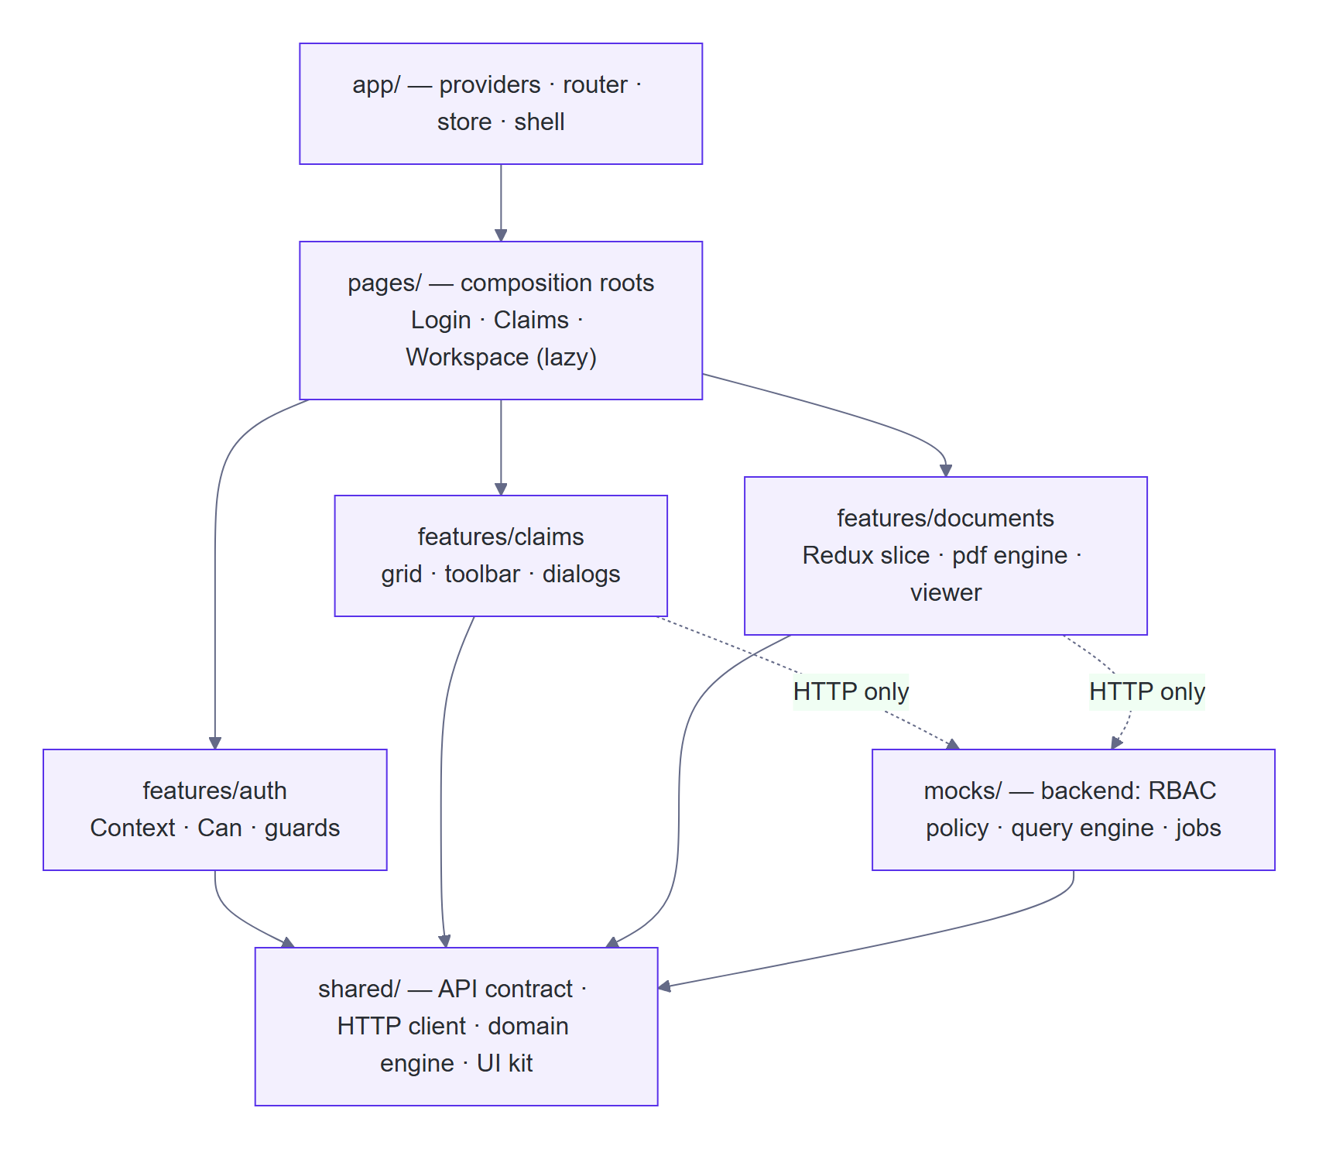
Figure 7 — Layers and dependency rules
Folder | Responsibility
src/app | Application shell: providers, router, Redux store, layout, error boundaries
src/pages | Route screens (Login, Claims, Workspace); the only place features are combined
src/features/auth | Session (React Context), <Can> permission gate, usePermission, route guard
src/features/claims | Grid (virtual and paged), toolbar, URL state, block loader, dialogs, mutations
src/features/documents | Workspace: Redux slice, PDF engine, viewer, thumbnails, save jobs, comments, annotations
src/shared | API contract (types), HTTP client, pure domain engine, UI components, utilities
src/mocks | The mock backend: data generator, RBAC policy, query engine, job engine
docs/ | Architecture document and four Architecture Decision Records (ADRs)

4.4 State management
The job description lists Redux, Context API and MobX. Rather than one global store, each kind of state has exactly one owner, chosen for what that state needs:
State | Owner | Reasoning
Server data: claims, documents, comments, jobs | TanStack Query | Needs caching, de-duplication, cancellation, prefetch and eviction — reimplementing this in Redux adds code and bugs
Grid sort, filter, page, view mode | URL query string | Shareable links, survives refresh, Back button restores the exact view with no extra code
Document editing draft, selection, tool, zoom | Redux Toolkit | Client-owned, read by many distant components, updated frequently; the command log gives undo/redo and is the save payload
Signed-in user and permissions | React Context | Read everywhere but changes only at sign-in/out, so Context re-renders are irrelevant
PDF download statistics | useSyncExternalStore | The data lives in the PDF engine outside React; this is the tear-free way to read it
Transient UI (open menus, hover) | Component state | Local by nature
MobX was considered and not used: the combination above covers every case with explicit data flow and better debugging tools (Redux DevTools, Query DevTools).

4.5 Backend API contract
Shared TypeScript types (src/shared/api/contracts.ts) define the contract between UI and backend; in production these would be generated from an OpenAPI specification.
Endpoint | Purpose and behaviour
POST /auth/login · GET /auth/me | Session with user and role permissions
GET /claims?offset&limit&sortBy&sortDir&q&status&priority&channel | Server-side paging, sort, filter, search; each row includes a version and the actions the current user may perform
GET /claims/stats | KPI cards, restricted to the user’s data scope
PATCH /claims/{id} · POST /claims/{id}/assign · DELETE /claims/{id} | Writes carry a version; stale writes are rejected with 409
GET /claims/{id}/documents | Document structure (page references), file metadata (size, page count, page size) and the user’s capabilities
POST /claims/{id}/document-operations | Starts a save job (202 Accepted); idempotent per key; 409 on conflict, 422 on invalid operations
GET /jobs/{id} · POST /jobs/{id}/cancel | Job status/progress; cooperative cancellation
/claims/{id}/comments · /claims/{id}/annotations | Collaboration data keyed by stable page id
Document file URLs | Must support HTTP Range requests (206 Partial Content)

5. Key flows

5.1 Grid data flow
- The virtualizer reports which rows are visible. Only the 100-row blocks covering those rows (plus a margin) are requested.
- Each block is a separate cache entry: requests are de-duplicated, cancelled if no longer needed, and evicted 60 seconds after scrolling away, so memory stays flat no matter how far the user scrolls.
- The server caches the filtered and sorted list per user and query, so 250 block requests cost one sort, not 250.

5.2 Grid to document workspace
- Intent detection. Hovering a row for 120 ms (or focusing it with the keyboard) starts prefetching in parallel: the workspace code, the document list, and the first page of the first document.
- Instant navigation. The click navigates immediately with an animated transition; the header renders at once from the grid row data while skeletons hold the layout.
- Return. Back restores the grid’s filters, sort and page from the URL and its data from the cache — no reload flash.

5.3 Loading very large documents
pdf.js normally starts with a full download and aborts it once it sees the server supports partial requests. Because the server already reports the file size, a custom Range transport skips that step: every byte that crosses the network is an explicit, cancellable, counted request. Parsing and drawing happen in a Web Worker so the interface never freezes.
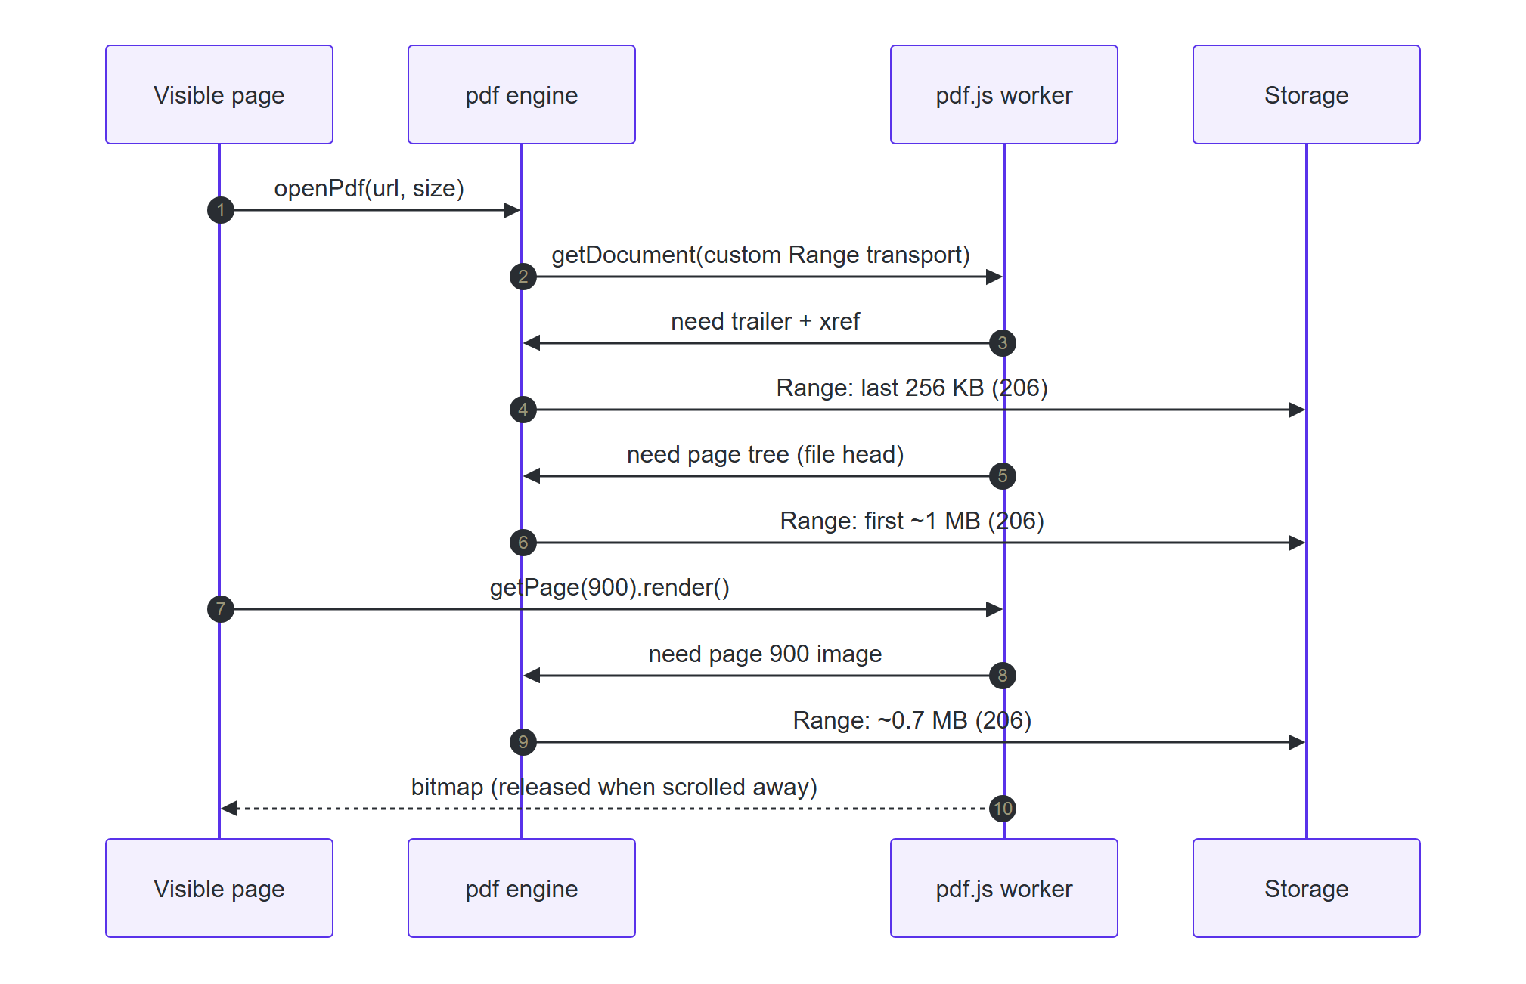
Figure 8 — Loading page 900 of a 1 GB document
Finding: the layout of the PDF matters as much as the viewer
Locating page N requires reading the PDF’s page tree. In a file where each small page entry sits next to a large image, reaching page 360 of a 250 MB file forced the download of 152 MB. With page entries stored together at the start of the file (a “web-optimised” layout), the same jump downloaded ~10 MB.
Recommendation: the ingestion pipeline should web-optimise (linearize) every PDF after OCR. The included document generator produces this layout.

5.4 Editing and saving documents
A document is an ordered list of page references — (source file, page number, rotation) — never raw bytes. Split, merge, reorder, rotate and delete therefore take the same time for a 1 MB or a 1 GB file. Each edit is a command in a log; the visible document is the log replayed over the last saved version. The same pure function applies the log in the browser (instant preview) and on the server (authoritative save).
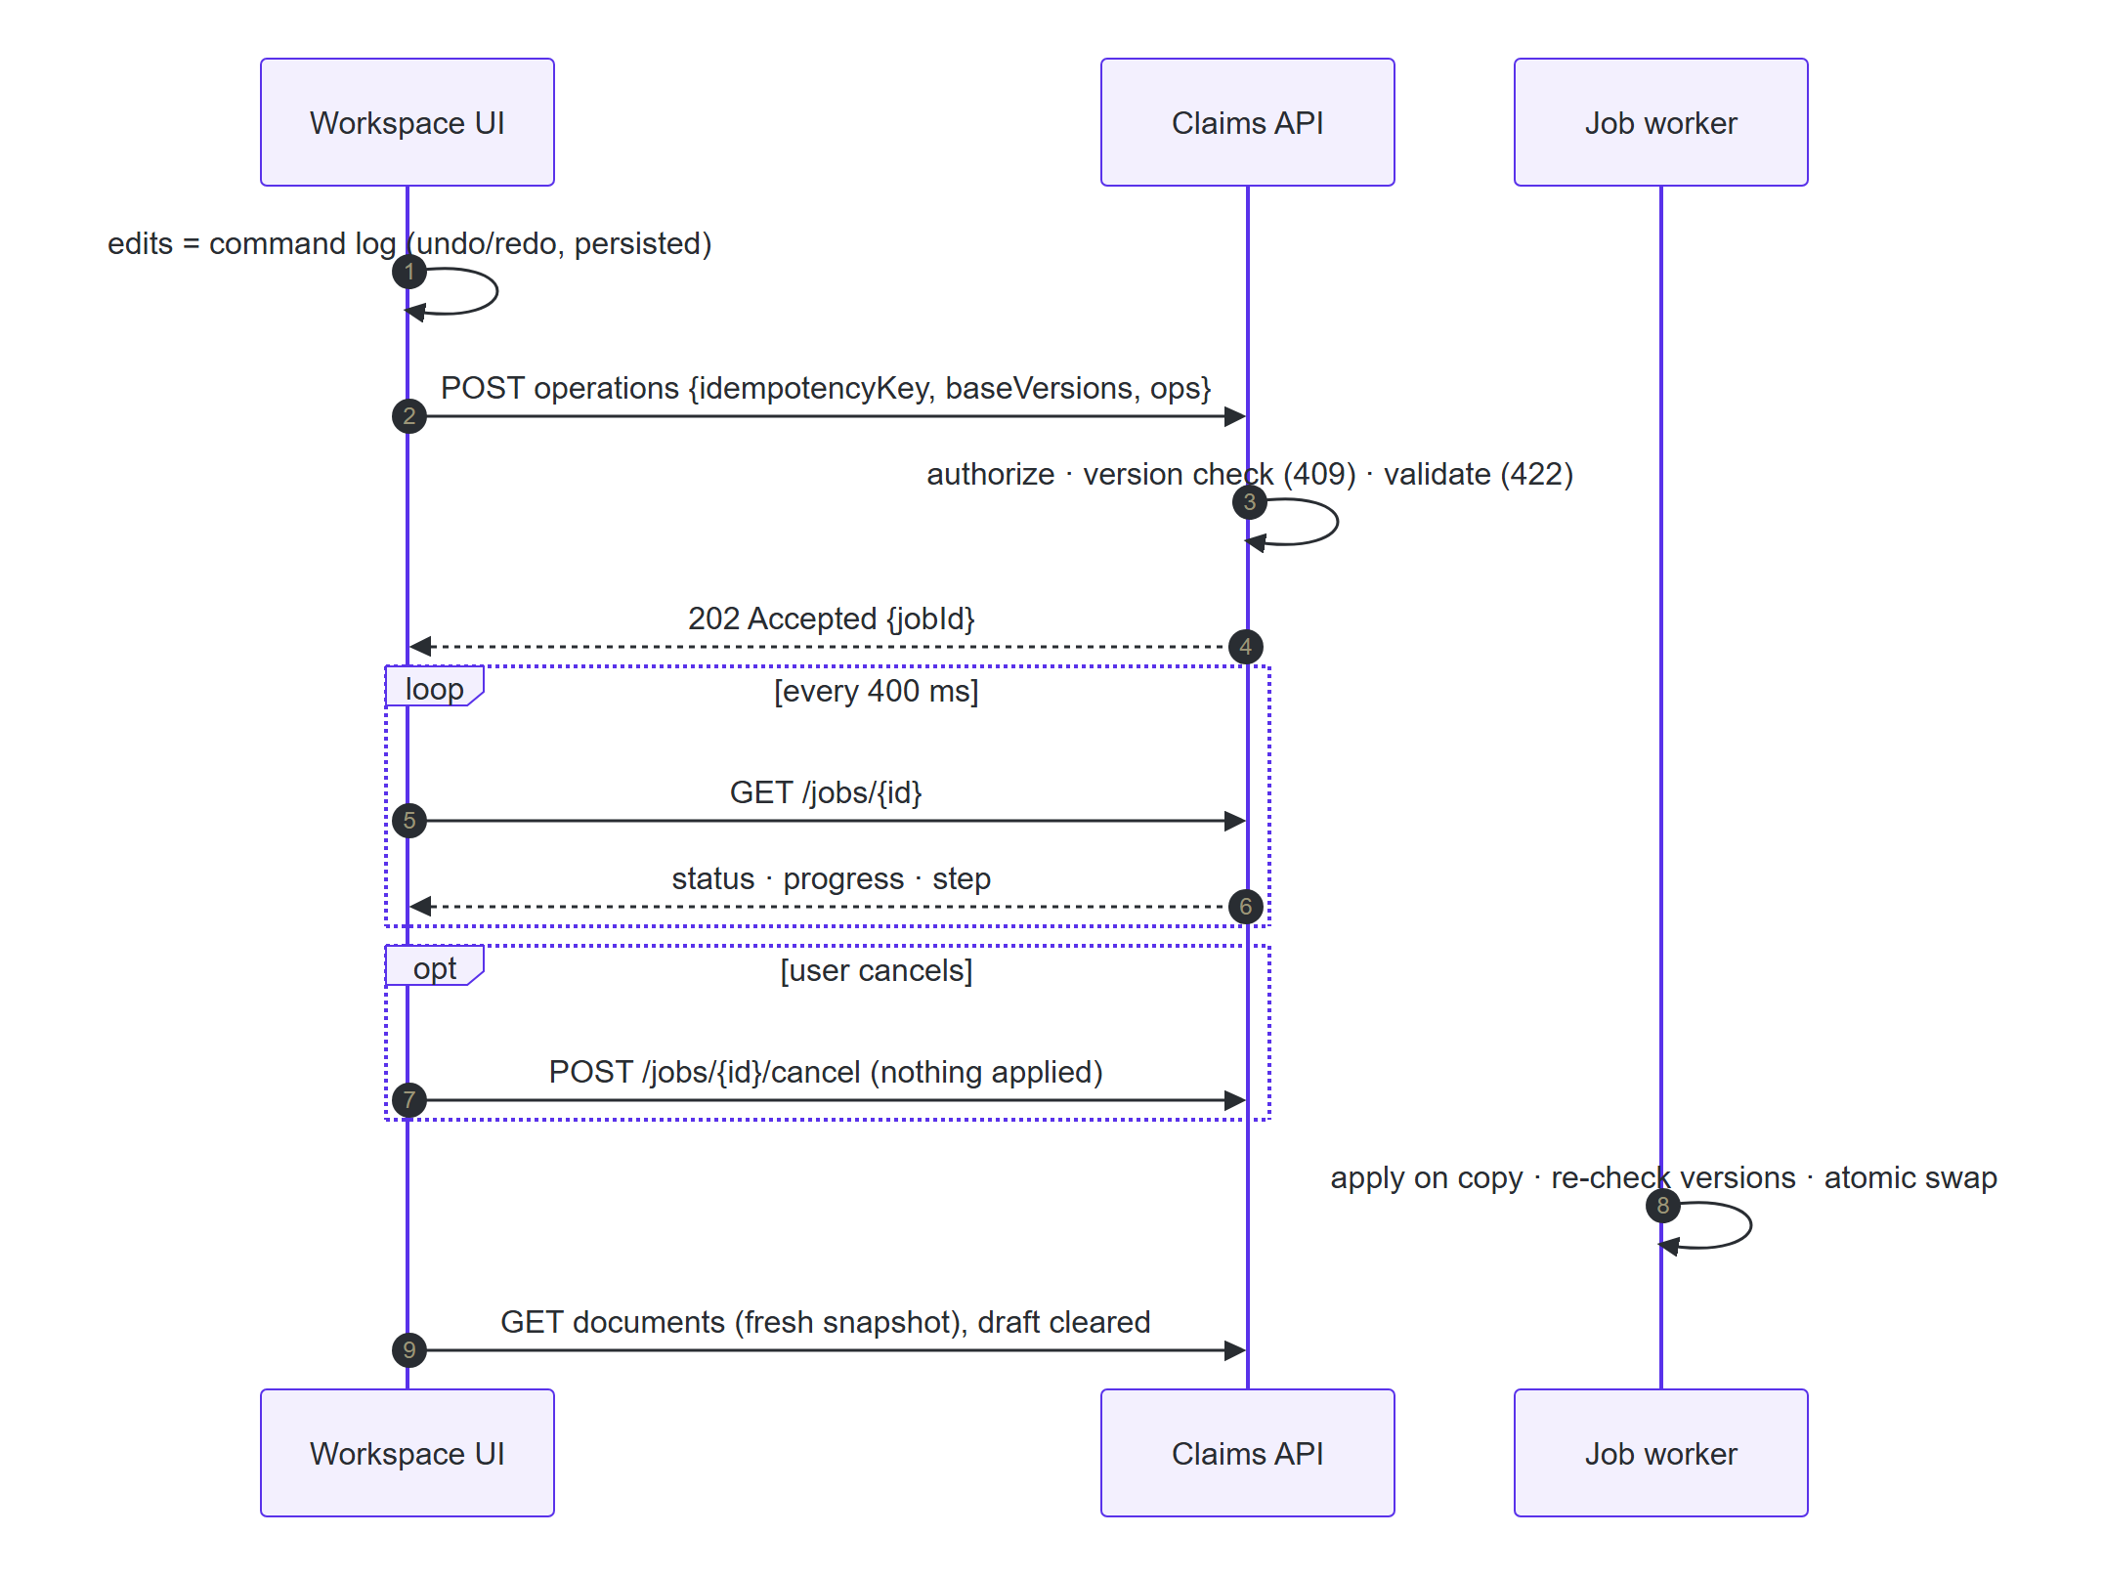
Figure 9 — Saving edits as one atomic, cancellable, idempotent job
Guarantee | How
All-or-nothing | The server applies all operations to a copy and swaps it in only at the final step; a failure or cancel leaves documents untouched — there are no partial failures to repair
No lost updates | The request includes the versions the user edited; if someone else saved first, the server returns 409 and the user chooses “keep my draft” or “load latest”
No duplicates | An idempotency key per save attempt: a double-click or network retry returns the same job
Safe retry | The draft is kept on failure, so Retry resubmits exactly the same work
No lost work | The command log is stored locally and restored after a refresh — only if the documents have not changed in between
Comments stay attached | Comments and annotations reference stable page ids, so they follow pages through split, merge and reorder; those on deleted pages are removed in the same save

6. Design patterns used
Pattern | Where | Benefit
Feature-based modular architecture | features/* with public index.ts; lint-enforced boundaries | Teams can own features independently; dependencies stay one-directional
Composition root | pages/* wire features together | Features stay decoupled (the grid does not know about the PDF engine)
Command pattern (event-sourcing style) | Document operations log in Redux | Undo/redo, replay, persistence and the save payload from one model
Functional core, imperative shell | shared/domain/documentOperations.ts | Pure, deterministic, unit-testable; identical rules on client and server
Adapter | HttpRangeTransport adapts HTTP Range requests to the pdf.js transport interface | Full control over network use, cancellation and measurement
API client layer + query-key factory | claimsApi, documentsApi, claimKeys, queryOptions factories | One place per endpoint; precise cache invalidation
Observer / external store | PDF download statistics + useSyncExternalStore | Live UI updates from a non-React source without global state
Cache with LRU eviction | Open PDF documents (max 4); grid blocks via cache GC | Bounded memory
Optimistic UI with rollback | Assign, comments, annotations | Instant feedback; consistent state on failure
Optimistic concurrency control | Version tokens on every write (409 on conflict) | No silent overwrites between users
Asynchronous request-reply | 202 Accepted + job status endpoint | Long operations without blocking or timeouts
Idempotency key | Save job submission | Safe retries
Policy object + declarative guards | Server policy.ts; client <Can>, RequireAuth | Authorization rules in one place; readable UI code
Bulkhead error boundaries | Shell, viewer, thumbnails, comments | A failure in one region does not take down the page
Strategy | Virtual and paged grid share columns and rows | Two row models, one presentation
Lazy loading + prefetch on intent | Workspace route, dialogs, PDF engine | Small initial download, yet instant navigation
Headless components + design tokens | Radix primitives styled with Tailwind tokens | Accessible behaviour with a consistent, themeable look

7. Performance optimisation
Measured in Chromium on a development laptop against the development build; production builds are faster.
Area | Technique | Result
Grid rendering | Virtualization (TanStack Virtual), fixed 56 px rows, overscan | ~20–35 rows in the page for 25,000 claims
Grid memory | 100-row blocks as cache entries, evicted 60 s after leaving view | Flat memory; no growth while scrolling
Re-renders | Memoized rows, stable callbacks, structural sharing of query data, Redux selectors | Unchanged rows never re-render
Server load | Debounced search (300 ms); server caches sorted results; hard limit of 500 rows per request | One request per pause in typing
Perceived speed | Prefetch on hover intent; skeletons; instant header from grid data; previous page kept visible while the next loads | Workspace opens with content ready
Document download | Custom Range loader, 256 KB chunks, no background download | 1 GB file: first page < 2 s with 6.6 MB
Document rendering | Web Worker; virtualized pages; render only after 60 ms on screen; cancel when scrolled away | Fast scrolling does not queue hundreds of renders
Document memory | Release canvas memory when a page leaves view; cap pixel density at 2×; keep at most 4 documents open | Off-screen pages hold no images
Bundle size | Lazy workspace route and dialogs; PDF engine in its own chunk; vendor chunks for caching | App code ~74 KB gzipped (down from 168 KB before splitting)
Annotations | Vector overlay in normalized coordinates | Zoom and rotation never redraw the PDF for annotations

Trade-offs considered
Decision | Alternatives | Why this choice
Virtualization + server blocks (pagination available) | Pagination only; infinite scroll; load all rows | Constant DOM and memory, true scrollbar, jump to any row; infinite scroll grows without bound and cannot jump
Server-side sort and filter | Client-side (20k rows is feasible today) | Scales with growth and respects data scoping — the client must never receive rows the user may not see
pdf.js with Range requests | Server-rendered page images/tiles | No rendition pipeline or storage; text stays selectable. Server tiles remain a good option for weak devices (hybrid possible)
Pessimistic, atomic save for document structure | Optimistic save | Expensive, destructive operations on large files must be all-or-nothing and truthful to the user
Optimistic comments, annotations, assignment | Pessimistic | Cheap, reversible, frequent — instant feedback matters more; rollback on failure
Polling job status (400 ms) | Server-Sent Events / WebSocket | Simple and robust for a demo; production would push updates

8. Security and role-based access

8.1 Personas
Persona | Role | Sees | Can do
Evano Morales | Adjuster | EMEA claims | Edit own claims; edit documents on own claims; comment; annotate
Priya Raman | Supervisor | EMEA claims | Edit and assign any open claim in the region
Marcus Lee | Viewer (auditor) | All regions | Read only
Sofia Alvarez | Admin | All regions | Everything, including delete

8.2 Where enforcement lives
Concern | Server (authoritative) | Client (user experience)
Authentication | Bearer token checked on every request; 401 signs the user out | Route guard; session restore
Authorization | Role permissions, region scoping, ownership and closed-claim lock — re-checked on every endpoint | Hide actions the role can never perform; disable with a reason when the record prevents it
Data scoping | Records outside the user’s scope return 404 (existence is not revealed) | —
Validation | Schemas (zod) on every write; document operations dry-run before a job is accepted | Same rules for instant feedback; URL parameters whitelisted
Consistency | Version tokens (409), idempotency keys, atomic commit | Conflict dialog; draft kept on failure

8.3 Further safeguards
- No raw HTML rendering; comment text is always rendered as text (prevents cross-site scripting).
- PDF engine runs with XFA forms disabled; documents are parsed in an isolated worker.
- All query parameters are validated against allow-lists before reaching the API; the server caps page sizes.
- Production hardening (documented, not in the demo): OIDC single sign-on with httpOnly cookies, Content Security Policy, short-lived signed document URLs, audit logging of document operations.

9. Accessibility (WCAG 2.1 AA)
Accessibility was treated as a requirement, not a final check. Every primary screen is audited automatically in the test suite, and the build fails on any violation.

9.1 Verification
- Automated audit: axe-core runs in Playwright against the sign-in screen, the claims grid and the document workspace with the WCAG 2.0/2.1 A and AA rule sets — 0 violations.
- Static analysis: eslint-plugin-jsx-a11y on every commit (labels, roles, keyboard handlers, no autofocus).
- Colour contrast: the Figma greys and greens were too light for small text (as low as 2.8:1). They were darkened within the same hue so that every text colour meets 4.5:1 on every surface it is used on.

9.2 What was implemented
WCAG criterion | Implementation
1.3.1 Info and relationships | Semantic roles: grid / row / columnheader / gridcell, listbox / option for thumbnails, toolbar, radiogroup, navigation and region landmarks, figure / figcaption for pages; labelled form fields
1.4.3 Contrast (minimum) | All text tokens ≥ 4.5:1 (verified by axe-core)
2.1.1 Keyboard | Grid: arrows, Page Up/Down, Home/End, Enter opens. Thumbnails: arrows, Shift to extend selection, Space/Enter to select, Alt+arrows to move a page. Ctrl+Z / Ctrl+Shift+Z undo/redo. Menus and dialogs fully keyboard operable
2.4.1 Bypass blocks | “Skip to content” link
2.4.3 Focus order | Roving tab index: the grid and the thumbnail list are each a single tab stop
2.4.7 Focus visible | High-contrast focus ring on every interactive element
3.3.1 / 3.3.2 Errors and labels | Inline errors linked to fields (aria-invalid, aria-describedby)
4.1.2 Name, role, value | aria-sort on columns, aria-selected, aria-pressed, aria-checked, aria-busy, progressbar values; disabled actions stay focusable with an explanation (aria-disabled)
4.1.3 Status messages | Live regions for result counts, save progress (status) and errors (alert); toast notifications
Virtualized content | aria-rowcount / aria-rowindex so assistive technology knows the grid has 25,000 rows even though only ~30 are rendered
Motion | prefers-reduced-motion disables animations and route transitions
Drag and drop alternative | Page reordering by drag also available via buttons and Alt+arrow keys (WCAG 2.2 “Dragging movements”)

Known gaps (honest assessment)
• Page content is drawn on a canvas, so screen-reader users cannot read the document text yet. Fix: add pdf.js’ text layer (also enables text selection and search).
• Annotations can only be drawn with a pointer. Fix: a keyboard “add annotation to selected region” command.
• No manual testing with screen readers (NVDA, JAWS, VoiceOver) has been done; automated tools detect only part of WCAG issues. Recommended before production.

10. Coding standards and best practices
Area | Practice
Type safety | TypeScript strict mode plus noUncheckedIndexedAccess, noImplicitOverride, verbatimModuleSyntax; no any in application code; one shared API contract
Linting | ESLint (flat config): TypeScript rules, React Hooks rules including React Compiler checks, jsx-a11y, consistent type imports; zero warnings allowed
Architecture rules | Lint rules forbid shared code importing features and UI code importing the mock backend
Formatting | Prettier with Tailwind class sorting; checked in CI
Git hygiene | Husky pre-commit hook runs ESLint and Prettier on staged files; Conventional Commit messages
Components | Function components and hooks; small, single-purpose files; one dialog host per page rather than per row; memoization where it measurably matters
Design system | Design tokens from Figma in one place; reusable primitives (Button, Badge, Dialog, Tooltip, Field, Skeleton, ProgressBar, ErrorBoundary)
Error handling | Typed API errors; transient errors retried with exponential back-off, client errors never retried; error boundaries per region
Documentation | Comments explain *why*, not *what*; README with requirement map; architecture document; four decision records (ADRs)
Reproducibility | Pinned Node version (.nvmrc), lock file, deterministic test data, npm run validate single command

11. Testing and continuous integration
Level | Tool | What is covered | Count
Unit | Vitest | Document operation engine; Redux slice (undo/redo, selection, draft restore); annotation geometry; URL parsing; pagination; LRU cache | 29
API contract | Vitest + MSW | Authentication, authorization (403), data scoping (404), per-row actions, server sort/filter, 409 conflicts, atomic + idempotent jobs, 422 validation | 13
Component | React Testing Library | Hide / disable rules for row actions per role | 3
End-to-end | Playwright (Chromium) | Virtualization, filtering, RBAC per persona, pagination, split + save, failure + retry, annotations + comments, read-only workspace | 7
Accessibility | Playwright + axe-core | WCAG 2.1 A/AA on sign-in, grid and workspace | 3

Continuous integration (GitHub Actions) runs on every push and pull request: format check, lint, type check, unit tests, production build and the end-to-end suite. A second workflow deploys the live demo to GitHub Pages, generating a 250 MB document at deploy time so partial loading can be seen live.

12. Running the project
Command | Purpose
npm install | Install dependencies (Node 22 or later)
npm run dev | Start the application at http://localhost:5173
npm run generate:docs -- --preset large | Generate 250 MB and 1 GB sample documents (about 2 seconds)
npm run validate | Lint, type check and unit/integration tests
npm run test:e2e | End-to-end and accessibility tests
npm run build | Production build

Suggested five-minute walkthrough
- Sign in as Sofia (Admin). Drag the grid scrollbar to the middle of 25,000 claims; the footer shows how few rows are in the page. Switch to Paginated for the Figma layout.
- Filter by Status and sort a column; note the URL updates and the Back button restores it.
- Sign out and sign in as Marcus (Auditor): no row actions. Then Evano (Adjuster): only EMEA claims; Edit disabled with a reason on colleagues’ claims.
- As Sofia, search for 100004, open the claim and select the Litigation Bundle (1 GB) (generated locally; the live demo includes a 250 MB document on every fourth claim). Watch the green download badge, then jump deep into the document.
- Open an In-Review claim: split a document, rotate a page, undo with Ctrl+Z, then Save to watch the job. Tick Simulate failure to see the atomic rollback and safe Retry.
- Refresh the page mid-edit: the draft is restored. Add a highlight and a page comment.

13. Limitations and roadmap
Current state | Next step for production
Mock backend runs in the browser; data resets on reload | Node or .NET backend-for-frontend implementing the same contract (OpenAPI-generated types)
Save job simulates PDF rewriting | Queue worker (e.g. qpdf/PDFium) writing new immutable file versions
Job status by polling | Server-Sent Events or WebSocket push; live collaboration (presence, live annotations)
Demo sign-in with a session token | OIDC single sign-on (e.g. Azure AD), httpOnly cookies, CSP
Document text not exposed to screen readers | pdf.js text layer: accessibility, selection and in-document search
Desktop-first layout | Responsive tablet layout for field adjusters
No visual component catalogue | Storybook for the UI primitives; visual regression tests
Client observability | Error and performance telemetry (e.g. Sentry, Web Vitals)

Detailed decision records are in the repository under docs/adr: virtualized grid (0001), large-document loading (0002), state management (0003) and optimistic vs pessimistic updates (0004).

