**A TEST APPLICATION REPORT ON**

**USER AUTHENTCATION SYSTEM**

**ABSTRACT:**

This is a Project handles **user** accounts, groups, permissions. This section of the documentation explains how the default implementation works out of the box, as well as how to extend and customize it to suit your project's needs.

show you how to allow users to log in to your site with their own accounts, and how to control what they can do and see based on whether or not they are logged in and their permissions. As part of this demonstration, we'll extend the local library website, adding login and logout pages, and user- and staff-specific pages for viewing books that have been borrowed.

**LANGUAGE AND TOOLS TO BE USED :-**

**A. FRONT END:-**

**1. DJANGO TEMPLATE LANGUAGE**

**2. HTML 5**

**3. BOOTSTRAP 4-.0**

**4. CSS**

**B. BACK END:-**

1. **PYTHON(3.9)**
2. **DJANGO**
3. **SQLITE 3(in built)**

**REQUIREMENT ANALYSIS:-**

**Software requirements**

* **Any Operating system**
* **Browser**
* **asgiref==3.3.1**
* **astroid==2.5.1**
* **colorama==0.4.4**
* **Django==2.2.7**
* **django-model-utils==3.1.2**
* **isort==5.7.0**
* **lazy-object-proxy==1.5.2**
* **mccabe==0.6.1**
* **Pillow==8.1.2**
* **pylint==2.7.2**
* **pytz==2021.1**
* **sqlparse==0.4.1**
* **toml==0.10.2**
* **wrapt==1.12.1**

**Features:**

* **In this project there is two type of user (admin & client), using the in-built library(auth) of Django.**
* **Use Django ORM.**
* **Using the in-built library(auth) password can be automatically hashed.**
* **Client can register but can’t login until admin not activate the user, if admin activate the then client can login.**
* **In admin site has permission to activate or deactivate the user.**
* **Admin can see the list of users with details and status of user (active or deactivate) as True or False.**

**Admin Site Credential:**

Username: admin

Password: admin

**Client Site:**

* Client site client can register, but admin has given the permission to login.
* Username: [rrasmi070@gmail.com](mailto:rrasmi070@gmail.com)
* Password: 1234

**SCREENSHOTS:**

**Home Page:-**

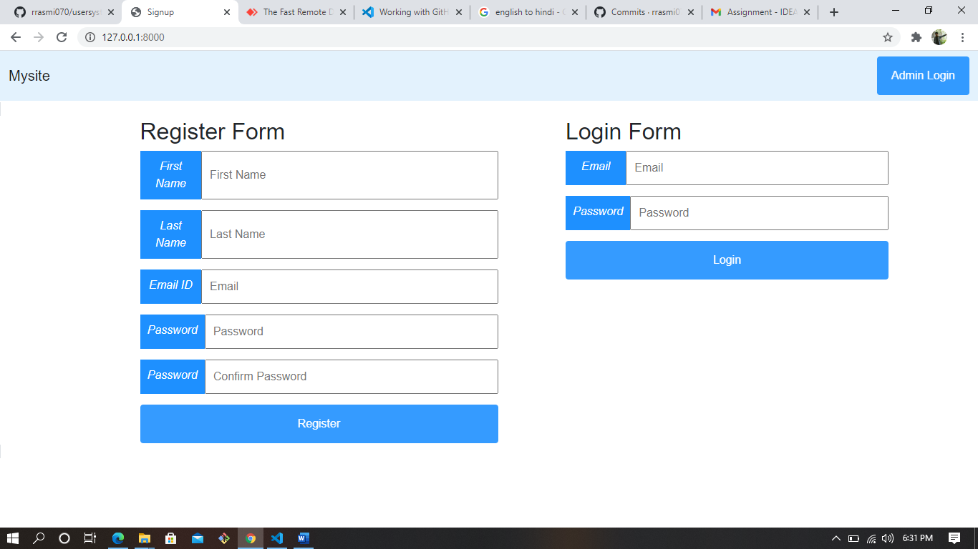

**Admin Login**

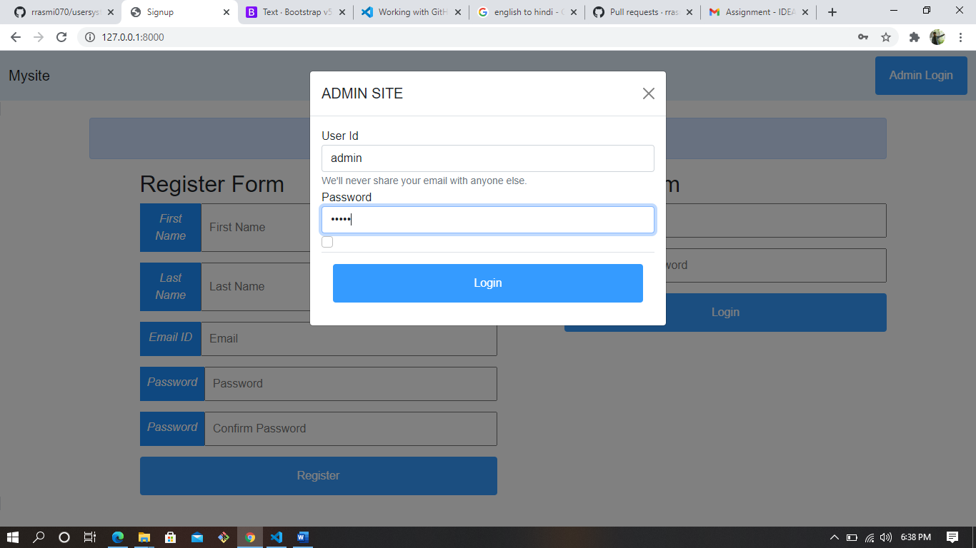

**Admin Permission(Active & Deactive)**

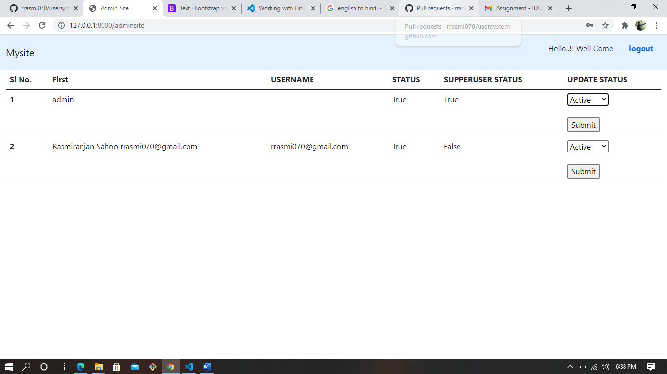

**Client Login**

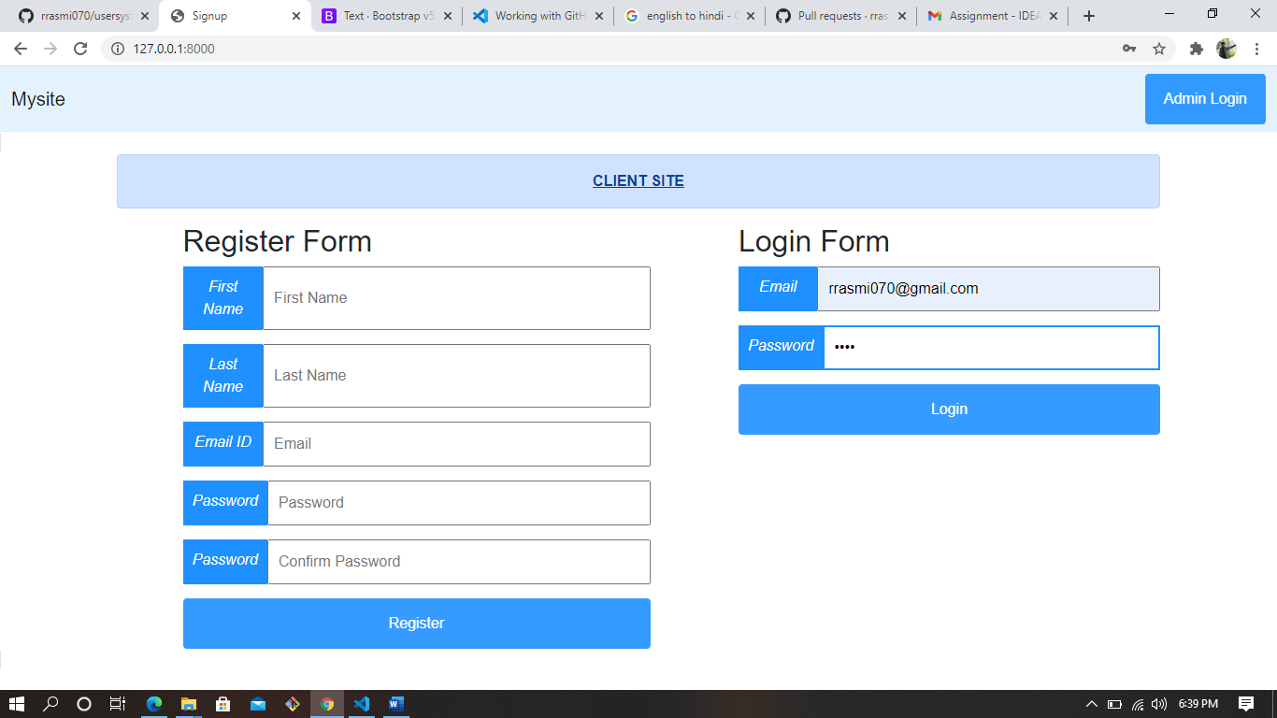

**User Profile**

