Statistics GR5203: Probability (Fall 2026)

Class sessions: Tuesdays and Thursdays 1:10-3:40 Location: Uris 331

Instructor: Ruchira Ray
Email: ruchira.ray@columbia.edu
Office Hours: TBD

Teaching assistant: TBD
Office Hours: TBD

Course description: This is a master's level introductory course in probability. This course covers basic probability theory for students seeking to build a foundation for further studies in the field of statistics and machine learning.

The aim of the course is to introduce the concept of probability. We also define conditional probability, random variables and the notion of the distribution of random variables. We introduce enough machinery needed to understand the two results that are fundamental to statistics --- the law of large numbers and the central limit theorem. Along the way, students will also obtain a foundation sufficient for STAT GR5207 (Elementary Stochastic Processes) and STAT GR5204 (Statistical Inference).

Note: The course covers the material of one full course in a half semester. The pace, therefore, is fast, and hence more effort is required from the student to keep up with the pace of the lectures. Furthermore, the material is cumulative, that is, almost every lecture builds on previously discussed concepts. Students who doubt their preparation or who are concerned that they will not be able to consistently devote time to the course would be well advised to consider taking the full semester version of this course.

Textbook: Probability and Statistics, 4th Ed., by DeGroot and Schervish (ISBN-10: 0321500466).
Prerequisites: A good working knowledge of single-variable calculus is necessary: differentiation, integration, infinite sums, Taylor expansions, limits. You should also have some experience with linear algebra: matrices, eigenvectors, quadratic forms. No previous experience with statistics or probability is necessary.

Class components and evaluation:

Homework (10% of final grade)
- Frequency: There will be a homework (HW) problem set due (almost) every week with the exception of the first week and the midterm week.
- Submission: HW is to be submitted on Courseworks
- Late policy: because of the fast pace of the course, it is advised to submit HW on time. However, you will be given four late days to be divided however you wish across the five assignments. Beyond this, late homework will not be accepted.
- Dropping HW: The HW with lowest score will be dropped
- Collaboration: Students can work together on the homework assignments but should write up solutions on their own.
- Solutions: will be posted on Courseworks each week.

Midterm (35% of final grade)
- Time/place: During the first half of class (time) on TBD in room TBD
- Coverage: the first half of the course (up to blah)
- Exam problems: will be similar to those given in the HW and lectures.
- Format: a practice exam with the exam format will be distributed one week before the exam
- Notes: The exam will be closed-book and closed-note; a one page (A4 sized paper) cheat sheet, where you can write on either side of the paper, will be allowed [where you can write/type important formulas and results by your own hand].
- Collaboration: All work on the exams absolutely must be each student's alone.

Final exam (45% of final grade)
- Time/place: During the entire class (time) on TBD in room TBD
- Coverage: the entire syllabus with greater emphasis on the second half of the course
- Exam problems: will be similar to those given in the HW and lectures.
- Format: a practice exam with the exam format will be distributed one week before the exam
- Notes: The exam will be closed-book and closed-note; two page (A4 sized paper) cheat sheet, where you can write on both sides of both papers, will be allowed [where you can write/type important formulas and results by your own hand].
- Collaboration: All work on the exams absolutely must be each student's alone.

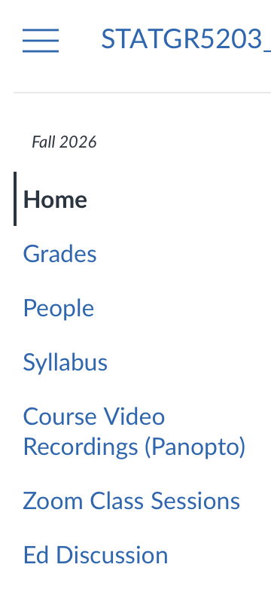
Makeup exam policy: Make-up exams will not be given routinely. Students who have a legitimate conflict with an exam date must make arrangements with the instructor. An exam missed due to a documented illness or other unforeseeable (and documented) extraordinary circumstances must be made up before the test papers are returned to the class.

Class participation and discussions (10% of final grade)
I will create opportunities for participation during class. Additional questions and discussion are highly encouraged. Participation on ‘Ed discussion’ is also highly encouraged. Ed discussion is a question/answer forum (see signup information below) where you may discuss anything class related. I will also consider participation (asking/answering questions) on Ed discussion in the final grade.)

Signup instructions for Ed discussion: It will show up as a button in the menu, together with 'Assignments' 'Grades' 'People' etc (right)

Accessibility and Accommodations: Students who may need disability-related accommodations for this course must register with the Office of Disability Services (https://www.health.columbia.edu/content/disability-services), and provide an accommodation letter issued by Disability Services to the instructor as soon as possible. Some students may wish to take part in religious observances that occur during this academic term. If you have a religious observance that conflicts with your participation in the course, please contact the instructor before the end of the second week of the term to discuss appropriate accommodations.

Academic Integrity: Students are expected to abide by the University’s student conduct policies and refrain from all forms of academic dishonesty. A non-exhaustive list of examples of academic dishonesty can be found here: https://cssi.columbia.edu/content/academic-violations. Please note that the use of generative Artificial Intelligence (AI) tools to complete homework and exams is prohibited. Suspected academic integrity violations will be reported and referred to the Dean’s Discipline process. The disciplinary process may result in sanctions, up to and including dismissal from the University.

