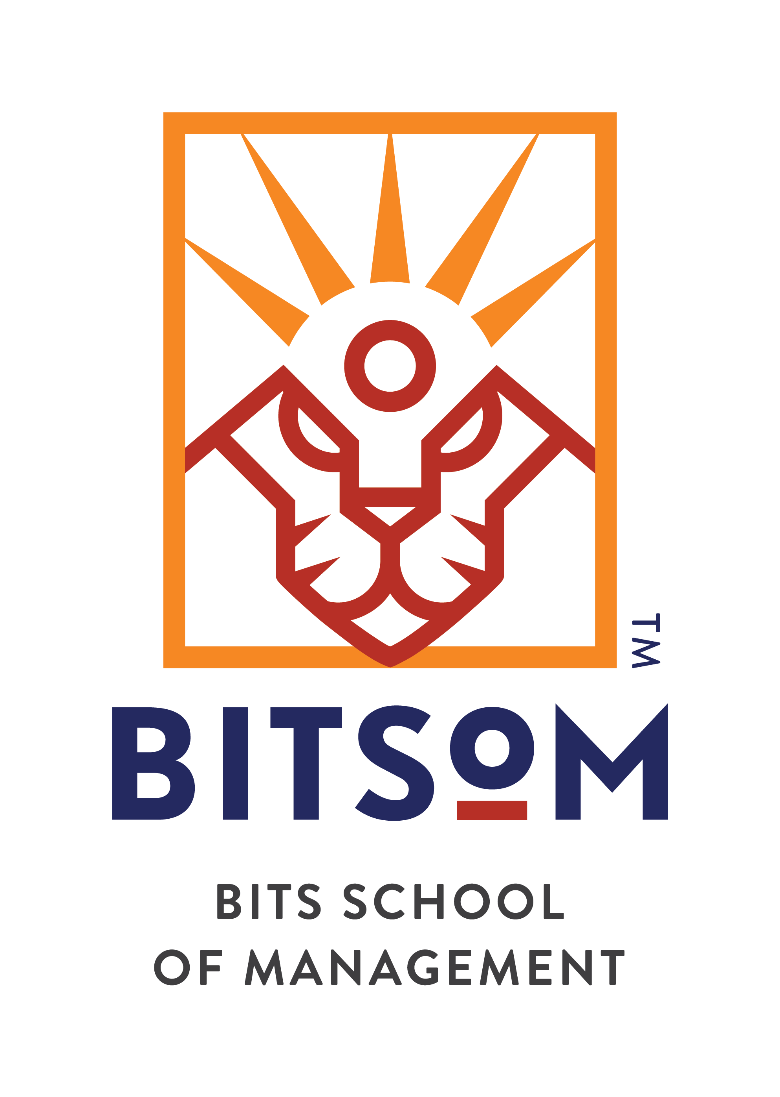
Ragini Bhayana (10261314)
Class of 2026
EDUCATION
Qualification | Institute/University | Remarks | CGPA/% | Year
MBA | BITS School of Management, Mumbai | Pursuing | Pursuing | 2026
B. Tech. (ECE) | Guru Gobind Singh Indraprastha University, Dwarka, Delhi | Rank 2 in Batch, Rank 1 in 16 Courses | 9.2/10 | 2023
Class 12 (CBSE) | Modern School, Vasant Vihar, Delhi | Above 94% in 3/5 subjects | 90% | 2018
Class 10 (CBSE) | Modern School, Vasant Vihar, Delhi | 10/10 in 3 subjects | 9.6/10 | 2016
ACHIEVEMENTS AND RECOGNITION
Case Competition | - Campus Finalist - SBI Life IdeationX 2.0|among 30,000+ participants on increasing insurance penetration %  - Secured Rank 44/907 |Ace the Case 2024 | SummIT, NMIMS Mumbai in Round 1 for Product Management |  |  | 2025  2024
Hackathon | - Earned 2nd position in Data Hackathon, BITSoM, evaluated by 3 ABG Group industry retail experts |  |  | 2025
Olympiad | - Ranked top 0.2% in National Fintech Olympiad, IFTA representing BITSoM among 2,000+ colleges |  |  | 2024
McKinsey | - Future-of-work program for problem-solving, effective communication, adaptability, resilience, & digital fluency |  |  | 2025
Nokia | - Received formal recognition for successful completion of time-sensitive project & rapid skill acquisition  - 1 among top 1% to secure job offer at Nokia Solutions and Networks in 3rd year among 160+ students |  |  | 2023  2022
Diploma | - Secured Excellent distinction in One-Year Diploma for Computer Applications & Programming |  |  | 2016
Olympiad | - Ranked 2/162 by scoring 83% to qualify Pre-Junior level of National Mathematics Olympiad Contest. |  |  | 2014
WORK EXPERIENCE AND INTERNSHIP
Supervity.AI Global Strategy and Community Catalyst, Intern (Feb’25-Jun’25)
Client Delivery & Value Realization | - Led end-to-end delivery of 5 PoCs demo for Deloitte partner clients (Blinkit, Zepto, Purplle, MitraQSR)  - Aligned stakeholder expectations and demonstrated tangible business value across 10+ organizations  - Reduced man-hours by 80% through the implementation of Agentic AI solutions on proprietary tool
Strategic Partnerships | - Ensured seamless adoption of Supervity as Saas for Deloitte through technical integration planning  - Drafted proposals for 7 state governments showcasing Supervity’s impact on governance transformation  - Researched to identify AI use-case at ArcelorMittal, Godfrey Phillips, Cisco, & Capwell Industries
Ecosystem Development | - Accelerated time-to-productivity by 95% by streamlining new hire’s access to tools & subscriptions  - Managed AI Agents Academy, enabling 100+ AI enthusiasts to upskill and reskill on Supervity platform

ChildFund India Women Entrepreneurship Program (WEP), Research Intern (Dec’24-Feb’25)
Research Scope & Methodology | - Evaluated economic, social & sustainability impact through 11+ qualitative in-person interviews  - Conducted quantitative analysis for 14,000+ data points to evaluate economic uplift of supported women
Key Findings | - Supported women reported improved economic stability & increase in financial decision capacity  - Quantitative analysis revealed a low p-value, supporting H_{a}=significant increase in household income

Nokia Solutions and Networks Associate, Cloud and Network Services, Full Time (Jun’23-Jul’24)
Product Development & Automation | - Demonstrated product improvement by enhancing security for 200+ member team on internal tool  - Achieved project optimization by reducing manual efforts by 90% through automation shell scripts  - Created 2 user-centric deliverables for updating network configuration for in-house Automation tool
Quality Assurance and Collaborative Maintenance | - Ensured QA by coordinating with Network Engineers of Fortune 500 telecommunications company  - Achieved 100% accuracy on 100+ 4G and 5G network parameters by analyzing network data metrics  - Enabled client reference by creating 6+ reports detailing network parameter values for 4G & 5G elements  - Trained a subcontractor by conducting 15+ sessions for 17 network elements and 5 advanced tools

Kylo Apps Product Intern, Internship (Jun’22-Jul’22)
Product Development | - Improved performance visibility by 50% by building dashboards & automating customer-facing reports  - Enhanced efficiency by 50% while maintaining 80% accuracy through elimination of manual errors

PRODUCT RESEARCH PROJECTS
Mango Leaves Disease Detection Analysis, Research Project (Jan’23-Jul’23)
Product Development | - Developed an agile product using user research, model selection & execution for disease detection  - Conducted literature survey: comparative analysis of 3 CNN architectures & 10 activation functions  - Achieved 98% accuracy with VGG16 architecture outperforming 29 other image classification models
Future Proofing LLM Companies, Future of Work and Jobs (August’’25)
Research & Strategy | - Future-proofed for LLM wrapper obsolescence with potential $18M ARR growth & 40% client base expansion  - Mapped upcoming risks & built reskilling pathways achieving 70% employee redeployment by AI-augmented roles
First Cry, International Marketing (July’25)
GTM Strategy | - Evaluated 3 international markets for sustainable growth & designed omnichannel roadmap & risk mitigation  - Created financial projections & breakeven analysis, securing profitability by year 5 with $30M capital infusion plan
Alphabet.Inc, Driving Business Innovation (Jan’25)
Corporate Finance | - Benchmarked P/E (25.4x), EV/EBITDA (15.2x), and P/B (5.8x) against peers, assessing relative market position  - Evaluated organic growth by financial modelling $101B operating cash flow, $32B CapEx, and $71B buybacks in 2023

SKILL TOOLBOX PRODUCT/STRATEGY
Business | Market Research, Problem Structuring (Issues Tree), Business Model Canvas, KPI, Market Research, Competitive Analysis
Technical Proficiency | Project Management – Agile methodologies, User Story Mapping, A/B testing, Product Road mapping
 | Technical: Tableau, Power BI, SQL, Google Analytics, Excel, Java, Python, Jira, Figma, Confluence

SKILL TOOLBOX FINANCE
Business | Market Research, Problem Structuring (Issues Tree), Business Model Canvas, KPI, Market Research, Competitive Analysis
Finance | Financial Modelling (DCF, LBO, M&A), Valuation (Comparables, Precedent Transactions), Cost-benefit Analysis, MIS
 | Technical: Bloomberg Terminal, Tableau, Power BI, SQL, Google Analytics, Excel, Python, Visual Basic, Black-Scholes

POSITIONS OF RESPONSIBILITY
Academic Committee | - Enhanced learning outcomes in 39+ courses by serving PoC with Programs impacting 100% batch  - Established key external stakeholder relationships by independently managing CFA affiliation  - Facilitating fairness and integrity through implementation of proctoring tool for 320+ students  - Recruited high-performance junior committee of 6/40 from 163 through 8 key evaluation metrics  - 1/6 student from batch of 158 to be selected as a member of Academic Committee of BITSoM | 2025  2025  2025  2025  2024
PM Club, BITSoM | - Secured selection 1/12 from 44 applicants to represent the Product Management Club from batch of 158  - Designed 4+ publications including company primers, interview transcripts & organized wireframe bootcamp  - Mentored 2 buddies in developing product sense through a structured & comprehensive learning roadmap  - Co-hosted inaugural finale of PM national case competition with 3 judge panel from Finzarc & 15+ finalists  - Facilitated rigorous recruitment process for 50+ applicants & onboarding of 12 members from batch of 163  - Revamped official PM Club pitch deck to present achievements & proposals to CXO-level stakeholders | 2024  2024  2025
Branch Mentor, IEEE GGSIPU | - Demonstrated project skills by leading 4 cross-functional teams for chapter’s Flagship event  - Conducted 30+ interviews to facilitate the expansion of college IEEE chapter into University  - Increased women participation by 50% in coding workshops as VC of Women in Engineering | 2023  2022  2021
Project Manager, ECELL | - Organized and led global stock market simulation event on Unstop engaging 160 participants  - Demonstrated diplomatic skills by negotiating MoUs with 3 colleges for funding & events | 2020  2020
Tech Lead, GDSC | - Trained 20 students & drafted deliverables through live webinar on Natural Language Processing | 2020

