Kwekstop E-commerce Website

Richard Raymond J. Canda

## CEIT Department, Surigao del Norte State University Narcisso St, Surigao City [rcanda1@ssct.edu.ph](mailto:rcanda1@ssct.edu.ph)

### *Abstract* — The Kwekstop e-commerce website is an online platform that offers a range of fast food items for sale, catering to customers who crave quick, tasty, and convenient meals. The website is designed to provide an easy, intuitive, and responsive user experience, enabling customers to browse through our menu, select items, track orders, and complete their orders quickly and easily. The target audience includes busy individuals, students, Friend Groups, and families who want to enjoy delicious fast-food meals at any time of the day. Key features of our e-commerce website include menu customization, secure online payments, and flexible delivery options. We are dedicated to providing an exceptional customer experience, and our website is always available to address any concerns or feedback.

—*“****Delicious Foods at a Very Affordable Price”*** —

# Introduction

The Kwekstop e-commerce website is a one-stop online destination for delicious and convenient fast food meals. Our e- commerce website is designed to provide a hassle-free experience, enabling you to easily browse through our menu, customize your order, and choose from a range of delivery options. Our restaurant specializes in serving high-quality fast food items, including burgers, sandwiches, wraps, fries, and more, all made with fresh and carefully selected ingredients. Whether you're on the go or simply in the mood for a quick and tasty meal, Kwekstop has got you covered. Our online platform also provides nutritional information and allergen warnings to help you make informed decisions about your food choices. We are committed to providing exceptional customer service, with a team of dedicated personnel available to assist you with any queries or concerns.

# OBJECTIVES

**Streamline Operations and Order Management**: Efficient operations are vital for an e-commerce website. The objective is to implement systems and processes that automate order management, inventory control, shipping, and fulfillment to ensure timely and accurate order processing.

**Enhance User Experience**: The objective is to create an intuitive, user-friendly interface that makes browsing, searching, and purchasing products effortless for customers.

**Ensure Security and Trust**: The objective is to prioritize security measures, including secure payment gateways, data encryption, and privacy policies, to protect customer information and instill confidence in the website's security.

**Adapt to Market Trends and Customer Preferences**: The objective is to stay updated with market trends, emerging technologies, and changing customer preferences. This includes adopting new features, integrating with popular platforms, and offering innovative solutions to meet customer expectations.

**Improve Customer Engagement and Retention**: The objective is to engage customers and build long-term relationships. This includes offering personalized recommendations, loyalty programs, and excellent customer service to encourage repeat purchases and customer loyalty.

# REVIEW OF RELATED LITERATURE

This review of relevant literature aims to examine the effect of e-commerce on the performance of small and medium-sized enterprises (SMEs). With the rapid advancement of technology and the widespread adoption of e-commerce platforms, it is crucial to understand the impact of this digital transformation on SMEs. This review synthesizes key findings from previous studies to provide insights into the relationship between e- commerce and SME performance, identifying both the advantages and challenges that arise from e-commerce adoption. The findings highlight the importance of strategic planning, technological capabilities, customer engagement, and market reach in determining the performance outcomes for SMEs in the e-commerce landscape.

INTRODUCTION

The growth of e-commerce has transformed the business landscape, providing SMEs with new opportunities for growth and expansion. This section introduces the research topic, highlighting the significance of understanding the effects of e- commerce on SME performance. It also presents the objectives and scope of the literature review.

### E-Commerce and SME Performance

This section explores the theoretical foundations and conceptual frameworks that underpin the relationship between e- commerce and SME performance. It examines the various dimensions of performance, including financial performance, market performance, operational performance, and customer performance, and discusses how e-commerce can influence each of these dimensions.

### Advantages of E-Commerce Adoption

This section delves into the benefits that SMEs can derive from adopting e-commerce platforms. It discusses improved market reach, enhanced customer engagement, cost savings, operational efficiency, and access to global markets. It cites empirical studies that have demonstrated the positive effects of e-commerce on SME performance.

### Challenges of E-Commerce Adoption

While e-commerce offers numerous advantages, this section addresses the challenges that SMEs may encounter when adopting e-commerce. These challenges include technological barriers, limited resources, cybersecurity risks, trust and reputation concerns, and competition from larger e-commerce players. The section also explores strategies and solutions to mitigate these challenges.

### Factors Influencing E-Commerce Adoption and Performance

This section examines the factors that influence SMEs' decision to adopt e-commerce and their subsequent performance outcomes. It considers internal factors such as organizational readiness, resource availability, and managerial capabilities, as well as external factors including industry characteristics, competitive dynamics, and market conditions. The section highlights the importance of strategic planning and the alignment of e-commerce initiatives with overall business objectives.

### The Role of Technological Capabilities

Technological capabilities play a critical role in e-commerce adoption and performance. This section investigates the impact of technological factors such as website quality, user experience, mobile responsiveness, online security, and integration with other business systems. It emphasizes the need for SMEs to invest in technological infrastructure and develop the necessary skills to fully leverage e-commerce opportunities.

### Customer Engagement and Experience

Customer engagement is a key driver of SME performance in the e-commerce realm. This section explores the importance of personalized marketing, user-friendly interfaces, efficient order fulfillment, customer reviews and ratings, and responsive customer service. It emphasizes the significance of building trust and loyalty among online customers to drive repeat purchases and positive word-of-mouth.

### Market Reach and Internationalization

E-commerce offers SMEs the potential to expand their market reach beyond traditional boundaries. This section examines the role of e-commerce in facilitating domestic and international market expansion. It discusses the challenges and opportunities associated with cross-border e-commerce, including logistics, regulatory compliance, and cultural differences. The section also explores the strategies that SMEs can employ to successfully enter new markets.

# METHODOLOGY

The creation of the Kwekstop E-commerce Website follows the Waterfall Model. The website has undergone 5 phases of development.

## REQUIREMENT ANALYSIS

The developer conducted a S.W.O.T. analysis of the Kwekstop Fast Food Restaurant to identify the important segments to be applied to the website.

The Analysis showed:

## STRENGTH

* + Extensive menu options that cater to a wide range of customer preferences
  + Fast and convenient service that appeals to busy customers
  + Affordable prices that attract price-sensitive customers

*WEAKNESSES*

* + Limited options for customization, which may not appeal to customers with specific dietary requirements

*OPPORTUNITIES*

* + Offering online ordering and delivery options to reach a wider customer base

*THREATS*

* + Competition from other fast food chains and local restaurants
  + Fluctuating food costs and inflation that can affect profit margins

Based on the results of the S.W.O.T. Analysis conducted by the developer, it has been found that the Kwekstop restaurant has an increasing customer base. It also shows that customer preferences are a factor to gain more revenue. Furthermore, due to an increasing customer, the chance of orders increasing is expected. The development of online ordering and delivery services would help to address such concerns and also make a step ahead of their competitors taking modernization into an advantage.

## SYSTEM DESIGN

The results of the S.W.O.T. analysis clearly outline the key systems that the website should be capable to manage. These are the outlined system design to be equipped in the website.

### User Interface

This includes the website design, layout, and features that enable users to navigate, search, browse, and select their preferred menu items. The user interface should be user-friendly, responsive, and accessible from multiple devices, including desktop and mobile.

### Order Management System

This includes order placement, payment processing, order tracking, and order fulfillment. The system should be efficient, secure, and scalable to handle multiple orders and transactions simultaneously.

### Menu Management System

Responsible for managing the restaurant's menu items, pricing, availability, and descriptions. It should be user-friendly and allow for easy updates and customization.

### Inventory Management System

Tracks the restaurant's stock levels and alerts the management when items are running low or out of stock. It should also generate reports on inventory levels, sales trends, and other key performance indicators.

### Customer Relationship Management (CRM) System

Tracks customer information, preferences, and order history to enable personalized marketing and customer support. It should also include features such as customer feedback, ratings, and reviews to help the restaurant improve its services and offerings.

### Security System

Ensures the website's safety and protects against cyber threats and fraud. It should include features such as SSL certificates, firewalls, and secure payment gateways to ensure that users' personal and financial information is kept safe.

*IMPLEMENTATION*

The development of the Kwekstop e-commerce website commenced on the 28th day of the month of January and was finished on the 10th day of the month of May 2025.

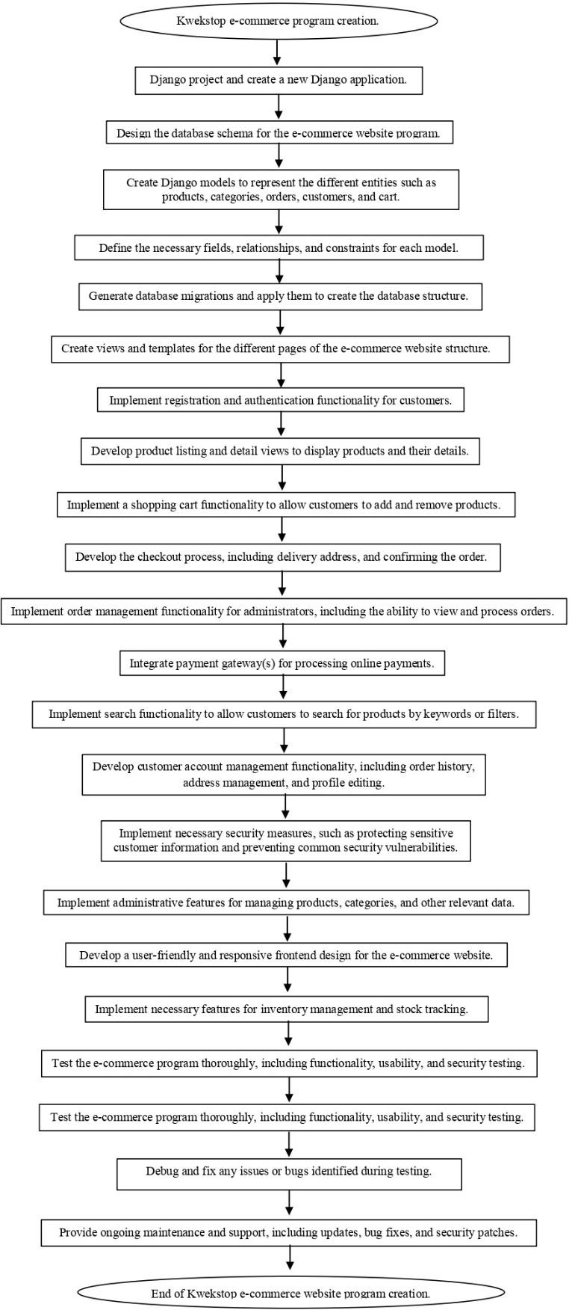**Development of the Website:**

## TESTING

### Functionality Testing:

* The website's navigation and ensuring all pages, links, and buttons are functioning correctly.
* The shopping cart functionality is working properly, allowing users to add, remove, and update items.
* The checkout process, including payment gateways and order confirmation have a small bug which needs fixing.
* The search bar functions correctly.
* The user registration and login features, including password reset and account management are well functioning.

### Content Testing:

* All textual content on the website like grammar, and spelling are accurate.
* The products information, pricing, and promotions are up-to-date.
* Multimedia elements (images, videos) are properly display and functioning. (Note: Some images are distorted, UI needs improvements.)

### Integration Testing:

* Verifies the interaction and integration between different modules or components of a software system.
* Ensures that the integrated components work together as expected.

### Usability Testing:

* Evaluates the user-friendliness and ease of use of a software application.
* Assesses how well users can navigate the system, complete tasks, and provide feedback on the user interface and overall user experience.

### Security Testing:

* Assess the e-commerce website's security measures and vulnerabilities.
* Verify the effectiveness of authentication and authorization mechanisms.

## MAINTENANCE

### Content Management:

* Update and manage product information, prices, and inventory levels regularly.
* Ensure accurate and up-to-date content, including product descriptions, images, and specifications.
* Add or remove product categories or sections as needed.
* Monitor and manage user-generated content, such as product reviews or comments.

### Regular Testing:

* Periodic testing to validate the website's functionality, including key features and workflows.
* Regression testing after updates or changes to ensure existing functionality has not been affected.
* Validate integrations with third-party services and ensure they are functioning as expected.

### Monitoring and Performance Optimization:

* Regularly monitoring of the website's performance, including page load times, server response times, and database queries.
* Identifying and resolving any performance bottlenecks or issues if any arise that may impact user experience.
* Optimizing website elements such as images, CSS, and JavaScript to improve load times.

### User Feedback and Continuous Improvement:

* Collect and analyze user feedback regarding the website's usability, features, and overall experience.
* Use user feedback to identify areas for improvement and prioritize enhancements.
* Continuously iterate and enhance the website based on user needs and market trends.

# RESULTS & DISCUSSION

These are the key features and systems that are integrated and manageable in using the Kwekstop e-commerce website.

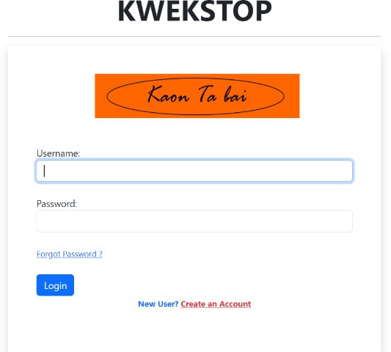

*Figure 1. Login page*

1. ***Login Page***: The purpose of the login page is to authenticate and grant access to users with existing accounts. Users provide their login credentials, such as username/email and password, to verify their identity. The login page ensures that only authorized users can access their personalized accounts and perform actions reserved for registered users. It enhances the security of user accounts by verifying the authenticity of login credentials and preventing unauthorized access.

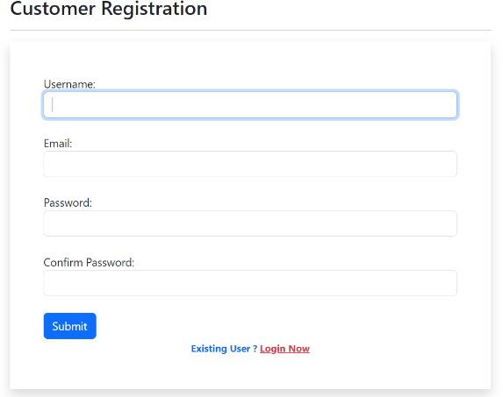

*Figure 2. Registration page*

1. ***Registration Page***: The purpose of the registration page is to allow new users to create accounts and join the e-commerce website. It provides a form where users can enter their relevant information, such as name, email, password, and additional details.

4. ***Home Page***: The home page is the main entry point for users and provides an overview of the website. It showcases featured products, promotions, or new arrivals to attract user attention. The home page may also include navigation menus, search functionality, and banners promoting key offers or categories.

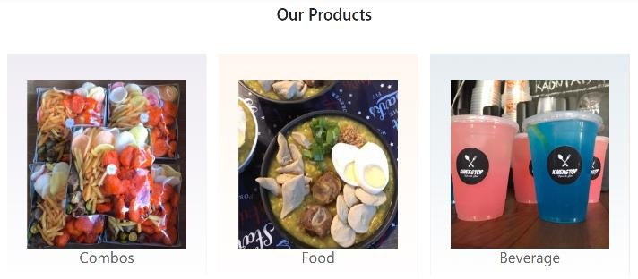

*Figure 5.1 Product Listing page*

The registration page often includes validation mechanisms to ensure data accuracy and to detect potential errors during the registration process. After successful registration, users gain the ability to log in and access personalized features, such as saving preferences, managing orders, and enjoying a seamless shopping experience.

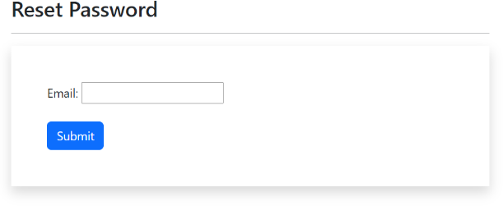

*Figure 3. Forgot Password*

3. ***Forgot Password***: The feature ensures that users have a reliable and secure method to recover access to their accounts when they forget their passwords. It helps maintain account security, prevents unauthorized access, and provides a convenient solution for users who experience password-related issues.

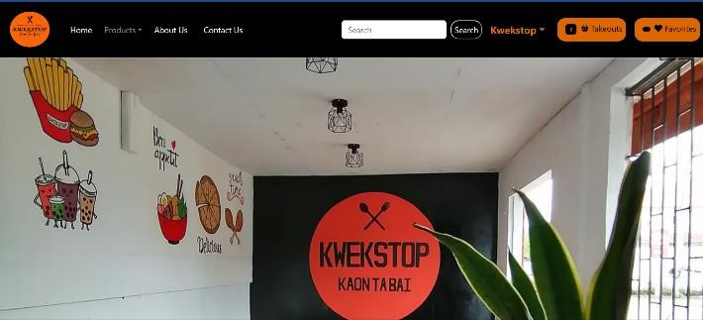

*Figure 4. Home Page*

*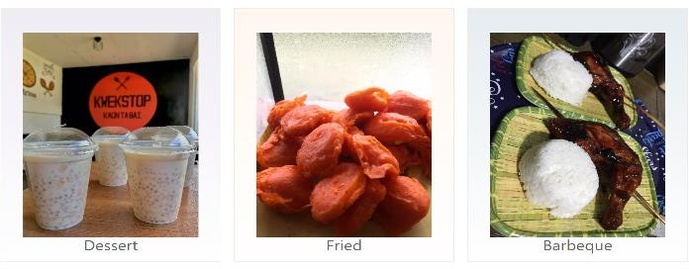Figure 5.2 Product Listing page*

5. ***Product Listing Page***: The product listing page displays a grid or list of products based on user-selected categories, search queries, or filters. It presents essential information such as product name, image, price, ratings, and short descriptions. Users can browse through the products, refine the displayed results using filters, and sort the products based on various criteria.

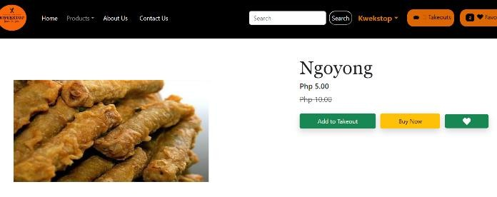

*figure 5.2 Product Details page*

1. ***Product Detail Page***: The product detail page provides comprehensive information about a specific product. It includes detailed product descriptions, additional images, specifications, available variations (e.g., sizes or colors), and customer reviews. Users can view multiple product images, read detailed descriptions, and make informed purchase decisions.

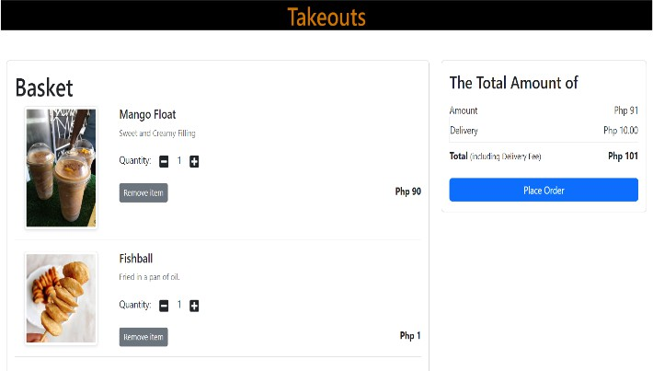

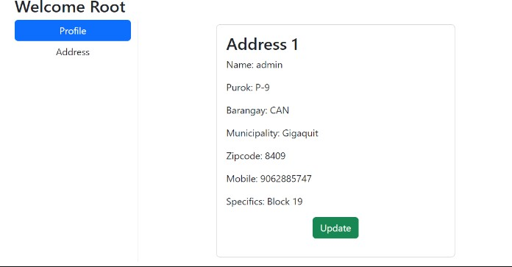

*figure 6. Add to Cart page*

1. ***Shopping Cart Page***: The shopping cart page displays the items selected by the user for purchase. It shows the product details, quantities, individual prices, and the subtotal of the items in the cart. Users can update quantities, remove items, apply coupon codes, or proceed to checkout from the shopping cart page.

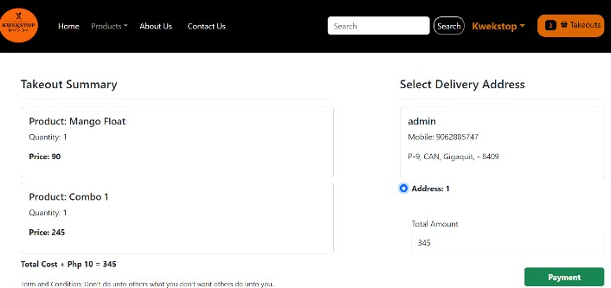

*figure 7. Checkout page*

1. ***Checkout Page***: The checkout page collects the necessary information to complete a purchase. It includes forms for billing and shipping addresses, payment method selection, and order summaries. Users provide their personal details, select shipping options, and enter payment information to finalize the purchase.

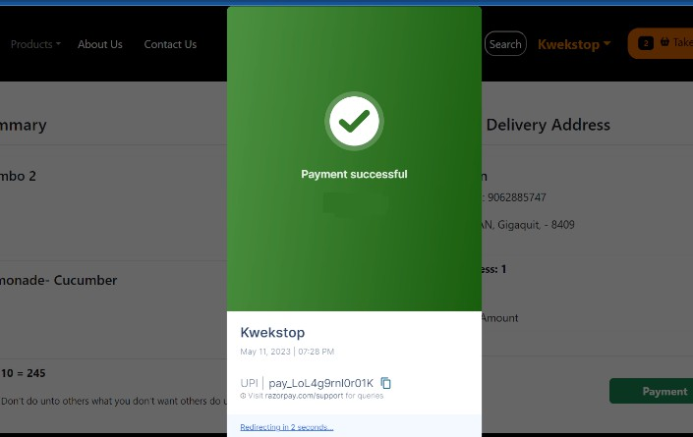

*figure 8. Checkout page*

1. ***Order Confirmation Page***: The order confirmation page is displayed after the successful completion of a purchase. It confirms the order details, including the order number, purchased items, shipping address, and payment information.

*figure 9. Add to Cart page*

1. ***User Account Page***: The user account page allows registered users to manage their account settings and view their order history. It provides options to update personal information, manage shipping addresses, and track the status of previous orders. Users can also view and manage saved payment methods, wish lists, or product reviews from their account page.

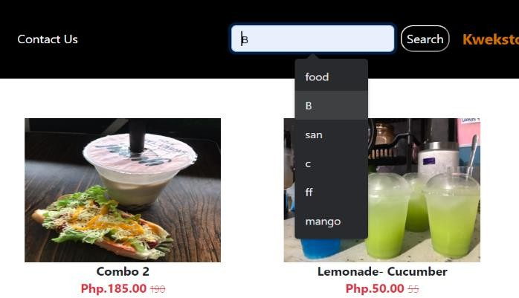

*figure 10. Search Result page*

1. ***Search Results Page***: The search results page displays products matching the user's search query. It shows a list of relevant products, often with filtering options to narrow down the results further. Users can refine their search or select a product from the results to view its details.

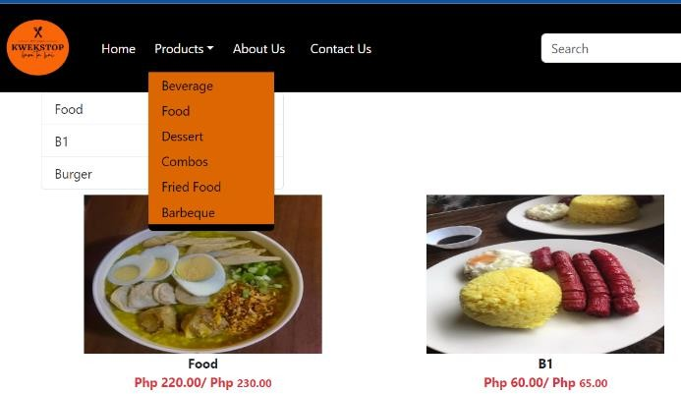

*figure 11. Category page*

1. ***Category Page***: Category pages display products grouped under specific categories or subcategories. They provide an organized view of products within a particular product category. Users can navigate through different categories, view product listings, and access relevant filtering options.

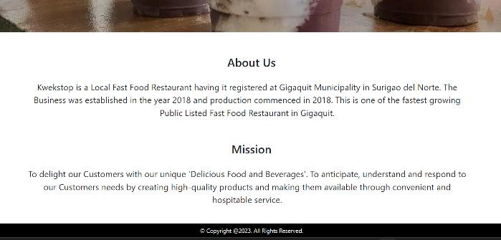*figure 12. About page*

1. ***About Us/Company Page***: The about us/company page provides information about the e-commerce business, its mission, history, and values. It may include details about the company's team, facilities, certifications, or awards. This page aims to build trust, establish credibility, and give users an understanding of the business behind the website.



*figure 13. Contact Us page*

1. ***Contact Us Page***: The contact us page provides users with methods to reach out to the website's support or customer service team. It includes contact details, such as email addresses, phone numbers, or a contact form. Users can ask questions, seek assistance, or provide feedback through the contact us page.

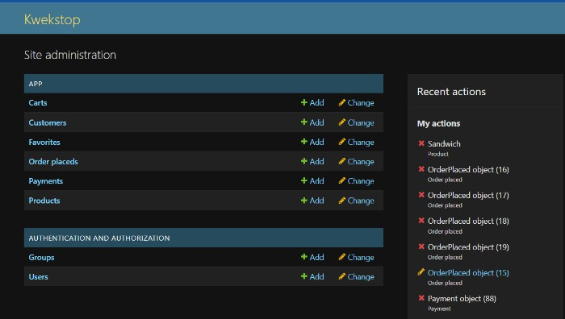

*figure 14. Administrator*

1. ***Administrator***: This serves as a management interface for administrators or website owners to control and manage various aspects of an e-commerce website. The purpose of the admin page is to provide an efficient and centralized platform for performing administrative tasks and maintaining the website's functionality.

### Product Management

* + The admin page enables administrators to manage the product catalog.
  + It allows them to add, edit, and remove products, along with their descriptions, images, pricing, and inventory information.

### Order Management

* + The admin page facilitates the management of customer orders and transactions.
  + Administrators can view and process orders, update order status, track shipments, and generate invoices or receipts.

### User Management

* + The admin page provides functionality to manage user accounts and customer data.

## DISCUSSION

During the Testing phase there are minor issues encountered by the developer, this includes the following:

### Payment Processing Issues

* + Payment gateway integration errors leading to failed or incomplete transactions.
  + Inconsistent handling of different payment methods or currencies.

### Product Catalog and Inventory Management

* + Displaying incorrect product information, such as prices, descriptions, or images.

### Cart and Checkout Problems

* + Inability to add products to the shopping cart or remove items from the cart.

### Performance and Loading Speed

* + Slow page loading times, resulting in a poor user experience.

The implementation of Kwekstop's e-commerce website has proven to be a transformative step for the fast-food restaurant. It has expanded the restaurant's online presence, improved customer convenience, and resulted in increased online sales. The website has enhanced operational efficiency, streamlined processes, and facilitated direct customer engagement. Though the website is still in its startup stage, the performance of the systems and functionality of each feature is well enough to handle customer transactions. The creation of the e-commerce website will enhance Kwekstop's overall performance and will meet the evolving needs of customers in the digital age.

# CONCLUSION

In conclusion, the Kwekstop e-commerce website is an excellent example of how fast-food restaurants can use technology and online services to enhance their operations and meet the needs of their customers. By providing a seamless and satisfying experience for customers, the website can become a valuable asset that drives growth, customer loyalty, and business success.

Moreover, the website's SWOT analysis highlights its strengths, weaknesses, opportunities, and threats, which can help the restaurant identify areas for improvement and potential areas of growth. By leveraging its strengths, such as fast and convenient service, extensive menu options, and strong brand recognition, the website can capitalize on its advantages to attract and retain customers. Meanwhile, by addressing its weaknesses, such as perceptions of unhealthy food and taking advantage of opportunities, such as expanding into new markets or introducing healthier menu options, the website can improve its customer satisfaction and grow its business.

# ACKNOWLEDGEMENT

We would like to express our heartfelt gratitude to all individuals and entities who have played a vital role in the development and success of Kwekstop's e-commerce website. Your support, dedication, and contributions have been instrumental in making our online presence a success. Thank you for being a part of our journey and for helping us bring the delicious flavors of our fast-food restaurant to customers wherever they may be.

# REFERENCES

Kwekstop (2018). Retrieved from Kwekstop facebok page (fast-food restaurant): *https://*[*www.facebook.com/kwkStp2018*](http://www.facebook.com/kwkStp2018)

S. Amir & S. Behroz (2018). The Effect of E-Commerce on SME Performance. *International Journal of Applied Research in Management and Economics.*INTL. J. APPL. Res. MANAGE. & ECON., 1 (2):71-81. https:/[/www.dpublication.com/wp-](http://www.dpublication.com/wp-) content/uploads/2018/09/ijarme-V1271-81.pdf

***“ Thank you for choosing Kwekstop for your fast food needs, and we look forward to serving you soon. “***