Explainable and Fair Credit Card Fraud Detection
Capstone Final Report
Postgraduate Diploma in Artificial Intelligence and Machine Learning

Author | Ryan Rey Corpin
Domain | Finance
Task | Transaction level fraud classification and risk ranking
Submission date | October 2026

Main conclusion The frozen model is a strong ranked review aid, capturing 92.54% of fraud cases and 98.61% of labelled fraud value within a 1% test-period review queue. Synthetic data, score calibration requirements, and confirmed subgroup disparities mean the evidence supports a governed shadow pilot, not automated customer-facing declines.

Contents
1 Executive summary
2 Problem framing
3 Data collection and understanding
4 Preprocessing exploratory analysis and feature engineering
5 Model implementation and evaluation
6 Explainability ethical analysis and fairness
7 Business value and deployment strategy
8 Limitations and conclusion
9 Reproducibility
10 References
Appendix A Data dictionary

1 Executive summary
This project develops an end-to-end machine-learning workflow for prioritising suspicious credit-card transactions. It covers problem framing, data quality, leakage-safe feature engineering, temporal validation, model comparison, calibration, final testing, model explanations, bias auditing, cost sensitivity, and deployment governance.
The public Sparkov benchmark contains 1,852,394 synthetic transactions and 9,651 labelled fraud cases. The evaluation design respects time: earlier transactions support development, a later block supports model selection, and the supplied future period is used once for the frozen final evaluation. Average precision is the primary metric because fraud prevalence is approximately one half of one percent.
Final test evidence | Result
PR AUC | 0.8584
Review policy | Assumed top 1% of period scores
Precision | 35.71%
Fraud case recall | 92.54%
Fraud value recall | 98.61%
Legitimate transactions reviewed | 3,573

The responsible-AI audit finds a 7.17 percentage-point gender true-positive-rate gap on the final test. Validation-derived group cutoffs reduce that gap out of time, but worsen other fairness measures and change workload. They are rejected. An illustrative cost model yields positive net benefit across the tested assumptions, but it excludes material implementation and governance costs and is not a production ROI forecast.

2 Problem framing

2.1 Business problem
A financial institution cannot investigate every transaction. Missed fraud creates direct loss, chargebacks, operational work, and customer harm, while unnecessary interventions delay legitimate activity and erode trust. The business question is therefore which transactions should enter a limited review queue so fraud capture rises without imposing excessive customer friction or unequal protection.

2.2 Data science formulation
The task is supervised binary classification at transaction level. The model produces a continuous risk score used to rank transactions. The primary target is is_fraud. The default decision scenario assumes analysts can review exactly the highest-scored 1% of a period; this is a workload assumption, not an optimized operating point. Review shares of 0.5% and 2% are reported as sensitivity cases. A production capacity must be selected prospectively using institutional staffing, recovery, and customer-friction estimates. Raw class-weighted scores are not treated as literal probabilities.
Measure | Role | Reason
Average precision | Primary model metric | Focuses on rare positive ranking
Precision at capacity | Review yield | Measures analyst efficiency and legitimate burden
Recall at capacity | Protection | Measures detected fraud cases
Fraud value recall | Financial exposure | Measures labelled fraudulent value captured
Brier and log loss | Calibration | Assess probability reliability
Group TPR and FPR | Fairness | Assess protection and service burden

2.3 Success criteria
- Beat a prevalence-aware dummy baseline on chronological validation and final test using PR-AUC.
- Demonstrate an explicit fraud-capture, review-yield, and workload trade-off.
- Report a transparent cost sensitivity rather than an unsupported ROI promise.
- Use raw scores only for ranking unless a separate later-slice calibration stage supports probability use.
- Document subgroup performance, limitations, mitigation trade-offs, and governance requirements.
- Make the full workflow reproducible from data instructions, source code, configurations, saved artefacts, and tests.

3 Data collection and understanding

3.1 Dataset and provenance
The project uses the Sparkov Credit Card Transaction Fraud Dataset distributed publicly on Kaggle. It includes transaction time, amount, merchant and category context, cardholder location and demographics, merchant location, and a binary fraud label. The records are synthetic; benchmark results must not be interpreted as evidence of performance at a real financial institution. Raw files are retained unchanged and verified with SHA-256 hashes.
File | Rows | Fraud cases | Fraud rate | Period
fraudTrain.csv | 1,296,675 | 7,506 | 0.5789% | Jan 2019 to Jun 2020
fraudTest.csv | 555,719 | 2,145 | 0.3860% | Jun 2020 to Dec 2020
Total | 1,852,394 | 9,651 | 0.5210% | Jan 2019 to Dec 2020

3.2 Data quality findings
- No missing values, invalid target values, duplicated transaction IDs, or cross-file transaction-ID overlap were found.
- No non-positive transaction amounts or invalid geographic coordinates were found.
- Extreme transaction amounts are valid observations and are retained because high value is materially related to fraud risk.
- The test-period prevalence is lower than training prevalence, reinforcing the need for temporal evaluation and drift monitoring.
- Direct identifiers such as names, street, transaction number, and card number are excluded from primary models.
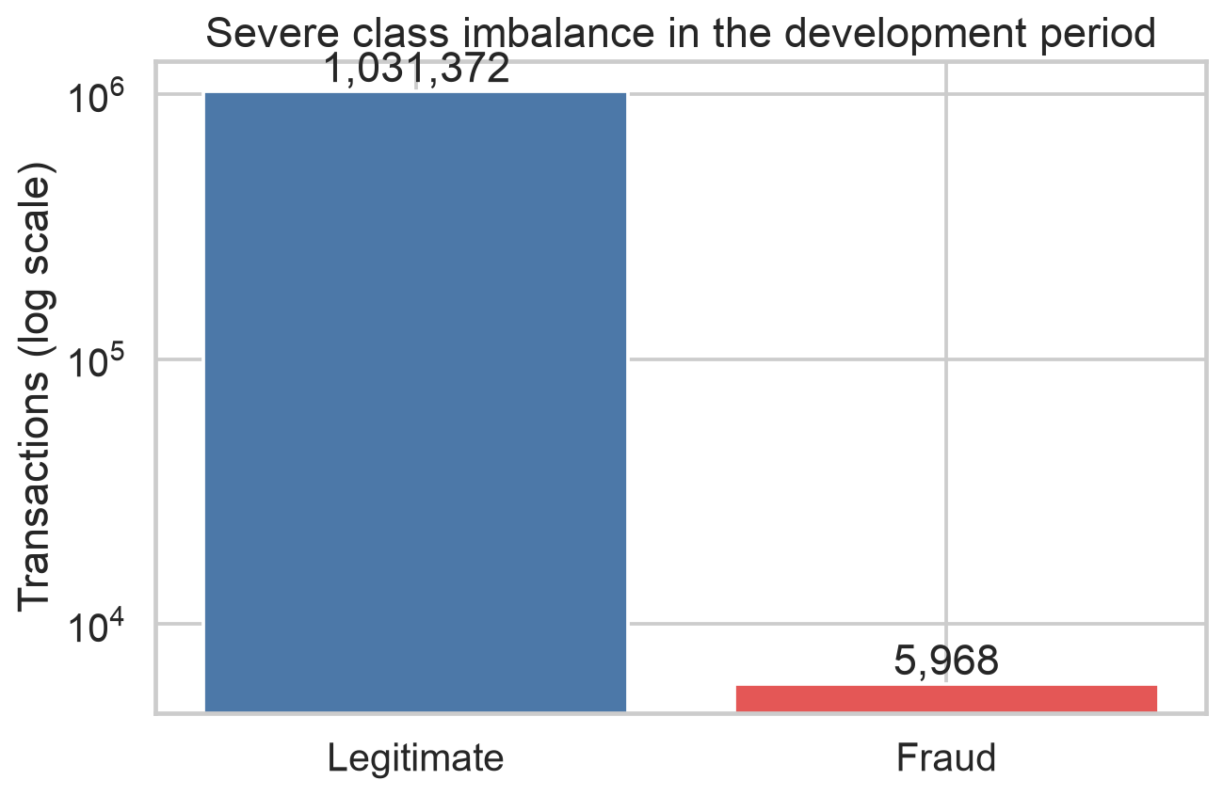
Figure 1 Class imbalance in the development data

4 Preprocessing exploratory analysis and feature engineering

4.1 Cleaning and preprocessing
No valid row is removed merely because it is statistically extreme. Numeric variables use log or cyclic transformations where appropriate. Low-cardinality categoricals are one-hot encoded; high-cardinality merchant, city, ZIP, and occupation values are frequency encoded using mappings fitted only on the development period. Numeric inputs are standardised for scale-sensitive branches.

4.2 Domain features and leakage controls
- Log amount and amount bands capture nonlinear transaction value effects.
- Cyclical hour and weekday features preserve temporal proximity.
- Customer-to-merchant distance captures unusual geographic context.
- Strict-past card counts, elapsed time, mean amount, and amount-to-history ratio describe behavioural deviation.
- Strict-past merchant and card-category counts describe experience without using future events.
- Transactions sharing the same timestamp never contribute history to one another.
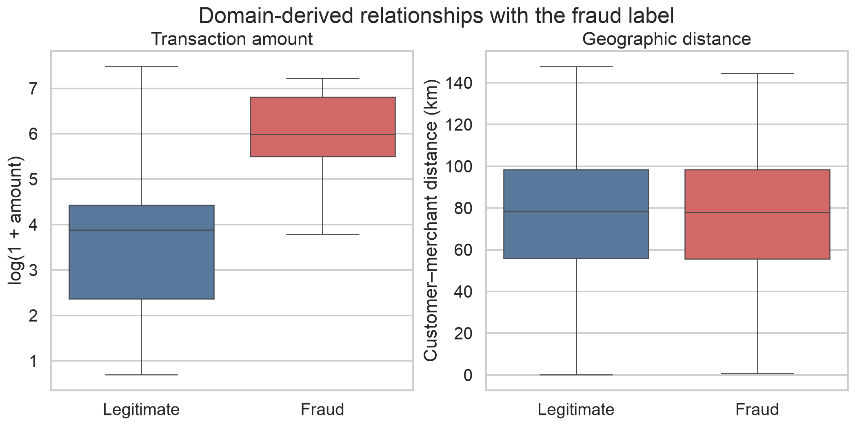
Figure 2 Relationships for selected engineered features

4.3 Applied exploratory analysis
Fraud is not distributed uniformly across operational context. Development-period fraud activity concentrates during late-night and early-morning hours, especially around 22:00 to 03:00. Merchant categories also differ materially: shopping_net has the highest observed rate at 1.7558%, followed by misc_net at 1.4594% and grocery_pos at 1.4037%. These are descriptive associations rather than causal fraud drivers.
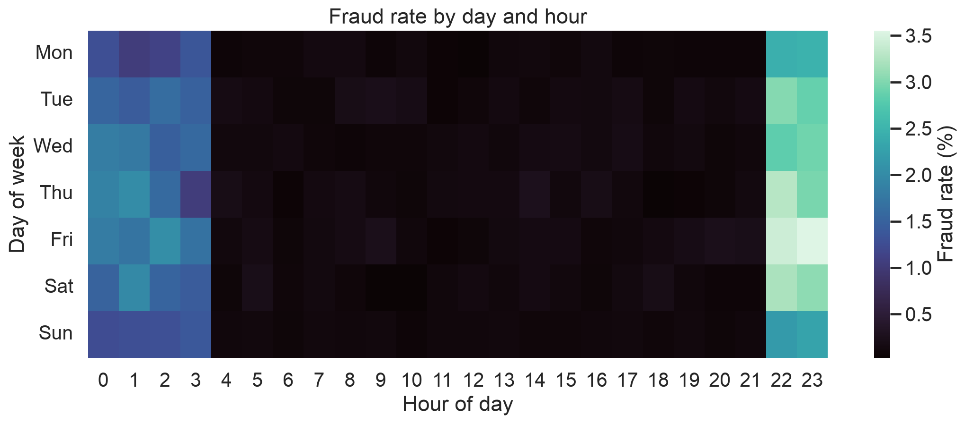
Figure 3 Fraud prevalence by day and transaction hour
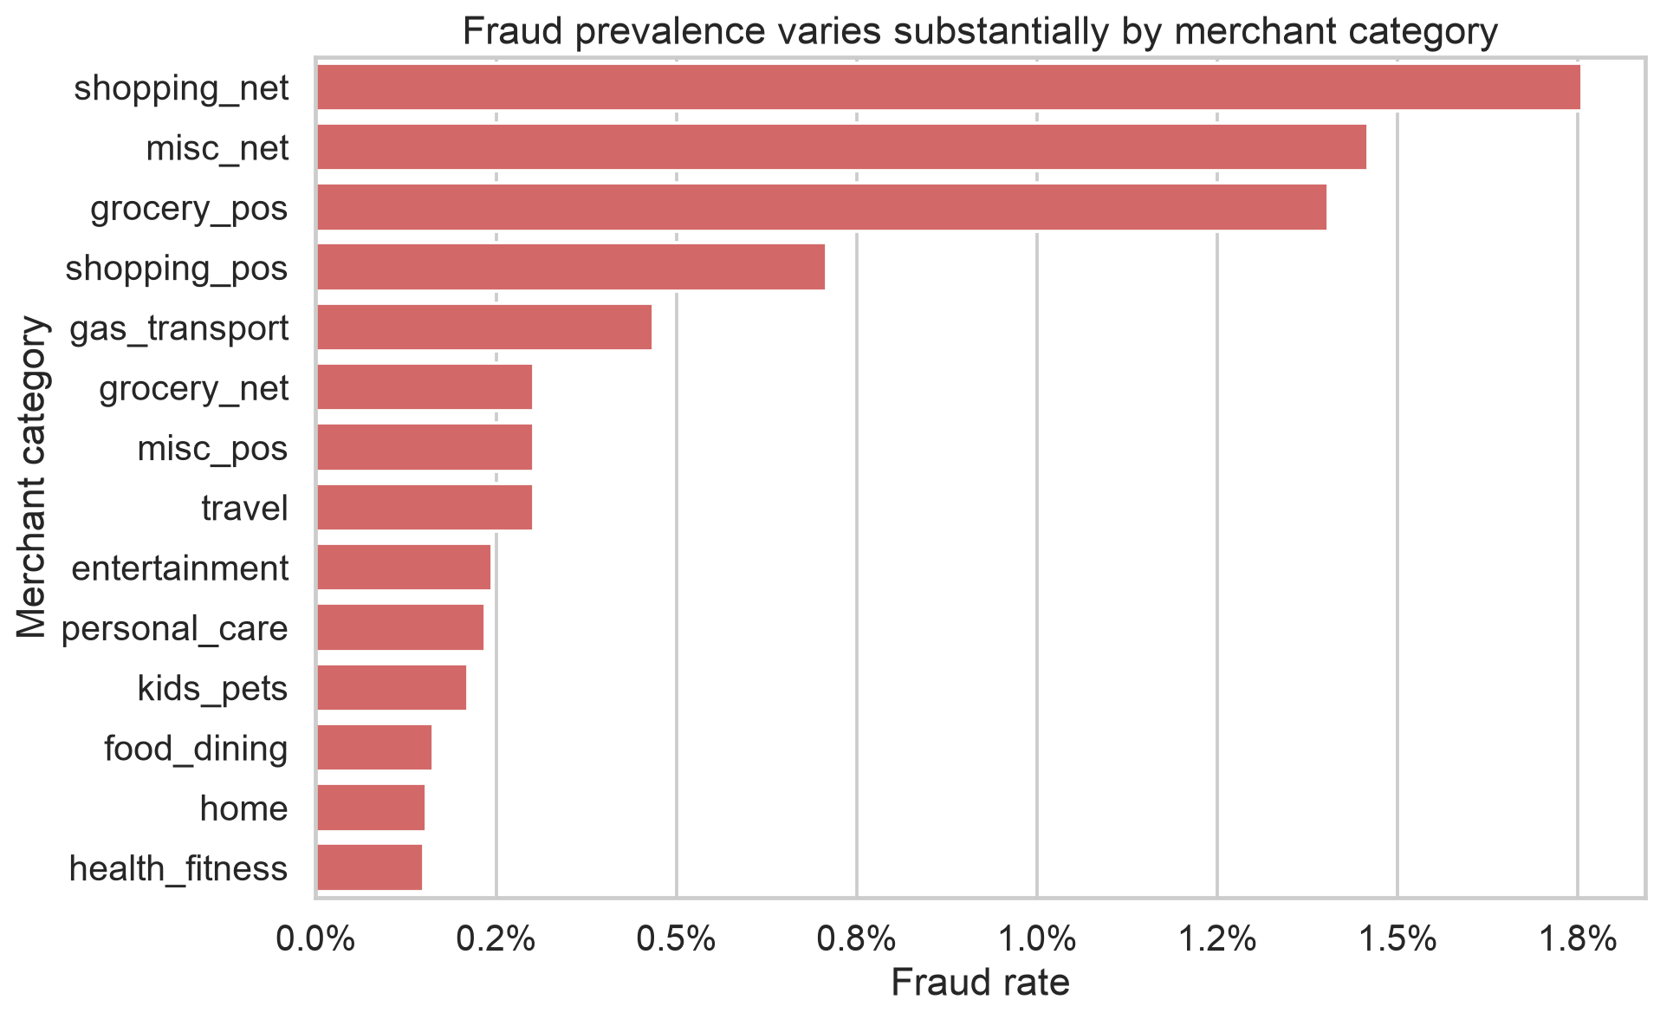
Figure 4 Fraud prevalence by merchant category

4.4 Selection and dimensionality reduction
Mutual information provides the required filter-selection method and identifies amount, time, behavioural deviation, geography, and frequency signals. A later controlled ablation shows that all 98 encoded engineered features outperform the selected 25 on outer validation (PR-AUC 0.9166 versus 0.8906). The selected branch remains useful for interpretation and compactness, but feature removal is not claimed to improve prediction.
PCA is used as the required dimensionality-reduction diagnostic. Thirteen of 20 numeric components are needed for 95% variance and the first two components show substantial class overlap. A PCA modelling branch is rejected because compression is limited, categorical signals would be discarded, and model explanations would become less actionable.
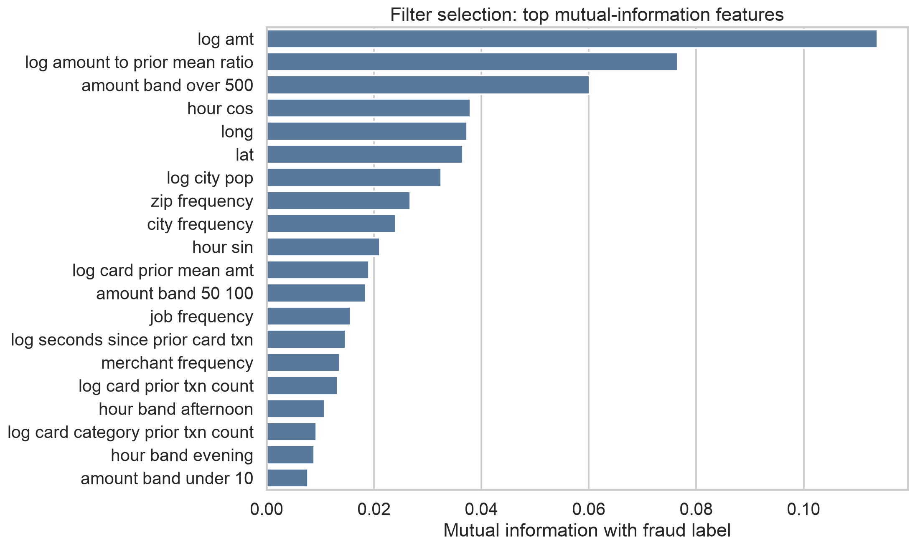
Figure 5 Mutual information ranking on the development period

5 Model implementation and evaluation

5.1 Model comparison
Eight initial candidates use an identical chronological split and feature branch: dummy prior, two logistic regressions, two decision trees, random forest, and two histogram gradient-boosting models. Balanced class weights make rare fraud consequential during fitting without resampling the validation distribution. Flexible histogram boosting leads the comparison.
Model | Validation PR AUC | Validation ROC AUC
Histogram boosting flexible | 0.8914 | 0.9968
Histogram boosting conservative | 0.8793 | 0.9969
Random forest | 0.8338 | 0.9931
Decision tree depth 12 | 0.8008 | 0.9710
Logistic regression | 0.3520 | 0.9601
Dummy prior | 0.0059 | 0.5000

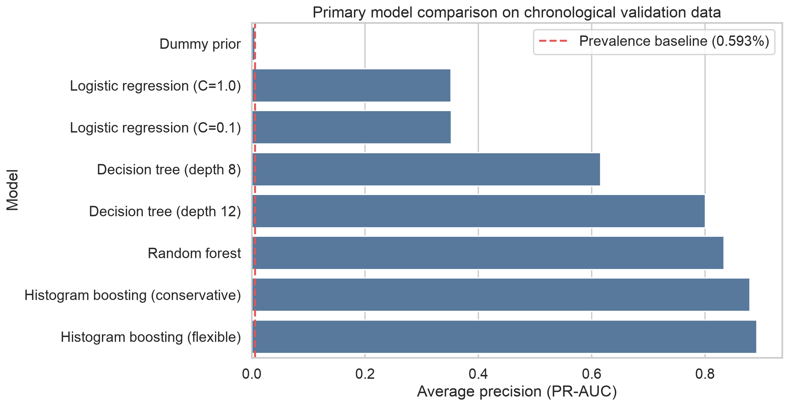
Figure 6 Original Step 4 comparison using 25 features; flexible HGB PR AUC 0.8914

5.2 Reviewer-driven tuning and representation ablation
To strengthen tuning, the development period is divided chronologically into 829,872 inner-training and 207,468 inner-tuning transactions. Four randomized configurations are sampled for each of random forest and histogram boosting, with the prespecified flexible booster added as a reference. The outer validation period is not used during search. Early stopping is disabled, removing reliance on a random internal holdout. The search independently selects the original flexible boosting capacity.
The values below use the reviewer-enhancement rerun protocol. Under that protocol the retuned 25-feature model scores 0.8906, while the 98-feature model scores 0.9166. The nearby 0.8914 value belongs to the original Step 4 25-feature experiment and is labelled separately so the three validation results are not treated as interchangeable.
Representation | Features | PR AUC | Precision at 1% | Recall at 1% | Value recall
Full engineered | 98 | 0.9166 | 55.28% | 93.24% | 97.66%
Mutual information | 25 | 0.8906 | 54.01% | 91.09% | 96.82%

The full representation is the stronger future candidate. It is not retroactively substituted into the locked test claim because the test period had already been opened. Promotion requires genuinely new out-of-time data. This distinction preserves the audit trail and avoids repeated test-set selection.

5.3 Calibration
An isotonic mapping is fitted only on the later inner-development slice and assessed on outer validation. Brier loss improves from 0.002244 to 0.001654 and log loss from 0.009177 to 0.007019, while PR-AUC decreases from 0.8775 to 0.8669 because tied calibrated values slightly disturb ranking. Raw scores remain appropriate for a fixed-capacity queue; calibrated values may support probability-based decisions only with current-period calibration monitoring.

5.4 Final test evaluation
The frozen 25-feature winner is refitted on all 1,296,675 training transactions and evaluated once on 555,719 later test transactions. Strict-past features for the test period include earlier training history but never future activity. The test period is not used for hyperparameter, feature, threshold, or calibration selection.
Review share | Reviewed | Precision | Fraud recall | Fraud value recall
0.5% | 2,779 | 65.67% | 85.08% | 95.78%
1.0% | 5,558 | 35.71% | 92.54% | 98.61%
2.0% | 11,115 | 18.48% | 95.76% | 99.27%

At 1% capacity the queue contains 1,985 fraud cases and 3,573 legitimate transactions, while 160 fraud cases remain outside review. The cutoff is period-relative: the top 1% are ranked using test scores without labels. Its score cutoff is 0.4692 versus 0.5782 on validation, which reflects distribution shift rather than label leakage.
Precision falls from 54.24% on validation to 35.71% on the final test largely because fraud prevalence falls from 0.5931% to 0.3860%. At a fixed 1% review share, final-test precision cannot exceed 38.60%, even with perfect ranking. The observed 35.71% therefore achieves about 92.5% of that prevalence-implied ceiling, comparable with approximately 91.5% on validation. The 1% share remains an assumed analyst capacity rather than a cost-optimized choice.
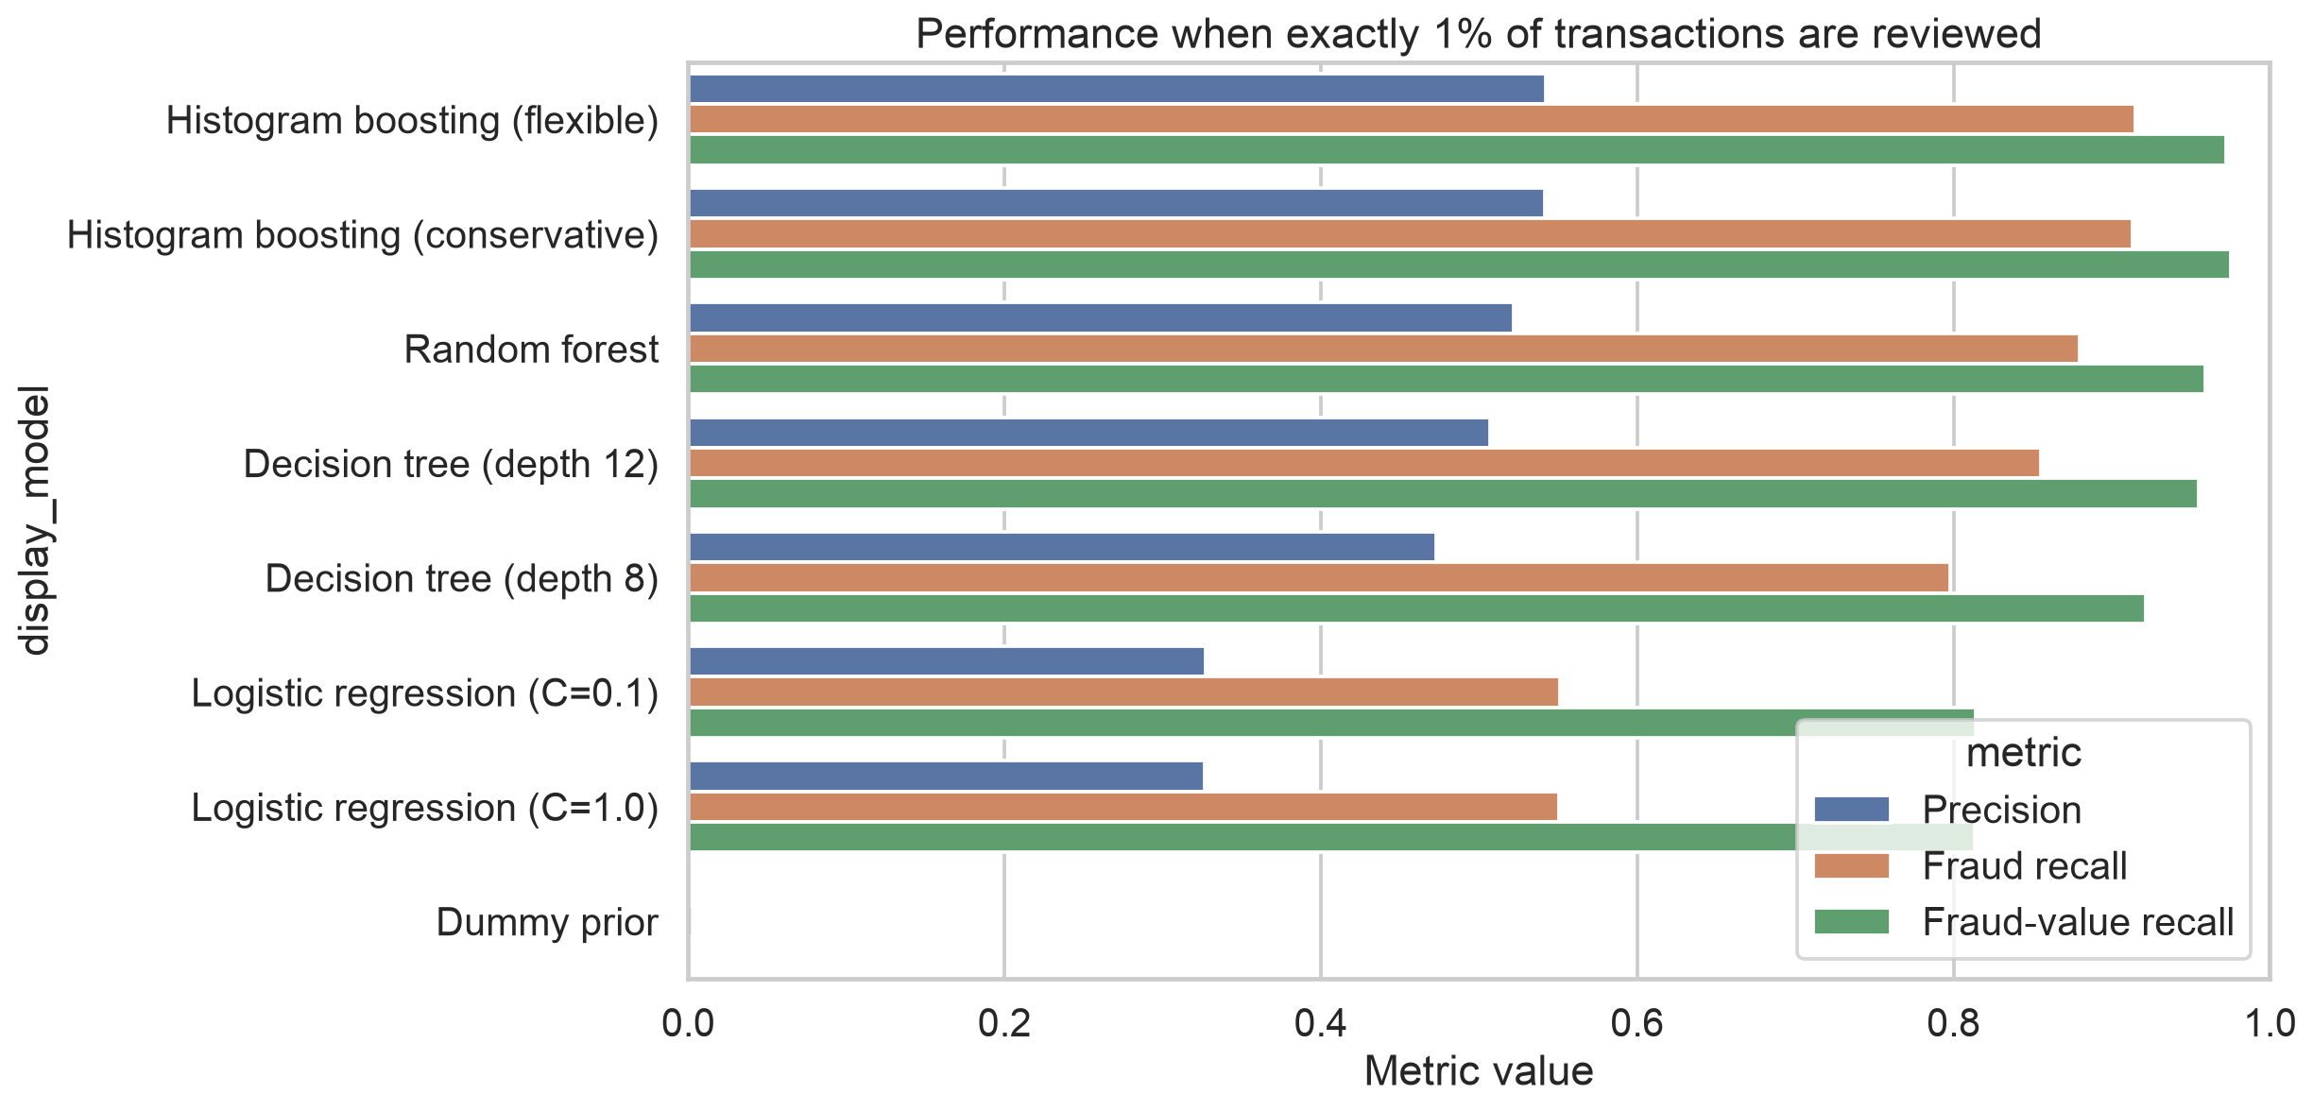
Figure 7 Validation operating comparison at an assumed 1 percent review capacity

6 Explainability ethical analysis and fairness

6.1 Model explanations
TreeSHAP, partial dependence, ICE, and local explanations describe how the selected model uses its inputs. Transaction amount is the dominant global contribution, followed by merchant and ZIP frequency, time of day, and prior card behaviour. These explanations describe model behaviour rather than causal fraud drivers. Frequency and geographic features may encode proxy effects and require monitoring.
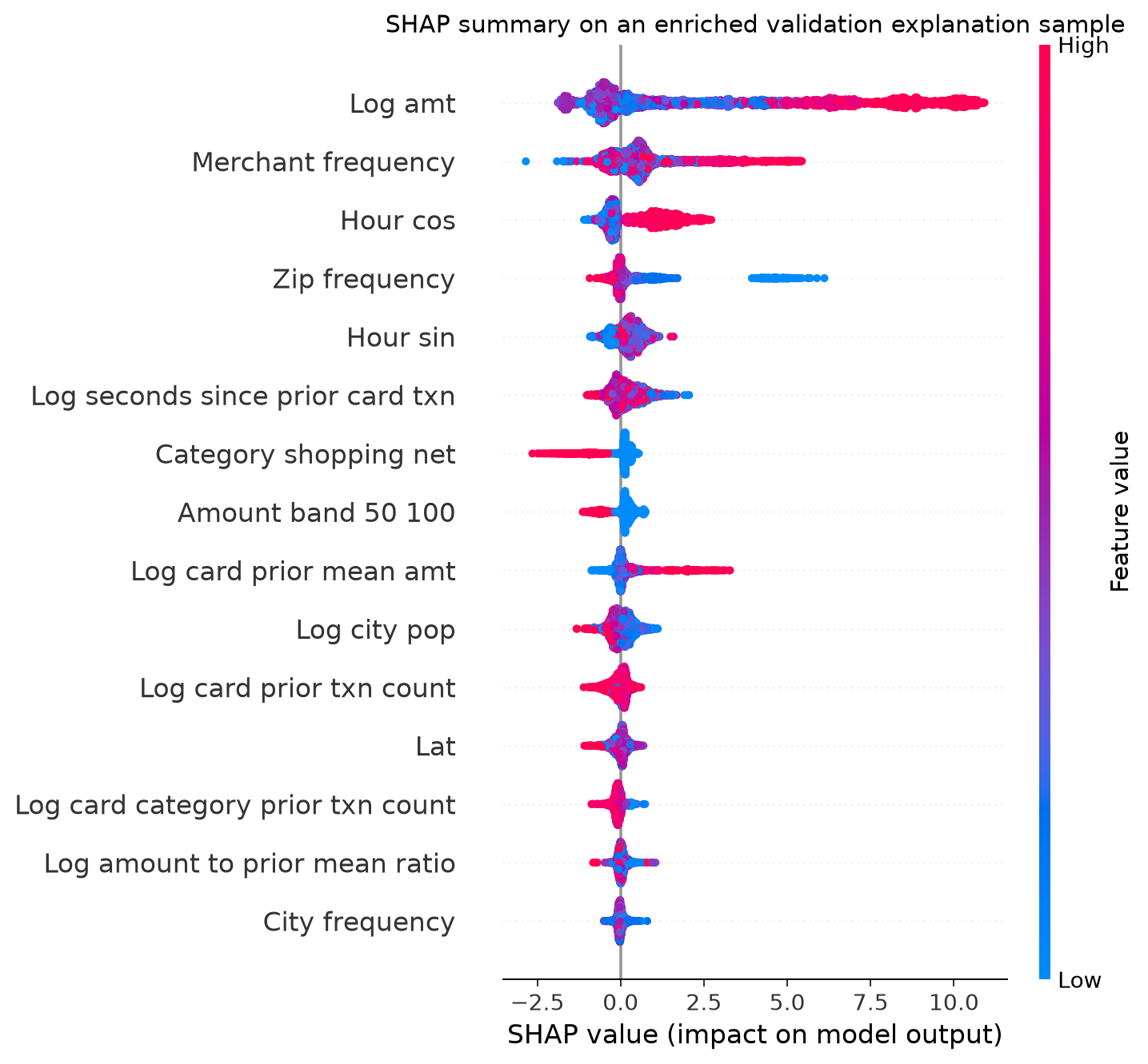
Figure 8 TreeSHAP summary on an enriched validation explanation sample

6.2 Bias audit
Gender and age are excluded from model inputs but retained for auditing. At the final-test 1% queue, female-cardholder fraud recall is 89.26% and male-cardholder fraud recall is 96.43%, a 7.17 percentage-point gap. Female transactions also experience a higher false-positive rate. Eligible validation gender-age intersections span 69.00% to 97.32% recall. Race and valid socioeconomic status are absent, so those audits cannot be claimed; city population is not treated as socioeconomic status.
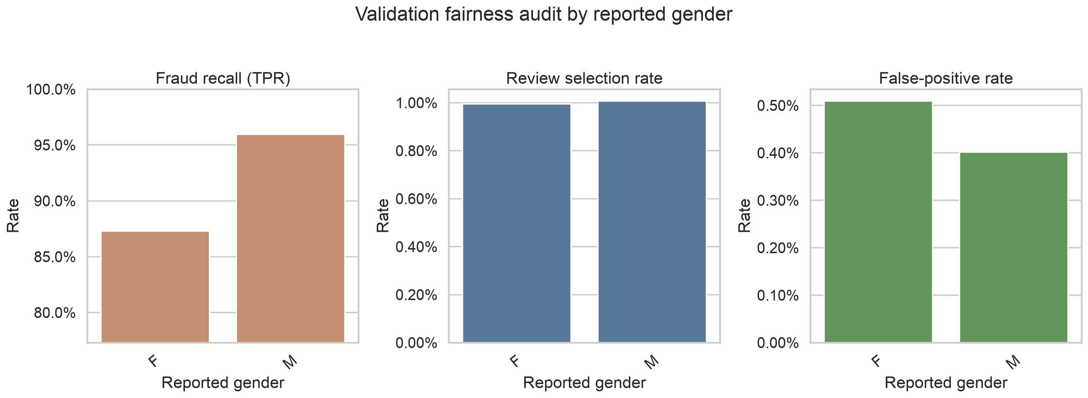
Figure 9 Validation gender audit at an assumed 1 percent review capacity

6.3 Mitigation experiments
Policy | Precision | Recall | Value recall | Gender TPR gap | DP ratio
Global test top 1% | 35.71% | 92.54% | 98.61% | 7.17 pp | 0.898
Validation-derived group cutoffs | 42.01% | 90.44% | 97.14% | 1.08 pp | 0.405

The validation-derived equal-opportunity cutoffs reduce the test TPR gap, but overall recall and fraud-value recall fall, review capacity changes, demographic parity worsens, and gender precision and false-positive gaps widen. Group-specific treatment may also be institutionally or legally unacceptable. The policy is rejected. Training-time representation, data quality, and governance investigation should precede threshold manipulation.

7 Business value and deployment strategy

7.1 Illustrative financial sensitivity
The 1% test queue captures USD 1,117,603.70 of USD 1,133,324.68 in labelled fraud value. Under the base assumptions of 70% recovery, USD 5 per review, and USD 10 false-positive friction cost, avoided loss is USD 782,322.59, modeled operating and friction cost is USD 63,520, and net benefit is USD 718,802.59. The benefit-cost ratio is 12.32.
The 1% queue is retained as an assumed workload, not the cost-optimal choice. Under the base assumptions, estimated net benefit is USD 736,379 at 0.5% compared with USD 718,803 at 1%, and 0.5% performs best in 24 of the 27 tested scenarios. Because these comparisons use final-test labels, they are descriptive and must not be used to retune the frozen policy. A production queue should be chosen prospectively on new institutional data.
Sensitivity input | Range
Fraud value recovery | 50% to 90%
Review cost | USD 2 to USD 10
False-positive friction | USD 5 to USD 25
Net benefit across 27 scenarios | USD 413,897 to USD 976,862

This scenario excludes model build, integration, infrastructure, monitoring, governance, legal review, customer lifetime impact, and reputational cost. The dataset is synthetic. These values illustrate how assumptions interact; they are not a production ROI forecast.

7.2 Recommended phased approach
Phase | Action | Gate
Offline | Validate on real historical data and confirm labels and costs | Performance, calibration, subgroup evidence
Shadow | Score live traffic with no customer action | Drift, workload, queue quality, incidents
Human review pilot | Use a limited queue with analyst oversight | Recovery, burden, appeals, fairness
Controlled scale | Expand only after independent approval | All agreed gates pass with rollback ready

7.3 Required controls
- No automated declines during early phases; preserve human review and proportionate challenge.
- Provide customer appeal, correction, override, and incident processes.
- Monitor PR-AUC, fraud and value recall, review yield, workload, calibration, drift, and subgroup gaps.
- Require privacy, security, retention, compliance, and model-risk approval before customer impact.
- Define stop conditions and a tested rollback path before controlled scale.

8 Limitations and conclusion

8.1 Limitations
- Synthetic transactions may reproduce simulator rules and may not represent real fraud, customers, merchants, or adversarial adaptation.
- The fixed review capacities are analytical scenarios, not confirmed staffing limits.
- The original locked test belongs to the 25-feature model; the stronger 98-feature candidate lacks a fresh independent test period.
- Isotonic calibration improves proper scoring losses but requires ongoing monitoring and can reduce ranking resolution through ties.
- Observed gender and age disparities do not establish their cause. Race and socioeconomic audits remain unavailable.
- Cost sensitivity omits material implementation, governance, and long-term customer costs.

8.2 Conclusion
The capstone demonstrates a complete and reproducible machine-learning lifecycle for rare-event fraud ranking. Histogram gradient boosting substantially outperforms prevalence and linear baselines, and the frozen model remains strong on a later test period. At a 1% queue it detects 92.54% of fraud cases and 98.61% of labelled fraud value.
The same evidence prevents an unconditional deployment recommendation. Performance changes over time, the scores require managed calibration for probability use, the data is synthetic, and the gender audit identifies unequal protection. The appropriate decision is a time-boxed, governed shadow pilot using real institutional data, human oversight, explicit fairness and workload gates, and no automated declines.

9 Reproducibility
The repository separates raw and processed data, source modules, configuration, notebooks, models, tests, reports, figures, presentations, and final submission artefacts. Random seed 42, chronological split boundaries, package versions, selected feature order, model parameters, metrics, and SHA-256 model manifests are recorded.
Workflow | Command
Install dependencies | .venv/bin/python -m pip install -r requirements.txt
Profile data | .venv/bin/python -m src.data_profile --project-root .
Run Step 3 | .venv/bin/python -m src.step3_analysis --project-root .
Run Step 4 | .venv/bin/python -m src.step4_modeling --project-root .
Run enhancements | .venv/bin/python -m src.step4_enhancements --project-root .
Run Step 5 | .venv/bin/python -m src.step5_fairness --project-root .
Run tests | .venv/bin/python -m unittest discover -s tests -v

The supplied final test evaluation is intentionally not included in a routine all-steps command. Its existing artefacts form the audit record of the one-time frozen evaluation.

10 References
Kaggle. Fraud Detection Sparkov Credit Card Transaction Fraud Dataset. https://www.kaggle.com/datasets/kartik2112/fraud-detection
Pedregosa F et al. Scikit learn Machine Learning in Python. Journal of Machine Learning Research 12 2011 2825 to 2830.
Lundberg S and Lee S. A Unified Approach to Interpreting Model Predictions. Advances in Neural Information Processing Systems 2017.
Barocas S Hardt M and Narayanan A. Fairness and Machine Learning. fairmlbook.org 2023.

Appendix A Data dictionary
The dictionary below documents every raw variable supplied in the Sparkov files. Identifiers and protected audit attributes are distinguished from predictive inputs so that exclusions and audit uses remain explicit.
Variable | Role and type | Format or range | Description
Unnamed: 0 | raw row index; integer identifier | sequential integer; 0 to rows_in_file - 1 | CSV export index; not a predictive feature and will be removed.
trans_date_trans_time | predictor / ordering; datetime | YYYY-MM-DD HH:MM:SS; observed dataset period | Transaction timestamp used for chronological splitting and temporal features.
cc_num | entity identifier; integer identifier | card number; synthetic card identifiers | Synthetic cardholder account identifier; excluded as a raw model feature but usable to construct past-only behavior.
merchant | predictor; categorical string | merchant name; observed merchant categories | Synthetic merchant associated with the transaction.
category | predictor; categorical string | merchant category; observed category labels | Type of goods or services associated with the merchant.
amt | predictor / value KPI; continuous numeric | US dollars; non-negative transaction amount | Monetary value of the transaction.
first | direct identifier; categorical string | given name; synthetic names | Synthetic cardholder first name; excluded from modelling.
last | direct identifier; categorical string | family name; synthetic names | Synthetic cardholder last name; excluded from modelling.
gender | protected audit attribute; binary categorical | category; F, M | Synthetic cardholder gender; retained for fairness auditing only and excluded from model inputs.
street | direct identifier; categorical string | street address; synthetic addresses | Synthetic cardholder street address; excluded from modelling.
city | predictor / quasi-identifier; categorical string | city name; observed cities | Cardholder home city; evaluated carefully because geography may proxy demographic characteristics.
state | predictor / quasi-identifier; categorical string | US postal abbreviation; observed state abbreviations | Cardholder home state.
zip | predictor / quasi-identifier; categorical integer | US ZIP code; observed synthetic ZIP codes | Cardholder home ZIP code; treated as categorical, not continuous.
lat | predictor; continuous numeric | decimal degrees; -90 to 90 | Latitude of the cardholder location.
long | predictor; continuous numeric | decimal degrees; -180 to 180 | Longitude of the cardholder location.
city_pop | predictor; non-negative integer | people; non-negative population | Population of the cardholder city.
job | predictor / quasi-identifier; categorical string | occupation title; observed occupation labels | Synthetic cardholder occupation; assessed for proxy-bias risk.
dob | protected-feature source; date | YYYY-MM-DD; date before transaction timestamp | Synthetic date of birth; converted to age at transaction for analysis and fairness auditing.
trans_num | transaction identifier; categorical string | 32-character hexadecimal identifier; synthetic unique transaction IDs | Transaction identifier used for integrity checks; excluded from modelling.
unix_time | ordering / derived-feature source; integer timestamp | seconds since Unix epoch; observed dataset period | Machine-readable transaction time; redundant with the human-readable timestamp.
merch_lat | predictor; continuous numeric | decimal degrees; -90 to 90 | Latitude of the merchant location.
merch_long | predictor; continuous numeric | decimal degrees; -180 to 180 | Longitude of the merchant location.
is_fraud | target; binary integer | class label; 0 = legitimate, 1 = fraudulent | Ground-truth transaction fraud label.

