Lab 1 – The Internet Protocols
Name: Reem Rashid Alharbi ID: 421201722
Git repository : https://github.com/rre1m/Reem_Rashid_Alharbi_web
Part 1: Capturing HTTP Traffic
Task 2: HTTP packets (filter: http)
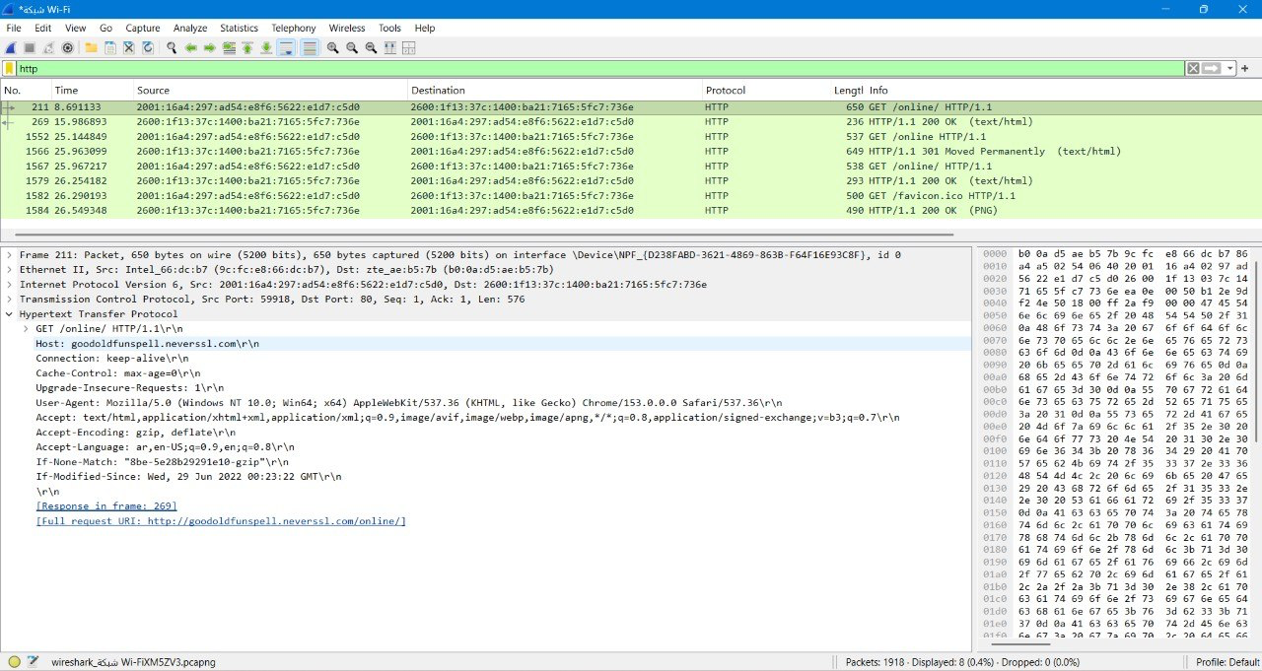
Figure 1: HTTP packets captured while browsing neverssl.com (filter: http), showing the GET request and the 200 OK response.
Observation: the client sends GET /online/ using HTTP/1.1 and the server replies with 200 OK (text/html). A request to /online returned 301 Moved Permanently, and the browser then requested /favicon.ico.
Part 2: Analyzing TCP/IP Traffic
Task 1: Follow TCP Stream
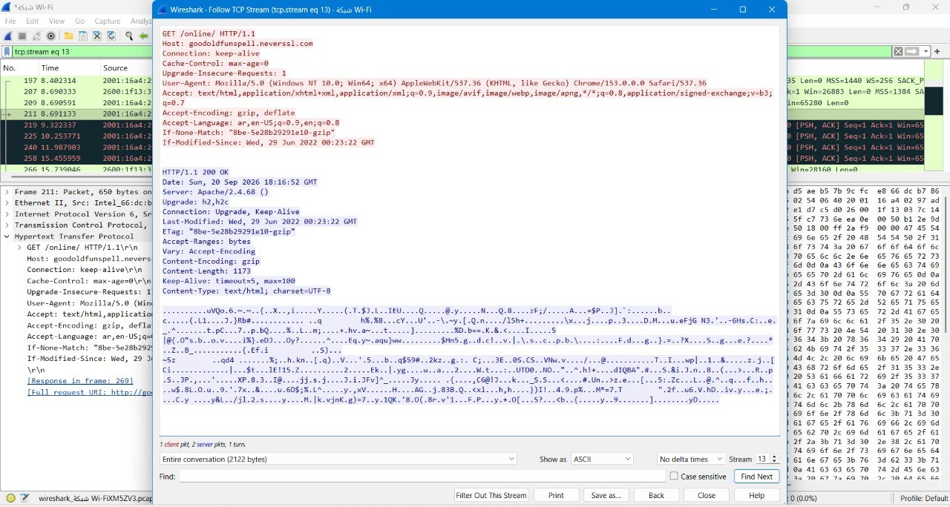
Figure 2: Follow → TCP Stream of the HTTP conversation (tcp.stream eq 13).
Observation: the window shows the whole conversation between the client and the server: the HTTP request followed by the HTTP response.
Task 2: TCP three-way handshake, data transfer and termination
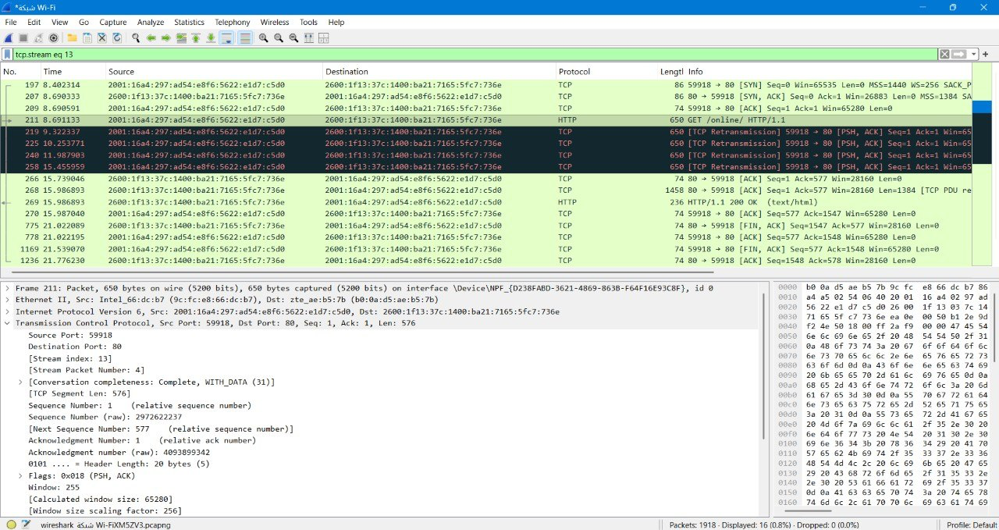
Figure 3: TCP stream 13 (filter: tcp.stream eq 13): handshake, data transfer and termination.
Observation: handshake = packet 197 SYN (Seq=0), packet 207 SYN-ACK (Seq=0, Ack=1), packet 209 ACK (Seq=1, Ack=1). Data = packet 211 GET request (Len=576) and packet 269 HTTP 200 OK. Termination = FIN, ACK packets followed by ACK from the other side.
Figure 4: TCP header details of the SYN packet: Sequence Number and Acknowledgment Number.
Observation: the SYN packet starts with a relative sequence number of 0. The server acknowledges it with Ack=1, and the client confirms with Seq=1, Ack=1.
Part 3: Capturing and Analyzing UDP Traffic
Task 2: UDP packets (filter: udp)
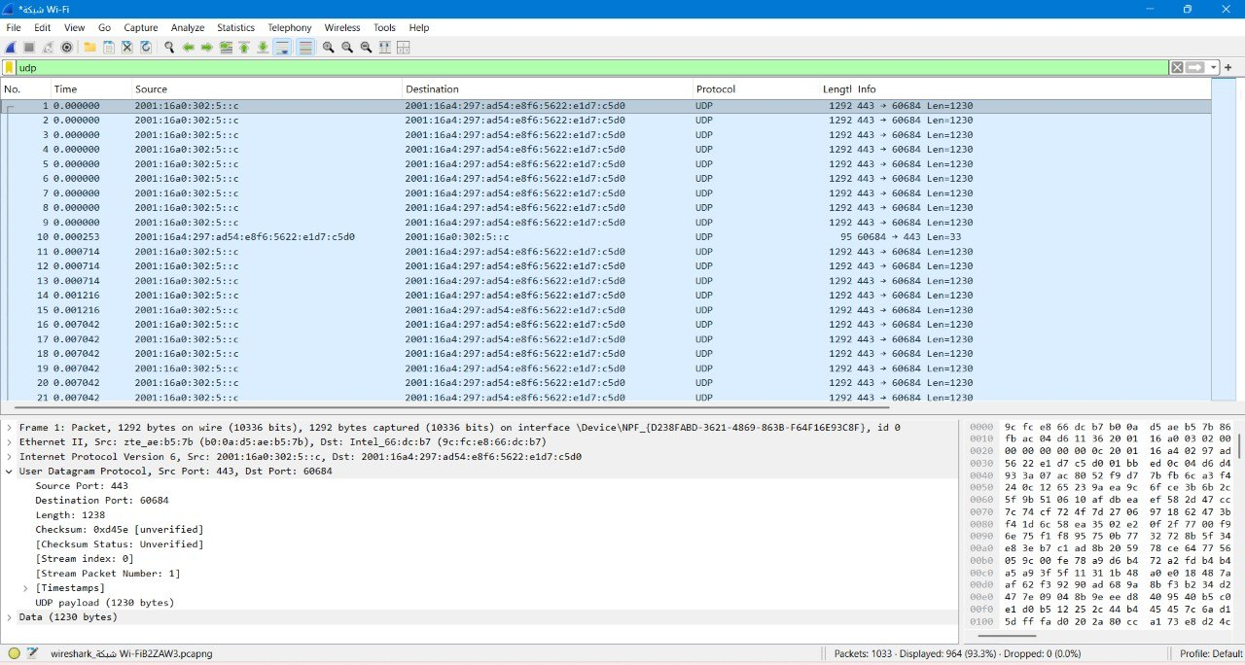
Figure 5: UDP packets captured (filter: udp)
Observation: source port 443, destination port 60684, packet length 1238 bytes, and 1230 bytes of data.
Part 4: Comparing TCP and UDP
Task 1: Fill in the following table and provide reasons.
 | TCP or UDP | Reasons
Reliability and Connection Establishment | TCP | - TCP is reliable and connection-oriented: it opens a connection with a three-way handshake (SYN, SYN-ACK, ACK) before any data is sent. In my capture this appears in packets 197, 207 and 209.  - It uses acknowledgments and retransmission: when an ACK did not arrive, the client re-sent the GET request (the black [TCP Retransmission] packets).  - UDP, by contrast, is connectionless: it has no handshake and no acknowledgments, so delivery is not guaranteed.
Data Integrity and Ordering | TCP | - TCP numbers every byte with a sequence number and the receiver confirms it with an acknowledgment number (e.g. Seq=577, Ack=1547), so data is delivered in order, without loss or duplicates.  - TCP also has a checksum, and lost or corrupted segments are retransmitted.  - UDP has only a checksum (optional in IPv4) and no sequence numbers, so packets can arrive out of order or be lost, and the application must handle that.
Task 2: Identify the use cases and performance of TCP and UDP.
 | TCP | UDP
Use cases | - Web browsing (HTTP/HTTPS)  - Email (SMTP, IMAP)  - File transfer (FTP)  - Remote login (SSH) | - Video streaming and video calls  - VoIP and online gaming  - DNS queries  - QUIC / HTTP3 (the UDP traffic on port 443 in my capture)
Performance | - Slower, with higher overhead: 20-byte header (or more with options), handshake, acknowledgments, retransmission and flow/congestion control.  - Best when accuracy and completeness matter more than speed. | - Faster, with lower overhead: only an 8-byte header (source port, destination port, length, checksum) and no handshake or acknowledgments.  - Best when low latency matters more than perfect delivery.

