


A Collaborative Requirements Tool with Automated Assistance

User Guide

Version 1.0

Copyright © 2008, 2009 Ron Regan Jr.

Permission is granted to copy, distribute and/or modify this document under the terms of the GNU Free Documentation License, Version 1.3 or any later version published by the Free Software Foundation; with no Invariant Sections, no Front-Cover Texts and no Back-Cover Texts. A copy of the license is included in the section entitled "GNU Free Documentation License".

Table of Contents
Table of Contents 2
Table of Figures 3
Acknowledgements and Disclaimers 5
Chapter 1 Introduction 8
What is Requel? 8
Overview of this Document 8
Chapter 2 Getting Started 9
Chapter 3 Working with Requirements 12
Creating a Project 12
Project Navigation 14
Creating and Editing Stakeholders 14
Creating and Editing Goals 18
Creating and Editing Stories 21
Creating and Editing Actors 23
Creating and Editing Scenarios 25
Creating and Editing Use Cases 26
Editing Scenario Steps 28
Generating Documents 30
Adding a Document Generator 32
Working with Terms 33
Chapter 4 Discussing and Negotiating Requirements 35
Adding Notes and Issues 35
Working with Analysis Issues 39
Chapter 5 Requel Setup 41
System Requirements 41
Create a Database User 41
Configuration 42
Deploying to Apache Tomcat 44
Completing the Setup 46
Chapter 6 User Administration 47
Chapter 7 GNU Free Documentation License 49

Table of Figures
Figure 1: Login Screen 9
Figure 2: Main Screen 10
Figure 3: Projects Navigation Details 10
Figure 4: Edit User Screen 11
Figure 5: Edit User Screen with Errors 11
Figure 6: New Project Screen 12
Figure 7: Import Project Screen 13
Figure 8: Project Import File Selection 13
Figure 9: Project Navigation Tab 14
Figure 10: Stakeholder Navigator 15
Figure 11: Sorting Stakeholders 15
Figure 12: Edit User Stakeholder Screen 16
Figure 13: Selecting a User for a Stakeholder 16
Figure 14: Stakeholder Permissions 17
Figure 15: Edit Non-User Stakeholder Screen 17
Figure 16: Goal Selector 18
Figure 17: Goal Navigator Screen 19
Figure 18: New Goal Screen 19
Figure 19: Goal Referring Entities 20
Figure 20: Goal Relations 20
Figure 21: Goal Relation Editor Screen 21
Figure 22: Goal Relation "To Goal" Selection 21
Figure 23: Stories Navigation Screen 22
Figure 24: Story Editor Screen 22
Figure 25: Story Goals and Actors 23
Figure 26: Actors Navigator Screen 23
Figure 27: New Actor Screen 24
Figure 28: Referenced Goals 24
Figure 29: Scenarios Navigation Screen 25
Figure 30: New Scenario Screen 26
Figure 31: Scenario's Referring Scenarios 26
Figure 32: Use Case Navigation Screen 27
Figure 33: Use Case Edit Screen 27
Figure 34: Use Case Auxiliary Actors 28
Figure 35: Use Case Stories 28
Figure 36: Empty Scenario Step Editor 28
Figure 37: Empty Step Node 28
Figure 38: Select Scenario Screen 29
Figure 39: Scenario Steps Editor 30
Figure 40: Documents Navigator 31
Figure 41: Generating a Document 31
Figure 42: Requirements Document 32
Figure 43: Document Editor Screen 32
Figure 44: Terms Navigator 33
Figure 45: A Term with a Canonical Term 33
Figure 46: Term Editor 34
Figure 47: Canonical Term Selected 34
Figure 48: Replace Term 34
Figure 49: Annotations Section 35
Figure 50: New Note Editor 36
Figure 51: Shared Notes 36
Figure 52: New Issue Editor 37
Figure 53: Adding Positions 37
Figure 54: Position Editor 38
Figure 55: Argument Editor 38
Figure 56: Open Issues 39
Figure 57: Example Analysis Issue 39
Figure 58: Example Analysis Positions 39
Figure 59: Create the Database User 42
Figure 60: Extracting the db.properties file from the WAR File 43
Figure 61: Editing the Database Properties 43
Figure 62: Updating the WAR file 44
Figure 63: Configure Memory for Tomcat 44
Figure 64: Apache Tomcat Manager 45
Figure 65: WAR File Deployment 45
Figure 66: Requel in the Tomcat Application Manager 46
Figure 67: Users Navigation Tab 47
Figure 68: User Editor 47
Figure 69: Username Already in Use 48
Figure 70: User Roles and Permissions 48

Acknowledgements and Disclaimers
Requel uses many open source components and data. Apache Xalan and Xerces for XML processing; Apache Commons libraries; Proxool Java connection pool; the MySQL connector for Java; the Spring Framework; Hibernate Java Persistence; the Stanford Parser; the Stanford Named Entity Recognizer; Jazzy spell checker; OpenNLP Tools; GNU Trove; WordNet SQL builder; WordNet; VerbNet; Extended WordNet; Echo2 Web Framework; EchoPointNG;
This product includes software developed by the Apache Software Foundation (http://www.apache.org/).
This product includes software developed by the Proxool Project (http://proxool.sourceforge.net/).
This product includes software developed by Spring Framework Project (http://www.springframework.org).
Hibernate is licensed under the GNU LGPL, Copyright by Red Hat Middleware LLC (http://www.hibernate.org).
GNU Trove is licensed under the GNU LGPL, Copyright 2001 Eric D. Friedman and portions Copyright 1999 CERN - European Organization for Nuclear Research (http://trove4j.sourceforge.net/).
Jazzy is licensed under the GNU LGPL, Copyright 2001 Mindaugas Idzelis. (http://jazzy.sourceforge.net/).
OpenNLP Tools are licensed under the GNU LGPL, Copyright 2004 Jason Baldridge, Gann Bierner and Tom Morton. (http://opennlp.sourceforge.net/).
The Stanford Parser is licensed under the GNU GPL, Copyright 2002, 2003, 2004, 2005 The Board of Trustees of The Leland Stanford Junior University. (http://nlp.stanford.edu/software/lex-parser.shtml).
The Stanford Named Entity Recognizer is licensed under the GNU GPL, Copyright 2002-2006 The Board of Trustees of The Leland Stanford Junior University. (http://nlp.stanford.edu/ner/index.shtml).
WordNet SQL builder is licensed under the GNU LGPL, Copyright 2009 Bernard Bou. (http://wnsqlbuilder.sourceforge.net/).
Echo2 Web Framework is licensed under the Mozilla Public License, GNU LGPL, or the GNU GPL, Copyright 2009 NextApp, Inc. (http://echo.nextapp.com/site/echo2).
EchoPointNG is licensed under Public License, GNU LGPL, or the GNU LGPL, Copyright 2009 bbakerman. (http://echo.nextapp.com/site/echo2).
WordNet Release 3.0 License (http://wordnet.princeton.edu/)
This software and database is being provided to you, the LICENSEE, by Princeton University under the following license. By obtaining, using, and/or copying this software and database, you agree that you have read, understood, and will comply with these terms and conditions:
Permission to use, copy, modify, and distribute this software and database and its documentation for any purpose and without fee or royalty is hereby granted, provided that you agree to comply with the following copyright notice and statements, including the disclaimer, and that the same appear on ALL copies of the software, database and documentation, including modifications that you make for internal use or for distribution.
WordNet 3.0 Copyright 2006 by Princeton University. All rights reserved.
THIS SOFTWARE AND DATABASE IS PROVIDED "AS IS" AND PRINCETON UNIVERSITY MAKES NO REPRESENTATIONS OR WARRANTIES, EXPRESS OR IMPLIED. BY WAY OF EXAMPLE, BUT NOT LIMITATION, PRINCETON UNIVERSITY MAKES NO REPRESENTATIONS OR WARRANTIES OF MERCHANT- ABILITY OR FITNESS FOR ANY PARTICULAR PURPOSE OR THAT THE USE OF THE LICENSED SOFTWARE, DATABASE OR DOCUMENTATION WILL NOT INFRINGE ANY THIRD PARTY PATENTS, COPYRIGHTS, TRADEMARKS OR OTHER RIGHTS.
The name of Princeton University or Princeton may not be used in advertising or publicity pertaining to distribution of the software and/or database. Title to copyright in this software, database and any associated documentation shall at all times remain with Princeton University and LICENSEE agrees to preserve same.
VerbNet 2.1 License (http://verbs.colorado.edu/~mpalmer/projects/verbnet.html)
This software and database is being provided to you, the LICENSEE, by University of Colorado under the following license. By obtaining, using and/or copying this software and database, you agree that you have read, understood, and will comply with these terms and conditions:
Permission to use, copy, modify and distribute this software and database and its documentation for any purpose and without fee or royalty is hereby granted, provided that you agree to comply with the following copyright notice and statements, including the disclaimer, and that the same appear on ALL copies of the software, database and documentation, including modifications that you make for internal use or for distribution.
VerbNet 2.1 Copyright 2006 by University of Colorado. All rights reserved.
THIS SOFTWARE AND DATABASE IS PROVIDED "AS IS" AND UNIVERSITY OF COLORADO MAKES NO REPRESENTATIONS OR WARRANTIES, EXPRESS OR IMPLIED. BY WAY OF EXAMPLE, BUT NOT LIMITATION, UNIVERSITY OF COLORADO MAKES NO REPRESENTATIONS OR WARRANTIES OF MERCHANT-ABILITY OR FITNESS FOR ANY PARTICULAR PURPOSE OR THAT THE USE OF THE LICENSED SOFTWARE, DATABASE OR DOCUMENTATION WILL NOT INFRINGE ANY THIRD PARTY PATENTS, COPYRIGHTS, TRADEMARKS OR OTHER RIGHTS.
The name of University of Colorado or CU may not be used in advertising or publicity pertaining to distribution of the software and/or database. Title to copyright in this software, database and any associated documentation shall at all times remain with University of Colorado and LICENSEE agrees to preserve same.
Extended WordNet License (http://xwn.hlt.utdallas.edu/)
XWN 2.0-1.1 software and database is being provided to you, the LICENSEE, by the University of Texas at Dallas under the following license. By obtaining, using and/or copying this software and database, you agree that you have read, understood, and will comply with these terms and conditions:
Permission to use, copy, modify and distribute this software and database and its documentation for any purpose and without fee or royalty is hereby granted, provided that you agree to comply with the following copyright notice and statements, including the disclaimer, and that the same appear on ALL copies of the software, database and documentation, including modifications that you make for internal use or for distribution.
eXtended WordNet 2.0-1.1 for WordNet 2.0 Copyright © 2003 by the University of Texas at Dallas. All rights reserved. (WordNet is copyrighted by the Princeton University)
THIS SOFTWARE AND DATABASE IS PROVIDED "AS IS" AND THE UNIVERSITY OF TEXAS AT DALLAS MAKES NO REPRESENTATIONS OR WARRANTIES, EXPRESS OR IMPLIED. BY WAY OF EXAMPLE, BUT NOT LIMITATION, UNIVERSITY OF TEXAS AT DALLAS MAKES NO REPRESENTATIONS OR WARRANTIES OF MERCHANTABILITY OR FITNESS FOR ANY PARTICULAR PURPOSE OR THAT THE USE OF THE LICENSED SOFTWARE, DATABASE OR DOCUMENTATION WILL NOT INFRINGE ANY THIRD PARTY PATENTS, COPYRIGHTS, TRADEMARKS OR OTHER RIGHTS.
The name of University of Texas at Dallas may not be used in advertising or publicity pertaining to distribution of the software and/or database. Title to copyright in this software, database and any associated documentation shall at all times remain with University of Texas at Dallas and LICENSEE agrees to preserve same.

Introduction

What is Requel?
Requel is a requirements engineering system that supports collaboration among business and technical stakeholders and provides automated assistance to validate requirements and suggest improvements.
It is a Web-based application to facilitate a distributed team of users. It supports collaboration with a semi-structured discussion and negotiation mechanism. It assists users by applying natural language processing to the requirements to detect and report ambiguity and complexity. It identifies potential significant terms in the requirements to assist in build a glossary and making the requirements more understandable and consistent.

Overview of this Document
This document describes how an administrator configures and installs the Requel system, and how users create and discuss requirements using the Requel system.
For administrators, the Requel Setup chapter describes how to prepare and install the system in a Web server. The User Administration chapter describes creating and editing users, and assigning roles and permissions.
For system users, the Getting Started chapter defines Web browser requirements, how to connect to the system, and how to login. The Working with Requirements chapter describes how to create a project and add requirements elements to it. The Discussing and Negotiating Requirements chapter describes adding notes and issues to requirements and negotiating resolutions to issues.

Getting Started
To get started you need a Web browser, the URL to the Requel system, and a username and password. Mozilla Firefox version 3.0 or later is the only Web browser with which the system is certified to work correctly.
To connect to the system, enter the URL of the application in the address bar of the browser. The system returns the login screen as shown in Figure 1. Enter the username and password supplied by your administrator and click the “Login” button.
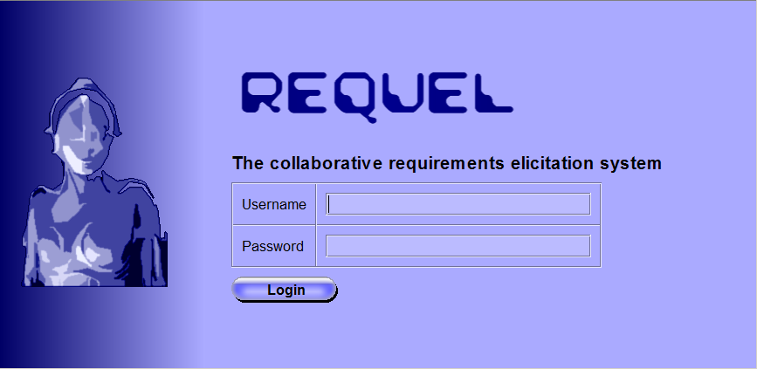
Figure 1: Login Screen
If your account is setup correctly you will see the main screen as shown in Figure 2. On the left hand side of the screen is a tab labeled “Projects” with a tree containing the projects that you are assigned. If you have project creation authorization you will also see a “New Project” button above the projects.
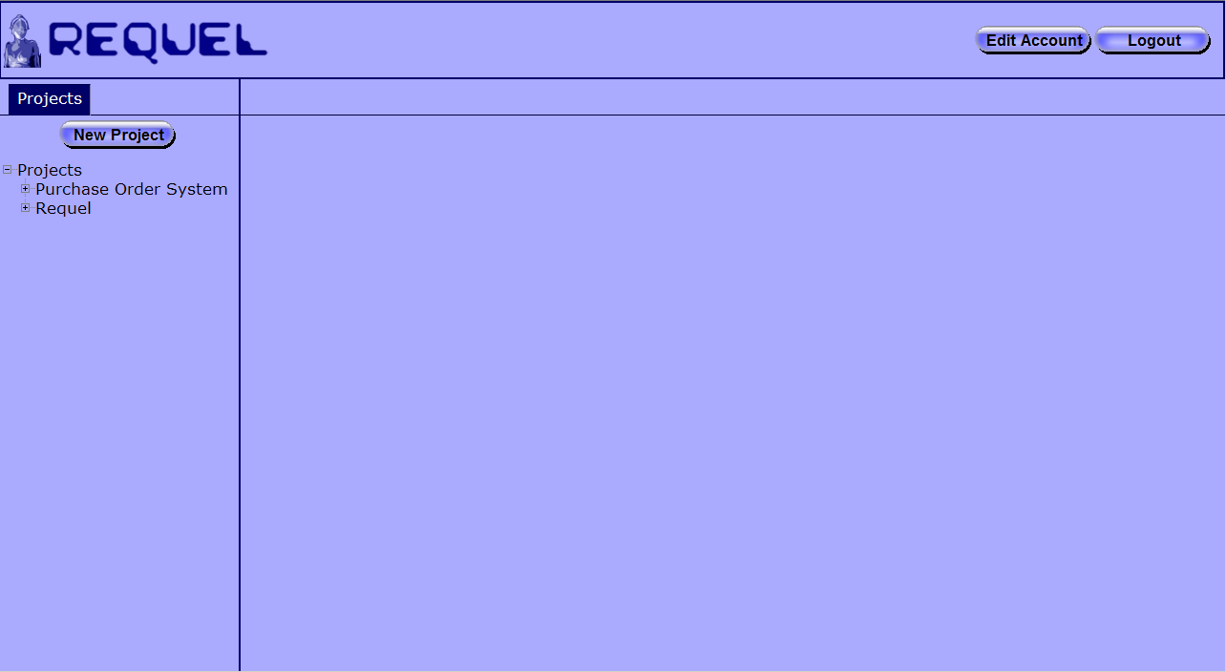
Figure 2: Main Screen
Figure 3 shows a close up of the project navigation tab.

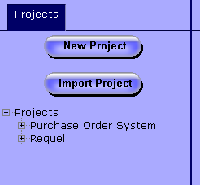
Figure 3: Projects Navigation Details
On the upper right hand of the screen, as shown in Figure 2, are a “Logout” button and “Edit Account” button. The logout button clears out your user session on the server and returns you to the login screen. The edit account button opens the “Edit User” screen for your system account as shown in Figure 4.
When you first login you should change the password assigned by the administrator to something more secure and fill in any missing personal data, such as your name, email address, and phone number. Unless you have system administrator privileges you will not be able to change your username.
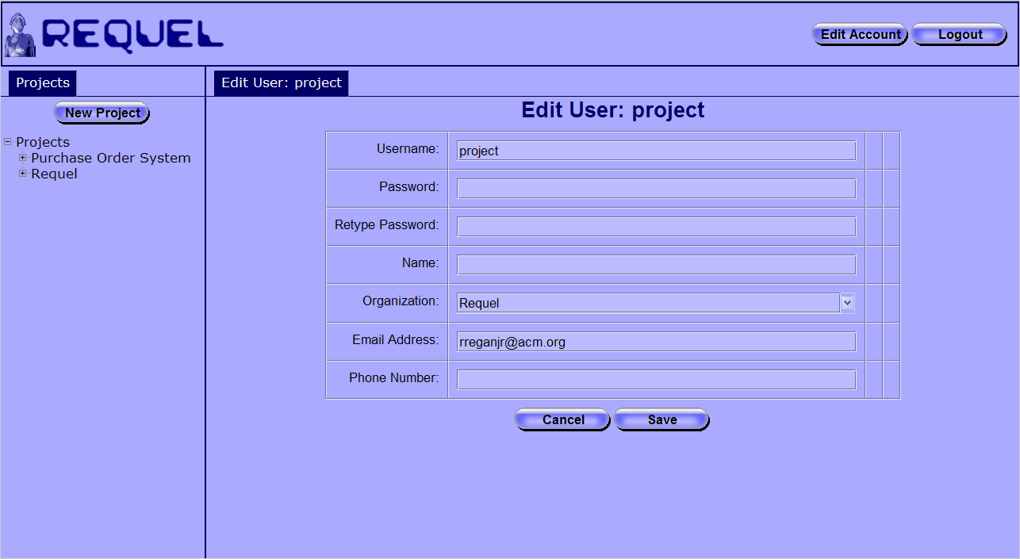
Figure 4: Edit User Screen
After making changes to your account you must click the “Save” button at the bottom to submit the changes to the system. If everything is valid the edit user panel will close and your changes will be saved. If there are any problems with your data, such as the password and retype password fields don’t match, your email address is not formatted properly, or your phone number is not formatted properly, the system will display error messages next to the fields that need to be corrected as shown in Figure 5
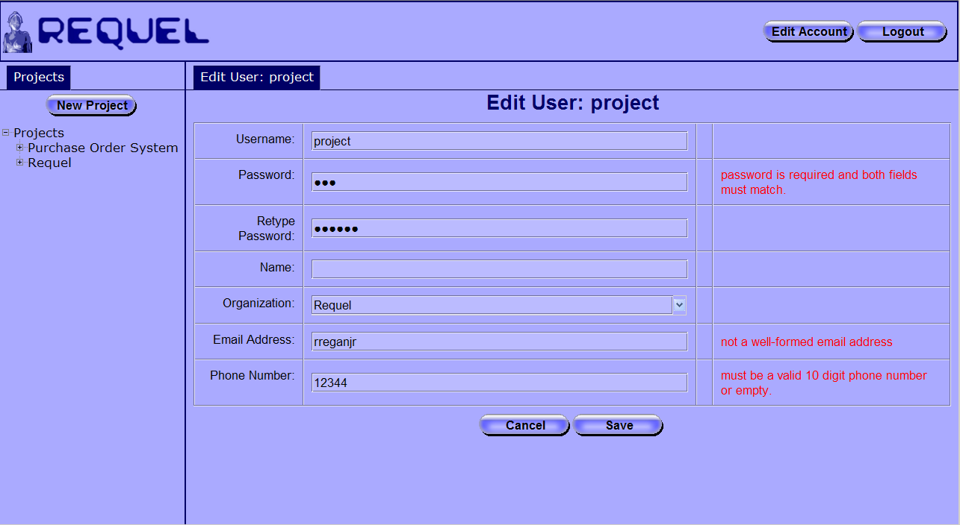
Figure 5: Edit User Screen with Errors

Working with Requirements
This section shows you how to create a project and add requirements to it. Requel doesn’t impose any particular process for creating requirements, which makes it flexible, but the flexibility may make it harder for you to get started if you don’t have a process for gathering requirements in mind. If you don’t have a process in mind, you may want to start with stories to describe the behavior of the system.
In any case, to start you will need to create a project and the stakeholders that will work on the requirements.

Creating a Project
Requel organizes requirements into projects. If you have project creation authorization the “New Project” button appears at the top of the project navigation tab as shown in Figure 3. Clicking the button opens the “New Project” screen show in Figure 6. Enter a name, organization, optional description, and click the save button. The combination of project name and organization are required to be unique. The system verifies the values are valid, creates the project, and adds it to the project navigation tab. If there are validation problems the system puts a message to the right of the affected fields.
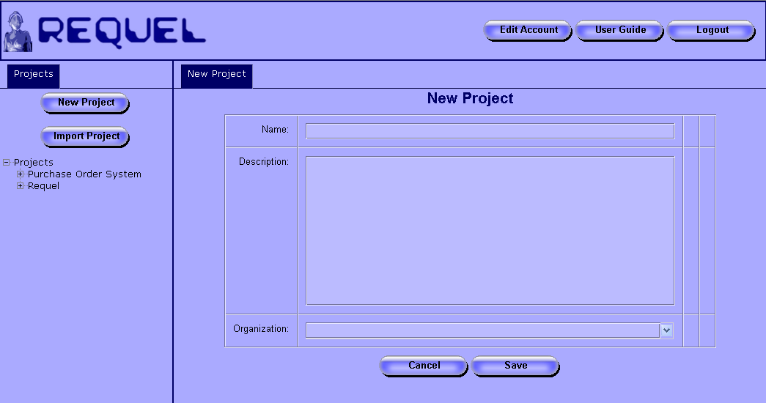
Figure 6: New Project Screen
Requel also supports importing a project stored in an XML file. If you have project creation authorization the “Import Project” button appears below the “New Project” button in the project navigation tab as shown in Figure 3. the button opens the “Import Project” screen show in Figure 7.
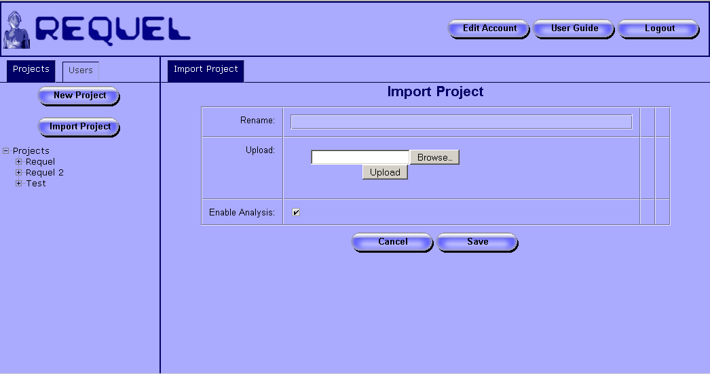
Figure 7: Import Project Screen
To import a project from an XML file, click the “Browse” button in the “Upload” field and use the file upload dialog to navigate to the file to import as shown in Figure 8. If you are importing a project that already exists in Requel, you must change the name by entering a new name in the “Rename” field to meet the uniqueness requirement described earlier.
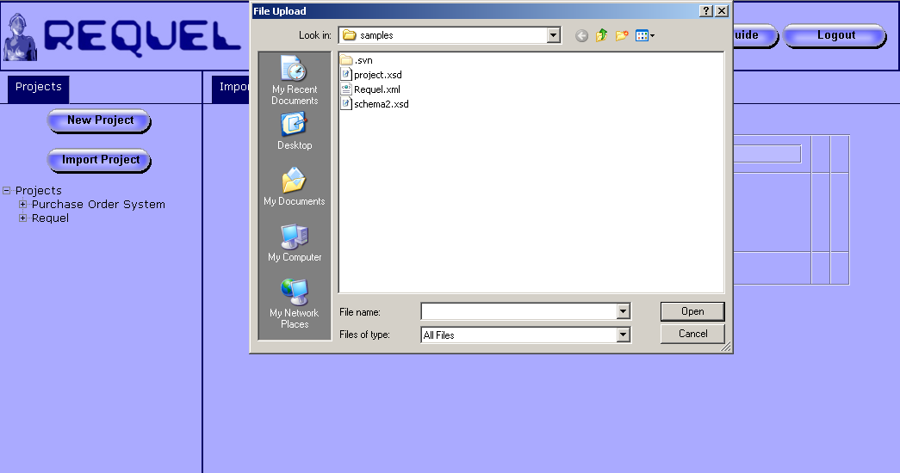
Figure 8: Project Import File Selection
When importing a project you have the option to turn off analysis by unchecking the “Enable Analysis” checkbox. This is useful for projects that were exported from the system and the elements have already been analyzed. Since the analysis uses a significant amount of processing power and can take a long time to complete. Projects created by hand or by another tool in the project XML format should have analysis enabled.
After selecting the file in the upload dialog, click the “Upload” button to upload the project file to the server. Then click the “Save” button at the bottom of the screen. The system creates a new project and adds it to the project navigation tab.

Project Navigation
Figure 9 shows a close up of the project navigation tab with the “Purchase Order System” project node in a closed state and the “Requel” project node in an open state. Clicking on the project name opens the “Project Overview” panel for editing the name, description and organization of the project, as well as adding issues and notes to the project. Clicking on the + next to a project name in the project navigation tab expands the project node to display the links to the requirements elements.
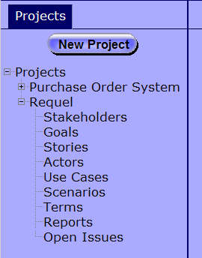
Figure 9: Project Navigation Tab

Creating and Editing Stakeholders
The first task to do after creating a new project is adding stakeholders for the users that will work on the project. Clicking on the “Stakeholders” link under a project in the navigation tab opens the stakeholder navigator, which lists all the stakeholders on the project, ordered by username as shown in Figure 10.
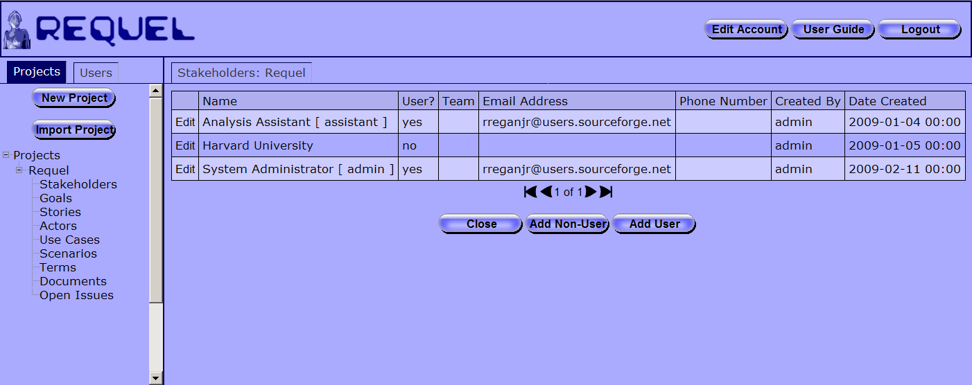
Figure 10: Stakeholder Navigator
Users authorized to edit stakeholders will see an “Edit” link in the first column of each stakeholder entry in the table and an “Add” button below the table. If you are not authorized to edit stakeholders the first column contains a “View” link that opens the stakeholder editor, but with read-only access. Clicking on the column titles sorts the stakeholders by that column. The first click sorts them in ascending order alphabetically as shown in Figure 11.
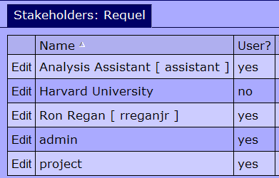
Figure 11: Sorting Stakeholders
The column indicates the sorting order with an arrow next to the column name. An arrow pointing up indicates ascending order and an arrow pointing down indicates descending order. Clicking on the column title, when it is sorted in ascending order, changes the sorting to descending order. Note: stakeholders without a name, for example the admin and project stakeholders in Figure 11, appear at the end of the results.
There will always be at least two stakeholders, the person that created the project and the “Analysis Assistant” that the system uses to indicate issues and notes created by the system.
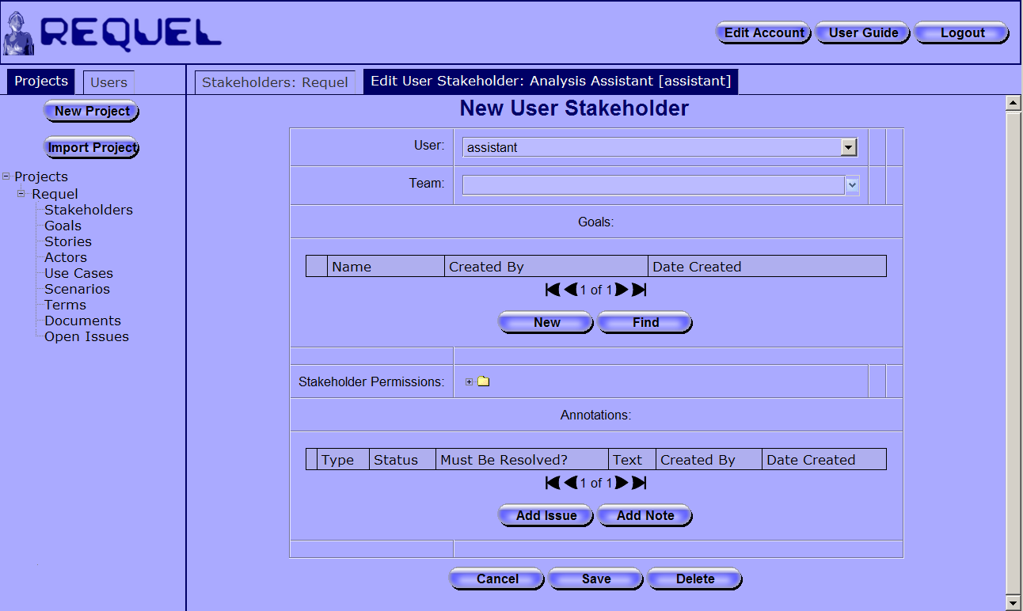
Figure 12: Edit User Stakeholder Screen
Clicking the “Add User” button on the stakeholder navigator screen opens the “New Stakeholder” screen shown in Figure 12. This screen is used for creating both user and non-user stakeholders for the project. To create a user stakeholder, leave the “Non-User Name” field empty and select a user from the “User” field, as shown in Figure 13.
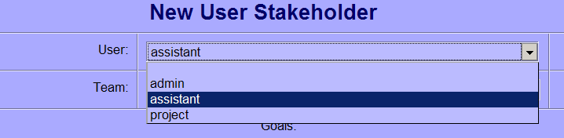
Figure 13: Selecting a User for a Stakeholder
Only administrators can create user accounts. If a person that you want to add to a project doesn’t appear in the list they may not have a user account. You should ask the Requel administrator to add an account for that person, with the “Project User” role.
You may optionally enter or select a team name in the “Team” field. The team is for documentation purposes only. Customer and Supplier are examples of team names.
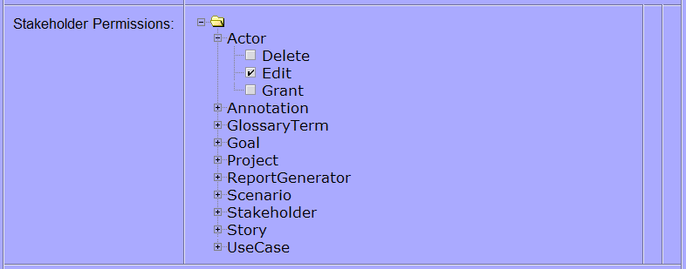
Figure 14: Stakeholder Permissions
User stakeholders can view all requirements elements on a project, but require explicit authorization to edit or delete requirements. The “Stakeholder Permissions” field contains a tree with nodes for each of the requirement element types. Each of the nodes has child nodes with permissions for actions such as “Delete”, “Edit”, and “Grant”, and a checkbox as shown in Figure 14. Checking a box grants permission to the user to perform that action on that element type; unchecking the box revokes the permission. For example in Figure 14 the checkbox for “Edit” under “Actor” is checked indicating the user can create and edit actors.
The “Grant” action permission allows a user with stakeholder “Edit” permission to grant permissions for that element type to other users. For example, if stakeholder “A” has stakeholder edit permission and story grant permission, he or she can edit stakeholder “B” and grant or revoke “Delete”, “Edit”, and “Grant” permission for actors to stakeholder “B”. If stakeholder “A” does not have grant permission for story elements, he or she can not grant or revoke permissions related to stories to stakeholder “B.”
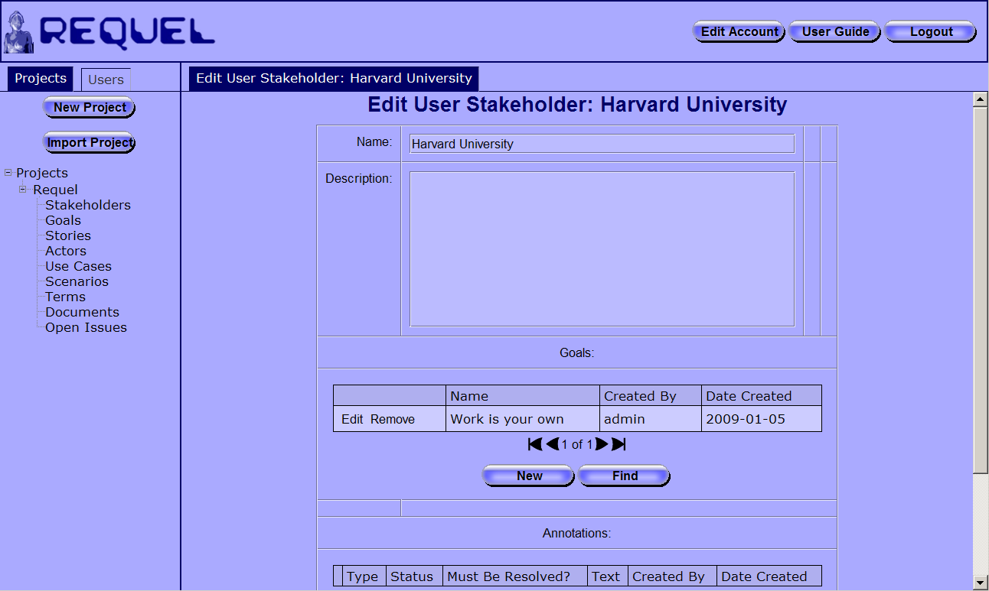
Figure 15: Edit Non-User Stakeholder Screen
Non-user stakeholders represent organizations or regulatory bodies that don’t have a user representative, but have interests or goals that the system must meet. Figure 15 shows a non-user stakeholder “Harvard University” with one goal named “Work is your own”; representing that projects submitted for homework are expected to be your own work. Non-user stakeholders are created by clicking the “Add Non-User” button on the stakeholder navigator screen as shown in Figure 10. Non-User stakeholders have a name, description, and goals.
After creating a stakeholder, goals can be added to it. Both user and non-user stakeholders can have goals. A new goal can be added by clicking the “New” button, which opens the “New Goal” screen, or an existing goal can be added to the stakeholder by clicking the “Find” button and selecting a goal from the goal selector panel. Figure 16 shows the goal selector panel with the selected goal highlighted.
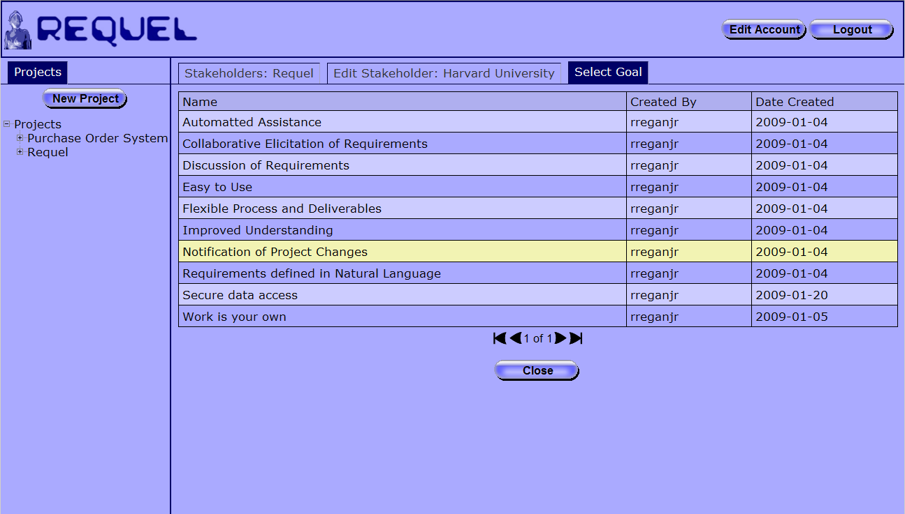
Figure 16: Goal Selector
The full goal can be viewed or edited by clicking on the “Edit” link in the first column of the goal table. The goal can be removed from the stakeholder by clicking the “Remove” link as shown in Figure 15. Removing a goal from a stakeholder does not delete it from the system.

Creating and Editing Goals
Goals are used to indicate desired properties, qualities, constraints, features and functions that the system must support. For example, “Easy to Use” is a high-level quality goal; “Must run on Linux” is a technology constraint; “Support an IBIS style of discussion” is a feature.
Clicking on the “Goals” link in the project navigation tab opens the goal navigator screen shown in Figure 17. The goal navigator has a table with the name of each goal, who created it, and when it was created. If you are authorized to edit goals the first column contains an “Edit” link and below the table is an “Add” button. If you are not authorized to edit goals the first column contains a “View” link that opens the goal editor for read-only viewing.
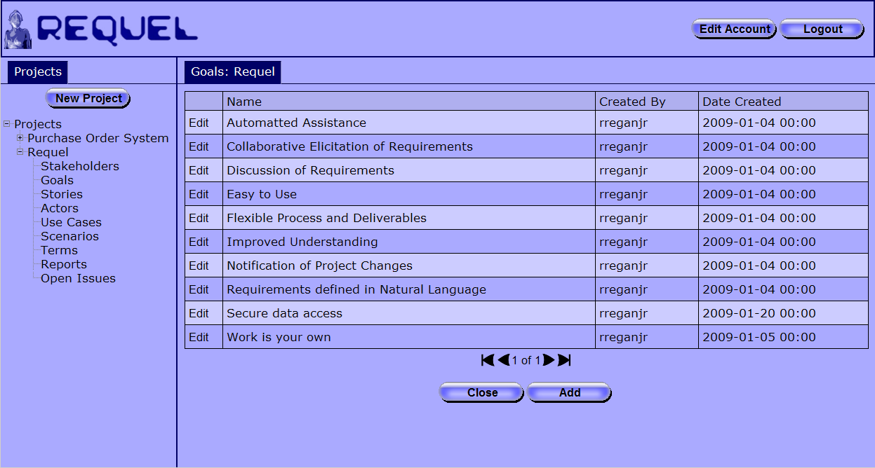
Figure 17: Goal Navigator Screen
Clicking the add button opens the “New Goal” screen shown in Figure 18. Goals have a name, which is a short one-line description, and a text body that is the full description of the goal. The goal name must be unique in a project. After entering a name and text body, click the save button at the bottom of the screen to create the goal. If the name is unique the system creates the goal and adds it to the goal navigator table.
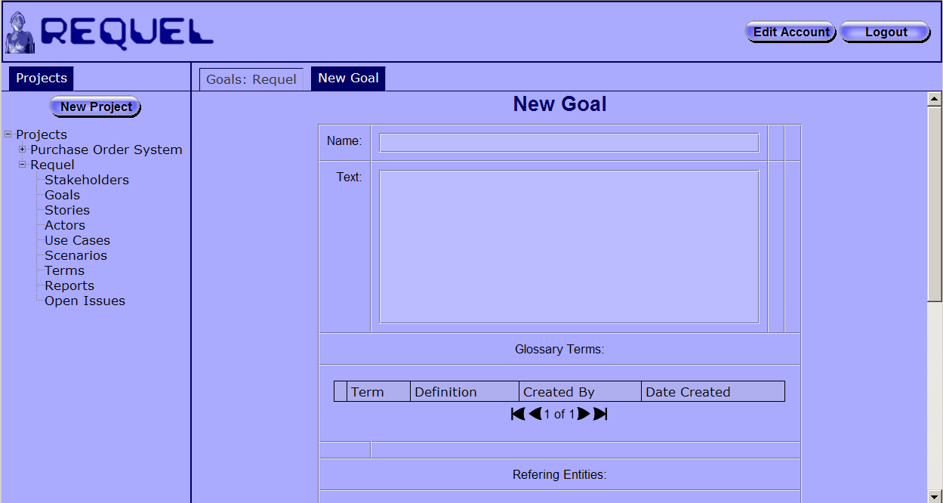
Figure 18: New Goal Screen
If the goal was created from another requirements element such as a stakeholder or use case, then the goal is also added to the goals field of that element. All the entities that refer to a goal are shown in the goal editor’s “Referring Entities” table shown in Figure 19.
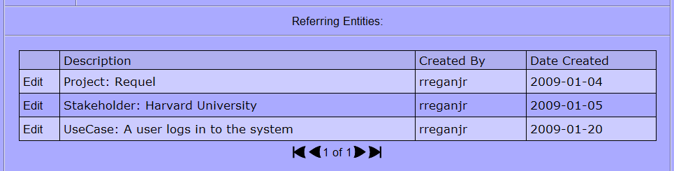
Figure 19: Goal Referring Entities
Upon saving the goal, the system initiates analysis of the goal as a background task referred to as the “Automated Assistant.” The assistant adds notes and issues to the goal as it analyzes it. During analysis of a goal the assistant identifies unknown or misspelled words; potential “significant terms” to add to the glossary; potential actors that don’t already exist in the project; and complex sentences that may be difficult to understand. You may work on any requirements elements as the assistant analyzes them; the assistant will not interfere with your work. See the Working with Analysis Issues section for more information about the analysis.
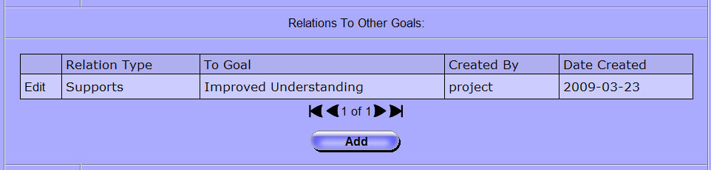
Figure 20: Goal Relations
Goals can have relationships with other goals listed in the goal editor’s “Relations to Other Goals” field, as shown in Figure 20. The relationships can be used to add traceability of goals from high level soft goals to specific functional requirements and as an indication of how goals interact with each other. Goals may support or conflict with each other. Conflicts help to identify places where tradeoffs may be needed, and to document the rationale behind the decisions made. Goal relations are directional, for example if goal “A” supports goal “B” there is a relationship from goal “A” to goal “B”, but not from goal “B” to goal “A”.
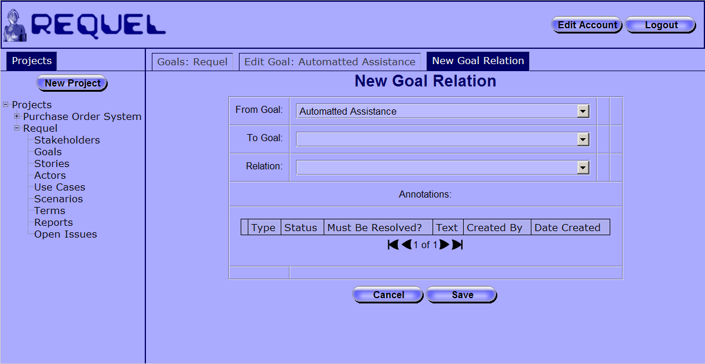
Figure 21: Goal Relation Editor Screen
Clicking the “Add” button opens the “New Goal Relation” editor as shown in Figure 21. A goal relation has a “From Goal”, a “To Goal”, and the relation type. The editor defaults the “From Goal” selector to the goal in the editor where the add button was clicked. Both the “To” and “From” goal fields list all the goals in the project as possible options as shown in Figure 22. After selecting the “To Goal” and relation type, clicking save creates the relationship and adds it to the goal relations table of the original goal as shown in Figure 20.
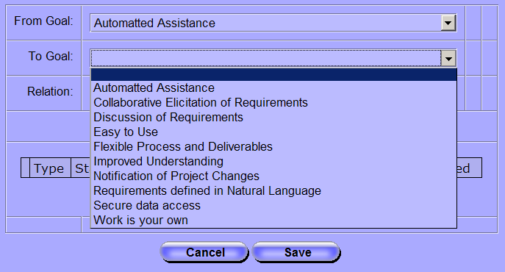
Figure 22: Goal Relation "To Goal" Selection

Creating and Editing Stories
Stories are simple narratives of how a user interacts with the system. Stories can be used to describe how things work before the new system is in place, i.e. the current state of affairs, or how things will be when the new system is in place. Stories can describe negative cases, such as problems with the current system, or how the new system should behave in a bad situation.
Clicking the “Stories” link in the project navigator tab opens the stories navigation screen as shown in Figure 23.
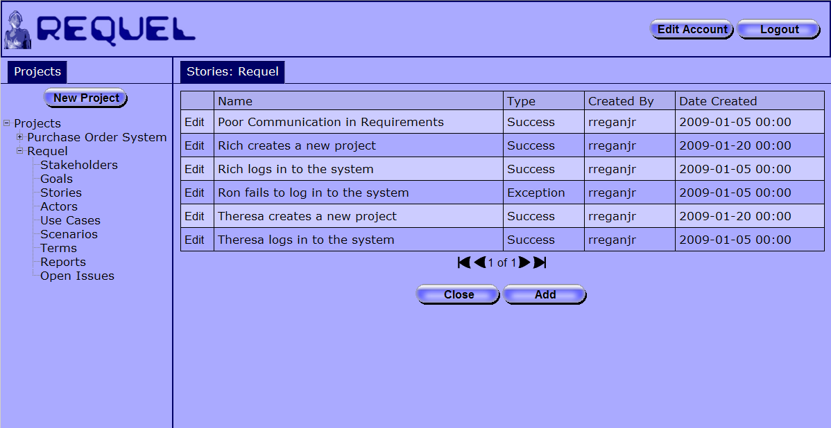
Figure 23: Stories Navigation Screen
The stories navigator has a table with the name, type, who created it, and when it was created. If you are authorized to edit stories the first column contains an “Edit” link and below the table is an “Add” button. If you are not authorized to edit stories the first column contains a “View” link that opens the story editor in read-only mode.
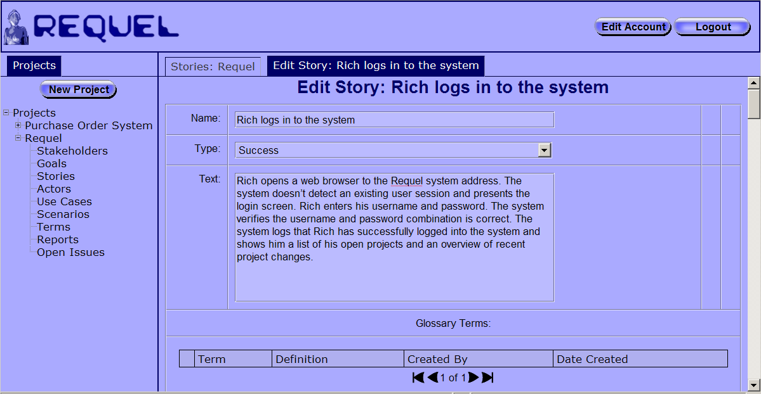
Figure 24: Story Editor Screen
Clicking the “Edit” button for an existing story opens the story editor screen shown in Figure 24. A story has a short one-line name, a type of “Success” or “Exception” and a text body. The story name must be unique in the project. Clicking the “Save” button, located at the bottom of the screen, validates and creates or updates the story and initiates analysis as a background task. See the Working with Analysis Issues section for more information about the analysis.
Optionally, stories can have goals and actors assigned. The actors add traceability to the types of users appropriate to the story. The goals can be used to indicate the goals supported by the story or derived from the story. For both goals and actors there are “New” and “Find” buttons as shown in Figure 25. The “New” button is used to open an editor for creating a new actor or goal that gets assigned to the story. The “Find” button is used to open a selector, like the one in Figure 16, to choose an existing goal or actor.
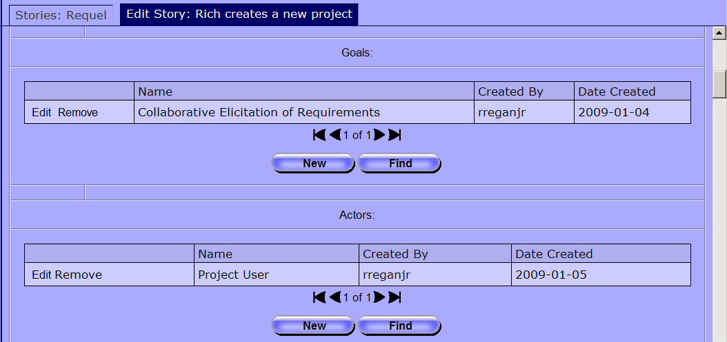
Figure 25: Story Goals and Actors

Creating and Editing Actors
Actors represent the types of users that will interact with the system. Actors may be human users or other systems. Clicking on the “Actors” link in the project navigation tab opens the actor navigator screen shown in Figure 26. The actor navigator contains a table of the actors with columns for the name, description, who created it, and when it was created. If you are authorized to edit actors the first column contains an “Edit” link and below the table is an “Add” button. If you are not authorized to edit actors the first column contains a “View” link that opens the actor editor for read-only viewing.
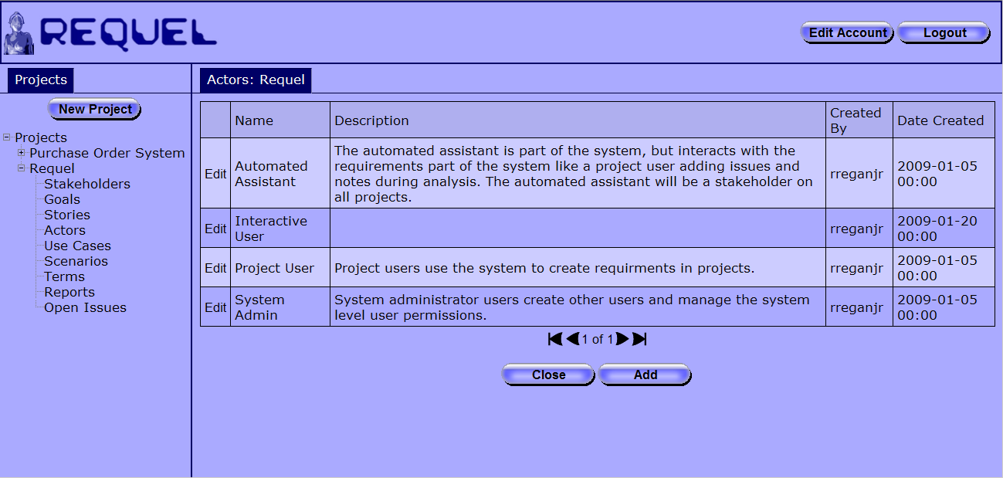
Figure 26: Actors Navigator Screen
Clicking the “Add” button opens the “New Actor” editor as shown in Figure 27.
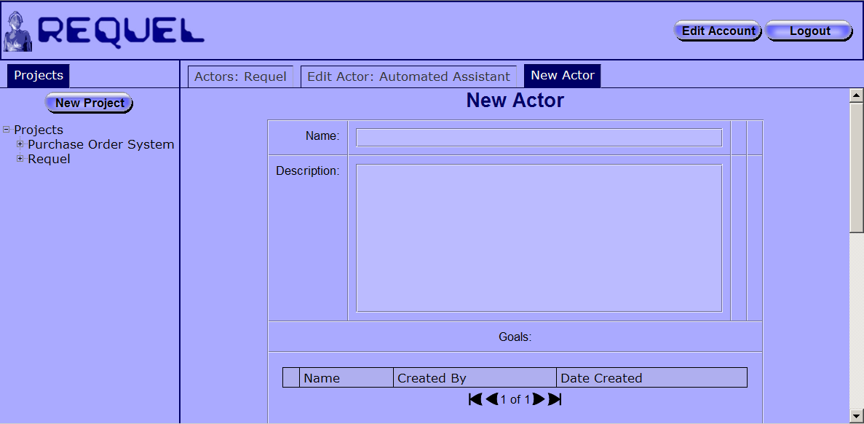
Figure 27: New Actor Screen
An actor has a name that must be unique in the project, and a description. The description can be used to describe the actor’s primary function or to describe an example “persona” for a person or system that typifies the actor. For example the following is a persona for a user of the Requel system:
Theresa is an accountant for Bailey Pet Supply tasked with specifying the requirements for integrating the purchase order system with the accounting system using the system. Theresa has never used a requirements tool before and has no projects. Theresa will be an end-user of the resulting system.
Actors may have goals that identify the functions of the system relevant to the actor, or general interests that the actor has that the system must meet. Figure 28 shows the goal references of an actor in the Requel system.
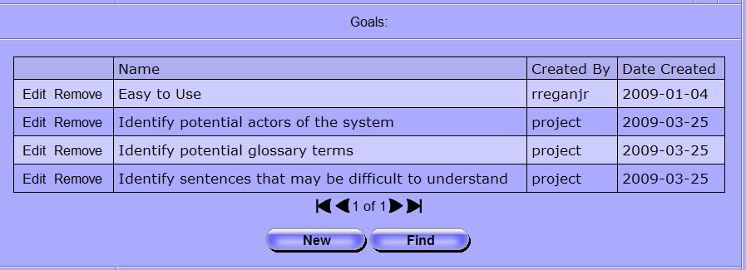
Figure 28: Referenced Goals
From the actor editor new goals can be added using the “New” button or existing goals can be added using the “Find” button. Goals attached to the actor can be removed by clicking the “Remove” link in the first column of the goals table. Goals that are removed from the actor are not deleted from the project.
Like other requirements element actors are analyzed when saved. See the Working with Analysis Issues section for more information about the analysis.

Creating and Editing Scenarios
Scenarios are semi-structured sequences of steps where the actor invokes an action on the system in one step, followed by a response by the system in the next step. Scenarios are composed of an ordered list of steps where a step may be a single action or a reference to another scenario with its own set of steps. Scenarios may be used as stand alone entities that describe an interaction more explicitly than a story, or in conjunction with a use case.
Clicking on the “Scenarios” link in the project navigator opens the scenarios navigator screen as shown in Figure 29. In addition to the standard name, created by, and date created columns, the scenario navigator has two additional columns: “Top Level” and “Type”. The top level column indicates if a scenario is used as a step in another scenario. Scenarios with a “Yes” value means the scenario is a top level scenario and not used in other scenarios. The type column indicates how the scenario is used, for example if it is used as an alternate, exceptional, or optional sequence of steps in another scenario.
If you are authorized to edit scenarios the first column contains an “Edit” link and below the table is an “Add” button. If you are not authorized to edit scenarios the first column contains a “View” link that opens the scenario editor for read-only viewing.
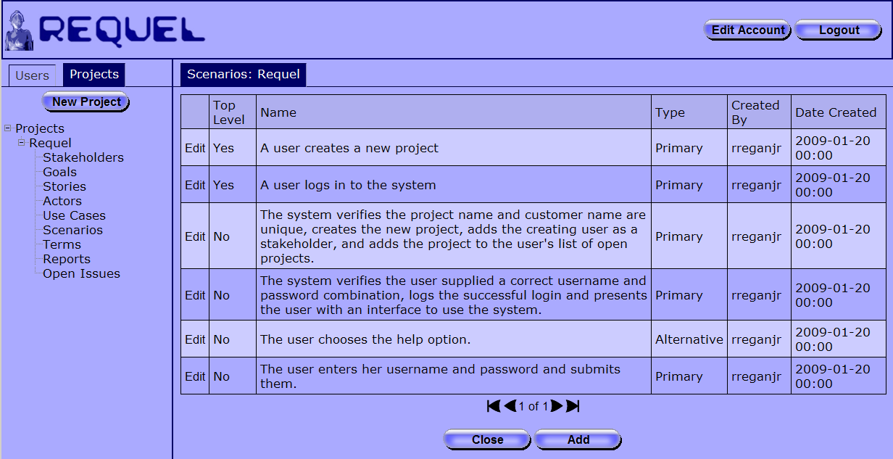
Figure 29: Scenarios Navigation Screen
Clicking the “Add” button opens the “New Scenario” editor as shown in Figure 30. A scenario has a name, type, optional descriptive text, and a sequence of steps. The scenario name must be unique in a project. The type of scenario is most relevant for scenarios that are steps in other scenarios and is described in the Editing Scenario Steps section, which gives a description of how to add and edit the steps of a scenario.
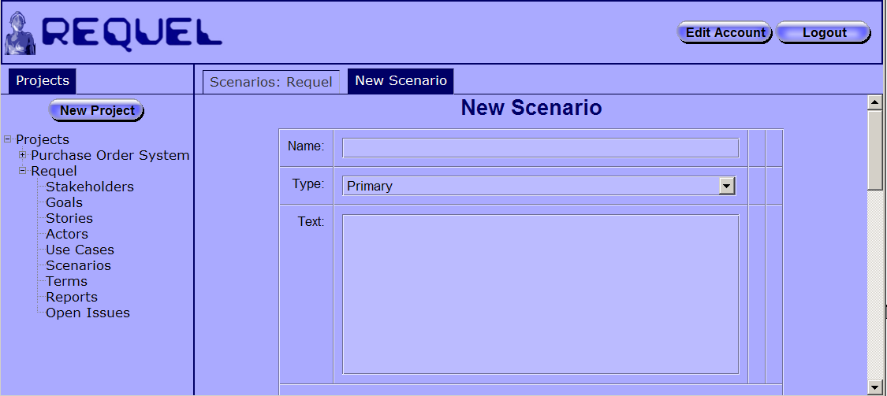
Figure 30: New Scenario Screen
The scenario editor lists the scenarios that use the scenario being edited in the “Referring Scenarios” table as shown in Figure 31. Clicking the edit link in the table opens the scenario editor for that scenario.
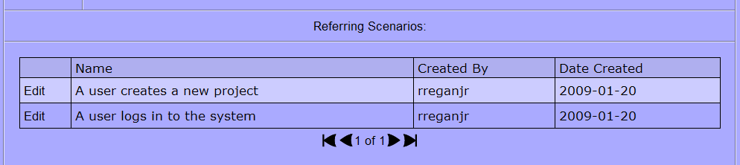
Figure 31: Scenario's Referring Scenarios

Creating and Editing Use Cases
Use cases represent functional requirements in terms of how a user interacts with the system. In the Requel system a use case is a confluence of stories, goals, and actors with a scenario to describe the behavior of a specific function of the system.
Clicking on the “Use Cases” link in the project navigator opens the use case navigator screen as shown in Figure 32. The navigator includes columns for the use case name, primary actor, created by username, and date created. If you are authorized to edit use cases the first column contains an “Edit” link and below the table is an “Add” button. If you are not authorized to edit use cases the first column contains a “View” link that opens the use case editor for read-only viewing.
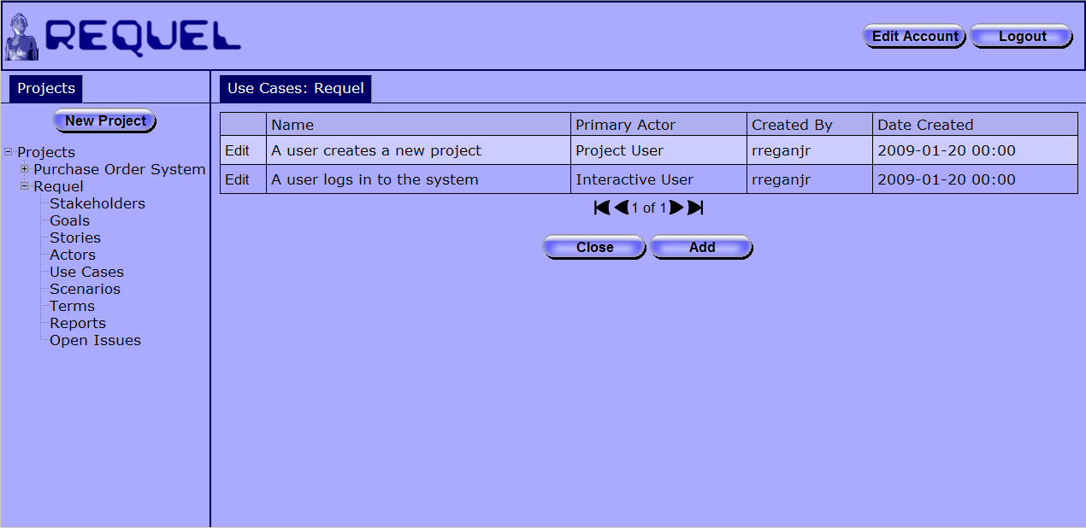
Figure 32: Use Case Navigation Screen
Clicking the “Add” button opens the “New Use Case” editor as shown in Figure 33. A use case has a name, which must be unique in a project, an optional description, and a primary actor. The primary actor input is a combo-box where the actor can be selected from the drop-down list, or a name can be entered. If a name is entered, when the use case is saved, a new actor is created, added to the project, and set as the primary actor. The description and other information of the actor can be edited later, by opening the actor editor through the actor navigation screen.
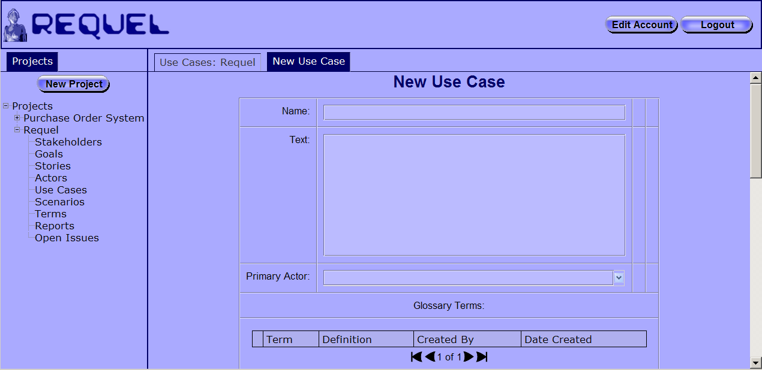
Figure 33: Use Case Edit Screen
A use case can contain a set of goals that represent what the primary actor is trying to accomplish with the use case. Goals are added and removed from use cases just like goals on other entities, such as on the actor editor screen as shown in Figure 28.
Most use cases only have a single primary actor, but in some cases additional actors are needed to show complex interactions where the system interacts with external services to support the user’s actions. Auxiliary actors are displayed in a table as shown in Figure 34. Like goals, a new actor can be created and added, or an existing actor can be added to the auxiliary actors of the use case.
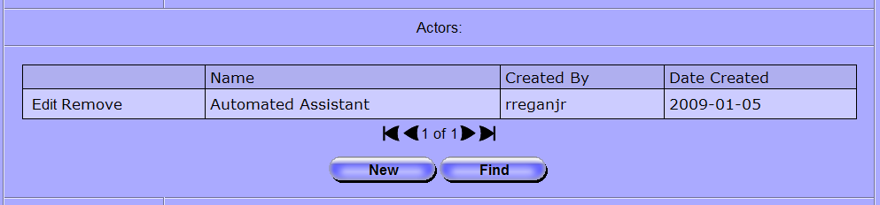
Figure 34: Use Case Auxiliary Actors
Use cases can reference multiple stories as example of successful and exceptional interactions with the system. Stories are useful as rationale for understanding the scenario of the use case. Stories are displayed in a table as shown in Figure 35 and can be added and removed just like actors and goals.
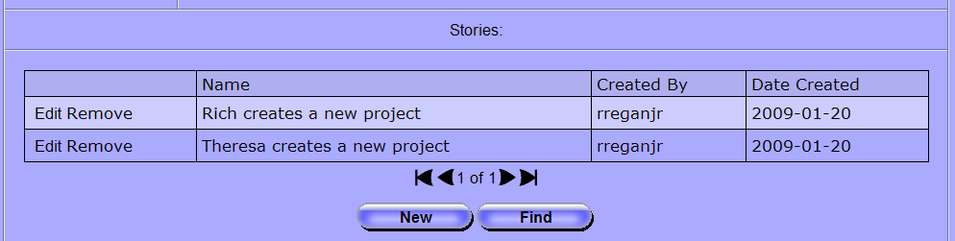
Figure 35: Use Case Stories
Editing the scenario of the use case is described in the Editing Scenario Steps section.

Editing Scenario Steps
The scenario step editor is used by both the scenario editor and use case editor screens. When creating a new scenario the steps editor appears with no steps and two buttons as shown in Figure 36.
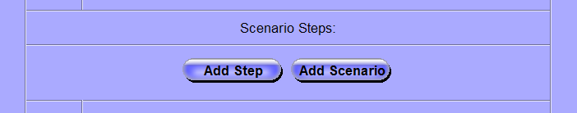
Figure 36: Empty Scenario Step Editor
The “Add Step” button creates an empty step node as shown in Figure 37. New steps are added below any existing steps.
Figure 37: Empty Step Node
Each step has a box for editing the text, a drop down list for selecting the type, and a collection of buttons and icons for manipulating the step described in Table 1. The text of the step is limited to 255 characters. The types are pre-condition, primary, alternative, exception, and optional. A step with the pre-condition type isn’t really a step, but indicates a condition that must be met for a scenario to start or continue. The primary type indicates the step is part of the primary flow of the scenario; alternative means the step is an alternative to the primary flow, but part of a successful interaction; exception indicates a problem or error condition; and optional means the step is a successful interaction, but one that is not required to take place.
 | The “slotted puzzle” icon is used to drag a step to a new location in the scenario by dropping it on the tabbed puzzle piece. A step can be dragged from and dropped to any sub-step level.
 | The “tabbed puzzle” icon is the drop target for moving a step. Dropping a step on the target inserts that step in the location and moves the existing all subsequent steps down by one.
 | The “X” button removes the step from the scenario and moves all subsequent steps up by one. If the step is a simple step with no sub-steps it is deleted from the project. If the step is a sub-scenario it is removed, but not deleted.
 | The “sub-step” button adds a new sub-step to this step. If the step has other sub-steps the new one is added at the end of the sequence.
Table 1: Step Node Controls
The “Add Scenario” button shown in Figure 36 is used to add an existing scenario as a step in the current scenario. Clicking the button opens the “Select Scenario” screen as shown in Figure 38. Clicking on a scenario selects it and adds it as the last step in the scenario. Note: if the original scenario is a step or sub-step reachable through the selected scenario, then it would result in a cycle in the steps and it is not added.
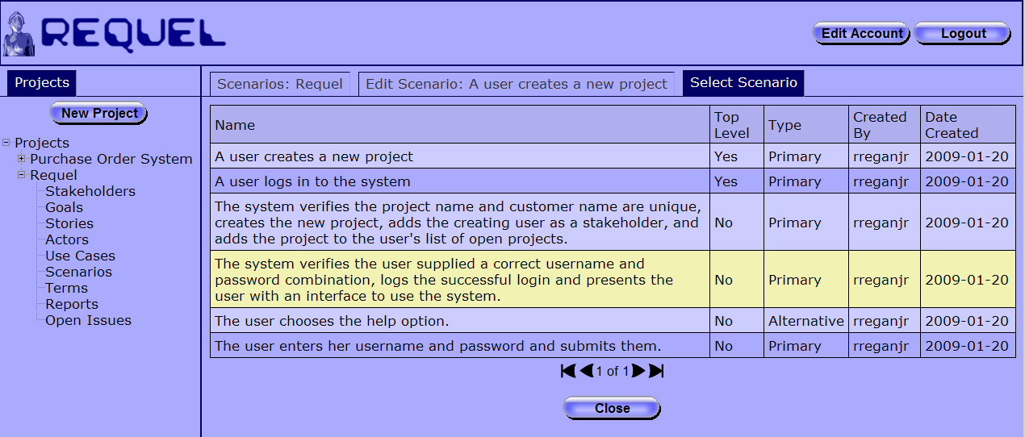
Figure 38: Select Scenario Screen
When editing a scenario with existing steps, the steps are ordered in the sequence they should occur, with sub-steps below and to the right of their parent step as shown at the bottom of Figure 39.
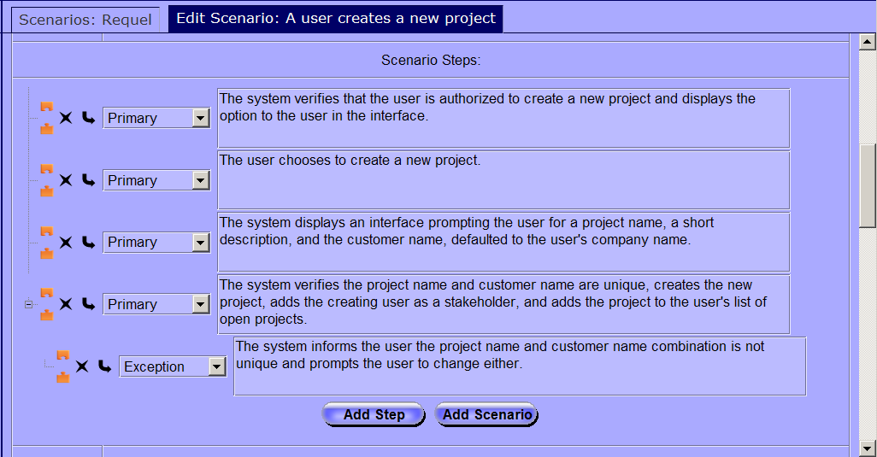
Figure 39: Scenario Steps Editor
Sub-steps can be nested to any level. Each step that contains sub-steps has a “-” button to the left of all other controls when the sub-steps are visible. Clicking it hides the sub-steps. When a step’s sub-steps are hidden the step has a “+” button, which exposes the sub-steps when clicked.

Generating Documents
Once the requirements are in Requel you will want to generate a specification document to provide to the developers to build the system. Just as there are many processes for acquiring requirements, there are many formats for specifying requirements. Requel supports creating custom documentation using the XML Stylesheet Language Transformations (XSLT) language to transform the requirements from an XML format into a specification document. XSLT is a powerful language that can transform XML into a variety of structured or unstructured document formats such as HTML, PDF, and Microsoft Office documents using the Office Open XML format.
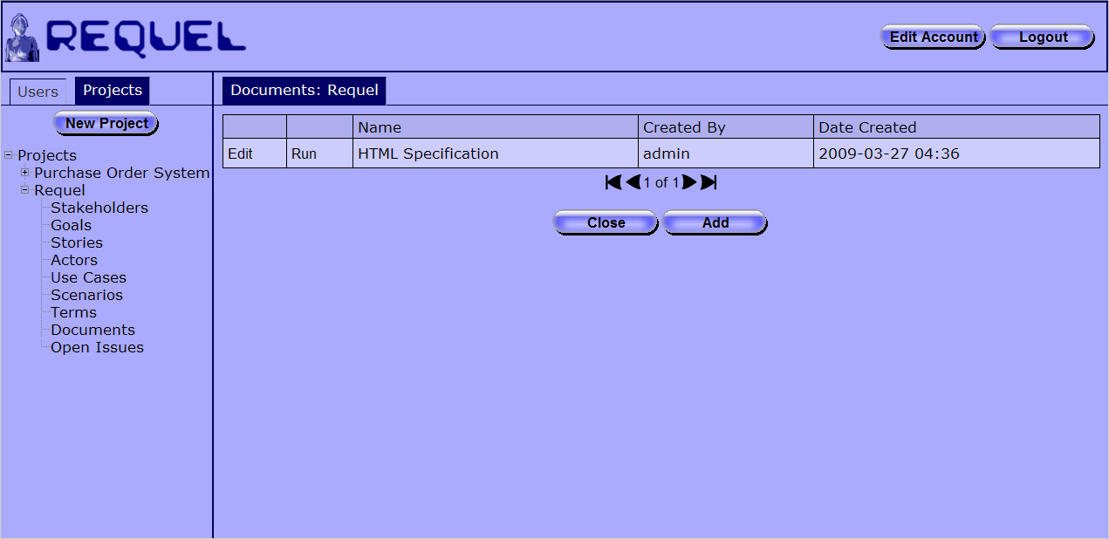
Figure 40: Documents Navigator
Clicking on the “Documents” link in the project navigation opens the documents navigator as shown in Figure 40. Each entry in the table represents an XSLT script for generating a document. If you are authorized to edit documents (in the stakeholder permissions it is labeled as ReportGenerator) the first column contains an “Edit” link and below the table is an “Add” button. If you are not authorized to edit documents the first column contains a “View” link that opens the document editor for read-only viewing.
The second column of the table holds a “Run” link that executes the XSLT script on the requirements to generate a document. The document is returned to the browser, which gives you the option to open it or save it as shown in Figure 41. The document will have the project’s name as the file name with an appropriate extension for the type of document as a suffix. For example, an HTML document for a project named “Requel” will be named “Requel.html”.
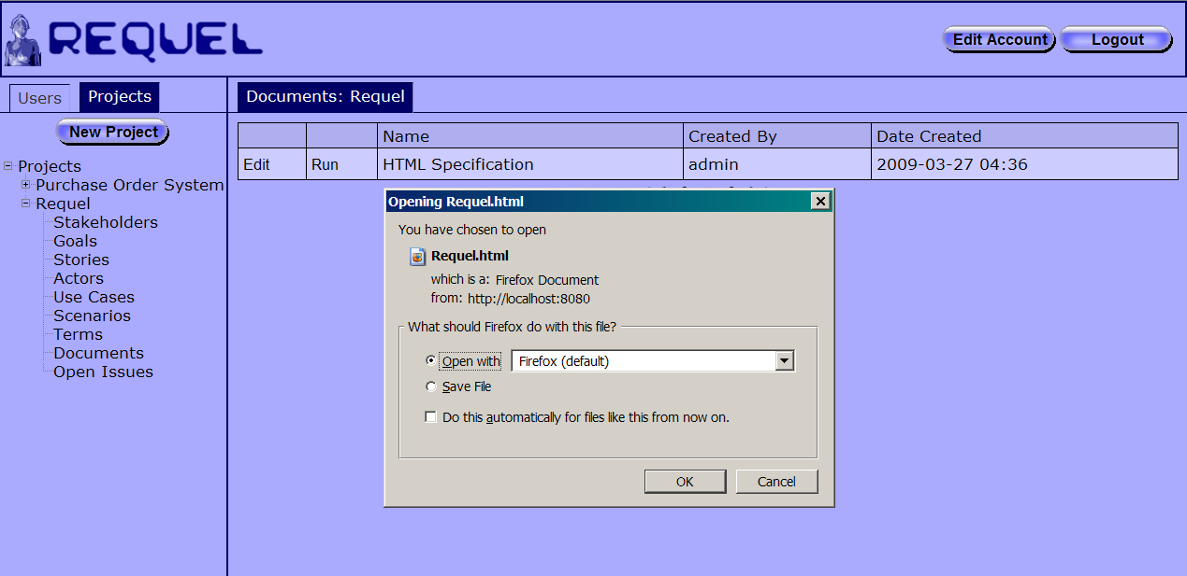
Figure 41: Generating a Document
The built-in “HTML Specification” document is added to all projects when they are created. It generates a simply formatted Web page with all requirements elements as shown in Figure 42. There is a section for each of the requirement element types: stakeholders, actors, goals, stories, use cases and scenarios. At the top of the document is a table of contents that links to each section and also to each element of the requirements.
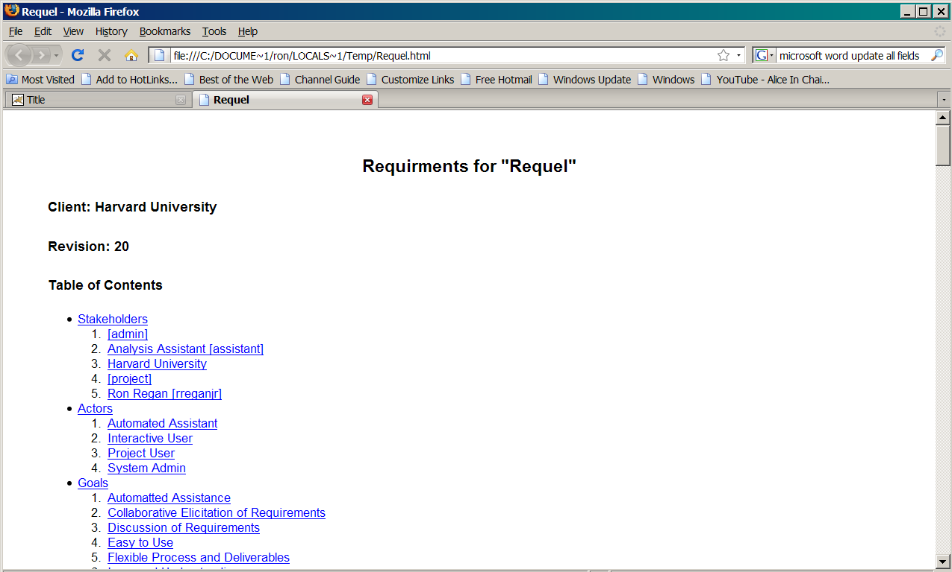
Figure 42: Requirements Document

Adding a Document Generator
Clicking the “Add” button opens the “New Document” editor as shown in Figure 43. A document has a name, which must be unique in the project, and the XSLT script text.
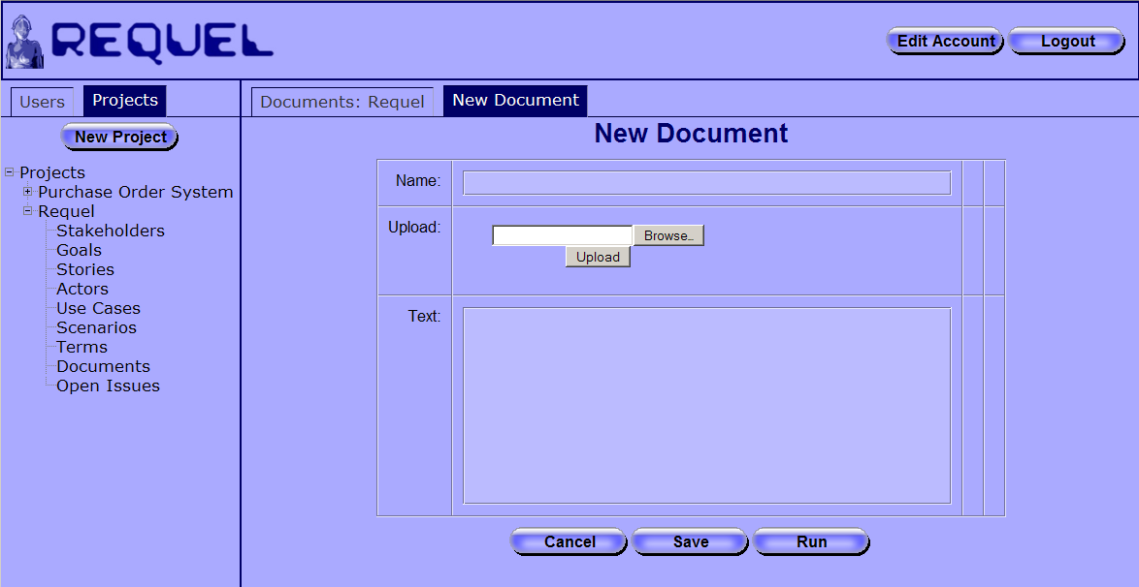
Figure 43: Document Editor Screen
An XSLT can be uploaded from your local system by clicking the “Browse” button, finding the file with the file upload dialog, and then clicking the “Upload” button. The contents of the XSLT will be loaded in the “Text” field. You can edit the XSLT in the text box, but it is not an effective tool for more than simple text changes.

Working with Terms
Each project has a glossary of terms. Using a glossary to explicitly define how words are used in a project can help improve understanding by using a consistent and explicitly defined set of terms. Clicking on the “Terms” link in the project navigator opens the terms navigator screen shown in Figure 44. If you are authorized to edit terms (in the stakeholder permissions it is labeled as GlossaryTerm) the first column contains an “Edit” link and below the table is an “Add” button. If you are not authorized to edit terms the first column contains a “View” link that opens the term editor for read-only viewing.
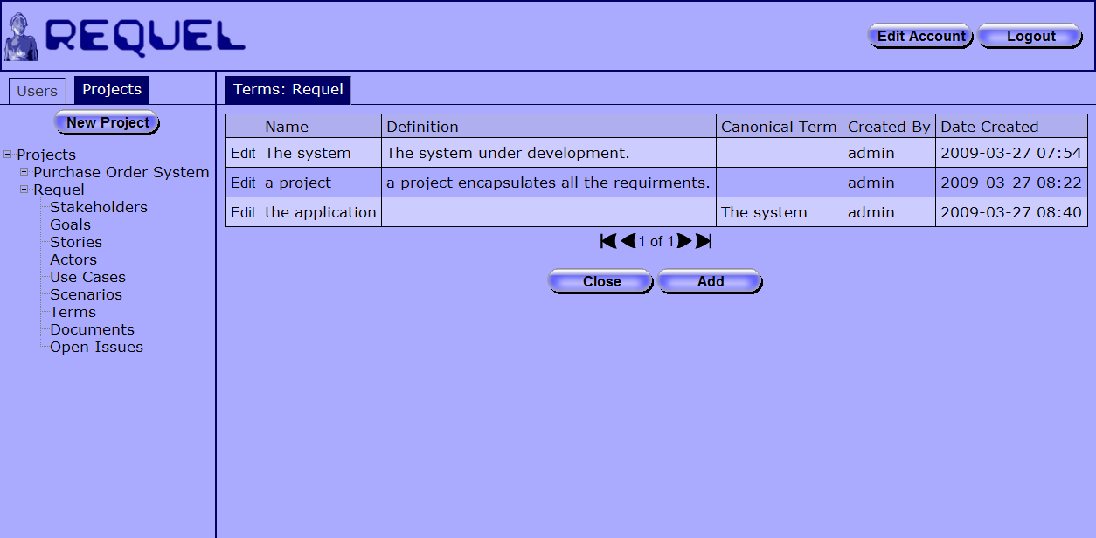
Figure 44: Terms Navigator
The terms navigator shows the text of the term in the “Name” column and the full text of the definition. The canonical term column contains the name of another term if the term is not the preferred term for the concept. For example the term “the application” in Figure 45 has the term “The system” as the canonical term. Ideally there should only be one term per concept and the system has a feature to solve this problem described below.
Figure 45: A Term with a Canonical Term
Clicking the “Edit” button on a term opens the term editor shown in Figure 46. The editor has text fields for the name and description and a selector button for choosing a canonical term.
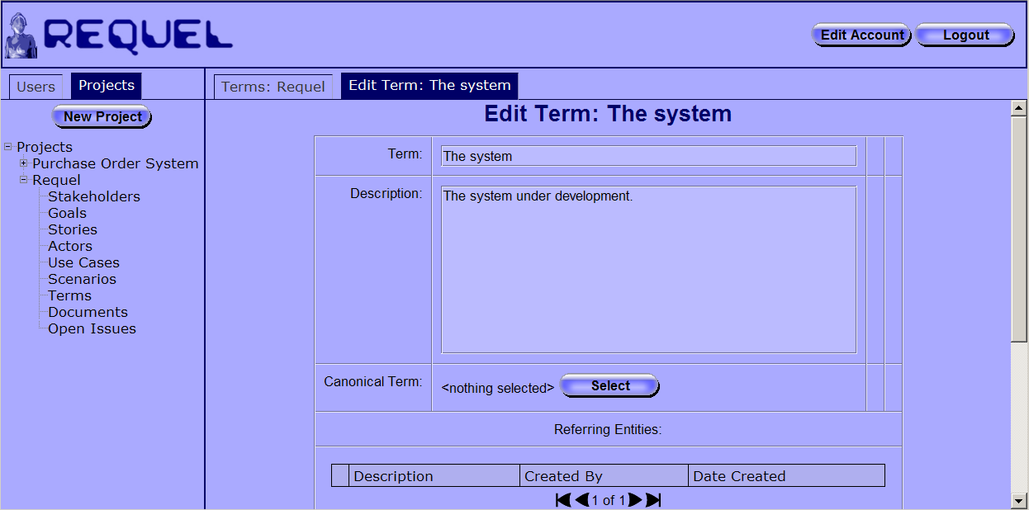
Figure 46: Term Editor
The selector button displays “<nothing selected>” when the term doesn’t have a canonical term. Clicking the “Select” button opens a selector screen that looks like the navigator screen. When a canonical term is selected the name of the term shows up to the left of the button as shown in Figure 47. When creating a new term or changing the name of the term, the system scans all the requirements and adds cross-references between the elements and the term.
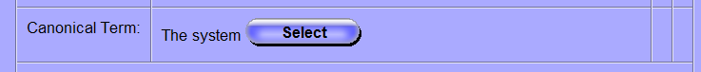
Figure 47: Canonical Term Selected
As stated before, ideally there should only be one term per concept. In many cases different people use different terms to refer to the same thing when writing requirements individually. To solve the problem Requel has function that will replace all the occurrences of a term with its canonical term in all the requirement elements. First, all the terms need to be added to the glossary. The automated assistant will probably create issues identifying them as potential glossary terms; resolving these issues will create the terms and add references to all the requirement elements that use them. For all the terms that you want to replace, edit them and select the preferred term as the canonical term. At the bottom of the term editor is a “Replace Term” button shown in Figure 48. Clicking the button causes the system to update all the occurrences of the term in the requirements elements with its canonical term.
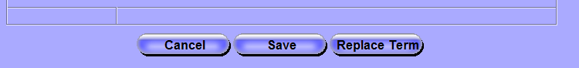
Figure 48: Replace Term

Discussing and Negotiating Requirements
This section describes adding notes and issues to requirements, and negotiating resolutions to issues.
Discussion and negotiation are an important aspect of collaboration. For example a stakeholder adds an issue indicating a goal needs more details. Other stakeholders then propose solutions to the issue, and argue the merits of each with arguments supporting or conflicting with the potential solution. Once all the proposed solutions have been discussed, one can be chosen as the resolution.

Adding Notes and Issues
All the requirements elements support adding notes and issues. Each of the requirements editors has an “Annotations” table with the notes and issues as shown in Figure 49. If you are authorized to edit annotations the first column contains an “Edit” link and below the table are “Add Issue” and “Add Note” buttons. If you are not authorized to edit annotations the first column contains a “View” link that opens the note or issue editor for read-only viewing. Note: typically you will want all stakeholders to have “Edit” permission for annotations.
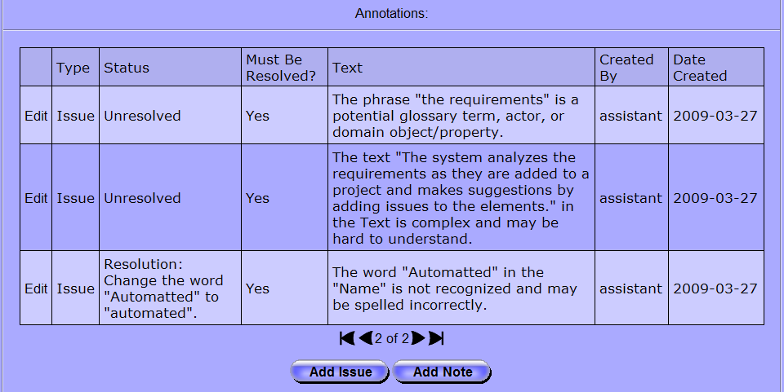
Figure 49: Annotations Section
The type column in the table indicates if the annotation is a note or issue. The status column will always have the value “Informational” for notes and either “Unresolved” or “Resolution: …” for issues. When an issue is resolved the status will start with “Resolution:” followed by the text of the position that resolved the issue. The “Must be Resolved?” column will always have “No” for notes and either “Yes” or “No” for issues. The “Text” column contains the full text of the issue.
Clicking on the “Add Note” button opens the “New Note” editor as shown in Figure 50. A note only has the text of the note.
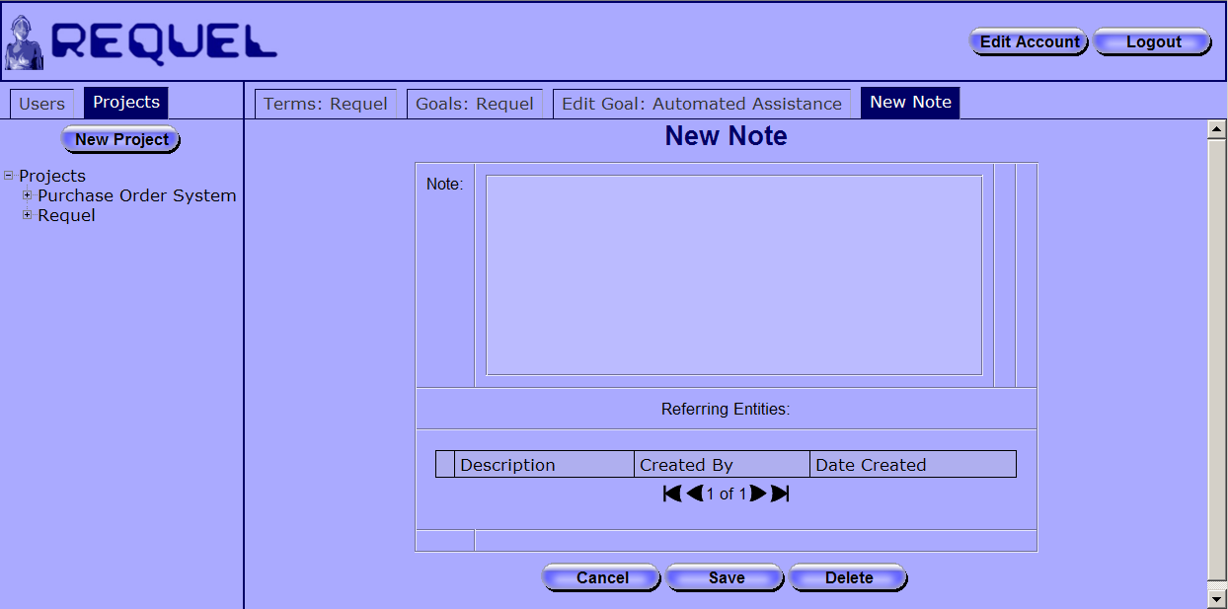
Figure 50: New Note Editor
There isn’t a way to find existing notes and add them to multiple requirement elements, but the system automatically detects adding notes with identical text and instead of creating a new note it will add the existing note to the requirement. Figure 51 shows a note shared by two goals, indicated in the “Referring Entities” table.
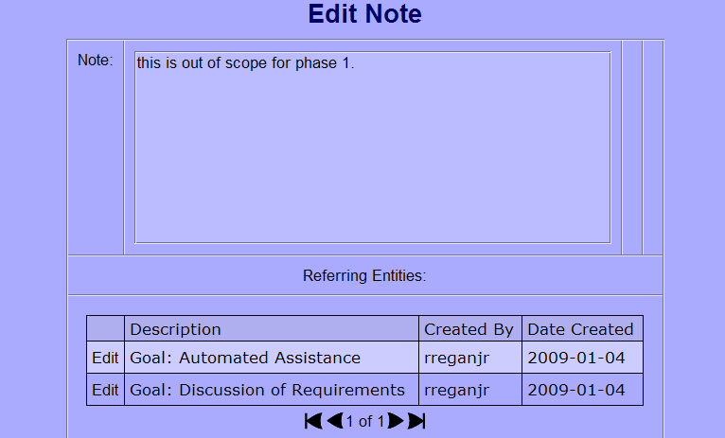
Figure 51: Shared Notes
Clicking on the “Add Issue” button opens the “New Issue” editor as shown in Figure 52. An issue has text, a must be resolved checkbox, and positions. The must be resolved property is only for documentation purposes.
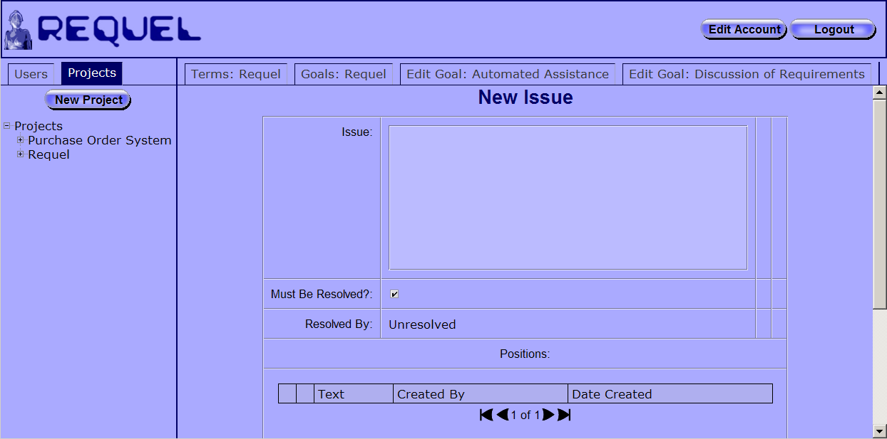
Figure 52: New Issue Editor
After an issue is saved positions can be added by users authorized to edit issues by clicking the “Add” button below the positions table as shown in Figure 53.
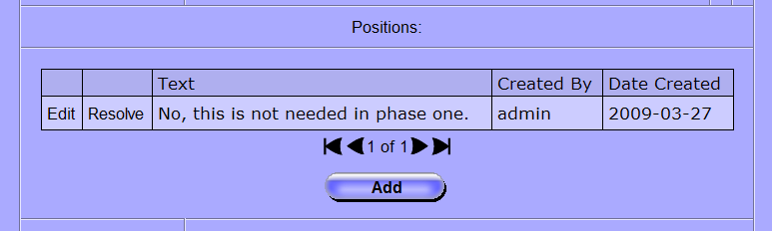
Figure 53: Adding Positions
Positions represent potential solutions to an issue. The position editor has a text field to enter the text of the position and a table of arguments that argue for or against the position as a solution to the issue, as shown in Figure 54. After a position is saved arguments can be added by users authorized to edit issues by clicking the “Add” button below the arguments table.
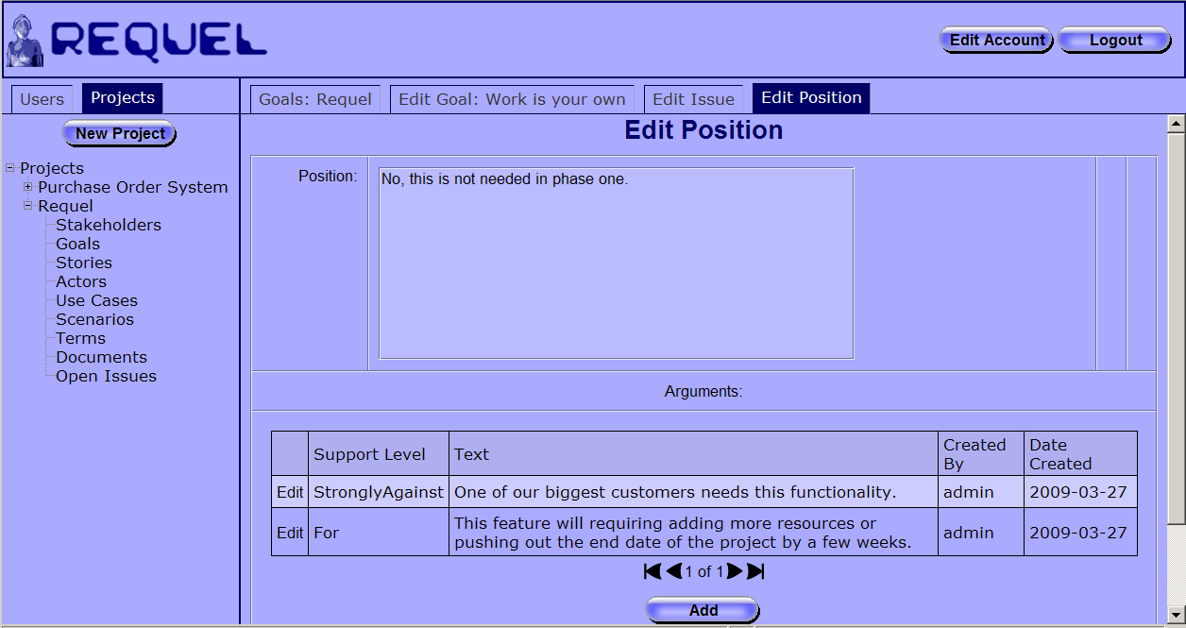
Figure 54: Position Editor
Arguments are the reasons why a particular position of an issue should or should not be chosen as the solution. Arguments have text description and a support level with values from “strongly against” to “strongly for.” Clicking the add or edit button opens the argument editor shown in Figure 55. The argument editor has a field for entering the text of the argument and a drop down list with the support levels.
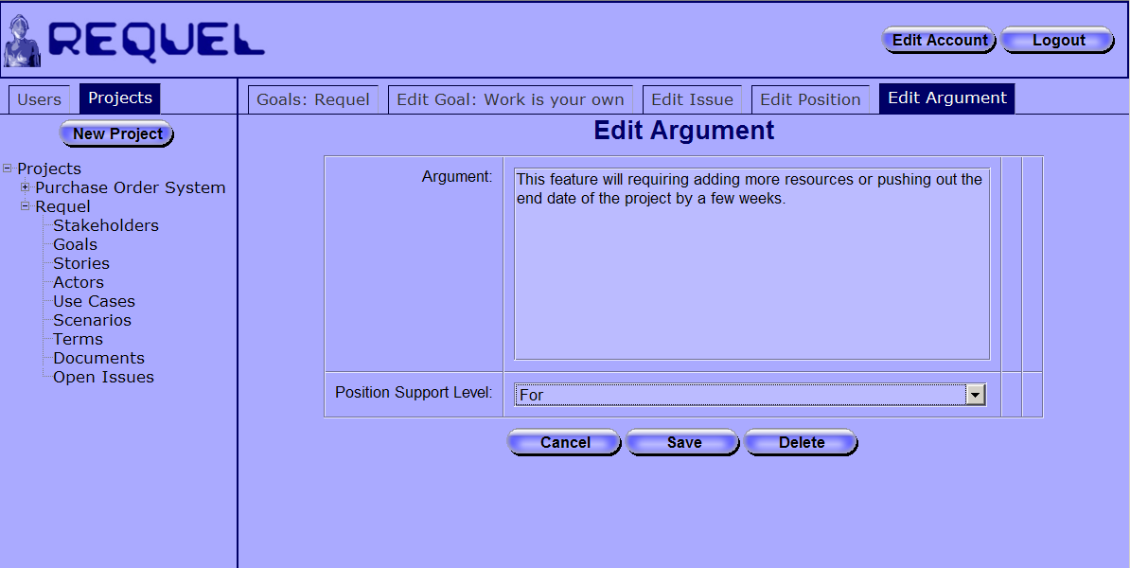
Figure 55: Argument Editor
All the open issues for all the elements of a project can be seen on the “Open Issues” screen as shown in Figure 56. The screen can be opened from the project navigator “Open Issues” link. The issues screen has a “View” link for each issue that opens the issue editor. The issues table has a column labeled “Annotatables” that lists out all of the requirements elements that are assigned to the issue.
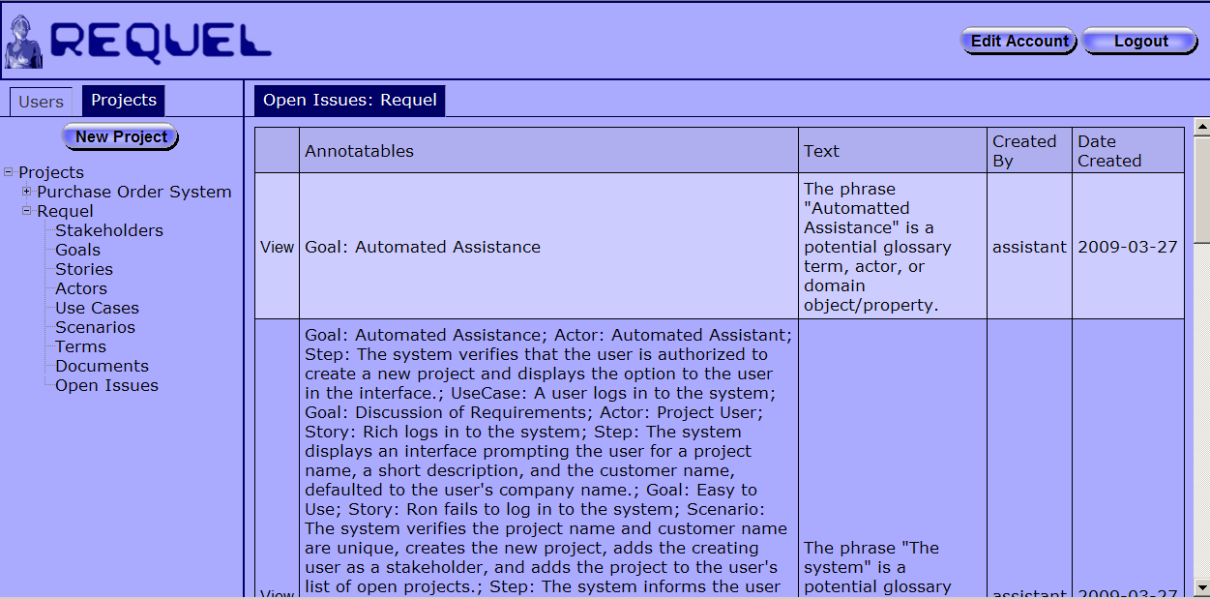
Figure 56: Open Issues

Working with Analysis Issues
Every time a requirement element is saved the system’s “Automated Assistant” analyses it and adds issues for potential problems or improvements. The issues will concern potential spelling errors or unfamiliar words, possible glossary terms and actors, complex sentences, and poorly structured scenario steps. Issues added during analysis will always have the “assistant” user as the creator as shown in the second column from the right in Figure 57.
Figure 57: Example Analysis Issue
The issues added by the assistant have specialized positions that automate the task described in the position. Figure 58 shows the positions of the issue “The phrase ‘a project’ is a potential glossary term, actor, or domain object” from Figure 57. The position “Ignore this phrase” resolves the issue without taking any action. The position “Add ‘a project’ to the project glossary” adds the term “a project” to the glossary and a reference to all the project elements that are assigned to the issue, when used to resolve the issue.
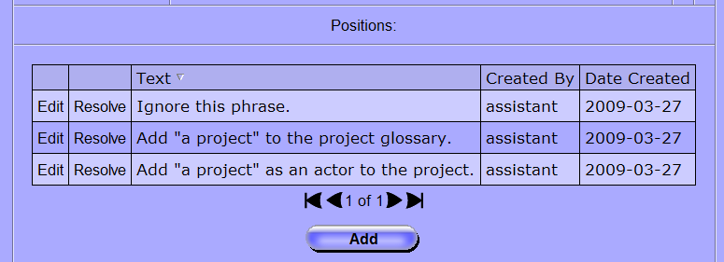
Figure 58: Example Analysis Positions
Table 2 lists the text of the special positions that invoke an automated task when used to resolve an issue.
Position Text | Action taken when the position is used to resolve the issue.
Add "…" to the project glossary. | Creates the term in the glossary and adds a reference to all the project elements that are assigned to the issue.
Add "…" as an actor to the project. | Creates a new actor in the project and adds a reference to all the project elements that are assigned to the issue.
Change the word "…" to "…". | Updates the name and text of all the requirement elements that are assigned to the issue to replace the original text with the new text.
Add "…" to the dictionary. | Adds the word to the systems global dictionary so that future occurrences of the word will not be identified as unknown.
Add the actor “…” to the use case. | Adds the actor to the auxiliary actors of the use case.
Change “…” to the primary actor. | Replaces the text in the scenario step with the name of the primary actor.
Table 2: Automated Task Positions

Requel Setup
This section describes the setup of the Requel system. The system is distributed as a Java Web Archive File (WAR) and requires only minimal configuration to setup.

System Requirements
Requel is a Web application implemented in the Java language and based on the Java Enterprise Edition (JEE5) platform, intended to run in a standard Web container. Requel requires the standard Sun Microsystems Java runtime version 6 update 4 or later to operate properly. Requel has dependencies on Sun’s virtual machine and will not work with a third-party virtual machine. Requel is known to work with versions 5.5 and 6.0 of the Apache Tomcat Web container.
Requel stores user and project data in a standard SQL database. It is known to work with MySQL Server version 5.0. The database initialization scripts may have MySQL specific syntax and commands, so using a different database my require converting the SQL syntax of the files.

Create a Database User
Before Requel can be installed a database user account must be created. Requel will use this account to create and initialize the database when first installed, and to update the requirements and user data during normal operation. It is important that the account has all privileges granted for the database that Requel will use.
The MySQL commands below create a user named ‘requel’ with the password ‘password’ and grants all privileges to that user for all objects in the database named ‘requeldb’. The database does not need to be created ahead of time; Requel will create it on the first startup if it doesn’t exist.
CREATE USER 'requel' IDENTIFIED BY 'password';
GRANT ALL PRIVILEGES ON requeldb.* TO requel;
FLUSH PRIVILEGES;

Figure 59 shows how to use the MySQL command line interface to login as the root user and create the Requel user. If the Web server and database server are on different physical servers, then in the create user and grant commands append the Web server hostname or IP address to the username. For example, requel@192.168.1.100.

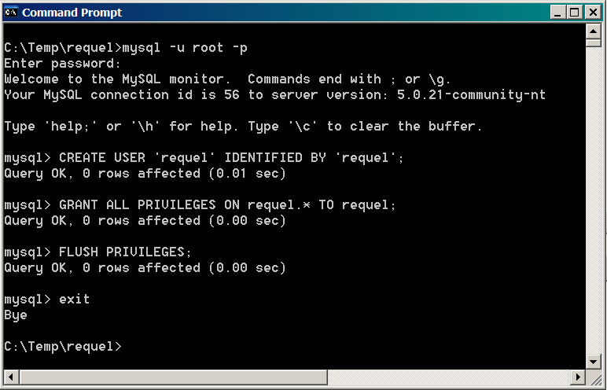
Figure 59: Create the Database User

Configuration
The Requel system requires minimal configuration to get running. The database settings are the only settings that must be configured before the system can be used and they should be configured before installing the WAR file in a Web server.
To configure the database settings the db.properties file must be unpacked from the WAR file. This can be done using the Java jar command as shown in Figure 60. Create a directory to hold the contents of the WAR file and copy the file into that directory. Use the jar command below to extract the file:
jar xvf requel.war WEB-INF\classes\db.properties

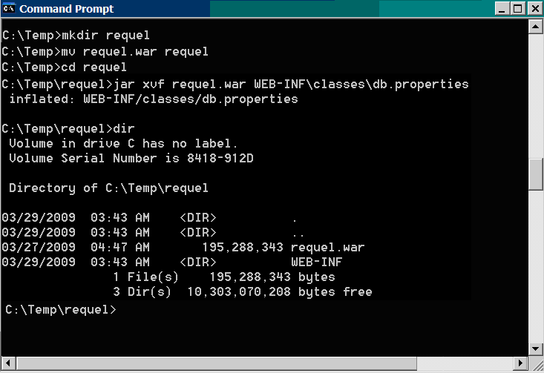
Figure 60: Extracting the db.properties file from the WAR File
When the jar command completes there will be a WEB-INF directory. Open the file WEB-INF\classes\db.properties in a text editor such as WordPad in Windows as shown in Figure 61. You will need to set the db.username, db.password, db.server, db.port, and db.name properties. Note: the Requel database user must have database creation permission if the database specified in the db.name property doesn’t already exist.
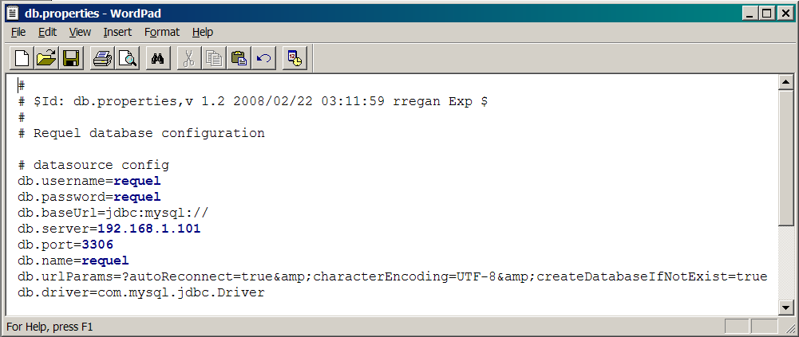
Figure 61: Editing the Database Properties
After saving the properties file, it must be added back to the WAR file. Use the jar command below to add the updated properties file to the war file as shown in Figure 62.
jar uvf requel.war WEB-INF\classes\db.properties

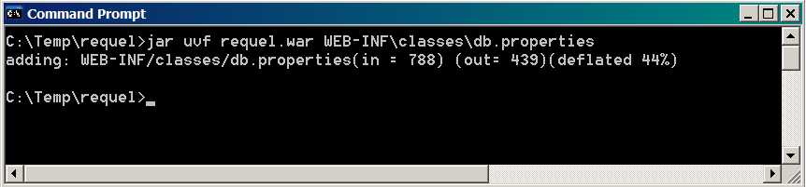
Figure 62: Updating the WAR file
The WAR file is now ready to be deployed to a Web server.

Deploying to Apache Tomcat
NOTE: The language processing library used by Requel require a lot of memory at start up and you will need to configure the Java runtime to allow up to a gigabyte of heap space before starting Tomcat. In Windows in a command window set the JAVA_OPTS environment variable like this: set JAVA_OPTS=-Xms512m -Xmx1000m. Then start the server using the startup script as shown in Figure 63.
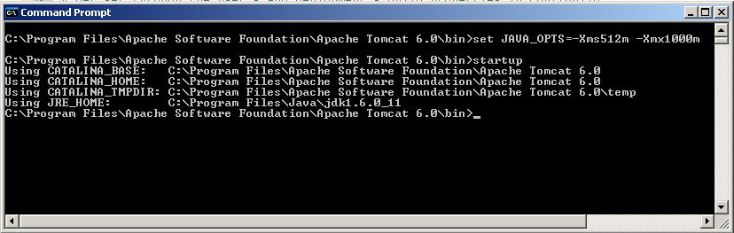
Figure 63: Configure Memory for Tomcat
Apache Tomcat is a freely available open source JEE Web container. Use the Web application manger that comes with Tomcat to deploy the Requel WAR file. Open a Web browser to the manager page of the Tomcat server. The server prompts you for a username and password and then displays the manager page as shown in Figure 64.

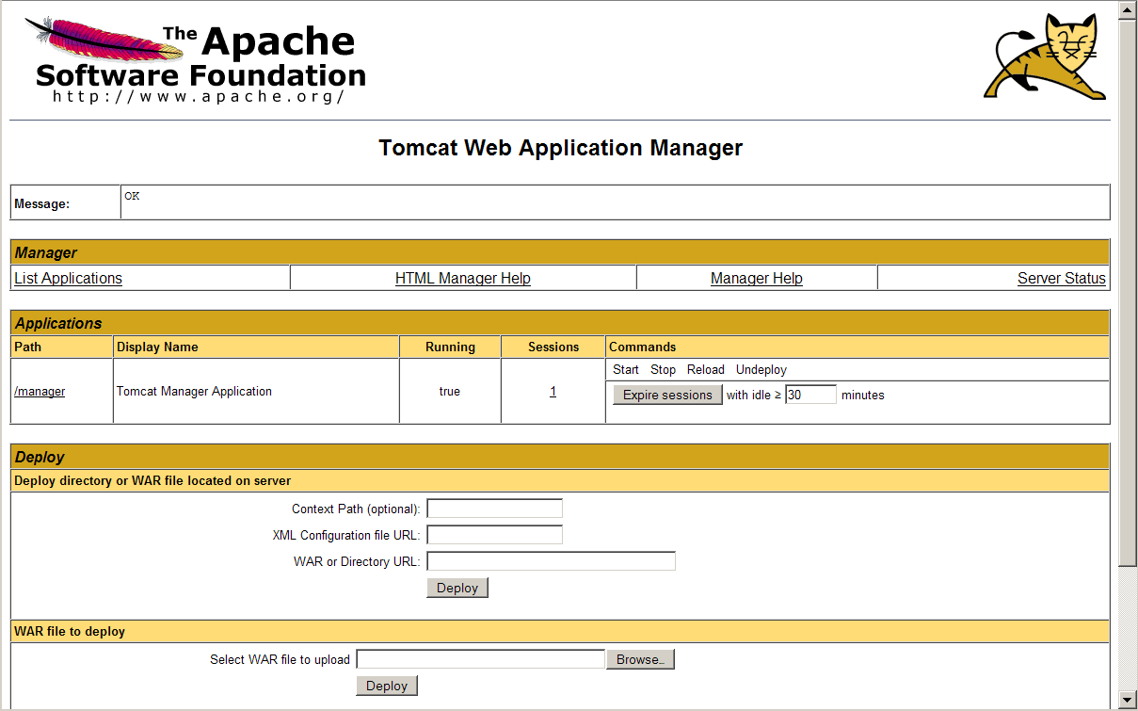
Figure 64: Apache Tomcat Manager
At the bottom of the page is the WAR file deployment form as shown in Figure 65. Use the browse button to locate the Requel WAR file with the updated database properties and then click the Deploy button to upload and install the application. It will typically take from between five and twenty minutes for Requel to create and initialize the database depending on the performance of the database server.
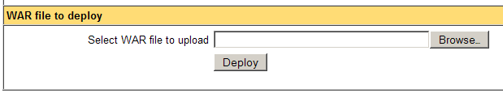
Figure 65: WAR File Deployment
When the deployment completes the application manager lists Requel in the applications section as shown in Figure 66. Clicking the “/requel” link in the “Path” column of the table connects to Requel and the login screen should appear as shown in Figure 1. You should record the URL from the address bar of the Web browser to send to users for accessing the system.
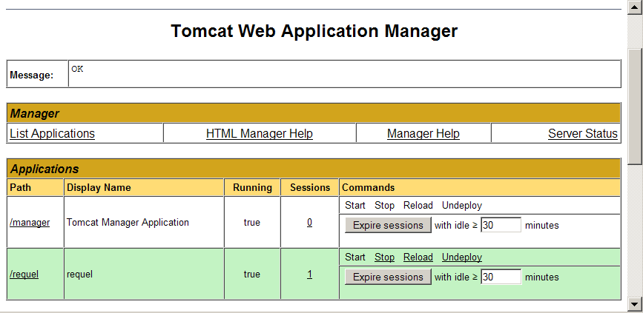
Figure 66: Requel in the Tomcat Application Manager

Completing the Setup
The first thing to do when the system is ready for access is to login using the built-in administrator account and change the password. The username and password are both set to ‘admin’ when the system is initialized. See the User Administration section for instructions on changing the password. You should also change the password of the built-in project and assistant users.
The system is now ready to be used. The next step is creating accounts for the users to access the system. See the User Administration section for instructions on creating users.

User Administration
The primary task of system administrators is creating and managing users. System users with the system administrator role are authorized to edit user accounts for all users, and to add new users.
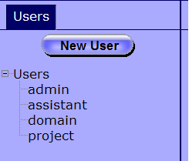
Figure 67: Users Navigation Tab
After logging in the left hand side of the screen will contain a tab labeled “Users” with a “New User” button for creating new users and tree containing all the users of the system as shown in Figure 67. Clicking the new user button opens the “New User” editor as shown in Figure 68. Clicking on a user name in the tree opens that user for editing. Each user must have a username, password, organization, email address, and at least one user role. The name and phone number are optional.
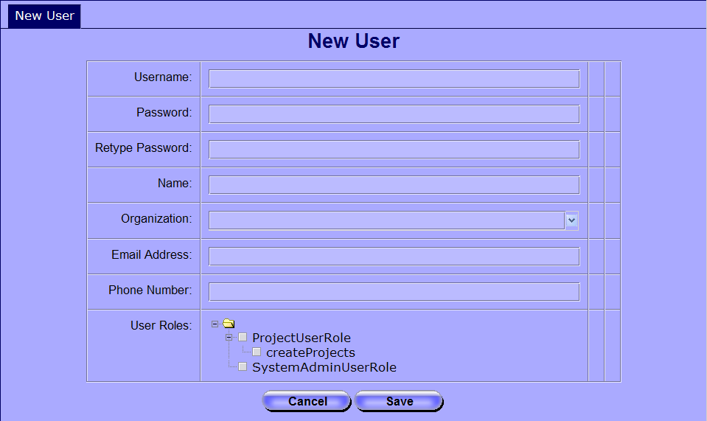
Figure 68: User Editor
The user name must be unique. If the chosen name is already in use by another user, the system reports an error message to the right of the username field as shown in Figure 69.
Figure 69: Username Already in Use
The user roles and permissions are used to authorize a user to access different features of the system. The “Project User Role” grants the user access to the project features of the system. The “Create Projects” permission under the project user role grants the user the ability to create new projects. The “System Admin User Role” grants the user access to the user administration function of the system. Figure 70 shows an example of a user with the project user role and permission to create new projects.
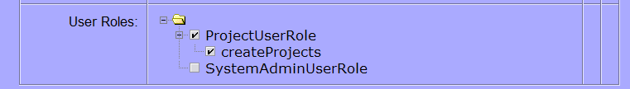
Figure 70: User Roles and Permissions
Roles and permissions can be changed after a user is created, but a user must always have at least one role. To disable a user’s access to the system the password should be reset.

GNU Free Documentation License
Version 1.3, 3 November 2008

Copyright © 2000, 2001, 2002, 2007, 2008 Free Software Foundation, Inc. <http://fsf.org/>

Everyone is permitted to copy and distribute verbatim copies of this license document, but changing it is not allowed.
0. PREAMBLE

The purpose of this License is to make a manual, textbook, or other functional and useful document "free" in the sense of freedom: to assure everyone the effective freedom to copy and redistribute it, with or without modifying it, either commercially or noncommercially. Secondarily, this License preserves for the author and publisher a way to get credit for their work, while not being considered responsible for modifications made by others.

This License is a kind of "copyleft", which means that derivative works of the document must themselves be free in the same sense. It complements the GNU General Public License, which is a copyleft license designed for free software.

We have designed this License in order to use it for manuals for free software, because free software needs free documentation: a free program should come with manuals providing the same freedoms that the software does. But this License is not limited to software manuals; it can be used for any textual work, regardless of subject matter or whether it is published as a printed book. We recommend this License principally for works whose purpose is instruction or reference.
1. APPLICABILITY AND DEFINITIONS

This License applies to any manual or other work, in any medium, that contains a notice placed by the copyright holder saying it can be distributed under the terms of this License. Such a notice grants a world-wide, royalty-free license, unlimited in duration, to use that work under the conditions stated herein. The "Document", below, refers to any such manual or work. Any member of the public is a licensee, and is addressed as "you". You accept the license if you copy, modify or distribute the work in a way requiring permission under copyright law.

A "Modified Version" of the Document means any work containing the Document or a portion of it, either copied verbatim, or with modifications and/or translated into another language.

A "Secondary Section" is a named appendix or a front-matter section of the Document that deals exclusively with the relationship of the publishers or authors of the Document to the Document's overall subject (or to related matters) and contains nothing that could fall directly within that overall subject. (Thus, if the Document is in part a textbook of mathematics, a Secondary Section may not explain any mathematics.) The relationship could be a matter of historical connection with the subject or with related matters, or of legal, commercial, philosophical, ethical or political position regarding them.

The "Invariant Sections" are certain Secondary Sections whose titles are designated, as being those of Invariant Sections, in the notice that says that the Document is released under this License. If a section does not fit the above definition of Secondary then it is not allowed to be designated as Invariant. The Document may contain zero Invariant Sections. If the Document does not identify any Invariant Sections then there are none.

The "Cover Texts" are certain short passages of text that are listed, as Front-Cover Texts or Back-Cover Texts, in the notice that says that the Document is released under this License. A Front-Cover Text may be at most 5 words, and a Back-Cover Text may be at most 25 words.

A "Transparent" copy of the Document means a machine-readable copy, represented in a format whose specification is available to the general public, that is suitable for revising the document straightforwardly with generic text editors or (for images composed of pixels) generic paint programs or (for drawings) some widely available drawing editor, and that is suitable for input to text formatters or for automatic translation to a variety of formats suitable for input to text formatters. A copy made in an otherwise Transparent file format whose markup, or absence of markup, has been arranged to thwart or discourage subsequent modification by readers is not Transparent. An image format is not Transparent if used for any substantial amount of text. A copy that is not "Transparent" is called "Opaque".

Examples of suitable formats for Transparent copies include plain ASCII without markup, Texinfo input format, LaTeX input format, SGML or XML using a publicly available DTD, and standard-conforming simple HTML, PostScript or PDF designed for human modification. Examples of transparent image formats include PNG, XCF and JPG. Opaque formats include proprietary formats that can be read and edited only by proprietary word processors, SGML or XML for which the DTD and/or processing tools are not generally available, and the machine-generated HTML, PostScript or PDF produced by some word processors for output purposes only.

The "Title Page" means, for a printed book, the title page itself, plus such following pages as are needed to hold, legibly, the material this License requires to appear in the title page. For works in formats which do not have any title page as such, "Title Page" means the text near the most prominent appearance of the work's title, preceding the beginning of the body of the text.

The "publisher" means any person or entity that distributes copies of the Document to the public.

A section "Entitled XYZ" means a named subunit of the Document whose title either is precisely XYZ or contains XYZ in parentheses following text that translates XYZ in another language. (Here XYZ stands for a specific section name mentioned below, such as "Acknowledgements", "Dedications", "Endorsements", or "History".) To "Preserve the Title" of such a section when you modify the Document means that it remains a section "Entitled XYZ" according to this definition.

The Document may include Warranty Disclaimers next to the notice which states that this License applies to the Document. These Warranty Disclaimers are considered to be included by reference in this License, but only as regards disclaiming warranties: any other implication that these Warranty Disclaimers may have is void and has no effect on the meaning of this License.
2. VERBATIM COPYING

You may copy and distribute the Document in any medium, either commercially or non-commercially, provided that this License, the copyright notices, and the license notice saying this License applies to the Document are reproduced in all copies, and that you add no other conditions whatsoever to those of this License. You may not use technical measures to obstruct or control the reading or further copying of the copies you make or distribute. However, you may accept compensation in exchange for copies. If you distribute a large enough number of copies you must also follow the conditions in section 3.

You may also lend copies, under the same conditions stated above, and you may publicly display copies.
3. COPYING IN QUANTITY

If you publish printed copies (or copies in media that commonly have printed covers) of the Document, numbering more than 100, and the Document's license notice requires Cover Texts, you must enclose the copies in covers that carry, clearly and legibly, all these Cover Texts: Front-Cover Texts on the front cover, and Back-Cover Texts on the back cover. Both covers must also clearly and legibly identify you as the publisher of these copies. The front cover must present the full title with all words of the title equally prominent and visible. You may add other material on the covers in addition. Copying with changes limited to the covers, as long as they preserve the title of the Document and satisfy these conditions, can be treated as verbatim copying in other respects.

If the required texts for either cover are too voluminous to fit legibly, you should put the first ones listed (as many as fit reasonably) on the actual cover, and continue the rest onto adjacent pages.

If you publish or distribute Opaque copies of the Document numbering more than 100, you must either include a machine-readable Transparent copy along with each Opaque copy, or state in or with each Opaque copy a computer-network location from which the general network-using public has access to download using public-standard network protocols a complete Transparent copy of the Document, free of added material. If you use the latter option, you must take reasonably prudent steps, when you begin distribution of Opaque copies in quantity, to ensure that this Transparent copy will remain thus accessible at the stated location until at least one year after the last time you distribute an Opaque copy (directly or through your agents or retailers) of that edition to the public.

It is requested, but not required, that you contact the authors of the Document well before redistributing any large number of copies, to give them a chance to provide you with an updated version of the Document.
4. MODIFICATIONS

You may copy and distribute a Modified Version of the Document under the conditions of sections 2 and 3 above, provided that you release the Modified Version under precisely this License, with the Modified Version filling the role of the Document, thus licensing distribution and modification of the Modified Version to whoever possesses a copy of it. In addition, you must do these things in the Modified Version:

* A. Use in the Title Page (and on the covers, if any) a title distinct from that of the Document, and from those of previous versions (which should, if there were any, be listed in the History section of the Document). You may use the same title as a previous version if the original publisher of that version gives permission.
* B. List on the Title Page, as authors, one or more persons or entities responsible for authorship of the modifications in the Modified Version, together with at least five of the principal authors of the Document (all of its principal authors, if it has fewer than five), unless they release you from this requirement.
* C. State on the Title page the name of the publisher of the Modified Version, as the publisher.
* D. Preserve all the copyright notices of the Document.
* E. Add an appropriate copyright notice for your modifications adjacent to the other copyright notices.
* F. Include, immediately after the copyright notices, a license notice giving the public permission to use the Modified Version under the terms of this License, in the form shown in the Addendum below.
* G. Preserve in that license notice the full lists of Invariant Sections and required Cover Texts given in the Document's license notice.
* H. Include an unaltered copy of this License.
* I. Preserve the section Entitled "History", Preserve its Title, and add to it an item stating at least the title, year, new authors, and publisher of the Modified Version as given on the Title Page. If there is no section Entitled "History" in the Document, create one stating the title, year, authors, and publisher of the Document as given on its Title Page, then add an item describing the Modified Version as stated in the previous sentence.
* J. Preserve the network location, if any, given in the Document for public access to a Transparent copy of the Document, and likewise the network locations given in the Document for previous versions it was based on. These may be placed in the "History" section. You may omit a network location for a work that was published at least four years before the Document itself, or if the original publisher of the version it refers to gives permission.
* K. For any section Entitled "Acknowledgements" or "Dedications", Preserve the Title of the section, and preserve in the section all the substance and tone of each of the contributor acknowledgements and/or dedications given therein.
* L. Preserve all the Invariant Sections of the Document, unaltered in their text and in their titles. Section numbers or the equivalent are not considered part of the section titles.
* M. Delete any section Entitled "Endorsements". Such a section may not be included in the Modified Version.
* N. Do not retitle any existing section to be Entitled "Endorsements" or to conflict in title with any Invariant Section.
* O. Preserve any Warranty Disclaimers.

If the Modified Version includes new front-matter sections or appendices that qualify as Secondary Sections and contain no material copied from the Document, you may at your option designate some or all of these sections as invariant. To do this, add their titles to the list of Invariant Sections in the Modified Version's license notice. These titles must be distinct from any other section titles.

You may add a section Entitled "Endorsements", provided it contains nothing but endorsements of your Modified Version by various parties—for example, statements of peer review or that the text has been approved by an organization as the authoritative definition of a standard.

You may add a passage of up to five words as a Front-Cover Text, and a passage of up to 25 words as a Back-Cover Text, to the end of the list of Cover Texts in the Modified Version. Only one passage of Front-Cover Text and one of Back-Cover Text may be added by (or through arrangements made by) any one entity. If the Document already includes a cover text for the same cover, previously added by you or by arrangement made by the same entity you are acting on behalf of, you may not add another; but you may replace the old one, on explicit permission from the previous publisher that added the old one.

The author(s) and publisher(s) of the Document do not by this License give permission to use their names for publicity for or to assert or imply endorsement of any Modified Version.
5. COMBINING DOCUMENTS

You may combine the Document with other documents released under this License, under the terms defined in section 4 above for modified versions, provided that you include in the combination all of the Invariant Sections of all of the original documents, unmodified, and list them all as Invariant Sections of your combined work in its license notice, and that you preserve all their Warranty Disclaimers.

The combined work need only contain one copy of this License, and multiple identical Invariant Sections may be replaced with a single copy. If there are multiple Invariant Sections with the same name but different contents, make the title of each such section unique by adding at the end of it, in parentheses, the name of the original author or publisher of that section if known, or else a unique number. Make the same adjustment to the section titles in the list of Invariant Sections in the license notice of the combined work.

In the combination, you must combine any sections Entitled "History" in the various original documents, forming one section Entitled "History"; likewise combine any sections Entitled "Acknowledgements", and any sections Entitled "Dedications". You must delete all sections Entitled "Endorsements".
6. COLLECTIONS OF DOCUMENTS

You may make a collection consisting of the Document and other documents released under this License, and replace the individual copies of this License in the various documents with a single copy that is included in the collection, provided that you follow the rules of this License for verbatim copying of each of the documents in all other respects.

You may extract a single document from such a collection, and distribute it individually under this License, provided you insert a copy of this License into the extracted document, and follow this License in all other respects regarding verbatim copying of that document.
7. AGGREGATION WITH INDEPENDENT WORKS

A compilation of the Document or its derivatives with other separate and independent documents or works, in or on a volume of a storage or distribution medium, is called an "aggregate" if the copyright resulting from the compilation is not used to limit the legal rights of the compilation's users beyond what the individual works permit. When the Document is included in an aggregate, this License does not apply to the other works in the aggregate which are not themselves derivative works of the Document.

If the Cover Text requirement of section 3 is applicable to these copies of the Document, then if the Document is less than one half of the entire aggregate, the Document's Cover Texts may be placed on covers that bracket the Document within the aggregate, or the electronic equivalent of covers if the Document is in electronic form. Otherwise they must appear on printed covers that bracket the whole aggregate.
8. TRANSLATION

Translation is considered a kind of modification, so you may distribute translations of the Document under the terms of section 4. Replacing Invariant Sections with translations requires special permission from their copyright holders, but you may include translations of some or all Invariant Sections in addition to the original versions of these Invariant Sections. You may include a translation of this License, and all the license notices in the Document, and any Warranty Disclaimers, provided that you also include the original English version of this License and the original versions of those notices and disclaimers. In case of a disagreement between the translation and the original version of this License or a notice or disclaimer, the original version will prevail.

If a section in the Document is Entitled "Acknowledgements", "Dedications", or "History", the requirement (section 4) to Preserve its Title (section 1) will typically require changing the actual title.
9. TERMINATION

You may not copy, modify, sublicense, or distribute the Document except as expressly provided under this License. Any attempt otherwise to copy, modify, sublicense, or distribute it is void, and will automatically terminate your rights under this License.

However, if you cease all violation of this License, then your license from a particular copyright holder is reinstated (a) provisionally, unless and until the copyright holder explicitly and finally terminates your license, and (b) permanently, if the copyright holder fails to notify you of the violation by some reasonable means prior to 60 days after the cessation.

Moreover, your license from a particular copyright holder is reinstated permanently if the copyright holder notifies you of the violation by some reasonable means, this is the first time you have received notice of violation of this License (for any work) from that copyright holder, and you cure the violation prior to 30 days after your receipt of the notice.

Termination of your rights under this section does not terminate the licenses of parties who have received copies or rights from you under this License. If your rights have been terminated and not permanently reinstated, receipt of a copy of some or all of the same material does not give you any rights to use it.
10. FUTURE REVISIONS OF THIS LICENSE

The Free Software Foundation may publish new, revised versions of the GNU Free Documentation License from time to time. Such new versions will be similar in spirit to the present version, but may differ in detail to address new problems or concerns. See http://www.gnu.org/copyleft/.

Each version of the License is given a distinguishing version number. If the Document specifies that a particular numbered version of this License "or any later version" applies to it, you have the option of following the terms and conditions either of that specified version or of any later version that has been published (not as a draft) by the Free Software Foundation. If the Document does not specify a version number of this License, you may choose any version ever published (not as a draft) by the Free Software Foundation. If the Document specifies that a proxy can decide which future versions of this License can be used, that proxy's public statement of acceptance of a version permanently authorizes you to choose that version for the Document.
11. RELICENSING

"Massive Multiauthor Collaboration Site" (or "MMC Site") means any World Wide Web server that publishes copyrightable works and also provides prominent facilities for anybody to edit those works. A public wiki that anybody can edit is an example of such a server. A "Massive Multiauthor Collaboration" (or "MMC") contained in the site means any set of copyrightable works thus published on the MMC site.

"CC-BY-SA" means the Creative Commons Attribution-Share Alike 3.0 license published by Creative Commons Corporation, a not-for-profit corporation with a principal place of business in San Francisco, California, as well as future copyleft versions of that license published by that same organization.

"Incorporate" means to publish or republish a Document, in whole or in part, as part of another Document.

An MMC is "eligible for relicensing" if it is licensed under this License, and if all works that were first published under this License somewhere other than this MMC, and subsequently incorporated in whole or in part into the MMC, (1) had no cover texts or invariant sections, and (2) were thus incorporated prior to November 1, 2008.

The operator of an MMC Site may republish an MMC contained in the site under CC-BY-SA on the same site at any time before August 1, 2009, provided the MMC is eligible for relicensing.
ADDENDUM: How to use this License for your documents

To use this License in a document you have written, include a copy of the License in the document and put the following copyright and license notices just after the title page:

Copyright (C) YEAR YOUR NAME.
Permission is granted to copy, distribute and/or modify this document
under the terms of the GNU Free Documentation License, Version 1.3
or any later version published by the Free Software Foundation;
with no Invariant Sections, no Front-Cover Texts, and no Back-Cover Texts.
A copy of the license is included in the section entitled "GNU
Free Documentation License".

If you have Invariant Sections, Front-Cover Texts and Back-Cover Texts, replace the "with … Texts." line with this:

with the Invariant Sections being LIST THEIR TITLES, with the
Front-Cover Texts being LIST, and with the Back-Cover Texts being LIST.

If you have Invariant Sections without Cover Texts, or some other combination of the three, merge those two alternatives to suit the situation.

If your document contains nontrivial examples of program code, we recommend releasing these examples in parallel under your choice of free software license, such as the GNU General Public License, to permit their use in free software.

