Requel Setup
This section describes the setup of the Requel system. The system is distributed as a Java Web archive file and requires only minimal configuration to setup.

System Requirements
Requel is a Web application implemented in the Java language and based on the Java Enterprise Edition (JEE5) platform, intended to run in a standard Web container. Requel requires the standard Sun Microsystems Java runtime version 6 update 4 or later to operate properly. Requel has dependencies on Sun’s virtual machine and will not work with a third-party virtual machine. Requel is known to work with versions 5.5 and 6.0 of the Apache Tomcat Web container.
Requel stores user and project data in a standard SQL database. It is known to work with MySQL Server version 5.0. The database initialization scripts may have MySQL specific syntax and commands and the configuration

Create a Database User
Before Requel can be installed a database user account must be created. Requel will use this user account to create and initialize the database when first installed, and to update the requirements and user data during normal operation. It is important that the user has all privileges granted to the database name that Requel will use.
The MySQL commands below create a user named ‘requel’ with the password ‘password’ and grants all privileges to that user for all objects in the database named ‘requeldb’. The database should not be created ahead of time; Requel will create it on the first start.
CREATE USER 'requel' IDENTIFIED BY 'password';
GRANT ALL PRIVILEGES ON requeldb.* TO requel;
FLUSH PRIVILEGES;

Figure 1 shows how to use the MySQL command line interface to login as the root user and create the user. If the Web server and database server are on different physical servers, then in the create user and grant commands append the Web server hostname or IP address to the username. For example, requel@192.168.1.100.

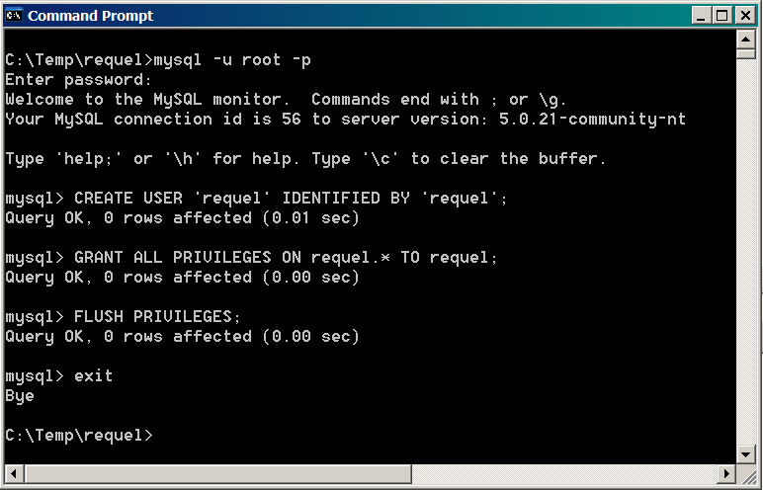
Figure 1: Create the Database User

Configuration
The Requel system requires minimal configuration to get running. The database settings are the only settings that must be configured before the system can be used and they should be configured before installing the system in a Web server.
To configure the database settings the db.properties file must be unpacked from the war file. This can be done using the Java jar command as shown in Figure 2. Create a directory to hold the contents of the war file and copy the war file into that directory. Use the jar command below to extract the file:
jar xvf requel.war WEB-INF\classes\db.properties
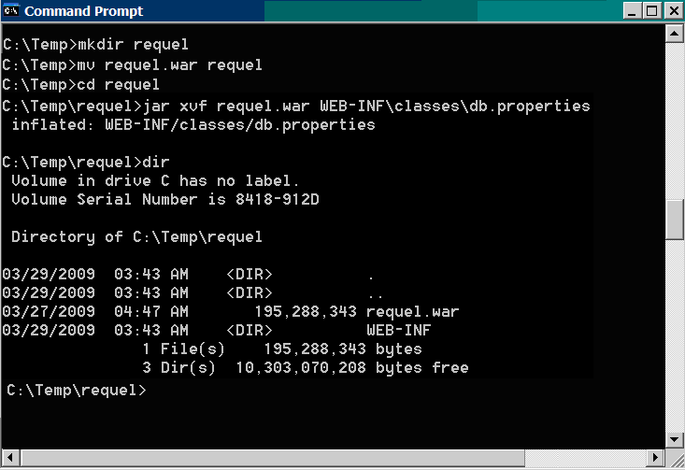
Figure 2: Extracting the db.properties file from the WAR File
When the jar command completes there will be a WEB-INF directory. Open the file WEB-INF\classes\db.properties in a text editor such as WordPad in Windows as shown in Figure 3. You will need to set the db.username, db.password, db.server, db.port, and db.name properties. The database user must have database creation permission if the database specified in the db.name property doesn’t already exist.
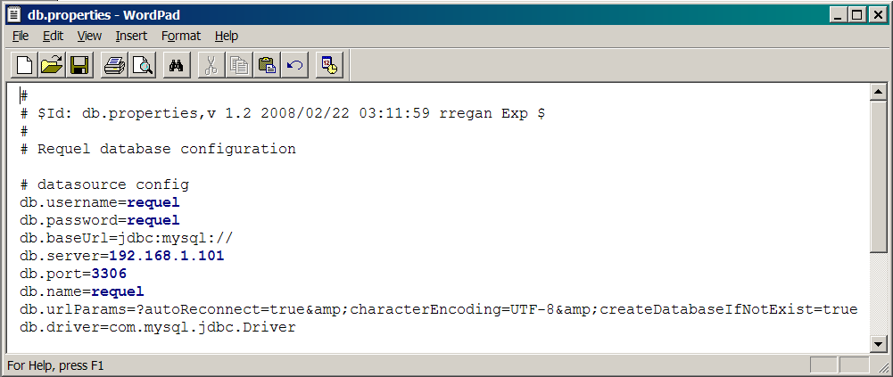
Figure 3: Editing the Database Properties
After saving the properties file, it must be added back to the war file. Use the jar command below to add the updated properties file to the war file as shown in Figure 4.
jar uvf requel.war WEB-INF\classes\db.properties

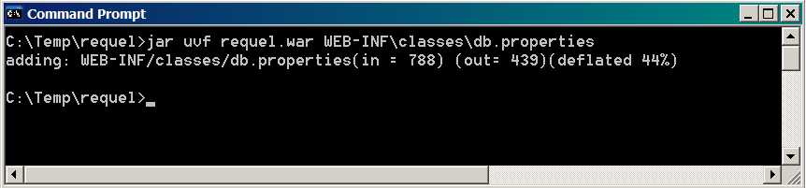
Figure 4: Updating the WAR file
The war file is now ready to be deployed to a Web server.

Deploying to Apache Tomcat
Tomcat is a freely available open source JEE Web container. Use the Web application manger that comes with Tomcat to deploy the Requel war. Open a Web browser to the manager page of the Tomcat server. The server prompts you for a username and password and then displays the manager page as shown in Figure 5.

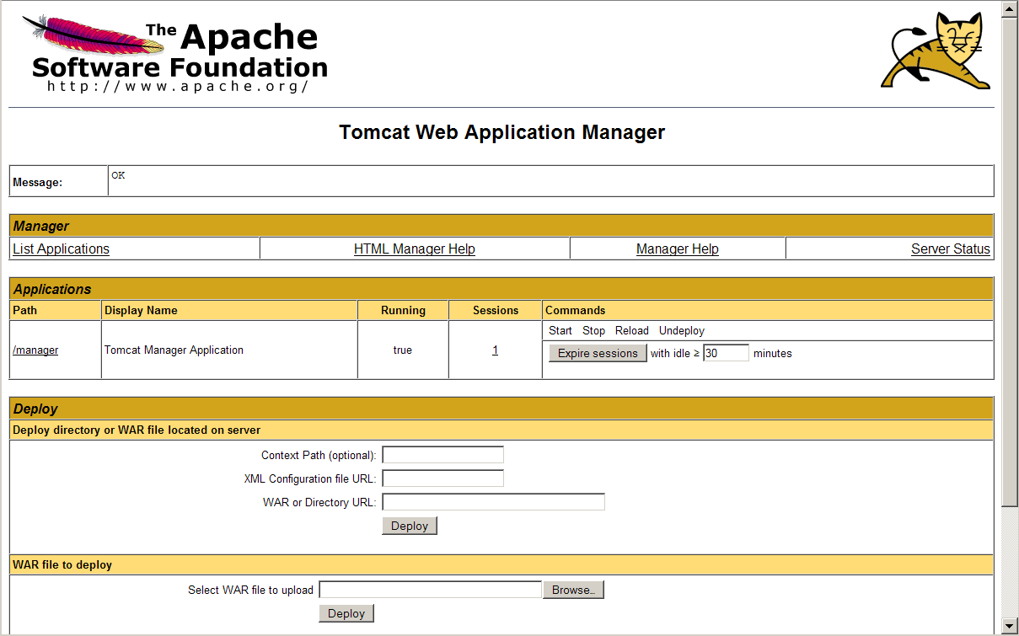
Figure 5: Apache Tomcat Manager
At the bottom of the page is the war file deployment form as shown in Figure 6. Use the browse button to locate the Requel war file with the updated database properties and then click the Deploy button to upload and install the application. It will typically take from between five and twenty minutes for Requel to create and initialize the database depending on the performance of the database server.
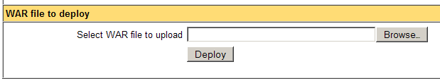
Figure 6: WAR File Deployment
When the deployment completes the application manager lists Requel in the applications section as shown in Figure 7. Clicking the “/requel” link in the “Path” column of the table connects to Requel and the login screen should appear as shown in Error: Reference source not found. You should record the URL from the address bar of the Web browser to send to users for accessing the system.
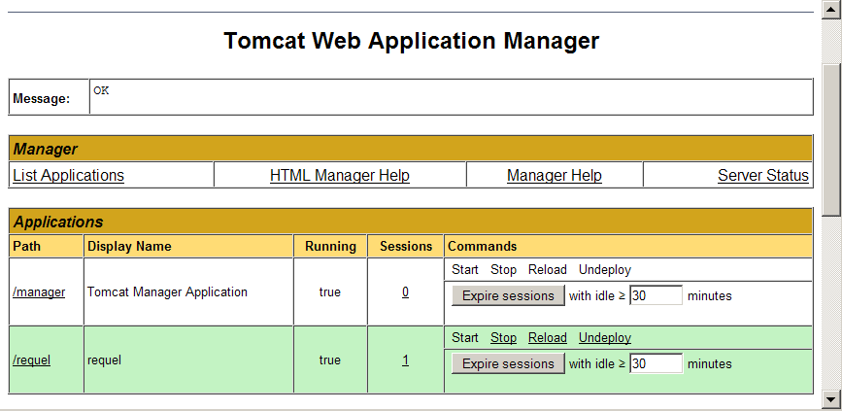
Figure 7: Requel in the Tomcat Application Manager

Completing the Setup
The first thing to do when the system is ready for access is to login using the built-in administrator account and change the password. The username and password are both set to ‘admin’ when the system is initialized. See the User Administration section for instructions on changing the password. You should also change the password of the built-in project and assistant users.
The system is now ready to be used. The next step is creating accounts for the users to access the system. See the User Administration section for instructions on creating users.

User Administration
The primary task of system administrators is creating and managing users. System users with the system administrator role are authorized to edit user accounts for all users, and to add new users.
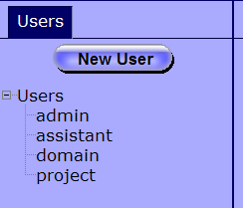
Figure 8: Users Navigation Tab
After logging in the left hand side of the screen will contain a tab labeled “Users” with a “New User” button for creating new users and tree containing all the users of the system as shown in Figure 8. Clicking the new user button opens the “New User” editor as shown in Figure 9. Clicking on a user name in the tree opens that user for editing. Each user must have a username, password, organization, email address, and at least one user role. The name and phone number are optional.
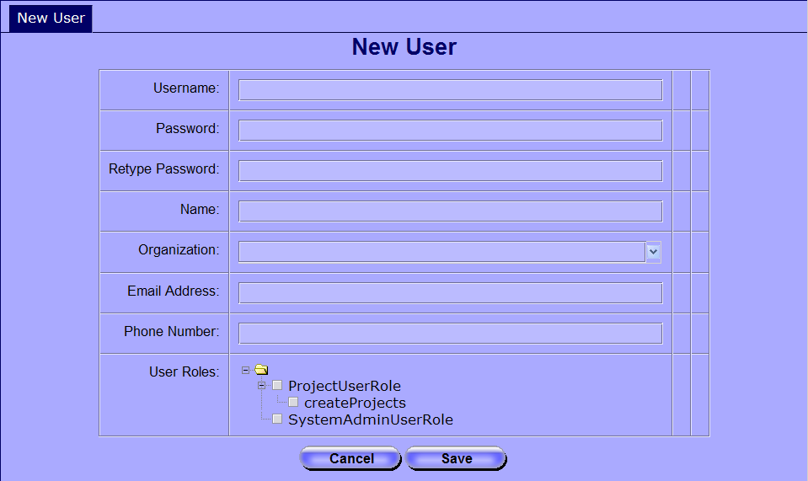
Figure 9: User Editor
The user name must be unique. If the chosen name is already in use by another user, the system reports an error message to the right of the username field as shown in Figure 10.
Figure 10: Username Already in Use
The user roles and permissions are used to authorize the user access to different features of the system. The “Project User Role” grants the user access to the project features of the system. The “Create Projects” permission under the project user role grants the user the ability to create new projects. The “System Admin User Role” grants the user access to the user administration function of the system. Figure 11 shows an example of a user with the project user role and permission to create new projects.
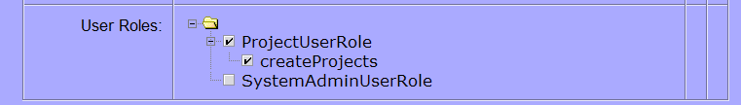
Figure 11: User Roles and Permissions
Roles and permissions can be changed after a user is created, but a user must always have at least one role. To disable a user’s access to the system the password should be reset.

