Proposal for a
Thesis in the Field of
Information Technology
In Partial Fulfillment of the Requirements
For a Master of Liberal Arts Degree

Harvard University
Extension School
January 25, 2008

Ron Regan Jr.
73 Bailey Road
Somerville MA 02145
Work: 781-645-1472
Home: 617-623-1245
rreganjr@acm.org
Proposed Start Date: February 4, 2008
Anticipated Date of Graduation: June, 2009
Thesis Director: Bill Robinson

Tentative Thesis Title
Requel: A collaborative system for the elicitation and analysis of requirements as use-cases with assistance from automated assistants.

Abstract
Use-cases are a simple and effective tool for describing the behavioral aspects of a software system, but writing good quality use-cases can be difficult for the uninitiated. I am proposing a system where all stakeholders can collaborate to create better quality use-cases, supported by automated assistants that analyze the use-cases to suggest improvements and point out problems.
Stakeholder involvement is a critical factor in creating correct requirements because requirements engineering is fundamentally a knowledge sharing activity. Business stakeholders must communicate knowledge about their domain and goals so that developers can understand the product being developed in the context where it will be used. Unfortunately, on many projects direct interaction between business and developer stakeholder is limited to occasional meetings. Communication between stakeholders mostly comes in an indirect form such as documentation or messages passed through a requirements engineer or project manager. The proposed system will give all the stakeholders a platform to communicate more directly with each other while developing use-cases.
Use-cases are conceptually simple, but writing good quality use-cases that are precise, unambiguous, understandable, consistent and correct can be difficult, especially for users with little or no experience writing use-cases. The automated assistants will use knowledge about writing use-cases, requirements engineering methods, and the application domain to assist users to be more productive. As a user works with the system, the assistants will interpret and analyze the user’s text for well-formedness and semantic information. The assistants will then make suggestions on how to improve the structure of the information, what the user should do next, and make comments or ask questions about possibly missing or conflicting information relevant to the domain.
The proposed system will have a web-based interface to make it easy to support a distributed team environment and simple to manage. Because the system supports only part of the requirements engineering process, the system will support an interface for importing and exporting data to integrate with other tools. To support use-cases, which are defined in natural language, the automated assistants will need to be able to parse and understand the content to be helpful. This requires translating natural language of the use-cases into a knowledge representation such as a logic-based language and holding the state of the use-cases and domain knowledge in a knowledge-base that can be queried and evaluated by a reasoning engine. I expect to use open source language processing tools and an open source knowledge-base instead of writing my own.

Table of Contents
1 Tentative Thesis Title 2
2 Abstract 2
3 Table of Contents 3
4 Thesis Project Description 8
4.1 Requirements Engineering 9
4.1.1 What is Requirements Engineering 9
4.1.2 Decomposing Requirements Engineering 10
4.1.3 Context 10
4.1.4 Communication 10
4.1.5 Documentation 11
4.1.6 Acquisition 11
4.1.7 Analysis and Modeling 14
4.1.8 Measurement 14
4.1.9 Methods and Techniques 15
4.2 Related Tools 16
4.2.1 The Requirements Apprentice 17
4.2.2 UC Workbench 18
4.2.3 Procasor 19
4.2.4 Requirements Assistant for Telecommunication Services (RATS) 20
4.2.5 gIBIS 20
4.2.6 EColabor and Tuiqiao 20
4.2.7 CREWS 21
5 Requirements 22
5.1 Goals 22
5.2 Contextual Stories 25
5.2.1 Example: Poor Communication 25
5.3 Actors 26
5.3.1 Interactive User (Person) 26
5.3.2 Project User/Stakeholder 26
5.3.3 System Administrator 28
5.3.4 Domain Administrator 28
5.3.5 Automated Assistant 29
5.3.6 External Tool 29
5.4 Interactive User - Use Cases 29
5.4.1 Use Case: Login to the system 29
5.4.2 Use Case: Confirm/Setup user account 31
5.4.3 Use Case: Edit user account 32
5.5 Project User - Use Cases 32
5.5.1 Summary Case: Use the Requel System to Create Requirements 32
5.5.2 Use Case: Create a new project 33
5.5.3 Use Case: Select an open project 35
5.5.4 Use Case: Open a closed project 36
5.5.5 Use Case: Create/Edit a stakeholder 37
5.5.6 Use Case: Invite a stakeholder to be a user 41
5.5.7 Use Case: Create/Edit a goal 42
5.5.8 Use Case: Add/edit a relationship between two goals 43
5.5.9 Use Case: Create/Edit a story 44
5.5.10 Use Case: Create/Edit an actor 45
5.5.11 Use Case: Create/Edit a persona 47
5.5.12 Use Case: Create a use-case 48
5.5.13 Summary Case: Edit a use-case 49
5.5.14 Use Case: Add a goal to a use-case 50
5.5.15 Use Case: Add a story to a use-case 51
5.5.16 Use Case: Add a secondary actor to the use-case 51
5.5.17 Summary Case: Create/Edit a scenario 52
5.5.18 Use Case: Add/Edit/Remove a step to/of a scenario 53
5.5.19 Use Case: Refer a step to another use case 55
5.5.20 Use Case: Create/Edit a pre/post-condition of a use-case 55
5.5.21 Use Case: Add/Edit the effort estimate on a use-case 56
5.5.22 Use Case: Remove a story, goal, or actor from a use-case 56
5.5.23 Use Case: Mark a use-case as out of scope 57
5.5.24 Use Case: Copy a use-case/scenario 57
5.5.25 Summary Case: Discuss/negotiate entities 57
5.5.26 Use Case: Annotate an entity with a note or issue 58
5.5.27 Use Case: Change the type of an annotation 60
5.5.28 Use Case: Propose a Position/Answer to an issue 61
5.5.29 Use Case: Propose an argument to a position/answer 63
5.5.30 Use Case: Select a Position/Answer as a resolution to an issue 64
5.5.31 Use Case: Unselect a Position/Answer as a resolution to an issue 64
5.5.32 Use Case: Attach a document/diagram to the project 65
5.5.33 Use Case: Add an entry to the dictionary 65
5.5.34 Use Case: Add/edit an entry to/in the glossary of a project 66
5.5.35 Use Case: Link two glossary entries 67
5.5.36 Use Case: Replace a glossary entry by another entry 67
5.5.37 Use Case: Remove a glossary entry 68
5.5.38 Use Case: Add/edit an entry to/in the object model of a project 68
5.5.39 Use Case: Review the history of a project entity 68
5.5.40 Use Case: Review the open issues of a project 69
5.5.41 Use Case: Review the differences between two revisions of an entity 69
5.5.42 Use Case: Review the dependencies of an entity 70
5.5.43 Use Case: View and restore deleted project entities 70
5.5.44 Use Case: Generate requirements documentation for a project 70
5.5.45 Use Case: Export a project in XML format 71
5.6 Automated Assistant - Use Cases 71
5.6.1 Use Case: Analyze the syntax of the text of an entity 72
5.6.2 Use Case: Analyze the semantics of the text of an entity 73
5.6.3 Use Case: Analyze a story 73
5.6.4 Use Case: Analyze a goal 74
5.6.5 Use Case: Analyze a scenario step 74
5.6.6 Use Case: Analyze the structure of a project 75
5.6.7 Use Case: Analyze the structure of a scenario 75
5.6.8 Use Case: Warn about changes to related entities 75
5.6.9 Use Case: Add an item to the object model 75
5.7 System Administrator - Use Cases 76
5.7.1 Use Case: Create/Invite a user 76
5.7.2 Use Case: Edit a user 77
5.8 Domain Administrator - Use Cases 77
5.8.1 Summary Case: Create/edit an application domain. 77
5.8.2 Use Case: Create a new domain 78
5.8.3 Use Case: Open an existing domain 79
5.8.4 Use Case: Import a domain from a file 79
5.8.5 Use Case: Include contents of another domain 79
5.8.6 Use Case: Learn terms, rules and questions from a project 79
5.8.7 Use Case: Export the domain to an XML formatted file 79
5.9 Glossary 79
6 Problem Domain Model 84
6.1 User 84
6.1.1 Properties 84
6.2 Project User Role 85
6.3 System Admin User Role 85
6.4 Domain Admin User Role 85
6.5 Stakeholder 86
6.5.1 Properties 86
6.6 Stakeholder Role 86
6.6.1 Properties 87
6.7 Project Permission 87
6.7.1 Properties 87
6.8 Project Entity Type 87
6.8.1 Properties 87
6.9 Team 87
6.9.1 Properties 87
6.10 Project 88
6.10.1 Properties 88
6.11 Application Domain 90
6.11.1 Properties 90
6.12 Glossary 91
6.12.1 Properties 91
6.13 Glossary Entry 91
6.13.1 Properties 91
6.14 Problem Domain Model 92
6.14.1 Properties 92
6.15 Problem Domain Model Entry 92
6.15.1 Properties 92
6.16 Document 93
6.16.1 Properties 93
6.17 Goal 94
6.17.1 Properties 94
6.18 Goal Relationship 94
6.18.1 Properties 94
6.19 Story 95
6.19.1 Properties 95
6.20 Actor 95
6.20.1 Properties 95
6.21 Persona 95
6.21.1 Properties 95
6.22 Use Case 96
6.22.1 Properties 96
6.23 Scenario 97
6.23.1 Properties 97
6.24 Scenario Step 97
6.24.1 Properties 97
6.25 Condition (Pre- or Post-Condition) 98
6.25.1 Properties 98
6.26 Stateless Condition 98
6.27 Stateful Condition 98
6.27.1 Properties 98
6.28 Annotation 99
6.28.1 Properties 99
6.29 Annotatable 99
6.29.1 Properties 99
6.30 Note (Annotation) 99
6.31 Issue (Annotation) 99
6.31.1 Properties 99
6.32 Position (Answer) 100
6.32.1 Properties 100
6.33 Argument 100
6.33.1 Properties 100
6.34 Assistant 101
6.34.1 Properties 101
6.35 Rule 101
6.36 Syntax Assistant 101
6.37 Natural Language Processing (NLP) 102
6.38 Dictionary 102
6.38.1 Properties 103
6.39 Dictionary Term 103
6.39.1 Properties 103
6.40 Dictionary Term Sense 103
6.40.1 Properties 103
6.41 Semantic Assistant 103
6.42 Goal Assistant 103
6.43 Story Assistant 104
6.44 Step Assistant 104
6.45 Scenario Assistant 104
6.46 Use Case Assistant 104
6.47 Project Assistant 104
7 Approach 105
7.1 User Interface 105
7.2 Project Requirements Data 106
7.2.1 Data Management 107
7.2.2 Versioning 108
7.2.3 Integration, Import, and Export 111
7.3 Automated Assistants 113
7.3.1 Spelling and Dictionary 113
7.3.2 Natural Language Processing 113
7.3.3 Domain Knowledge 118
7.4 Architecture 123
7.5 Design 123
7.5.1 UI Framework 123
8 Work Plan 130
8.1 Assumptions, Risks and Alternatives 130
8.2 Preliminary Schedule 130
9 References 132

Thesis Project Description
In this thesis I am proposing a tool for the stakeholders of a software development project to collaboratively develop a set of software requirements as a set of use-cases with supporting goals, stories and a problem domain model. I am motivated to pursue this project because poor quality requirements have been a major issue on most of the projects on which I have participated as a software tester or developer. By poor quality I mean the requirements are often too vague and incomplete to implement or test; they are often hard to understand because of inconsistent or ambiguous use of terminology. Documents are often poorly organized, they become out dated quickly, and changes are rarely communicated to all stakeholders. As a software user it is frustrating to use software that doesn’t meet your needs; as software developer it is hard to write software if you don’t know what it is suppose to do at a fairly precise level; and as a software tester it is hard to know if the software is working correctly if you don’t know with certainty its intended use or expected behavior.
The primary goal of the thesis is creating a tool that will help the stakeholders of a project develop a set of good quality use-cases. The tool will allow all stakeholders to actively participate in the process of creating the use-cases. It will identify and communicate changes and issues to all the stakeholders in a timely manner. It will be flexible so that it can fit into different software engineering process with other tools and activities.
By good quality use-cases I mean that they will be:
- Well organized – everything that is needed to know about a particular use-case is kept together in the same use-case or clearly referred to in another location; all open issues and problems are clearly marked.
- Understandable and unambiguous – all stakeholders will understand and agree on the exact behavior of each use-case; all terminology that may be ambiguous or unfamiliar to any of the stakeholders is clearly defined in a glossary.
- Precise and complete – there is enough explicit information in the use-case that a developer can implement it and a tester can verify that the implementation behaves correctly.
Use-cases are conceptually simple but writing good quality use-cases that are precise, unambiguous, understandable, consistent and complete can be difficult. Especially for people with little or no experience writing use-cases or for people unfamiliar with the domain of the application being developed. To assist the users in writing good quality user-cases I am proposing using automated assistants that analyze the structure and content of the use-cases and notify the users of problems or make suggestions on how to improve the use-cases.
The assistants will use a combination of natural language understanding and logical reasoning to ensure that the use-cases are complete, correct and consistent within a defined domain of knowledge. For example, if the application domain is music with concepts like artists, albums, and songs, and a user adds a new use-case with a goal “the user can search for artists.” The agent identifies “search” as an activity and “artist” as the subject of the search. The agent looks up the “search” activity in the domain rules and sees that it requires a subject to search for and properties to search on. The agent reports to the user that the goal is incomplete because “search” requires a property to search on. The user may update the goal to read “the user can search for artists by height.” The agent would then analyze the goal again and report an inconsistency problem that an artist doesn’t have a height property.
So far I have given an overview of my motivation, the high level goals I hope to achieve, and the concept of automated assistants and the role they play in the system to assist users to create use-cases. Use-cases are only part of the requirements (Cockburn 2000, p. 13) and the creation of use-cases is only one part of a larger process to develop a complete set of system requirements. For the tool created in this project to fit into the larger process it must be developed with awareness of the needs and issues relevant to the whole process.
In the rest of this chapter I will give an overview of the requirements engineering domain and how it relates to this project. I will give an overview of natural language processing and understanding; the principle areas related to automated assistants . I will describe similar tools in the requirements engineering space and the approaches they use to solve problems similar to what I propose to solve.

Requirements Engineering
Poor requirements have been cited as the primary cause of software project failures and cost overruns to the point of being a cliché. Why is it so difficult to create precise, unambiguous, consistent and correct software requirements? The field of software requirements engineering has grown out of the need to answer this question and solve the problems that it raises. As this project is concerned with behavioral requirements in the form of use-cases it is important to understand the requirements engineering domain to see what problems the proposed system is intended to solve and how it fits into the overall process.

What is Requirements Engineering
In their roadmap of requirements engineering, Bashar Nuseibeh and Steve Easterbrook (2000, p. 1) quote Pamela Zave’s definition of requirements engineering as one of the clearest:
“Requirements engineering is the branch of software engineering concerned with the real world goals for, functions of, and constraints on software systems. It is also concerned with the relationship of these factors to precise specifications of software behavior, and to their evolution over time and across software families.”
They go on to expand the definition as a “multi-disciplinary human-centered” process that draws on the cognitive and social sciences for both theory and techniques in eliciting and modeling requirements (Nuseibeh & Easterbrook 2000, p. 2.)
Anliang Ning and a team from Northwest University of Beijing (Ning, Hou, Hua, Yu & Hao, 2005, p. 5) define requirements engineering as:
“A process of discovering the purpose, by identifying stakeholders and their needs, and documenting these in a form that is amenable to analysis, communication, and subsequent implementation.”
What’s clear from many sources is that communication and collaboration are important aspects of requirements engineering. Requirements are concerned with more than just functional requirements, including the stakeholders, environment and risks.

Decomposing Requirements Engineering
When working on a complex problem decomposing it into simpler sub-problems is an effective approach. Many authors have decomposed the space of requirements engineering into various sub-areas. Finkelstein (1994) identifies seven areas of concern that reflect the basic structure in the requirements engineering process: context, groundwork, acquisition, modeling and specification, analysis, measurement, and communication and documentation. Nuseibeh and Easterbrook (2000) expand on Finkelstein’s areas, combine some and extract others, although primarily focusing on the activities. In his chapter on good practices Weigers (1999, pp. 38-39) organizes the practices into seven categories: knowledge, requirements management, project management, elicitation, analysis, specification and verification. In the OOSE method Jacobson (1992, ch 7.) doesn’t define the activities at all, but looks at the problem from the point of view of the models or artifacts, namely use cases, a problem domain model, and an analysis model.
There isn’t a standard or consistent set of areas or categories. Even when the areas seem to cover the same topic, authors may include different aspects or concepts. For example, Finkelstein includes stakeholder analysis in acquisition where most authors only include acquisition of the actual requirements. I’ve chosen to base my decomposition on a combination of Finkelstein’s areas of concern and Weigers categories, although in a more consolidated form.

Context
Before a project can begin the context in which it will exist must be determined so that an appropriate method or set of activities, tools, and deliverables can be chosen that are appropriate to the project’s needs. Christel and Kang (1992, p. 8) identify three broad contexts for requirements engineering: organization, environment, and project. The context can also be divided into two levels. The lower level is concerned with the particular problem at hand. The higher level is a meta-level concerned with procedures and communication.
A tool should support contextual information relevant to the requirements, including stakeholder’s (in particular user) information and environmental information.

Communication
Requirements engineering is fundamentally an exercise in communication and understanding. The customer stakeholders must communicate their goals and desires so that the development stakeholders can understand what they truly need and determine what is feasible in the provided environment. Both teams must gain an understanding of the domain of the other team to be able to effectively communicate.
Use cases are an effective communication tool because they are easy to understand for both technical and non-technical personnel. Use cases are also flexible in that when needed, they can be very detailed with lots of example stories or scenarios defining the interaction between the user and the system. Stories describing actual problems that have occurred in the past including details of who, what, and why are very helpful for developers to understand the context of the problem.
Discussion or negotiation is an important aspect of collaboration. While in person verbal conversation is usually the quickest way to resolve issues, it isn’t always the most effective or practical way to communicate. People may misunderstand a point made, forget the details of what someone else said, or even forget what they said. When teams are distributed globally it may not be possible for all required parties to be available to have a conversation. Verbal communication is only effective for the people involved; someone not involved in the conversation may never get the new information or even know that there is new information. Email is somewhat better because you can send it to someone even if they are not available to read it immediately, and it can be saved and forwarded to other people not included in the original distribution.
Dealing with informality is a key aspect of general knowledge acquisition characterized by domain specific terminology and ambiguity (Reubenstein, & Waters, 1991, p. 228.) A glossary defining the key terms of the project is an important tool in combating ambiguity and sharing understanding. This is particularly important when a term is used in different ways between the customer’s domain and the software engineering domain.

Documentation
The requirements specification is an agreement between the customer and developers defining in a very precise way what the resulting implementation should do (Weigers 1999, p. 148). There are a variety of ways to structure the specification, both Weigers (1999, p. 153-154) and Cockburn (2000, p. 13-14) include outlines and descriptions of what should typically be included in a specification. This project is focused on the behavioral requirements and generating use-cases so a detailed discussion of a complete requirements specification is out of scope.
There are a variety of formats in use for structuring use-cases in natural language and other format. Cockburn (2000, ch. 11) covers textual use-cases from fully dressed formats with detailed scenarios for success and failure cases, to casual formats that present scenarios as narratives more like eXtreme Programming user stories.
Diagrams are useful for showing the relationships between the elements of the requirements. The Unified Modeling Language (UML) from the Object Management Group (OMG 2007) includes a use-case diagram for modeling the relationships between use-cases, actors and the system being developed. Other UML diagrams can be used to model the details of use-cases such as the scenarios of use-cases. Hurlbut (1997, p. 2) gives a description of different ways that use-cases can be formalized, including using UML sequence, collaboration and state diagrams.
Requirements may be formalized into a specification language such as Z, VDM or Larch or a requirements specific modeling language such as the Requirements Modeling Language (RML) of Greenspan (1984; Borgida, Greenspan, and Mylopoulos, 1985) but formal languages are not easily understood by all stakeholders and usually need to be translated into natural language so they can be understood. Formal languages are better used for automated validation.
Given the varying documentation needs of projects, a tool should have customizable templates with different levels of details that can be selected on a per project basis. The system should also support a way to incorporate diagrams into the generated documents. There are many tools available for creating UML diagrams, so built-in diagram support may not be warranted, but being able to integrate with these tools should be supported.

Acquisition
Acquisition is concerned with identifying the environment, stakeholders and requirements of the project (Finkelstein, 1994, pp. 3-4.) Two key issues in this area are stakeholder participation and information gathering (Finkelstein, 1994, p. 4.) Having a team of diverse stakeholders including customers and developers is critical to the success of a project.
Christel and Kang (1992, pp. 7-14) organize acquisition problems into three categories: scope, understanding, and volatility. Scope has two meanings in this case, the functional boundaries of the system as defined above and the scope of the requirements engineering activities in defining the requirements and not including software design concerns.
Acquisition is a continuous and iterative process of refinement. Stakeholders may be identified as a project progresses. A project may start with a user heavy team and add technical stakeholders after a first pass to identify the context and high level goals. Requirements will be identified at various levels of abstraction from high level goals to low level functions, and not in any particular order. Requirements are not gathered in a strictly top down approach because people don’t think that way (Rich & Waters, 1990, p. 200.) The identification of one use case may lead to others, or a new step in one use case may require a corresponding step in another use case. Scope will continuously change as new functionality is requested, feasibility is analyzed and resources are allocated or removed from the project.
The key point is that requirements continuously change during acquisition and a tool must facilitate making and tracking changes.

Stakeholders
Stakeholder analysis involves identifying the roles of the people (and organizations) that should be involved in the project, the individuals (or organizations) that fill those roles, and the responsibilities, capacities and relationships of those stakeholders (Finkelstein, 1994, p. 3.) Robinson and Volkov (1997, p. 1) extend analysis to include the “representation and reasoning” about stakeholders “which affect or are affected by the system” such as developers and users. The basic idea is that more must be known about the stakeholders than just their functional needs of the system being developed. The knowledge about stakeholders is important for interpreting, prioritizing, and reconciling the information gathered from them (Sharp, Finkelstein, & Galal 1999, p. 2.)
Before the stakeholders can be understood they must be identified. Sharp, Finkelstein, and Galal (1999) point out that there wasn’t a lot of help in the literature for identifying the stakeholders of a project, and propose a simple approach.
There are many examples of stakeholder roles or categories. Sharp, Finkelstein, and Galal (1999, pp. 1-2) include examples of roles such as end-users, managers, developers, and regulatory bodies. They also describe categorizations that have been suggested by other authors that focus on the stakeholders’ relationship to the system being developed or the project.
Beyond helping to identify stakeholders the roles of stakeholders also indicate their responsibilities in a project. Business stakeholders drive the business level and quality requirements and make decisions about the scope of the product. They include executives, managers, or staff from various disciplines like marketing, sales, services, and support. User stakeholders or surrogate users drive the user level requirements. Technical stakeholders include requirements engineers, domain experts and developers that identify functional requirements from the business, user and quality requirements. Finally there are supporting stakeholders that may not contribute to the requirements, but play a role in the process. Project managers organize the activities and measure progress and costs; quality assurance engineers make sure the requirements can be verified as the system is implemented.
The identification of stakeholders is dependent on the context of the project. The stakeholders may be obvious or a method may be required to identify them. It’s not clear that a tool should impose or support different methods for identifying stakeholders. At a minimum it should be able to keep track of the stakeholders that are identified and the roles that they play in the project.

Scope
A fundamental part of acquisition is identifying the scope or functional boundaries of the system. What behavior the system will supply. Cockburn and Weigers also include the concept of a project’s vision along with the scope. Weigers (1999, pp. 96-97) defines the vision as the idealized set of business goals and features that the system could support and the scope as the boundaries and limitations on what will actually be delivered. Cockburn (2000, p. 35) uses the term design scope and describes it as “the extent of what we design as opposed to someone else’s design job or an already existing design.” He defines the vision statement as the outermost boundary of defining what should and should not be in scope, it “holds together the overall discussion” of the system (Cockburn 2000, p. 51.)
The scope is concerned with functionality at all levels of a system and will evolve throughout the entire project. During elicitation all possible goals and requirements are identified and analyzed on whether or not they are in scope. Cockburn (2000, p. 35) defines an in/out list as a simple mechanism for tracking and identifying what is in or out of scope.
While the delivered requirements should only include what is going to be delivered, while the requirements evolve the status of what is in and out of scope may change from iteration to iteration. It’s important that a system supports tracking of in and out of scope status of requirements without having to remove or re-add them when their status changes.

Requirements
Weigers (1999, p. 7) identifies three distinct levels of requirements: business, user and functional, as well as various nonfunctional or quality requirements. Weigers covers a variety of models for describing requirements, including use-cases, qualities and functional requirements of the form “the system shall…” Using Axel van Lamsweerdem’s definition of a goal (2001, p. 2) “as an objective the system under consideration should achieve”, Weigers functional requirements can be considered as a type of goal. Cockburn focuses on use cases and (2000, pp. 61-66) organizes the levels of use-cases in a comparable way to Weigers levels as summary, user, and sub functions.
Various method use different techniques to identify requirements. Agile methods, such as eXtreme Programming attempt to minimize documentation and uses user stories exclusively to define requirements. Many formal methods focus on different requirements entities. There are goal-oriented methods such as Eric Yu’s i* or KAOS, scenario-based methods such as CREWS, and use case oriented methods such as OOSE or RUP.
Many projects don’t use a specific or explicit method for acquiring requirements, but rather pick and choose different styles of describing requirements. A tool should be flexible and not force users to use a specific method or requirements entities.

Analysis and Modeling
Modeling activities take informal information and create abstract descriptions amenable to analysis in a variety of viewpoints such as application domain, data and behavior (Nuseibeh & Easterbrook, 2000 pp. 4-5.)
A tool should allow for some type of analysis of the requirements either internally or through an external tool. External analysis requires putting the requirements in a form recognizable by other tools. Using an XML format will facilitate integrating with multiple systems by having an internal rich structure that can be transformed with XSLT into alternate XML or text based formats.

Measurement
There are two aspects in measuring of requirements, validation and verification.
Validation is concerned with measuring how correctly the requirements identify and communicate the needs and goals of the stakeholders. Key properties in validation include:
- Accurate – the requirements are what the stakeholders want;
- Unambiguous – all stakeholders agree on what each requirement means;
- Understandable – all stakeholders know what each requirement means;
- Consistent – requirements don’t contradict each other;
- Complete – all the requirements and only the requirements are documented and they are documented to a level of precision where they can be implemented and tested.
Accuracy is impossible to detect and measure automatically because it is subjective (Reubenstein & Waters, 1991, p. 229.) Only the customer knows if a documented requirement or goal is what they really want. The only way to measure accuracy is to have the customer stakeholders indicate that the requirements reflects what they want.
Ambiguity can be detected at a general level based on the abstractness and use of certain words. For example, the word “vehicle” is more abstract than the word “automobile” and a requirement like “there must be parking for 6 vehicles” without constraints on the type or dimensions of the vehicle, the statement is ambiguous. Using a glossary to explicitly define how words are used in a project can help disambiguate words, as long as the words are used consistently, which again may be hard to detect.
Measuring understanding based on what stakeholders know is impossible without the stakeholder explicitly indicating that they do or do not understand a specific requirement. Like ambiguity using linguistic analysis can help determine the complexity of statements in a requirement, which may be an indication of its ability to be understood.
Consistency can be measured from different perspectives, for example from simple logical contradictions to more subtle issues like ordering in time. Contradiction is likely to be the easiest to automatically measure, if the system is capable of logically modeling the requirements and detecting contradictions in the logic. Given that use-cases are defined in natural language, converting them to accurate logical models is not a trivial task. Temporal logic, in which the truth value of a proposition can vary depending on time, can be used to detect ordering issues.
There are two aspects to completeness: all the requirements are known, and all the information about a particular requirement is known. In the later case with the use of semantic information and domain knowledge it may be possible to detect an incomplete requirement, for example in the case of an artist search, not defining criteria of the search can be detected. Identifying missing requirements may be possible in a limited fashion by identifying goals that are not represented in any use cases, or by goals without relationships to other goals.
Verification is concerned with measuring the correctness of the implementation with respect to the requirements. From the Requirements Engineering point of view the key issue is whether or not the requirements are in a form that can be tested as being correct. Based on the definition of what makes requirements valid above, if the requirements are valid then they are verifiable.
Measurement is an import task in requirements engineering to ensure the requirements are of high quality. For projects with many use cases the effort to manually measuring the quality can be so large that it is impractical or impossible to do in a timely manner. A tool must be used to automatic validate the requirements.

Methods and Techniques
Nuseibeh and Easterbrook (2000, p. 4) define six classes of techniques and methods: general data gathering techniques like surveys and interviews; group or team oriented techniques like focus groups and the Joint Application Design (JAD) method; prototyping; goal and scenario-based methods such as Knowledge Acquisition in automated Specification (KAOS) and Cooperative Requirements Engineering With Scenarios (CREWS); cognitive techniques adapted from psychology and knowledge engineering such as protocol analysis to understand how a user thinks about a task; and contextual or ethnographic techniques where the tasks of a process are observed while a user performs them.
Christel and Kang (1992, p. 16) organize techniques and methods into the general requirements engineering areas of information gathering, analysis and validation and then rate them on how well they solve key elicitation issues as well as on their maturity and prescriptiveness. A few of the methods they include that are not already mentioned are Issue-Based Information System (IBIS), Controlled Requirements Expression (CORE), Soft Systems Methodology (SSM), Planning and Design Methodology (PDM) and Quality Function Deployment (QFD).
The earliest activities in a process involve identifying the context of the project. These activities are concerned with understanding the problem from the point of view of the organizational and environmental setting (Mylopoulos & Castro, 2000, p. 2.) Identifying who the stakeholders are and what their interests and concerns are. Early-phase requirements engineering activities focus on the organizational goals and why the system is needed (Yu 1997, p. 1.) Yu claims that most existing requirements engineering techniques and frameworks don’t focus on the stakeholders’ interests but, agent- and goal-oriented techniques may be adapted to the early-phase activities (1997, p. 2.)
The application domain has a large influence on the requirements process, for example collecting requirements for an information system will use a different process than the requirements for an embedded system (Nuseibeh & Easterbrook, 2000 p. 3.) There are a variety of methods defined specifically for different application domains. For example, Bresciani and Donzelli (2003) define a framework called REF designed to deal with, and reason about, socio-technical systems and give examples of its application in e-Government systems. Eberlein (1997 p. 6) created the Requirements Assistant for Telecommunication Services (RATS) service development methodology and tools as the topic of his thesis that covers the complete service development life cycle for telecommunication systems from initial requirements acquisition to deployment.
The maturity of the application domain also plays a large role in choosing a process (Christel & Kang 1992, pp. 8-9.) More mature application domains usually have well defined methods and experienced teams with rich domain knowledge. This results in better understanding of risks and a more predictable process. In less mature domains where the risks are not well understood a process with short iterative cycles can be beneficial by not investing too much working in the wrong direction.
Given the variety of methods and techniques the tool should be flexible in how it’s used so that it can be used in different processes and customizable to better support a method or technique.

Related Tools
There are many tools specific to, or contain features for requirements engineering. The International Council on Systems Engineering (INCOSE) has a web site for the Requirements Management Tools Survey with a matrix of tools and supported features. Ian Alexander (2007) also maintains a web site with a list of requirements related tools and summaries of their features.
Based on a review of the tool descriptions from both sites most of the tools focus on management issues such as traceability and change management, documentation and visualization, and analysis of requirements. Borland’s CaliberRM™, IBM Rational’s® RequisitePro®, and Telelogic’s DOORS® are the most popular commercial products that fall into the Requirements Management category.
There are very few tools in the requirements elicitation category. On Ian Alexander’s site the tools “FeaturePlan” by Ryma Technology Solutions and Telelogic’s “Focal Point” include features for requirements “collection” and customer involvement. Both tools are categorized as product management tools by the vendors. The EColabor and Tuiqiao tools (Smith, 1997; Takahashi, Potts, Kumar, Ota, & Smith, 1996) work together to support elicitation and distributed collaboration.
There are a number of research projects that use processing of use cases written in a natural language like English for generating formal or semi-formal requirements models and for measuring the quality of the use cases. Tools such as Procasor and the Use Case Workshop fall into this category.
The software for this thesis project falls into two categories: Knowledge-based Software Assistants (KBSA) and Collaborative Development Environment (CDE) (Booch & Brown, 2002.) A CDE goes beyond an IDE to include communication and community tools. Examples of CDE tools specifically for software development include Microsoft’s SharePoint and CollabNet’s SourceForge.
Tools in the KBSA category use knowledge bases to assist requirements analysts in defining the requirements; in particular they focus on analyzing the requirements for consistency and pointing out problems. Examples in the category include tools such as the Requirements Apprentice and RATS.

The Requirements Apprentice
In the 1980’s Rich and Waters (1987, 1990) among others started the Programmer’s Apprentice (PA) research project at the MIT A.I. lab with the goal of understanding how expert programmers develop programs from requirements to implementation and how the tasks can be automated (Reubenstein & Waters 1991 p. 226). At that time they recognized it would be difficult to fully automate all the tasks of developing software and opted to create a system that would assist a software engineer by handling the simpler tasks and not get in the way when dealing with more complicated tasks (Reubenstein & Waters 1991 p. 226). The PA was distinct from other software engineering tools in that it was designed as an autonomous agent that cooperated with the developer through the development environment instead of being a separate tool (Rich & Waters 1990 p. 2). Rich and Waters (1987, p. 3) identify three key areas that the PA project would entail: requirements acquisition, software design, and software implementation.
The Requirements Apprentice (RA) is one of the tools conceived as part of this research (Rich & Waters, 1986, 1987, 1990; Reubenstein & Waters 1991) and is the most relevant to this thesis project. The focus of the RA is on the transformation from informal requirements into a formal specification (Rich & Waters, 1990 p. 201.) A fundamental difference between the RA and other requirements tools of the time is that it focused on the transition from informal to formal requirements rather than the validation of requirements already in a formal representation (Reubenstein & Waters 1991 p. 227.) The authors noted that creating a formal specification was a difficult task that had been avoided by previous research. The RA is not intended to interact with end-users directly, but as a tool used by an analyst. This is mainly to avoid natural language processing issues that would arise from having to communicate with “naive” end-users in free-form text (Reubenstein & Waters 1991 p. 227.)
The RA and other tools created by the project are composed of three modules: a hybrid knowledge-representation and reasoning system called Cake, a library of clichés – pattern-like structures defined using frames and the plan calculus of the Cake system, and the executive module, which is the interface between the users and reasoning parts of the system (Reubenstein & Waters, 1991 pp. 227-228.)
The Cake system uses a layered representation of specialized structures and processing on top of general-purpose logical reasoning. This layered approach helps to avoid some of the complexity issues that a general-purpose logical reasoning system typically encounters (Rich & Waters, 1990 p. 193). The reasoning and knowledge representation are a key aspect of the system because dealing with requirements is fundamentally a knowledge and understanding problem.
At the lowest layer is the propositional logic which supports very simple “one-step” logical deductions. It is intentionally limited to reduce complexity. Its main purpose is for tracking dependencies and supporting explanations through rule tracing. It supports retraction or removing of propositions and can contain contradictions and continue reasoning in areas not affected by the contradiction (Rich & Waters, 1990 pp. 193-194.)
The algebraic layer extends the propositional layer with typing and limited quantification of variables. It contains special-purpose logic for functions of set theory (such as union and intersection), commutativity, associativity, transitivity, equality and partial functions (Rich & Waters, 1990 p. 194.) The combination of the propositional logic and algebraic functions provides a limited first-order logic capability for defining the pre- and post- conditions of the Plan Calculus and constraints between the attributes of the frames.
The frames layer adds object-oriented concepts like inheritance, instantiation and attributes (slots.) A key feature of Cake’s frame logic is the handling of constraints between the attributes using general-purpose reasoning so that new information can be added incrementally and in any order (Rich & Waters, 1990 p. 194.) The frames represent the structural properties of the Plan Calculus; i.e. the data and flow-control structures and their relationships.
At the top of the stack is the Plan Calculus a formal representation based on graph theory for describing data and control flow of program fragments abstracted away from a particular implementation or programming language (Rich & Waters, 1990 pp. 23-24.) It uses aspects of logic and data abstraction to represent data invariants and other constraints (Rich & Waters, 1990 p. 37.) [NOTE: this may be false see R&W p. 201] The Plan Calculus is used primarily for encoding programming clichés and not used by the RA tool (cite.)
The clichés library is a collection of hierarchically organized frames and plans with variable attributes called roles and sets of constraints. Clichés are implemented as logic frames.

UC Workbench
The UC Workbench is a tool for requirements analysts to create and validate use-cases for well formed-ness based on patterns of good quality use-cases (Ciemniewska, Jurkiewicz, Olek, & Nawrocki, 2007.) It uses NLP tools (specifically the Stanford parser) to detect defects or bad smells, a term the authors borrow from Kent Beck defined as a surface indication that indicates a deeper problem. In NLP terms “surface” usually indicates syntactic or grammatical information versus “deeper” semantic information.
The authors codify the best practices described by Cockburn (2000) and Adolph, Bramble, Cockburn, and Pols (2002) into rules used to validate use-cases at the specification level, use-case level, and scenario step level. At the specification level they try to detect use-cases that have the same behavior in steps, only varying in the data objects being manipulated. At the use-case level they validate the name, number of steps, and complexity. At the step level they validate the grammar, sentence complexity and detect missing actors.
The UC Workbench is implemented as an Eclipse Rich Client Platform (RCP) application. It has an interesting interface for editing use-cases that is similar to a WYSIWYG interface used by most modern word processors.
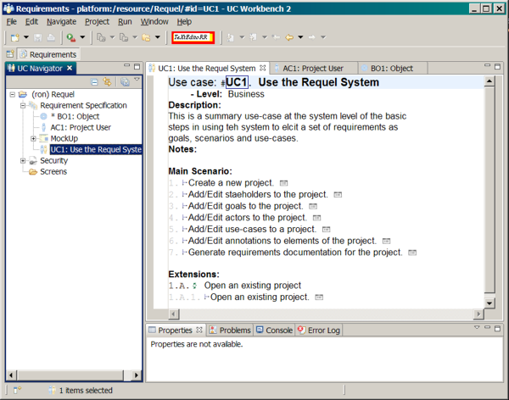
Figure 1: UC Workbench
Another nice feature of the UC Workbench is that it can generate a web based form of the requirements document that stakeholders can navigate and review.

Procasor
The Procasor project is concerned with converting use cases in natural language to a more formal behavioral specification called Pro-Cases. The project is led by Vladimir Mencl at the Charles University in Prague, Czech Republic.
Procasor is similar to the UC Workbench in that it uses NLP to analyze use-cases at the step level, although it differs in how the analysis is done. It uses a constituent parse tree (phrase structure) in contrast to the UC Workbench, which uses a dependency parse tree. A limitation of using the constituent parse is that the tool requires sentences to be restricted to the form: subject - verb - direct object - preposition - indirect object.
The analysis that it uses seems very close to what the Requel system will use for scenario step analysis. Although some of the analysis is specific to the generation of pro-cases, these concepts seem similar to what may be involved in generating logical representations that the Requel system will use for validation.
It uses the Collins parser, a separate POS tagger (MXPost tagger) and a word morphology tool (Morph-a) for getting the lemma, the base/canonical form of a word.

Requirements Assistant for Telecommunication Services (RATS)
The RATS tool was developed by Armin Eberlein as part of his PhD thesis on telecom service requirements (Eberlein, 1997.) The tool was conceptually similar to the Requirements Apprentice in that it was an expert system designed to assist a requirements engineer in creating a requirements specification using a knowledge base of telecom service domain models. The tool provides two type of assistance; passive assistance that validated the requirements against the domain knowledge and active assistance that gave suggestions on what the requirements engineer should do next based on the RATS method.
The tool was based on a three-layer architecture with an interface layer, development layer, and domain layer. The interface layer contained a user interface, inference engine and frame generator. The interface layer was tasked with taking user input, translating it into logical commands to the development layer, and presenting the results back to the user. The development layer contained models of the requirements and the RATS method. It provided the intelligent assistance to the user. The domain layer was a collection of domain models with knowledge about different aspects of telecom systems.
In the RATS prototype described in the thesis only the development and domain layers were actually implemented, so the approach on how user input was translated into logical commands to the development layer was at a high level. A natural language interface was not discussed.
The development and domain layers were both implemented in Telos using the ConceptBase knowledge base. Eberlein used a variety of techniques supported by Telos to track the state of requirements by applying rules that attached “intelligent” objects to them that described what needed to be done to make the requirements complete.

gIBIS
The gIBIS tool is not related to requirements engineering directly, but is a standalone tool that implements the IBIS method of discussion and negotiation. The goals of the tool include keeping track of the decision making process history, and having a collaborative environment for discussions. The authors of the tool make some suggestions on enhancements to the IBIS method (Conklin & Begeman, 1988.)

EColabor and Tuiqiao
Tuiqiao (Chinese for ‘elaboration’) is a single-user hypertext tool that implements the Inquiry Cycle method for requirements analysis. It allows a user to manage requirements as text and scenarios, and add annotations such as questions, answers and reasons as part of a discussion about the requirements. Initially, as a single-user tool, to use it collaboratively during meetings a screen sharing system was used so that all members of the meeting could see the requirements. While this was useful, problems arose related to communications outside of meetings when the information in the tool was not available, or new information was not added to the tool (Takahashi, Potts, Kumar, Ota, & Smith, 1996, pp. 32-33.)
The EColabor tool grew out of the need to more easily share the data and functionality of the Tuiqiao tool as well as incorporate “volatile” data such as verbal discussions and diagrams drawn on whiteboards. The Tuiqiao tool was enhanced with multimedia capabilities for audio/visual sharing, digital white board capture, and other possible media types. A client-server architecture was developed so that multiple instances of the Tuiqiao tool could communicate over the Internet and interact with a central database that also managed versions of project elements like a revision control system (Takahashi et. all, 1996, p. 34-36.)
The interesting aspects of this tool relevant to this thesis are the collaboration through discussions as question and answer annotations of requirements; versioning of individual elements of the requirements document; and traceability of the annotations to give rationale to the requirements.

CREWS
In 1996, the European Community started a research project called CREWS (Cooperative Requirements Engineering with Scenarios) to address the issues of using scenarios for requirements analysis encountered in practice, such as what techniques to use, when to use them, how to support them, and how to integrate them with the rest of the software development process (Jarke 1999, p. 3.)
The project has developed a set of prototype tools for the key issues identified, focusing on requirements elicitation and validation tools (Jarke 1999, p. 10.) The CREWS-L’Ecritoire tool facilitates elicitation and elaboration of requirements through goals and scenarios. It uses NLP and patterns to assist users. (Tawbi, Achour, & Vélez, 1999) The CREWS-SAVRE tool is used to generate use-cases and sets of related scenarios that describe the different possible paths through a use case using object system models (Maiden, 1998.)

Requirements
This section defines the requirements of the system as a set of stories, goals and use-cases with annotations (notes, questions, discussions) as an example or snapshot of what the requirements may look like being collected in the Requel system.

Goals
I’m using the term goals in a general sense that includes answers to why, what and how questions concerning the systems operation. In this sense the goals include desired properties, constraints, features and functions. I think separating the goals into fine grained categories can be tedious and it doesn’t add significant value because the level of abstraction or intent of a goal is evident in the language used. For example “The system should be easy to use for non-technical users” is a soft goal that doesn’t lead to a specific function of the system, but dictates a quality of the system. On the other hand a goal like “The system needs to be accessible to users in multiple locations” dictates a mode of operation for the system as a whole. Finally, goals like “The system must support an IBIS style discussion and negotiation of issues” dictate a feature and functionality that the system must support. Categorizing a statement as a goal, feature or functional requirements doesn’t change what it means or make it easier to understand. Not categorizing the goals removes the burden of the user having to choose a category and the impact of the user choosing the wrong category.
More important than categorizing goals is identifying the relationships between them. For example having a requirement that “a user must assign one of five different types of goals to a goal for it to be processed” contradicts the goal that the system should be easy to use. On the other hand there may be another goal that is supported by the goal that there are five different types of goals. The relationships help users understand how the goals impact or influence each other and identify areas where tradeoffs between conflicting goals are needed.
- A team of technical and business stakeholders can use the system to create accurate, precise, unambiguous and consistent requirements.
- Improve communication between stakeholders.
- The system supports collaboration among the stakeholders of a project. (Supports 2.)
- The system supports discussion of requirements. (Supports 2.)
- Improve shared understanding of project context and requirements among stakeholders. (Supports 2.)
- The system shouldn’t burden the users with tasks that don’t improve the quality of a project’s requirements.
- The system shouldn’t force users into a fixed elicitation and analysis process. (Supports 6.)
- Users need to be able to work at different levels of abstraction and in different directions from abstract to concrete and vice-versa. For example a user can start with a functional requirement or scenario and then define the features, goals and stories that explain why a functional requirement or scenario exists. After a goal or story is defined the user may go back and modify a functional requirement based on ideas or discussions about the goals and add new ones. (Supports 6, 7.)
- Support incomplete and inconsistent requirements. For example, conflicting goals, features without rationale or supporting goals; scenario steps referencing non-existing use-cases. (Supports 8.)
- The project structure should be flexible, like a collection of ideas or notes, and as the project progresses the structure gets more refined. (Supports 6, 7, 8, 9.)
- The system should support moving things around for example a note into a goal or story. Splitting a goal, story, use-case, scenario, or actor into multiple entities of the same or different types. Combining goals, stories, use-cases, scenarios or actors into a single entity. (Supports 10.)
- The system can track the requirements for multiple projects concurrently.
- The system supports multiple users possibly working concurrently.
- The system supports operation level permissions (create/edit/read) on a per-user and project basis.
- The system supports traceability of who did what and when to answer the question “How has something changed over the course of the project?” (Supports 26.)
- The system supports traceability of relationships between entities to answer the question “What will be impacted by changing or deleting a goal?”
- The system supports different styles of use-case writing from simple user stories to formal "fully-dressed" use-cases. (Supports 6, 7.)
- The system helps users create accurate, precise, unambiguous and consistent requirements with automated assistance. (Supports 1.)
- The system uses natural language processing to identify ambiguous or complex statements and communicate this in a form that a non-technical person can understand. (Supports 18.)
- The system uses natural language processing to identify and validate relevant domain or contextual terms for consistency checking. (Supports 18.)
- The system maintains a glossary of terms. (Supports 20.) QUESTION: what if a user uses a term that’s in the glossary, but they mean a different sense of the word?
- The system maintains a model of the domain objects including properties and relationships between objects. (Supports 20.)
- The system verifies logical consistency of the requirements using application domain knowledge. (Supports 18.)
- The system can be customized for domain specific application with terminology and rules about a domain. (Supports 18.) QUESTION: can multiple domains apply to a single application? QUESTION: What if a term is used that is defined differently in two domains?
- The system can notify stakeholders when a project changes. Stakeholders can customize how and when notifications are sent. For example a daily summary list of changes or immediate email when a change is made. Options for emails based on what changed; for example, send emails immediately when a question is added or answered to use-cases on which the user is working. (Supports 2, 15.)
- The system can show a summary of recent changes for one or more projects for a user.
- The system keeps revisions of all changes to the overview, actors, personas, goals, use-cases, stories, and scenarios. Each revision has a unique id, date and who made the change. The system can show the revision history for a particular entity or as a history of items that have changed for the whole project. (Supports 15.)
- Each goal, use-case, or story can be tagged as in or out of scope; possibly open for voting or comment. A key stakeholder may override the in and out of scope status. See Cockburn 2000, p. 35: in/out lists. QUESTION: what about adding a priority or phase/version that the item is expected to be in scope? QUESTION: what is a key stakeholder? Is there a role that should control scoping or permissions?
- A story can be shared by multiple use-cases as the basis for goals and scenario steps. This allows a story to describe a complete set of related interactions that would be hard to follow if broken across multiple use-cases. See the stories in the use-case “Summary Case: Discuss/negotiate entities” as an example.
- The system supports annotating entities at various levels from projects, to text fragments of goals or stories. Annotations may be notes or issues requiring discussion or negotiation. Annotations may be annotated. (Supports 3, 4.)
- The system supports an IBIS style of discussion or negotiation of issues. An issue may be a problem or a question. Issues have zero or more positions or “answers”. Positions have zero or more arguments for or against the position. (Supports 30.)
- The system supports goal and scenario based methods of requirements elicitation and analysis; for example, KAOS or CREWS. (Contradicts 7; Supports 18.)
- The system supports goals in a hierarchy from more abstract to less, with supporting or contradicting relationships. The most abstract goals being qualities such as “easy to use”, secure, or extensible. (Supports 8, 10, 32.)
- The system provides help to users based on experience. (Supports 1, 18.)
- The system supports users in a distributed environment.
- The system supports prose stories for contextual and behavioral information. For example stories about an existing system or process, stories about potential problems, or stories of how the expected system should behave. (Supports 5.)
- Support learning terms and requirements from past projects. (Supports 1, 5.) (Out of scope?)
- Users can customize the layout of the application user interface to match their needs. (Out of scope?)
- The system allows two or more users logged into the system to have a real-time discussion (chat) that gets attached to the project like other discussions. (Out of scope)
- The system maintains relationships between domain objects, glossary entries and the requirement entities (goals, stories, use cases, and scenarios.) (Supports 16, 22.)
- A user may work with multiple projects open at the same time without having to close one and open another to work on it. (Supports 44.)
- The system secures project content from unauthorized access by users not assigned to a project or non-users of the system.
- The system supports estimating effort for use cases.
- It is easy for a user to switch between active projects they are working on.
- Over time, projects that a user isn’t working with (not recently used) will be hidden from the active projects (Supports 44.)
- Support uploading, attaching or linking of resources such as documents and diagrams to projects and project entities.

Contextual Stories
Stories are used to describe behavioral and contextual information and as sources for goals and scenarios. Stories may be “matter of fact” stories that define how an existing process works, good or bad. Some stories may be “anti-“stories that define existing problems that need to be solved or potential problems that need to be avoided. Other stories will be “how things should be” that describe how the system will improve processes or what the system needs to do to meet the needs of the stakeholders. The later stories can be used as the basis for use-cases.

Example: Poor Communication
This is a contextual story that describes a scenario with communication problems. It is an example of the types of problems that the Requel system intends to solve.
Buddy the controller of Bailey Pet Supply has a problem; it takes over a month to close the books each quarter. Due to new disclosure requirements, Alex the CFO needs to submit quarterly results to the board of directors one week after the end of the quarter. Buddy tells Theresa, the accounting manager, that they need to close the books each quarter in less than a week. Theresa tells Buddy that the problem stems from the order processing system not being integrated with the accounting package and at the end of each month data must be entered into both systems to reconcile them manually.
Buddy decides that the systems must be integrated before the end of the next quarter so that the one week turn-around for reporting can be met. Buddy meets with Dave the IT manager to discuss the work. Dave assigns Tim, one of the IT project managers, to work with Buddy to determine the requirements and estimate the work. Tim meets with Buddy and they generate a list of high level requirements. Tim gives the requirements and a rough estimate of two months to Dave, who in turn gives them to Ron, an MIS programmer, to design and develop. Ron reviews the requirements and goes back to Dave and tells him there are a lot of vague areas and he needs to get clarification from Tim and Buddy.
Ron and Tim have a meeting to discuss the requirements. Ron asks Tim “What is a purchase order?” Tim response “It’s a record in the purchase system that Linda enters based on information from a sales person.” Ron asks “What information is in the purchase order?” Tim doesn’t know and tells Ron he will ask Buddy and get back to him. Tim sends an email to Buddy and calls it a day.
Buddy replies to Tim’s email that he should talk to Linda to get the details of a purchase order. Tim has a meeting with Linda and gets the details on the data for a purchase order. Tim sends Ron an email with the information. Ron replies to Tim’s email “Is there a database with data that I can look at for a sample?”
To be continued…

Actors
The actors represent the roles that users and other external entities, such as other systems, play in the behaviors (use cases) that the system supports.

Interactive User (Person)
An interactive user is any human user of the system that logs into the user interface. This is the base actor for all human actors. There are three actors extending interactive user that represent the users of the three primary aspects of the systems. Project users use the system to create requirements. System admin users create other users and manage system level permissions. Domain admin users create and manage application domains used to jump start projects and define rules for automated assistants. 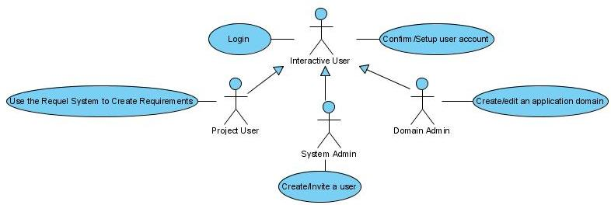

Project User/Stakeholder
Project stakeholders are the principle users of the system. They are members of one or more projects in the system and use the system to create requirements. The stakeholders can be categorized based on their role in the project. The system may use the actor’s role in a project for authorization or communication.
Stakeholder Type/Role | Description | Personas
Customer/Consumer  (Business stakeholders, End-users) | These are users that are part of the customer organization that will use or have an interest in the system being specified. These users primarily define the “what and why” goals of the software and review and refine the use cases, although sometimes create them outright. Examples are end users and business management or customer proxies that act on behalf of end users or business management. | Theresa is an accountant for Bailey Pet Supply tasked with specifying the requirements for integrating the purchase order system with the accounting system using the Requel system. Theresa has never used the Requel system before and has no projects. Theresa will be an end-user of the resulting system.  Buddy is the controller of Bailey Pet Supply; he is the sponsoring manager of the project with interests, but not a direct user of the resulting system.
Supplier/Developer | These users are part of the team that will deliver the software requirements of the system being specified and possibly the software. These users primarily review and discuss goals and use-cases to help refine them, estimate effort and feasibility. | Ron is a software developer contracted by Bailey Pet Supply to create the new purchase order system. Ron has not used the Requel system, but is familiar with requirements engineering.
Analyst/Requirements Engineer | The analyst actor represents the requirements analyst (a sub-role of supplier?) This user is most likely part of the development team. This user works with the customer to review and refine goals and create use-cases. | Rich is a freelance requirements engineer and experienced Requel user with many active and completed projects in the system. Rich is tasked with creating the requirements for a new mobile phone multi-media application for Virile Mobile.
Project Manager | A project manager is a project user whose main objective is managing the team of project users for one or more projects in the system. A project manager may act on behalf of another stakeholder to ask or answer questions and make comments. The PM may be on the consumer or supplier team. | Peter is the project manager for Virile Mobile that Rich assigned to the "Mobile Media Portal" project to post answers to questions that other team members have posted and to ask questions about requirements entered for the project.
Authority (non-user role) | Some application domains are subject to rules by consortiums or government agencies. These agencies typically will not be represented by a stakeholder user in the system. | FASB is the Financial Accounting Standards Board that sets rules on accounting practices.

In addition to having a role in a project, a stakeholder user has an experience level that the system may use to alter the user experience to assist users.
Experience | Description | Personas
Novice User | A novice user is a project user that is not familiar with the system or requirements engineering. This type of user is expected to require a lot of help from the system to lead them through the elicitation process. | Theresa is an accountant for Bailey Pet Supply tasked with specifying the requirements for a new purchase order system using the Requel system. Theresa has never used the Requel system before and has no projects.  Ron is a software developer contracted by Bailey Pet Supply to create the new purchase order system. Ron has not used the Requel system, but is familiar with requirements engineering.
Expert User | An expert user is a project user that is experienced with the system and requirements engineering. | Rich is a freelance requirements engineer and experienced Requel user with many active and completed projects in the system. Rich is tasked with creating the requirements for a new mobile phone multi-media application for Virile Mobile.

System Administrator
A system administrator manages things like user accounts and system configuration.

Domain Administrator
A domain administrator is a user that maintains the information about application domains such as the example project entities, rules for the assistants, help text, glossary entries and ontology.
NOTE: The domain management is out of scope for the first phase of development.

Automated Assistant
The assistants are part of the system, but interact with some parts of the system like project users in that they review work done by other users and add issues to elements of a project.

External Tool
An external tool is a secondary actor that can take project data created by the system, possibly after some sort of transformation, and do something useful with it. For example create a UML use-case diagram.

Interactive User - Use Cases
These are the common use cases that all human users use. They are primarily concerned with accessing the system.

Use Case: Login to the system
To track user activity and secure project content all users must be authenticated by the system.

Supports System Goals
- The system supports traceability of who did what and when. (Goal 15.)
- The system secures project content from unauthorized access by users not assigned to a project or non-users of the system. (Goal 42.)

Actor Goals
- Login and use the system.

Example Success Story
Theresa connects to the Requel system via a web browser from a link in an email message sent by the Requel system when Dave the system administrator created an account for her. The system displays the new user setup interface, prompting Theresa to confirm the personal information Dave entered about her and filling in any missing information, such as name, phone number, email address, a username and a password. When Theresa completes entering the information the system forwards her to the login screen [QUESTION: sends her a confirmation email with a link to log into the system that Theresa opens in a browser and the system displays the login screen?] Theresa enters her username and password, and the system verifies it as correct. The system logs that Theresa has successfully logged into the system, and because Theresa is a novice user, the system displays the novice user interface to help her get started.

Example Success Story
Rich opens a web browser to the Requel system address. The system doesn’t detect an existing user session and presents the login screen. Rich enters his username and password. The system verifies the username and password combination is correct. The system logs that Rich has successfully logged into the system and shows him a list of his open projects and an overview of recent project changes.

Example Exception Story
Ron opens a web browser to the Requel system address. The system doesn’t detect an existing user session and presents the login screen. Ron doesn’t have a username and password yet so he chooses the help option. The system displays a message that the system requires a distinct username and password and that the user should contact Dave at extension 500 or via email to dave@requel if they need a new account or are having a problem connecting. The system also displays a help message describing what to do if the user forgot their account information. Ron sends Dave an email to create him a new account.

Example Exception Story
Peter opens a web browser to the Requel system address. The system doesn’t detect an existing user session and presents the login screen. Peter enters an incorrect username and password combination. The system logs that an unsuccessful login attempt from Peter’s pc with the date, time and username and redisplays the login screen with a message that the username and password combination were not correct and an option if the user forgot their username or password. Peter tries again and gets the same result. Peter selects the “forgot username or password” option and is given a form to enter his email address to send a message to fix his login problem.

Scenario
- The user accesses the system.
- The system determines the user doesn’t have an active session and displays a login interface prompting the user for a username and password. The system includes a help option that a user can choose if they need help.
- The user enters their username and password and submits them to the system to verify.
  - (alt.) The user chooses the help option.
    - The system displays a helpful message of whom to contact to get a user account and an option of what to do if they forgot their username or password.
- The system verifies the user supplied a correct username and password combination and then creates a log entry with client host address, date and time of when the user logged into the system. Depending on the user’s system roles, experience level, preferences or previous session with the system, the system displays the appropriate interfaces.
  - (exc.) The system informs the user the username and password combination are not valid and redisplays the login interface with an additional option if the user has forgotten their username or password to get help.
    - The user chooses the forgotten username or password help.
    - The system displays a form for the user to enter their email address.
    - The user enters their email address.
    - The system displays a message for the user to check their email for a message from the system shortly. The system looks up a user account by the email and sends a message with the process to fix the problem.
      - (exc.) The system doesn’t find an account by email address and aborts the process.

Use Case: Confirm/Setup user account
The system uses an invitation style account setup where the system administrator or a project user with account creation authority invites a new user to use the system. The user then enters their personal information and creates an account.

Example Success Story
Theresa connects to the Requel system via a web browser from a link in an email message sent by the Requel system when Dave the system administrator created an account for her. The system displays the new user setup interface, prompting Theresa to confirm the information Dave entered about her and filling in any missing information, such as name, phone number, email address, a username and a password. When Theresa completes the form and the system verifies her responses, it forwards her to the login screen. Theresa enters her username and password, and the system verifies it as correct and logs that Theresa has successfully logged into the system. Because Theresa is a new user the system displays the novice user interface to help her get started.

Scenario
- The system sends a message to the user to setup their user account.
- The user uses the information in the message to connect to the system.
- The system prompts the user for name, phone number, email address, username and password.
- The user enters and submits the data.
- The system verifies the username and password are valid and forwards the user to the login screen.
QUESTION: how does the system authenticate the invited user to make sure they are the intended audience?

Use Case: Edit user account
After a user confirms their account they can go back and change their personal information such as phone number or email address as well as change their password.

Project User - Use Cases
This section defines the use-cases in which the Project User/Stakeholder actor is the primary actor. Use-cases define the behavioral requirements of the system. As with goals I’m using use-cases in a general sense that includes stories and scenarios. Unlike the different types of goals which are syntactically similar and differ in the level of abstraction and scope, stories and scenarios are structurally different. Stories are unstructured text and scenarios are an ordered list of steps.

Summary Case: Use the Requel System to Create Requirements
This is a summary use-case of the basic steps that a Project User will follow in using the system to create a set of requirements.
QUESTION: What about deleting project elements?

Scenario
NOTE: Each step below refers to another use-case. All the steps after logging in and creating, selecting or opening a project are optional, repeatable and can happen roughly in any order.
- Login to the system.
- Create a new project.
  - (alt) Select an open project.
  - (alt) Open a closed project.
- Create/Edit/Delete a project entity (stakeholder, goal, story, actor, persona, or use-case)
- Discuss/negotiate a project or project entity.
- Add a relationship between two goals.
- Add/Edit an entry in the glossary of a project.
- Add/Edit an entry in the object model of a project.
- Upload/attach a document/image to a project or project entity.
- Review the history of a project entity.
- Review the open issues of a project.
- Review the differences between two revisions of an entity.
- Review the dependencies of an entity.
- Generate requirements documentation for a project.
- Export a project in XML format.

Use Case: Create a new project
Add a new project to the system. A project has a name and customer, the customer defaults to the user’s company.

Example Success Story
When Theresa logs in, the system determines that she has permission to create projects, but has no existing projects and displays the "Create Project" interface. Theresa enters "Purchase Order System" for the project name and leaves “Bailey Pet Supply”, her default customer/company, as the customer. Theresa selects “end-user” as her role and “consumer” for her team. The system creates the new project and because Theresa is a new user, the system goes into “help” mode and displays the "Getting Started" interface with hypertext instructions for creating the requirements.
NOTE: The system will automatically figure out which domains to include in a project based on terminology detected in the stories, goals, and use-case text. In cases where a term can’t be found or where the term has multiple uses in a single domain or in different domains, the system will give the user the option to choose a domain (or sense in a domain with multiple uses of a term) for how the term is being used. The system will allow experienced users to pre-select domains that the system should use in the case of ambiguous terms instead of waiting for a conflict.
NOTE: A domain is like a starter project with predefined entities with goals, actors, use-cases and a glossary of terms, and domain model objects. A user can choose to copy the domain entities into a project and then make changes as needed.
NOTE: a domain should include help and logic-based rules associated with the terms that can be used by a knowledge base to validate statements for use by the assistants.

Example Success Story
Rich logs in to the system and it displays a list of his active projects, the option to open a closed project, and the option to create a new project. Rich chooses to create a new project and the system displays the "Create Project" interface. Rich enters "Mobile Media Portal" for the project name, "Virile Mobile" for the customer name, and selects the producer team and analyst role for himself in the project. The system creates the new project, and because Rich is an experienced user it gives him the option to pre-select application domains to include in the project and he selects "mobile multimedia". Because Rich is an experienced user, it displays the project summary instead of the getting started interface.
NOTE: The "mobile multimedia" domain is a custom domain that Rich created for previous projects. The domain is based on the more generic "client-server" and "mobile" domains.

Example Success Story (Extension of previous story)
Rich indicates to create a new project and the system displays the "New Project" form. Rich enters "Mobile Media Portal" for the project name, "Virile Mobile" for the customer name, and selects "mobile multi-media" for the domain.
The system displays a message under the project name that a project with that name already exists for that customer and asks him to change the name. Rich changes the name to "Mobile Media Portal 2" and the system creates the project. NOTE: Rich could have changed the customer name instead.
QUESTION: Should project names be unique system wide, or by customer? ANSWER: project name + customer name must be unique. The customer name will default to the user’s company name.
QUESTION: should all users be associated with a company that is used as the default for the project customer? Or maybe the user is used as the default customer. ANSWER: All users will have a company name that will be the default customer name for all their projects.
QUESTION: should users see projects for which they are not members of team? Should projects have a public/private flag so that all users can see (but not edit) projects marked as public?

Example Exception Story
Peter is a project manager for Virile Mobile that Rich assigned to the "Mobile Media Portal" project to post answers to questions that other team members have posted and to ask questions about requirements entered for the project. Rich did not grant project creation authorization to Peter.
When Peter logs in to the system, because he is only assigned to one project, the system opens the project overview or getting started interface. Because Peter doesn’t have permission to create a project, he does not have access to create new projects.

Scenario
- The system verifies that the user is authorized to create a new project and gives the user the option to create a new project. QUESTION: is this a step or pre-condition?
- The user chooses to create a new project.
- The system prompts the user for a project name, customer name, defaulted to the user’s company name, the team (consumer or producer) and the role of the user in the project.
- The system verifies that the project name + customer name is unique.
  - (exc.) The system tells the user the project name + customer name is not unique and prompts the user to change the project or customer name.
- The system creates the project, adds the creator as a stakeholder, sets the creator’s role, team and initiates appropriate analysis and communication.
- The system gives experienced users the option to select application domains from a list of domains to choose from.
NOTE: default issues will be created by the appropriate assistants such as a project structure assistant or process assistant. The default issues will be like “The project has no goals” or “What are the goals of the project?”
QUESTION: should users have roles in the project, for example customer or developer or analyst that dictates their basic access to the system? Maybe there should be an “any” role to bypass restricted access when it is not desired.

Use Case: Select an open project
The system will maintain a set of the user’s open projects that the user can use to quickly switch between projects to complete tasks.

Supports System Goals
- It is easy for a user to switch between active projects they are working on. (Goal 44.)
QUESTION: should the system use a tree like structure, like the eclipse navigator, that shows all the users active projects (or most recent) so they don’t have to go through the steps of opening a project unless they want to look at an old completed project?
QUESTION: how is the list of open projects determined? Is it every project that a user hasn’t closed (implies a close operation), a list of the latest N projects that a user has opened, a list of the N projects with most recent activity or a list of projects with activity within a time span like one week or one month?

Example Success Story
Rich logs in to the system and it displays a list of his active projects. Rich selects the “Mobile Media Portal 2” project and the system displays the project overview. Then Rich selects another project from the list and sees the overview of that project.

Scenario
- The user logs into the system.
- The system displays an interface with the user’s active projects such that it is always available for the user to switch between the projects.
- The user can select a project, see the entities and initiate any appropriate actions

Use Case: Open a closed project
The system supports accessing multiple projects concurrently. For a user with lots of projects it isn’t practical for the system to list them all at once, so it must possible for a user to find a project not in their active list in as few steps as possible.

Supports System Goals
- It is easy for a user to switch between active projects they are working on. (Goal 44.)
- Over time projects that a user isn’t working with (not recently used) will be hidden from the active projects (Goal 45)

Example Success Story
Rich logs in to the system and it displays a list of his active projects with the option to open a project not in his active list or create a new project. Rich scans the list of active projects and doesn’t see the project he wants so he chooses to open a project. The system displays a list of all Rich’s projects with the ability to filter the projects by partial name, partial customer name, status, create date and last modified date. Rich enters “Virile Mobile” for the customer name and the system shows all the projects for Virile Mobile. Rich sorts the list by create date ascending and sees the old project he wants to open and selects it. The system opens the project and displays the project overview.
QUESTION: Is the newly opened project added to Rich’s active list? That will work if the list is maintained by last access date or most recently opened, but not for last modified date or recent activity.
QUESTION: How should the list of projects be ordered initially? By date created, last accessed or updated, by name?
QUESTION: What information should be included in the list of projects: name, customer, date created, status (active, completed), last access date, last modified date etc?

Scenario
- The user chooses to open an existing project not already opened.
- The system displays the user’s available projects with options to sort the project by creation date, last modified date, project name, customer name; and options to filter the project by partial name, creation date over a time span, last modified over a time span, and customer name. The system will handle long project lists by paging or scrolling the list.
QUESTION: what are a user’s available projects? All projects that the user is a stakeholder on?
- The user selects a project from the list.
  - (alt.) The user doesn’t see the project they want to open in the current view of the projects. The user sorts the list, filters the list, or scrolls/pages through the list of projects until the desired project is found.
  - (alt.) The user doesn’t find a project and cancels.
- The system opens the projects and displays the overview or getting started interface.
NOTE: Depending on how the active project list is maintained the system may add the opened project to the list and remove another project.

Use Case: Create/Edit a stakeholder
Each project will have two teams (consumer and producer) with stakeholders that will interact with the system to build the requirements. Some stakeholders will have a supervisory role primarily answering and asking questions related to their areas of interest. Other stakeholders will be more involved in the requirements elicitation process adding use cases and other project elements. The system will track contact information for each stakeholder, specific goals/interests, the team, the role the stakeholder is playing in the project (customer, end-user, developer, analyst, etc), the permissions the user has for editing the project, and a history of what changes the stakeholder has made to the project.

Supports System Goals
- The system supports operation level permissions (create/edit/read) on a per-user and project basis. (Goal 14)

Example Success Story (Create a stakeholder from a user)
Theresa wants to add her boss Buddy to the system so he can review the status of the project and make decisions related to the business rules the system should honor. When Theresa created the project the system initialized the project with a set of questions, one of which is "Who are the people with a vested interest in this project?" [NOTE: this may be part of the “help” mode “Getting Started” UI and not an annotation.]
Theresa selects "Who are the people with a vested interest in this project?" and the system displays a summary of the current stakeholders. The system verifies that Theresa has the authority to add new stakeholders to the project and gives her the option to do so. Theresa chooses to create a stakeholder and the system presents her an interface to enter a name, email address, phone number, select a role, select a team, and the option to create a stakeholder from an existing system user. Theresa chooses to create a stakeholder from a user and the system displays an interface to browse the users of the system. Theresa finds Buddy in the list of system users and selects him. The system automatically fills out Buddy’s name, email and phone number in the stakeholder, leaving only the role he will play and team empty. Theresa selects “consumer” for the team and “business user” for role and saves the new stakeholder. The system asks Theresa what permissions Buddy should have for the project. Theresa skips the permissions and saves the new stakeholder. The system returns her to the summary list of stakeholders. Buddy will have default access to review the status of the project, but not make any changes to entities or participate in discussions.
QUESTION: should a user be able to view all other users in the system? Are there security risks in allowing that behavior?
NOTE: a stakeholder’s team is required.
QUESTION: should role be required or optional?
NOTE: Project users can only invite (initiate new accounts) for new project users. The new users will not have project creation permission or be able to invite other users without the system administrator granting authority.

Example Success Story (Create a stakeholder and user)
Theresa chooses to add a new stakeholder and the system presents her an interface to enter a name, email address, phone number, select a role, select a team, and the option to create a stakeholder from an existing system user. Theresa chooses to create a stakeholder from a user and the system displays an interface to browse the users of the system. Theresa looks for Buddy in the list of system users, but doesn’t find him. When Dave created Theresa’s account he granted her permission to add new users so the system displays an option to create a new user. Theresa chooses the option to create a new user account for buddy. The system displays an interface to enter new user account information including name and contact information. Theresa enters "Buddy Bailey" for his name, "buddy@baileypetsupply.com" for his email and leaves his phone number blank. Because Theresa is not a system administrator the system only gives her the option to invite a new user. Theresa selects that option and the system creates the new user account with a pending status, initiates the new account step process. The system then fills in the stakeholder information from the user account information, leaving the role he will play and team empty. Theresa selects “consumer” for the team and “business user” for role and saves the new stakeholder.

Example Success Story (Add a non-user stakeholder)
Theresa chooses to add a new stakeholder and the system presents her an interface to enter a name, email address, phone number, select a role and the option to create a stakeholder from an existing system user. Theresa enters “FASB” for the name and leaves everything else blank as this is a representational stakeholder for the “Financial Accounting Standards Board” where standards rules set by FASB will be added as goals.
Theresa then adds a series of goals to the FASB stakeholder representing the relevant standards rules set by the board.

Scenario (Create a stakeholder)
- The system verifies the user has permission to add stakeholders to the project and presents the capability to do so.
- The user chooses to add a new stakeholder to the project.
- The system displays an interface to enter the stakeholder including name, phone number, email address, team, role in project, and to create a stakeholder from a system user.
- The user enters the stakeholder information.
  - (alt.) The user chooses to create a stakeholder from a user.
  - The system verifies the user can create new users and displays the system users with the ability to choose one or create a new one.
    - (alt.) The system displays the list of system users but does not give the user to create a new user.
  - The user chooses an existing system user.
    - (inc.) The user chooses to create a new user (see Use Case: .)
  - The system copies the information from the user to the corresponding stakeholder values. QUESTION: should the data be “linked” and read-only so that the user can’t change the values in the stakeholder from what is in the user record?
- The system verifies the data entered by the user and creates the stakeholder’s information in the system.

Scenario (Edit a stakeholder)
- The user chooses an existing stakeholder.
- The system verifies the user has permission to edit stakeholders.
  - (alt.) The system displays the stakeholder information in a read-only form.
- The system displays the stakeholder in an editable form including name, phone number, email address, goals/interests, permissions, team, role in project, and associated user.
  - (inc.) The user chooses to add a user to the system for the stakeholder.
  - (inc.) The user chooses to add/remove a goal to/of the stakeholder. (see use-case “Add/Edit a goal to/of the project”)
  - (inc.) user chooses to edit the stakeholder’s permissions. NOTE: editing stakeholder permissions requires a separate permission.
- The system verifies the data entered by the user and updates the stakeholder’s information in the system.

Example Success Story (Edit a stakeholder’s permissions)
Theresa wants to grant Buddy access to ask and answer questions about the project. She selects "Who are the people with a vested interest in this project?" and the system displays a summary of the current stakeholders. Theresa selects Buddy’s stakeholder record. The system verifies that Theresa has the authority to edit the stakeholder’s permissions and gives her the option to edit Buddy’s permissions. The system displays the current permissions that Buddy has for all the types of tasks that can be performed. Theresa indicates that Buddy shall have the permission to engage in discussions (for example, add or answer questions) and saves the change.
QUESTION: what are the individual permissions that can be granted?
- Create/edit stakeholders.
  - Granting stakeholder permissions
- Create/edit actors
- Create/edit goals
- Create/edit stories
- Create/edit use cases including scenarios.
QUESTION: should edit permissions be for specific entities vs. types of entities such as a specific use-case, story, etc? Based on who created the entity, such as edit only entities created by self or team mates? What about stakeholder role based permissions?
NOTE: The versioning of entities may be sufficient so that if a user changes an entity they shouldn’t have, the previous version can be recovered easily.
QUESTION: what should happen if a user is already logged into the system when their permissions change? Ideally the permissions should take immediate effect without the user needing to logout and back in.

Scenario (edit permissions)
- The user selects an existing stakeholder.
- The system verifies the stakeholder is a user stakeholder and that the user has permission to edit stakeholder permissions and displays the list of available permissions indicating which ones the stakeholder has and doesn’t have in an editable form.
  - (alt.) The stakeholder isn’t a user stakeholder so the system doesn’t display permissions for the stakeholder.
  - (alt.) The system displays the stakeholder permissions in a read-only form.
- The user chooses to add and/or remove permissions to/from the stakeholder.
- The system updates the permissions of the stakeholder.

Post-Condition
- The stakeholder user is immediately impacted by the permission change. If the user was already in the process of editing something that they no longer have permission to edit they will be able to complete that work.

Use Case: Invite a stakeholder to be a user
Project users can add new users to the system to assign them as stakeholders to their projects. Once a user is created the system goes through a new user account setup process with the new user to verify their information and create a new username and password. Once a user is created only that user can only edit their user information (or the system administrator.)
NOTE: The created user does not have permission to create new projects or create/invite new users to the system.

Example Success Story (Add a user)
Theresa chooses to add a new stakeholder and the system presents her an interface to enter a name, email address, phone number, select a role, select a team, and the option to create a stakeholder from an existing system user. Theresa looks for Buddy in the list of system users, but doesn’t find him, so she chooses to create a new user account for buddy and enters "Buddy Bailey" for his name, "buddy@baileypetsupply.com" for his email and leaves his phone number blank. The system creates the new user account and initiates the new account setup process.

Pre-conditions
- The user is adding/editing a stakeholder.

Scenario
- The system verifies the user has permission to create new users and gives them the option to create a new user for the stakeholder.
- The user chooses to create a new user for a stakeholder.
- The system presents an interface to create the new user, including a name, email and phone number, and copies information from the stakeholder to the corresponding user fields.
- The user enters an email address and optionally enters a name and phone number.
- The system verifies the email address format is a valid format and initiates the user account setup process.
  - The system informs the user the email address is invalid and prompts for it to be corrected. (Back to 4.)

Use Case: Create/Edit a goal
The Requel system uses the term “goals” as a generalization that includes desired properties, constraints, features and functions. The system supports a graph of related goals with various relationships such as those used by the KAOS, CREWS, and i* methods. Goals may be abstract such as “The system is easy to use” relating to a quality (non-functional requirement) of the system. Goals may conflict with or support other goals, and may be decomposed into multiple less abstract goals that support it. The lower level of goals (hard goals such as features and functions) will be “operationalized” in the use-cases or scenario steps.
NOTE: Users shouldn’t have to choose between soft and hard goal types or mark goals with levels. The level of goals will be implicit in its relationship to other goal.
NOTE: When a goal is created it can be associated with another project entity as part of the creation. For example adding a goal to a stakeholder creates the goal in the project and associates it to the stakeholder.
NOTE: Goals will have supportive or contradictive relationships to other goals.
QUESTION: If goals are determined from contextual stories, should the relationship between them be made explicit for tracing dependencies?
QUESTION: Does there need to be a distinction between system level goals, stakeholder goals/interests, and actor use-case goals? If a stakeholder is removed do their interests no longer need to be supported? If an actor is removed from a use-case do their goals get removed from the use-case?

Example Success Story
Buddy wants to make sure the primary goal of the project “to speed up the closing of the books at the end of each quarter” is identified in the system. Buddy logs in to the Requel system and select the Purchase Order Integration project. Buddy is authorized to add goals to the system and is an inexperienced user of the system so it presents him a helpful interface with an option to “add a goal” Buddy selects the option and the system presents Buddy a helpful interface that leads him through the process of adding a goal. Buddy adds the goal text “Speed up the closing of the books at the end of each quarter.” The system analyzes the goal and adds some issues to the goal such as “Why does the closing of the books at the end of each quarter need to be sped up?”

Scenario
- The system verifies the user has authority to add a goal to the project and presents the user an interface to add the goal.
  - (alt) The user selects an existing goal.
  - The system verifies the user has authority to edit the goal and presents the user an interface to edit the goal.
    - (alt.) the user is presented the goal in read-only format.
- The user enters the goal as natural language text.
- The system verifies the user entered some text, saves the goal, and initiates appropriate analysis and communication.
QUESTION: should goals have status like analyzed, reviewed by consumer, and reviewed by producer with a date? These could help the assistants and users with TODO items to make sure things are analyzed and reviewed after being edited.
NOTE: the goal should have a created by, created date, last updated by, and last updated date (maybe the last updates are part of the revision information.)

Use Case: Add/edit a relationship between two goals
The system supports relationships between goals such as one goal supporting another goal. Relationships may be positive or negative.

Example Success Story
Ron creates a new goal in the Requel project “The system provides help to users based on experience.” After creating the goal the system displays the edit goal interface with the option to add goals that support this goal or that are supported by this goal. He decides that the new goal is a supporting goal of the goal “A team of technical and business stakeholders can use the system to create accurate, precise, unambiguous and consistent requirements” and chooses to add this goal as supporting another goal. The system opens the goal relationship editor with the new goal in the “from” field and a search list of all the system level goals in the “to” field. Ron filters the goals in the search list to only show top level goals (goals that don’t support or contradict other goals) and in the shorter list he finds and selects the desired goal “A team of technical and business stakeholders…” Ron then selects “supports” as the relationship type and saves. The system adds the relationship to the list in the editor.
Ron opens the supported goal in the editor and sees that his new goal is in the list of “supported by” goals.

Scenario
- The user selects a goal.
- The system verifies the user has permission to edit goals and gives the user the option to create a new relationship with another goal.
- The user selects to add a new relationship.
- The system prompts the user to select either supports or contradicts and allows the user to select another goal from the project.
- The user selects a relationship and goal.
- The system verifies that a relationship between the two goals doesn’t already exist and adds it to the system. The system initiates appropriate analysis and communication.
  - If a relationship already exists between the two goals the system informs the user that the relationship exists and gives the user the option to edit that relationship.

Use Case: Create/Edit a story
A use case may have zero or more stories that describe using the system in a successful or unsuccessful way to accomplish some goals. Stories may refer to personas, which are exemplary actors. Stories may be general contextual stories not specific to a particular use-case or shared by multiple use-cases.
QUESTION: should personas be explicitly referenced by a story or implicitly? Should the system (an assistant) add personas based on proper names in a story?

Example Success Story
Ron chooses to create a new story in the Requel project describing successful example of using the “create a story” use case. Ron opens the “create a story” use case and chooses to add a new story. The system displays an interface to select the type of story “success” or “exception” and a field to enter the story text. Ron selects “success” for the type and the story text “Ron chooses to create a new story…” The system creates the story, adds it to the use-case, and passes the story to an assistant for analyzing the story text.
QUESTION: should the system support structured text with paragraphs, formatted text (like italic, bold or underlined) and other types of structures?

Example Success Story
Early in the development of the Requel project Ron wants to describe some of the problems he has had in the past with requirements on projects to help figure out what goals and functionality the system should have to improve requirements for future projects. Ron writes out a story (more of an anecdote) about a past accounting project where communication problems between the stakeholders caused delays in collecting requirements.
Envisioning using the Requel system to record this story, after creating the project Ron wants to add stories to help figure out the requirements and chooses to create a new story directly attached to the project since it is too early to know what the use cases will be. As the project progresses this story may be added as reference for use-cases, although the subject matter has nothing to do with using the system so it may be that this story will only be a contextual story.
QUESTION: The idea of contextual stories as the basis for goals and functionality seems to imply that goals may reference these stories as rationale of their necessity. Should the stories have explicit references to the goals that are derived from them?

Scenario
- The system verifies the user is authorized to create stories in the project and presents the user with the option to create a new story.
- The user chooses to create a new story.
  - (alt.) The user chooses an existing story to edit.
  - The system verifies the user is authorized to edit a story.
    - (alt.) The system displays the story in read-only format.
- The system presents the user with an interface to enter a large text string and select the type of story as “contextual”, “success” or “exception”.
- The user submits the story. QUESTION: should the app save snap shots of the text while the user is editing it so that if there is a failure the user doesn’t lose all their work?
- The system saves the story and initiates appropriate analysis and communication.
  - (ext.) If the story was created via adding a story to the use-case then the system also adds the story to the use-case.

Use Case: Create/Edit an actor
Actors represent different roles that an entity outside of the system being designed will play when interacting with the system. Different types of users or external tools or systems are actors. In some instances it may be appropriate to define an internal part of the system as an actor that uses another part of the system. For example the automated assistants of the Requel system that interact with the projects component of the system similarly to the way a user may work with projects.

Example Success Story
Ron wants to add the “Project User” actor to the Requel project to represent users that will create requirements using the Requel system. Ron opens the Requel project and navigates to the actors section. The system checks that Ron has permission to create actors for the project and displays the option to create an actor for the project. Ron chooses to create an actor and the system displays an interface to enter the name of the actor and a description. Ron enters “Project User” for the name and “Project Users are the principle users of the system. They use the system to create requirements” for the description and saves. The system checks that the actor name isn’t already in use for the project and then displays an interface with the ability to edit the name or description, and add/remove personas, add/remove goals or add/remove relationships to other actors, such as extends.
Ron chooses to add an “extends” relationship to the Project User and the system displays a list of the existing actors in the project and an option to create a new actor. Ron chooses to create a new actor named “Interactive User” with a description “a general person user of the system that must login to the system” and saves it. The system returns to the Project User editor interface and the new Interactive User actor is added to the Project User actor as an actor that is extended by the Project User.

Scenario (create actor)
- The system verifies the user is authorized to add actors to a project and presents the user with the option to create a new actor.
- The system prompts for the actor’s name and description.
- The user enters a name and optionally a description and saves.
- The system verifies the name is unique in the project, creates the actor and initiates any appropriate analysis and communication.
  - (alt.) The system detects that the actor name is already in use and prompts the user to change the name.

Scenario (edit actor name or description)
- The user selects an existing actor.
- The system verifies the user is authorized to edit actors and displays the name, description, goals, personas and relationships to other actors in an editable form.
  - (alt.) The user is presented the actor properties in a read-only form.
- The user changes the name and/or description of the actor and saves.
- The system verifies the name is unique, updates the actor and initiates any appropriate analysis and communication.
  - (alt.) The system detects that the actor name is already in use and prompts the user to change the name.

Scenario (add a persona to an actor)
- The user selects an existing actor.
- The system verifies the user is authorized to edit actors and displays the name, description, goals, personas and relationships to other actors in an editable form.
  - (alt.) The user is presented the actor properties in a read-only form.
- The user chooses to add a persona.
- The system displays an interface for selecting an existing persona from a list of personas attached to the project or creating a new persona.
- The user chooses an existing persona from the list.
  - (alt.) The user chooses to create a new persona.
  - The system displays an interface to create the new persona (see Use Case: Create/Edit a persona]
- The system adds the persona to the actor.
NOTE: Adding an actor follows the same basic scenario as adding a persona.

Use Case: Create/Edit a persona
Personas exemplify actors and add context to help understand an actor.

Example Success Story (creating and adding)
Tim creates an actor “Order Entry Clerk” and wants to add a persona “Linda” describing Linda’s technical experience and general duties into the system. Tim selects the “Order Entry Clerk” actor and then chooses to add a persona. The system shows a list of existing personas and an option to create a new one. Tim selects to create a new one and the system displays an interface to enter a name and description. Tim enters the name “Linda” with a description summarizing Linda’s experience and other information that may be helpful in designing the system.

Scenario
- The user selects an entity (project or actor.)
- The system verifies the user is authorized to create personas and presents the user with the option to create a new persona.
- The user chooses to create a new persona
  - (alt.) The user chooses an existing persona to edit.
  - The system verifies the user has permission to edit the persona.
    - (alt.) The system displays the persona in read-only form.
- The system displays an interface to enter a name and description for the persona.
- The user enters the information.
- The system verifies the name is unique in the project and creates the new persona.
  - The system detects that the name is already in use and prompts the user to change the name.

Use Case: Create a use-case
A use case is the primary structure for managing requirements in the Requel system. Use cases may be hierarchical in nature with top level summary use-cases specific to each primary actor that drill down into task specific use cases with a higher level of precision through the scenario steps.
A use case is a composite structure with a name, description and references to actors, goals, stories and scenarios. The name of the use case typically implies the goal of the primary actor, although it is conceivable that the actor may have further goals that must be accomplished as well. Further, the use-case includes goals/interests of stakeholders that must be satisfied and general system goals that it satisfies or references as rationale for behaving a specific way.

Example Success Story
After a meeting with Linda, Tim wants to create a use case to describe the process that Linda follows to add a purchase order to the system. Tim logs into the Requel system and selects the Purchase Order Integration project. Tim selects the use cases of the project and because he is authorized to add use cases the system gives him the option to add a new one. Tim chooses to add a new use case and the system prompts him for a name, primary actor and description. Tim enters “Purchase Order” for the name and scans the list of actors. He sees Linda as the persona for the actor “Purchase Clerk” and chooses it. He enters “Create a purchase order” for the description and saves. The system analyses Tim’s entry and adds an issue that the name “Purchase Order” does not follow the proper convention. The system presents Tim with the option to edit the name, primary actor and description. The system also presents him with the option to add goals, stories, pre-conditions, post-conditions, and scenarios to the use-case.
QUESTION: what is the rule the system uses for validating the use-case name? ANSWER: It assumes the primary actor is the subject and expects a verb/object phrase. For example “create a purchase order” where the purchase clerk is the implied subject (actor.)
QUESTION: what about extending another use case?

Scenario
- The system verifies the user is authorized to create use-cases on the current project and presents the user with the option to create a use-case.
- The user chooses to create a use-case.
- The system prompts the user for a use-case name, primary actor, and optional description.
- The user enters a name of the use case, a description and selects the primary actor from a list of actors in the project.
  - (alt.) The user chooses to create a new actor.
- The system verifies the name is unique and an actor is selected in the project and attaches the use-case to the project, with a created by, and date attribute and initiates analysis of the name based on naming conventions and other appropriate analysis and communication.
QUESTION: should the system accept the use case without an actor and add an issue that the use-case doesn’t have a primary actor?

Summary Case: Edit a use-case
Once a use case has been created the project users can associate goals and stories to the project that the use case supports or add new goals and stories specific to the use case. Users can add scenarios to the use case or edit existing ones. Users can add secondary actors that support the use case (scenarios.)

Example Success Story
Early in the requirements phase of the Requel project Ron created a use-case “Add/Edit use-cases”. As he refined the requirements he decided that the use case should be split into two separate cases. Ron chooses the use case “Add/Edit use-cases” and changes the name to “Create a use-case” and removes (but does not delete) the stories and scenarios related to adding and removing goals, stories and scenarios. Ron then chooses to create a new use case named “Edit a use-case” and adds the goals, stories and scenarios he removed from the original use-case.

Example Success Story (add a new story)
After Tim creates the “create a purchase order” use-case, he goes back to add story describing what Linda typically does when creating a purchase order. Tim chooses the “create a purchase order” use case and the system gives him the option to add goals, stories, secondary actors and scenarios. Tim chooses to add a story and the system shows him a list of the existing stories in the project to select from and an option to create a new story. Tim chooses to add a new story and fills in the information. The system creates the story and adds the story to the use-case.
NOTE: The process of adding goals, secondary actors and scenarios is basically the same.
QUESTION: do stories and scenarios need names so that they can be more easily searched for?

Scenario
- The user chooses a use case.
- The system verifies the user is authorized to edit the use case and presents the user with an editable form of the use case name, description and primary actor and the ability to add or remove relationships with goals and stories, add/edit scenarios.
  - (alt.) The system presents the user with a read-only version of the use case.
  - (ext.) The system verifies the user is a developer user and also presents the user with the option to add an effort estimate.
- Add a goal to the use-case from existing system goals or create a new goal.
- Add a story to the use-case from existing stories or create a new story.
- Add a secondary actor to the use-case.
- Add/edit a scenario to/of the use-case.
- Add/edit a pre/post-condition to/of the use-case.
- Discuss/negotiate the use-case (see user-case “Discuss/negotiate entities”).
- Edit the effort estimate of the use-case. [QUESTION: what about automatically calculating of use-case points?]
- Generate a use case from a step in another use case.
- Remove a goal, story, secondary actor, scenario from a use-case.

Use Case: Add a goal to a use-case
A use-case may refer to stakeholder and system goals that the use-case must satisfy and as rationale on why the use-case is needed. A use-case may also have actor goals that the primary actor or secondary actors desire to accomplish as part of the use-case.
QUESTION: should actor goals be distinct from stakeholder/system goals that the use-case must satisfy?

Pre-conditions
- The user is editing a use-case.

Scenario
- The system verifies the user is authorized to add goals to a use-case and presents the user the option to add a goal.
- The user chooses to add a goal.
- The system displays all the goals in the project with the option to sort, filter and scroll/page through the goals and the option to create a new goal if the user is authorized to create goals.
- The user searches through the goals optionally filtering and sorting and selects a goal to add to the use-case.
  - (alt.) The user doesn’t select a goal and chooses to create a new one (see Use Case: Create/Edit a goal)
- The system gives the user the option to attach the goal as a goal of a specific actor in the use case or as a system goal that the use case supports.
- The user selects an actor that the goal is assigned with.
  - (alt.) The user doesn’t select an actor indicating the goal is a system goal that the use case supports.
- The system adds the goal to the use-case related to an actor or not as the user chose.

Use Case: Add a story to a use-case
Typically a use-case will have stories that describe the desired behavior and interaction with actors of the use case. Some stories may be alternative successful behavior or exceptional behavior describing a problem where the goals of the use case aren’t fully met. Alternately a use-case may reference a story purely for contextual information or for rationale on why a use case behaves in a specific way.

Pre-conditions
- The user is editing a use-case.

Scenario
- The system verifies the user is authorized to add stories to a use-case and presents the user the option to add a story.
- The user chooses to add a story.
- The system displays all the stories in the project with the option to sort, filter and scroll/page through the stories and the option to create a new story if the user is authorized to create stories.
- The user searches through the stories optionally filtering and sorting and selects a story to add to the use-case.
  - (alt.) The user doesn’t select a story and chooses to create a new one (see Use Case: Create/Edit a story)
- The system adds the story to the use-case.

Use Case: Add a secondary actor to the use-case
A use-case must have a primary actor, but it may also include secondary actors to facilitate the process.

Pre-conditions
- The user is editing a use-case.

Scenario
- The system verifies the user is authorized to add secondary actors to a use-case and presents the user the option to add an actor.
- The user chooses to add an actor.
- The system displays all the actors in the project in alphabetical order to select from [NOTE: typically the number of actors in a project is small so filtering is probably not necessary.] with the option to create a new actor if the user is authorized to create actors.
- The user searches through the actors and selects one to add to the use-case.
  - (alt.) The user doesn’t select an actor and chooses to create a new one (see Use Case: Create/Edit an actor.)
- The system adds the actor to the use-case.

Summary Case: Create/Edit a scenario
Scenarios are a semi-formal representation of a use-case as a set of steps that complete the use case goals completely or partially with at least the minimal guarantees of the post conditions. A use case may have multiple scenarios and typically have at least a primary success scenario describing the typical interaction between the primary actor and the system.

Example Success Story
As Ron reviews the login use case for the Requel system he realizes that there isn’t any way of handling the case of a user that forgets their password. Ron adds a story describing what should happen and then edits the main scenario. The system lists the existing steps. Ron chooses to add a new step and enters the text of what the system does if the username and password aren’t verified and marks the step as an exception. The system prompts Ron to select which step this is an exception to and Ron chooses the last step. The system saves the new step and adds it to the scenario display below the step that it is an exception to identifying it as an exception.
Ron Now wants to add the sub-steps of the exception step. He selects the exception step and chooses to create a new sub-scenario. Ron adds the steps and saves the scenario. The system links the new scenario to the exception step and updates the display of the original scenario to show the sub-scenario as part of the exception step.

Pre-conditions
- The user is editing a use-case.

Scenario
- The system verifies the user is authorized to add scenarios to a use-case and presents the user the option to create a scenario.
- The user chooses to create a scenario.
  - (alt.) The system presents the steps of the scenario in read-only form.
  - (alt.) The user chooses an existing scenario.
- The system verifies the user is authorized to edit the scenario.
  - (alt.) The system displays the scenario in a read-only format.
- The system displays an interface to edit the steps.
- Add/Edit/Remove a step to/of a scenario.
- Move a step up or down in the sequence order of a scenario.

Use Case: Add/Edit/Remove a step to/of a scenario
A scenario is made up of multiple steps; each step has a text description and optionally references another use case or alternate sub-scenario. A step may be sequential and ordered in relation to previous steps, unordered where a series of steps may occur in any order, repeatable where a step may occur one or more times, and optional where the step may be skipped.

Example Success Story
As Ron reviews the login use case for the Requel system he realizes that there isn’t any way of handling the case of a user that forgets their password. Ron adds a story describing what should happen and then edits the main scenario. The system lists the existing steps. Ron chooses to add a new step and enters the text of what the system does if the username and password aren’t verified and marks the step as an exception. The system prompts Ron to select which step this is an exception to and Ron chooses the last step. The system saves the new step and adds it to the scenario display below the step that it is an exception to identifying it as an exception.

Scenario (add/edit)
- The system verifies the user is authorized to edit a scenario and presents the user with the option to add/edit/remove/move steps.
  - (alt.) The system presents the steps of the scenario in read-only form.
- The user chooses to add a new step to a scenario.
  - (alt.) The user chooses to edit an existing scenario step.
- The system opens an interface to enter the text, choose whether this step is an alternate, exception or extension to the current flow, and whether the step is sequential, non-sequential, repeatable or optional, and optionally refer the step to another use case or sub-scenario.
- The user enters the text and optionally marks the step as an alternate, exception, extension, or non-sequential.
  - (alt.) The user refers the step to another use case.
  - (alt.) The user creates a sub-scenario based on the step.

Scenario (remove a step)
- The system verifies the user is authorized to edit a scenario and presents the user with the option to add/edit/remove/move steps.
- (alt.) The system presents the steps of the scenario in read-only form.
- The user chooses to remove a step from a scenario.
- The system removes the step from the scenario and reorders all following sequential steps.
  - (alt.) The step contains a sub-scenario so the system prompts the user to confirm to remove the entire sub-scenario with the step.
  - The user verifies the sub-scenario should also be removed
    - (alt.) The user indicates to not remove the sub-scenario
    - The system attaches the sub-scenario to the use-case.
QUESTION: should the system confirm with the user that they want to delete the step? In what order should the step be inserted into the scenario if other steps have been added?
NOTE: Deleting a step should be undoable using the revisioning information to its last revision before being deleted.

Scenario (move a step)
- The system verifies the user is authorized to edit a scenario and presents the user with the option move all but the first step up and all but the last step down a position.
- (alt.) The system presents the steps of the scenario in read-only form.
- The user chooses to move a step up or down in the scenario.
- The system moves the step and if the step is sequential, the system reorders the affected steps above or below the moved step.

Use Case: Refer a step to another use case
A step in one use case may be a reference to a whole other use-case following the hierarchical model of summary, user and function level use cases as described by Cockburn (2000.)

Pre-conditions
- The user is adding/editing a scenario step.

Example Success Story
Ron is creating the main scenario use case “Create/Edit a scenario” in the Requel project. As he adds a new step to edit a scenario he determines that this step has multiple sub-options and should be its own use-case. On the scenario step editor he chooses to link the step to another use case. The system displays a list of use-cases and the option to create a new use case. Ron chooses to create a new use case. After creating the new use case the system returns to the step editor interface with the new use case referenced from the step.

Scenario
- The system gives the user the option to reference a use case from the step interface.
- The user chooses to reference a use case.
- The system displays a list of all the use cases in the project, with the option to sort, filter or create a new use case.
- The user sorts and/or filters the displayed use cases and finds the use case they want to reference and select it.
  - (alt.) The user doesn’t find a use case they want to reference and chooses to create a new use case (see Use Case: Create a use-case.)
  - The system uses the new use case as if the user had selected it.
- The system creates a reference to the selected use case from the step.

Use Case: Create/Edit a pre/post-condition of a use-case
The pre-conditions are the expected state the system is in before the use-case can start. For example before a user can do any of the use cases except login, they must be logged in. The post-conditions are the state the system will be in after a use-case completes. Some post-conditions must always be met by the end of a use-case (minimum guarantees) while others will depend on the scenario that is completed.

Example Success Story (add a pre-condition)
Ron wants to make it clear that the use case of a project user to create new system users is part of the process of adding a stakeholder. Ron opens the use case and adds a pre-condition that references the add/edit stakeholder use case, indicating that this use case can only be initiated from that use-case.
NOTE: this indicates that a pre-condition may need to be more than just text so that dependencies between use-cases can be tracked correctly. For example removing a use case that includes other use-cases may not impact the included use-cases, but there may be cases where the included use-case is dependent on the including use-case and that relationship should be tracked.

Use Case: Add/Edit the effort estimate on a use-case
Supplier users (developers/analysts) with appropriate permissions can add an estimate of effort for how long a use case may take to implement as a time span like 100 hours or 5 days. The estimate may be a range like 10 to 12 days. The estimate can be qualified with a confidence level like “I’ve done this same exact thing before and I know exactly what needs to be done” or “I’ve done something very similar to this” or “I’ve never done anything like this before.”
QUESTION: what about having the system automatically create estimates based on use-case points?

Scenario
- The system verifies the user is a stakeholder on the supplier team and displays an interface to enter an estimated effort with a low and optional high value and an optional confidence level.
  - (alt.) The system displays the estimate in read-only form.
- The user enters appropriate values as time spans such as 10 minutes or 5 hours or 10 days for the low and high values and a confidence value. NOTE: using days implies that a standard work day span should be defined like 8 hours.
- The system validates the time spans and then converts them to minutes for easy management and saves them.

Use Case: Remove a story, goal, or actor from a use-case
Allow users to remove references to secondary actors, stories and goals from a use-case with out deleting them from the project.

Example Success Story
Early in the requirements phase of the Requel project Ron created a use-case “Add/Edit use-cases”. As he refined the requirements he decided that the use case should be split into two separate cases. Ron chooses to edit the use case “Add/Edit use-cases” and remove the stories and scenarios related to adding and removing goals, stories and scenarios. On the use case edit interface Ron chooses the remove option next to the story “add a story to a use case”. The system prompts if the story should also be deleted and Ron chooses no. The system removes the story from the use-case but leaves it attached to the project.
NOTE: To be able to easily identify stories and scenarios they should have names.

Scenario
- The user chooses the use-case.
- The system verifies the user is authorized to edit the user-case and displays the goals, stories, and secondary actors with the option to edit or remove each.
- The user chooses to remove a goal, story or secondary actor.
- The system removes the goal, story or secondary actor from the use-case.
  - (alt.) The goal, story or secondary actor is not referenced by any other project entity so the system prompts if the item should be deleted from the project.
QUESTION: How can something be undeleted? The system needs a way for a user to view deleted project entities and add them back into the project.

Use Case: Mark a use-case as out of scope
As a project progresses, some of the use-cases may be deemed unneeded or of a lower priority than other use cases. It would be useful to mark these use-cases as out of scope for the current iteration/phase instead of deleting them so that they can be reviewed in the future and added to the scope of a future version of the system.

Use Case: Copy a use-case/scenario
It would be useful if a user could copy a whole use case to a new use case that will have a similar structure and then make edits to the new one without affecting the original. The copy would include the description, pre/post-conditions, scenarios and references to goals, actors and stories, where the original entity is not copied but a new reference from the new use case is created.

Example Success Story
Early in the requirements phase of the Requel project Ron created a use-case “Add/Edit use-cases”. As he refined the requirements he decided that the use case should be split into two separate cases. Ron makes a copy of the use case naming the copy “Edit a use-case.” Ron then edits the original use case renaming it to “Create a user case” and remove the goals, stories and scenarios relevant to the new “edit a use case” use case. Ron then edits the new use case to remove the goals, stories and scenarios relevant to the “create a use case” case.

Summary Case: Discuss/negotiate entities
The system supports a mechanism for users to discuss requirements using an IBIS like process via annotations on project entities. This is a summary use-case of the process. After an annotation is added positions and arguments can be added eventually leading to a position/answer be selected as a resolution.

Goals
- Refine goals and use-cases by discussing issues (questions/problems) so that in the future the reasons why a particular answer was chosen can be reviewed.
- Help users not familiar with requirements by asking them questions about the requirements (from other users or assistants.)
- Help a requirements expert by pointing out imprecision, ambiguity or inconsistencies.
- If necessary answers may be constrained to specific sets of answers.
- Assistants can add issues with positions that automate some action.

Scenario
- Annotate an entity with a note or issue.
- Change the type of an annotation.
- Propose a Position/Answer to an issue.
- Propose an argument to a position/answer.
- Select a Position/Answer as a resolution to an issue.
- Unselect a Position/Answer as a resolution to an issue.

Use Case: Annotate an entity with a note or issue
The system supports adding annotations such as notes that don’t require discussion or issues in the form of problems and questions that require resolution. Annotations can be added directly to a project, entities of the project such as a goal, use-case, actor, scenario, or step in a scenario, as well as other annotations and related entities. Annotations may also be added to a fragment of text such as a word or phrase in a goal, story, or scenario step. The system notifies appropriate users when annotations are added to the system.
QUESTION: what is an appropriate user? All users? The user that created the entity? Users in a specific role or set of roles? Based on user preferences?
NOTE: The annotation feature is the primary way that intelligent assistants communicate issues to the system users.
QUESTION: how does deleting or changing a project element or fragment of text with an annotation affect the annotation? Deleting should probably resolve (or delete) an open issue. Editing may be tricky. The system should re-evaluate the text in question and resolve issues that no longer occur, and leave identical issues the same. There may be cases where a new issue doesn’t exactly match an original issue. It’s not clear if the original issue should be changed or resolved and a new one added. There may be relevant discussion on the original issue that is appropriate for the new issue.
QUESTION: should a user be able to completely change an issue? This could be a problem for existing discussions making positions and arguments irrelevant. It seems that editing could be difficult to manage, although not allowing minor edits can make using annotations frustrating. Maybe adding notes to an issue to amend it is the best option.
QUESTION: should a user be able to edit other users’ annotations? Probably not annotations added by assistants. Maybe annotations need permissions?
QUESTION: could the assistants add special issues that are action type elements instead of discussion elements? Such that positions initiate actions like opening an editor for project entity, fix a spelling mistake, or guide the user through a process. This would be useful but it seems that it may require lots of effort and make the annotations and user interface tightly bound.

Example Success Story
The spelling assistant gets notified that a user added a new goal with the text “The user can saerch for artists by name.” The assistant finds the word “saerch” that appears to be spelled incorrectly or is a new word. The assistant adds an issue annotation to the text fragment of the goal that the word is unknown to the assistant and may be a new word or a spelling error.
NOTE: if a user edits the text of the goal and changes the word to “search”, the spelling assistant should detect the change and automatically resolve the question. This could be done by just marking the question as resolved, or by adding a position as “changing spelling to ‘search’” and marking that as the resolving position for the question.
NOTE: this is a case where the positions to the question could be actions like “change the spelling to ‘search’”, or “add this word to the glossary/dictionary.”

Example Success Story
Joe, a customer stakeholder on the project adds a goal “Users can view the latest news for an artist.” Rich adds a question to the goal “where should the news come from?” and immediately adds two answers/positions: “news can be imported daily from the Muzik artist data service” and “news can be imported from the Music Charts news service.” Rich then adds a supporting argument to the “Muzik” answer “We already have a licensing agreement with the Muzik service for artist data.” Rich then adds a negative argument to the “Music Charts” answer “the Music Charts service is expensive” and a positive argument “the Music Charts service is updated frequently with new news items.” Joe adds a question to Rich’s original question “Can we use more than one service?” Rich adds an answer “Yes” and a negative argument “it will require extra development time.” Joe adds an answer “No, we don’t have time in the schedule.” (NOTE: this is a combined answer/argument, ideally they should be separate, but for usability it should be supported.) Joe then selects his No answer as the resolution. Joe then goes back to the original question and selects Rich’s “Muzik” answer as the resolution.

Example Success Story
Rich adds a goal to the project “The system supports importing artist data from the Muzik artist data service.” Steve, one of the customer stakeholders of the project, adds a question to the goal: “what artist data is available?” Rich adds an answer to the question “Artist biography, discography and related artists.” The spelling assistant doesn’t know the word “discography” and adds an annotation to Rich’s answer that the word is unknown and may be a spelling error. Rich adds an answer that “discography” means “the set of albums for an artist” (NOTE: there should be a simple interface for adding a word to the glossary, and for the system to resolve all questions related to the word.)

Example Success Story
Ron creates a use-case “Annotate an element of the project” and adds a note to the use-case “The annotation feature is the primary way that intelligent assistants communicate issues to the system users.” As a note it doesn’t require a discussion and resolution.

Example Success Story
As Theresa defines the requirement for reporting quarterly reports, she is not sure if old versions of the reports need to be kept for historical purposes. Theresa attaches the question "Does the system need to keep old versions of the report?" to the use-case "Quarterly Reports." The system adds the question to the project and sends a notification to Buddy about Theresa's question.

Scenario
- The user chooses an entity (project, actor, goal, another annotation, etc.)
  - (alt) User chooses a text fragment in a goal, story, etc.
- The system verifies that the user is authorized to add annotations to the selected entity or text fragment and gives them the option to add one.
- The user chooses to add an annotation (note or issue) on the selected entity.
- The system prompts the user to select the type: note or issue (other types?), and the annotation text.
- The user selects the type, enters some text, and indicates the annotation is complete (i.e. save.)
  - (alt.) The user cancels adding the annotation.
- The system creates the annotation and assigns it to the selected entity or text fragment and initiates any appropriate analysis and communication. Issues are initialized with a status of open, requiring a resolution.

Use Case: Change the type of an annotation
When users create annotations they select a type of note or issue (other types?) If a user later decides that the type they selected wasn’t what they wanted they can go back and change the type.

Example Success Story
Ron adds a note annotation to the goal “The purchase order system creates a receivables entry in the accounting package when an order is shipped” that “the accounting package doesn’t have an API to add new objects to the accounting package.” Later on Ron decides that the note should be discussed and edits it to change the type to an issue.

Example Exception Story
Rich adds an issue to the goal “The purchase order system creates a receivables entry in the accounting package when an order is shipped” that “the accounting package doesn’t have an API to add new objects to the accounting package” and a position that “the integration could access the accounting database directly to create a receivables object.” Ron tries to edit the type of the issue, but the system doesn’t allow changing the type of a issue once positions are already added.

Scenario
- The user chooses an annotation.
- The system verifies the user is authorized to edit the selected annotation and that the annotation type can be changed, and prompts the user to change the type. [QUESTION: what qualifies an annotation to have its type changed? Notes or issues without positions?]
- The user changes the type and saves.
  - The user cancels changing the type.
- The system changes the type of the annotation and initiates any appropriate analysis and communication.

Use Case: Propose a Position/Answer to an issue
Issues (questions/problems) may be added by a user or by an assistant to various entities of a project (use-cases, goals, steps or text fragments.) An issue can have zero or more positions/answers that are options for resolving the issue. Most issues will be open-ended and can have positions added by any other user. Some issues may have fixed positions set by the author of the question that can be chosen or argued but not changed.
Issues support an IBIS like discussion/negotiation where multiple positions/answers with arguments for or against them help users identify the best options.
NOTE: Assistants may add special issues that have positions that initiate actions when chosen, for example opening an editor for a project entity, fixing a spelling mistake, or guide the user through a process via help like a wizard.

Example Success Story
Bob, one of the customers, adds a goal “support audio samples of all the artists’ albums.” Rich adds a problem to the goal “The Musik service doesn’t have audio samples for album tracks.” Bob adds a question to Rich’s problem “Are there any other services that we can get audio samples from?” Rich adds two positions “The TracksRus service” and “The MobileAudio service.” Rich then adds a bunch of positions supporting and contradicting each position.
NOTE: It would be nice to be able to promote position/answers from questions on questions or problems to the original question or problem such that relationship between positions and questions are many-to-many. QUESTION: Should a position be able to have distinct supporting/contradicting arguments for each problem/question it is added to? That may be complicated.
QUESTION: Can a position/answer be added to a question/problem that is already resolved? It makes sense that new information may become available and things can change. What impact will this have on other entities that depend on an answer? Being able to trace the impact will be important.

Example Story
The spelling assistant gets notified that a user added a new goal with the text “The user can saerch for artists by name.” The spelling assistant finds the word “saerch” in the goal, but it isn’t in the glossary so the assistant adds a problem annotation to the text fragment of the goal that the word is unknown to the assistant and may be a new word or a spelling error. The assistant adds three positions: 1. “Leave it as is” 2. “Change the spelling to ‘search’”, and 3. “Add ‘saerch’ to the glossary”. The assistant marks the annotation to not allow adding new positions.
When Rich logs in he sees the problem in the recent changes for the Virile Mobile project and opens it. The system displays the 3 positions. Rich chooses position 2 as the resolution for the problem. The system sets it as the resolution to the problem, marks the problem as resolved and removes the problem from the list of open issues. Because the position has an action attached to it the system executes the action. The action updates the text of the goal changing the fragment “saerch” to “search” and saves the changes. The system detects the goal has changed and performs analysis on it again. This time the spelling assistant finds no errors and triggers further analysis of the goal.

Example Story
Theresa adds the new non-user stakeholder “FASB” to the project. The system initiates the stakeholder assistant to analyze. The assistant detects that the stakeholder has no goals/interests and creates a problem attached to the stakeholder “The FASB stakeholder has no interests.” The assistant sets the problem so that no positions can be added. Theresa sees the new issue in the open problems list and opens it. The system detects that there are no positions and that no positions can be added, so it verifies that Theresa has permissions to edit the goal and displays the option to edit the goal instead of a discussion interface. Theresa chooses to edit the goal and the goal editor opens.

Scenario
- The user chooses a question or problem.
- The system verifies that the issue supports adding positions and that the user has appropriate permissions to propose a position and presents the user with the option to add a new position or to select an existing position from another issue to add.
  - (alt.) The system displays the issue text with current positions in read-only form with the ability to add an argument or select a position as a resolution if appropriate.
  - (alt.) The system displays the issue text with an option to edit the related project entity.
- The user enters the position text.
  - The user searches through existing positions and selects one.
- The system adds the position to the issue and initiates any appropriate analysis.

Use Case: Propose an argument to a position/answer
To help negotiate or discuss an issue positions/answers can have arguments proposed that support or contradict the proposed answer. The arguments aren’t used to automatically select the most positive position (although assistants can make this assumption to help with validation like a “what if” case.)
QUESTION: Can an argument be shared by multiple positions? Not sure if it makes sense. If it should be so it probably makes sense to have distinct supporting/contradicting values for the different positions the arguments are attached to.
QUESTION: Can an argument be added to a position of a question/problem that is already resolved? It makes sense that new information may become available and things can change.

Example Success Story
Joe, a customer stakeholder on the project adds a goal “Users can view the latest news for an artist.” Rich adds a question to the goal “where should the news come from?” and immediately adds two answers/positions: “news can be imported daily from the Muzik artist data service” and “news can be imported from the Music Charts news service.” Rich then adds a supporting argument to the “Muzik” answer “We already have a licensing agreement with the Muzik service for artist data.” Rich then adds a negative argument to the “Music Charts” answer “the Music Charts service is expensive” and a positive argument “the Music Charts service is updated frequently with new news items.” Joe adds a question to Rich’s original question “Can we use more than one service?” Rich adds an answer “Yes” and a negative argument “it will require extra development time.” Joe adds an answer “No, we don’t have time in the schedule.” (NOTE: this is a combined answer/argument, ideally they should be separate, but for usability it should be supported.) Joe then selects his No answer as the resolution. Joe then goes back to the original question and selects Rich’s “Muzik” answer as the resolution.

Scenario
- The user chooses a position of a question or problem.
- The system presents the user with the option to add an argument to the position.
- The user enters the text of the argument and selects a contradicting/supporting value. QUESTION: should there be multiple levels of each? For example something strongly supports a position vs. weakly contradicting it.
- The system adds the argument to the position and initiates any appropriate analysis.

Use Case: Select a Position/Answer as a resolution to an issue
Issues (questions/problems) can be marked as resolved by selecting one of the proposed position/answers. Being resolved doesn’t lock an issue, but rather acts as flag to the validating assistants and users that an acceptable solution was found.

Example Success Story
This extends the story for the use-case “Propose a Position/Answer for an issue”
Bob reviews the arguments that Rich added and determines that the position “The MobileAudio service” is the appropriate choice and selects it as the resolution in the system. Rich then promotes the positions from Bob’s question “Are there any other services that we can get audio samples from?”, just resolved, to the original problem he posted, and makes the position chosen by Bob the resolution to the original problem.

Scenario
- The user selects a position on an issue.
- The system verifies the user has authority to resolve the issue and presents the user with the option to select this position as the resolution to the issue.
- The user chooses to make this position the resolution.
- The system updates the issue, making the selected position the resolution, removes the issue from the open issue list and initiates any appropriate analysis and communication.

Use Case: Unselect a Position/Answer as a resolution to an issue
A user should be able to change their mind based on new information, or a different user may determine that a resolution shouldn’t have been chosen yet.
QUESTION: what should happen when the resolution position has an attached action and the resolution is unselected? How can an action be undone? Roll back the version of the entity that was edited? What if the entity was changed after the action executed?

Example Success Story
Steve, Bob’s boss, returns from vacation and sees that Bob choose the position “The MobileAudio service” as the resolution. Steve has additional ideas on the problem. He unresolves the problem and adds a new position to use another service he read about. More discussion is needed to determine if the new position is appropriate.

Scenario
- The user selects a resolved issue.
- The system verifies the user has authority to unresolve the issue and presents the user with the option to unresolve the issue.
- The user initiates unresolving the issue.
- The system marks the issue as unresolved and initiates any appropriate analysis and communication.

Use Case: Attach a document/diagram to the project
The system supports attaching external documents to a project or project entity that adds extra information for describing the entity. This can be used to attach relevant documents such as documentation for existing systems, procedures or policy manuals, or diagrams that may be relevant to the requirements process or design.

Example Success Story
Ron creates a diagram describing the proposed components of the Requel system and wants to upload it to the system so other stakeholders that may be interested can view the diagram. Ron logs into the system and opens the Requel project. The system verifies Ron has permission to attach documents and gives him the option to attach a document. Ron chooses to attach a document and the system displays an interface to enter a short label and description of the uploaded document and a way to upload the document. Ron enters “component diagram” for the label and then locates the file on his computer and uploads it to the system.

Use Case: Add an entry to the dictionary
The system has a dictionary used by the automated assistants to check spelling. All projects share the same dictionary. The dictionary also keeps track of different tenses, senses and uses of the word and relationships; for example run, ran, running, and runs.
QUESTION: should it work like a thesaurus too? It would be cool if the assistants detect an ambiguous word and suggest a less ambiguous alternative.
NOTE: The dictionary may be a better place to attach semantic frames; instead of in an application domain.

Example Success Story
When Ron adds the goal “The system supports different styles of use-cases…” The system adds an annotation that the word “use-cases” is not known. Ron opens the annotation and chooses the position “add ‘use-cases’ to the dictionary” as the resolution. The system updates the annotation and then displays an interface to add a new word to the dictionary with “use-cases” pre-filled for the word. Ron changes the word to use-case as the base form. The system displays an interface for choosing the part-of-speech that the word may be used in and Ron only chooses “noun”. The system prompts for the definition of the word and as a noun, the option to define an object model entry.
QUESTION: what are the parts of speech that a user can choose from?
NOTE: There is probably more information that can be added about a how a word can be used (for example semantic frames), but it is likely that most users won’t have the expertise to enter semantic or ontological information. The system may try to lead a user through the process or rely on an expert user to complete this information.

Use Case: Add/edit an entry to/in the glossary of a project
Each project has a glossary of “significant” words or phrases incorporating entries from application domains and possibly containing new entries or alternate definitions from the original domain. New or changed entries are only relevant to the project and do not affect the entries of a domain.

Goals
- Define terminology in an unambiguous way so that all stakeholders can understand it.
- Define terminology so that automated assistants can better analyze text elements.

Example Success Story
When Ron adds the goal “The system supports different styles of use-cases…” The automated assistant system identifies “The system” as an existing glossary entry and the phrase “styles of use-cases” as a new significant phrase and adds it to the glossary. The system also identifies the word “use-case” as a significant word and adds it to the glossary. For each new entry the system adds an issue that the glossary entry does not have a definition with an action position to edit the glossary entry.

Example Success Story
Ron sees the issues that the system added related to the glossary entries added when the goal “The system supports different styles of use-cases…” was analyzed. Ron chooses the issue related to the glossary entry for “use-case” and selects the position to edit the entry. The system opens an interface to enter a definition for the entry and choose a related dictionary entry. Ron enters a definition for “use-case” and links it to the dictionary entry for use-case as a noun (the only entry. NOTE: the system could automatically make this association if there is only one dictionary entry.)
NOTE: when a glossary entry is added manually by a user the system should look for references in all the text of a project.
QUESTION: should glossary entry definitions be analyzed like other text?

Use Case: Link two glossary entries
Glossary entries may be cross-referenced to indicate synonyms or aliases, for example “the system”, “the Requel system”, and “the application” can all be cross referenced to indicate that they all refer to the same concept.

Example Success Story
As Ron reviews the glossary he notices that there are entries “The system” and “The Requel system” Ron reviews where how the entries are used and sees that the entry for “the system” is used frequently in the goals, scenarios and stories and the entry “The Requel system” is used a few times in stories. Ron decides the use of the entry “The Requel system” makes sense in helping the stories where it is used be less ambiguous and it should remain in the glossary. Ron opens the entry for “The Requel system” and chooses to link it to another term as an alternative name. The system displays all the glossary entries with the option to sort and filter and Ron chooses the entry “the system”. The system creates the association.
QUESTION: can a glossary entry link to multiple other entries? It makes sense that it shouldn’t because the glossary entries should represent only a single concept one thing to be unambiguous.

Use Case: Replace a glossary entry by another entry
Sometimes different terminology may be used to reference a single concept, but to make the requirements clearer the concept should only be represented by a single term. For example two different users may use a different term when they mean the same thing.

Example Success Story
As Ron reviews the glossary he notices that there are entries “The system” and “The Requel system” Ron reviews where how the entries are used and sees that the entry for “the system” is used frequently in the goals, scenarios and stories and the entry “The Requel system” is used a few times in stories. Ron decides the use of the entry “The Requel system” may confuse users who think it means something different from the usage of “the system. Ron opens the entry for “The Requel system” and chooses to replace it with another term in the glossary. The system displays all the glossary entries with the option to sort and filter and Ron chooses the entry “the system”. The system replaces the text “The Requel system” with the text “the system” in the text of all project entities referenced in the glossary entry for “The Requel system.” The system then marks the glossary entry “The Requel system” as being replaced by the glossary entry “the system” so that future uses of the phrase “The Requel system” will be tagged as potentially incorrect.

Use Case: Remove a glossary entry
In some cases the system may add a glossary entry that isn’t really a significant word or phrase. A user may remove it from the glossary (or mark it as “ignore”) so that the system won’t include it in the requirements documentation or promote it to a domain object. The system should keep track of deleted entries so that if they appear in future text the system won’t add it back into the glossary.

Use Case: Add/edit an entry to/in the object model of a project
The system can analyze text from goals, stories, and scenarios to guess or predict the domain objects that a project may need. In some cases not all the information about domain objects will be extractable from the requirements text. In those cases a user can modify the objects the system generates or create new ones from scratch.

Example Success Story
Tim is analyzing the accounting aspects of the financial system integration project. The accounting package already has a set model for general ledger entries so Tim wants to explicitly enter a general ledger entry object to the system so that as users add use-cases that refer to general ledge entries, the system can incorporate that information into the use-case or validate what users enter. Tim navigates to the object model for the project and chooses to add a new object. The system prompts him for a name, description and properties.

Example Success Story
After the system creates a glossary entry for “use-cases” Ron decides that a use-case is a candidate for the problem domain model. Ron opens the glossary entry and the system gives him the option to create a domain object for the entry. Ron chooses to create a domain object and the system opens an interface with name, description inputs and the option to add properties. The name is pre-filled with the glossary entry word or phrase and the description is pre-filled with the definition from the glossary. Ron leaves the defaults for the name and description and chooses to add a property. The system displays an interface to enter a name and description [QUESTION: what about a type or reference to another domain object?] Ron adds a property named “name” and description. Ron adds another property named “primary actor” with a description [NOTE: if type is supported this should reference the Actor type.]

Use Case: Review the history of a project entity
A user can select an entity and see a revision history of how the entity has evolved, who has changed it and when.

Scenario
- User selects an entity (a goal, story, actor, use-case etc.) and chooses to view the entities history.
- The system displays the most recent history (like 25) for the entity in a summary with who made the change and when. The summary shows the most recent first with the option to get older history. The user can select any item and see all the details of that version of the item.
NOTE: it would be nice if two versions could be compared to show the differences.

Use Case: Review the open issues of a project
A user can view all the open issues (questions and problems) attached to any entity of the project. This can be used as a TODO list.

Example Success Story
Ron is working on the requirements for the Requel system and wants to see a list of the open issues to figure out what to work on next. Ron selects the issues element of the project in the navigation and sees a list of the issues. Ron is mostly interested in the incomplete use-cases of the project so he filters the list by issues concerning use-cases and then by the problem category “incomplete.”

Scenario
- The user chooses to view the list of open issues of an open project.
- The system displays the list with an option to filter by entity type and problem category.
- The user chooses to filter by entity type and/or problem category.
- The user chooses to sort by entity type

Use Case: Review the differences between two revisions of an entity
The system maintains every change by any user to all the entities of a project. A user can select an entity and then see the differences between two revisions of that entity in a form like a visual diff.

Scenario
- User selects an entity (a goal, story, actor, use-case etc.) and chooses to view the differences between two revisions.
- The system displays an interface for the user to choose two revisions of the entity.
- The user chooses two different revisions.
- The system shows how the entity differs between the two revisions.

Use Case: Review the dependencies of an entity
A user can select an entity such as a goal, actor, use-case or step and see what other entities have relationships with that entity and what type of relationships. When a user deletes or structurally changes an entity (join or split) the system should confirm with the user how the relationships to other entities are affected.
QUESTION: should this show direct dependencies only or indirect dependencies too, displayed as a tree with direct dependencies as the first level of children with indirect dependencies as children below the appropriate direct dependency.

Example Success Story
Ron is considering changing the goal of supporting multiple use case styles and wants to see what project entities will be affected by changing the goal. Ron navigates to the goal in the project and the system displays the option to review the dependencies. Ron chooses the option and the system opens an interface show the direct dependencies and the indirect dependencies associated through the direct ones, for example the “create use cases” use case.

Scenario
- User selects an entity (a goal, story, actor, use-case etc.) and chooses to view the entities dependencies.
- The system displays a tree of the relationships between the original entity and all other entities in the project including the type of entity and type of relationship.

Use Case: View and restore deleted project entities
When an entity gets deleted from a project, it does not appear in the project, but it is maintained in the revision history. The system has the capability to list all the entities deleted and allow a user to undelete an item.

Use Case: Generate requirements documentation for a project
The primary goal of the Requel system is the development of requirements. When the requirements phase of development is complete a document is generated to use as the basis for the next phases of design and implementation.

Example Success Story
Ron has a meeting with Bill to review the requirements of the Requel system but will not have access to the system for the meeting so he wants to print out a copy of the requirements. Ron logs into the system and opens the Requel project overview. On the overview the system displays the option to generate a requirements document. Ron chooses the option and the system displays an interface to select a template and format for the output. Ron chooses the basic template that includes goals and use-cases and pdf for the format. The system generates the document and gives him the option to save it.
QUESTION: what are the supported templates and formats? Can the templates be customized or new templates added?
QUESTION: Are there configurable options such as including information from domains attached to the project, like the glossary entries or problem domain objects?

Scenario
- The user chooses to generate a document.
- The system displays an interface to select a pre-defined template and format of the document as html or pdf.
- The user chooses a template and format.
- The system generates the document and gives the user the option to save it or open it. NOTE: As a web app, the browser controls what options the user has when the system generates.

Use Case: Export a project in XML format
The system can export a project into an xml file based on a system specific schema. This can be used to move the project to another repository or to interact with other tools.

Example Success Story
Ron wants to generate a UML model of the Requel system to use with a diagram tool to create class diagrams from the object model to help with the design of the system. The tool he has uses the XML Metadata Interchange to import models. Ron logs into the system and opens the Requel project. On the overview the system displays the option to export the requirements. Ron chooses the option and the system displays an interface to select an output format including the XMI format. Ron chooses the XMI format and the system gives him the option to save the file.

Scenario
- The user chooses to export a project.
- The system displays an interface to select a format to generate.
- The user chooses a format.
- The system generates the file and gives the user the option to save it or open it. NOTE: As a web app, the browser controls what options the user has when the system generates.

Automated Assistant - Use Cases
Automated assistants act like users reviewing the content added by human users and attaching issues (questions and problems) to project entities. Different assistants review content at different levels. The use cases in this section aren’t true use cases in the sense of an interaction with the system but describe the different processes of analysis.

Use Case: Analyze the syntax of the text of an entity
This is a base use case with common aspects related to general text analysis. Other text based analysis cases extend (or use) this one with specialized rules for different types of project entities.

Scenario (text assistance)
- The system sends a notification to the assistant that the text of an entity has changed or a new entity with text has been added.
- The assistant verifies that all words are recognized against the dictionary and that the spelling of the text is correct.
  - For each unknown word in the text the assistant adds an issue to that the word “word” is unknown and may be spelled incorrectly. NOTE: when an assistant adds an issue it would be nice if it could add positions that represent actions such as “change the spelling to ‘word’” and “add this word to the dictionary.”
- The assistant verifies that the grammar of each sentence is correct.
  - For each sentence with “bad” grammar the system adds an issue such as “the sentence is not grammatically correct. QUESTION: can the assistant suggest a change? It may be difficult with the tools in use.
- The assistant verifies that each sentence meets the simplicity and comprehensibility criteria.
  - For each sentence that doesn’t meet the simplicity and comprehensibility criteria the assistant adds an issue “this sentence is complex, consider revising.”
- For each noun and noun phrase in the text the assistant adds or updates a glossary entry. The glossary keeps track of each occurrence of an entry in project elements. See “Use Case: Add/edit an entry to/in the glossary of a project.”
- The assistant identifies the subject, predicate (verb), and object(s) of each sentence. NOTE: this should not fail as part of the checking in step 3 and 4 of the use case “review the text of an entity” should identify this as grammatically incorrect or too complex to comprehend before getting here.
NOTE: For grammar and comprehensibility checking the system shouldn’t require the issues added to be resolved, or should add a position “ignore”.
NOTE: Assistants shouldn’t re-analyze text unless non-white space is changed.

Use Case: Analyze the semantics of the text of an entity
Using semantic information the assistant can determine if a sentence is sensible in the context of the application and if a sentence provides complete information. For example the phrase “the user eats a sandwich” is grammatically correct but makes no sense as a step in scenario. Using semantic information an assistant can determine that eating is not an action relevant to a financial application.

Scenario
- The assistant verifies that at least one semantic frame sense exists for the verb in the knowledge base.
- The system creates an issue that the verb (action of the sentence) is unknown with positions like “change the action word”, “add this word as a synonym to a word the system does know”, or “create a new frame.” NOTE: The last action is only appropriate for the domain administrator to execute.
- The assistant verifies that at least one of the semantic frame senses for the verb is appropriate for the subject entity ontological entity.
- The system creates an issue that the subject of the sentence is not appropriate for the verb and creates an issue. NOTE: for example using the system in a case where the user should be the subject.
- The assistant verifies that at least one of the semantic frame senses for the verb and subject is appropriate for all the grammatical objects of the verb.
- The system creates an issue that the sentence is missing information needed by the semantic frame for the verb. NOTE: for example “the user clicks” is missing the object representing what the user is clicking.
- The assistant selects the most specific semantic frame sense and creates an entry in the knowledge base for the user’s data using the frame to guide the semantics.
- If there is more than one matching semantic frame and the system can’t determine which frame to use the assistant creates an issue with a position for each potential semantic meaning for the user to select.

Use Case: Analyze a story
This use case incorporates the grammatical and semantic analysis with additional analysis specific to stories. Stories are typically made of multiple sentences that describe an interaction with the system or the context of an existing process that may be manual or use another system. A story should describe one course through a use case, although it may not follow the basic alternating pattern of user and system of a scenario. Stories may have references to personas or use a general user.

Scenario
- Analyze the syntax of the text of an entity.
- Analyze the semantics of the text of an entity.
- Identify personas and potential actors.
- Identify conflicting or repetitive statements.
- Identify potential objects.

Use Case: Analyze a goal
This case extends the use case “review the text of an entity” with extra validation specific to goals. Goals may define qualities that the system should have or features and functions. The assistants will try to represent the goals in logical terms and determine conflicts between goals. The assistants will also use semantic information to determine if goals are complete. For example a goal that “the system supports searching for artists” doesn’t define what of an artist is searchable.

Scenario
- Analyze the syntax of the text of an entity.
- Analyze the semantics of the text of an entity.
- Determine the level of a goal based on the content such as describing an quality of the system or functionality and adding “why” issues to find higher level goals and “how” issues to identify features and functionality.

Use Case: Analyze a scenario step
This case extends the use case “review the text of an entity” with extra validation specific to the structure of a scenario step.

Scenario
- Analyze the syntax of the text of an entity.
- Analyze the semantics of the text of an entity.
- The assistant verifies that the subject is an actor or the system under development and identifies the most specific knowledge base entity that matches it.
- The system creates an issue that the subject is not the system or an actor in the project with action type positions “create a new actor”, “change the subject to an actor”, “change the subject to the system.”
- The assistant verifies that the step represents an actor or the system performing some sort of action relevant to the application domain.
  - The system creates an issue that the step is performing some action based on the verb of the sentence that does not seam appropriate for the application.

Use Case: Analyze the structure of a project
An assistant (or more than one) reviews the structure of a project for missing information based on pre-defined rules, such as a project must have goals that describe a feature or function that the system will perform or have at least one actor. Most of the analysis will be based on best practices and define issues that may or may not describe a real problem. For example the analysis may determine that there are no end user stakeholders.

Use Case: Analyze the structure of a scenario
There are some basic rules of thumb described by Cockburn (2000) and other authors that describe good quality scenarios, such as having between three and nine steps. The structural assistant reviews scenarios for these types of rules.

Scenario
- The assistant verifies that the first step has the primary actor as the subject doing something to the system.
  - The system creates an issue that the first step concerns an action by the system and should be changed to a pre-condition or step in another use case that references this use case.
- The assistant verifies that sequential steps alternate between the primary actor and the system or an alternate actor and that the same actor does not perform two sequential steps.
  - The system creates an issue that two sequential steps should be combined into a single step.
NOTE: this implies that an issue can have more than one entity as a target.
NOTE: There is probably more analysis that the assistant should perform.

Use Case: Warn about changes to related entities
An assistant checks when an entity such as a story in a use-case is changed, but other related entities are not changed. The system then “warns” the user of the possible incomplete changes.

Use Case: Add an item to the object model
The system analyzes the information entered by users and picks out likely candidates for data entities the project is concerned with. The system can generate questions specific to the data model about completeness or ambiguity, for example "You've made references to "address" in the use cases. What information makes up the address?"
Based on domain information the system can make suggestions such as "You've made references to 'billing address' in the use cases. Should these entities have a street address, city, state and zip code?"
See “Use Case: Add/edit an entry to/in the object model of a project.”

System Administrator - Use Cases
The system administrator is mainly responsible for creating users and granting roles and permissions.

Use Case: Create/Invite a user
The system administrator can create new users with various roles and permissions for using the system.

Example Success Story (invite a user)
Dave gets an email request from Rich to create a new user account. Rich will use the application as a project user as well as a domain administrator. Dave logs into the Requel system, and because he is a system administrator the system gives him the option to create new users. Dave chooses to create a new user for Rich and the system displays an interface for entering a name, email address, phone number, username, password and the option to grant roles and permissions.
Dave enters Rich’s email address, selects project user and domain admin for roles and grants project creation and user creation applicable to the project user role. Dave then chooses to send an invitation to Rich to confirm and setup his account. The system sends an email to rich to confirm and setup his account (see Use Case: Confirm/Setup user account.)
NOTE: Rich will be able to fill in all the fields that Dave left empty or change the values that Dave entered, including choosing his own username and password. Rich will not be able to change his roles or role level permissions.

Example Success Story (create a user)
Dave want to create a general guest user account for anyone to use to login to the Requel system and review project status information. The guest account won’t be for a specific person so no email address or contact information will be included. Dave logs into the Requel system, and because he is a system administrator the system gives him the option to create new users. Dave chooses to create a new user and the system displays an interface for entering a name, email address, phone number, username, password and the option to grant roles and permissions. Dave enters Guest for the name, username and password, grants the project user role, but without create project or user permission. He also chooses to not grant the user the ability to edit the user account. This will restrict users from changing the guest password or adding an email or contact information. Because there is no one to invite, Dave chooses to “create” the user without using the confirm/setup procedure.

Use Case: Edit a user
The system administrator can edit the properties of a user after it is created. In particular the administrator can add or remove a user’s authorization to create projects or login to the system.

Example Success Story (invite a user)
Dave gets an email request from Rich to create a new user account. Rich will use the application as a project user as well as a domain administrator. Dave logs into the Requel system, and because he is a system administrator the system gives him the option to create new users. Dave chooses to create a new user for Rich and the system displays an interface for entering a name, email address, phone number, username, password and the option to grant roles and permissions.

Domain Administrator - Use Cases
The domain administrator’s primary responsibility is managing application domains for use by projects.
NOTE: The domain administrator functionality is out of scope for the first phase of development. Initial domain information will be manually integrated into the system.

Summary Case: Create/edit an application domain.
The system supports domains with pre-defined project entities that a project can reuse as needed. A domain administrator can manually create the entities in a domain or copy them from other projects. Domains may contain entities for a specific area of knowledge such as finance or music. Domains may also contain entities related to types of applications such as mobile or web.
QUESTION: How is a domain different from a project?
QUESTION: Should a domain have pre-defined annotations?
QUESTION: should editing a domain be the same as editing a project and have the same steps?

Goals
- Define a glossary of terms specific to a type of application or business function so the system can effectively analyze the language in requirements to make intelligent suggestions or ask relevant questions.
- Define a set of questions and rules for applying/invoking them specific to a type of application or business function so the system can help improve the quality of the requirements relative to the context.

Scenario
NOTE: After the first two steps the remaining steps are optional and can occur in any order.
NOTE: This scenario should be similar to the create/edit project use case and the steps for adding/editing sub-entities such as goals, actors, stories, glossary, object models may share the same use cases with projects.
- The system verifies the user is authorized as a domain administrator and presents the user with an interface to create, open, or import a domain.
- The user chooses to create a new domain.
  - (alt) The user chooses to open an existing domain.
  - (alt) The user chooses to import a domain from a file.
- Include contents of another domain.
- Learn rules and questions from a project.
- Add/Edit a stakeholder to/of the domain.
- Add/Edit a goal to/of the domain.
- Add/Edit a story to/of the domain.
- Add/Edit an actor to/of the domain.
- Add/Remove document attachments.
- Add/Edit a term to/in the domain glossary.
- Add/Edit dictionary items, including semantic frames.
- Add/Edit logic rules to customize the assistants for a domain.
- Add/Edit a class to/in the problem domain model.
- Export the domain to an XML formatted file.

Use Case: Create a new domain
This will be similar to creating a project. A domain will have a name and description and entities similar to a project. Only domain administrators will be able to create domains.

Use Case: Open an existing domain
This will be similar to the use case for opening closed projects by a project user. A domain administrator will be able to view all the domains in the system not just domains that they have created.

Use Case: Import a domain from a file
There are existing tools for defining logical, semantic and ontological information and it may make sense to use those tools instead of recreating that functionality in the system. It is also possible that different organizations may define domains that they want to share.

Use Case: Include contents of another domain
A more specific domain can be created by mixing and matching the entities from other domains. It may make sense to include that information by reference rather than copying so that changes to an included domain are incorporated automatically through the reference instead of having to manually copy changes to multiple domains. There may also be cases where a copy of domain information is preferred because changes to the included domain are undesired or changes are made to the copied content that should not be made to the original content.
QUESTION: What if there are conflicting entities between two domains?

Use Case: Learn terms, rules and questions from a project
As a project evolves, users (and the system) ask questions and make comments about the requirements. The system can take this information and extend the original domain to include the questions and terms in the appropriate context.

Use Case: Export the domain to an XML formatted file
This will be similar to the use case for exporting a project as xml. This can be useful for sharing domains between organizations that are not related or working in the same Requel system instance.

Glossary
The glossary defines key terms from the goals, stories and use cases. Multiple glossary entries may be cross-referenced to indicate synonyms or aliases for the same concept, for example “the system”, “the Requel system”, and “the application” may all have been used to refer to the system in the goals, stories and use-cases.
Term | Definition
account | See user account.
active projects | The most recently accessed projects for a specific user. The set will most likely have a numeric maximum, although it may be based on a date such as accessed in the last 30 days.
actor | The actors represent the roles that users and other entities external to the system, such as other systems, play in the use cases that the system supports.
ambiguous or complex statement | A statement is ambiguous if it may be interpreted in different ways by different stakeholders. A statement is complex if it contains multiple verb phrases.
annotation | An annotation is a note or issue attached to a project entity or fragment of text used as the basis for discussion through the system or as an indicator of future work.
application domain knowledge | Knowledge or information specific to a business type of application, such as financial or media, or technical information such as a web or mobile application.
automated assistance | An aspect of the system that appears as another user that reviews projects and make suggestions to improve the quality of the requirements.
attribute | An abstract concept representing a variable data element or relationship of a domain object.
consistency checking | The process of detecting logical contradictions or inconsistencies in requirements. The system will translate natural language statements into logical representation and determine if there is a contradiction or circular definition.
discussion | Collaboration between stakeholders to resolve question or problem annotations.
distributed environment | An environment where users may access the system independent of their locality with respect to the system. Users may access the system from remote locations. In this sense the users are distributed and not necessarily the system.
domain | A representation of a type of application, either business oriented such as financial or media, or technically oriented such as a web or mobile application.
domain object | An object or class of objects
effort | A measure of the work to complete a task in particular an estimate of the time-span measured in hours or days.
elicitation and analysis process | A process of creating a requirements specification where a requirements engineer elicits information from the consumers of the project and specifies the requirements in various models, such as use cases, goals and object models.
feature | A set of conceptually related functionality identified as a distinct unit in the system.
functional requirement | A requirement of particular behavior that the system supports.
goal | An abstraction representing answers to why, what and how questions concerning the systems operation. In this sense the goals include desired properties, constraints, features and functions.
goals in a hierarchy | A set of goals organized in a tree like structure with abstract goals closer to the root and concrete goals as the leaves.
IBIS style of discussion or negotiation | IBIS stands for Issue Based Information Systems and is a method for collaboratively reaching an agreement through a structured conversation consisting of issues, positions and arguments (cite.)
in and out of scope status | The status of a project entity (use-case) in relation to whether it will be delivered in the current iteration of a system or not; i.e. whether it is in or out of the scope of what is to be delivered.
issue | An annotation indicating a problem or question that should be resolved, possibly through an IBIS discussion.
key stakeholder | QUESTION: what is a key stakeholder and how is it different from other stakeholders?
glossary | A set of significant terms (words or phrases) from the requirements with definitions. The goal of having a glossary is to have a shared and unambiguous understanding of terms.
glossary entries | A glossary is made up of entries of terms (words or phrases) and definitions. Glossary entries may be linked together to indicate different terms for the same or related concepts.
logical consistency | When the requirements are translated into logical terms, they are considered consistent if they do not produce any contradictions or circular definitions.
method | A collection of techniques and procedures for creating a specific type of product. For example the IBIS method for discussions or the OOSE method for software engineering.
model | An abstract used for analysis or simulation. In particular the domain model is an abstraction of the real world data or objects used in a particular application.
natural language processing | The processing of grammatically structured text to understand the structure or meaning of the text.
negotiation | See discussion.
non-technical person | A person not trained in software engineering and development.
note | A comment annotation not intended for discussion.
notification | A message from the system to a user. The message may be sent via an email or other mechanism.
novice user | A user not familiar with the Requel system or with the concepts of requirements engineering.
operation level permission | User permissions configured for distinct operations such as creating, editing, deleting, etc as opposed to data/object specific permissions or more coarse grained permissions such as full access to a project.
persona | Individual examples of the actor such as people or specific systems or tools.
position | An answer or potential solution to an issue (question or problem) annotation.
problem | An annotation typically indicating an inconsistency or error requiring a resolution. See issue.
project | A concept encompassing all the work and information related to the requirements for a specific system.
property | See attribute.
prose story | Prose is a simple descriptive style of writing closely associated with conversational speech as opposed to a structured form of writing such as a poem or song.
qualities | Non-functional attributes typically defining a level of performance such as how quick, efficient, easy to use, or secure a system performs its operations.
question | An annotation typically indicating ambiguity or incomplete information requiring a resolution. See issue.
requirement | A function, behavior, constraint or quality deemed as necessary for success of a project. These are represented in the system through the requirement entities.
requirement entities | The goals, use-cases, stories, scenarios, actors and personas that collectively define the requirements of a project.
requirements elicitation | See elicitation and analysis process.
revision | The state of an entity at a particular time as defined by the values of its attributes and relationships.
revision history | A sequential set of entity revisions collectively describing how an entity has changed over time.
scenario | A collection of steps that may or may not be sequential describing the interaction between a user or external tool and the system.
scope | A boundary delineating what is include or excluded from the system or sub-system in question.
stakeholder | Stakeholders are entities such as a person or organization with an interest and possible impact on a particular project.
story | Prose describing a desired behavior of the system or as contextual information describing an existing process or system. See prose story.
system administrator | A user of the Requel system tasked with managing user accounts and system behavior.
team | A collection of stakeholders organized into a unit of consumers and producers.
text fragment | A contiguous series of words in a project entity that is equal to or less than the whole set of text in that entity. For example in the text “the cow jumped over the moon” each word is a fragment as well as “the cow”, “the moon”, and “jumped over”, but “cow over” is not a fragment because it does not include the word “jumped” between the words in the phrase.
The Requel system | The system described in this document. See the system.
the system | A general reference to the system being defined by a project.
use-case | An abstraction encompassing the interaction of a user with the system to complete a specific set of goals.
user | A person that directly uses the system being specified.
user account | Information contained in the system about a user. See user.
user session | A technical term defining a variable time span beginning when a user logs into the system and ending when the user logs out or does not interact with the system for at least a defined timeout period.
user story | See story.

Problem Domain Model
This section defines the domain objects identified from the stories, goals and use cases of the previous requirements chapter. In the OOSE method Jacobson (1992; p167-170) describes this model as a tool for communication to help refine the use cases and as a starting point for future analysis.
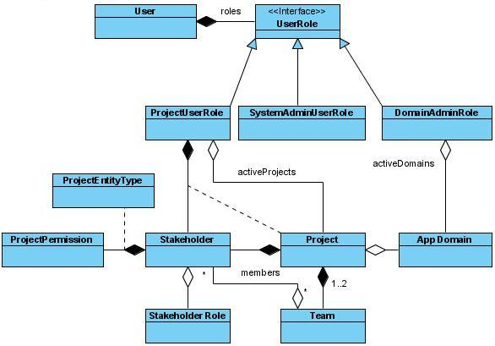
Figure 2: Users, Roles and Stakeholder Associations

User
A user represents the interactive human users of the Requel system including project users, system administrators, and domain administrators. It is conceivable that a user may have multiple roles in the system, such as a domain administrator and project stakeholder.

Properties
- Username – a system-wide unique text identifier for the user.
- Password – a string used to authenticate a user. This must be kept secret. It may be better to store a hashed value to help keep it secure. NOTE: this is really an implementation detail, users may be authenticated in different ways such as keys or biometrics.
- Name – The users real name useful for identifying the user in documents or reports generated by the system.
- Email Address – The user’s email address. The system will use this for sending communications to the user and may be included in generated documents or presented to other users of the system for contacting this user.
- Phone Number – The users primary contact number. This may be included in generated documents or presented to other users of the system for contacting this user.
- User Roles – The system level roles that the user has permission to use, such as project user, domain administrator, and system administrator.
- Can be edited? – The system administrator can create accounts intended to be shared by multiple users conceivably for reading project status. The administrator can indicate that these accounts can not be edited by the user.

Project User Role
The project user role represents a user’s general project information and permissions. This is different than a user’s project specific “stakeholder” information, such as their role, team and permissions on a specific project.
- User – The owning user. This is needed because the role contains user specific information.
- Active Projects – A set of projects that this user has opened.
- Projects – All the user’s projects.
- Last Project Accesses – A map of projects keyed by the date the user last accessed those projects.
- System Permissions – A project user may have permission to create projects and/or invite new project users to the system.
- Stakeholders – A map of stakeholders the user represents in projects keyed by the project for that stakeholder. The user will represent only one stakeholder per project.
NOTE: in implementation the set of all the user’s projects could use the key set of the map.

System Admin User Role
The admin user role represents the system admin actor from the use cases. A user with this role has authority to create and edit other users. The role has no properties. NOTE: this could be represented as a singleton.

Domain Admin User Role
The domain admin user role represents a domain admin actor from the use cases. A domain administrator can access all domains defined in the system. A domain admin user has a set of active or recent domains that are displayed when the user logs in.
- User – The owning user. This is needed because the role contains user specific information.
- Active Domains – A set of application domains that this user has opened.

Stakeholder
Stakeholders are entities such as a person or organization with an interest and possible impact on a particular project. Stakeholders have goals (stakeholder interests) that a project should satisfy. A stakeholder is specific to a project. All users of the system are stakeholders, although not all stakeholders are users. The role a stakeholder plays and their interests will vary from project to project.

Properties
- Name – a project (or domain) unique readable identifier for the stakeholder. This may be a username for user stakeholders or a title for an organizational entity such as “Financial Accounting Standards Board” or “Bailey Pet Supply Board of Directors.”
- Project or Domain – The project or domain to which the entity is associated.
- User – If this stakeholder represents a user, then the user is referenced.
- Interests – a set of goals that the stakeholder desires.
- Roles – the roles that a stakeholder plays in a project. Non-user stakeholders may have a role, such as a “standards board”. A user will be responsible for managing the interests of non-user stakeholders. Typically a stakeholder will have a single role, although in projects with small teams a stakeholder may play many roles such as a developer, analyst and project manager.
- Teams – The teams a stakeholder is on in a project. Stakeholders will typically only be on one team, but in some circumstances a stakeholder may be on more than one team. For example a requirements engineer may be on the producer team but also represent the customer and have authority to act on behalf of the customer.

Stakeholder Role
Stakeholders may play a variety of roles in a project. The roles are mostly for show as permissions are assigned at the stakeholder level. Roles may be represented as singletons or simply as a string with the name.
NOTE: Roles may be used by automated assistants to give hints when a project’s teams may not adequately represent appropriate stakeholders.
NOTE: Roles may be used to determine “appropriate” recipients of communication initiated by the system.
NOTE: The possible roles should be customizable at either the system or project scope.

Properties
- Name – The name of the role such as “end user”, “manager”, “executive”, “developer”, “project manager”, or “analyst.”

Project Permission
Stakeholders are assigned operation level permissions such as create, edit, or delete on a per project entity basis. Permissions may be represented by singletons for each of the permissions types and granted to a user in a map keyed by the project entity type for which the permission is granted. Project entities may have specific permission types appropriate only for those types of entities, such as the permission to edit the effort estimate for a use case.
NOTE: permissions may be implemented as a Java enum type.

Properties
- Name – the name indicates the type of permission and will be limited to values like “Create”, “Edit”, “Delete”, or “Estimate.”

Project Entity Type
Project entity types represent the types of entities, such as goals, actors, or use cases. They may be represented by singletons for each of the entity types and are used as keys to the map of permissions granted to a stakeholder.
NOTE: entity types may be implemented as a Java enum type.

Properties
- Name – the name indicates the type of entity and may be the class name of the entities or a pretty name.

Team
A Project will typically have two teams: a consumer team representing the customer stakeholders of the project and a producer team representing the development stakeholders. On small project one team may be sufficient.
NOTE: a project contains references to all stakeholders; if there is only one team that team will duplicate the set of stakeholders.

Properties
- Name – a project distinct name for the team. The names may be representative such as consumer and producer, or customer and engineering, or fun names like team “a” and team “b.”
- Project – The project to which the entity is associated.
- Stakeholders – The set of stakeholders on the team.
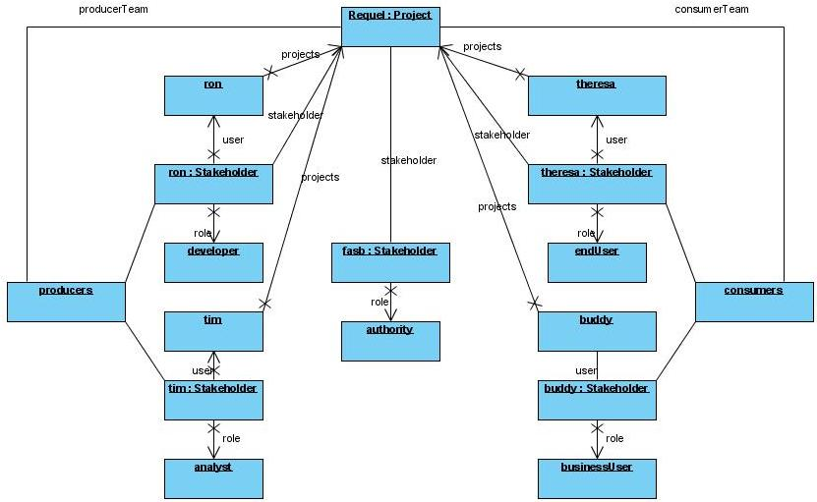
Figure 3: Project User Stakeholder Team Example
The example shows four users: Ron, Theresa, Tim and Buddy and associated stakeholder information, including role, for the Requel project. The Requel project has two teams; the producer team with Ron and Tim; and the consumer team with Theresa and Buddy. The example also shows a non-user stakeholder representing the FASB authority board.

Project
A Project is a container for all the objects that make up a set of requirements and the ancillary objects created while eliciting the requirements.

Properties
- Name – a customer unique readable identifier for the project.
- Creator – The user that created the project.
- Date Created – A timestamp with date and time of when the project was created.
- Customer – The organization the requirements are for. This is mainly for organizing projects. [QUESTION: should this just be a name string or an object?]
- Teams – A set of 1 or 2 teams depending on needs of the project. For small internal IT projects a single team may be sufficient. In other cases there should be a consumer team representing the customer of the project and a producer team representing the development stakeholders.
- Stakeholders – A set of one or more users assigned to the project with a team and role. The creator of the project is a stakeholder so there is always at least one. Removing a stakeholder effectively deletes it, although the goals/interests of the stakeholder and project entities and annotations added by the stakeholder remain. NOTE: this may just replicate the information in the teams and be unnecessary.
- Goals – A set of goals that the project must satisfy. [QUESTION: should this contain all goals, only goals explicitly added to the project, or only goals not assigned to stakeholders or use cases?]
- Stories – A set of the stories that give context to the project. [QUESTION: should this contain all stories, only stories explicitly added to the project, or only stories not assigned to use cases?]
- Actors – A set of all actors that may be used in any use cases of the project. Actors must have a unique name in the project.
- Personas – A set of all the personas in the project. Personas must have a unique name in the project.
- Use Cases – A set of all the use cases in the project. Use cases must have a unique name in the project.
- Scenarios – A set of scenarios describing user interactions. [QUESTION: should this contain all scenarios or only scenarios not assigned to use cases?]
- Annotations – A set of notes or issues attached to the project [QUESTION: should this set contain all annotations, only annotations explicitly added to the project, or only annotations not associated to any sub-object of the project?]
- Activity – A log of all the changes made to a project or component of the project since it was created.
- Application Domains – A set of all application domains associated with the project.
- Glossary – A project specific glossary of terms.
- Problem Domain Model – A project specific set of problem domain objects.
QUESTION: should a project have a status like open or complete?

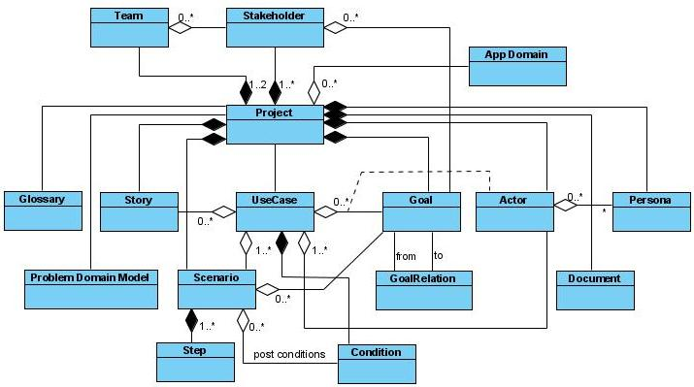
Figure 4: Project Entities

Application Domain
A domain is a container for seed data – in the form of entities like those in a project, which can be incorporated into many projects. Domains also include data used by assistants for logical reasoning.

Properties
- Name – a system unique readable identifier for the domain indicating what the domain represents, such as Finance, Mobile, or Storefront.
- Stakeholders – A set of zero or more non-user stakeholders typically used to represent authoritative bodies with goals that reflect rules or laws that have to be considered.
- Goals – A set of zero or more goals that represent typical goals appropriate for an application of this type.
- Stories – A set of zero or more stories that represent typical usage appropriate for an application of this type.
- Actors – A set of zero or more actors that represent typical roles of interaction appropriate for an application of this type.
- Personas – A set of zero or more personas that represent typical user (human or otherwise) appropriate for an application of this type.
- Use Cases – A set of zero or more use cases that represent typical usage appropriate for an application of this type.
- Scenarios – QUESTION: should a domain have stand-alone scenarios or should they all be in use-cases?
- Glossary – A glossary of words and phrases typical for an application of this type with definitions.
- Problem Domain Model – A model of object types typical for an application of this type. Each with a name, description, set of properties and possibly associations to other object types.
- Logic Rules – Rules to customize the assistants with domain specific knowledge.

Glossary
A glossary contains a set of “significant” words and phrases from the requirements that are explicitly defined to promote a shared understanding of terms across stakeholders of a project. Glossaries assigned to application domains will be read-only for associated projects. Each project will contain its own glossary of custom terms. The glossary is made up of entries with names, definitions and optional cross-references.

Properties
- Project or Domain – The project or domain to which the glossary is associated.
- Entries – a set (or map) of entries uniquely represented by a name.

Glossary Entry
A glossary entry defines a single term or concept. Entries may be cross-referenced such that two terms are used to represent the same concept, such as “the system” and “the application.”

Properties
- Name – a glossary unique string representing the term. It may be a single word or a phrase.
- Glossary – The glossary in which the entry is contained.
- Definition – a text definition of the term.
- Canonical Term – if two (or more) entries represent a single concept; the subordinate terms will reference the primary or preferred term. A term can only be subordinate to a single term so that the meaning will be unambiguous.
- Aliases – A set of terms that are subordinate to this term.
- References – A set of text fragment pointers to the use of the term in all project entities, for example “goal 46: offset 100 characters” or “use case ‘login’: name: offset 21 characters.”
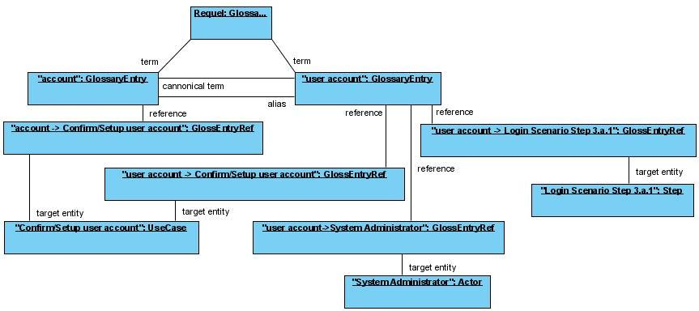
Figure 5: Glossary Object Example
In the example objects the “user account” term is the canonical form while “account” is an alias for the same concept. The “user account” term is referenced from three project entities: the “Confirm/Setup user account” use case name, the “System Administrator” actor, and the first alternate step of the third step of the scenario for the “Login to the system” use case. The “account” term is referenced from the “Confirm/Setup user account” use case description.

Problem Domain Model
A set of domain object types identified from the requirement goals, stories and use cases.

Properties
- Project or Domain – The project or domain to which the model is associated.
- Domain Object Model Entries– A map of domain object types keyed on name.

Problem Domain Model Entry
Each entry defines a distinct object type with a name, description, properties and associations to other object types.
NOTE: the associations may be represented as properties as done in this section.

Properties
- Domain Model – the model this entry is part of.
- Name – a model unique string representing the object type. The name should be descriptive and may contain spaces for readability; i.e. it doesn’t have to follow naming conventions of classes or modules in programming languages.
- Description – a description of the role an object of this types plays as described in the project requirements.
- Properties – The properties an object of this type will have and the other object types it associates with. Properties should use abstract concepts like text, strings, numbers, lists, sets, trees, or maps and other object types to describe the values they represent. Each property should have a name unique in the object type and description. NOTE: it may be appropriate for a property to have explicit links to other object types in the model to which the property associates.
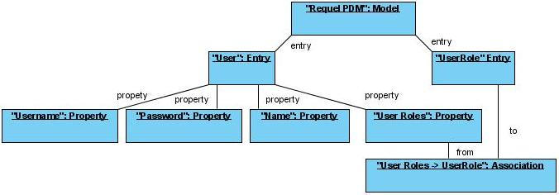
Figure 6: Problem Domain Object Example
The example shows a sample of the problem domain model for the Requel project with the “User” and “UserRole” domain object types, some of the user properties, and an association between the “User Roles” property and the “UserRole” object type.

Document
A project may have multiple documents attached. The system treats the documents as black boxes that can be added or retrieved from the system, but the system has no idea of the contents.

Properties
- Name – A project unique symbolic name for the document not necessarily its file name.
- Project or Domain – The project or domain to which the entity is associated.
- Description – A short description of what the file is for.
- Content – The document may be stored as a blob of bits in the system or as a URL to access the document located someplace else.

Goal
Goals include desired properties, constraints, features and functions. Goals are primarily textual with associations between them.

Properties
- Name – A goal may have a short name to make it easy find in a search and as a label in documents for cross-referencing.
- Project or Domain – The project or domain to which the entity is associated.
- Text – The text of the goal.
- Relationships – relationships this goal has with other goals. NOTE: this may be implemented as two sets one for relationships to this goal and another for relationships from this goal.

Goal Relationship
Goals may have relationships to other goals. Each relationship is directional from one goal to another. A relationship will either support or conflict with the target goal.

Properties
- From Goal – The originating goal that either supports or conflicts with the target goal.
- To Goal – The target or “subject” goal of the relationship.
NOTE: If the relationships of goals are thought of as operations, for example “a supports b” or “b conflicts with c” the properties of the two operations are not symmetrical. The supports relationship is not symmetric; if a supports b the reverse is not true, but the conflict relationship is symmetric. Neither relationship is transitive; for example it may be valid to have b support a, c support a, d conflict with b, and d support c. In that case d both conflicts with and supports a indirectly.
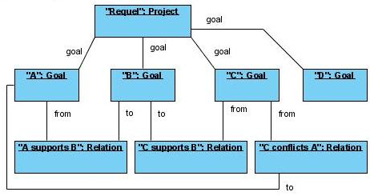
Figure 7: Goal Object Examples
In the example both goal A and C support goal B, but goal C also conflicts with goal A. Goal D has no relations to the other goals.

Story
Stories may be contextual “matter of fact” stories that define how an existing process works, good or bad used to describe the context of a project. Some stories may be contextual “anti-“stories that define existing problems that need to be solved or potential problems that need to be avoided. Other stories will be “how things should be” that describe how the system will improve processes or what the system needs to do to meet the needs of the stakeholders.

Properties
- Name – A story may have a short name to make it easy find in a search and as a title or label in the requirements documents.
- Project or Domain – The project or domain to which the entity is associated.
- Type – the role the story plays in the project: context, problem, or behavioral.
- Use Cases – A set of use cases that this story or part of the story describes the behavior of or has relevant context for.

Actor
The actors represent the roles that users and other entities external to the system, such as other systems, play in the behaviors (use cases) that the system supports.

Properties
- Name – A project distinct name for the actor. The name should be descriptive.
- Project or Domain – The project or domain to which the entity is associated.
- Description – A detailed description of what the actor represents.
- Personas – Example individuals of the actor such as people or specific systems that this system will integrate with.

Persona
Personas are example individuals of the actor such as people or specific systems that this system will integrate with. Personas add contextual information to actors and are referred to in stories.

Properties
- Actor – The actor the persona is an example of.
- Name – A project unique name used to identify personas in stories.
- Project or Domain – The project or domain to which the entity is associated.
- Description – A detailed description of the persona with relevant contextual information to the project.

Use Case
Use cases define a specific behavior of the system through goals, stories and scenarios. A use case may be a summary case that collects related use cases.

Properties
- Name – a project unique name.
- Project or Domain – The project or domain to which the entity is associated.
- Description – A text description of the use case. The description may be empty.
- Estimate – An estimate of the effort to develop this use case in hours.
- Primary Actor – The actor that initiates the use case.
- Secondary Actors – Additional actors involved in the completion of the use case.
- Scope Status – This may be a simple Boolean true/false indicating if the use case is in scope for the project at a given revision, or it may be a label like “phase 2”.
- Actor Goals – A map of goals keyed by the actor that desires to attain them by working through the use case. Typically the use case name represents the primary goal of the primary actor.
- System Goals – The stakeholder and general system goals that the use case satisfies on successful completion. [QUESTION: is there a set of minimum goals that the use case must satisfy even if it fails?]
- Stories – Stories that describe the behavior of the use case or are relevant to the context of completing the goals.
- Pre-Conditions – A set of conditions indicating the required state the system must be in before the use case can be initiated.
- Post-Condition – a set of conditions defining the state of the system when the use case ends successfully.
- Main Scenario – The scenario that defines the successful completion of all the goals of the use case.
- Alternate Scenarios – A set of scenarios that have an alternate flow from the main scenario and may not satisfy all or any of the goals. [Except the minimum.]

Scenario
A scenario defines a sequence of steps to complete a use case. A scenario may be successful (meets all the goals) or unsuccessful (meets less than all the goals.)

Properties
- Use Case – The use case the scenario is part of, which may be empty.
- Project or Domain – The project or domain to which the entity is associated.
- Steps – A sequence of interactions between the user and the system. In some cases some of the steps may not require a particular order or may be optional. A step may be a simple text statement or a reference to a use-case.
- Post-Conditions – A set of conditions defining the state of the system when this scenario ends. Note the primary success scenario should have the same entries as the use case. It’s not clear if the use case should have its own set, although it must if stories are used instead of scenarios and post conditions are desired.

Scenario Step
A step is a single directional interaction between an actor and the system or between the system and an actor. Steps may be optional, ordered, repeatable, or have alternate branches.

Properties
- Scenario – The scenario the step is part of.
- Description – A textual description of what the task entails.
- Follows Steps – A set of steps that must occur before this step. This is used to determine order.
- Optional – A Boolean flag indicating if this step is optional or not.
- Repeatable - A Boolean flag indicating if this step may occur more than once.
- Branches – A set of alternate steps.
- Sub-Use Case or Scenario – A step may be complex enough that it is defined in a separate use case or scenario.

Condition (Pre- or Post-Condition)
Conditions define the expected or required state that the system must be in to initiate a use case or the state that the system is in when a use case or scenario completes. Conditions may be stateless or stateful. A stateless condition indicates that the system does something like make a log entry or send a message. A stateful condition maintains a state, such as a user is logged in or not. Stateful conditions are set by post-conditions and tested in pre-conditions.

Properties
- Description – A textual description of what the condition is.

Stateless Condition
A stateless condition indicates that the system does something like make a log entry or send a message. A stateless condition has no additional properties.

Stateful Condition
A stateful condition maintains a state. A state may be global, requiring explicit setting, such as the login use case that sets the logged in state to true, which continues to be true until another use case sets it to false. Alternatively a state my be relative to the scope of what a user is doing, for example when a user initiates a use case, an implicit “in use case” state is set true and when the user exists the use case it is set false.
Global stateful conditions are set by post-conditions, such as “user logged in” for the login use-case. Scoped state changes are set in pre-conditions and removed in post-conditions. States are only tested in pre-conditions.

Properties
- State – this describes the setting or testing of the state of the condition.

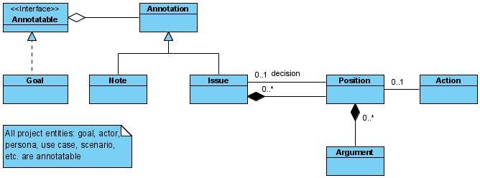

Annotation
An annotation is an abstraction of notes and issues that can be attached to all types of project entities. Annotations are the basis for collaborative discussions based on the IBIS model.

Properties
- Text – The text of the annotation.
- Project Entity – The entity to which this annotation is associated. See Annotatable.

Annotatable
This is an abstraction of something that can be annotated. All project entities, including projects and annotations are annotatable. NOTE: this is really a design/implementation concept.

Properties
- Annotations – a set of all the annotations attached to this entity.

Note (Annotation)
A note is an annotation that does not have a discussion or resolution. A note has no extra properties.

Issue (Annotation)
An issue is an annotation that supports discussion and needs a resolution (answer.)

Properties
- Positions/Answers – potential resolutions for the issue.
- Resolution – One of the positions/answers that was decided to be the desired solution to the issue.

Position (Answer)
Issues may have multiple positions that are the potential answer/decision for the issue.

Properties
- Name – A string that uniquely identifies the position for this issue.
- Description – the text of the position.
- Action – Assistants may add special types of positions that initiate an action in the system.
- Arguments – A set of arguments supporting or contradicting the position.

Argument
A position may have multiple arguments supporting or contradicting it. Collectively the arguments for all the positions should help the stakeholders agree on the deciding position.

Properties
- Support/Conflicts – this may be a simple Boolean or multiple levels of support like strongly support.
- Description – The text of the argument.
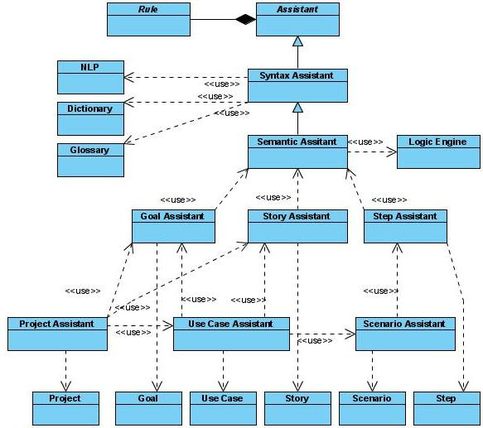

Assistant
This is an abstract base for all assistants to have a set of rules for implementing functionality. NOTE: This is a design/implementation concept.

Properties
- Rules – a set of rules that the assistants uses to implement different types of analysis.

Rule
This is an abstraction of how assistants will implement different types of analysis. NOTE: This is a design/implementation concept.

Syntax Assistant
The syntax assistant analyzes text for spelling, grammar and complexity. It identifies use of ambiguous words, use of glossary terms, possibly non-canonical, and potential new terms. See “Use Case: Analyze the syntax of the text of an entity” for the details of analysis.
It uses a constituent and dependency parse with the parts of speech and grammatical relationships generated by the NLP (natural language processing) components.
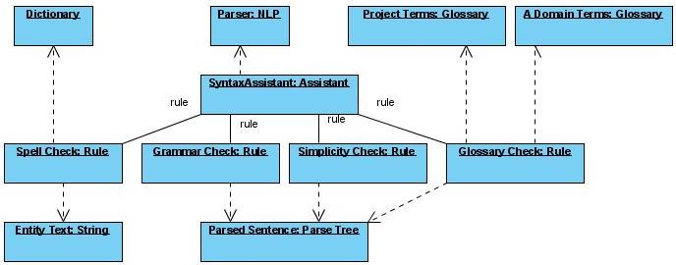
Figure 8: Syntax Assistant Objects

Natural Language Processing (NLP)
This is an abstraction representing the natural language tools that will be used for the syntactic and semantic analysis of text. It is expected that the NLP will support constituent parsing into phrases and parts-of-speech and dependency parsing into a dependency map of words and their relationships, such as verb subject and objects.
NOTE: The details of the NLP interface are a design and implementation concern to be defined during design.
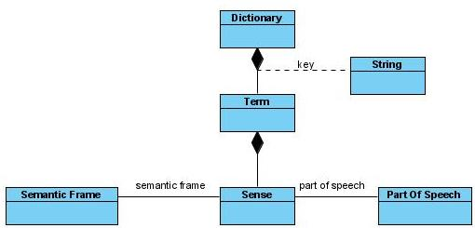
Figure 9: Dictionary Classes

Dictionary
The dictionary contains language related information and rules. There is a single dictionary shared by all projects. Each term in the dictionary may contain multiple definitions or sense of a word.

Properties
- Terms – a map of terms keyed by the text of the term, each with additional information related to the word.

Dictionary Term
Each term contains a single word with possible multiple definitions or sense, references to related words like synonyms and antonyms, and semantic information.

Properties
- Text – The text of the term.
- Senses – A set of different uses of the words with part of speech, definitions and semantic information.

Dictionary Term Sense
Each sense contains the part of speech, definition, references to related words like synonyms and antonyms, and semantic information.

Properties
- Part of Speech – The part of speech like noun, verb, adjective, etc. NOTE: These may be defined as strings, in a separate class or set of classes.
- Definition – a textual definition of the word.
- Semantic Frame – A template/pattern of how this word is used in sentences and how it relates to the words around it. Most likely only verbs will have frames. NOTE: the structure of the frames depends on the NLP tools used and will be defined during design.

Semantic Assistant
The semantic assistant analyzes the text for completeness and appropriateness in the given context of the domains of the project. It creates a logical representation of the text, applies it to a knowledge base, and checks for logical inconsistencies. See “Use Case: Analyze the semantics of the text of an entity” for the details of analysis.

Goal Assistant
The goal assistant takes the syntactic and semantic information produced by the syntactic and semantic assistants and applies rules to determine the level of a goal (abstract or concrete.) The assistant then examines the goals relationships to determine if there are potentially missing higher and lower level goals.
Through the use of the knowledge base the goal assistant may be able to automatically detect missing associations between goals. See “Use Case: Analyze a goal” for the details of analysis.

Story Assistant
The story assistant takes the syntactic and semantic information produced by the syntactic and semantic assistants and applies rules to identify personas and potential actors, identify duplicate or conflicting statements, and identify potential problem domain objects. See “”Use Case: Analyze a story” for the details of analysis.

Step Assistant
The step assistant takes the syntactic and semantic information produced by the syntactic and semantic assistants and applies rules to determine if the step is well formed, for example the subject is an actor or the system and that the step indicates some sort of interaction, i.e. the actor or system does something. See “Use Case: Analyze a scenario step”for the details of analysis.

Scenario Assistant
The scenario assistant analyzes steps as a group and how they relate to each other. See “Use Case: Analyze the structure of a scenario” for the details of analysis.

Use Case Assistant
The use case assistant is a composite assistant that takes a use case and applies the goal, story, and scenario assistants to each component of the use case.

Project Assistant
The project assistant is a composite assistant that takes a project and applies the goal, story, use case, and scenario assistants to each component of the use case.
The project assistant also applies project wide rules or cross-entity rules such as there must be at least one goal and actor in the project, or that a project team should have user representatives. See “Use Case: Analyze the structure of a project” for the details of analysis.

Approach
This chapter describes the design and implementation concerns, options, and early decisions made.
The first decision is which platform to use. I plan to use Java for the bulk of the development. Primarily because it is the language I have the most experience with, but also because of the open source tools and APIs that are available. All the external tools and libraries used must be open source or freely available as I intend to release the project as open source when the thesis is complete.
There are three aspects of the system that are the focus of the concerns: the user interface, project requirements data, and automated assistants. There are various technical concerns in these three areas:
- The user interface must be accessible for non-technical users; it must be easy to use with a minimal level of training or referencing documentation.
- The project data needs to be persistent as a project will be developed over multiple interactions by multiple users.
- The project data will need to be versioned for historical analysis.
- The data must be capable of being exported and imported for integration with external tools and conversion to html or other document formats.
- The automated assistants use a combination of natural language processing and rules to validate the requirements. The assistants do a combination of syntactic and semantic analysis; the later requires some sort of language understanding and domain knowledge to determine if the requirements are sensible.
- The domain knowledge needs to be defined in some way, i.e. there must be some sort of knowledge representation. The requirements need to be evaluated with respect to the domain knowledge with some sort of rule or inference engine.
- Any problems detected by the assistants needs to be communicated back to the users in an understandable form.

User Interface
There are two choices for implementing the user interface: a web based interface or a desktop application. While a desktop application usually allows a richer user experience, newer Ajax based web applications can have an experience almost as rich. The down side of desktop applications revolves around maintenance and setup. Technologies such as Java Web Start reduce the effort of maintenance and setup, but require that the users have the Java runtime with Web Start installed. Another potential problem with a desktop application is access to shared data. The desktop application would either need to connect to a database server remotely, have a local copy of the database and use synchronization, or access an application server through a service API. The first two options may require specialized network configuration or additional software setup and maintenance. While using a local database that synchronizes with a master server would have the benefit of allowing a user to work while not connected to a network, the synchronization issue is very difficult and can lead to a poor user experience. A web-based service using SOAP or something similar would not have the same issues as a database oriented client-server application.
The fact that most people know how to use a web browser and that a web based interface require minimal or no client-side maintenance makes using a web based interface the best choice to easily support a distributed team environment. While a web start based client using web services would allow a some what richer experience, and not have the maintenance and setup issues of a client-server architecture, the few extra steps can have an impact on non-technical users.
To support users with a variety of backgrounds and technical capabilities the application must have a rich user experience that doesn’t distract the user with complicated interactions or slow page oriented workflows. Nowadays that means it should use an Ajax based framework. There are quite a few Java web UI frameworks that support Ajax based applications, such as Struts 2, ICEfaces, Ajax4JSF, Google Web Toolkit (GWT), Eclipse Rich Ajax Platform (RAP), AjaxSwing, and Echo2.
The Eclipse RAP project seems to have a lot of potential because it is mostly source compatible with the Eclipse RCP platform; allowing an application to be developed with a web interface and desktop interface with minor modifications. However, it is a relatively new project and the demos seem to respond slowly, so I am reluctant to be an early adopter. The AjaxSwing framework seems to be in the same state as the Eclipse RAP.
After a cursory investigation, ICEfaces and Echo2 appear to be the top two candidates from which to choose. ICEfaces is an open source JSF based API with a rich set of Ajax based components accessible through a custom JSP tag library. Echo2 is an API based framework for creating an Ajax based user interface that is very similar to the Java Swing API. Both frameworks supply a comparable set of components. The benefits of the ICEfaces framework are that it is standards based (JSF), has a descent amount of documentation and examples, and is well maintained. Echo2 is not standards based, although it is similar to the Swing API. It has less documentation and examples than ICEfaces, but it is improving in this area. The biggest issue with Echo2 is its slow release cycle; a final release for the 2.1 version is still not complete and has been in release candidate status for more than six months. Despite the issues of Echo2 I find writing the UI in Java instead of in JSP pages, more than compensates for its short comings. I plan to use the Echo2 framework for the user-interface.
I intended to use a standard web-container such as Tomcat or a full JEE application server such as Glassfish. It is not clear if I need full EJB support or only entity persistence support, which is available without a full application server. Tomcat is preferred because it is easier to setup.

Project Requirements Data
The focus of this thesis is the incremental and collaborative development of requirements. Collaborative implies that the requirements must be shared by all the stakeholders, and incremental implies that they are developed over time and change. These two requirements point to the use of a data management system. This is further constrained by the requirement that the system keep track of the changes over time with a versioning mechanism.
The requirements also indicate the tool will integrate with other tools and generate a requirements document with customizable structure and style. This will involve representing the requirements in a form that is easily manipulatable. Using an XML representation of the requirements with an import and export capability can support this capability.

Data Management
Key issues for data management are transactions, concurrency and querying. There are a variety of options for storing data: relational database, object database, knowledge base, or serialized as xml data.

Serialization
Serialization entails mapping objects from Java to XML files and back again. There are many tools that provide this service, such as JAXB and XStream. To facilitate querying, the XML data could be indexed using an xml database or a tool like the Apache Lucene text search engine. Because the system will support multiple users, possible concurrently, some sort of transaction and synchronization support would be needed. A revision system such as CVS or Subversion could be used to handle the concurrency issues. There is also the issue of partitioning of the objects across multiple files. XML serialization usually works on whole graphs of objects, but holding whole projects in a single file is not practical from a revisioning and indexing point of view. So, while tools exist for each concern, it is not clear how they would interact. It seems integrating them would be prohibitively laborious to implement and unrelated to the primary focus of this thesis.

Object Database
An object database may be a good match for the project. The db4o database is available under the GPL license for projects that are also licensed as GPL (db4objects, n.d.) I don’t have any experience using an object database, and while the promise of easy development is enticing, most technologies have idiosyncrasies that require investigation and I think that time would be well spent in an area more relevant to the thesis.

Knowledge base
Using a knowledge base as the database for the project data would have the benefit that the data would be in a format that the automated assistants could apply logical analysis to directly. Both the Requirements Assistant and RATS tools use this approach. I am reluctant to follow this approach for a few reasons. The Requel tool may be useful without the logical analysis component, so storing the data in a knowledge base adds unnecessary constraints on its configuration. There are a variety of knowledge bases that support different kinds of logic and use vastly different knowledge representations. I don’t have any experience with knowledge bases and may choose one that will have unforeseen consequences that jeopardize the whole project.

Relational Database
Relational databases are very popular and widely used for web applications. There are many open source and freely available relational databases, such as MySQL or PostgreSQL. While there are potential issues mapping objects to relational tables, known as the “object-relational impedance mismatch” or “paradigm mismatch” (Bauer & King, 2004, pp. 7-16) , I have a lot of experience in this area and know most of the traps and pitfalls that can occur.
I plan to use a relational database to store project data using an Object-Relational mapping (ORM) tool to map the data to and from the database and Java. There are many ORM tools available, but my preference is to use a tool compatible with the Enterprise Java Beans (EJB) persistence API version 3. The benefits of using EJB3 include: it is a standards based API; there are multiple implementations available, most notably Hibernate and TopLink; it can be used in standalone applications without a full JEE EJB container. I plan to use Hibernate as the EJB3 provider, as I am more familiar with Hibernate than TopLink.

Versioning
An important aspect of incremental work is maintaining revisions of the work over time. Revisioning allows for analysis of the evolution of the work. Changes can be examined to see who has changed what and when. Revisions assist in conflict resolution when concurrent changes are made. Milestones can be defined as sets of revisions for others to use as a basis for their work while work on the requirements progress.

Revisioning Systems
Revisioning systems such as CVS or Subversion were designed to manage concurrent editing of sets of files including conflict resolution, branches and history. Unfortunately these systems are file oriented and don’t work with data stored in a relational database.

Temporal Database
Temporal databases were conceived to deal with data relative to time. For example, in a standard SQL database there may be a record representing a person and where they are employed. When that person changes jobs the record becomes invalid until it is updated with that person’s new employer, but when changed the fact that the person was employed somewhere else prior to now is gone. In a bitemporal database data has a period of validity and a transaction time of when the data was changed (Steiner, 1997; Snodgrass, 2000.) Using a temporal database with the example above, instead of replacing the employer information, new information and a relevant time span for the new employer are added, in this case an open ended span starting from when the new job was started. Queries in a temporal database include the time aspect, for example “where does John work now”, “where did John work in 1998”, or even “where has John worked” are possible with a temporal database.
Most relational databases don’t support temporal data concepts natively, however a separate project called TimeDB exists that can be used with a standard relational database to add temporal support (Tang, Liang, Huang, & Yu, 2004.) TimeDB is implemented as a Java library that supports a slight variance of the ATSQL2 language (Steiner, 1999.) The latest version of TimeDB 2.2, has been tested with the Oracle 10g and IBM Cloudscape 10 databases, but in theory should work with any JDBC compliant database.
A potential problem with using a temporal database or the TimeDB middleware is how it will interact with the ORM software. EJB3 was designed with the standard relational model in mind. While Hibernate supports writing adapters for specific databases, it doesn’t support the temporal concepts internally so an adapter wouldn’t help. Also, while a temporal database would make managing the versions of content almost free, I don’t need all the aspects of a temporal database to support versioning.

Audit Logs
Audit logs are a mechanism to track changes to data over time. Audit logs differ from the temporal database in that they are explicitly separate from the original data which is stored in a standard relational table. Audit logs are conceptually different from temporal databases in that they focus on tracking changes as opposed to holding data that changes, although they can be used to get the same results. Audit logs are relatively easy to implement, and in many cases their creation can be hidden away at the database level using triggers. The Hibernate site has an example of implementing an Audit log as an Interceptor to avoid having database dependencies using triggers (Monie, 2005.)
The downside of using the audit log is that processing the data can be complicated and slow (Fowler, n.d.) Martin Fowler suggests using the Temporal Object pattern instead of an audit log if the temporal data is tightly integrated into the functionality of the system.

Temporal Objects/Properties
As an alternate of using a temporal database, Martin Fowler describes two patterns that can be used to model temporal data: Temporal Object and Temporal Property (Fowler, n.d.2.) The basic idea is that a collection is used to hold the history of the data, either for a single property or a whole object. The Temporal Object pattern can be implemented using a single class for both the primary object and the history objects, or it can be implemented as two separate classes.
The downside of using these patterns versus the Audit Log pattern is that the history is explicitly managed in the entity objects. This can be complicated and data intensive, especially with highly associated object model containing lots of collections. For example in the Requel system a stakeholder can have a set of goals; when a goal is added to a stakeholder a new version of the stakeholder is created with a new set of goals where the new goal is added.
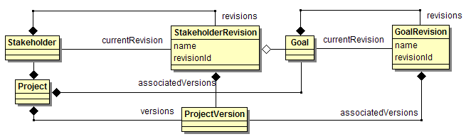
Figure 10: Stakeholder and Goal Classes using the Temporal Object Pattern
In Figure 10 the Stakeholder class acts as a proxy to the underlying StakeholderRevision class that contains the actual data of the stakeholder. Each StakeholderRevision will contain all the data of the stakeholder, not just the values that changed, as well as a distinct revision id that identifies the specific version of the stakeholder. The Goal and GoalRevision classes work in the same manner. An important issue surfaces with respect to the stakeholder’s goals. If a new goal version is added to the goal does a new stakeholder version need to be added as well to account for the new goal version? There are valid reasons for wanting both revision aware collections and collections that track the current revision. For the case of a milestone or snapshot where a specific state of the requirements is desired then the exact revision of each goal in relation to the revision of the stakeholder is necessary. For the case when the requirements are being developed, the user should see the latest revision.
I believe I can achieve both desired behaviors by implementing the simple case where a collection contains the master object (Stakeholder or Goal objects) without an explicit reference to a revision object (StakeholderRevision or GoalRevision) by adding a ProjectVersion object reference to all revision objects in a project to identify an explicit version. Querying the system for a specific ProjectVersion will constrain the master object (Goal) to the correct revision object (GoalRevision) by the associated version object.
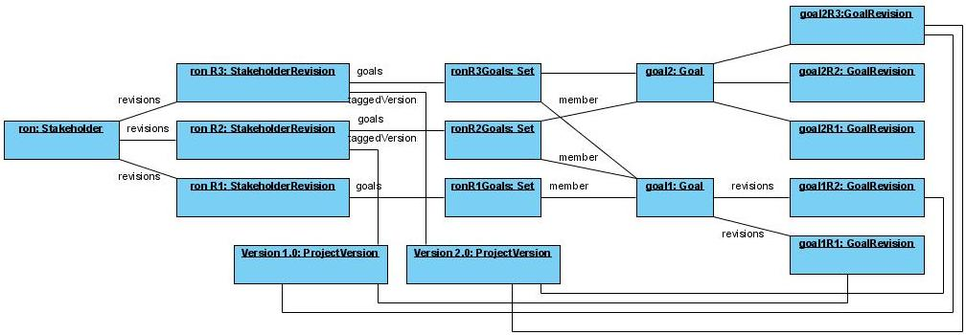
Figure 11: Example Versioned Objects
In the example of Figure 11, the stakeholder “ron” has three revisions. Revision one references goal one, and revision two and three references goals one and two. Goal one has two revisions and Goal two has three revisions. Project version 1.0 is associated with stakeholder revision two, goal one revision one, and goal two revision three. Project version 2.0 is associated with stakeholder revision three, goal one revision two, and goal two revision three. Querying for the contents of project version 1.0 will result in the objects shown in Figure 12, while querying for the contents of project version 2.0 will result in the objects shown in Figure 13.
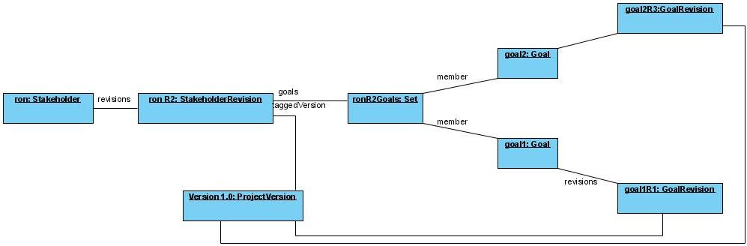
Figure 12: Example Version 1.0 Objects
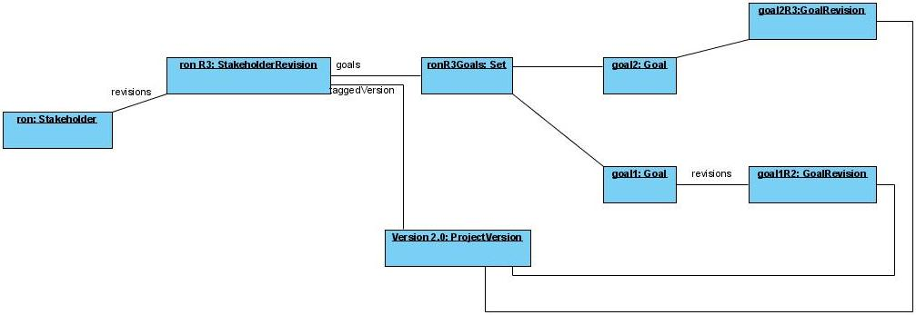
Figure 13: Example Version 2.0 Objects
The important points of the example are that specific revisions of master objects are tied to versions and revisions of different master objects are independent. This avoids the potential problem of two different revisions of one object being tied to a single version through two different project objects that would occur if master objects referenced specific revisions through associations to other master objects.

Integration, Import, and Export
There are two requirements concerned with moving project data in and out of the Requel system. The primary requirement is generating a requirements document that can be printed or referenced without having access to the Requel system. The document generation will allow for customizable formats. This requirement is only concerned with outputting data. The second requirement is integration with external tools, although there are no specific tools in mind with which Requel will interact. This requirement is concerned with both input and output of project data. The requirements indicate using XML in both cases and while it is really a design decision that crept into the requirements, it seems like a reasonable approach, although an API exposing services for manipulating project data is also a good solution for integration.
Using a combination of project data in XML and rendering rules in XSLT is a very flexible approach for document generation. XSLT stylesheets can transform XML into HTML, PDF (using XSL-FO with the Batik tool), Open Document Format (ODF), or any other XML or text format.
I think using XML for integration via import/export is the preferred method for two reasons. First, I will need to support an XML format for projects to implement the document generation. Second, many tools support XML formats natively; using XSLT to transform one XML format to another will allow integration without having to write code to integrate with a service API. For example most UML modeling tools support importing and exporting models in XMI format. There are different approaches for generating XML from Java objects, which I will review below.

Java Architecture for XML Binding (JAXB)
JAXB is a framework for working with XML data files with the promise of not having to understand XML or XML processing APIs (Ort & Mehta 2003.) It uses a binding compiler to generate a set of Java classes representing the XML data from an XML Schema (XSD) file or a schema generator to create an XML Schema from a set of Java classes. It works for both input and output of XML data using an Unmarshaller to read the XML file and generate a graph of Java objects and a Marshaller to write out a graph of Java objects.
The initial JAXB 1.0 API was oriented towards the XML data and schema, and not the object model. It was really an API for wrapping an XML document in JavaBean objects and not a framework for importing and exporting a Java object model. Version 2.0 of the API added facilities for starting from the Java side. JAXB 2.0 adds a schema generator, a set of annotations for controlling the output of the XML, and the ability to add custom adapters that alter JAXB’s view of objects (Goncalves, 2007.)
The advantage of using annotations to control the mapping to XML with the ability to automatically generate a corresponding XSD file makes JAXB seem like an efficient and time saving approach. My previous experience with JAXB didn’t live up to the hype. In particular I had problems related to a liberal use of Java Interfaces and mapping collections and maps.
I will try to use JAXB, but if I run into trouble I will switch to an alternate option if I can’t resolve problems quickly.

XStream
XStream is an open source project from the Codehaus community for serialization of Java objects to and from XML files. Its ease of use and adaptability are comparable with JAXB, although it doesn’t generate XML Schemas or Java code. In cases where the XML structure doesn’t matter, XStream can be used without any configuration, relying purely on reflection to traverse the object graph and generate XML.
Like JAXB XStream supports annotations and adapters (called converts) to control the structure of the generated XML. The lack of XML Schema generation makes this a second choice to JAXB.

XMLStreamWriter and XMLStreamReader
The XMLStreamWriter and XMLStreamReader are two classes from the Streaming API for XML (StAX) that support low level access to XML comparable to SAX but instead of operating in a push style of interaction it uses a pull style where the program asks for data using a cursor. StAX supports both cursor and event based models of interaction. With cursor based access programs can skip to specific elements in the XML without having to process the elements before it.
It is unlikely that I will use this solution as it appears it would require as much development effort as the SAX option, and I have no experience with it.

Simple API for XML (SAX) and Commons Digester
In previous projects working with XML import and export I have found working at a the SAX level provides the most control, and while it requires more code the code is easy to implement and understand. The Commons Digester facilitates reading XML data using a SAX parser by mapping elements using a simple path structure to rules for processing those elements.
The benefit of using this approach is the control over the XML generated, the simplicity of the code, and my previous experience. The disadvantage is the amount of code required. I will only use this approach if I encounter problems using JAXB or XStream and run out of time to find a solution.

Automated Assistants
The automated assistants will use a combination of natural language processing, domain knowledge, and logical analysis to identify problems and make suggestions to improve the requirements. There are a variety of approaches and tools for the analysis.

Spelling and Dictionary
The spell checker is important more as a precursor to further lexical analysis. Words spelled incorrectly can cause problems parsing the sentences and creating logical representations. I could use an open source spell check tool, such as Jazzy (http://jazzy.sourceforge.net/). Ideally the spell checker will use the dictionary built into the system.
One of the features of the system is a dictionary with part-of-speech and semantic information that are used by other parts of the analysis. Tools such as WordNet, VerbNet, and FrameNet, contain various types of information from word relationships like synonyms, to semantic frames describing how the word can be used and how it relates to other words in a sentence. It may be better to use an external tool like WordNet instead of implementing my own dictionary, although users will need to be able to update the contents.

Natural Language Processing
There are three aspects of natural language processing that the assistants will require:
- Parsing – The assistants must parse the text into a form that can be syntactically and semantically analyzed. The assistants will use this information for grammar checking, dictionary and glossary lookup, complexity checking and as a precursor for logical analysis.
- Translating – The assistants must translate the parsed structures into a representation that a knowledge base or inference engine can reason about and submit it for processing.
- Responding – The assistants must take the results of the analysis communicate the problems or suggestions to users in a natural language they understand.

Parsing
There are a variety of tools that provide different levels of language processing from identifying sentence boundaries and words in a text, to marking the part of speech of each word and associating the relationships between the words.

Sentence Segmenter
A sentence segmenter takes a document and breaks it into a set of sentences. This is non-trivial because a period “.” can be used for more than ending a sentence. A sentence segmenter is also known as a sentence boundary detector or sentencizer.
I’ve found a few implemented in Java: The jTokenizer package by Andrew Roberts, the sptoolkit by Dr. Scott Piao and Yoshimasa Tsuruoka, and the OpenNLP framework includes one too. Most parsers expect single sentences as input and don’t include this functionality so a separate tool will most likely be needed.

Tokenizer
A Tokenizer takes the text of a sentence and breaks it into separate words. This is more difficult than it initially seems because spaces and punctuation don’t always indicate the boundaries of a word. For example “New York” is really one word.
Both jTokenizer and the OpenNLP framework include word level tokenizers, but most parsers include this functionality. I expect to use the tokenizer built in to the parser, but if I encounter problems I will experiment with the external tokenizers to see if they improve the results of the parser.

Part of Speech (POS) Tagger
For each word in a sentence or phrase a POS tagger adds the grammatical type of a word, such as noun, verb or adjective. This can be tricky because some words have different senses in different cases, meaning that the word has different meanings or uses and even that they are sometimes used as nouns and sometimes used as verbs (or other grammatical types.) For example in the phrase “The duck flew south” the word duck is used as a noun. In the phrase "Duck your head under the doorway” duck is used as a verb. Determining what sense of a word in use is called word sense disambiguation and is an important sub-area of natural language processing research.
There are many distinct POS taggers, but most parsers include this functionality. I don’t plan to use a separate POS tagger.

Morphological Processor
Some words have many forms such as various tenses or plurals, for example “be” has: am, are, is, was, were, be, being, been. To simplify processing it is convenient to convert the words into a normalized form. This is particularly useful when applying the semantic frame of a word. The Java WordNet Library package has a Morpher that uses the WordNet dictionary to find the normal form.

Syntax/Grammar Parser
Syntax parsers take a sentence of words and describe the relationships between the words. There are three common types of syntactic parsers: constituent, dependency, and link. A constituent parser organizes the words into a phrasal tree structure with terminal components like nouns and verbs and structural components like sentences and verb, preposition, and noun phrases. A dependency parser returns a set of word relationships (or grammatical functions), such as determiner, subject, object, and modifier. A link parser also returns a set of word relationships, although the relationships are derived differently and in theory are different from what a dependency parser returns.
Following are examples of the results from the different types of parsers for the sentence “An old man drove the red car quickly” visualized with the Stanford Parser Parse Visualization Tools (available at http://ai.stanford.edu/~rion/parsing/index.html.) The constituent parse is clearly different from the dependency and link parses. The constituent parse adds nodes to the tree representing the organizational structure and the arcs are unlabeled. The dependency and link parses in contrast only have nodes for the words, and the relationships are identified through the arcs. The dependency and link parses have almost identical links, although labeled and laid out differently.
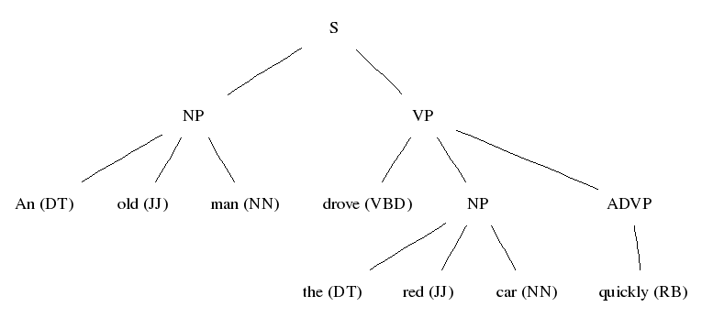
Figure 14: Example Constituent Parse
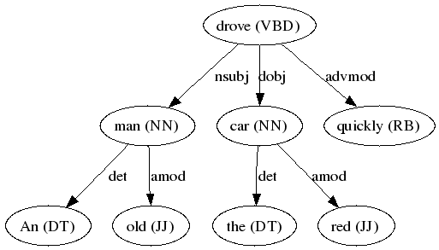
Figure 15: Example Dependency Parse

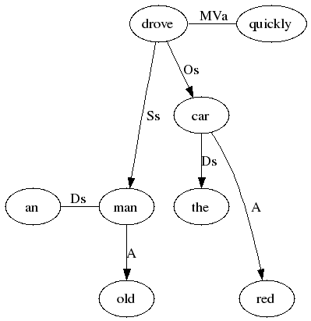
Figure 16: Example Link Parse
While the relationships of dependency and link parses are syntactically based, they appear to be related to thematic relations of semantics. For example the syntactic subject “man” represents the FrameNet semantic role of “driver” and the syntactic object “car” represents the semantic role of “vehicle”. Unfortunately this is deceiving. Taking the example sentence and making it passive “the red car was driven quickly by an old man” results in a completely different dependency parse. In the original sentence the man was the subject, in the passive sentence the car is the subject. From a semantic point of view the man is the driver in both cases.
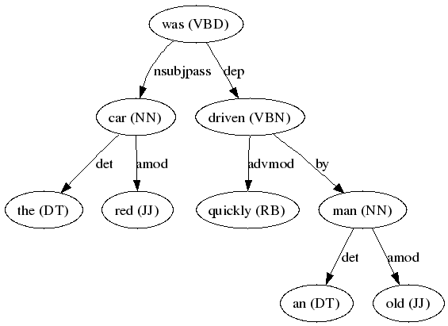
Figure 17: Passive Example Dependency Parse
I plan to use the Stanford parser. It is a collection of statistical (probabilistic) context free grammar (PCFG) parsers for creating constituent and dependency parses of natural languages. It is implemented in Java and the easiest parser to use I have found. The down side is that the performance drops quickly with the length of the sentence.

Semantic Parser (or Semantic Role Labeler)
A semantic parser assigns semantic (or thematic) relationships to the parts of a sentence typically revolving around a verb. For example the statement “I eat ice cream” can be represented in a thematic role form such as verb, agent, and patient form from VerbNet as <verb: eat, agent: I, patient: ice cream> or in a more verb specific form as <verb: eat, eater: I, eaten: ice cream> such as used by FrameNet.
The Semantic Role Labeler (SRL) of the Cognitive Computation Group at the University of Illinois Urbana-Champaign is a good quality labeler, but it is written in C++ and Perl and uses the Charniak’s Parser and I prefer to use a Java based parser if possible. There is a web based demo of the tool and I used it on the two example sentences from the syntax parsing section. As can be seen in Figure 18 the semantic roles stay attached to the same target text unlike the syntactic roles of subject and object.
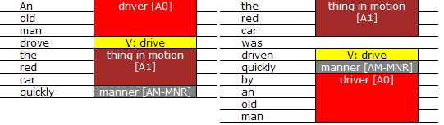
Figure 18: Example Semantic Parses
Xara is a Java based semantic role labeler original designed to generate training data for the Dutch Language Corpus Initiative (Stevens, 2007.) The tool reads in text in Alpino Treebank structured xml files and adds semantic role properties to the elements using rules that apply PropBank style roles based on XPath rules.
I haven’t tried to use Xara, but the interface is oriented towards updating sets of XML files and not plain text or syntax parse trees. The rules used also seem pretty simple, basically assigning the PropBank Arg0 to the syntactic subject and Arg1 to the syntactic direct object, unless the subject was passive in which case they would reverse the assignment (Monachesi, Stevens, & Trapman, 2007.) The approach seems like something I could do easily myself. I need to do further investigation to determine if there is any part of the tool that could be useful if adapted to my needs.
As part of his PhD. thesis combining natural language processing, translation to logical representation, and language generation Wong (2007) developed the WASP* semantic parser and text generator system. An example of how WASP* can be applied for NL -> logic -> NL is the Geoquery demo; a U.S. geographic query system with an English language interface. I haven’t had a chance to evaluate the WASP* system, but I tried out the Geoquery demo and it seems pretty cool.
VerbNet is not a parser, but each frame includes a mapping from constituent parser nodes to semantic roles. The SYNRESTRS elements indicate that all the contents of the syntactic elements in the NP element make up the semantic content:
<SYNTAX>
<NP value="Agent">
<SYNRESTRS/>
</NP>
<VERB/>
<NP value="Patient">
<SYNRESTRS/>
</NP>
</SYNTAX>

This information could be applied to the constituent parse tree to generate a semantic representation.

Translating
Translating from plain English into a logical representation is a difficult problem. I recently found the WASP* system (Wong, 2007) mentioned in the semantic parsing section, but I haven’t had time to evaluate it. I’ve found other research on different aspects of a solution.
Mollá and Schwitter (2001) describe a process to convert plain English into controlled English. The first step is to generate syntactic parse of the plain English and translate it into flat logical forms, a concept similar to Discourse Representation Structure (DRS) used by Attempto Controlled English (ACE) (Fuchs, Schwertel, & Schwitter, 1999.) I may be able to use this idea to generate ACE and then use the Attempto Controlled English Parser (APE) web service to generate FOL or RuleML to apply to the knowledge base.
I still need to do more research in this area.

Responding
There are two types of responses that the assistants need to generate: pattern based and logical translations. Pattern based messages will use a fixed text with embedded variables to report thinks like unknown words, grammatical problems, and sentence complexity. For example, “The word ‘use-case’ may be spelled incorrectly or is an unknown word” is made up of mostly static text with the word use-case injected in the single quotes. These types of messages will be generated using the Java text package Formatter class.
Logical translation this will require taking a logical explanation on how the knowledge base or inference engine reached a conclusion and translating it to natural language. Typically the explanations generated by a knowledge base include every rule and fact used to reach the conclusion, which would probably overwhelm a user and not offer good advice on how to solve the problem, so the system should be able to prune an explanation.
One of the features of the WASP* system (Wong, 2007) is generating an English response from logical forms. I haven’t evaluated the system so I’m not sure if it is a workable solution.
I still need to do more research in this area.

Domain Knowledge
There are two main issues in dealing with the domain knowledge: how it will be defined, and how it will be applied by the automated assistants to validate the project data.
A key aspect of the system is evaluating the use-cases structure and content for completeness, consistency and correctness and pointing out problems or making suggestions on how to improve them. For the system to be able to do this the knowledge must be in a form that can be reasoned about. A knowledge base is the collection of knowledge facts and rules that works with a reasoning engine that can evaluate the rules to answer a query. The knowledge may be represented in logical models like Datalog/Prolog, Frame Logic (Kifer, Lausen, &Wu, 1995) or Description Logics (Nardi & Brachman, 2003), or non-logical models such as networks or rules-based representations (Nardi & Brachman, 2003, p. 6.) There is also the possibility of hybrid knowledge bases that combines logical and non-logical representations, for example frame-based systems such as Cake (Rich & Waters 1986, 1987, 1990), ConceptBase (Jarke, M. et al., 1995), and KM (Clark & Porter n.d.)
Formal representations based on logical reasoning theories, such as datalog, frame logic or description logics, have the benefit of being mathematically sound and having well defined properties of computability: completeness – is it possible to prove something, decidability – is it possible to compute the proof of something, and complexity – how efficient is it to prove something. The key factors involved in choosing a logical knowledge representation are the logical expressiveness of the language, which determines how and what kind of concepts and rules of the knowledge can be defined (Nardi & Brachman, 2003, pp. 14, 23, 28, 37; Baader & Nutt 2003, pp. 48, 92-93); the computational complexity of the algorithms needed to reason about the knowledge, which determines if it is possible to get an answer and in a reasonable time (Baader & Nutt 2003, pp. 48-49; Nardi & Brachman, 2003, pp. 8, 14-15, 23); and the usability of the knowledge representation, which determines if it can be used as an effective modeling language (Nardi & Brachman, 2003, pp. 21, 24, 26.) An important consideration pointed out by Nardi and Brachman (2003, p. 14) citing work done by Brachman and Levesque that showed the more expressive the representation, the more complex the reasoning.
There are three sets of knowledge that the system needs to represent for the analysis of use-cases; the concepts and rules about use-cases in general; the concepts and rules about application domains; and the information about the requirements of a particular project. For a particular project the information about how it complies with the general use-case rules and application domain will most likely be represented by two distinct conceptual models. The model for use-cases will include entities for stakeholders, actors, goals, use-cases, stories, scenarios, and steps. The definition of these entities and the operations on them will likely be fixed so it may be possible to codify the knowledge in Java instead of using a general purpose logic-based model, but Eberlein (1997) showed how powerful and elegant Telos could be used for this purpose in the RATS system. The knowledge about application domains is expected to be extensible and customizable, so the representation will need to be more general to support various types of knowledge.
The following are requirements that the knowledge base must support:
The knowledge base must support multiple contexts so that rules and facts from one project don’t affect the state of another project. The contexts should be able to inherit rules and facts from other contexts so that domain data can be partitioned into a context and included into a project by having the project context inherit from the domain context. It may also be possible to represent beliefs of different stakeholders in separate contexts to allow for conflicting ideas that need to be resolved if the system doesn’t support inconsistency.
The knowledge base must support incrementally adding, modifying and deleting knowledge facts and rules so that as new use-cases are added or existing ones changed the system can verify the consistency of the model without rebuilding it every time.
The knowledge base must be able to explain how it reached a conclusion or why it rejected a rule or fact as contradictory. Ideally this would be in natural language, but if that is not possible, at a minimum the system must return the list of rules.
A practical constraint of the knowledge base is that it must be open-source or available to use as part of this thesis for free.
The following are “nice to have” features:
Support for inconsistency, for example two contradicting facts, could be useful, although this could be implemented using user-specific contexts or by tagging a statement (like a goal) external to the knowledge base as contradicting another statement that is in the knowledge base.
Support for inductive reasoning or defaults could make the system more user friendly by allowing it to assume information so that users don’t need to explicitly supply every detail unless they need to over-ride an assumption. This can also make defining application domains more compact (Greenspan, Mylopoulos, & Borgida 1994, p. 7.)
Support for temporal reasoning such that the system can place use-case scenarios into a time sequence and identify when data entities come into or go out of existence. This will allow the system to detect when ordering of use-cases or the steps in use-cases reference data that doesn’t exist yet or no longer exists.

Telos
The Telos language (Mylopoulos, J. Borgida, A., Jarke, M. & Koubarakis M. 1990) was founded on concepts from knowledge representation and designed to support the development of information systems. It has evolved from the requirements model language (RML) of Greenspan to allow for richer modeling beyond the original concepts of entities, activities and assertions (Greenspan, Mylopoulos, & Borgida 1994, p. 4.) It is a language for modeling rather than specifying requirements. As described by Greenspan, Mylopoulos, and Borgida (1994, p. 2) a modeling language needs to include explicit knowledge about the environment so that an understanding of the system in its environment can be achieved by all the stakeholders. This is distinct from specification languages that focus solely on the system being developed.
Telos can also be described as a meta-modeling language in which specialized conceptual models can be modeled. For example the Entity-Relationship model can be defined in the Telos language, done as an example of the ConceptBase system (ConceptBase Team 2007, pp. 106-115.) Mylopoulos, Borgida, Jarke and Koubarakis (1990) use Telos to define a specialized meta-model for modeling information systems from the view of the application domain, the system implementation, the user environment, and the development process. Hahn (1996) created a meta-model in Telos representing the analysis and design phases of the Fusion development method, an object-oriented software development method developed at Hewlett-Packard.
More formally Telos is an object-oriented language with objects, classes, inheritance (is-a relationships), and attributes (has-a relationships.) It has facilities for defining integrity constraints and deductive rules; and integral support for creating, updating, deleting and querying classes and objects in a knowledge base. It uses a frame-based syntax for defining classes and objects and a first-order predicate calculus like syntax for defining deductive rules and constraints.

ConceptBase
ConceptBase is a deductive object database that uses a variant of the Telos object-oriented deductive modeling language called O-Telos and implemented on the Datalog with negation logical framework using Prolog (Jarke, M. et al., 1993, pp. 4, 31; ConceptBase Team 2007, p. 6.) It supports a frame-based notation similar to that of Telos and logical notation called CBL (ConceptBase predicative language) for defining integrity constraints, deductive rules, and queries. CBL requires all variables to be typed and quantified (ConceptBase Team 2007, pp. 14-19.) ConceptBase supports the standard Telos ASK, TELL, and UNTELL operations (Jarke, M. et al., 1993, pp. 6, 13, 15.)
ConceptBase is implemented using a client-server architecture that supports multiple users, although its concurrency control is limited to forced serialization which could pose a performance problem if many users are accessing the system concurrently (ConceptBase Team 2007, p. 4.) It supports access from Java applications over TCP/IP connections through a simple API for asking, telling and untelling frames. It has two Swing based Java user interfaces, one for editing models via O-Telos frames and another for editing models graphically. Both interfaces can be run as desktop applications or as applets through a web browser (ConceptBase Team 2007, pp. 34-60.)
ConceptBase supports the concept of modules for partitioning of data into distinct contexts. Modules support import and export to expose specific objects for use in other modules, and it supports module inheritance or “nested” modules (ConceptBase Team 2007, pp. 61-64.)
ConceptBase supports a concept called “hints” for providing natural language error messages to constraint rules. Hints support a simple form of parameterization to replace embedded variables in the text of a message with variables from the constraint rule (ConceptBase Team 2007, p. 18.) This could be used for the template based responses mentioned in section 7.3.2.3.
I was able to do some simple experiments interacting with ConceptBase from Java.

Knowledge Machine (KM)
The KM knowledge base uses a frame-based knowledge representation based on LISP with first-order logic semantics (Parmar 2001.) I was able to experiment with KM, but not though Java, although it is network based

Mandarax
Mandarax is forward chaining inference engine written in Java. I have not evaluated it; further investigation is needed to determine if it is suitable for my needs.

jDREW
jDREW is deductive reasoning engine written in Java that supports rules in Prolog and RuleML. I have not evaluated it; further investigation is needed to determine if it is suitable for my needs.

RuleML
RuleML is an XML based markup language for expressing FOL based logical rules. It is supported by a variety of tools. RuleML is oriented towards rule or inference engines and not frame-based knowledge bases. If I use an infrenece engine like Mandarax, jDREW or Drools, I will probably use this format for knowledge representation.

Drools (JBoss Rules)
Drools is rules engine written in Java. It supports FOL based logical rules in RuleML or x. I have not evaluated it; further investigation is needed to determine if it is suitable for my needs.

Florid/Flora-2/Ontobroker
Florid is an object-oriented f-Logic knowledge base system developed at Freiburg University that uses the Flora-2 frame-based language. Florid is the open source sister project of the commercial Ontobroker tool. an F-logic system developed at Freiburg University. It is implemented in C++

Cyc and OpenCyc
CycL is based on first-order predicate calculus extended with Zermelo-Fraenkel set theory; an axiom based set theory expressed in first-order predicate logic (Weisstein n.d.), meta-level assertions, multiple contexts, and modal operators. It also included special-purpose representations used in situations for heuristic shortcuts. (Lenat, et al. 1995. p. 38) It is an integral part of the Cyc and OpenCyc knowledge bases.

OWL/RDF or OIL-DAML
The Web Ontology Language (OWL) and Resource Description Framework (RDF) are XML based knowledge representations. The OWL Web Ontology Language extends the concepts of RDF for building domains of knowledge with richer vocabulary and three levels of formal semantics (W3C 2004b.) RDF is a language for representing semantic information about resources on the Web (W3C 2004.) OWL adds reasoning capabilities to the RDF semantics and is compatible with many description logics based inference engines.
The benefit of OWL over RuleML is hierarchical nature of the descriptions. It’s not clear if I need to use an ontology language.

Architecture
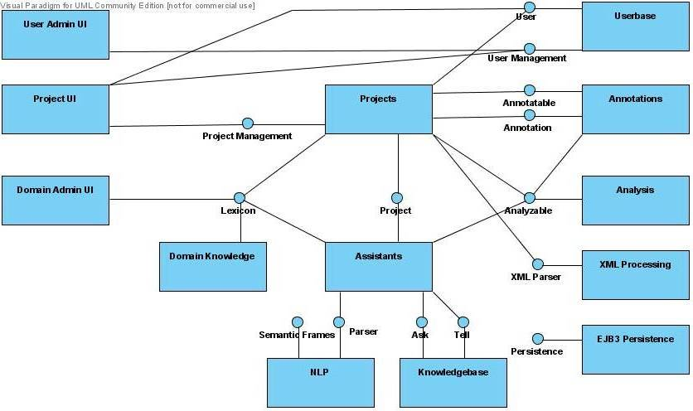

Design
This section defines initial design ideas.

UI Framework
The Echo2 framework is based on the MVC pattern (more accurately the Model-Delegate variant of the MVC pattern) and is very similar to the standard Java Swing API. It has many basic components such as text inputs, different types of buttons, lists, as well as more advanced components like trees, tables and tabsets.
A downside of the Echo2 framework is that it only provides low level components, which requires significant effort to create higher level constructs such as forms and navigation. Another issue, inherent in the observer pattern used for event passing, is that the controllers need to be explicitly wired together with the components they listen to. That is not such a big problem for components and controllers that are only concerned with activity internal to a panel or form, but when panels and forms need to interact, managing the relationships can add complexity and unwanted dependencies.
The UI Framework will build upon the Echo2 framework and provide higher level components such as screens, panels and forms. The framework will also provide a navigation mechanism to remove cross panel coupling. The navigation will use a broker to forward navigation related events such as opening panels to edit or find data objects by type and returning edited or found objects to the original requestor.

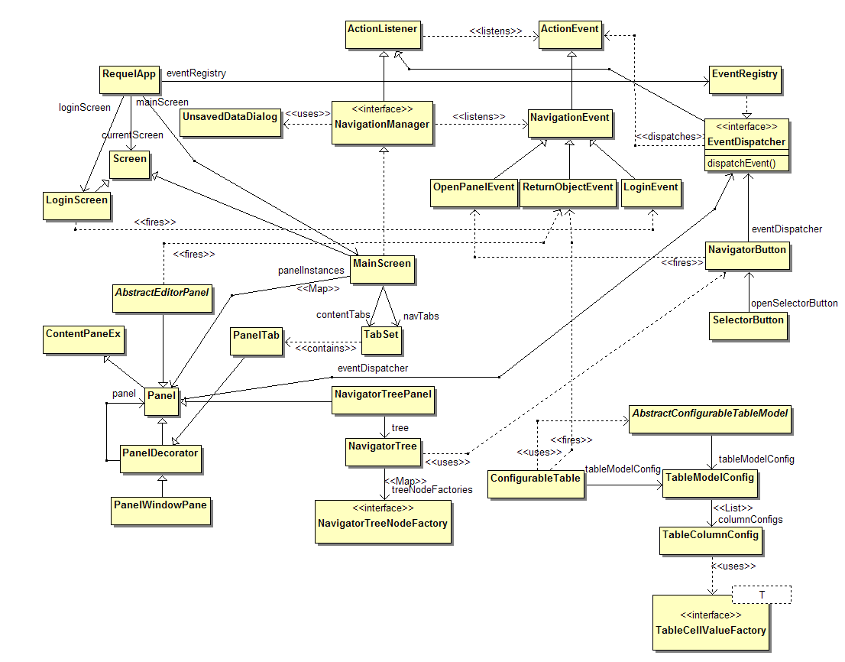
Figure 19: UI Framework

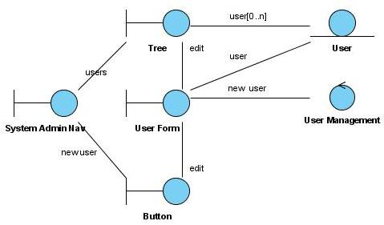
Figure 20: Analysis of Create/Invite a user

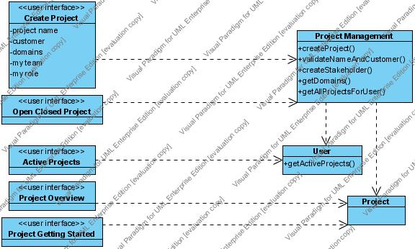
Figure 21 Project UI
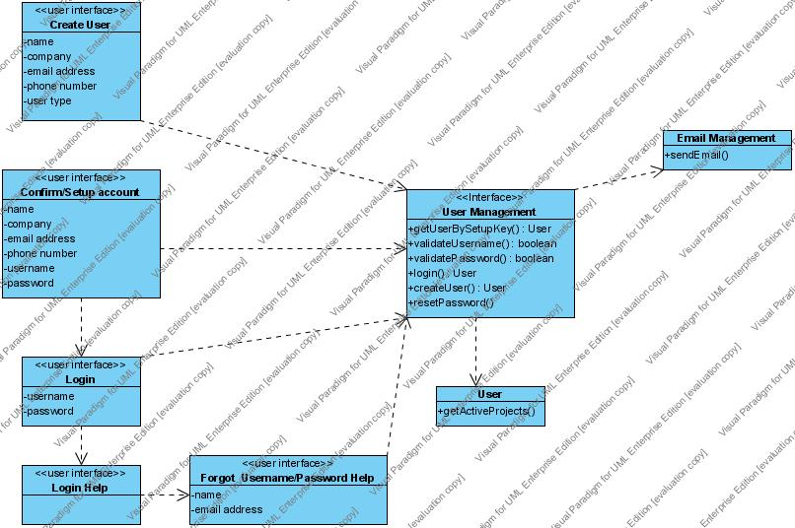
Figure 22 User UI
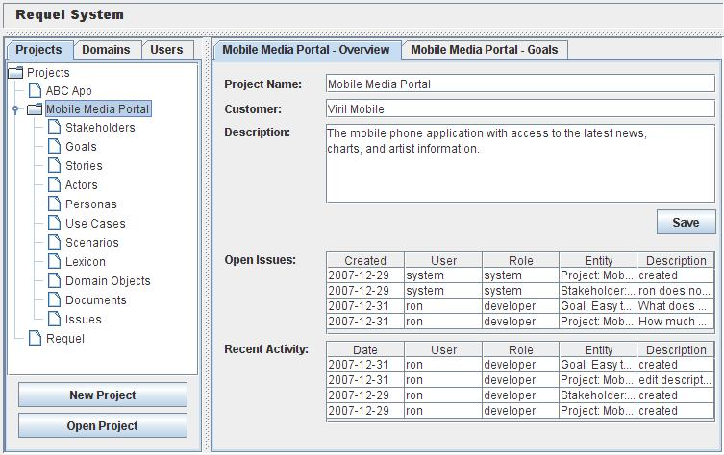
Figure 23 Main UI with Project Overview
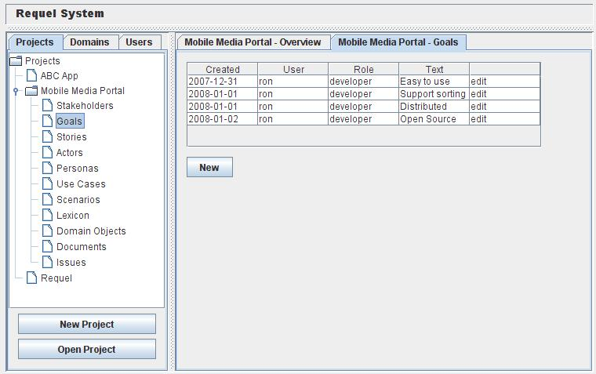
Figure 24: Main UI with Goals List
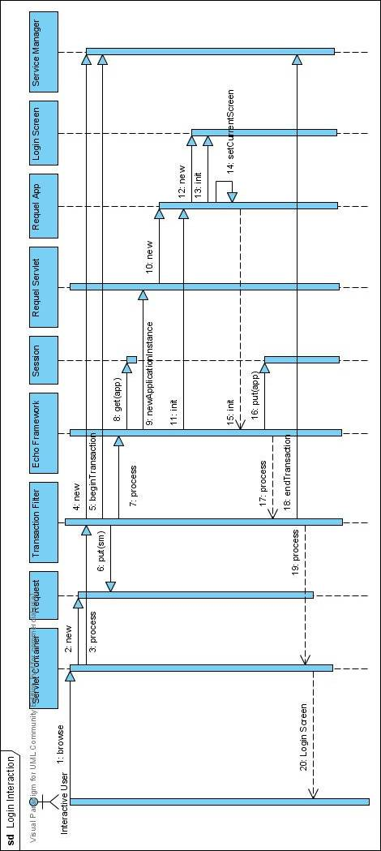
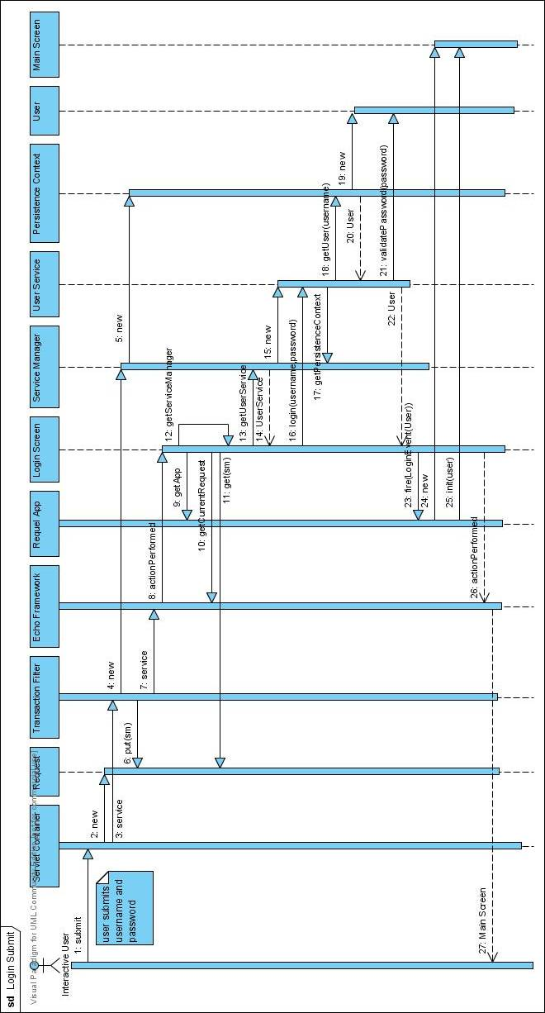
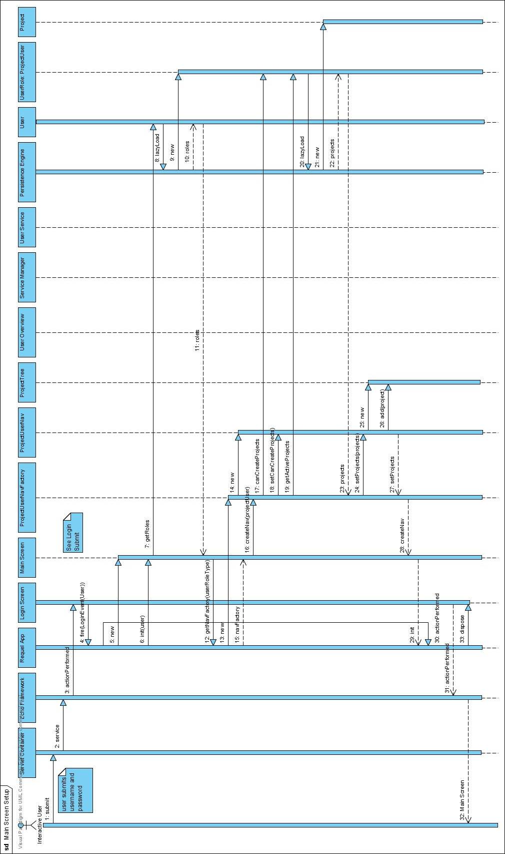

Work Plan
This project has a huge scope and it is unlikely that I will be able to implement all the features described in the requirements. I plan to order the work effort so that the primary features of collaboration and assistance take priority over the features that aren’t as interesting, such as automatic revisioning, inviting stakeholders as users, and integration.
I plan to start with the UI framework, as I will need it to produce all the user interface components. I will then add the simple user management features (create and edit) of the system administrator and login. I will add project support for stakeholders and goals. I will add enough support for annotations so that I can start implementing the assistants.

Assumptions, Risks and Alternatives
I have limit experience with natural language processing and knowledge bases, basically only the time I’ve spent investigating and experimenting while working on this proposal. I’ve identified a variety of tools as a starting point, but as I progress I may need to find alternative tools.
I don’t have a well planned approach for integrating NLP with the inference or rule engine. I haven’t selected a knowledge base, inference engine, or knowledge representation. To mitigate the risk the design of the features for the assistants I plan to integrate them as observers to the project data so I can swap them out or remove them completely and the system will still function without the intelligent help or with less intelligent help.
The Echo2 framework release schedule is pretty slow, if bugs exist in the code that impacts my ability to deliver I may need to fix them myself or switch to another UI framework.
There is not a lot of documentation with the Echo2 framework, and while the API is very similar to the Java Swing API there are significant differences in how it operates that require understanding of how the API works. For example the concept of stylesheets doesn’t exist in Swing and their implementation is nothing like the CSS standard stylesheets.
I don’t have a detailed design and I’ve never developed functionality similar to what the assistants support, so my effort estimates on those tasks are mostly a guess.

Preliminary Schedule
I’m guessing I will be able to work about 15 hours a week, so a day in schedule time is about 3 hours of effort.
Task | Duration | Start | End
Project Setup: configure environment (get cvs setup, setup project source structure, ant build script, get initial tools and libraries. | 3 days
UI Framework | 10 days
User Management and Login | 7 days
Projects with stakeholders and goals, main project UI | 15 days
Basic annotation support (creating and viewing) | 5 days
Syntax assistant: spelling, dictionary, syntax NLP, action annotations, grammar checking | 30 days
Simple semantic assistant: natural language to logical representation, knowledge base setup; simple knowledge definition. | 30 days
Goal assistant | 10 days
Story support | 5 days
Scenario support | 15 days
Use case support | 5 days
Document generation | 5 days
Annotation negotiation | 5 days
Story assistant (discourse parsing and anaphoric referencing) | 15 days
Scenario assistant | 10 days
More advanced domain knowledge | 30 days
Use case assistant | 5 days
Entity revisioning and project versioning | 10 days

References

Alexander, I. (2007) Requirements Tools web page Available at http://easyweb.easynet.co.uk/~iany/other/vendors.htm

Ambriola, V. and Gervasi, V. (1997) An Environment for Cooperative Construction of Natural-Language Requirement Bases. In Proceedings of the Eighth Conference on Software Engineering Environments p. 124-130. Los Alamitos, CA: IEEE Computer Society Press.

Baader, F. and Nutt, W. (2003) Basic description logics. In the Description Logic Handbook: theory, Implementation, and Applications. Baader, F., Calvanese, D., McGuinness, D. L., Nardi, D., and Patel-Schneider, P. F. (eds.) Cambridge University Press: New York, NY. pp. 43-95.

Ball, J., and Burns, E. (December 2006) New Technologies for Ajax and Web Application Development: Project Dynamic Faces. Sun Developer Network Article. Available at http://java.sun.com/developer/technicalArticles/J2EE/webapp_3/

Bauer, C., and King, G. (2004) Hibernate in Action (In Action Series). Manning Publications Co.: Greenwich, CT

Belkhouche, B. and Kozma, J. (1993) Semantic Case Analysis of Informal Requirements. In Brinkkemper, S. and Harmsen, F. (Eds.), Proceedings of the fourth Workshop on the Next Generation of CASE-tools, Paris

Booch, G., and Brown, A. (2002) Collaborative Development Environments. Rational Software Corporation White Paper. Retrieved from http://www.booch.com/architecture/blog/artifacts/CDE.pdf

Borgida, A., Greenspan, S., and Mylopoulos, J. (1985) Knowledge representations as the basis for requirements specifications. IEEE Computer vol. 18 no. 4, pp. 82-91.

Borland Software Corporation (2006), Effective Requirements Definition and Management Improves Systems and Communication. Retrieved June 20, 2007 from http://www.borland.com/resources/en/pdf/solutions/rdm_whitepaper.pdf.

Bramble, P., Cockburn, A., Pols, A. and Adolph, S. (2002), Patterns for Effective Use Cases, Boston, MA: Addison-Wesley.

Bresciani, P., and Donzelli, P. (2003) Goal-Oriented Requirements Engineering: a Case Study in E-Government In Eder, J. and Missikoff, M. (eds.) Advanced Information Systems Engineering (CAiSE'03), number 2681 in LNCS, pp. 605-620, Klagenfurt/Velden, Austria, Springer-Verlag. Retrieved August 3, 2007 from http://citeseer.ist.psu.edu/donzelli03goaloriented.html

Christel, M. G. and Kang, K. C. (1992) Issues in Requirements Elicitation. Technical Report (CMU/SEI-92-TR-12) Pittsburgh, PA: Software Engineering Institute, Carnegie Mellon University Retrieved July 9, 2007 from http://www.sei.cmu.edu/pub/documents/92.reports/pdf/tr12.92.pdf

Ciemniewska, A., Jurkiewicz, J., Olek, Ł., and Nawrocki, J. (2007) Supporting Use-Case Reviews. Business Information Systems vol. 4439/2007 Springer Berlin: Heidelberg. Draft Retrieved October 1, 2007 from http://www.cs.put.poznan.pl/lolek/homepage/Research_files/07-BIS.pdf

Clark, P. and Porter, B. (n.d.) KM - The Knowledge Machine 2.0: Users Manual Retrieved July 29, 2007 from http://www.cs.utexas.edu/users/mfkb/km/userman.pdf

Cockburn, A. (1995). Structuring Use Cases with Goals. Humans and Technology Technical Report, Retrieved July 1, 2005 from http://alistair.cockburn.us/crystal/articles/sucwg/structuringucswithgoals.htm

Cockburn, A. (2000). Writing Effective Use Cases. Boston, MA: Addison-Wesley.

ConceptBase Team (2004) ConceptBase Tutorial. Aachen University, Germany. Accessible from
http://www-i5.informatik.rwth-aachen.de/CBdoc/tutorial/cbTutorial.html

ConceptBase Team (2007) Jarke, M., Jeusfeld, M., and Quix, C. (eds.) ConceptBase V7.0 User Manual Aachen University, Germany. Accessible from
http://www-i5.informatik.rwth-aachen.de/CBdoc/userManual/

Conklin, J. and Begeman, M. L. (1988). gIBIS: a hypertext tool for exploratory policy discussion. ACM Trans. Inf. Syst. Vol. 6, issue 4 pp. 303-331. Retrieved September 12, 2007 from http://www.cs.hut.fi/Opinnot/T-93.850/2005/Papers/gIBIS1988-conklin.pdf

Coughlan, J. and Macredie, R. D. (2002) Effective Communication in Requirements Elicitation: A Comparison of Methodologies. In Requirements Engineering Vol. 7 Issue: 2 p. 47 – 60

Coursey, K. (2004) Living in CyN: Mating AIML and CYC Together with Program N.
Daxtron Laboratories. Retrieved May 15, 2007 from http://www.cyc.com/doc/white_papers/Cyn_description.pdf

Czuchry, A. J. and Harris, D. R. (1988) KBRA: A New Paradigm for Requirements Engineering. IEEE Expert: Intelligent Systems and Their Applications 3, 4 (Dec. 1988), 21-24, 26-32, 34-35. DOI= http://dx.doi.org/10.1109/64.10017

db4objects (n.d) The db4objects community page, Retrieved January 18, 2008 from http://www.db4o.com/community/

Eberlein, A. (1997) Requirements Acquisition and Specification for Telecommunication Services. PhD thesis, University of Wales, Swansea, UK. Retrieved August 3, 2007 from http://www2.enel.ucalgary.ca/People/eberlein/publications/PhD_Thesis.pdf

Eberlein, A. and Leite, J. (2002) Agile Requirements Definition: A View from Requirements Engineering. The International Workshop on Time-Constrained Requirements Engineering. Retrieved July 10, 2007 from http://www-di.inf.puc-rio.br/~julio/tcre-site/p4.pdf

Fowler, M. (n.d.) Audit Log Pattern, Martin Fowlers web site. Retrieved January 21, 2008 from http://martinfowler.com/ap2/auditLog.html

Fowler, M. (n.d.2) Temporal Object/Property Patterns, Martin Fowlers web site. Retrieved January 21, 2008 from http://martinfowler.com/ap2/timeNarrative.html

Finkelstein, A. (1994) Requirements Engineering: a review and research agenda. In Proceedings of the First Asia Pacific Conference on Software Engineering, New York, NY: IEEE CS Press, pages 10-19.

Firesmith, D. (2004) Generating Complete, Unambiguous, and Verifiable Requirements from Stories, Scenarios, and Use Cases. In Journal of Object Technology Vol. 3, No. 10 pp. 27-39

Fuchs, N. E., Schwertel, U., and Schwitter, R. (1999). Attempto Controlled English - Not Just Another Logic Specification Language. In Proceedings of the 8th international Workshop on Logic Programming Synthesis and Transformation (June 15 - 19, 1998). P. Flener, Ed. Lecture Notes In Computer Science, vol. 1559. Springer-Verlag, London, 1-20. Retrieved on January 15, 2008 from http://citeseer.ist.psu.edu/fuchs99attempto.html

Goguen, J. A. and Linde C. (1993) Techniques for requirements elicitation. In Proceedings IEEE International Symposium on Requirements Engineering, New York, NY: IEEE, pages 152-164.

Goncalves, A. (March 2007) Generate an XML Document from an Object Model with JAXB 2. DevX website article Retrieved January 22, 2008 from http://www.devx.com/Java/Article/34069

Google (n.d.) Google Web Toolkit homepage. At http://code.google.com/webtoolkit/

Greenspan, S. J. (1984) Requirements Modeling: a Knowledge Representation Approach to Software Requirements Definition. Doctoral Thesis. University of Toronto.

Greenspan, S., Mylopoulos, J., and Borgida, A. (1994) On Formal Requirements Modeling Languages: RML Revisited. In Proceedings of the 16th International Conference on Software Engineering. IEEE Computer Society Press, Los Alamitos, CA, pp. 135-147. Draft Retrieved July 15, 2007 from http://citeseer.ist.psu.edu/64478.html

Hickey, A. M. and Davis, A. M., (2003) Requirements Elicitation and Elicitation Technique Selection: A Model for Two Knowledge-Intensive Software Development Processes. In Proceedings of the 36th Annual Hawaii International Conference on System Sciences. Los Alamitos, CA: IEEE Computer Society Press.

Hurlbut, R. (1997) A Survey of Approaches for Describing and Formalizing Use Cases. Expertech Technical Report. Retrieved August 22, 2007 from http://www.iit.edu/~rhurlbut/xpt-tr-97-03.pdf

ICEsoft Technologies Inc (n.d.) Product Overview webpage. Available at http://www.icefaces.org/main/product/product-overview.iface

ISO/IEC 13568:2002 (2002) Information technology — Z formal specification notation — Syntax, type system and semantics.

Jacobson, I. (1992) Object-Oriented Software Engineering: A Use Case Driven Approach, Addison Wesley Longman: Harlow, England

Jarke, M. (1999) CREWS : Towards Systematic Usage of Scenarios, Use Cases and Scenes. Wirtschaftinformatik 99, Saarbrucken, Springer Aktuell, 3-5 March 1999. CREWS Report Series 9902 Retrieved August 6, 2007 from
ftp://sunsite.informatik.rwth-aachen.de/pub/CREWS/CREWS-99-02.pdf

Jarke, M., Eherer S., Gallersdörfer, R., Jeusfeld, M., and Staudt, M. (1993) ConceptBase - A Deductive Object Base Manager. Retrieved August 6, 2007 from http://citeseer.ist.psu.edu/566148.html

Jarke, M., Gallersdörfer, R., Jeusfeld, M., Staudt, M., and Eherer S. (1995) ConceptBase a Deductive Object Base for Meta Data Management. In Journal of Intelligent Information Systems, Special Issue on Advances in Deductive Object-Oriented Databases, Vol. 4, No. 2, pp. 167-192. Draft appeared as technical report Aachener Informatik-Berichte 93-14. Retrieved August 6, 2007 from ftp://ftp.informatik.rwth-aachen.de/pub/reports/1993/93-14.ps.gz

Jeffries, R., Anderson, A., & Hendrickson, C. (2001) Extreme Programming Installed. Boston, MA: Addison-Wesley.

Kifer, M., Lausen, G., and Wu, J. (1995) Logical foundations of object-oriented and frame-based languages. J. ACM 42, 4 (Jul. 1995), 741-843. Retrieved July 15, 2007 from http://www.cs.umbc.edu/771/papers/flogic.pdf

Lenat, D., Guha, R., Pittman, K., Pratt, D., and Shepherd, M. (1990) Cyc: toward programs with common sense. Communications of the ACM 33 (8) pp. 30-49

Lenat, D. (1995) Cyc: a large-scale investment in knowledge infrastructure. Communications of the ACM 38 (11) pp 33 - 38.

Liu, H. (2004). MontyLingua: An end-to-end natural language processor with common sense. Available from http://web.media.mit.edu/~hugo/montylingua.

Maiden, N. A. (1998). CREWS-SAVRE: Scenarios for Acquiring and Validating Requirements. Technical Report CREWS-98-03, Centre for HCI Design, School of Informatics, City University London. Retrieved August 20, 2007 from http://citeseer.ist.psu.edu/maiden98crewssavre.html

Manning, C. (2006) Stanford Lexicalized Parser: a probabilistic lexicalized NL CFG parser. Copyright (c) 2006 The Board of Trustees of The Leland Stanford Junior University. Available from http://www-nlp.stanford.edu/downloads/lex-parser.shtml

McKeen, J. D., Guimaraes, T., and Wetherbe J. C. (1994) The Relationship between User Participation and User Satisfaction: An Investigation of Four Contingency Factors MIS Quarterly, Vol. 18, No. 4 (Dec., 1994), pp. 427-451.

Mollá, D., and Schwitter, R. (2001) From Plain English to Controlled English. Retieved January 16, 2008 from http://www.ics.mq.edu.au/~rolfs/papers/anlp2001.pdf

Monachesi, P., Stevens, G., and Trapman, J. (2007) Adding Semantic Role Annotation to a Corpus of Written Dutch in Proceedings of the Linguistic Annotation Workshop. Association for Computational Linguistics:Prague, Czech Republic Retreived January 24, 2008 from http://www.aclweb.org/anthology-new/W/W07/W07-1513.pdf

Monie, R. (2005) AuditLogInterceptor Java class, Retrieved January 21, 2008 from http://www.hibernate.org/318.html

Mylopoulos, J., Borgida, A., Jarke, M. and Koubarakis M. (1990) Telos: Representing Knowledge about Information Systems. In ACM Transactions on Information Systems, Vol. 8, No. 4, Pages 325-362. New York: ACM Press. Retrieved August 6, 2007 from http://www.cs.toronto.edu/~jm/Pub/Telos.pdf

Mylopoulos, J. (1998) Information Modeling in the Time of the Revolution. Information Systems vol. 23, issue 3-4, pp. 127-155, Oxford: Elsevier Science Ltd. Retrieved June 15, 2007 from http://www.cs.toronto.edu/~jm/2507S/Readings/Survey.pdf

Mylopoulos, J. and Castro, J. (2000) Tropos: A Framework for Requirements-Driven Software Development. In Brinkkemper, J. and Solvberg, A. (eds.), Information Systems Engineering: State of the Art and Research Themes. Lecture Notes in Computer Science, Springer-Verlag. Retrieved August 22, 2007 from http://www.troposproject.org/papers_files/Fossil.pdf

Nardi, D. and Brachman, R. J. (2003) An introduction to description logics. In the Description Logic Handbook: theory, Implementation, and Applications, Baader, F., Calvanese, D., McGuinness, D. L., Nardi, D., and Patel-Schneider, P. F. (eds.) Cambridge University Press: New York, NY. pp. 1-40.

NextApp (n.d.) Echo2 homepage. At http://www.nextapp.com/platform/echo2/echo/

Ning, A., Hou, H., Hua, Q., Yu, B., and Hao, K. (2005) Requirements Engineering Process Improvement: A Systematic View. Presentation to SPW2005, May 25-27, 2005 Beijing. Retrieved July 14, 2007 from http://www.cnsqa.com/cnsqa/jsp/html/spw/ppt/25101/Requirements%20Engineering%20Processes%20Improvement_A%20Systematic%20View.pdf

Nuseibeh, B. and Easterbrook, S. (2000) Requirements Engineering: A Roadmap. In A. Finkelstein (ed.) The Future of Software Engineering (pp. 35-46). (Companion volume to the proceedings of the 22nd International Conference on Software Engineering, ICSE'00). Los Alamitos, CA: IEEE Computer Society Press. Retrieved July 14, 2007 from http://www.cs.toronto.edu/~sme/papers/2000/ICSE2000.pdf

Object Management Group (2007) Unified Modeling Language: Superstructure

Ort, E. and Mehta, B. (March 2003) Java Architecture for XML Binding (JAXB) from Sun Developer Network website Retrieved January 22, 2008 from http://java.sun.com/developer/technicalArticles/WebServices/jaxb/

Parmar, A. (2001) The Representation of Actions in KM and Cyc. Stanford University Technical Report (FRG-1). Retrieved June 15, 2007 from http://www.cs.utexas.edu/users/mfkb/km/aarati.pdf

Potts, C., Takahashi, K., & Anton, A.I. (1994) Inquiry-based requirements analysis. Software, IEEE vol. 11-2, pp. 21-32.

Reubenstein, H. B. and Waters, R. C. (1991) The Requirements Apprentice: Automated Assistance for Requirements Acquisition. IEEE Transactions on Software Engineering vol. 17 no. 3, 226-240

Rich, C., and Waters, R. (1986). Toward a Requirements Apprentice: On the Boundary between Informal and Formal Specifications. (AI Memo AIM-907). Cambridge, MA: MIT, Computer Science and Artificial Intelligence Lab. Retrieved April 30, 2007 from http://hdl.handle.net/1721.1/5516.

Rich, C., and Waters, R. (1987). The Programmer's Apprentice Project: A Research Overview. (AI Memo AIM-1001). Cambridge, MA: MIT, Computer Science and Artificial Intelligence Lab. Retrieved June 15, 2007 from http://hdl.handle.net/1721.1/6054.

Rich, C., and Waters, R. (1990). The Programmer’s Apprentice. New York, NY: ACM Press.

Rich, C. (1991) CAKE: an implemented hybrid knowledge representation and limited reasoning system. SIGART Bull. 2, 3 (Jun. 1991), pp. 120-127. DOI= http://doi.acm.org.ezp1.harvard.edu/10.1145/122296.122315

Robinson, W. N. and Volkov, S. (1997) A meta-model for restructuring stakeholder requirements. In Proceedings of the 19th international Conference on Software Engineering. ICSE '97. ACM Press, New York, NY, 140-149. Retrieved August 8, 2007 from http://www.cis.gsu.edu/~wrobinso/papers/icse97.ps

Sharp, H., Finkelstein, A., and Galal, G. (1999) Stakeholder Identification in the Requirements Engineering Process. In Proceedings of the 10th international Workshop on Database & Expert Systems Applications, IEEE Computer Society, Washington, DC. Draft Retrieved September 5, 2007 from http://www.cs.ucl.ac.uk/staff/A.Finkelstein/papers/stake.pdf

Smith J. D. (1997) EColabor: Collaborative Elaboration of Documents. NTT Multimedia Communications Laboratories. Berkeley Multimedia and Graphics Seminar. Retrieved July 3, 2007 from http://bmrc.berkeley.edu/courseware/cs298/spring97/w5/slides.ppt

Snodgrass, R. T. (2000) Developing Time-Oriented Database Applications in SQL. Morgan Kaufmann Publishers Inc.

Spivey, J. M. (1992). The Z Notation. A Reference Manual. Upper Saddle River, NJ: Prentice-Hall Retrieved July 3, 2007 from http://spivey.oriel.ox.ac.uk/~mike/zrm/index.html

Steiner, A. (1997) A Generalization Approach to Temporal Data Models and their Implementation. Ph.D. thesis, Department Informatik, ETH Zurich. Retrieved January 20, 2008 from http://citeseer.ist.psu.edu/147397.html
Steiner, A. (1999) TimeDB 2.0 User Guide, TimeConsult whitepaper Retreived January 19, 2008 from http://www.timeconsult.com/Software/TimeDB%202.2.zip
Stevens, G. (2007) XARA: An XML- and rule-based semantic role labeler in Proceedings of the Linguistic Annotation Workshop. Association for Computational Linguistics: Prague, Czech Republic. Retrieved January 24, 2008 from http://www.aclweb.org/anthology-new/W/W07/W07-1518.pdf
Tang, Y., Liang, L., Huang, R., and Yu, Y. (2004) Bitemporal Extensions to Non-temporal RDBMS in Distributed Environment. Retreived on January 19, 2008 from http://www.timeconsult.com/Publications/TimeDB.pdf
Takahashi, K., Potts, C., Kumar, V., Ota, K., and Smith, J. D. (1996) Hypermedia Support for Collaboration in Requirements Analysis. In Proceedings of the 2nd international Conference on Requirements Engineering (ICRE '96) (April 15 - 18, 1996). ICRE. IEEE Computer Society, Washington, DC, 31.

Tawbi, M., Achour, C. B., and Vélez, F. (1999) Guiding the Process of Requirements Elicitation through Scenario Analysis: Results of an Empirical Study. In Proceedings of the 10th international Workshop on Database & Expert Systems Applications. IEEE Computer Society: Washington, DC. Retrieved April 24, 2007 from http://citeseer.ist.psu.edu/269590.html

Tomayko, J. E. (2002) Engineering of Unstable Requirements Using Agile Methods, Agile Alliance Retrieved July 10, 2007 from http://www.agilealliance.org/show/1162

Tsai, J. J., Weigert, T., and Jang, H. (1992). A Hybrid Knowledge Representation as a Basis of Requirement Specification and Specification Analysis. IEEE Trans. Softw. Eng. 18, 12 (Dec. 1992), 1076-1100. DOI= http://dx.doi.org.ezp1.harvard.edu/10.1109/32.184762

Tuzhilin, A. (1995) Templar: a knowledge-based language for software specifications using temporal logic. ACM Transactions on Inf. Syst. 13, 3 (Jul. 1995), pp. 269-304.

van Lamsweerdem, A. (2001) Goal-Oriented Requirements Engineering: A Guided Tour Retrieved July 15, 2007 from http://www.info.ucl.ac.be/Research/Publication/2001/RE01.pdf

W3C (2004) Manola, F., and Miller, E. (eds.) Resource Description Framework (RDF) Primer, W3C Recommendation 10 February 2004, Retrieved July 10, 2007 from http://www.w3.org/TR/REC-rdf-syntax/

W3C (2004b) McGuinness, D., and van Harmelen, F. (eds.) OWL Web Ontology Language Overview, W3C Recommendation 10 February 2004, Retrieved July 10, 2007 from http://www.w3.org/TR/owl-features/

Weigers, K. E. (1999). Software Requirements. Redmond, WA: Microsoft Press.

Weisstein, E. (n.d.) Zermelo-Fraenkel Set Theory. From MathWorld: A Wolfram Web Resource. http://mathworld.wolfram.com/Zermelo-FraenkelSetTheory.html

Wong, Y. W. (2007) Learning for Semantic Parsing and Natural Language Generation Using Statistical Machine Translation Techniques. Ph.D. thesis University of Texas at Austin. Retrieved January 24, 2008 from http://www.cs.utexas.edu/users/ml/papers/john-dissertation.pdf

Yu, E. S. (1997) Towards Modeling and Reasoning Support for Early-Phase Requirements Engineering. In Proceedings of the 3rd IEEE international Symposium on Requirements Engineering (Re'97) (January 05 - 08, 1997). RE. IEEE Computer Society, Washington, DC, 226. Draft Retrieved August 21, 2007 from http://www.cs.toronto.edu/pub/eric/RE97.pdf

Zhang, Z. (2007) Effective Requirements Development - A Comparison of Requirements Elicitation techniques. Working draft accepted by 2007 SQM and INSPIRE Conferences Retrieved July 9, 2007 from http://www.cs.uta.fi/re/rem.pdf

