Title:

“Mutant KRAS reprograms the non-coding transcriptome during transformation”

Figures:

1) KRAS 🡪 KZNF down

2) KZNF down 🡪 TE up

3) TE up 🡪 ISG up

4) ISG up 🡪 VIABILITY up

Context vs. Us:

TE & Methylation

2 x 2015 cell Papers:

Cancer

DNMT 🡪 TE 🡪 Immune Response

Therapy

Vs.

AALE:

Non-cancer 🡪 pre/early-cancer

KZNF 🡪 TE 🡪 Immune Response

Basic, biological mechanism

Role of TEs in Cancer:

Retrotransposition vs RNA function

Figures needed:

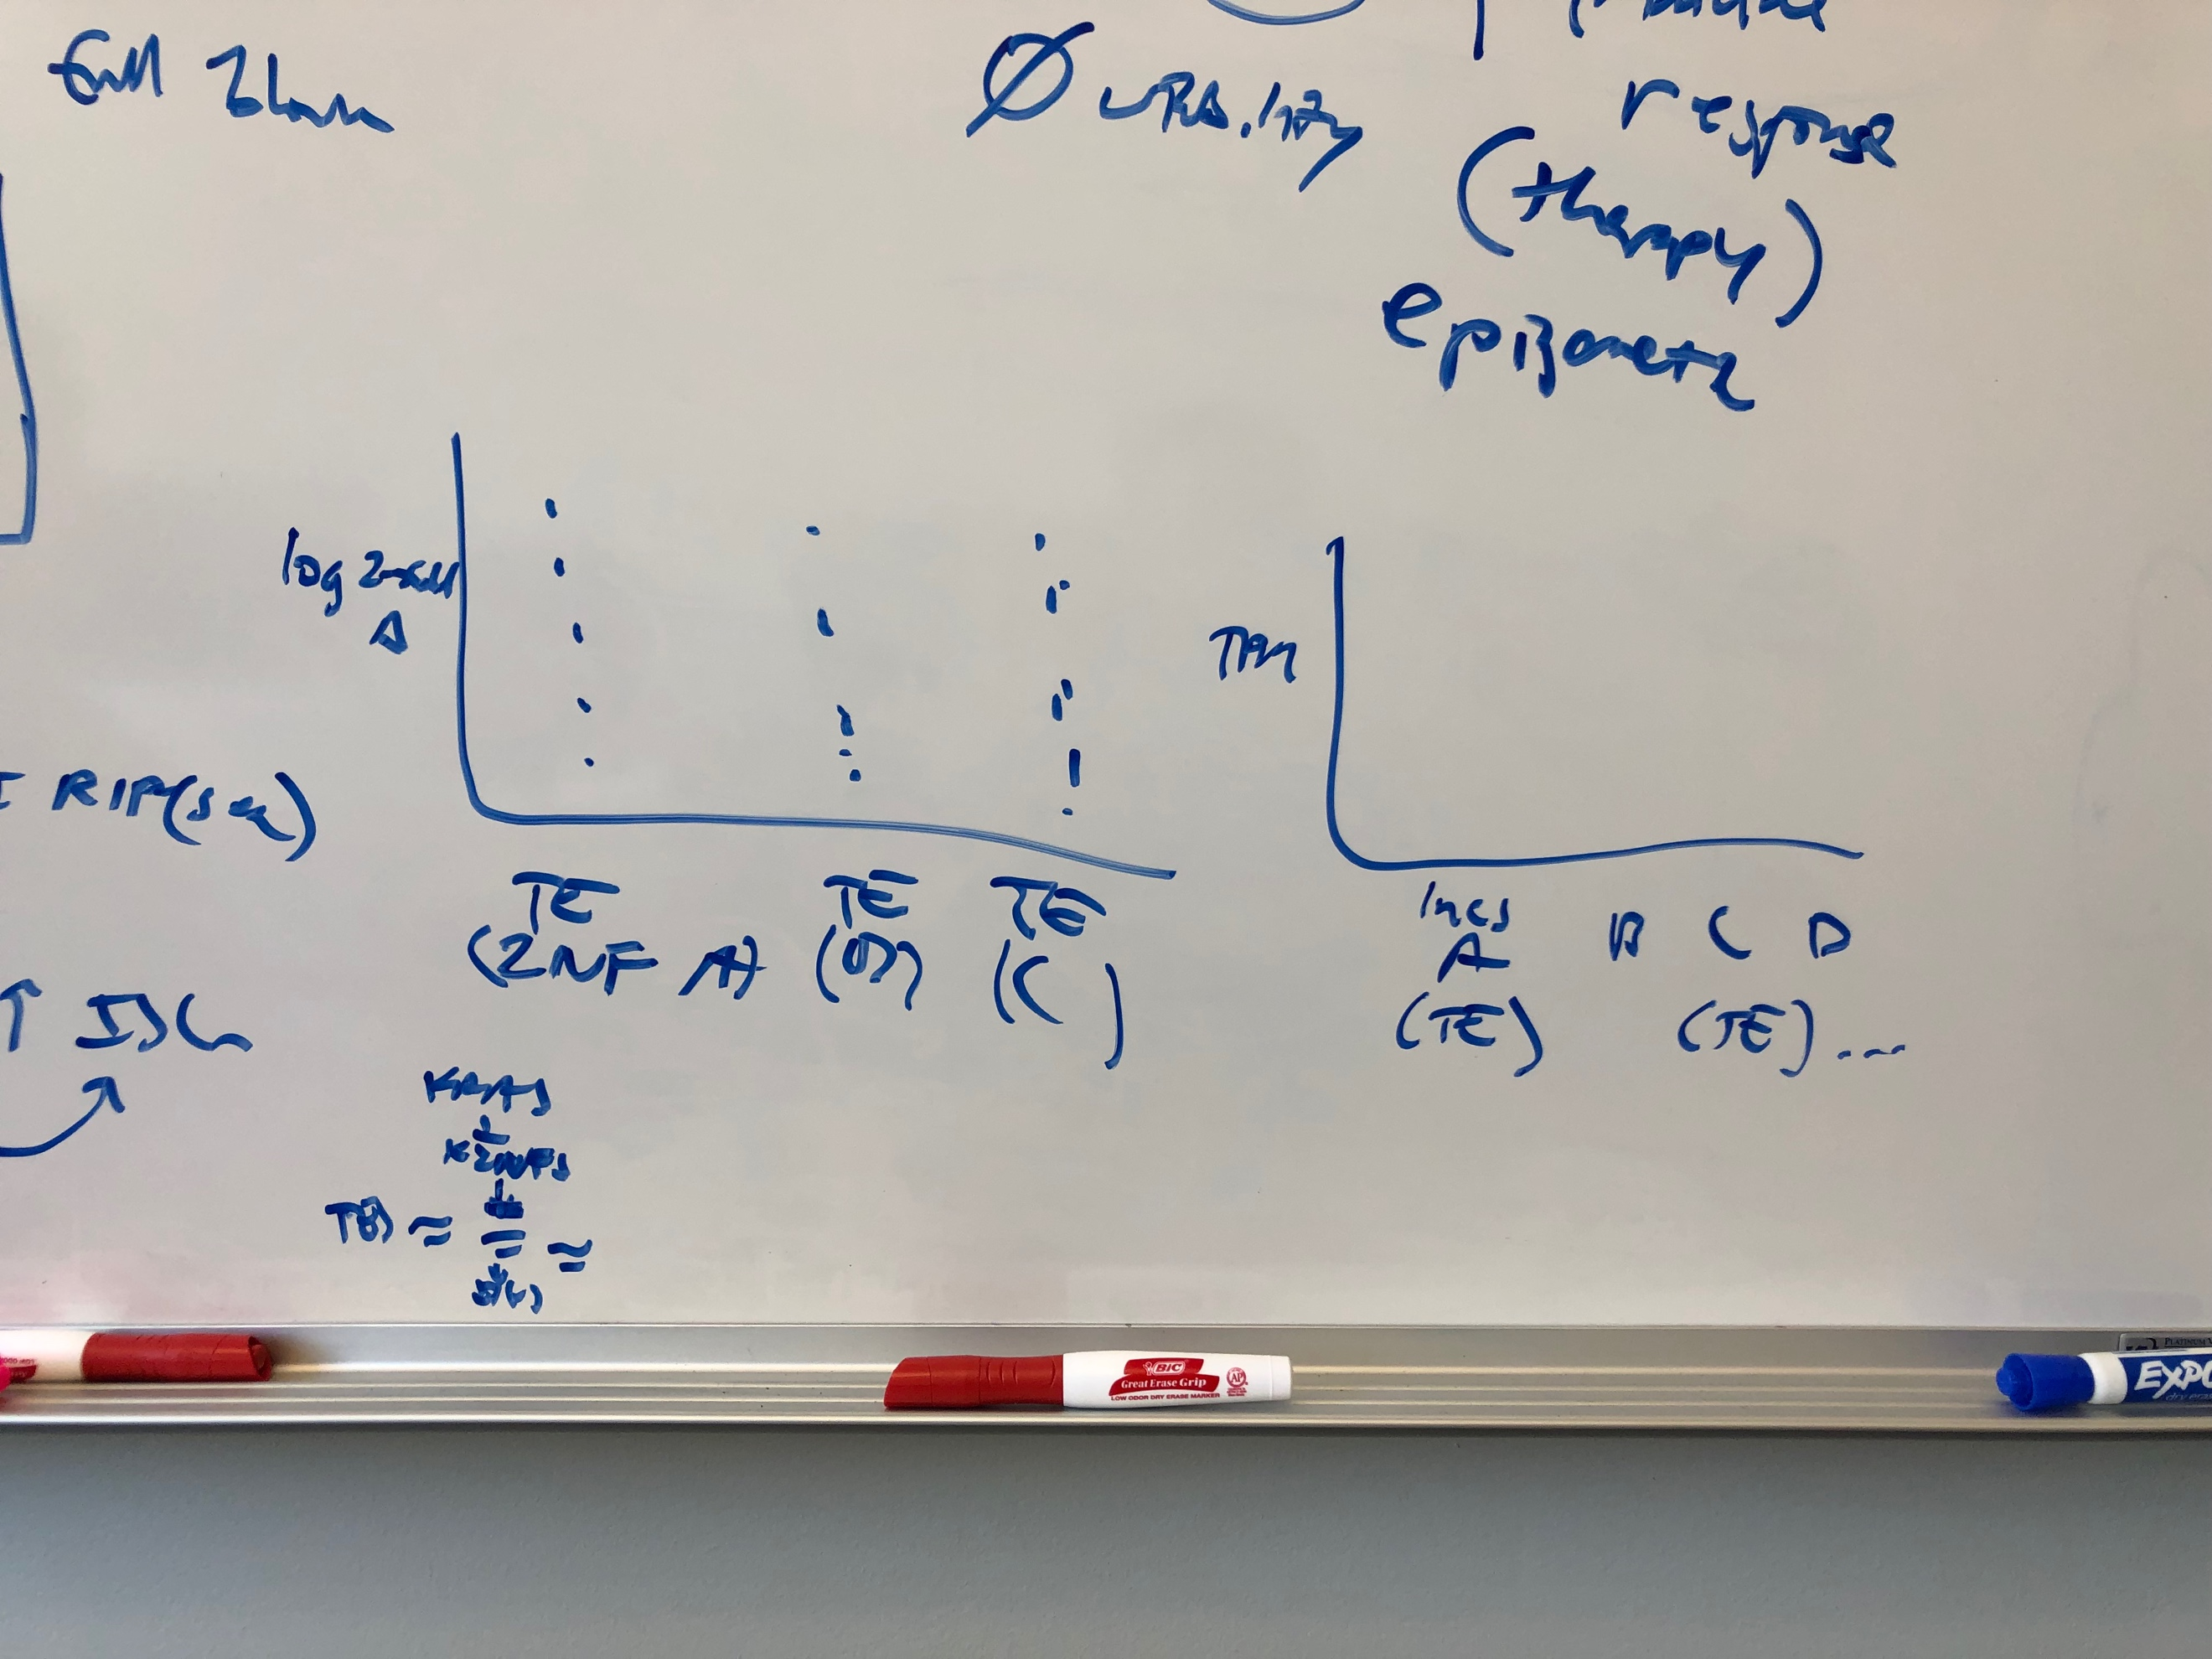KZNF and putative target ‘X-mas’ tree & lnc upstream TE plot

Apoptotic genes

Cytokines