Data storage

Richard Rennehan

NSCC Institute of Technology

OSYS1700

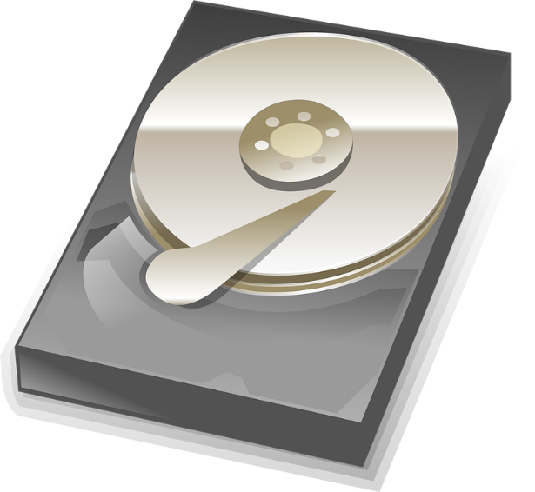

Contents

Introduction 2

Storage Types 3

Options for Upgrades 4

Conclusion 5

References 6

# Introduction

Our digital world is growing at an incredible rate. According to a December 2016 study, ninety percent of the world’s data has been generated in the last two years alone! [1]

Such a large amount of data can be overwhelming. All of the data has to be stored somewhere. As a result, knowledge about data storage technologies is a great trait to have. This paper will explain the different devices used to store data along with upgrade options.

# Storage Types

There are many ways to store information and data. Each method has its own strengths and weaknesses. Therefore, it is key to know which type should be used for each situation. This section will explain each storage type as well as their strengths and weaknesses.

Hard Disk Drive: A hard disk drive, commonly referred to as an HDD, is a cheap and conventional way to store data. It is the most common device used to store a large amount of data for home computers.

A hard disk drive contains a magnetic spinning disk, also known as a platter. Alongside the disk is an arm with a magnetic head that touches the disk. It’s almost like an old record player in some ways. As the computer runs, the arm scratches the disk, writing data to it using magnetism. The data is stored in an orderly fashion within the disk so it can easily be read and stored. To read from the disk, the arm goes to the exact spot that the specified data is stored and reads it through magnetism.

The low cost of a hard disk drive allows it have the highest capacity for data out of all drives on the market. However, they are vulnerable and slower than other devices. A little dust is all it may take to stop the arm from functioning properly and break the drive. In general, a hard disk drive is the best choice for the average home computer. [2][3]

Solid State Drive: A solid state drive, known as an SSD, is a storage device that is strong on speed and reliability.

HDD and SSD Comparison

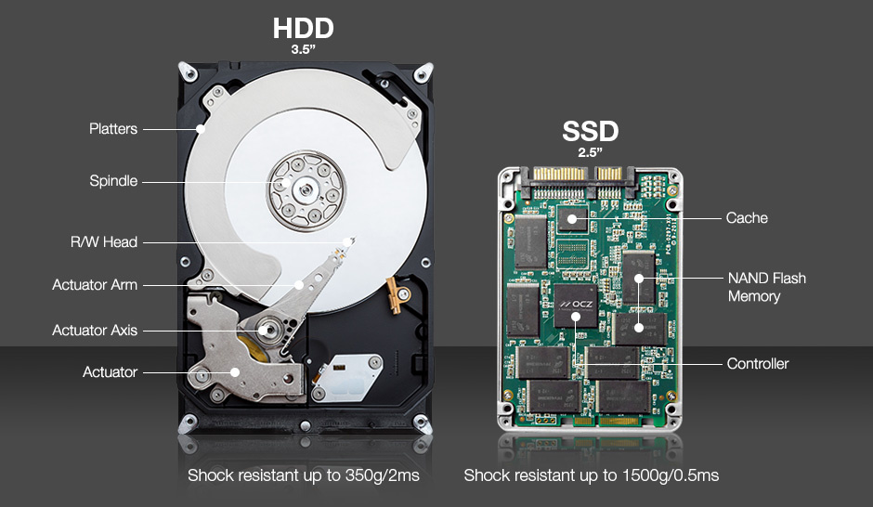A solid state drive functions through electricity rather than magnetism. Inside, there are many semiconductors that allow electricity to flow. There are also chips inside that store the data like how the disk does in a hard disk drive. To make sure it all functions properly, a controller helps control the flow of electricity and data between the SSD parts and the computer.[4] [5]

https://www.partitionwizard.com/clone-disk/clone-hard-drive-ssd.html

A solid state drive has no moving parts, so it is much more reliable and strong than a hard disk drive. SSD also boots up 3x faster than a hard disk drive and data can has near instant read speeds. However, solid state drives often cost 3x as much than a hard disk drive with the same storage capacity. As the price of solid state drives fall, however, they are becoming more commonplace. At this time, solid state drives are most commonly used for laptops, where the risk of falls is higher. However, people in the business industry may prefer forking extra for an SSD in exchange for the extra reliability and speed. [6][7]

Internal Drive: An internal drive is a hard disk drive or solid state drive that is confined within a machine. Compared to external drives, internal drives are the best at holding larger capacities and working at faster speeds. The reason why is because the drive can be as large as it needs to be, never having to worry about portability.

Internal Drive Connection Types: There are three connector types on the market used to connect the internal drive to the internal parts of the machine. They are SCSI, SATA, and IDE

SCSI is the most outdated connection type. SCSI stands for small computer system interface. SCSI connections suffer from the worst data transfer speeds, at a maximum of 80 megabytes per second. SCSI connections work best when connecting multiple devices together. However, because an SCSI connector on a drive only serves one purpose, its potential goes to waste. Low end computers may come with a cheap SCSI hard drive built in, but SCSI connections are otherwise becoming obsolete. [8][9]

Comparison between Connector Types

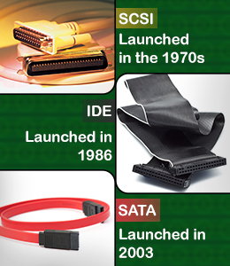IDE is the successor to SCSI. IDE stands for integrated drive electronics. IDE connections offer up to 133 megabyte per second data transfers. However, IDE connections are not common for internal drives because they can be expensive for. It was 17 years after the introduction of IDE that a new competitor arrived. [8]

SATA is the rising star. SATA stands for Serial advanced technology attachment. Although it is the newest type, arriving in 2003, it is quickly becoming the most common for internal storage devices. SATA allows data transfer speeds from 133 megabytes per second to 750 megabytes per second. It is the cheapest option for new internal drives too. SATA connectors and internal drives are a match made in heaven. [8]

https://www.buzzle.com/articles/scsi-vs-sata-vs-ide.html

External Drive: An external drive is a hard disk drive or solid state drive that is a standalone device. It is not confined to the inside of one computer. An external drive can be taken anywhere and connected to any computer device that supports it.

USB is the most common connection type for external hard drives. This is because USB ports can be found on about every laptop and home computer. To connect to a computer, all that is needed is to take the USB end of the supplied cable and put it in a USB port, then put the other end in the external drive slot.

Some high-level computers may also have an eSATA port. eSATA ports are specifically designed to work only with external drives that support it while USB ports are designed to be universal. As a result, connecting with eSATA results in better performance with external drives. [10]

There are all kinds of external drive form factors out there to suit the needs of customers. There are big, bulky external drives that can store large amounts of data. There are also smaller and lighter kinds to maximize portability, but at the cost of less space for data. It all depends on what the user needs most – portability, or storage capacity. If the external drive will be used with only one machine, portability won’t be needed, and money can be saved. However, if the user frequents public spaces like libraries to work on assignments, portability is crucial. If both portability and lots of storage capacity is needed, expect to pay more. [11]

SD Cards: SD cards are another way to stare data externally. Similarly to solid state drives, SD cards hold rows of memory chips within pins that connect the card to an SD card slot. SD stands for secure digital. They are the most portable storage device on the market. They are most often used for older phones and digital cameras.

SD Card Examples

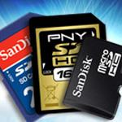

Over the years, many reiterations of SD cards were born. Two new sizes came to be, known as MiniSD and MicroSD. MicroSD cards are the smallest and are used for lightweight high-end smartphones as well as any device where there is not much room to work with. MiniSD cards are rarely used.

Evolutions to SD, MiniSD, and MicroSD bring upgrades to storage capacity and speed. At one point, SD cards, at one time, could only support 1 GB at most. However, they now support up to 2 TB (which is 2000GB). There are also 4 distinct speed classes. They are class 2 (2MB/s), class 4 (4MB/s), class 6 (6MB/s), and class 10 (10MB/s). High end devices like smartphones and cameras over $300 typically require faster cards with more storage. [12][13]

https://www.pcmag.com/article2/0,2817,2388408,00.asp

Cloud Storage: Cloud storage is a way to store data online. Cloud storage has two perspectives. It can be viewed in the perspective of a business or in the perspective of a customer. This report will focus on the customer perspective.

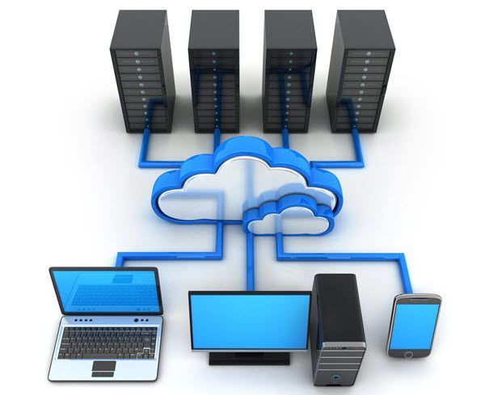A customer may imagine cloud storage as a way of storing their data, almost like magic. A customer does not need to buy a storage device to take advantage of cloud storage. Instead, a company like Google or Microsoft runs cloud services. To make use of it, all the customer has to do is sign up for an account or pay a recurring fee. Afterward, the customer can store any of their files by going to their website and uploading the files desired. When the customer needs the file, they go back to the website again and it’s instantly ready to download back on to the machine.

A Cloud System Overview

Because files are stored on internet servers and within other companies, there are concerns for privacy. Someone could find a way to take a peek at your work. If you are not concerned about privacy, however, cloud storage is a great way to store data. One of its strengths is convenience and usability. Cloud storage can be accessed on any computer, and the user never needs to bring an external drive along. [14]

https://www.online-tech-tips.com/computer-tips/setup-personal-cloud-storage/

# Options for Upgrades

Upgrades for data storage are never out of the question. For example, have you ever ran out of storage on your phone or computer and wish you had more? As times move forward, individuals and businesses may find the need to upgrade storage devices on occasion. Upgrades bring needed improvements to speed, reliability, and total storage capacity. This section will introduce the upgrade options.

HDD to SSD: This is a good upgrade method for hard disk drive owners. With an SSD instead of an HDD, students and businesses can rest easy knowing their storage device with all of their important files is less likely to break. As mentioned before, solid state drives bring improvements in speed. If the internal drive in the computer is an SSD, boot times are much faster.

A switch from an external HDD to an external SSD is easy. Just copy all of the files on the old hard drive to the new solid state drive and you are good to go. However, switching internal hard drives is much more complicated. A computer technician is a great help if you ever need to switch internal drives, whether because the old one broke or because it’s time for an upgrade.

More Storage: Adding storage can be either easy, difficult, or impossible depending on the machine that needs more storage. If the machine is a home computer, a laptop, or a video game console, an external hard drive can easily be connected to give more storage capacity. If a phone is any phone other than an iPhone, a new, larger SD card must be purchased and must replace the old card. Cameras, like phones, need a new SD card as well.

When it comes to cloud storage, you typically have to pay to get more storage. The more storage reserved, the more it costs per month or year.

More Speed: For internal and external drives, the aforementioned switch from HDD to SSD is the best way to speed up performance. For SD cards, make sure to check the speed class (2, 4, 6, 10) of the new SD card needed. Recall that class 2 is the slowest while class 10 is the fastest.

# Conclusion

Ninety percent of the world’s data has been generated all in the last two years. How are we going to handle this large increase in data? Surely, computer scientists all over are working hard to come up with new innovations in the data storage industry. For us customers, we may even be introduced to brand new data storage device types on the market. Anyway, data will lead our generation forward, and it’s great to have you aboard.

# References

1. Big Data, for better or worse: 90% of world's data generated over last two years. (2013, May 22). Retrieved October 13, 2017, from <https://www.sciencedaily.com/releases/2013/05/130522085217.htm>

2. Woodford, C. (2017, April 03). How does a hard drive work? Retrieved October 10, 2017, from <http://www.explainthatstuff.com/harddrive.html>

3. Baxter, A. (2011, December 01). SSD vs HDD. Retrieved October 10, 2017, from <http://www.storagereview.com/ssd_vs_hdd>

4. Rent, T. M. (2010, April 08). SSD Controller. Retrieved October 10, 2017, from <http://www.storagereview.com/ssd_controller>

5. Tokar, L. (2016, October 16). SSD Components and Make Up – An SSD Primer. Retrieved October 12, 2017, from <http://www.thessdreview.com/ssd-guides/beginners-guide/ssd-components-and-make-up-an-ssd-primer/2/>

6. Rouse, M. (n.d.). What is SSD (solid-state drive)? - Definition from WhatIs.com. Retrieved October 12, 2017, from <http://searchsolidstatestorage.techtarget.com/definition/SSD-solid-state-drive>

7. Kyrnin, M. (n.d.). What is a Solid State Drive (SSD)? Retrieved October 12, 2017, from <https://www.lifewire.com/solid-state-drive-833448>

8. Lovekar, V. (2016, August 05). SCSI Vs. SATA Vs. IDE. Retrieved October 13, 2017, from <https://www.buzzle.com/articles/scsi-vs-sata-vs-ide.html>

9. Beal, V. (n.d.). SCSI - Small Computer System Interface. Retrieved October 12, 2017, from <http://www.webopedia.com/TERM/S/SCSI.html>

10. Domingo, J. S. (2013, January 08). Comparing eSATA vs. USB 3.0. Retrieved October 13, 2017, from <https://www.pcmag.com/article2/0,2817,2413310,00.asp>

11. Fisher, T. (2017, Sept. & oct.). External Hard Drives Make It Easy to Expand Your Computer's Storage. Retrieved October 13, 2017, from <https://www.lifewire.com/what-is-an-external-drive-2625867>

12. Zahradnik, F. (n.d.). What Is an SD Card and What Can It Do? Retrieved October 13, 2017, from [https://www.lifewire.com/sd-and-micro-sd-cards-1683317](https://www.lifewire.com/sd-and-micro-sd-cards-1683317%20)

13. Greenwald, W. (2011, July 13). Flash Memory Cards: What You Need to Know. Retrieved October 13, 2017, from <https://www.pcmag.com/article2/0,2817,2388408,00.asp>

14. Strickland, J. (2008, April 30). How Cloud Storage Works. Retrieved October 13, 2017, from <http://computer.howstuffworks.com/cloud-computing/cloud-storage1.htm>

15. MiniTool. (2016, December 13). Retrieved October 13, 2017, from <https://www.partitionwizard.com/clone-disk/clone-hard-drive-ssd.html>

16. Kishore, A. (2016, May 31). How to Setup Your Own Personal Cloud Storage. Retrieved October 13, 2017, from <https://www.online-tech-tips.com/computer-tips/setup-personal-cloud-storage/>