Installing Linux Ubuntu virtual machine with lamp services in vmware Workstation on windows client

OSYS1000 Final Project

Richard Rennehan

NSCC Institute of Technology



# Contents

Contents 1

Introduction 3

Virtual Machine Setup 4

Boot the New Virtual Machine Wizard 4

Choose Virtual Machine Hardware Compatibility 4

Guest Operating System Installation Screen 5

Select a Guest Operating System 5

Name the Virtual Machine 5

Processor Configuration 7

Memory for the Virtual Machine 7

Network Type 8

Select I/O Controller Types 8

Select a Disk Type 8

Select a Disk 8

Specify Disk Capacity 9

Specify Disk File 10

Ready to Create Virtual Machine 11

Linux Ubuntu Installation 12

Install Linux Ubuntu ISO file 12

Add ISO File to Virtual Machine 13

Virtual Machine First-time Boot Up 15

Power on the Virtual Machine 15

Don’t Try Ubuntu, Install Ubuntu 16

Preparing to Install Ubuntu Screen 16

Installation Type 17

Configure Partitions 18

Select Location 21

Keyboard Layout 21

The “Who are you” Screen 22

Ubuntu is now Installing 23

Remove the Installation Medium 24

Backup your Virtual Machine 26

Swapping to Command Line Interface 27

Boot in Non-GUI mode 27

Quick Briefing on CLI 29

If you Wish to Go Back to GUI 30

Ubuntu Configuration 31

Confirm Partitions Were Set Successfully 31

Confirm Networking is Set 31

Boot in Multi-User Runlevel 32

Update and Upgrade 33

Install VMWare Tools 35

Enable Firewall 36

Virtual Machine LAMP Configuration 37

Install LAMP Stack 37

Install phpMyAdmin 38

Install Samba 40

Install OpenSSH 40

Alter Firewall to Allow Access from Windows 40

Configure Apache after Installation 42

Configure MySQL after Installation 44

Ensure Each Process is Running 45

To check that Apache is running: 45

To check that MySQL is running: 45

To check that PHP is Running: 45

To check that Samba is running: 45

To check that openSSH is running: 46

To check that phpMyAdmin is running: 46

Experiment with LAMP 47

Access Apache Site From Windows 47

Create Sample Database with MYSQL 51

View Database with phpMyAdmin 54

Create Automated Backup of Database 57

References 58

# Introduction

Did you know that Linux Ubuntu is the most common operating system for web servers? Ubuntu powers over 20% of the web today. [1]

Linux Ubuntu machines can be configured with what is called a LAMP stack. LAMP is an abbreviation of Linux, Apache, MySQL, and PHP. Apache, MySQL, and PHP help us get a web server running.

This document will assist you in setting up your very own virtual machine Linux Ubuntu server in VMWare, assuming you are running a Windows 10 device. We will start by configuring the virtual machine, then installing Ubuntu, configuring Ubuntu, and finally, installing the LAMP stack.

# Virtual Machine Setup

In this section, you will create and configure a brand-new virtual machine.

## Boot the New Virtual Machine Wizard

A screenshot of a social media post

Description generated with very high confidence

With VMWare powered on, press ctrl+n to start the new virtual machine wizard. Make sure to select Custom (advanced). Once you are ready to begin, click next.

## Choose Virtual Machine Hardware Compatibility

On this screen, you likely won’t have to change any settings. If your virtual machine will be confined to just one computer, you can go ahead and click next.

If you will be working across multiple computers, there’s a chance each could be running a different version of VMWare Workstation. Do some research to figure out which versions you’ll need to support. Next to hardware compatibility, select the lowest version you’ll have to support. Be aware that selecting lower versions poses more limitations on your virtual machine.

## Guest Operating System Installation Screen

On this screen, you’ll be presented with three options: Installer disc, installer disc image file, and I will install the operating system later. You will want to select “I will install the operating system later”. Then, click next.

## Select a Guest Operating System

Because you will be running a Linux Ubuntu virtual machine, make sure to select Linux under the Guest operating system section. Then, under the version tab, select Ubuntu 64-bit. Once you are set, click next.

## Name the Virtual Machine

A screenshot of a cell phone

Description generated with very high confidence

On this screen, you will name the virtual machine and store it in a location on your computer. Any name will work, but it is a good idea to name it something unique.

If you will be running the virtual machine off the single computer, you should not have to change the location. However, if you will be running it off an external hard drive, you will have to change the location.

To start changing the location, it is a good idea to create a new folder just for your virtual machine. To create a new folder, simply right click inside the white space of any folder and select new, followed by create new folder. Once you have the folder created, click on browse. Anytime you click on browse, a popup screen will display. Now navigate to where the new folder is and select it. In the above picture, It is placed in a folder called OSYS1000_FinalProject, which was created just for this virtual machine.

Once you have your virtual machine in an organized spot and given it a proper name, click next.

## Processor Configuration

On this screen, you have two options. You can tweak the number of processors the virtual machine will have and the number of cores per processor. Real servers generally require multiple processors and cores to handle the countless tasks thrown at them. However, your virtual machine will be just fine with both set to 1, so you won’t have to change anything. Click next.

If you know you have a powerful computer, feel free to raise either if you wish.

## Memory for the Virtual Machine

A screenshot of a cell phone

Description generated with very high confidence

On this screen, you can select how much memory, or RAM, your virtual machine will have. A memory size of 2048 MB is sufficient. However, if your computer has 4GB of RAM or less, it’s better going with the recommended value of 1024MB.

To check how much RAM your computer has, open file explorer, right click on This PC found on the left sidebar, then click on properties. Look under the system section to see the amount of RAM installed on your computer.A screenshot of a cell phone

Description generated with very high confidence

## Network Type

This screen has 4 options. We want to choose the top option, “Use bridged networking.” This will allow interconnectivity between the Windows client and the Linux Virtual machine. Once selected, click next.

## Select I/O Controller Types

Nothing has to be done here. Stick with LSI Logic. Click next.

## Select a Disk Type

This screen presents three options. While SCSI is displayed as the recommended, SATA is a more reliable choice and may lead to fewer crashes. Click the SATA option, then, click next.

## Select a Disk

This screen lets us select or create the virtual disk to use with the virtual machine. Nothing has to be done on this screen. Stick with “Create a new virtual disk,” then, click next.

## Specify Disk Capacity

A screenshot of a cell phone

Description generated with very high confidence

The image above shows the recommended options for this screen.

Maximum disk size allows you to set the maximum amount of space your virtual machine can hold. A good amount is 40GB. When you create the virtual machine, it will not be this size immediately. As you install more onto the virtual machine, it will increase in size until it reaches this maximum. If you prefer, you can also select “Allocate all disk space now”, which instead creates all the space and storage at the start.

Make sure to check how much storage you have on the actual disk you will be running the virtual machine on. If you do not have room for at least 20GB, you may have to delete files or move them to another disk.

Finally, it is recommended to select “Split virtual disk into multiple files” rather than “Store virtual disk as a single file.” This makes it easier and safer to move the virtual machine to another computer if you ever have to do it.

Once you are all set, click next.

## Specify Disk File

A screenshot of a cell phone

Description generated with very high confidence

Once you reach this screen, click browse and make sure the disk file you specified on the last screen is placed in the correct virtual machine folder. If not, navigate to it and select it. The above picture shows that the disk file is correctly placed in the folder I created. Click next once you are done.

## Ready to Create Virtual Machine

A screenshot of a cell phone

Description generated with very high confidence

Congratulations! You are now ready to create the base virtual machine. Use this opportunity to take a final look at your configuration settings displayed to make sure everything is ok. Then, click finish.

# Linux Ubuntu Installation

In this section, you will install the Linux Ubuntu ISO file from the official Ubuntu website and connect it to your virtual machine. VMWare uses ISO files to install an operating system on a blank machine.

## Install Linux Ubuntu ISO file

To start, head to the website below. It will take you to the site pictured below.

<https://www.ubuntu.com/download/desktop>

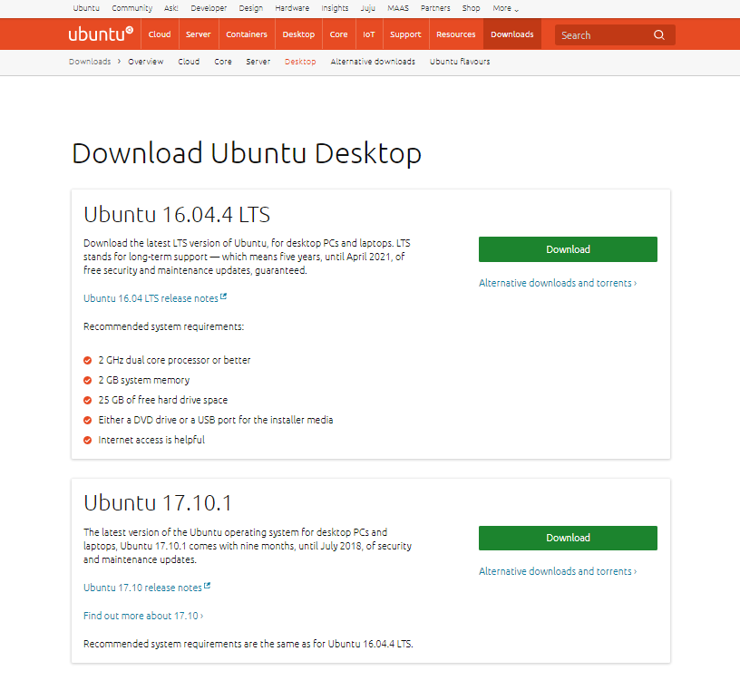

For this project, we are choosing Ubuntu Desktop because it gives us more flexibility. You will later configure the virtual machine to boot into a non-GUI (graphical user interface) mode to lower resource usage.

On this site, you will want to select Ubuntu 16.04.4 LTS and click download. If you see a survey screen afterward, simply click continue to installation. Then, your download will start automatically as an ISO file.

This ISO file will be used to install Ubuntu on the virtual machine. It acts as a virtual installation disc.

## Add ISO File to Virtual Machine

Now that the ISO file is installed, head back to the configuration page of your virtual machine. It should look like this. If you cannot find it immediately, click on File at the top left, then, click on open. From there, navigate to where you stored the virtual machine and open it.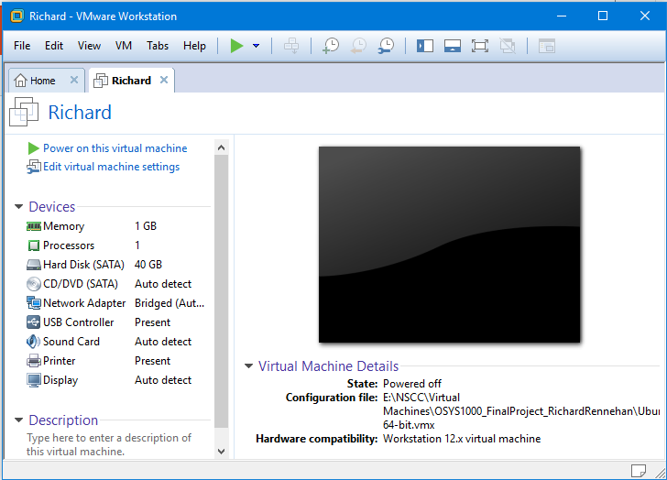

Now click on edit virtual machine settings. Then, click on CD/DVD. Under the connection tab, make sure “Use ISO image file” is selected. Then, click on browse. Again, anytime you click on browse, a popup window will appear. Now, simply find where you stored the ISO file. If you do not know where to find it, it is most likely in the downloads folder.

The image below demonstrates that the virtual machine is linked to the ISO file.

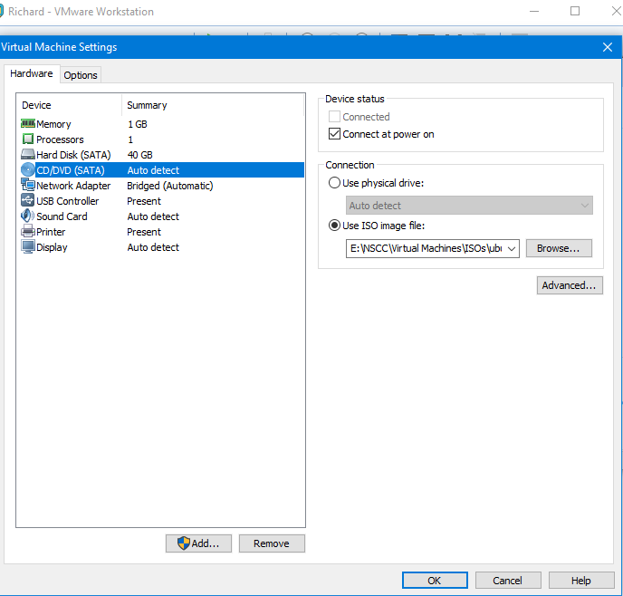

Congrats! Now you are ready to boot up the virtual machine for the first time.

# Virtual Machine First-time Boot Up

In this section, you will power on your virtual machine for the first time. This section will guide you through the installation process.

## Power on the Virtual Machine

Now, simply click “Power on this virtual machine,” which can be found at the top left of the configuration page.

If everything is configured correctly, you will see a purple screen on boot-up followed by a Ubuntu splash screen like the one pictured below. If you see a network boot screen, go back and make sure the ISO file was selected.

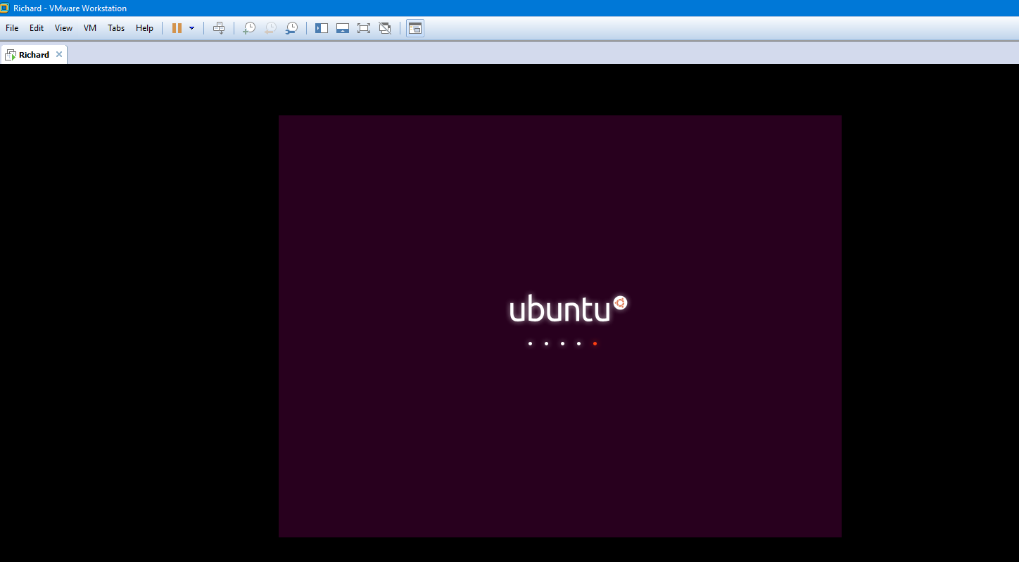

## Don’t Try Ubuntu, Install Ubuntu

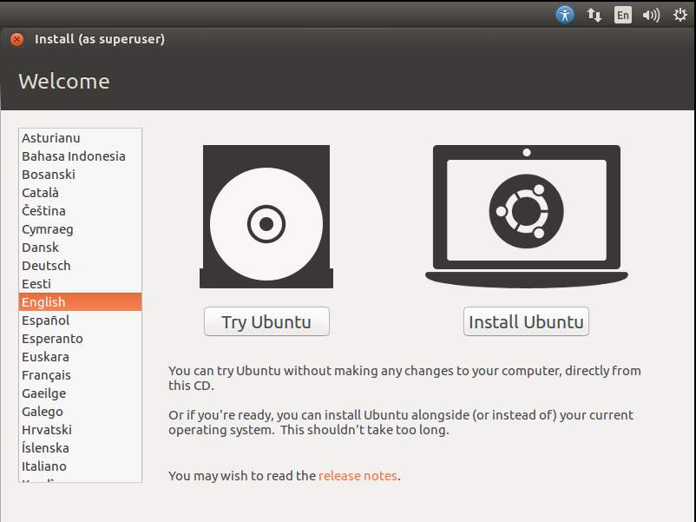

The first screen gives you the option to select a language on the left side. Feel free to select any language.

More importantly, though, it gives you an option to try Ubuntu or Install Ubuntu. You must click “Install Ubuntu”.

## Preparing to Install Ubuntu Screen

This screen gives you two checkboxes. One is to download updates while installing Ubuntu and another is to install third-party software. Select both and click continue.

## Installation Type

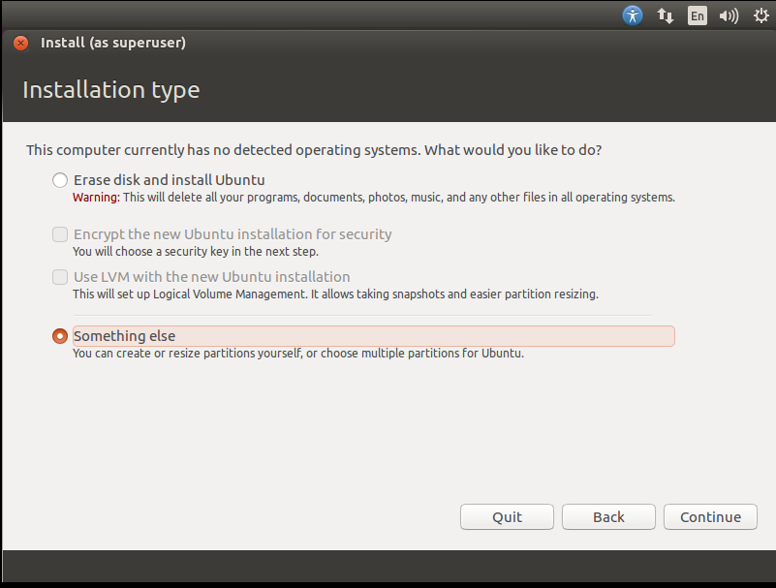

For the purposes of this project, we want to create our own custom partitions. Select “Something else”, then, click continue.

Also, don’t worry about the warning saying all of your storage will be deleted. This would only affect your virtual disk, not your actual computer.

## Configure Partitions

You will come across a screen that looks like this.

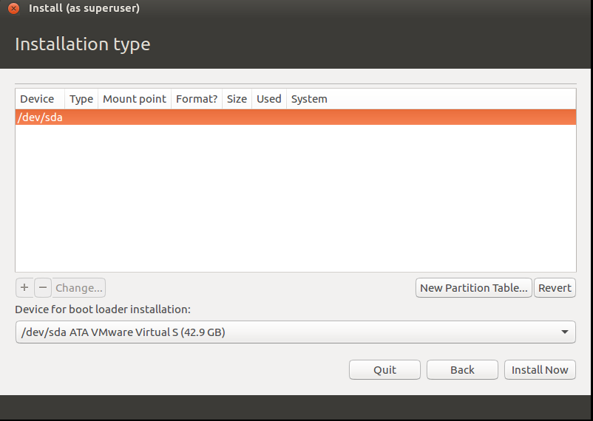

Configuring our own partitions allows us to customize and omptimize our system. We can configure a swap partition, which works as backup memory to improve performance and multitasker. We can also configure a data partition, which works as a way to organize files.

Start by clicking new partition table. Then, press continue when the popup appears. The page will update as shown below.

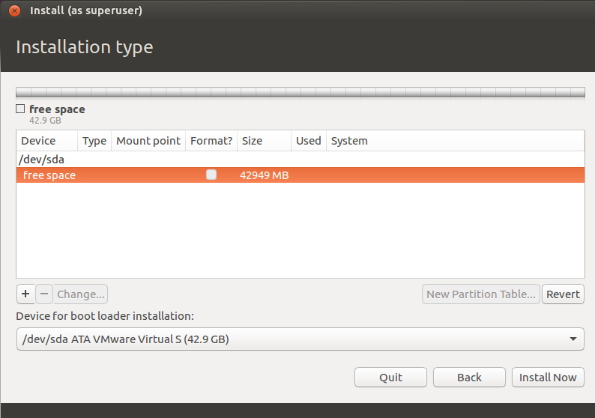

Start by clicking on free space. Then, you can click on the plus symbol below it. You will see a popup similar to the one displayed below. First, configure your swap partition by configuring the options as shown below. Click OK once your popup matches the one shown before.

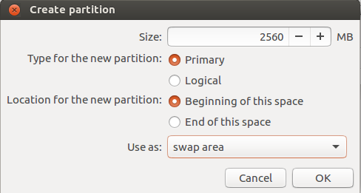

To create your data partition, click free space followed by the plus button again. Configure the page as shown below. Make sure to type /data next to mount point as you can’t select /data.

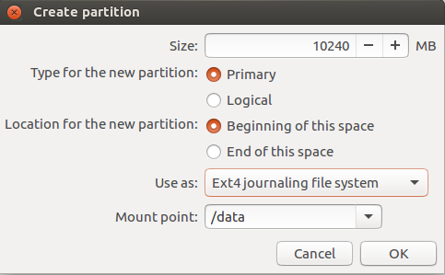

Finally, you will have to use up the rest of the free space. You can do so by allocating it to a root partition. Click on free space followed by the plus button once more. This time, do not set a specific size. This will use up all the space remaining. Configure the other options as displayed below.

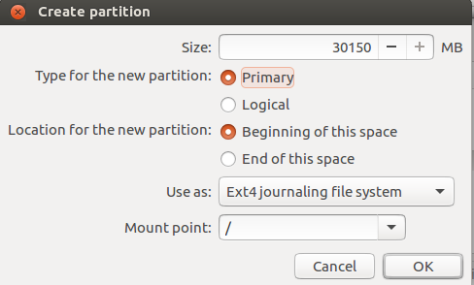

To confirm everything is OK, your partition table should have 4 devices as displayed below.

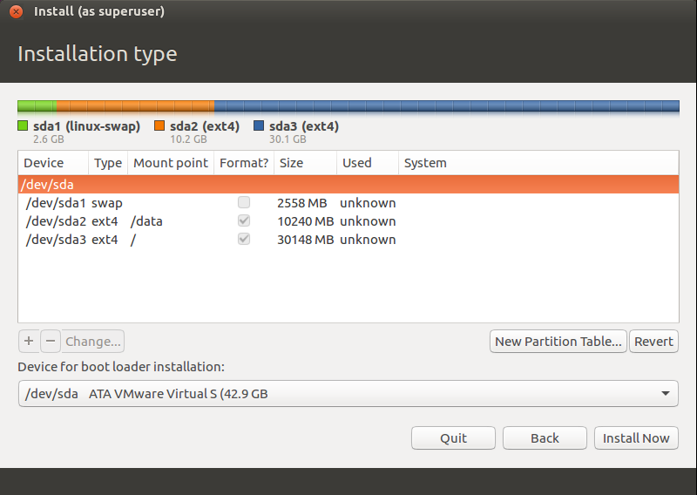

Once you click Install Now, you cannot go back. Make sure everything is correct before clicking Install Now.

## Select Location

This screen displays an interactive world map. To select a location, click where it would be located on the map until the name is displayed in the text box below the map.

If you have no idea where on the map your location is, you can instead type the name of your city below until it pops up. Then, choose the best match.

Once complete, select continue.

## Keyboard Layout

On this screen, simply select the keyboard layout that matches your keyboard. Once selected, type into the text box below to make sure every key prints the correct letter. Click continue once it is all working. If you can’t find the continue button, click on the window and drag it to the left.

## The “Who are you” Screen

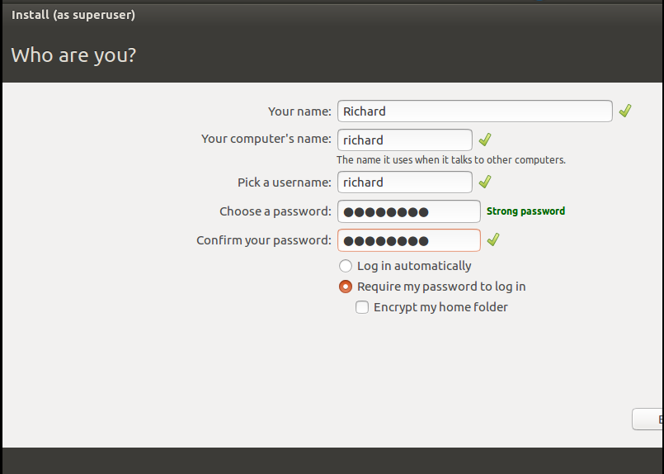

This screen lets you set your computer’s hostname and lets you create your user account. Pick an appropriate name for your computer and a username and password you won’t forget.

For convenience, you can select “Log in automatically,” Or you can stick with “Require my password to log in” if preferred. Once you are set, drag the window to the left to reveal the continue button. Then, press continue.

## Ubuntu is now Installing

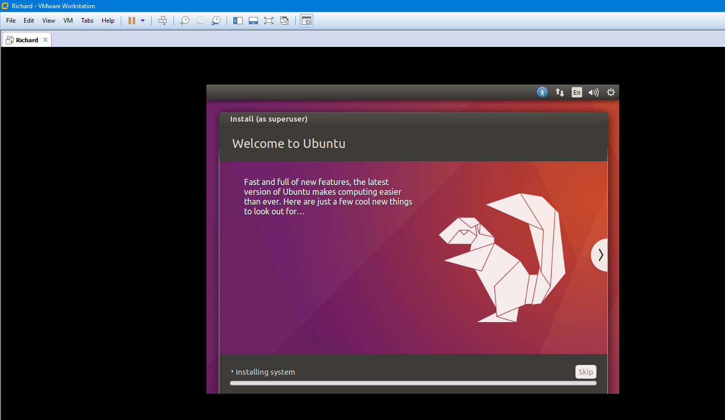

Congratulations! Linux Ubuntu should now be installing. You are now a proud user of Ubuntu, the most popular distribution of Linux.

When installation is complete, you will get a popup saying you will need to restart. Simply click restart now to reboot the virtual machine

## Remove the Installation Medium

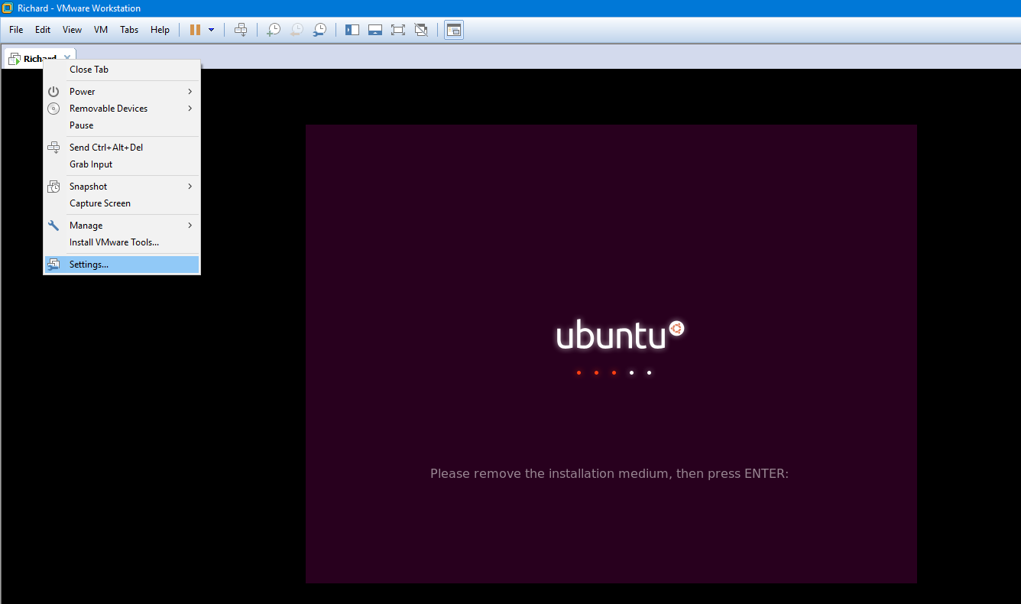

Finally, you’ll come across a screen as shown above. To remove the installation medium, right click on the tab with the virtual machine name as displayed above. Then, click on settings.

If your mouse is stuck in the virtual machine, press the Ctrl and Alt keys together to break the mouse free.

Now, go back to the CD/DVD section. Under connection, switch the setting back to “Use physical drive.”

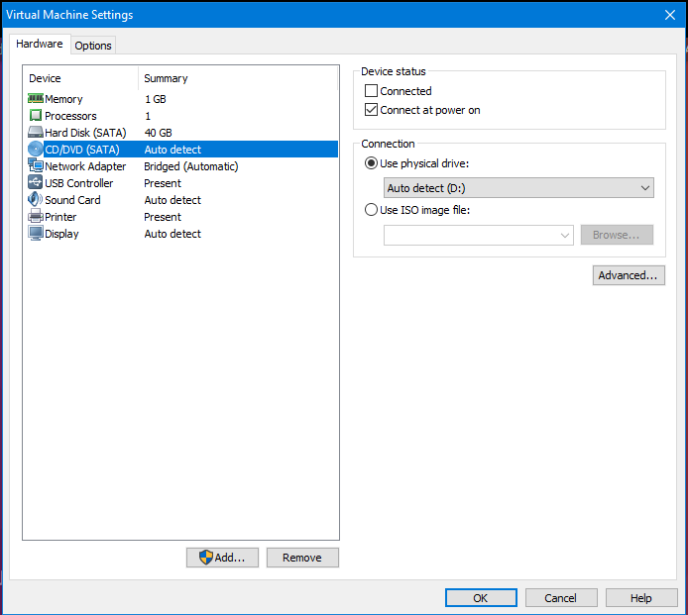

Then, press Ok. Now, you can press ENTER on your keyboard to continue. Make sure to click on the virtual machine window first, or the virtual machine may not recognize the ENTER key being pressed.

# Backup your Virtual Machine

Now’s a good time to take a break and create a backup of the virtual machine. Simply copy the folder with your virtual machine (in my case, OSYS1000_FinalProject) and place the copy in a new location. If you have access to another physical drive, such as a USB stick, external hard drive, etc., place it there.

# Swapping to Command Line Interface

In this section, you will configure your virtual machine to run and boot in a non-graphical user interface mode. You will be introduced to how command line interfaces work and how to navigate them.

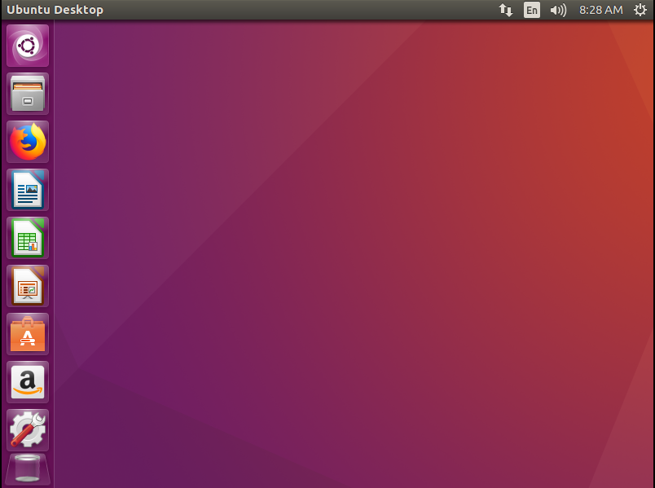

Upon logging in the first time, you should be greeted with the screen shown above. This is the Ubuntu GUI (graphical user interface). While user-friendly and colorful, GUIs are not great for computers dedicated to server processes. Servers are designed to run in the background, where having a GUI is both unnecessary and takes resources away. As this computer will be used with a LAMP stack, you will begin by configuring to boot in a non-GUI mode.

## Boot in Non-GUI mode

While on the home screen as displayed in the backup section above, press ctrl, alt, and the F2 keys together (ctrl+alt+F2). After a minute of waiting, you will come across a black screen as shown below. This is called a CLI (command line interface).

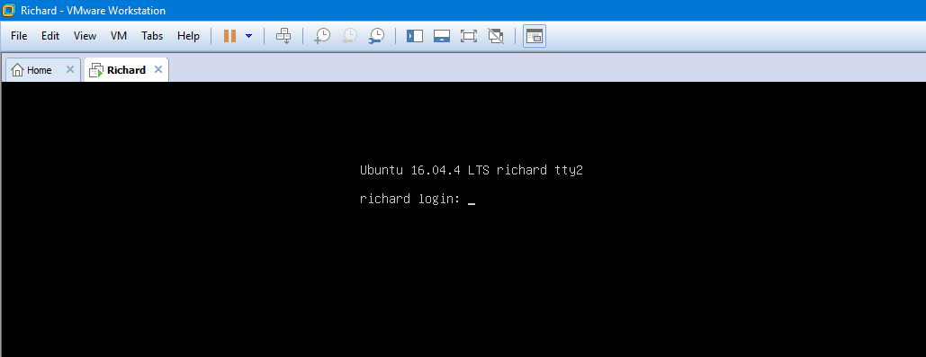

If you are requested to log in, simply enter your username and hit enter. Then, enter your password as requested. The CLI won’t display any of the characters you type when you enter your password, so do not worry if nothing shows up on screen while you are entering your password. Skip this paragraph if you are not requested to log in.

Type the following command to disable the GUI from activating each time the system boots:

* sudo systemctl disable lightdm

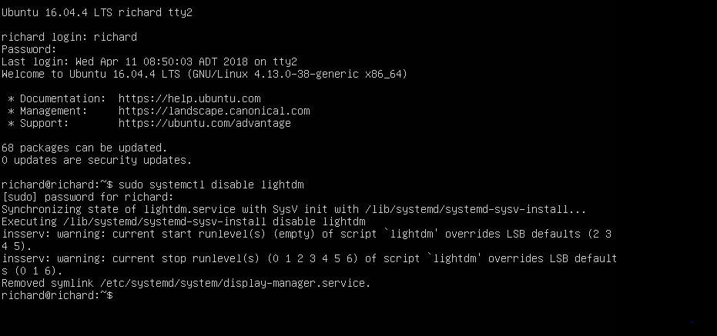

This command means disables the lightdm service, which is used to power the GUI. The sudo word at the start prevents us from getting an access denied message. We’ll be adding sudo to a lot of commands that otherwise would not be allowed. Reboot your virtual machine to make sure it boots into the same black screen.

There’s a quick way to restart a Linux operating system using the command line interface. Type this command:

* sudo reboot now
* The equivalent for shutting down is: sudo shutdown now

## Quick Briefing on CLI

Welcome to the dark side, I mean the command line interface (CLI)! Command line interfaces are great because the commands you can pull off can often be more efficient than doing the equivalent with the GUI. On top, CLIs use fewer resources to run, so they perform better on older computers and on computers that work as servers.

Here are some basic commands you must know to get around the CLI

|  |  |
| --- | --- |
| Command | Description |
| pwd | Displays which directory you are currently in |
| ls | Displays files and folders in the directory you are currently in |
| cd Directory | Move to the directory specified. Replace Directory with the name of the folder or directory. Replace Directory with .. to go in the opposite direction back up. |
| touch file.txt | Create a file named file.txt. Replace file.txt with anything you like. To delete it, use rm file.txt |
| cat file.txt | Allows you to open a text file. Replace file.txt with the name of the file |
| nano file.txt | Allows you to edit a text file. Replace fie.txt with the name of the file |
| clear | Clears all previous commands and output from the screen |
| mkdir name | Makes a new folder in your current location. Replace name with the desired name of the folder. To remove a folder, use rm -r /name. |

In the following picture below, I use pwd to discover that I am in my home directory. The home directory is /home/yourUsername (/home/richard in this example). You will land in this directory when you boot up the virtual machine. Then, I use *ls* to see what I can find here. Items in blue are folders while items in white are files. I then use *cd Downloads* to head to the downloads folder. I then use the ls command while in the Downloads folder, only to see there is nothing there. I would then use *cd ..* to go back to the above folder.

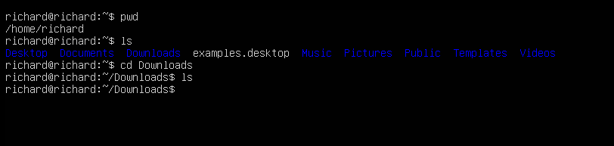

Remember that folders and files are case sensitive. You must enter them as they appear.

## If you Wish to Go Back to GUI

It is recommended to stay in the command line interface to continue this project. However, you can go back to GUI anytime you wish.

Anytime you want to go back to the GUI from the CLI, type the following command and you will be taken right back to the graphical user interface:

* sudo service lightdm start

If you wish to have the computer load the GUI by default for each bootup again, type the command below before you enter the above *sudo service lightdm start* command

* sudo ln -s /lib/systemd/system/lightdm.service /etc/systemd/system/display-manager.service

This creates the link to the lightdm service that was deleted when the *sudo systemctl disable lightdm* command was ran.

# Ubuntu Configuration

In this section, you will confirm your Ubuntu machine was configured successfully, as well as make further configurations.

## Confirm Partitions Were Set Successfully

Run the following command to check your partitions

* sudo lsblk

You’ll notice that it displays your partitions and their sizes. You can confirm that the swap partition was set to around 2.5 GB, for example.

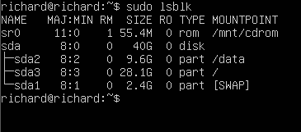

## Confirm Networking is Set

A quick way to check whether networking services are set properly is through the ping command. Try running this command to see if you can connect to Google:

* ping www.google.com

Be aware that the ping command will continue forever until you cancel it. To cancel any command, press ctrl and c together (ctrl+c). If you find you are stuck after using a command, try ctrl+c.

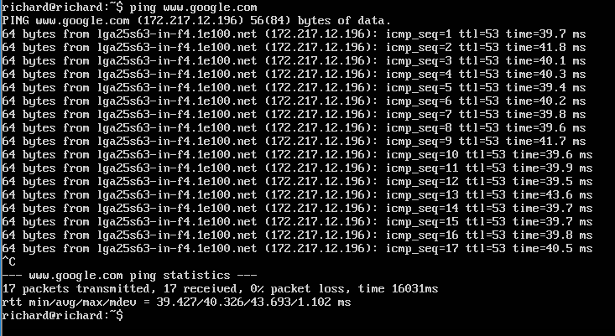

## Boot in Multi-User Runlevel

The default run level for Ubuntu is 5. For this project, we want the computer to start in run level 3, which is Multi-User Mode with networking. Run the two commands below in a row:

* sudo systemctl enable multi-user.target
* sudo systemctl set-default multi-user.target

An example is shown below

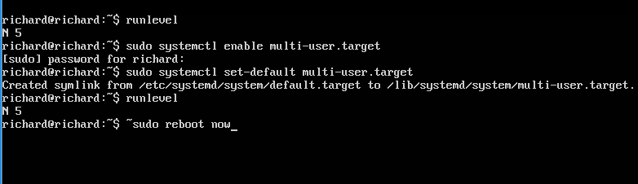

The system will still be at run level 5, so a reboot is required. Reboot your virtual machines. Once you login, use the *runlevel* command again. It should now display N 3.

More information on run levels can be found at:

<http://www.pathbreak.com/blog/ubuntu-startup-init-scripts-runlevels-upstart-jobs-explained> [2]

## Update and Upgrade

When you install Ubuntu, there may be packages that can be updated. Use the following command to update all packages with updates:

* sudo apt-get update

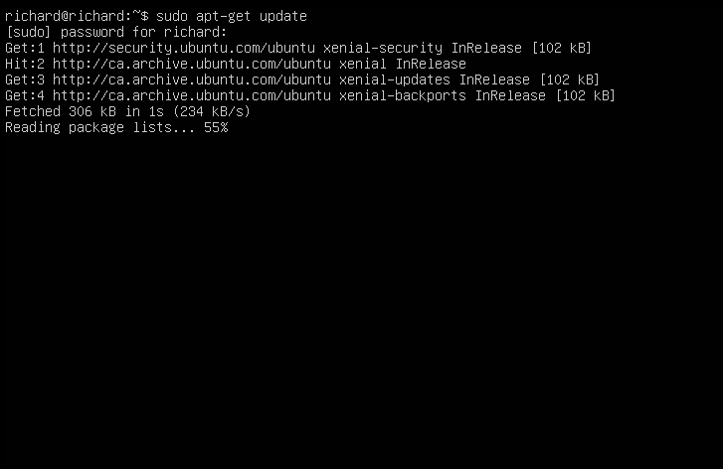

Same thing goes for upgrading packages. Run this command as well:

* sudo apt-get upgrade

When you are prompted, “Do you want to continue?” type y and press enter.

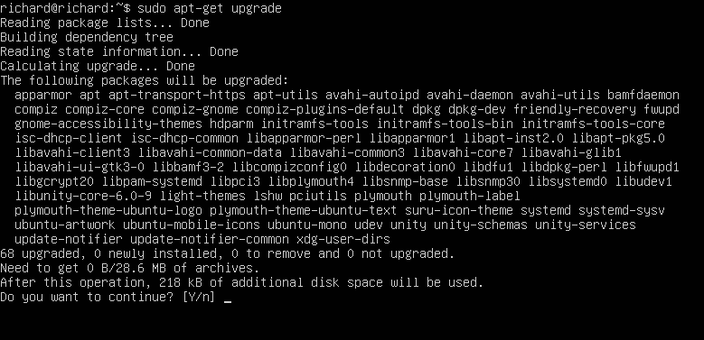

Reboot your virtual machine to ensure everything installed correctly. When you login, it should show 0 package updates and 0 security updates.

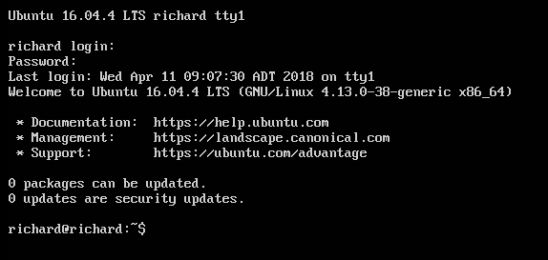

## Install VMWare Tools

VMWare tools provide additional functionality, such as being able to copy and paste text from Windows to the virtual machine. VMWare tools also provide improvements in performance.

While logged in, escape the mouse from the virtual machine. Then, click on VM near the top followed by Install VMWare Tools

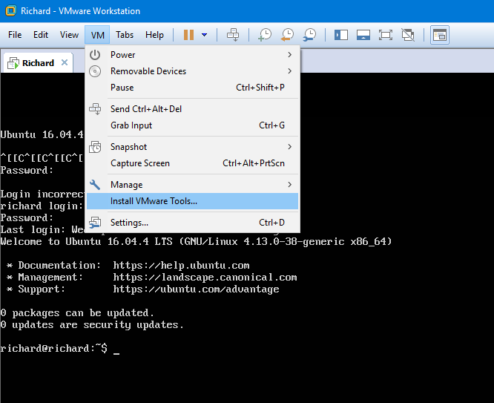

Then, run the following command:

* sudo apt-get install open-vm-tools-desktop

Once it is complete, you can check to see if it is running through the following command:

* sytemctl status open-vm-tools.service

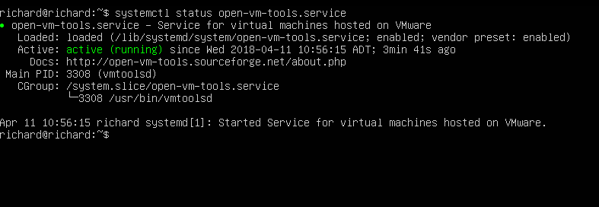

## Enable Firewall

By default, the firewall is turned off. To enable the firewall, enter the following command:

* sudo ufw enable

Check firewall status with following command:

* sudo ufw status

A black and silver text on a white background

Description generated with very high confidence

# Virtual Machine LAMP Configuration

In this section, you will install each component of your server and configure them.

## Install LAMP Stack

Ubuntu offers a convenient way to install Apache, MySQL, and PHP all at once.

First, tasksel must be installed. Type the following command

* sudo apt install tasksel

tasksel allows us to install the LAMP stack in one command. Once the last command is complete, type the following command:

* sudo tasksel install lamp-server

Briefly afterward, you’ll come across an install window with a purple or pink background. The first prompt you will have is to set a password for the MySQL user. Enter a password. This password will be used across multiple services that connect to MySQL.

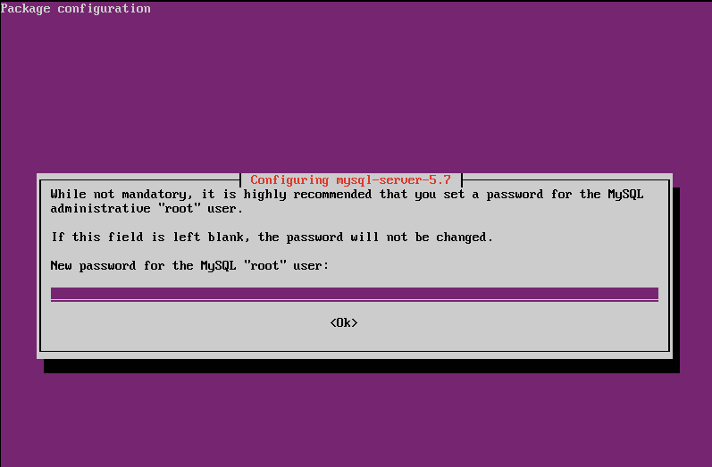

If everything is correct, you will land at the install page as displayed below

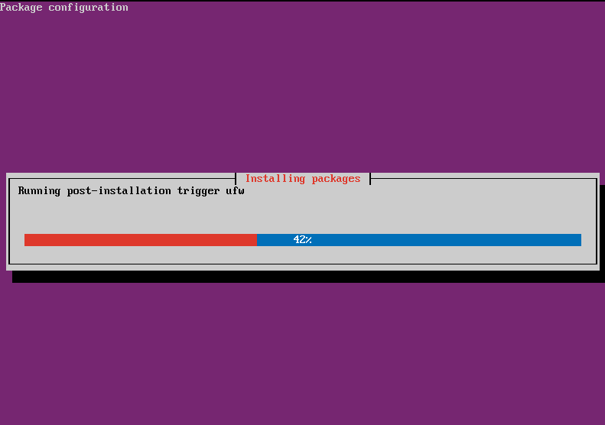

Once it is complete, you now have a basic LAMP stack installed on your virtual machine!

## Install phpMyAdmin

While the LAMP stack includes the PHP programming language, it does not include phpMyAdmin. phpMyAdmin is a special service that simplifies working with MySQL.

After the LAMP is installed, install phpMyAdmin with the following command:

* sudo apt install phpmyadmin apache2-utils

When prompted with a purple screen, make sure that apache2 is selected. Then, press enter.

A screenshot of a cell phone

Description generated with very high confidence

Then, when it asks to configure a database, select yes as shown below.

A screenshot of a cell phone

Description generated with very high confidence

Then, enter the password you used for MySQL.

Now, restart apache to confirm the changes.

* sudo service apache2 restart

## Install Samba

Samba is another important tool, but is not included by default in the tasksel LAMP stack. Samba allows us to share access to files, printers, serial ports, and other connections between systems.

To install Samba, enter the following command:

* sudo apt install samba

This project will not cover how to configure Samba for network sharing. However, you can check out the following link if you are interested in configuring the service:

<https://help.ubuntu.com/community/How%20to%20Create%20a%20Network%20Share%20Via%20Samba%20Via%20CLI%20%28Command-line%20interface/Linux%20Terminal%29%20-%20Uncomplicated,%20Simple%20and%20Brief%20Way>!

## Install OpenSSH

Finally, openSSH is a suite of utilities providing security for networks.

To install OpenSSH, enter the following command:

* sudo apt install openssh-server

## Alter Firewall to Allow Access from Windows

Now with all of our tools installed, enter the following command to see all applications that cam interact with the firewall:

* sudo ufw app list

A screenshot of a cell phone

Description generated with very high confidence

To ensure each service can be accessed from Windows:

* sudo ufw allow ‘Apache Full’
* sudo ufw allow ‘OpenSSH’
* sudo ufw allow ‘Samba’

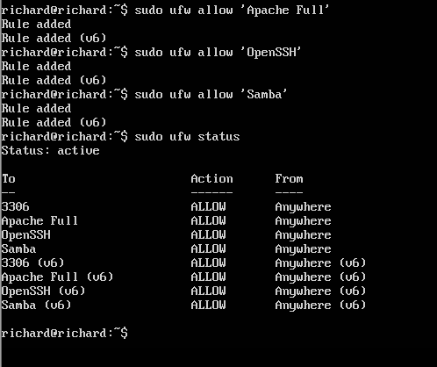

## Configure Apache after Installation

This section requires working with a major configuration file, so make sure to follow the next few steps carefully. A small error in any configuration file can break the service it belongs to.

There are a few default settings with Apache that are not desired. An example is the KeepAlive setting, which keeps the server running in the background. It may be turned off by default.

You will also need to add a line to the end of the file so phpMyAdmin will run on our apache site.

To start, it is a good idea to create a backup of our configuration file. Do so with this command

* cp /etc/apache2/apache2.conf ~
* This makes a copy of the apache2.conf file and places it in our home directory.
* Across linux, the tilde symbol is used to represent the home directory.

Then, to start editing the configuration file:

* sudo nano /etc/apache2/apache2.conf

Use the up and down arrows to scroll. Make sure these settings are configured as so:

* KeepAlive On
* MaxKeepAliveRequests 50
* KeepAliveTimeOut 5

A screenshot of a cell phone

Description generated with very high confidence

Now scroll all the way down to the bottom and add the following line word for word:

* Include /etc/phpMyAdmin/apache.conf

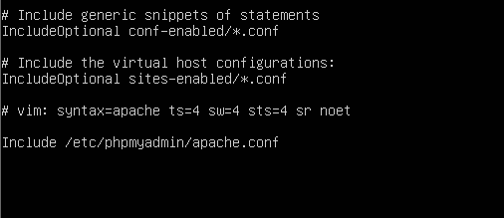

Use ctrl+x to exit the file. Confirm changes when prompted to save.

Once you are done, conclude by restarting the Apache service:

* sudo systemctl restart apache2

If issues follow, the following command checks your apache configuration file for errors:

* apachectl configtest

If you see Syntax OK, you should be good

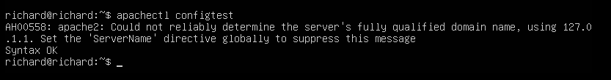

## Configure MySQL after Installation

After installing MySQL as part of the LAMP stack, it is good to make sure remote access is allowed and that the database service launches after each reboot.

Allow remote access to the MySQL server with this command:

* sudo ufw allow mysql

Start the database service with this command:

* systemctl start mysql

Finally, ensure the database service launches after each reboot:

* systemctl enable mysql

Then, continue to enter your password until complete.

## Ensure Each Process is Running

### To check that Apache is running:

* sudo service apache2 status

A close up of text on a black background

Description generated with very high confidence

### To check that MySQL is running:

* mysqladmin -u root -p status

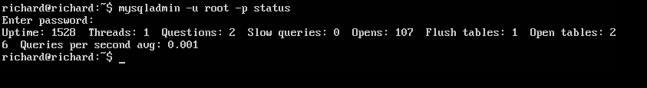

### To check that PHP is Running:

* php –v

A close up of a logo

Description generated with very high confidence

### To check that Samba is running:

* sudo smbstatus

A screenshot of a cell phone

Description generated with very high confidence

### To check that openSSH is running:

* sudo service ssh status

A black and silver text on a screen

Description generated with high confidence

### To check that phpMyAdmin is running:

phpMyAdmin is tougher to check, but the next section will have an activity that will confirm it is running.

# Experiment with LAMP

Now with LAMP installed, here are some exercises to get you acquainted with the features of a LAMP server.

## Access Apache Site From Windows

With the default LAMP now installed, your virtual machine can act as a web server on your network. You can access the apache webpage set on your virtual machine from your Windows host machine!

First, enter ifconfig in your Ubuntu virtual machine. Take note of the address that appears next to “inet address:”. Then, go to a web browser on your windows machine and type the address in. In the example below, the inet address was 192.168.2.20

If successful, you’ll see a webpage like that below.

A screenshot of a computer

Description generated with very high confidence

If your phone is connected to the same network, it even works on your phone, so give it a try! With our machine’s configuration so far, the apache site will work on any device connected to your local network.

## Test PHP

To verify that PHP works from windows and on your site, make the following changes to your virtual machine:

1. Enter the command: sudo nano /var/www/html/info.php
   1. This allows you to edit the info page on your site
2. Enter this on the blank page:

<?php>

phpinfo();

?>

A screenshot of a cell phone

Description generated with high confidence

1. Press Ctrl and x (Ctrl+X) to exit. Confirm your changes when prompted.
2. Restart the web server with: sudo systemctl restart apache2
3. Like with the section above, go back to a web browser on your Windows machine. Enter the address you found like before, but add /php.info this time.
   1. An example: 192.168.2.20/info.php
4. The site should appear like that below

This also confirms that PHP has been configured successfully on our virtual machine.

A screenshot of a social media post

Description generated with very high confidence

## Create Sample Database with MySQL

MySQL is a database service that allows us to store data. In this exercise, you will create the framework for a table about computer users and insert some data into it.

To start, log into MySQL with the following command:

* mysql -u root -p

Upon successful password entry, you will be presented with the mysql prompt.

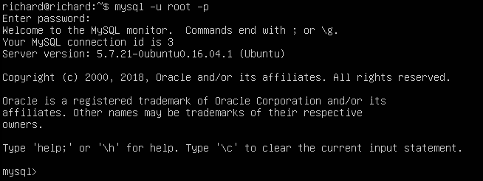

Next, ensure that you have all privileges with the following command:

* GRANT ALL PRIVILEGES ON *.* TO 'root'@ 'localhost ' IDENTIFIED BY 'password ';
  + Replace password with the current password you have set for MySQL. If you do not, it will change your password for MySQL.
  + Don’t forget the semicolon at the end.

We are almost all set. Before we can create a table, we need a database to store it in. Enter the two following commands to create a database named test and set it as the current database:

* CREATE DATABASE test;
* USE test;

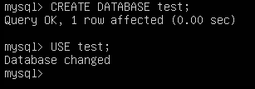

Now, enter the following to create the table structure:

CREATE TABLE Member (

,ID int(11) ZEROFILL primary key

,Username varchar(50) not null

,Password varchar(50) not null

);

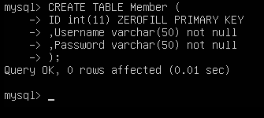

You can see that each user you add will have a unique identifier stored as an 11 digit number as well as a username and password stored as character strings with maximum length 50.

Now, enter data for 6 made up users.

INSERT INTO Member(ID,Username,Password)

VALUES (1, 'Bruce', 'password'),

(2, 'Charlotte', 'trustno1'),

(3, 'Richard', '123456'),

(4, 'Andrew', 'qwerty'),

(5, 'Wolf', 'letmein'),

(6, 'Barney', 'iloveyou');

Note that table names and fields (e.g. ID, Password) are case-sensitive and their names must be typed exactly as they were set.

Feel free to enter other made up names and passwords instead if desired.

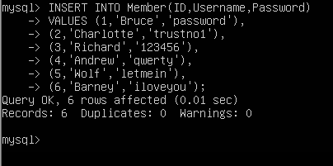

Once your table data is set, you can use a select command to view the table’s contents:

* SELECT * FROM Member;

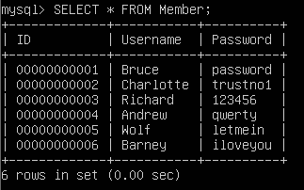

As amazing as it is, there’s still one problem. Imagine if this were an actual user database for a company. Having the passwords spelled directly out can impose security risks.

Use the following command to encrypt the password fields.

UPDATE Member

SET Password = MD5(Password);

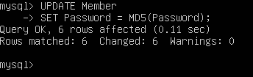

Then, you can do another select statement to see the changes

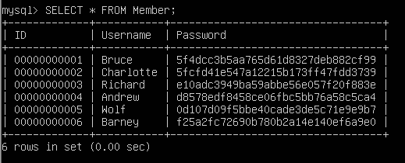

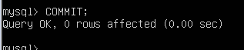The last step is to do a commit statement to ensure changes are saved.

COMMIT;

## View Database with phpMyAdmin

Assuming you followed the steps for installing the LAMP stack and phpMyAdmin, configuring the Apache config file, turning on your firewall, and adding each service to the allowed apps in the firewall, we can use phpMyAdmin from the Windows machine to view our database.

Like before, go to any web browser and enter serverIPAddress/phpmyadmin. In this example, the server IP address is 192.168.2.20

A screenshot of a cell phone

Description generated with very high confidence

You will be presented with a log in screen. The username is root. For the password, enter the password you configured for MySQL.

If correct, you will be presented with the dashboard as shown below

A screenshot of a computer

Description generated with very high confidence

Assuming you have created the database in the last section, you should see the name of the database you created on the left sidebar. By clicking on that, you should see a dropdown list containing the name of your table.

phpMyAdmin gives you a lot of options and tools to work with all of your databases. For example, you can click on a table to view the data inside it as shown below

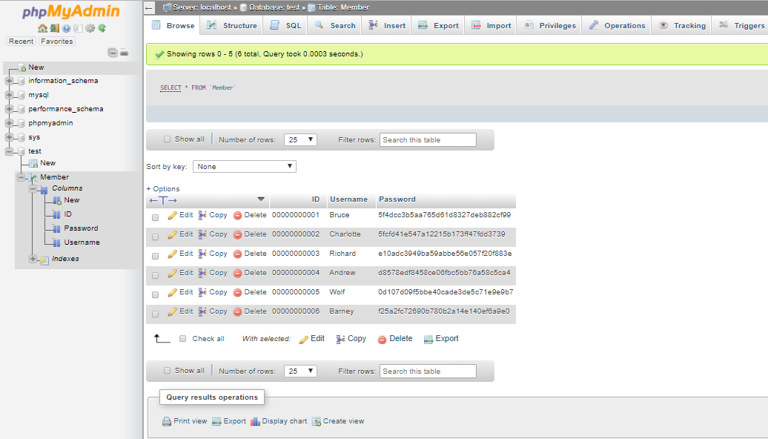

You can also click on “Column” to show the structure of the table.

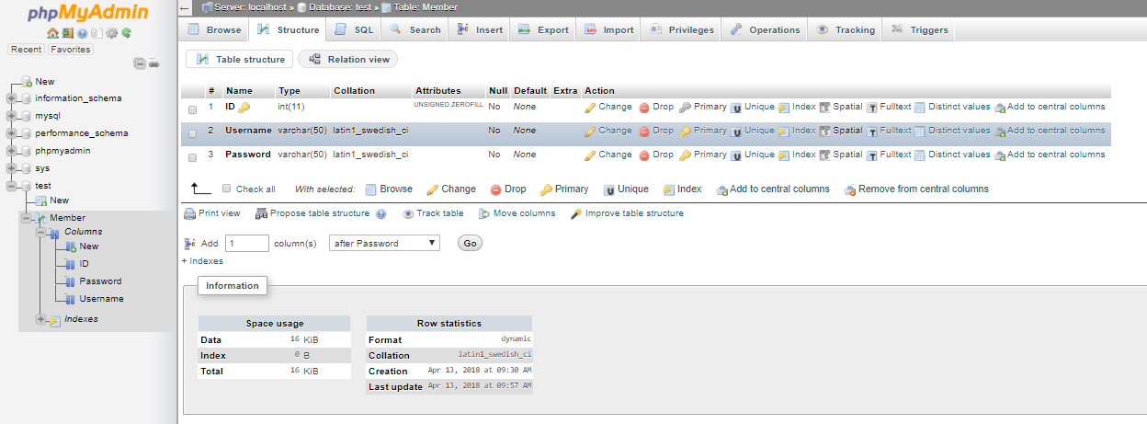

phpMyAdmin is also capable of much more. For example, you can also create your databases and tables right from the phpMyAdmin dashboard. You can also alter or change existing databases and tables.

## Create Automated Backup of Database

This exercise will require the creation of a script file and utilizing of crontab to create an automated routine

First, make sure you are in your home directory by typing:

* cd ~

Next, you will create a blank script file. For this exercise, call it mysqldump.sh. Use this command to create that file:

* touch mysqldump.sh

Now create a folder to use to store the backup. For this exercise, call it SQLBackup

* mkdir SQLBackUp

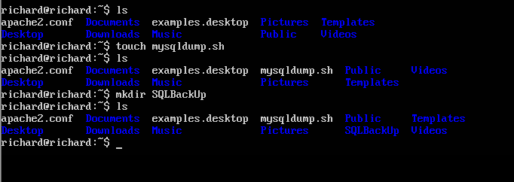

Then, edit the script file using nano

* nano mysqldump.sh

Add this line to the file (replace your_SQL_password with the actual password):

* mysqldump -u root -p your_SQL_password --all-databases | gzip > $HOME/SQLBackUp /mysqldb_`date +%F`.sql.gz

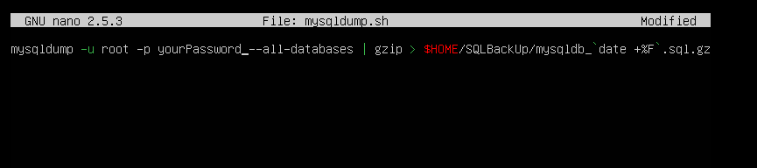

Exit and save your changes. Then, use the chmod command to add execute permissions to the script

* chmod +x mysqldump.sh

Now test the script to see if it works

* sh mysqldump.sh

Upon execution, you should get no warning errors. Now navigate to the backup folder and check what’s inside!

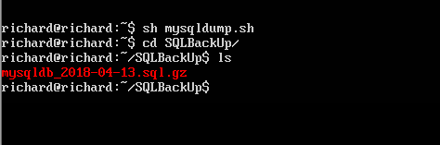

You can see that a zipped folder has been created containing the contents of all databases. It even adds the current date to its name.

Now, we will configure Ubuntu to run this script everyday at 11:00PM.

First, enter the crontab file with the following command:

* crontab -e

When instructed, choose nano as the editor. Nano is the editor you have been using for all editing so far.

At the bottom of the file, add the following line to make the script run every day at 11:00 PM

* 0 23 * * * sh /$HOME/mysqldump.sh

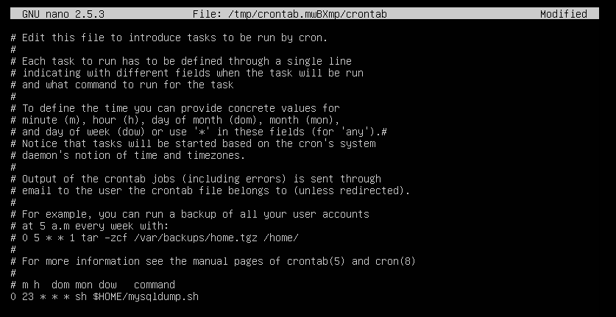

Now exit and save, and Ubuntu will take care of the rest! You’ll get a message stating “Installing new crontab” if successful.

# References

1. Prakash, A. (2016, December 16). 10 Amazing Facts About Ubuntu Linux. Retrieved April 08, 2018, from https://itsfoss.com/facts-about-ubuntu/

2. Shiraly, K. (2011, September 25). Ubuntu startup - init scripts, runlevels, upstart jobs explained. Retrieved April 11, 2018, from http://www.pathbreak.com/blog/ubuntu-startup-init-scripts-runlevels-upstart-jobs-explained

3. How to check running status of LAMP stack. (2017, February 03). Retrieved April 12, 2018, from https://www.e2enetworks.com/help/knowledge-base/how-to-check-running-status-of-lamp-stack/