CIVE 202 Project 4 Summary Report: Risk Assessment
University of Nebraska-Lincoln

CIVE 202
Andrew Croner, Chayse Jeanneret, Rylee Renner, and Jessica Tackett

April 21st, 2026

Table of Contents
Introduction 3
Project Goals 3
Project Tasks 3
Task 1: 3
Task 2: 3
Task 3 3
Task 4: 4
Task 5 4
Methods 4
Risk Definition Comparison 4
Results/Discussion 5
Conclusion 6
Figures 7
Project Deliverables 12
Reference List 13

Introduction

Project Goals
The goal of this project is to evaluate the potential bias in the National Risk Index (NRI) methodology by conducting a sensitivity analysis and developing an alternative risk scoring model. The project will compare FEMA’s NRI risk definitions with a newly proposed risk definition using census tract data from two selected states; Oklahoma and Oregon. The analysis will determine how differences in risk definitions impact risk classification and identify any potential categorical bias in how risk is assessed.

Project Tasks
The following tasks will be required of the professional engineering team to complete the project goals.

Task 1: Data Acquisition and Preparation
The team will download the NRI dataset for two selected states at the Census Tract level. Then metadata files will be obtained to understand variables in the dataset. Next, the Social Vulnerability Index (SVI) dataset will be downloaded. Then, the data will be cleaned and organized to handle missing values and format variables. Finally, prepare the dataset for merging and analysis.

Task 2: Data Integration and Processing
Using the cleaned datasets acquired in Task 1, the team will join NRI census track data for two states, Oklahoma and Oregon, with the SVI dataset using a common geographic identifier. To ensure variables are correctly interpreted and labeled across the merged dataset, the NRI metadata files will be referenced. This resulting integrated dataset will be the foundation of the risk model development in Task 3.

Task 3: Risk Model Development and Analysis
Currently, the FEMA NRI defines risk as the potential for negative effects due to a natural hazard. Risk is calculated using three different components, expected annual loss, social vulnerability, and community resilience. Together, these items produce a Risk Index score by multiplying the expected annual loss by the social vulnerability divided by community resilience. The scores are produced as percentages and qualitative ratings ranging from Very Low to Very High and can then be used to compare to communities across the globe (FEMA).

To develop an alternative risk scoring model, external research will be conducted by the team to form and propose a revised risk assessment. The team will analyze different variables and decide if more are needed to fully understand risk or if others should be weighed differently. Sources such as Cutter et al. (2003) and the UNDRR Sendai Framework for Disaster Risk Reduction may be used to develop and support the proposed risk assessment. Then, the team will compare NRI risk classifications with classifications produced by the alternative model. This will allow the team to analyze bias in how risk is assigned across Nebraska and Iowa.

Task 4: Visualization and Interpretation
At least two summary tables or figures comparing risk scores produced by NRI methodology and the alternative method across census tracts in Nebraska and Iowa will be produced. A map will be created using the GeoPandas package in Python to spatially communicate risk information to client. The results will be used to analyze patterns, differences, or any categorical bias between the two risk assessment models.

Task 5: Documentation and Reporting
All findings, method descriptions, and visualizations will be compiled into a final report deliverable for Risk Averse, LLC. The data sources used, the proposed alternative risk definition and its justification, and a comparison summary table between the two methods will be documented in a summary table. All sources will be cited, and conclusions about potential bias will be determined.

Methods
Our team defined risk as frequency times exposure. In the data these variables are defined by “AFREQ” and “EXPT”. Frequency refers to how often the hazards occurs within the given region (Brown, 2022). Exposure represents the amount or extent of population, infrastructure, or economic value is subjected to the hazard (“Hazard Exposure Definition”). When multiplied, we get the measure of how much impact the hazard can have over time. If a hazard occurs frequently, but does not cause a lot of damage, the risk will be lower. A hazard that happens rarely but causes a lot of damage will be moderate. As for natural hazards that occur frequently and affect a lot, it would get a higher risk score. This formula allows the team to easily interpret the data and find areas where hazards are more likely to occur. The formula used looks as such:
$$Risk=Frequency ×Exposure$$
or
$$Risk=AFREQ ×EXPT$$
To make sure that our results are reproducible we began by obtaining our data from FEMA’s National Risk Index (NRI) and the CDC’s Social Vulnerability Index (SVI). We then filtered the data to only contain data for Oklahoma and Oregon, the states we chose to evaluate.

Risk Definition Comparison
The National Risk Index (NRI) defines risk as the expected annual loss multiplied by the community risk factor. Expected annual loss represents the average economic loss in dollars resulting from the hazards. The community risk factor is social vulnerability divided by community resilience and incorporates social vulnerability and community resilience into the NRI. This model considers the vulnerability of people and their ability to recover. In contrast, our team’s model focuses on how often the hazards occur and how much is exposed. The model does not touch on community vulnerability and resilience. As for the ethicality, the NRI is more inclusive when compared to our model. The NRI considers that not all populations are affected equally by disasters. Some communities are more advantaged than others, and our model may underestimate the risk in disadvantaged communities. Therefore, the NRI model reduces more bias towards areas where the hazards are more likely to occur. Another bias shown in the custom model is that it is not consistent between states. The model assigns higher risk scores to states where the hazard activity is more frequent. In areas states where the hazard is not as frequent, counties will be subjected to lower risk values with some extreme outliers. This, in turn, creates geographic bias as the model does not equally represent risk across all communities. The NRI can also exhibit bias as sometimes data is limited for certain communities, making them unrepresented, but that would also go for the custom model. In cases of future funding, the NRI is fairer and more effective. Funding will go towards areas with high vulnerability and low resilience. For our model, funding would go towards areas where the event occurs most often and on a larger scale. This could result in an unequal distribution of funding. All in all, our model has a higher bias towards high hazard frequency and does not consider how vulnerable the communities are. This bias could greatly affect how communities interpret the results as they would give funding to areas hit more frequently by the hazard, even if they can bounce back quickly. The NRI model is able greatly reduce this risk and spread-out funding more evenly and fairly between communities. This leads to a significantly different assessment of risk between the two models.

Results/Discussion
All of the tables and maps created by our team show the same trends and results. The bar plots are able to showcase that the two models do not seem to have much relation to one another. For example, figure 1b showcases the differences between the tornado risk score for the NRI and custom models. The NRI data is consistently higher than the custom model, with Roger Mills being the only exception. This suggests that when only taking exposure and frequency into account, the risk score is much lower than the NRI. Higher populated counties such as Oklahoma, also show very little risk with the custom score, showing that the model heavily relies on tornado frequency. Oregon’s plot is very similar, with the custom model being more scattered than the NRI’s. Tornado frequency is low in Oregon, which can be seen with the custom risk plot as most counties have very low risk. In result, the counties that experience higher risk have very large spikes. The NRI score contrasts as it includes the ability for the community to recuperate from the event. So, even though Washington has a very low frequency of tornados (giving it a low score on the custom model), the county is more vulnerable to this event. This, in turn, increases risk, as it is harder for the community to snap back after the event. As for the winter weather risk of both states, the custom risk score is consistently greater than the NRI score as, again, it heavily relies on the frequency of the event, not how the community is affected.

The maps show the same trends but allow us to spatially interpret them. In Oklahoma, the NRI map shows a more continuous spread of moderate to high risk levels in the central regions, while the custom model gives higher scores to more localized spots in the western part of the state. In Oregon the spatial differences are even more pronounced as the custom model does not consider resilience and vulnerability.

The implications of the two models on people are very different. The custom model will only show how frequent events may occur in certain areas. Although the risk scores aren’t necessarily wrong, the risk is really only defined by how frequent the event occurs. The NRI model, on the other hand, considers how people will be affected by the hazards. Just because a hazard doesn’t occur in a region frequently, does not mean that the area does not have any risk to the event. The counties are all different, with different infrastructure, population, and economical assets. The NRI model takes into account how the people in the counties will be affected rather than just how probable the event will occur. This is incredibly important when it comes to funding to mitigate future disasters as communities that are more vulnerable to these events can receive more funding to rebuild. For example, the county Wasco in Oregon has a severe NRI risk value, but a moderate risk value for the custom model. As for most of the county, Hood River, there is middle to low risk for the NRI model, and a moderate to high risk for the custom model. If we were to base funding off solely our team’s model of frequency and exposure, Hood River would receive more FEMA funding than Wasco, as the hazard occurs more frequently. What the model did not consider is how the people of the areas would be affected, and ultimately Wasco would be underfunded and have a harder time bouncing back. The results of these plots and maps show that the NRI model would be better used to examine the implications of people impacted by natural disasters.

Conclusion
By developing an alternative risk scoring model and comparing results of two states, Oklahoma and Oregon, this project examined the potential bias in FEMA's National Risk Index methodology. The custom risk assessment model, defined as frequency times exposure, was straightforward and easily reproducible but it falls short of capturing the full picture of risk. Social vulnerability and community resilience, items covered in the NRI model, were omitted which can create geographic and categorical bias of its own.

Despite limitations such as data gaps in some communities, the NRI model provided a more comprehensive risk assessment. Since it incorporated vulnerability and resilience, it can help aid in providing resources to the communities most in need when a hazard occurs. As seen in the figures in the appendix, the two different models can yield highly different risk classifications for the same communities and same hazards. Ultimately, the NRI methodology seems to be the more practically effective tool for disaster risk.

Figures
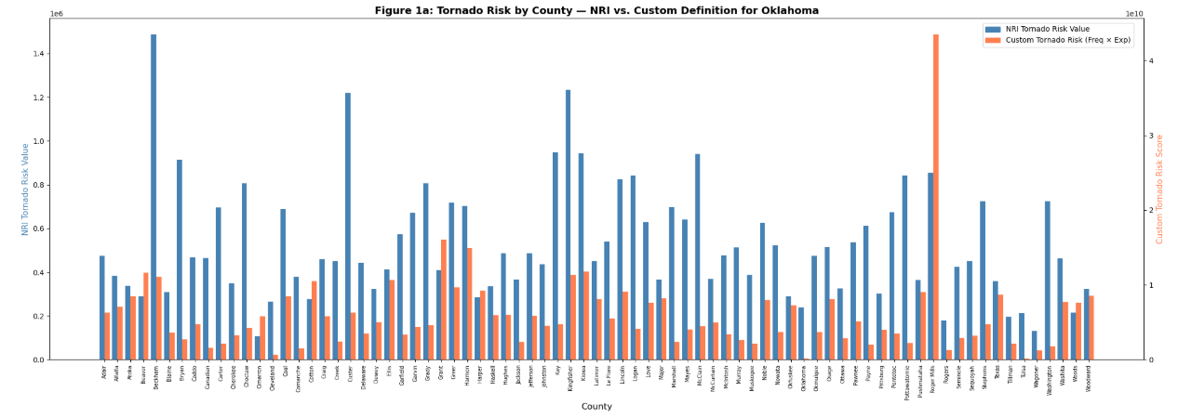
Figure 1. Oklahoma Tornado Risk by County

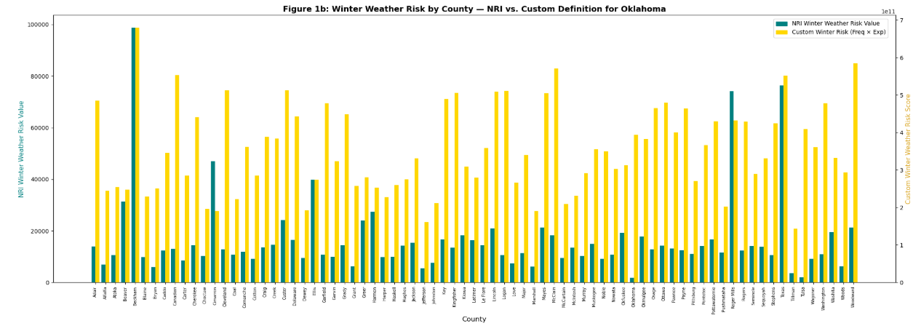
Figure 2. Oklahoma Winter Weather Risk by County

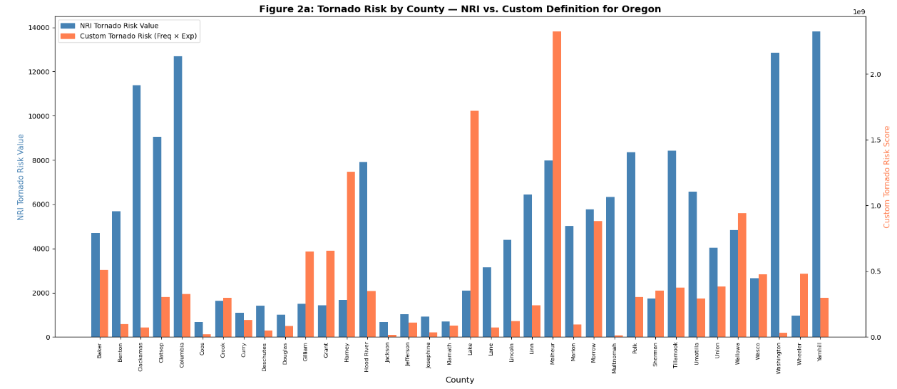
Figure 3. Oregon Tornado Risk by County

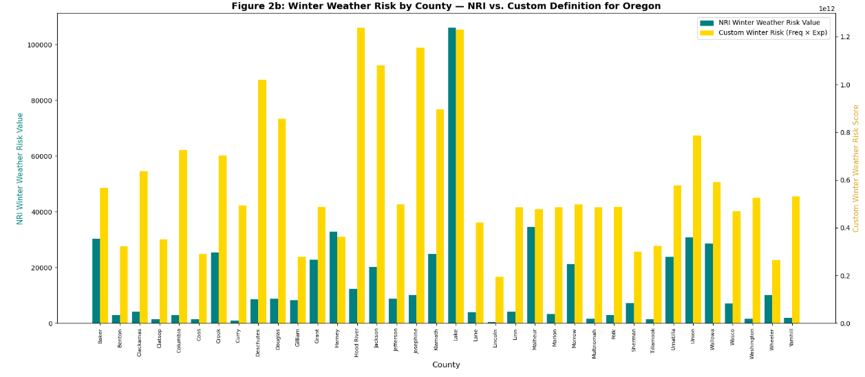
Figure 4. Oregon Winter Weather Risk by County

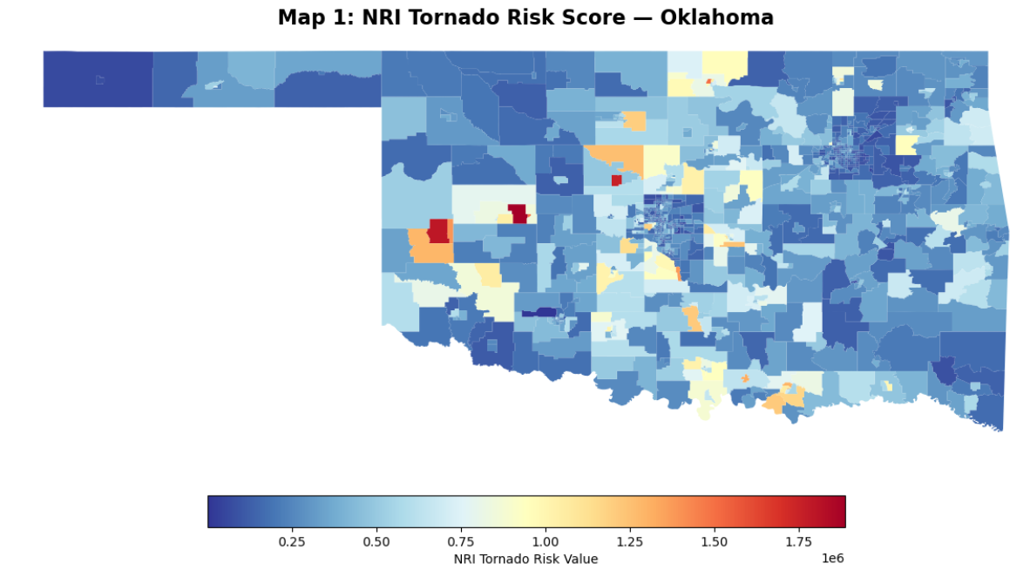
Figure 5. Oklahoma NRI Tornado Risk Score

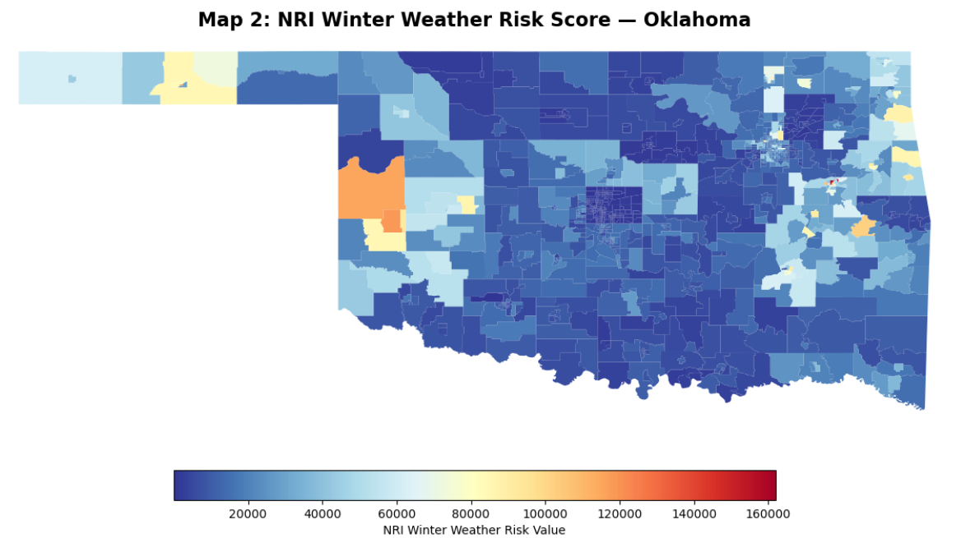
Figure 6. Oklahoma NRI Winter Weather Risk Score

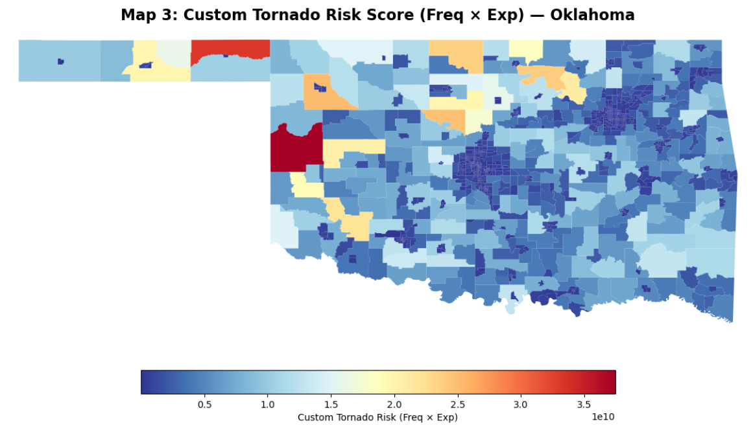
Figure 7. Oklahoma Custom Tornado Risk Score

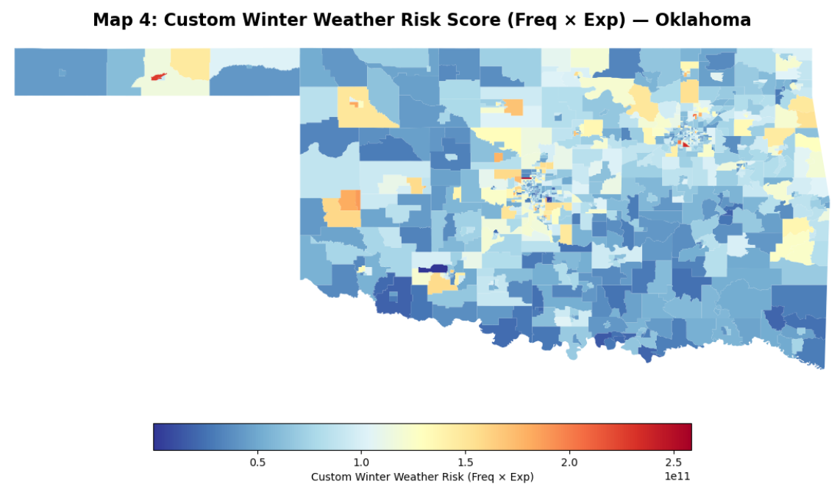
Figure 8. Oklahoma Custom Winter Weather Risk Score

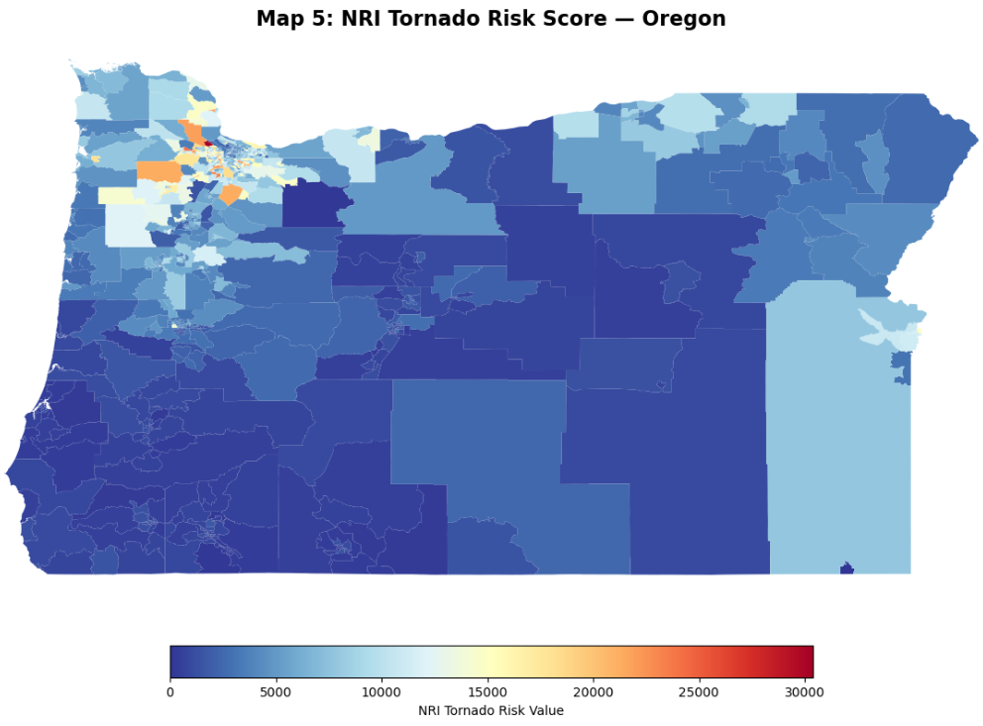
Figure 9. Oregon NRI Tornado Risk Score

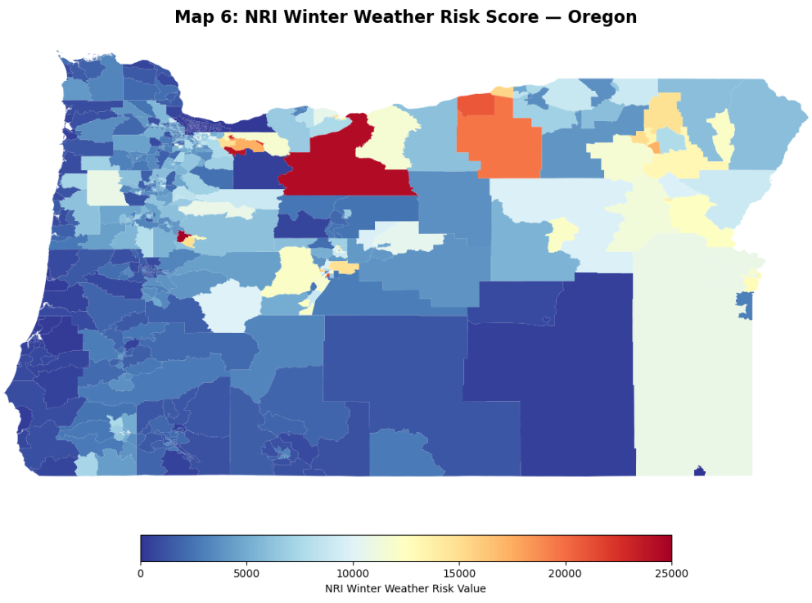
Figure 10. Oregon NRI Winter Weather Risk Score

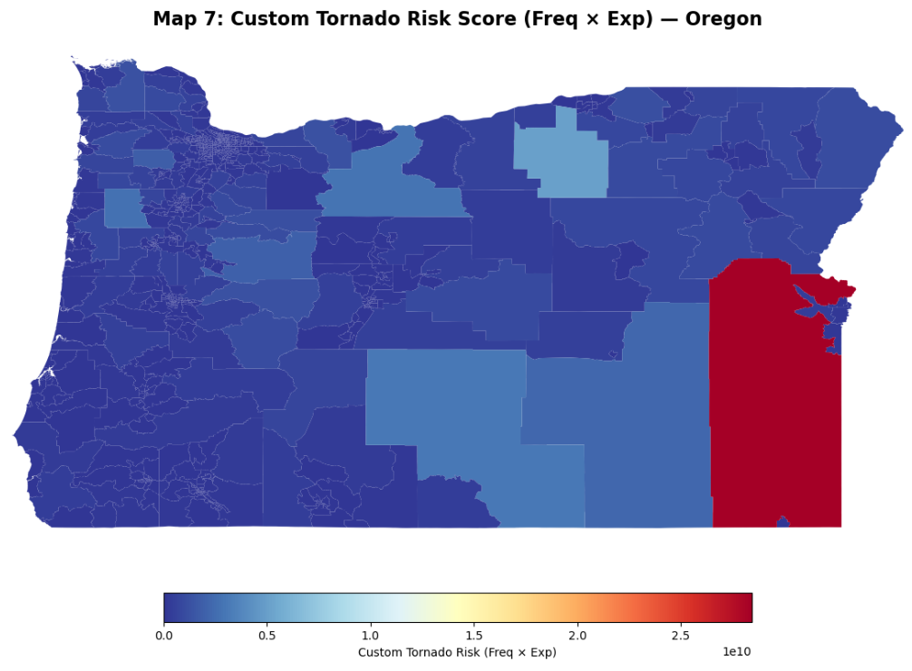
Figure 11. Oregon Custom Tornado Risk Score

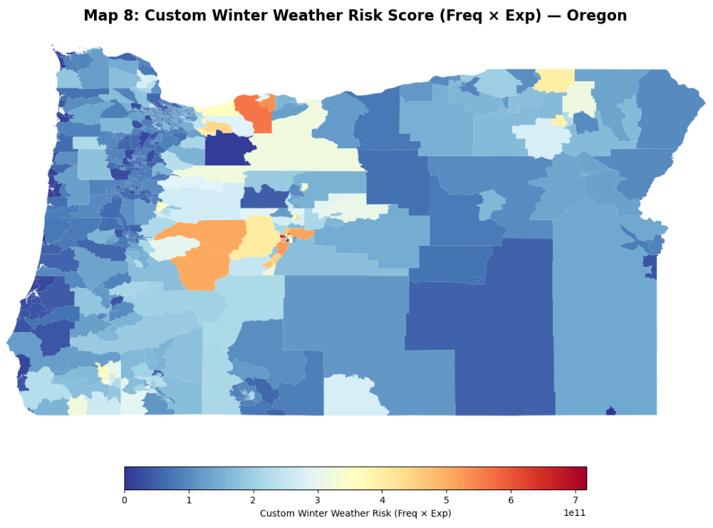
Figure 12. Oregon Custom Winter Weather Risk Score

Project Deliverables
Summarized in the table below are the deliverables and their corresponding due dates.
Table 1. Summary of Deliverables
Deliverable | File Name | Due Date
Gantt Chart | CIVE202_Spring2026_Group13_Project4_GanttChart | 4/21/26
Scope of Work (SOW) | CIVE202_Spring2026_ Group13_Project4_SOW | 4/3/26
Python Code | CIVE202_Spring2026_ Group13_Project4_PythonCode | 4/21/26
Annotated Code Document (ACD) | CIVE202_Spring2026_ Group13_Project4_ACD | 4/21/26
Time Sheet | CIVE202_Spring2026_ Group13_Project4_TimeSheet | 4/21/26
Written Report | CIVE202_Spring2026_ Group13_Project4_Report | 4/21/26
GitHub (All Files Used) | GitHub Repository Link | 4/21/26

Reference List
Works Cited
Brown, L. J. (2022, September 1). 1.4 magnitude and frequency of natural hazards. Canadian Physical Geography Perspectives on Natural Hazards, Climate Variability and Change. https://books.lib.uoguelph.ca/canadiannaturalhazardsclimatechange/chapter/intensity-magnitude-and-frequency-of-natural-hazards/
Centers for Disease Control and Prevention. (n.d.). SVI data & documentation download. Centers for Disease Control and Prevention. https://www.atsdr.cdc.gov/place-health/php/svi/svi-data-documentation-download.html
Hazard exposure definition for natural and human disasters... Definition for Natural and Human Disasters... (n.d.). https://fiveable.me/natural-human-disasters/key-terms/hazard-exposure
Resilience Analysis and Planning Tool (RAPT) | fema.gov. (n.d.-f). https://www.fema.gov/emergency-managers/practitioners/resilience-analysis-and-planning-tool

