CIVE 202 Project 1 Summary Report: Air Quality
University of Nebraska-Lincoln

CIVE 202
Rylee Renner

February 3, 2026

Table of Contents
Introduction 3
Project Goals 3
Project Tasks 3
Task 1: 3
Task 2: 3
Task 3 4
Task 4: 4
Task 5 4
Methods 5
Results/Discussion 6
Project Deliverables 10
Reference List 11

Introduction

Project Goals
Per a Request for Proposal (RFP) from UNMC Water, Climate, and Health, this project will develop an analysis of air quality in Nebraska. The client has requested four analyses: (1) determination of the five Nebraska locations where the mean and median values of VOC, PM 2.5, and PM 10.0 are the highest, (2) analyses of when and where the maximums occurred and any potential reason why, (3) if humidity and temperature affect air quality, and (4) determination of any Air Quality Index (AQI) health risks based on the EPA’s AQI ratings at any of the Nebraska locations for PM 2.5 and PM 10.0.

Project Tasks
The following tasks will be required of the professional engineering team to complete the project goals.

Task 1: Determine the five Nebraska locations with highest VOC, PM 2.5, and PM 10.0 concentrations
Utilizing the AirPurple dataset, the data will be imported and organized in a Python environment. The CSV file will be loaded and structured into a DataFrame for analysis. To support pollutant summaries based on location, the data will be grouped by location, using the sensor coordinate data. Using standard statistical aggregation methods, the mean and median of the concentrations of VOC, PM 2.5, and PM 10.0 will be calculated. The statistical summary output will be sorted in descending order to identify the five Nebraska locations with the highest concentration of each pollutant. If necessary, the coordinates may need to be cross-referenced with mapping tools to determine the locations in terms of city names. As a result of this task, the top five Nebraska locations with the highest mean and median concentrations of each of the three pollutants will be reported, along with the processed data.

Task 2: Locate peak pollutant levels across Nebraska and assess possible causes
To identify the date and location of the maximum pollutant levels, the dataset will be analyzed to determine the highest concentration of VOC, PM 2.5, and PM 10.0 across all locations. After separating the maximum values, the date and location will be determined. The coordinates may need to be cross-referenced with mapping tools to determine the city the events took place in. A review of environmental and weather-related conditions on the determined dates will be conducted to provide potential explanations for the high pollutant levels in those locations. As a result of this task, the dates, locations, and reasons behind the maximum levels of PM 2.5, PM 10.0, and VOC will be reported.

Task 3: Assess how humidity and temperature relate to pollutant concentrations
To determine whether humidity and temperature affect Nebraska air quality, the data will first be categorized based on the specified ranges. Humidity values will be categorized into low, high, and very high humidity and temperatures will be grouped into below freezing, cool, warm, and hot categories. The data will then be grouped based on these categories and the mean concentrations of PM 2.5, PM 10.0, and VOC for each category will be calculated. These statistical summaries will aid in identifying patterns of pollutant levels across different humidity and temperature conditions. To support data interpretation, brief research on atmospheric processes and seasonal conditions in Nebraska may be necessary. This task will aid in determination of whether humidity and temperature play a role in air quality, supported by statistical summaries.

Task 4: Determine AQI exceedances, document timing and location, and research potential influences
Based on the EPA’s Air Quality Index (AQI) ratings, the dataset will be analyzed to determine any health risks at any location for PM 2.5 and PM 10.0. Thresholds corresponding to the AQI will be applied to identify unsafe pollutant levels. Associated dates and locations will be extracted to find when any issues occurred. Additional research will be done to determine safe values of PM 2.5 and PM 10.0 based on the AQI. Analyzing potential reasons for any unsafe levels will be necessary. This task will result in the determination of any unsafe PM 2.5 and PM 10.0 levels, the location of this occurrence, and reasoning behind it.

Task 5: Determine if altitude impacts air quality
The dataset will be analyzed to identify how the concentrations of PM 2.5, PM 10.0, and VOC vary with sensor altitude. Sensor readings will be filtered by the sensor altitude and the pollutant values for each location will be aggregated to compute the mean of each contaminant. A summary table will be formed to determine observable trends between air quality and altitude. This task will result in a clear summary of pollutant concentrations in different altitudes.

Methods
The following tasks were accomplished using the python coding language in a Jupyter notebook environment.

To find the top five mean and median concentrations of each pollutant, first use the groupby function to group the data based on sensor name. Then using the aggregate function, calculate the mean and median for each of the three pollutants. Now using the statistical summary from the aggregation, sort the values so that the mean and median of each pollutant can be separately displayed. Utilizing the head term, show only five values. Lastly, using the print and display functions, the data is presented.

To identify the date and location of the maximum pollutant levels, again utilize the aggregate function and calculate the maximum value of each pollutant. The iloc function is also used here to utilize numerical positioning in a table. Then, the air data is filtered down to the rows where each pollutant is at a maximum. Last, each of the three rows can be displayed.

To determine whether humidity and temperature affect Nebraska air quality, first define a function utilizing if statements that assigns temperature levels and humidity levels, creating categories. For temperature, <32 degrees should be labeled Below Freezing, 32-50 as Cool, 50-70 as Warm, and anything else as Hot. For humidity, less than 50 is Low, 50-80 is High, and anything else is Very High. The next step applies the created function to the data by using the apply function. Lastly, use pivot tables to display the mean temperature and humidity levels for each pollutant.

Based on the EPA’s Air Quality Index (AQI) ratings, the PM 2.5, and PM 10.0 thresholds for unhealthy for sensitive groups are 35.5-55.4 and 155-254. Filter the air data by PM 2.5 in the above ranges, and do the same for PM 10.0. Then using that defined function for each, display the date, sensor name, pollutant, and latitude and longitude columns, sorting by date. Now a table is displayed showing dates with unhealthy spikes of PM 2.5 and PM 10.0.

To determine how concentrations of PM 2.5, PM 10.0, and VOC vary with altitude, create a pivot table based on sensor altitude, using values of each of the pollutants, and aggregating by mean. Use the sort index function to sort by the rows themselves. Now that the data has been sorted, consider any trends visible in the data.

Results/Discussion
After analyzing the AirPurple dataset using Python, the client requests were answered. First, the top five Nebraska locations for mean and median concentrations of PM 2.5, PM 10.0, and VOC were determined, resulting in six sets of information. Below, in figures 1, 2, and 3, the results are shown.

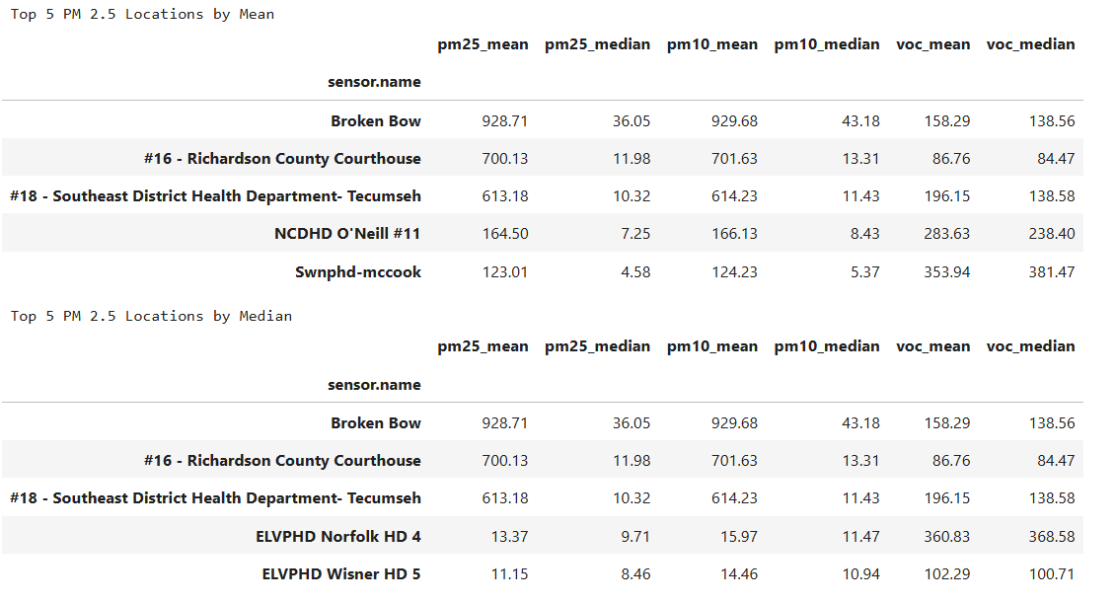
Figure 1. Top 5 Nebraska locations based on mean and median PM 2.5 concentrations

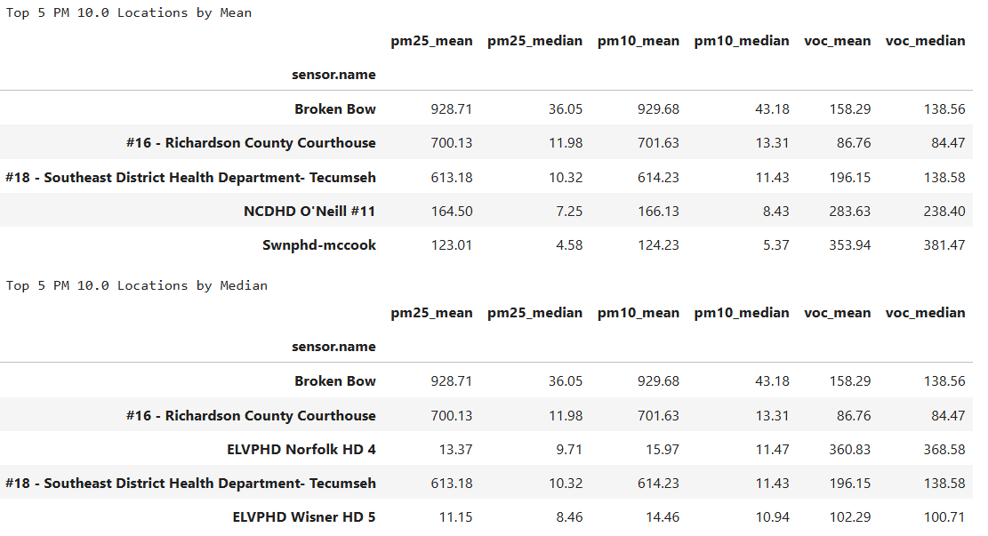
Figure 2. Top 5 Nebraska locations based on mean and median PM 10.0 concentrations

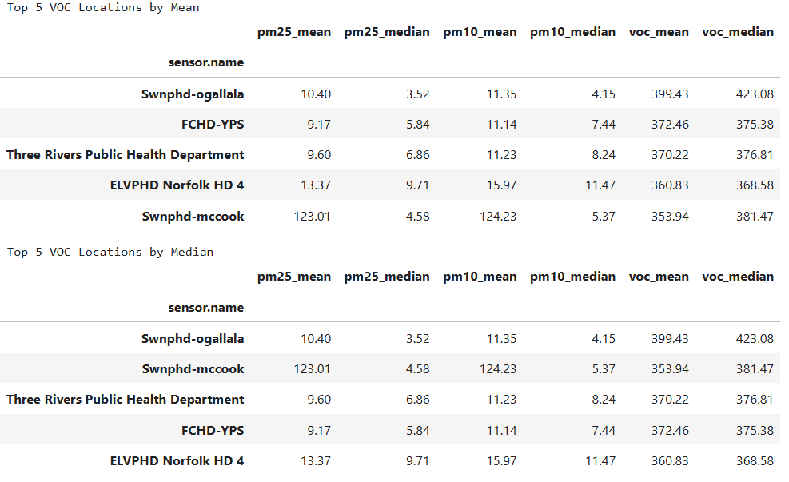
Figure 3. Top 5 Nebraska locations based on mean and median VOC concentrations

Second, the maximum values of each pollutant and the corresponding date and location were determined. In Table 1, each result is shown. Both PM 2.5 and PM 10.0 had maximums on the same day and location, February 18, 2025, in Richardson County, Nebraska.

The maximum PM 2.5 and PM 10.0 concentrations on February 18, 2025, can be attributed to wildfires or controlled burns. It is highly likely that smoke travelled from a neighboring state caused this spike in both PM 2.5 and PM 10.0 since it occurred during the winter months (Nebraska).

Unlike PM 2.5 and PM 10.0, VOC spikes are usually caused by a localized event rather than something widespread like smoke or dust. Volatile Organic Compounds (VOCs) can be produced by vehicle exhaust and agricultural chemicals. According to AirNow, VOCs sharply rise when temperatures are high, sunlight is intense, and air is stagnant. This described standard summer conditions in Nebraska and is likely the reason for the VOC spike (Lester 2023).

Table 1. Maximum pollutant levels
 | Date | Concentration | Latitude | Longitude | Sensor Name
PM 2.5 | 2/18/25 | 3782.82 | 40.0622 | -95.6024 | #16 – Richardson County Courthouse
PM 10.0 | 2/18/25 | 3784.68 | 40.0622 | -95.6024 | #16 – Richardson County Courthouse
VOC | 6/24/24 | 1209.93 | 41.1283 | -101.7202 | Swnphd-Ogallala

The next client request initiated analysis on temperature and humidity and how they affect air quality. Based on Figure 4, it can be seen that as temperature lowers, the concentration of PM 2.5 and PM 10.0 increase. However, temperature does not seem to have much impact on the concentration of VOC. Using Figure 5 for reference, it is clear that as humidity increases, PM 2.5 and PM 10.0 concentrations also increase. For VOC, the concentrations are higher with low humidities. Overall, it can be concluded that temperature and humidity do play roles in air quality, depending on their levels and which pollutants are being considered.

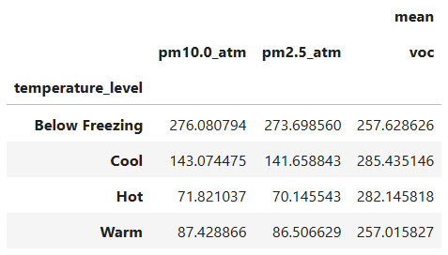
Figure 4. Temperature and Air Quality

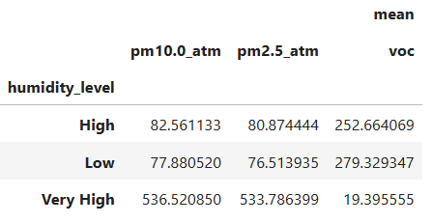
Figure 5. Humidity and Air Quality

The EPA has Air Quality Index (AQI) ratings to set a level on unhealthy versus healthy air quality. These ratings are in place to keep people safe. The categories range from good to hazardous, with unhealthy for sensitive groups falling in the middle. According to the EPA’s AQI, a range of 35.5-55.4 micrograms per meter cubed of PM 2.5, and a range of 155-254 micrograms per meter cubed of PM 10.0 is considered unhealthy for sensitive groups (U.S. 2018). There are multiple instances where the air quality was considered unhealthy for sensitive groups in the dataset. There were 118 occurrences for PM 2.5 and three for PM 10.0. For purposes of this document, only 3 of each will be shown and only one discussed. Figures 6 and 7 below highlight these values. The highest PM 2.5 and PM 10.0 concentrations that fell in the unhealthy for sensitive groups range, occurred on January 9, 2025, and June 14, 2024.

The high PM 2.5 concentrations on January 9, 2025, can likely be attributed to wildfires in surrounding states. Although there was no report of a wildfire in Nebraska around that time, there were wildfires in Kansas and Oklahoma. Smoke is associated with an increase in PM 2.5 levels especially in the winter months when the weather conditions trap pollutants near the surface. According to Nebraska’s Department of Water, Energy, and Environment, smoke is a leading contributor to spikes in PM 2.5 (Nebraska).

The PM 10.0 exceedance on June 14, 2024, aligns with typical early-summer Nebraska. The reasoning behind the spike in pollutant is due to an increased amount of dust driven by dry soils, agricultural activity, and wind. Dust can create unhealthy air quality for sensitive groups (National).

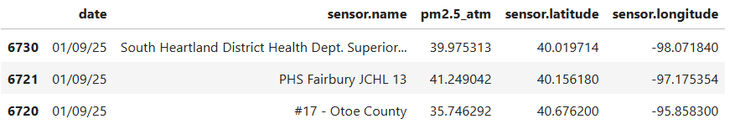
Figure 6. Unhealthy Air Quality by PM 2.5

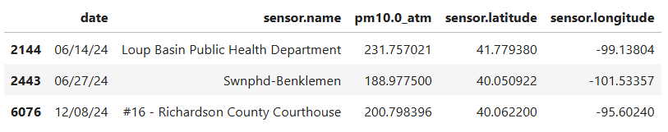
Figure 7. Unhealthy Air Quality by PM 10.0

Lastly, utilizing the air data given by the client, a determination was made about altitude and its impacts on air quality. From the Python analysis, the data in Figure 8 was found. Based on this, altitude of the sensor does not play a role in air quality since the data has no trend with altitude.
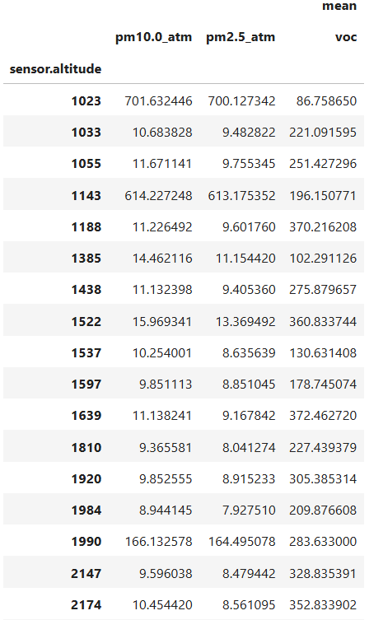
Figure 8. Air quality and altitude

In conclusion, the Python analysis effectively answered the client’s requests and supported project goals.

Project Deliverables
Summarized in the table below are the deliverables and their corresponding due dates.
Table 2. Final Deliverables
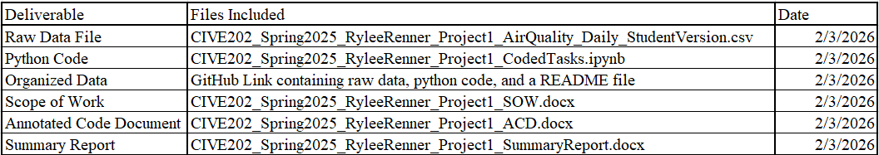

Reference List
Lester, D. (2023, November 17). What are volatile organic compounds and how do they affect
your air quality? AirNow. https://www.airnow.gov/indoor/what-are-volatile-organic
compounds/

National Weather Service. (n.d.). Nebraska state air quality alerts. U.S. Department of
Commerce. https://www.weather.gov/gid/NebraskaStateAirQualityAlerts

Nebraska Department of Water, Energy, and Environment. (n.d.). Wildfires and impacts in
Nebraska. https://dee.nebraska.gov/wildfires-and-impacts-nebraska

U.S. Environmental Protection Agency. (2018). Technical assistance document for the reporting
of daily air quality: The Air Quality Index (AQI) (EPA 454/B-18-007). Office of Air Quality
Planning and Standards, Air Quality Assessment Division.

