Note – I tested multiple times, and the context was retrieved only from one file. Post multiple ingestions, I realized that the other file was a scanned PDF :D
==================================================================
You: how can companies ensure that their overtime policy is as per teh ghuidelines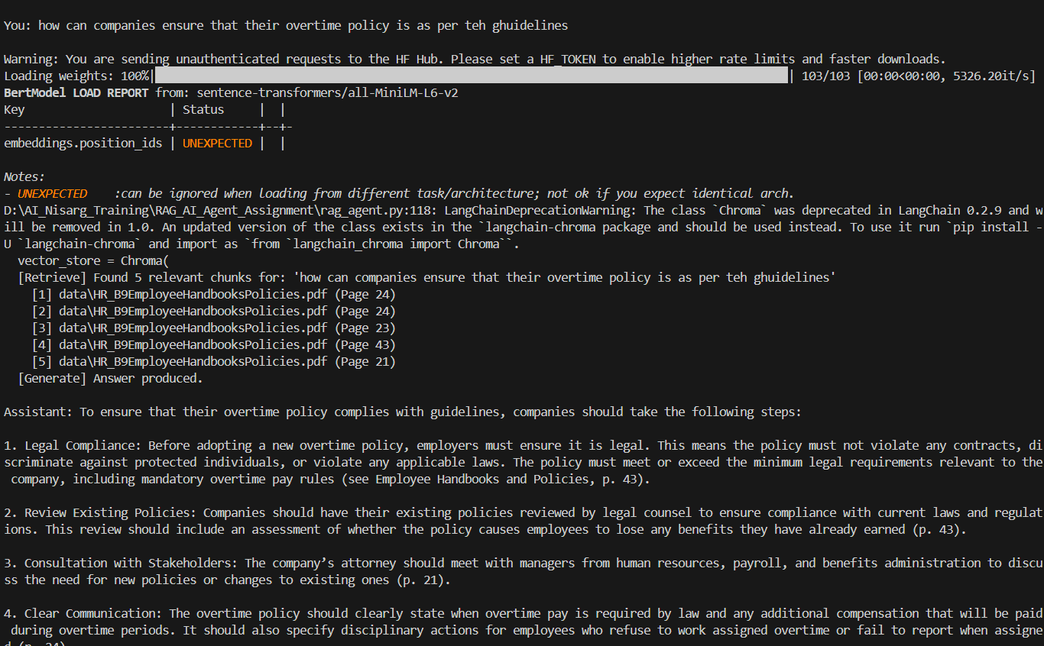

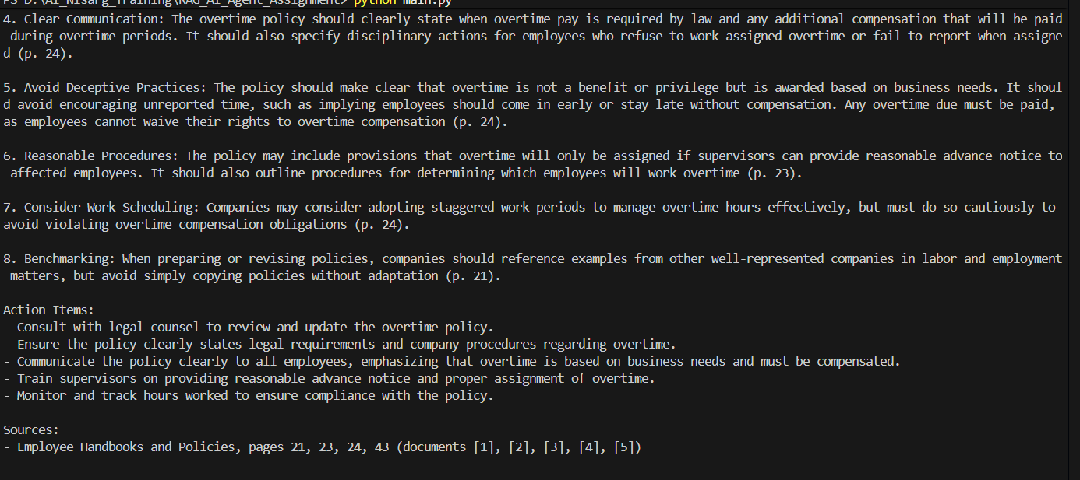

Is there any policy related to Drug free workplace??

