Does Anonymity Inflate the Subject?
A Comparative LLM-Based Analysis of Political and 4chan Discourse
Nazuki Takahashi
Abstract
This study analyzes subject size in online posts using the Mistral-Nemo-12B-Instruct-2407-Q6_K LLM and compares subject sizes between posts written by identified politicians and anonymous 4chan users. The study investigates whether anonymous users employ larger subjects, as criticized by Schopenhauer. The statistical results show a statistically significant difference between the two groups (politicians: 2.10, 4chan: 2.18). However, the effect size is small, suggesting that anonymity does not strongly affect subject size in online communication.
Keywords: online anonymity, subject abstraction, large language model, 4chan, political communication

Introduction
“A particularly ludicrous impertinence of such anonymous critics is that they, like kings, speak in the first-person plural ‘we’; whereas they should speak not in the plural we but, at most, in the singular.” (Schopenhauer, 1851)
Arthur Schopenhauer criticizes anonymous writers for their use of the first-person plural “we,” arguing that such usage falsely projects authority and collective legitimacy. According to him, anonymous authors tend to use the first-person plural rather than the first-person singular, contrary to the appropriate use of the singular form.
Relatedly, numerous studies suggest anonymity increases toxicity and behavioral disinhibition under anonymous conditions. Suler (2004) shows that people self-disclose or act out more frequently or intensely than they would in person. Nitschinsk et al. (2023) show that one motivation for being online is to seek anonymity in order to self-express or behave toxically.

Methods

Data
To score subject sizes, I used the dataset Social Media Posts from US Politicians (Damarla, 2020), consisting of approximately 5000 posts. For 4chan posts, I collected approximately 5000 posts from the /pol/ subforum.
Since 4chan data contains raw HTML and platform-specific syntax (e.g., greentext or post citations), I wrote a Python script to clean and normalize the text. This script removed HTML tags, converted character entities, and stripped post-ID references to ensure data consistency. The source code for this collection and cleaning process is available in the references.
The scripts used for data collection and preprocessing are publicly available at:
https://github.com/rrepo/subject-ai

Subject Scale
To compare subject sizes, I defined four stages of subject abstraction:
- Singular – an individual, clearly identifiable entity in context (e.g., I, you, he, she, a named person).
- Plural – a clear collection of individuals (e.g., we, they, teachers).
- Collective – an organizational or institutional entity treated as a single subject (e.g., government, company, university).
- Concept – highly generalized or conceptual entities (e.g., society, humanity, the nation).
As the stages progress, the level of abstraction increases.

LLM Analysis
To scale subject size automatically, I used the Mistral-Nemo-12B-Instruct-2407-Q6_K large language model. The model was executed locally using llama.cpp and was selected for its balance between performance and computational efficiency in structured text analysis.
A zero-shot prompt was used to isolate the “size” of the subject independently from emotional tone or sentiment.
- n_predict: 400
- temperature: 0.4
- top_k: 40
- top_p: 0.95
- repeat_penalty: 1.18

Statistical Tests
To compare subject sizes between politicians and 4chan users, Welch’s t-test was conducted, which is robust to unequal variances. Additionally, a Kolmogorov–Smirnov (KS) test was used to evaluate whether the distributions differ significantly.
Cohen’s $d$ was calculated to measure effect size. The significance level for all tests was set to $α=0.05$.
All scripts used for the analysis, including data cleaning, LLM inference, and statistical analysis, are publicly available in the GitHub repository listed in the references to ensure reproducibility.

Results
The analysis revealed distinct characteristics in the subject size distributions.
Posts by US politicians had a mean subject size of 2.10 ($SD=1.01$), with a median of 1.7. In contrast, 4chan /pol/ posts had a slightly higher mean of 2.18 ($SD=0.99$) and a median of 2.0.
Subject size statistics for the two datasets
Dataset | N | Mean | Median | Std. Dev | Min | Max
US Politicians | 4733 | 2.10 | 1.7 | 1.01 | 1.0 | 4.5
4chan /pol/ | 4960 | 2.18 | 2.0 | 0.99 | 1.0 | 4.5
To visualize the distributions, we compared subject sizes using boxplots, kernel density estimation (KDE), and cumulative distribution functions (CDF).
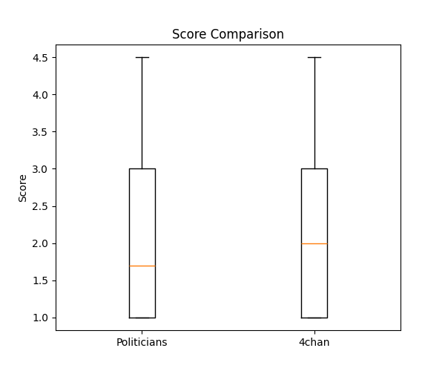
Boxplot comparison of subject size between posts by US politicians and 4chan /pol/ users.
The boxplot (Figure 1) shows that both datasets exhibit a similar spread, although the distribution for 4chan posts is slightly shifted toward higher subject abstraction levels.
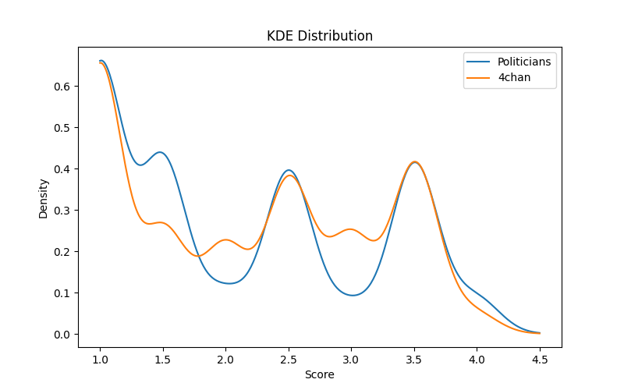
Kernel density estimation (KDE) of subject size distributions for the two datasets.
The KDE plot (Figure 2) further illustrates that the distributions roughly overlap. Although the peak of the 4chan distribution is slightly higher, both groups share a large portion of their density across similar ranges of subject abstraction.
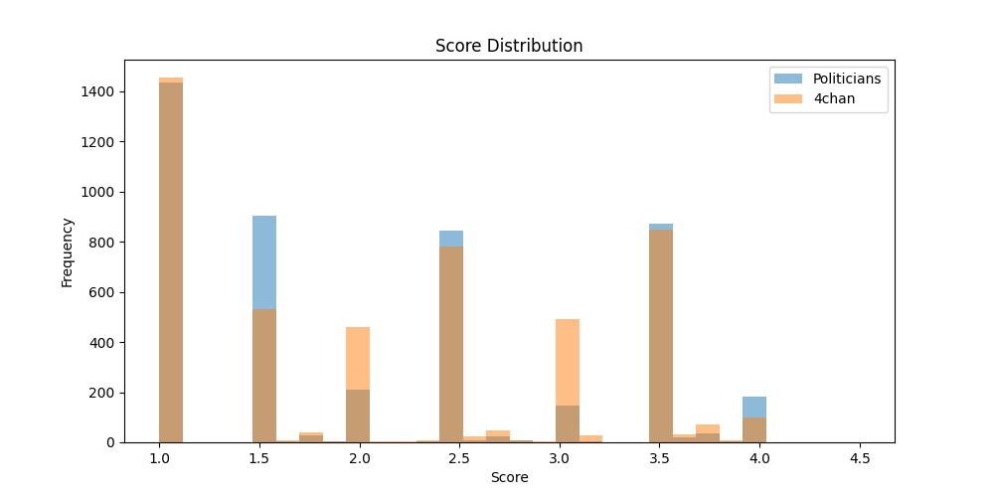
Histogram of subject size distributions for posts by US politicians and 4chan /pol/ users.
The histogram (Figure 3) provides a direct view of the raw distribution of subject size values. Both datasets show a concentration of observations in the lower to middle range of the scale, particularly between values near 1 and 3. While the overall shapes of the distributions are similar, the 4chan data exhibits a slightly greater frequency of higher subject size values, which is consistent with the small shift observed in the boxplot and KDE analyses.
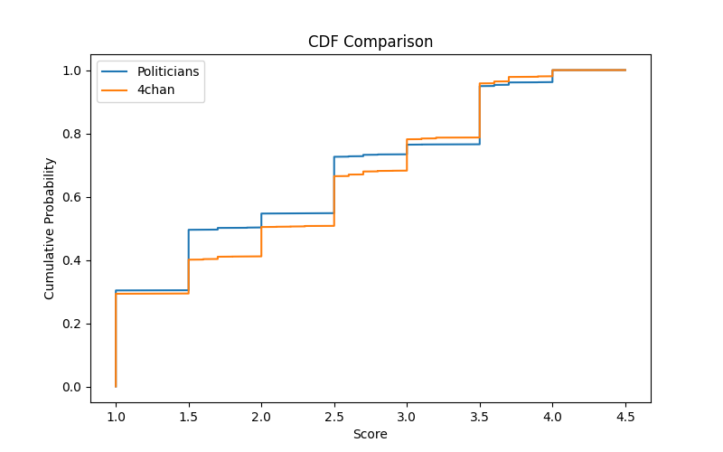
Cumulative distribution function (CDF) comparison of subject size distributions.
The cumulative distribution functions (Figure 4) highlight subtle differences. These differences correspond to the result of the Kolmogorov–Smirnov test.
A Welch’s t-test indicated a statistically significant difference between the groups ($t=−4.04$, $p<0.001$). However, the effect size was small (Cohen’s $d=−0.082$).
The Kolmogorov–Smirnov test also showed that the distributions differ significantly ($D=0.094$, $p<0.001$).

Discussion
The analysis reveals that posts on 4chan /pol/ exhibit a slightly higher mean subject size (2.18) compared to those of US politicians (2.10). Although the difference is statistically significant, the small effect size suggests that anonymity does not dramatically inflate subject abstraction as Schopenhauer’s critique might imply.
Anonymous users frequently discuss broad social categories such as “they” or “the people,” which may slightly increase abstraction levels. This pattern is consistent with the online disinhibition effect (Suler, 2004), where anonymity encourages individuals to speak more freely about collective entities.
However, politicians also frequently employ collective subjects (e.g., “our government,” “our nation”), which reduces the difference between the two groups. The high overlap between distributions suggests that online discourse itself encourages collective framing regardless of anonymity.

Limitations and Future Research
Several factors may influence these results:
- Platform differences between 4chan and Twitter
- Topic differences between political communication and imageboard discussion
- Limitations of the subject scale definition
Future research should separate grammatical person (e.g., “we”) from conceptual abstraction (e.g., “the nation”). Expanding the dataset to other platforms such as Reddit or parliamentary speech corpora would provide broader insight into how digital communication shapes subject abstraction.

Conclusion
This study examined subject usage in online discourse by comparing subject abstraction in posts from US politicians and anonymous 4chan users.
Although 4chan posts showed a slightly higher average subject size, the effect size was small. This suggests that anonymity alone does not substantially change how people frame the subject of their statements.
Instead, both identified and anonymous speakers appear to rely on similar ranges of subject abstraction when communicating in online environments.
9
Damarla, R. (2020). Social Media Posts from US Politicians. Kaggle dataset.
Nitschinsk, J., et al. (2023). Online anonymity and behavioral expression. Procedia Computer Science. https://www.sciencedirect.com/science/article/pii/S1877050925030935
Schopenhauer, A. (1851). Parerga and Paralipomena.
Suler, J. (2004). The online disinhibition effect. CyberPsychology & Behavior, 7(3), 321–326.
Takahashi, N. (2026). Subject abstraction analysis code and data collection scripts. GitHub repository. https://github.com/rrepo/subject-ai

LLM Prompt Used for Subject Size Evaluation
The following prompt was used to instruct the LLM to evaluate the subject abstraction level of each sentence.
Please rate the "subject size" of the post using the following criteria.
Only return a float number (e.g. 1.0, 2.3, 3.1). The number must include
a decimal. Output as a continuous value between 1.0 and 4.0.
Scale definition:
1.0 Singular
An individual, clearly identifiable entity in the context
Examples: I, you, he, she, Sato-san
2.0 Plural
A clear collection of multiple individuals
Examples: we, you, them, teachers
3.0 Collective
An organizational or institutional entity treated as a single subject
Examples: company, government, association, university, nation
4.0 Concept
Highly abstract conceptual entities
Examples: society, culture, gender, race, the universe, the future
Pay attention only to the size of the subject.
Do not consider the emotional tone or content of the sentence.
Rate the subject size of this sentence:
{input}
Examples:
"We Japanese work too much" → 2.8
"Internet people are really dangerous" → 3.1
"Democracy is collapsing" → 4.0

