ACP10_MC
Beispiele
To change the title and topic, use the File/Properties menu – Do NOT enter directly!
Date: | 9. Juni 2010

- Version information
 | Version | Date | Comment | Author
 | 00 | 16.04.2009 | First edition | Reischl Josef
 | 01 | 27.05.2009 | Detailed description removed | Reischl Josef
 | 02 | 28.05.2009 | Detailed description added | Reischl Josef
 | 02 | 14.12.2009 | Changes to the packages added to the description | Reischl Josef
 | 02 | 14.12.2009 | Descriptions added for LibACP10MC_RegMark_xx and LibACP10MC_Trace_xx | Reischl Josef
 | 03 | 25.02.2010 | Flowcharts changed as recommended by GPI | Reischl Josef
 | 04 | 09.06.2010 | Changes after discussion with Robert Schlager and Joachim Unfried | Reischl Josef
Table 1: Versions

- Table of contents
TOC

Examples
The following samples are available for Motion Control applications.

To complete the examples at least one axis must be added using the Motion Wizard.

Subject | Description | Sample program | Library
Single-axis functions | Example for commissioning one axis.  Shows how to use defined commands to turn on the controller, reference the axis and start/stop various movements. | LibACP10MC_SingleAx_ST,  LibACP10MC_SingleAx_C,  LibACP10MC_SingleAx_LD | ACP10_MC
Simple links | Example for starting a simple gear link between two axes.  It shows how to use defined commands to link two axes with a variable gear ratio. | LibACP10MC_Gear_ST,  LibACP10MC_Gear_C,  LibACP10MC_Gear_LD | ACP10_MC
Cam profiles | Example for transferring a cam profile and using it to start a link between two axes.  It shows how to use defined commands to transfer a cam profile to the drive and then start a link between two axes using the predefined cam profile. | LibACP10MC_Cam_ST,  LibACP10MC_Cam_C,  LibACP10MC_Cam_LD | ACP10_MC
Automats | Example for transferring, starting and stopping a cam profile automat.  Shows how to use defined commands to initialize a cam profile automat, start it and end it. | LibACP10MC_Automat_ST,  LibACP10MC_Automat_C,  LibACP10MC_Automat_LD | ACP10_MC
Registration mark control | Example of registration mark correction.  Shows how to use defined commands to perform registration mark correction on a slave axis linked to a master axis. | LibACP10MC_RegMark_ST,  LibACP10MC_RegMark_C,  LibACP10MC_RegMark_LD | ACP10_MC  MC_RegMa
Trace | Example of controlling and saving parameter and network command traces.  Shows how to configure, start, stop and save a parameter trace. Also shows how to turn on, turn off, delete and save a network command trace. | LibACP10MC_Trace_ST,  LibACP10MC_Trace_C,  LibACP10MC_Trace_LD | ACP10_MC

Detailed description of the packages

LibACP10MC_SingleAx_xx
Single-axis functions
Various basic functions for drive control are structured here in a complete sequence. This task also contains a routine for handling potential error situations.

Information:
When using this example, an error text module named "acp10etxen" (Motion Wizard) must be found in the project.

By default, the name "gAxis01" is used for the axis in the package (Motion Wizard). To use an axis with a different name, this name can be assigned in the init SP.

Requirements
Target system: SG4
ACOPOS and ACOPOSmulti
Program name
Basic
Program description
A predefined command structure (BasicControl.Command) can be used to execute the following functions with the Watch window.
- Turn on the controller (BasicControl.Command.Power)
- Reference the axis (BasicControl.Command.Home)
- Execute a movement in the positive direction as long as the command variable is set (BasicControl.Command.MoveJogPos)
- Execute a movement in the negative direction as long as the command variable is set (BasicControl.Command.MoveJogNeg)
- Start a movement with a defined end position (BasicControl.Command.MoveAbsolute)
- Start a movement with a defined path (BasicControl.Command.MoveAdditive)
- Start a movement with a defined speed (BasicControl.Command.MoveVelocity)
- Stop an active movement (BasicControl.Command.Halt)
- Stop an active movement and prevent a new movement from starting (BasicControl.Command.Stop)
- Acknowledge an axis error (BasicControl.Command.ErrorAcknowledge)

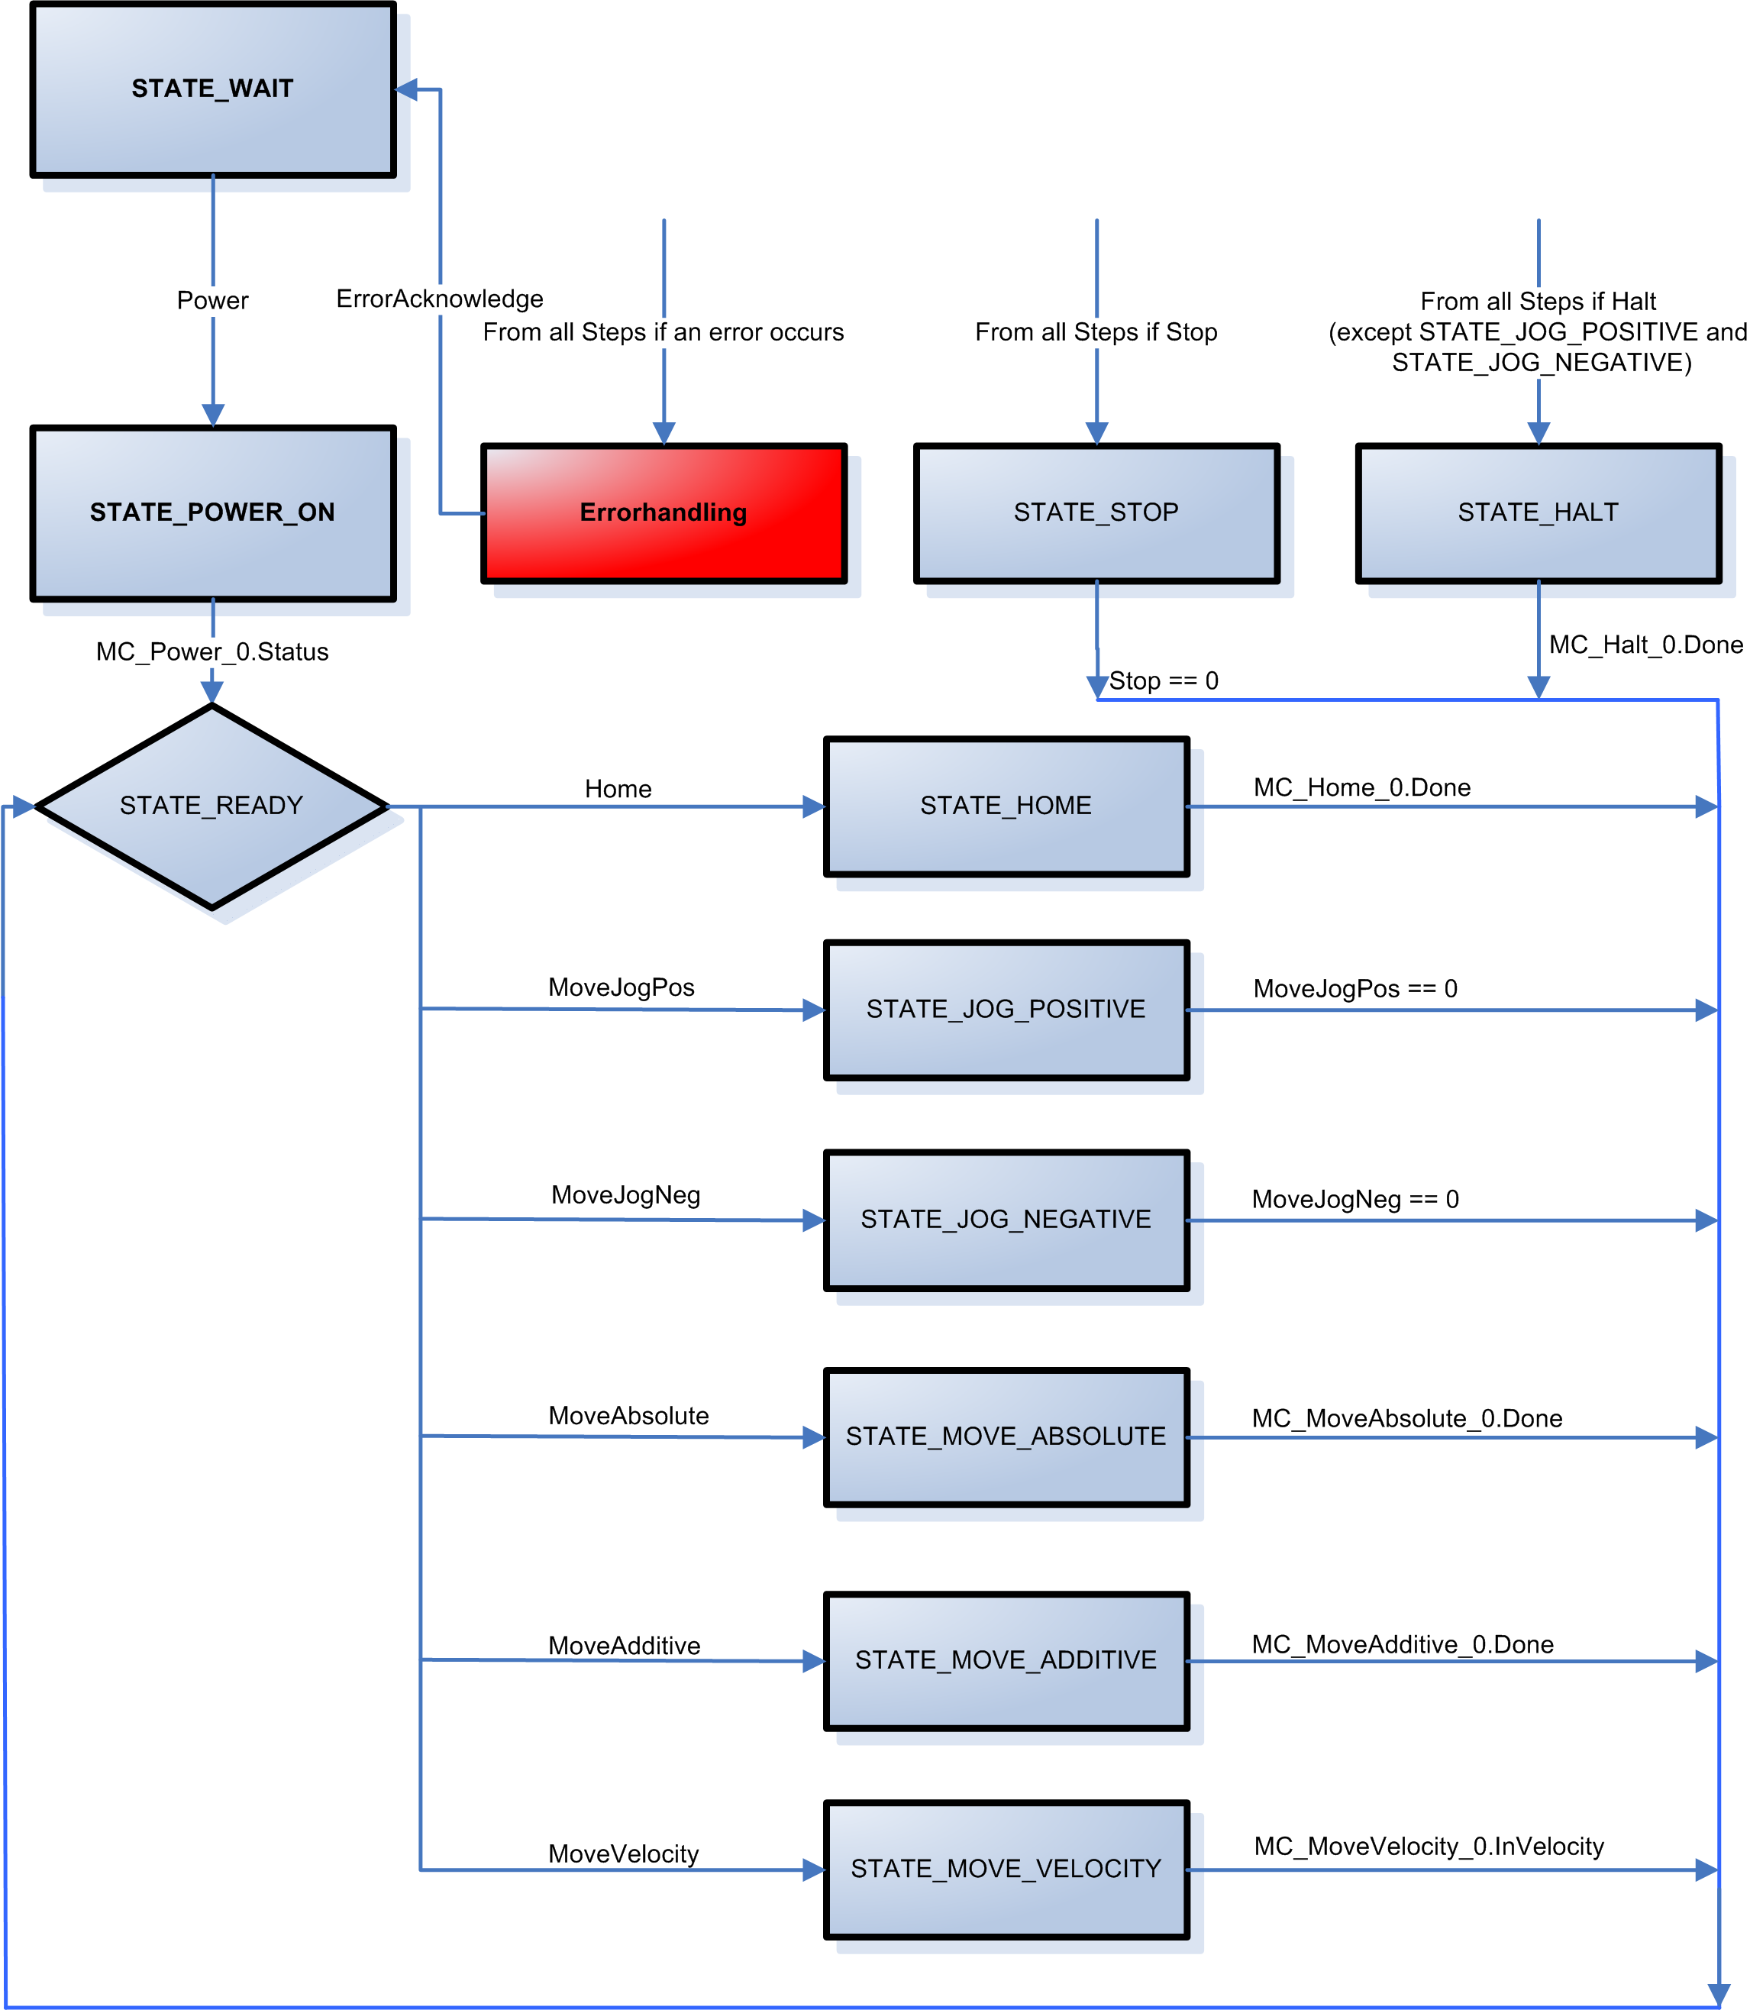

LibACP10MC_Gear_xx
Simple link of two axes
Example for starting a simple gear link between two axes. It shows how to use defined commands to link two axes with a variable gear ratio.

Function blocks from the ACP10_MC are used to link one axis (slave axis) to a corresponding link signal (master axis) via an electronic gear link. This example also contains basic functions for drive control.

In order to start a link with this example, the master axis must be prepared (turn on controller, reference). These functions can be performed using the example for single axis functions.

Information:
When using this example, an error text module named "acp10etxen" (Motion Wizard) must be found in the project.

By default, the name "gAxis01" is used for the master axis and "gAxis02" for the slave axis in the package (Motion Wizard). To use an axis with a different name, this name can be assigned in the init SP.

Requirements
Target system: SG4
ACOPOS and ACOPOSmulti
Program name
Gear

Program description

A predefined command structure (GearControl.Command) can be used to execute the following functions with the Watch window.
- Switch on the slave axis controller (GearControl.Command.Power)
- Reference the slave axis (GearControl.Command.Home)
- Start a simple electronic gear link between master axis and slave axis (GearControl.Command.StartSlave)
- End the link between master and slave axis (GearControl.Command.DisengageSlave)
- Execute a movement in the positive direction on the slave axis as long as the command variable is set (GearControl.Command.MoveJogPos)
- Execute a movement in the negative direction on the slave axis as long as the command variable is set (GearControl.Command.MoveJogNeg)
- Start a movement with a defined end position on the slave axis (GearControl.Command.MoveAbsolute)
- Start a movement with a defined path on the slave axis (GearControl.Command.MoveAdditive)
- Start a movement with a defined speed on the slave axis (GearControl.Command.MoveVelocity)
- Stop an active movement (GearControl.Command.Halt)
- Stop an active movement and prevent a new movement from starting (GearControl.Command.Stop)
- Acknowledge an axis error (GearControl.Command.ErrorAcknowledge)

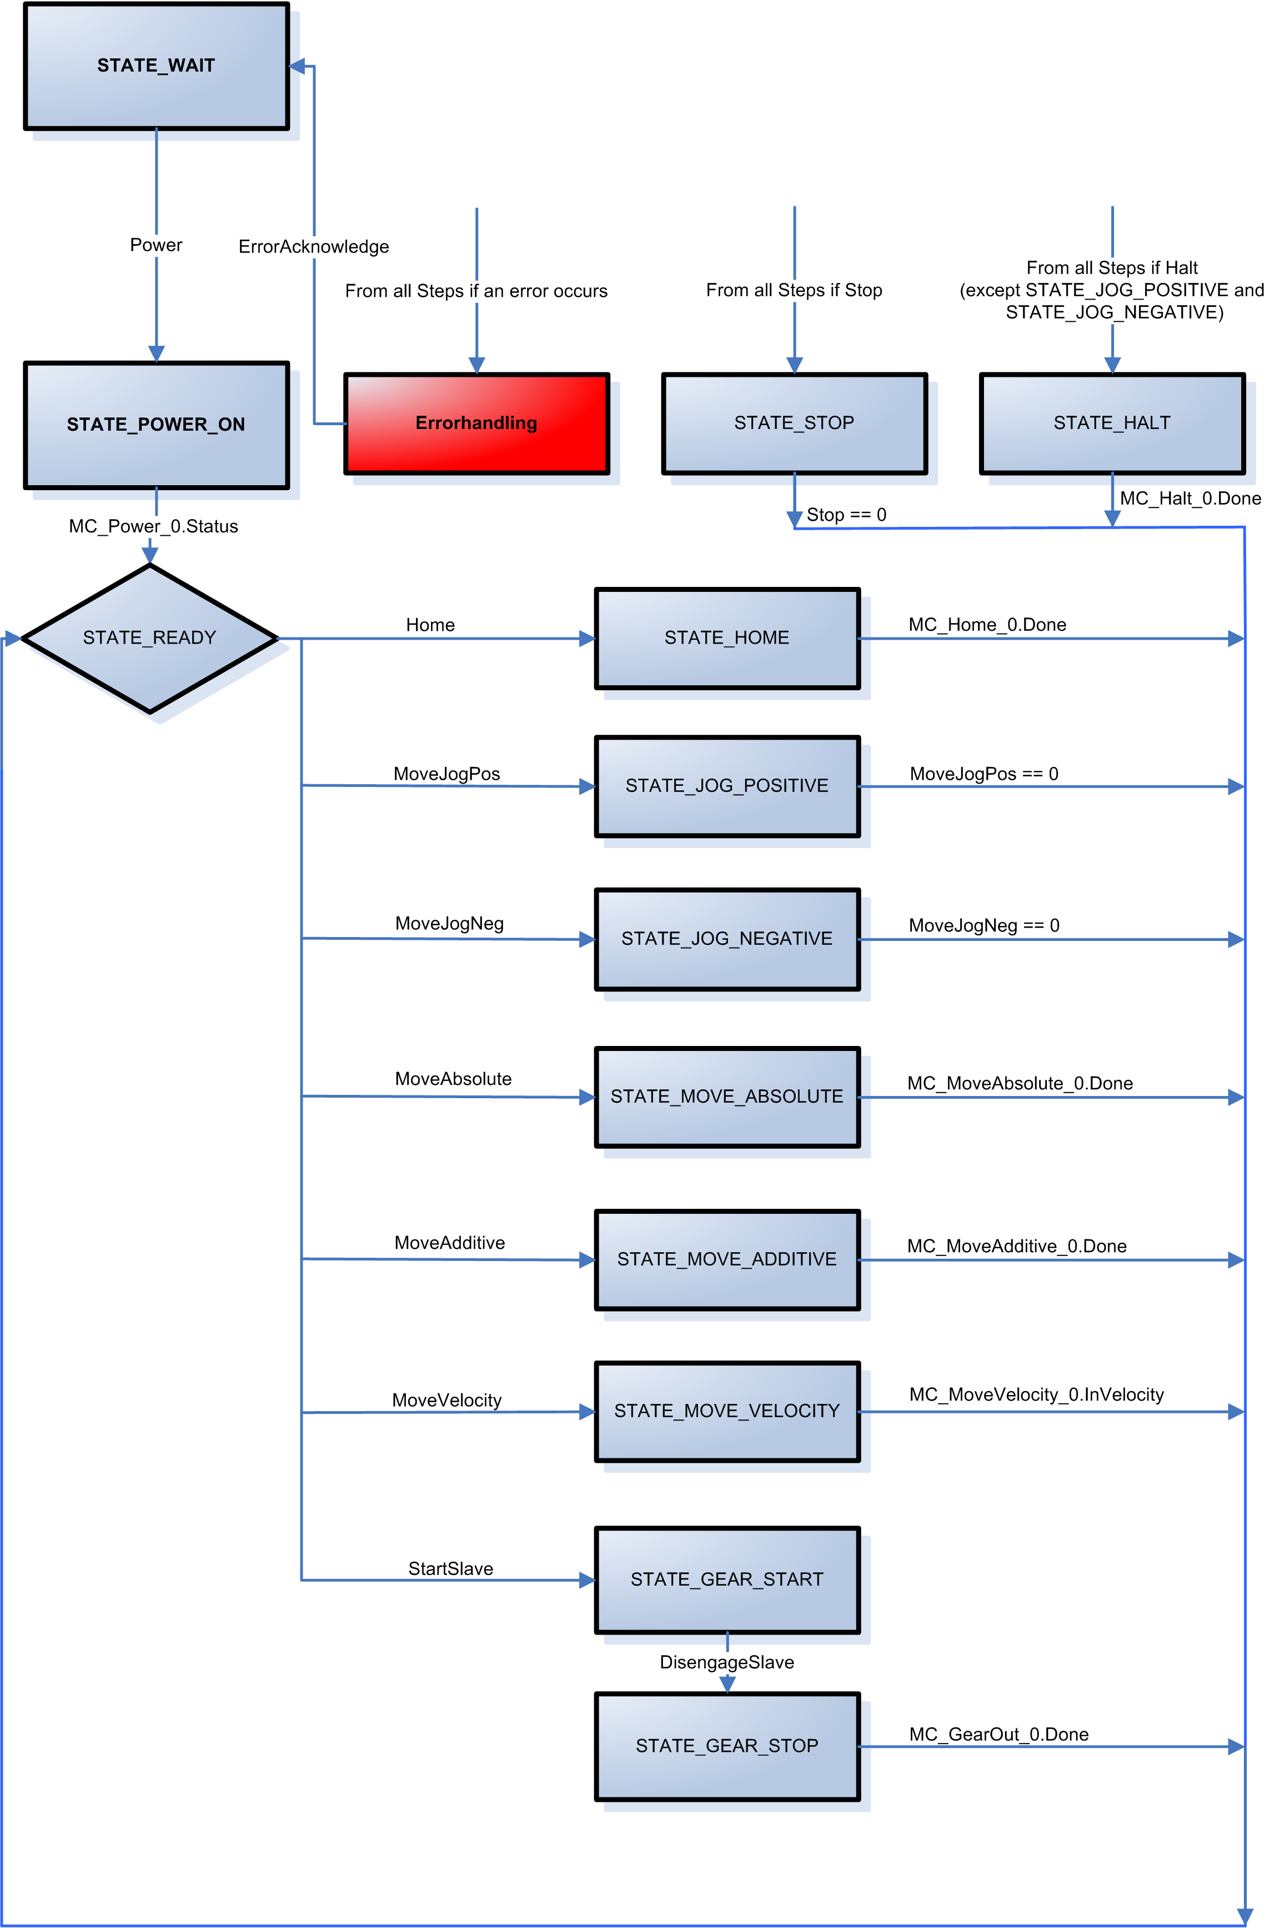

LibACP10MC_Cam_xx
Cam profiles
Example for transferring a cam profile and using it to start a link between two axes.

It shows how to use defined commands to transfer a cam profile to the drive and then start a link between two axes using the predefined cam profile.

Function blocks from the ACP10_MC library are used to link one axis to a corresponding link signal via cam profile. This example also contains basic functions for drive control.

In order to start a link with this example, the master axis must be prepared (turn on controller, reference). These functions can be performed using the example for single axis functions.

Information:
When using this example, an error text module named "acp10etxen" (Motion Wizard) must be found in the project.

By default, the name "gAxis01" is used for the master axis and "gAxis02" for the slave axis in the package (Motion Wizard). To use an axis with a different name, this name can be assigned in the init SP.

Requirements
Target system: SG4
ACOPOS and ACOPOSmulti
Program name
Cam

Program description
A predefined command structure (CamControl.Command) can be used to execute the following functions with the Watch window.
- Switch on the slave axis controller (CamControl.Command.Power)
- Reference the slave axis (CamControl.Command.Home)
- Select a cam profile from the controller to use for the link. The cam profile "profile" is listed in the package. (CamControl.Command.StartSlave)
- Start a link between the master axis and the slave axis via a cam profile (CamControl.Command.StartSlave)
- End the link between master and slave axis (CamControl.Command.DisengageSlave)
- Execute a movement in the positive direction on the slave axis as long as the command variable is set (CamControl.Command.MoveJogPos)
- Execute a movement in the negative direction on the slave axis as long as the command variable is set (CamControl.Command.MoveJogNeg)
- Start a movement with a defined end position on the slave axis (CamControl.Command.MoveAbsolute)
- Start a movement with a defined path on the slave axis (CamControl.Command.MoveAdditive)
- Start a movement with a defined speed on the slave axis (CamControl.Command.MoveVelocity)
- Stop an active movement (CamControl.Command.Halt)
- Stop an active movement and prevent a new movement from starting (CamControl.Command.Stop)
- Acknowledge an axis error (CamControl.Command.ErrorAcknowledge)

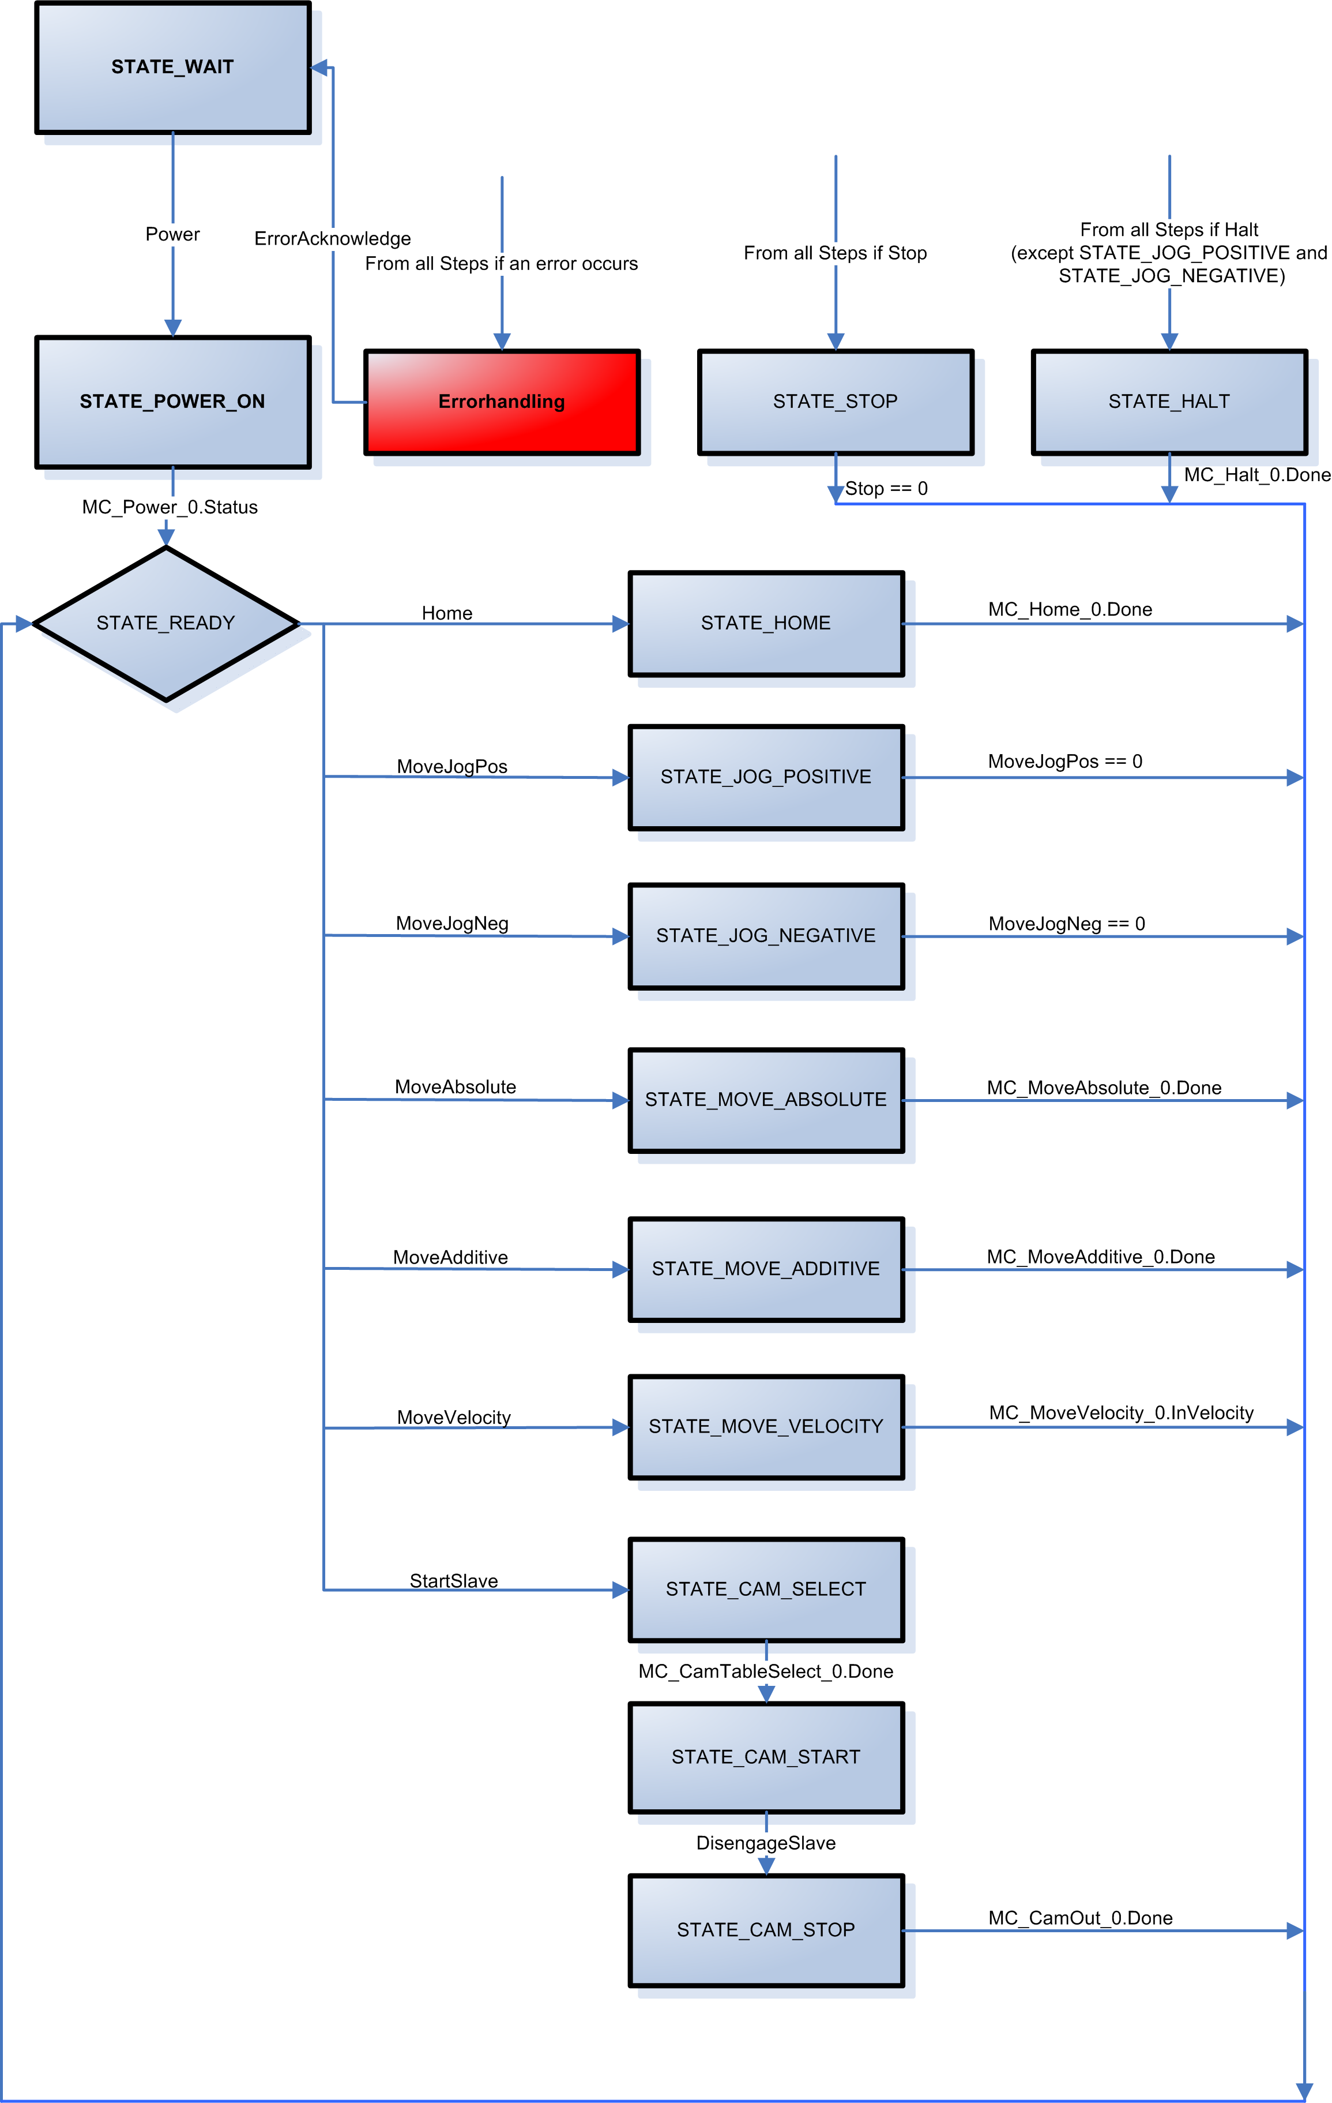

LibACP10MC_Automat_xx
Automats
Example for transferring, starting and stopping a cam profile automat.

Shows how to use defined commands to initialize a cam profile automat, start it and end it.

Function blocks from the ACP10_MC library are used to configure and control the cam profile automat. This example also contains basic functions for drive control.

This example contains three different automat configurations:
- Labeling machine
- Flying saws
- Cutting unit

In Structured Text and Ladder Diagram the automat configurations are implemented in actions. In ANSI C the automat configurations are implemented in functions.

The automat can be selected in the initialization by calling the action or function.

In order to start a link with this example, the master axis must be prepared (turn on controller, reference). These functions can be performed using the example for single axis functions.

Information:
When using this example, an error text module named "acp10etxen" (Motion Wizard) must be found in the project.

By default, the name "gAxis01" is used for the master axis and "gAxis02" for the slave axis in the package (Motion Wizard). To use an axis with a different name, this name can be assigned in the init SP.

Requirements
Target system: SG4
ACOPOS and ACOPOSmulti
Program name
Automat

Program description
A predefined command structure (AutomatControl.Command) can be used to execute the following functions with the Watch window.
- Switch on the slave axis controller (AutomatControl.CommandPower)
- Reference the slave axis (AutomatControl.CommandHome)
- Initialize and start a cam profile automat (AutomatControl.Command.StartSlave)
- Stop the cam profile automat (AutomatControl.Command.StopSlave)
- Execute a movement in the positive direction on the slave axis as long as the command variable is set (AutomatControl.Command.MoveJogPos)
- Execute a movement in the negative direction on the slave axis as long as the command variable is set (AutomatControl.Command.MoveJogNeg)
- Start a movement with a defined end position on the slave axis (AutomatControl.Command.MoveAbsolute)
- Start a movement with a defined path on the slave axis (AutomatControl.Command.MoveAdditive)
- Start a movement with a defined speed on the slave axis (AutomatControl.Command.MoveVelocity)
- Stop an active movement (AutomatControl.Command.Halt)
- Stop an active movement and prevent a new movement from starting (AutomatControl.Command.Stop)
- Acknowledge an axis error (AutomatControl.Command.ErrorAcknowledge)

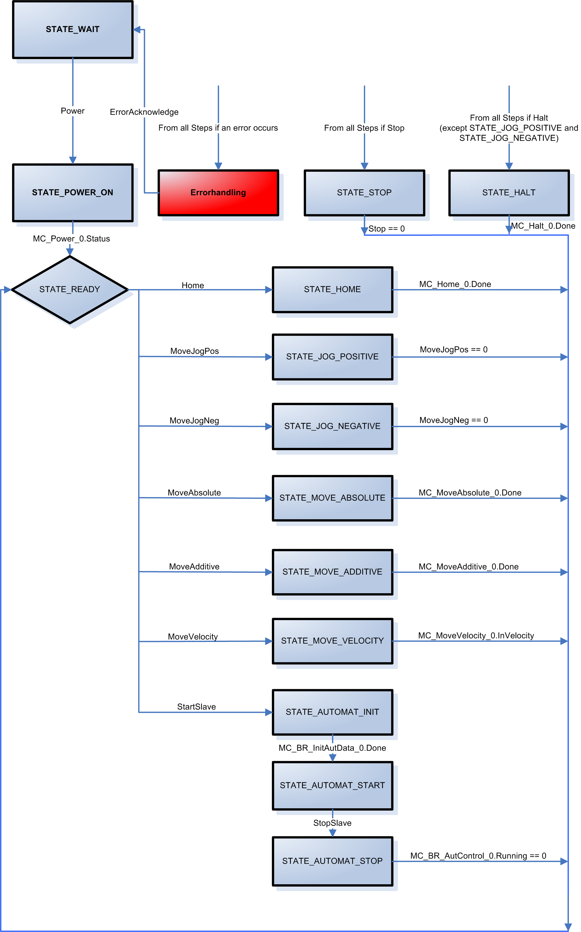
Automat configurations:

The following topics are covered in this section:

Labeling machine:
When a trigger edge arrives, a label should be dispensed.

The feed movement for the label band consists of a compensation movement and a synchronous phase where it is applied to the product. This is triggered by a product sensor.

If a product is missing, a compensation movement is made in the waiting state. Entry in State 2 and exit in State 4 is performed with a half slave interval in each case.

Information:
For this automat configuration, the axis periods must be set like this:
Master axis: 1000
Slave axis: 1000

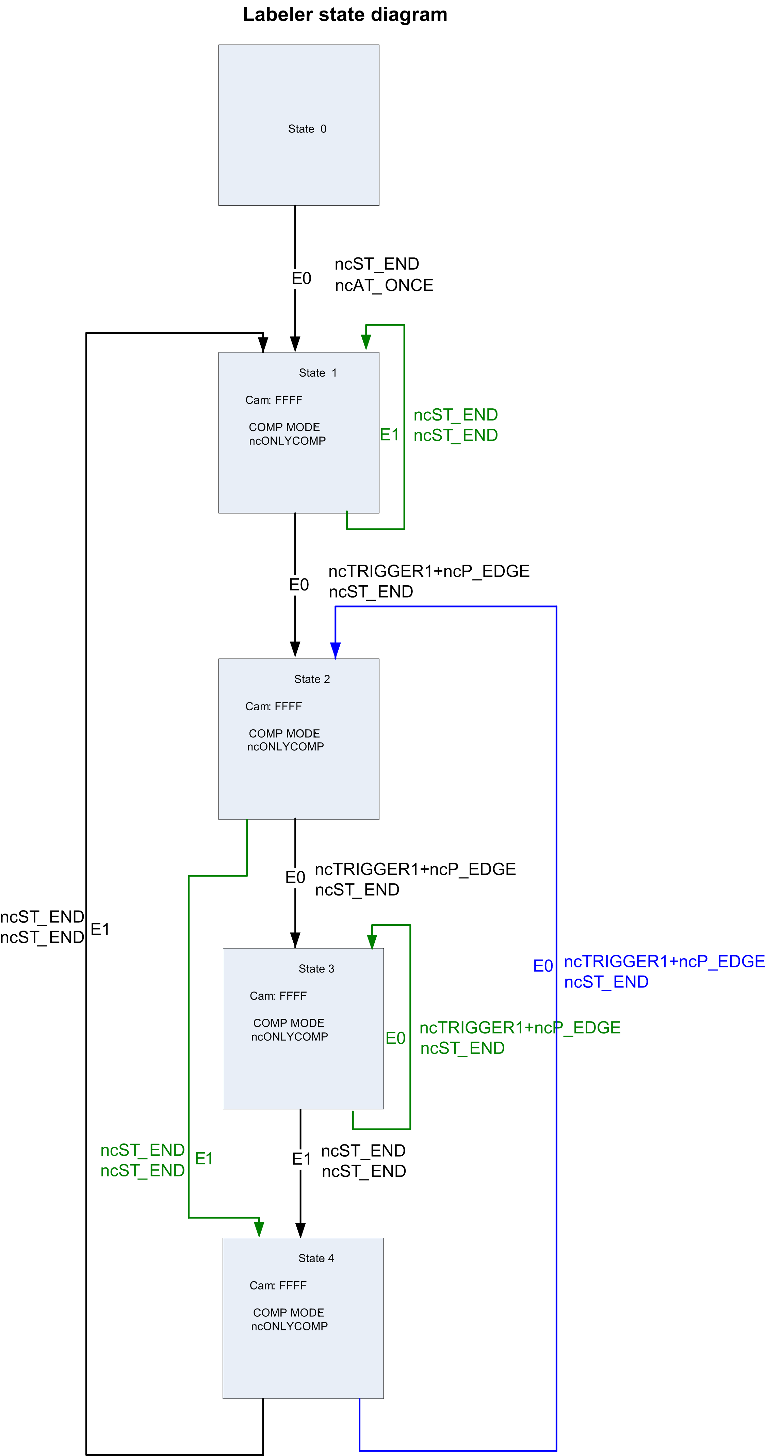
Flying saws:
Once the master axis reaches a certain position, the slave starts an entry movement that allows it to move in synch with the master for a certain path.
Once it reaches the end of this path, the slave returns to its original starting position.

Information:
For this automat configuration, the axis periods must be set like this:
Master axis: 3600
Slave axis: 1000

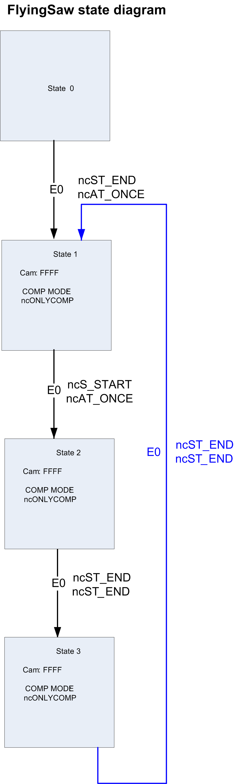

Cross cutters:

When Signal 1 occurs, the slave makes a compensation movement from its resting position to the position from which it will move in synch with the master.

Then one step is executed in each master period. One Signal 2 occurs, the slave follows an exit movement back to its resting position and waits for the next occurrence of Signal 1.

Information:
For this automat configuration, the axis periods must be set like this:
Master axis: 1000
Slave axis: 3600

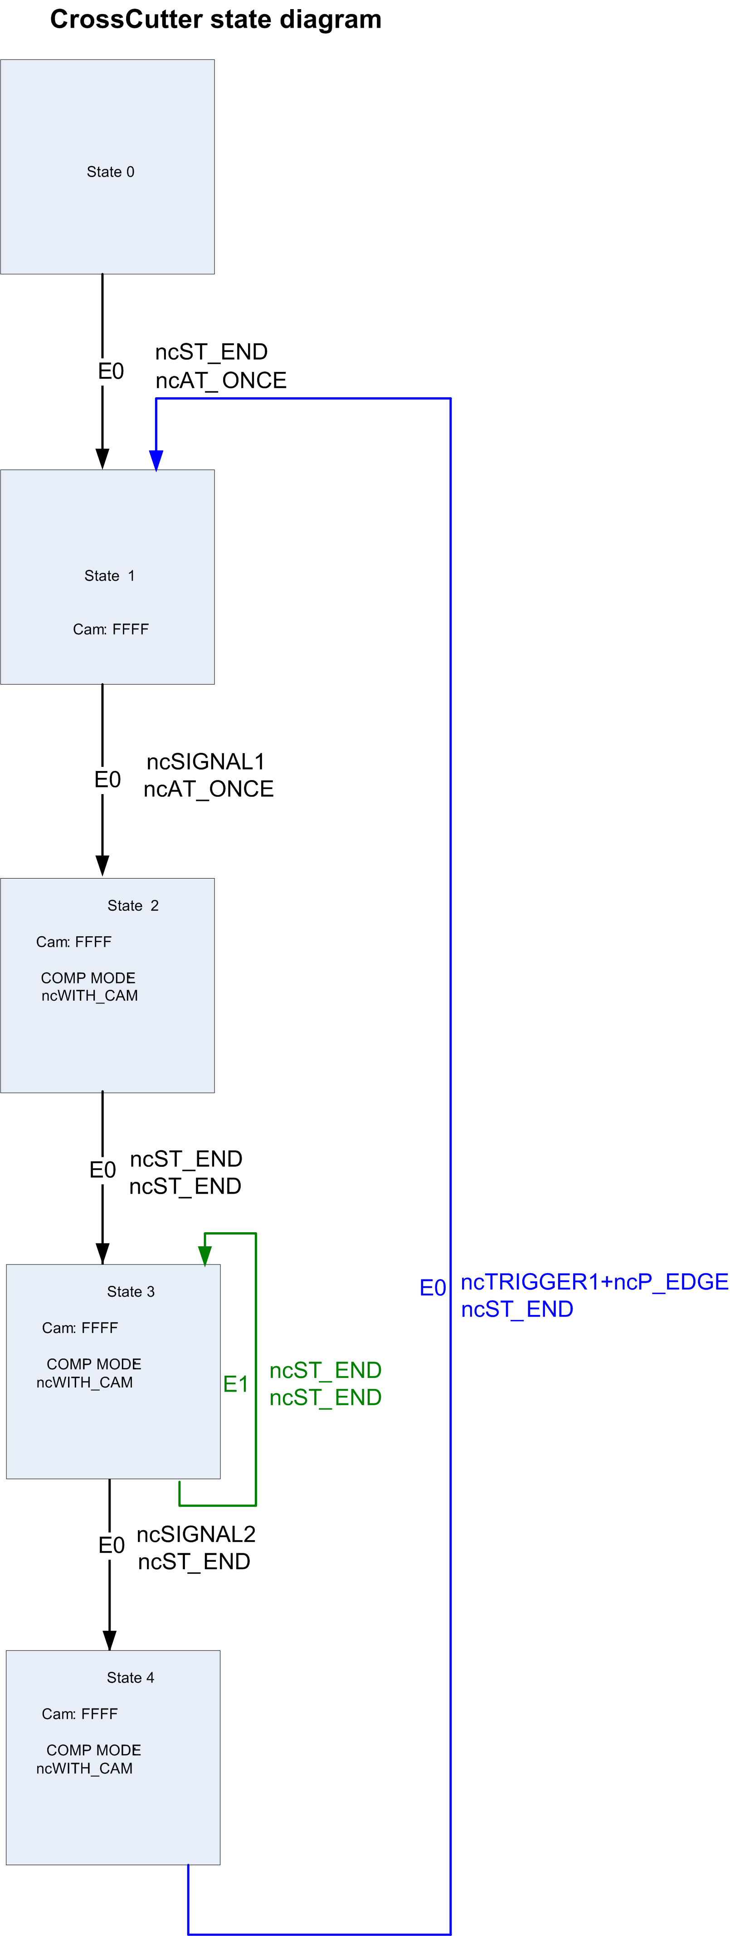

LibACP10MC_RegMark_xx
Registration mark correction
Example of registration mark correction.

Shows how to perform a registration mark correction. The positions of registration marks will be detected, compensation distances calculated and corrections made.

Function blocks from the ACP10_MC library and the add-on library MC_RegMa are used for the registration mark correction.

In order to make a registration mark correction with this example, the drive's master and slave axis must be prepared (turn on controller, reference) and the slave axis must be linked to a master signal. These functions can be performed using the example for Single-axis functions or one of the examples Simple link of two axes, Link between two axis with cam profile or Cam profile automat.

Description of example:
The following hardware structure was used for the example included in Automation Studio.

An ACOPOS directly drives the motor in a conveyor belt, whereby one motor revolution is equal to a conveyor belt movement of 10cm. The goal is for the conveyor belt to be positioned with 0.1 mm precision. This results in the following values for encoder scaling:

encoder_if.parameter.scaling.load.units = 1000
encoder_if.parameter.scaling.load.rev_motor = 1

Products are placed on the conveyor belt with an interval of approximately 10 cm (= 1000 units). A registration mark is located at the front of each product. The distances between products fluctuate in the range of +/- 1.5 cm.
The registration marks are detected by a sensor positioned above the conveyor belt. The sensor is connected to the "Trigger1" input on the ACOPOS.

The front of each product should always stop at a defined position (tool).

Registration marks
Tool

Photo eye
Direction of conveyor travel.

Information:
By default, the name "gAxis01" is used for the master axis and "gAxis02" for the slave axis in the package (Motion Wizard). To use an axis with a different name, this name can be assigned in the init SP.

Requirements
Target system: SG4
ACOPOS and ACOPOSmulti
Program name
RegMark

Program description
A predefined command structure (RegMarkControl.Command) can be used to execute the following functions with the Watch window.
- Determine the absolute position of a registration mark, calculate the correction distance and apply the required shift on the slave axis. (RegMarkControl.Command.StartCorrection)
- Stop registration mark correction (RegMarkControl.Command.StopCorrection)
- Reset calculation data in the queue or integrator (RegMarkControl.Command.ResetCalc)
- Manually start search for a valid trigger (RegMarkControl.Command.SearchTrigger)
- Initialize the changed parameters for registration mark detection (RegMarkControl.Command.InitCaptureData)
- Initialize the changed parameters for calculating the correction (RegMarkControl.Command.InitCalcData)
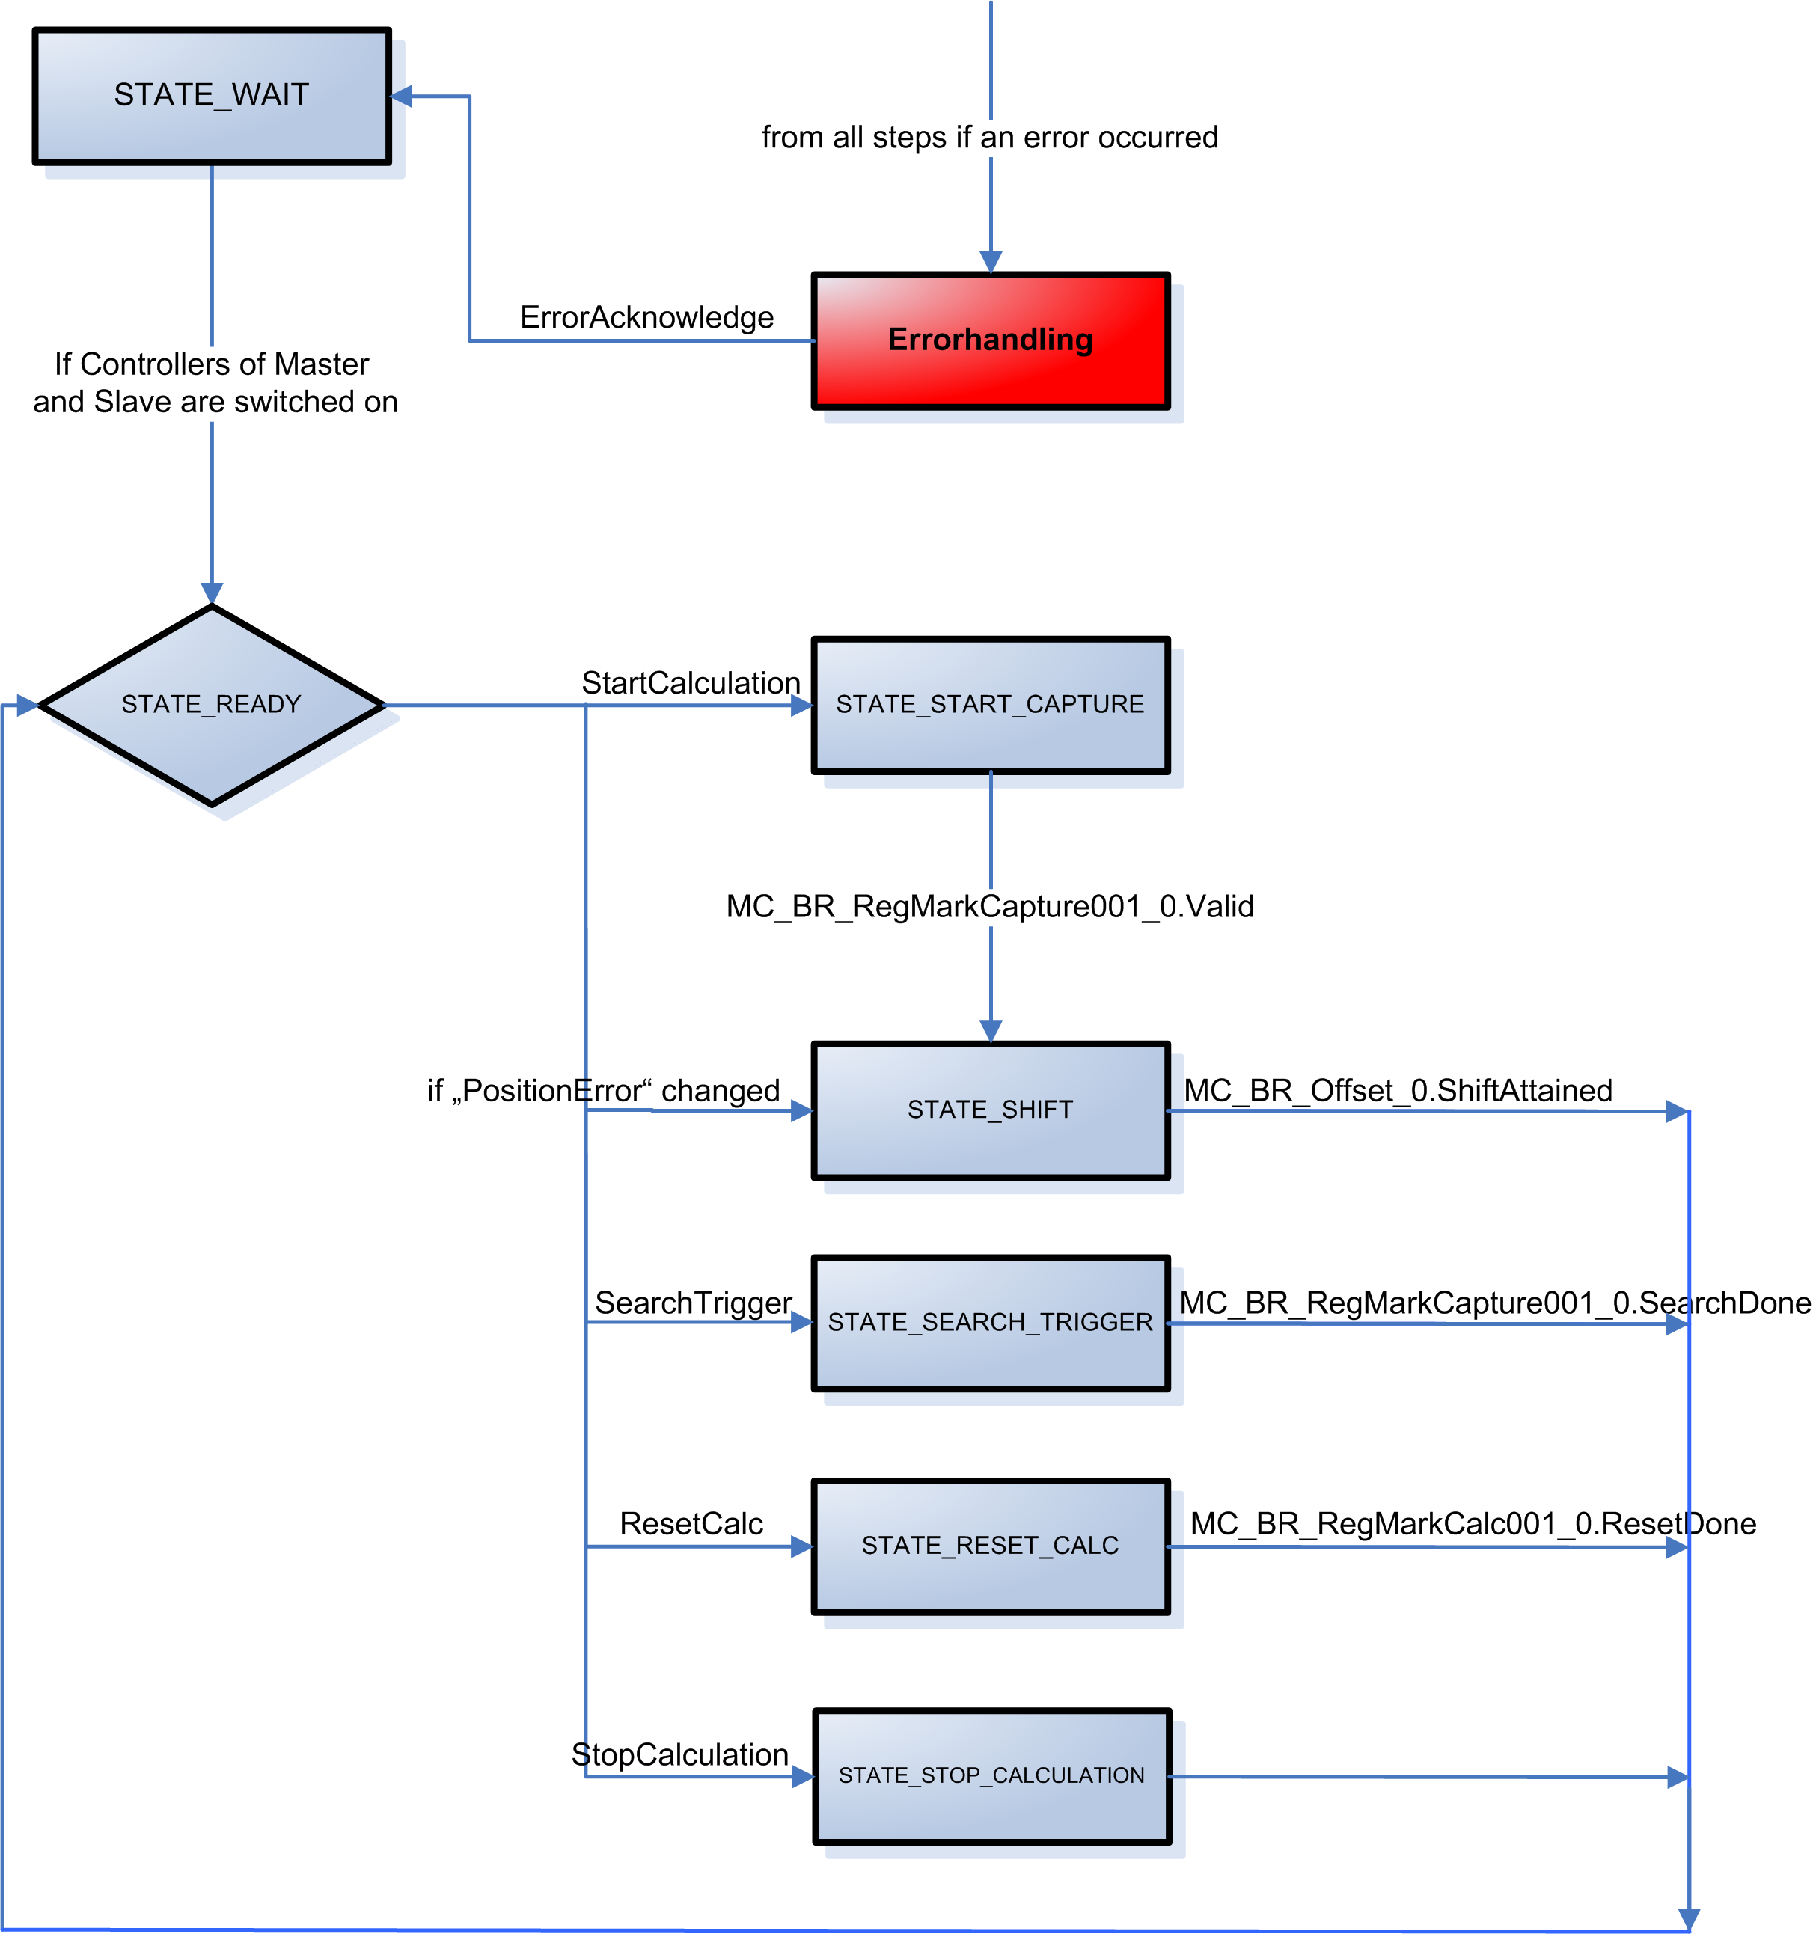For the most part, the function blocks MC_BR_RegMarkCapture001, MC_BR_RegMarkCalc001 and MC_BR_Offset are controlled outside the step sequence. To process the function blocks within the step sequence would require several more task cycles.

LibACP10MC_Trace_xx
Trace operation
Example for using the parameter and network command traces.

Shows how to operate the parameter trace and the network command trace with a common command structure. The parameter command trace can be turned on, turned off and saved. These options are also available for the network command trace, and the data from the network command trace can also be deleted.
It is also possible to determine the status of the parameter trace and the network command trace.

Function blocks from the ACP10_MC library are used to operate the trace.

To configure how the data from the parameter trace and network command trace is saved, see also the DatObj section for the MC_BR_ParTrace and MC_BR_NetTrace function blocks.

Information:
When using this example, an error text module named "acp10etxen" (Motion Wizard) must be found in the project.

By default, the name "gAxis01" (master) is used for the axis in the package (Motion Wizard). To use an axis with a different name, this name can be assigned in the init SP.

Requirements
Target system: SG4
ACOPOS and ACOPOSmulti
Program name
Trace

Program description
A predefined command structure (TraceControl) can be used to execute the following functions with the Watch window.
- Start the parameter trace (TraceControl.Command.StartParTrace)
- End the parameter trace (TraceControl.Command.StopParTrace)
- Save the parameter trace (TraceControl.Command.SaveParTrace)
- Read the status of the parameter trace (TraceControl.Command.ReadParTraceStatus)
- Turn on data entry into the network command trace (TraceControl.Commando.SwitchOnNetTrace)
- Turn off data entry into the network command trace (TraceControl.Commando.SwitchOffNetTrace)
- Delete the current data from the network command trace (TraceControl.Command.ResetNetTrace)
- Save the current data in the network command trace (TraceControl.Command.SaveNetTrace)
- Read the current status of the network command trace (TraceControl.Command.ReadNetTraceStatus)
- Acknowledge a function block error (TraceControl.Command.ErrorAcknowledge)
