SIAM’s Fall Picnic

Get ready to kick off the 2000-2001 school year at the annual Fall picnic sponsored by the SIAM Student Chapter. There will be the same great food and drinks as every semester, but this year we’re trying out a new location. Instead of the Y-beach, we’re moving to Clemson University’s Outdoor Laboratory. Located off of Twin Lakes Road, the Outdoor Lab is just up the street from Twin Lakes Campground and offers a wonderful change of pace. So, come and check out the new location, enjoy great food, conversations and a beautiful Clemson evening along with the rest of the Math Science Department!

WHEN: Friday, September 15th from 5 p.m. to 7 p.m.

WHERE: Clemson University Outdoor Laboratory Picnic Shelter and Amphitheater
1 Camper Trail, Pendleton, SC (see map on back)

PRICE: If you bring a food dish:
$3/person (faculty, staff & family)
$1/person (graduate students & family)

Otherwise:
$5/person (faculty, staff & family)
$3/person (graduate students & family)

Children under 10: FREE!!!

FOOD DISHES: A - G: Desserts
H – N: Cold Side Dishes
O – Z: Warm Side Dishes

SIAM PICNIC FORM

Name:_____________________________________________________

Number Attending: _______________________

Bringing Food Dish? Y or N Will you be drinking beer or wine coolers? Y or N

Money Enclosed: $ _____________

Please return this form to one of the following by Friday, September 8th.

Dr. Chris Cox O-224 John Paul Roop O-3
Alicia Teal O-6 Erin McNelis O-5
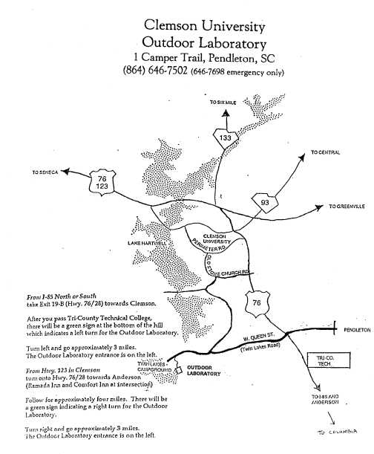
GARRISON
ARENA

