Tektronix 4010 and 4014 Storage
Tube Terminal Emulator
Table of Contents
Introduction 1
Getting started 3
Installation and first tests 4
Connecting to systems 5
Log directly into a remote historical Unix operating system 5
Log into the system running simh (same or different Raspberry Pi) 6
Log into PiDP-11 running on the same Raspberry Pi, using the console 7
Using tek4010 with a serial link 7
Using tek4010 as a terminal and device 8
tek4010 on the PiDP-8 8
Options of the command tek4010 9
Advanced features 10
APL mode 10
Screen resolution 10
Background and documentation 11
Manuals 11
Historically interesting facts about the ARDS terminal 11
Using other fonts 11
Making grayscale images for tek4010 11
Using tek4010 on a slow system 12
Miscellaneous 12
Contributors 12
The usual disclaimer 12

Introduction
tek4010 is a Tektronix 4010, 4013, 4014 and 4015 terminal emulator for the Raspberry Pi and other Linux systems.
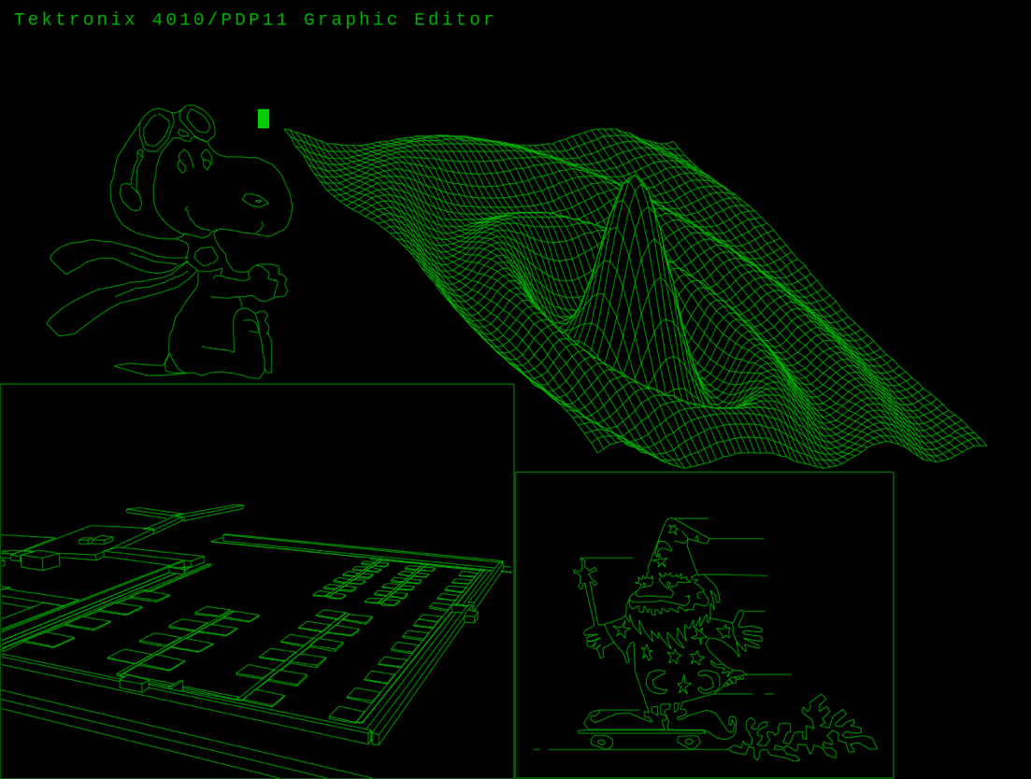
Below is a screen shot of the spacelab from the ICEMDDN CAD package running on a CDC Cyber 175 mainframe emulator:

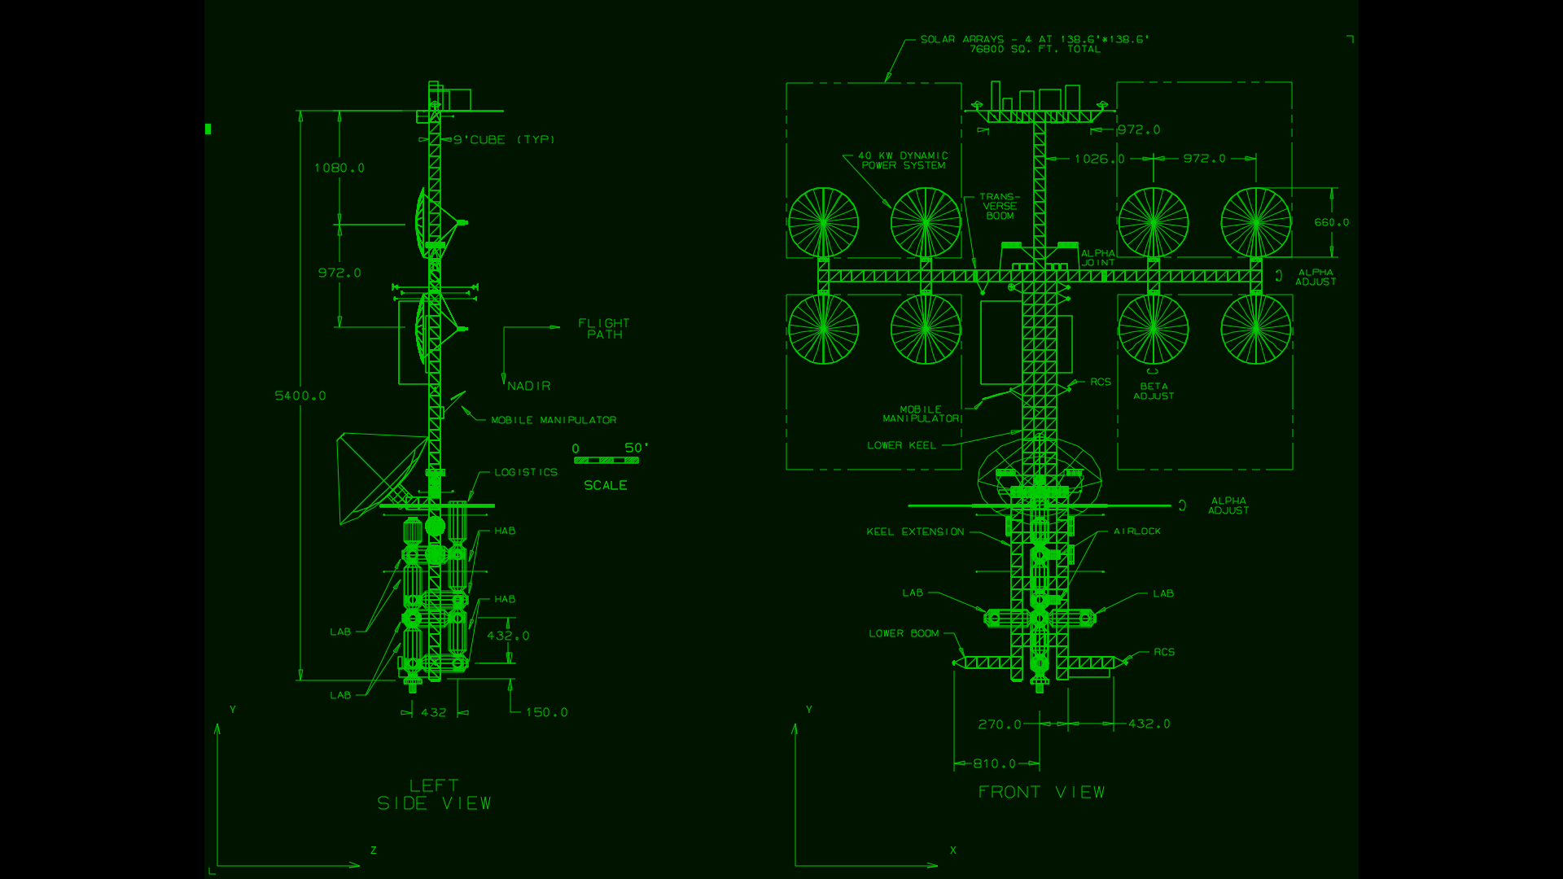
tek4010 can also display historical data for the MIT Project MAC ARDS (Advanced Remote Display Station):
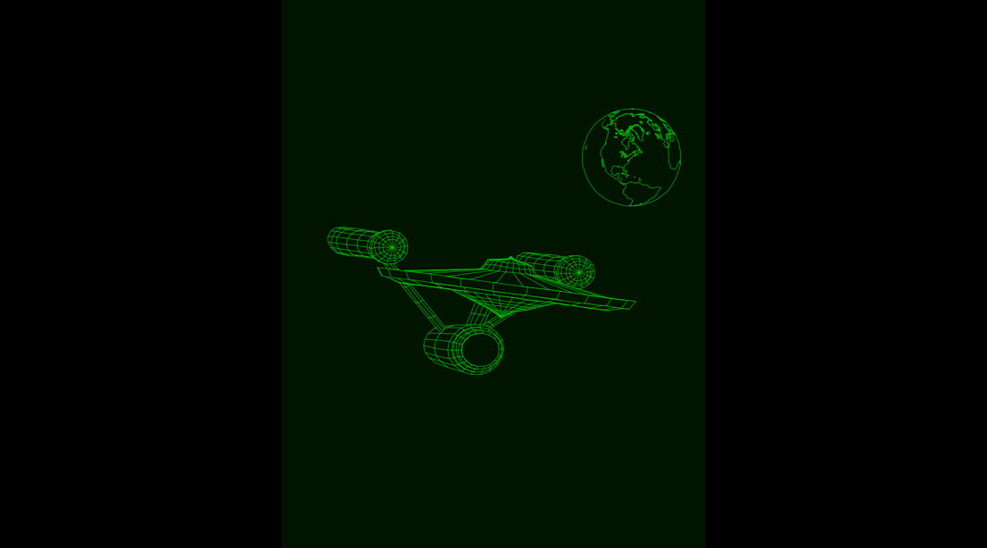
tek4010 makes a strong effort to reproduce the behavior of the Tektronix storage tube display, including the fading bright drawing spot.
If this look and feel is not important, a standard terminal such as xterm may be used instead. However, xterm does not support all graphics modes of the 4014.
Tek4010 can be used to log into historical Unix systems such as BSD 2.11 on the PiDP-11 or to connect to real historical systems. It can also be used to display historical plot data.
The following picture shows a scale model of the Tektronix 4010 crafted by Dave Ault using tek4010:

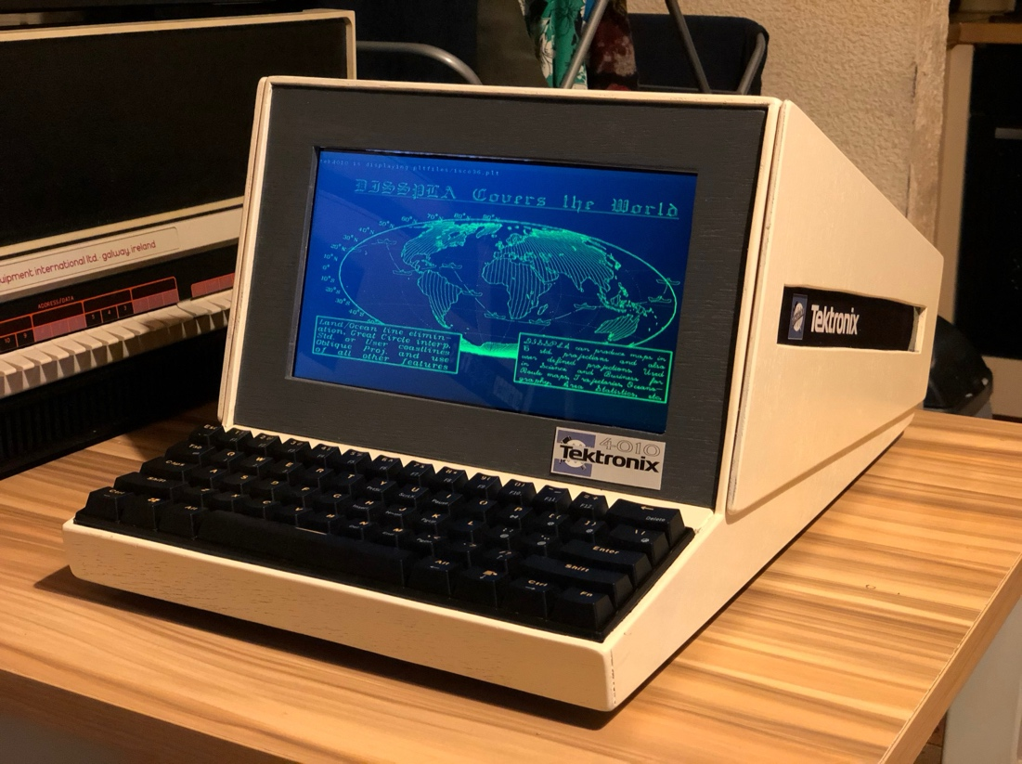

Getting started
Important features of tek4010

- Emulation of Tektronix 4010, 4013, 4014, 4015 and ARDS

- Emulation of the fading bright drawing spot

- Standard window resolution of 1024 × 780 pixels

- Scaled resolution for lower-resolution screens

- Full-screen mode with -full option

- Coordinate systems: 1024 × 780 and 4096 × 3072 tek points

- All Tektronix 4014 modes, including graphical input mode (GIN) and write-through mode

- Support for grayscale images (Tektronix 4014 intensity chart)

- APL character set and keyboard for Tektronix 4013 and 4015

- telnet and rsh connection to host systems and direct display of plot files

- Simulated baud rates from 300 to 19200

- Can be compiled for Raspberry Pi and other Linux distributions such as Ubuntu

- Tested with SimH, PiDP-11, PDP-11/93, VAXstation 4000/90a, 2.11 BSD, RSX-11M+, PLOT10

- GIN mode tested with the ICEMDDN CAD package on a CDC Cyber 175 emulator

- Raspberry Pi 4 Model B+ or faster recommended

Installation and first tests
Important: On Windows and macOS (Macintosh) you need to prepare your system before you can start with the installation as described here. See the files macintosh.txt or windows.txt in this repository.
Install the tek4010 emulator from this repo.

cd
sudo apt-get install git
git clone https://github.com/rricharz/Tek4010
cd Tek4010

Compile the program on the target system.:

cd ~/Tek4010
sudo apt-get install libgtk-3-dev
make clean
make
make install

If this is your first installation, reboot the system with

sudo reboot

All further commands are executed in the main tek4010 directory:

cd ~/Tek4010

There is a file "dodekagon.plt" in the repo, which you can use to test the tek4010 emulator. "dodekagon.plt" was produced in 2.11 BSD using my program "dodekagon". Type

tek4010 -noexit cat dodekagon.plt

If tek4010 screen refreshes are too slow or choppy in this test, use the -fast option in all calls to tek4010

tek4010 -noexit -fast cat dodekagon.plt

Or, for a ARDS display example type

tek4010 -noexit -ARDS cat ardsfiles/trek.pic

If you want to test text output, type for example

tek4010 -noexit head -n 32 src/tek4010.c

If you want to test an animation, type

tek4010 cat animation.plt

Don't forget the option "-noexit", which tells tek4010 to stay alive after cat or head has finished so that you have a chance to look at the output. For a list of all possible options, see the chapter "Options of the command tek4010" below.

If you want to see a demo of historical Tektronix 4014 plot files, type
tek4010 demos/demo.sh

There are more Tektronix 4014 plot files in pltfiles/More_pltfiles in this repo. You can find more ARDS plot files at larsbrinkhoff/ards-files in the folder pictures.

The emulator does use "rsh" or "telnet", because historical Unix systems do not support the secure ssh protocol, and because ssh does not allow using a virtual emulator such as tek4010 for security reasons. You need therefore to install rsh or telnet on the Raspberry Pi or Ubuntu running the tek4010 emulator:

sudo apt-get install rsh-client
or
sudo apt-get install telnet

If you want to use this emulator together with 2.11 BSD Unix, look also at Using the historical Unix 2.11 BSD operating system on the PiDP-11

Connecting to systems

Log directly into a remote historical Unix operating system
This can either be a real historical computer, or a virtual system using simh such as the PiDP-11.
First, you need to test the remote login from your client machine into your historical system, using

rsh -l user_name system
or
telnet system

where user_name is the name of the user on the historical operating system, and system is the hostname of this system. If the historical operating system is running using an emulator, this is NOT the hostname of the system, on which the emulator is running. See the chapter below if you prefer to log into the system, on which the emulator is running. For example, type

rsh -l user_name pdp11
or
telnet pdp11

If this works properly, you can use the tek4010 emulator as follows:

tek4010 rsh -l user_name system
or
tek4010 telnet system

If the terminal window is closed right away, there is a problem with your rsh or telnet call. Test it first without tek4010.

The following keys are not transmitted to the Unix system, but are executed locally in the terminal emulator and clear the persistent screen:

home
page up
page down
ctrl arrow up
ctrl arrow left

These keys emulate the "page" key of the Tektronix 4010. You need to use one of these keys frequently to avoid to get a mess on the screen, as on a real Tektronix 4010.
The hardcopy function on the Tektronix 4010 is emulated with a screen dump.

Ctrl-w Make a screen dump in current directory using scrot
Can be typed on the keyboard or sent by the computer during alpha mode

Note: On Wayland scrot does not work anymore. Instead of scrot one can use grim. To use grim when ctrl-w is typed or sent from the host, change the following in src/main.c:

from system("scrot -focussed");
to system("grim");

You can use the following ctrl key function to close tek4010:

ctrl-q Close tek4010 window and quit tek4010.

Log into the system running simh (same or different Raspberry Pi)
Log into the system running SimH (same or different Raspberry Pi)

This method is useful if a virtual DZ11 has been configured for multiple user logins, providing a telnet port for multiplexed terminals.

On the PiDP-11 with 2.11 BSD, the standard distribution already provides port 4000 for up to eight terminals. For RSX-11M+, port 10001 is typically configured instead.

First, install and test telnet (2.11 BSD must be running in multiuser mode):

sudo apt-get install telnet
telnet raspi_hostname 4000

or

telnet raspi_hostname 10001 (RSX-11M+)

Alternatively, if tek4010 and SimH run on the same system:

telnet localhost 4000

or

telnet localhost 10001 (RSX-11M+)

Here, raspi_hostname is the hostname of the system running SimH.

Once this works, start tek4010 as follows:

tek4010 telnet raspi_hostname 4000

or

tek4010 telnet raspi_hostname 10001 (RSX-11M+)

or, on the same system:

tek4010 telnet localhost 4000

or

tek4010 telnet localhost 10001 (RSX-11M+)

Log into PiDP-11 running on the same Raspberry Pi, using the console
This is the least preferred setup, only to be used if you cannot use one of the setups above. You cannot use the tek4010 emulator running screens, as it is done in the standard setup of the PiDP using the console, because screens filters the output stream of simh and is therefore unsuitable for graphics terminals such as the tek4010 emulator. If you don’t want to change the standard setup, use ctrl-e to stop simh, and then “exit” to quit simh.

Because tek4010 needs rsh, you need to install rsh-server and rsh-client on the Raspberry Pi. You cannot use telnet here.

sudo apt-get install rsh-server
sudo apt-get install rsh-client

Now start tek4010 as follows:

tek4010 rsh -l pi localhost

This should give you a login prompt into your Raspberry Pi. If not, test the rsh call first.
Once your password has been accepted, be prepared to use the “home” key or any of the other keys described above frequently to avoid to get a mess on the dump 4010 terminal emulator! The following will start the PiDP software without using screens:

cd /opt/pidp11/bin
./pidp11.sh

Everything should run as expected, and you should be able to use the tek4010 terminal emulator with any of the historical operating systems.

One word of caution! If you run the PiDP-11 software this way without using screens, you SHOULD NOT detach or quit the terminal while your historical operating system is running, because this will kill the PiDP-11 simh emulator right away. First run down your historical operating system and simh properly, before detaching the terminal emulator.

Using tek4010 with a serial link
Using tek4010 with a serial link

A helper program by Teunis van Beelen allows tek4010 to be used over a serial connection.

First, install the helper program (it is hosted on GitLab):

cd
git clone https://gitlab.com/Teuniz/rs232-console
cd rs232-console
make

Copy the executable rs232-console to a location in your PATH, for example ~/bin or /usr/bin.

Test the serial connection using:

rs232-console -p port -b baudrate -m mode -f hardware

Details of the command line parameters can be found in the README file of rs232-console.

Once this works, use it together with tek4010:

tek4010 [options] rs232-console [options]

In some cases, the serial port may remain locked after tek4010 exits. If this happens, terminate any remaining rs232-console process with:

kill rs232-console

The serial connection has been tested by Dave Ault using a PiDP-11 and a PDP-11/73 running RT-11. The command

COPY FILENAME.PLT TT:

was used in RT-11 to avoid filtering of control codes that occurs with TYPE. Tests were performed using MX Linux and an FTDI USB-to-RS232 converter.Using tek4010 as a plotting device.

Some simulators do not allow to attach a terminal for standard input and output, but are able to send data to a file. An example of such a simulator is my own simulator based on a home built 6502 system R65 simulator. The original system was not made for attaching a terminal, but could send formatted and raw data to an attached printer or plotter.

tek4010 can be attached to such a simulator as a pure plotter or printer, by monitoring the file created on the fly, and printing or plotting everything sent to that file while it is appended. The command to use in this case is
tek4010 tail -f printout.txt

where printout.txt is the output file created. The file needs to exist when tek4010 is started, and tek4010 displays whatever is already in that file, and keeps monitoring that file and displaying anything which is appended. Note that it is essential that the data is not filtered during the output process, because the tek4010 plotting code is 7 bits binary. Bit 8, the parity bit, is ignored.

Using tek4010 as a terminal and device

tek4010 on the PiDP-8
Details, programs and plot files for the PiDP-8 are available at tek4010-pidp8

Options of the command tek4010
The command tek4010 is called using the following syntax:

tek4010 [options] command [command options]

The command is mandatory and can be, for example, telnet, rsh or cat.

The following options are available:

-noexit
Do not close the window after the command has finished.

-raw
Do not execute an automatic carriage return (CR) after a line feed (LF).

-tab1
Insert a blank instead of a tab to the next 8-character column.

-b100000, -b38400, -b19200, -b9600, -b4800, -b2400, -b1200, -b600, -b300
Emulate a baud rate. The default is 19200 baud. The original Tektronix 4010 supported up to 9600 baud, while the 4014 could reach 100000 baud with a special interface. Lower baud rates can be used to emulate 1970s modem performance.

-full
Open a full-screen window. The full resolution of the 4014 with the enhanced graphics module is used, scaled to the window size. Use Ctrl + Q to close the window.

-fullv
Open a decorated window using the maximum vertical space available. The full resolution of the 4014 is used, scaled to the window size.

-ARDS
Display ARDS data.

-APL
Emulate a Tektronix 4013/4015 terminal with the APL character set.

-autoClear
Clear the screen automatically when a line feed occurs at the bottom of the screen. This simplifies usage as a primary terminal but does not reflect original hardware behavior.

-keepsize
Keep the current font size when the screen is cleared. Some historical plot files may not reset the font size correctly when this option is used.

-hidecursor
Hide the cursor. Do not use this option in GIN mode.

-wait n
Close the window n seconds after the command has finished. This option should not be combined with -noexit.

-fast
Use fast rendering without fading. Recommended on slower systems. This option is automatically enabled for baud rates above 19200.

-h, --help
Display a list of available options.

Advanced features

APL mode
tek4010 is started with the -APL option, a Tektronix 4013 or 4015 terminal is emulated using the alternative APL character set.

In this mode, the following key combinations are active:

Ctrl + N switch to APL character set
Ctrl + O switch to normal character set

These commands can also be sent by the host system as ESC Ctrl + N and ESC Ctrl + O.

To use APL mode, the Apl385 font must be installed. Starting from the Tek4010 directory:

cd ~/Tek4010/apl
sudo install_apl

After installation, the following line should be displayed:

/usr/share/fonts/truetype/apl385/Apl385.ttf: APL385 Unicode:style=Regular

You can test the APL character set with:

tek4010 -APL -noexit ./apltest

While the APL character set is active, it is possible to remap keyboard input. Any printable key (ASCII codes 32 to 127) can be translated to another printable character.

The file “aplkeys” in the apl directory provides an example of such a mapping. The first row contains the ASCII codes of the input keys, and the second row contains the corresponding output codes.

To use keys with the left Alt key, add 128 to the code in the first row.

It is also possible to generate overstrike glyphs by adding a second code multiplied by 256 in the second row.

The mapping table can be modified to match your keyboard and locale. The required codes can be obtained from the screenshot below.

To install the aplkeys table:

mkdir ~/.tek4010conf
cp aplkeys ~/.tek4010conf

Screen resolution
The tek4010 emulator creates a graphics window with a resolution of 1024 × 780 points. This corresponds to the display size of the Tektronix 4010 and the Tektronix 4014 without the enhanced graphics module.

Modern systems such as the Raspberry Pi can handle sufficiently high refresh rates at this resolution.

The emulator also supports Tektronix 4014 graphics code with the enhanced graphics module. In this case, the full coordinate range is accepted, but the lowest two bits of each axis are not used, as on a 4014 without the enhanced graphics module.

When started with the -full or -fullv options, tek4010 uses the full 4K resolution of the 4014 with the enhanced graphics module, scaled to the actual window size.

Use Ctrl + Q to close the tek4010 window.

The BORDER constant in main.h can be adjusted to control the space reserved for window decorations and desktop panels when using the -fullv option.

Background and documentation

Manuals
Documentation for the original Tektronix terminals is available in the “manuals” folder. This manual for the tek4010 emulator is provided in the Tek4010/docs directory as Manual.pdf.

Historically interesting facts about the ARDS terminal
The ARDS was a pioneering storage tube display terminal. It already supported a three-button mouse as a graphical input device, as described in the 1971 thesis:

Rhine, George Irvin Jr., “A hardware and software interface between a graphics terminal and the SCC 650 computer” (1971), Masters Theses, 5508, page 21
http://scholarsmine.mst.edu/masters_theses/5508

Detailed photographs of the terminal and the original mouse built by CDI can be found in the 1968 ARDS manual (see the manuals folder).

Using other fonts
The font used by tek4010 is defined in tube.h. If you prefer to use a different font, define STANDARD_FONT and STANDARD_FONT_SIZE in tube.h and recompile the program.

Making grayscale images for tek4010
The Tektronix 4014 was able to display grayscale images using the “special point plot mode”, which was state of the art in the 1970s. The grayscale was limited to 64 levels and was highly nonlinear.

Very few such images are still available today, but new images can be created using the make-tek-image tool.



Using tek4010 on a slow system
On slower systems such as the Raspberry Pi 3, screen refreshes may be too slow and the display may appear choppy.

In this case, start tek4010 with the -fast option to enable faster rendering without fading.

The -fast option is automatically enabled for baud rates above 19200.

Miscellaneous

Contributors

The storage tube emulator and the Tektronix 4010/4014 decoder were written by René Richarz.

The ARDS decoder was written by Lars Brinkhoff, who also provided historical documents and ARDS plot files.

Teunis van Beelen developed the helper program rs232-console for serial connections.

Dave Ault tested the serial link with a PDP-11/73.

Historical Tektronix 4014 plot data was provided by Jos Dreesen.

Special plot mode images with variable brightness were provided by Monty McGraw, who also contributed to debugging this mode.

The spacelab plot data from the ICEMDDN CAD package on a CDC Cyber 175 emulator was provided by Nick Glazzard, who also made substantial improvements to GIN mode.

CP/M GSXBASIC plot files were provided by Udo Munk.

Thanks to Ian Schofield for critical feedback and a code snippet for dashed and dotted lines, and to Oscar Vermeulen and Mark Matlock for their support.

The manuals were obtained from bitsavers.org.

Thanks also to all others who contributed ideas, assisted with debugging, and helped preserve historical data.

This program is the result of a community effort.

The usual disclaimer
This program is distributed in the hope that it will be useful, but WITHOUT ANY WARRANTY; without even the implied warranty of MERCHANTABILITY or FITNESS FOR A PARTICULAR PURPOSE.

