2.11 BSD on pidp11

Using a Tektronix 4010 graphics terminal emulator
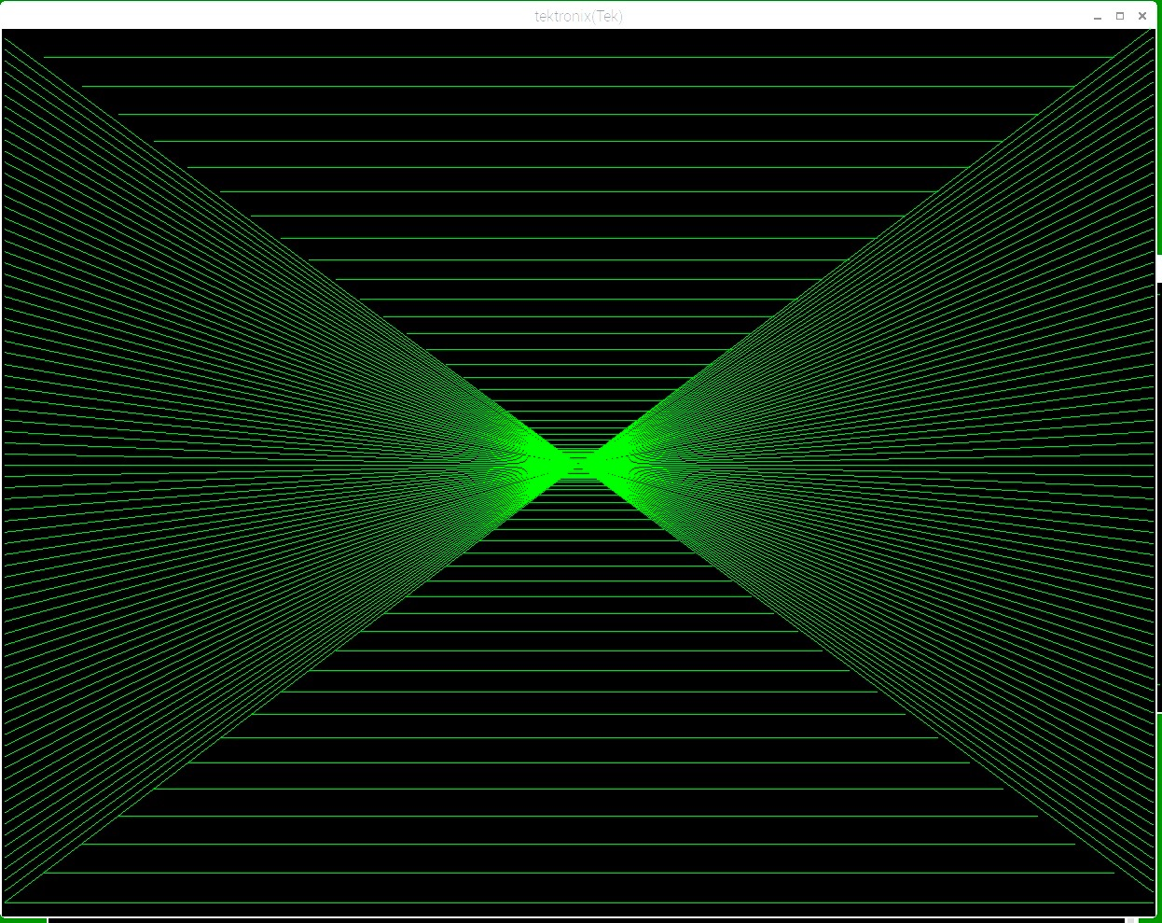
Output of the test program tek in this repo
We are here really in 1970s territory. Is it possible to use a Tektronik 4010 storage tube graphics terminal emulator with 2.11 BSD on the PiDP-11?

First, I propose that you read about the 4010 at

https://en.wikipedia.org/wiki/Tektronix_4010

Is is important to understand what one has to expect. Very important at that time, nice vector graphics, but awful text handling without scrolling.

Next, you have to choose the machine on which you want to emulate the terminal. I think xterm and rsh are available on all major systems. I decided to use a Raspberry Pi running Raspbian, because I do not want to install any potentially insecure software on my Mac. Using the approach described here I had to use a second Raspberry Pi, not the one on which the PiDP-11 was running.

We will need to login directly into 2.11 BSD, not using the console and screen, because screen refuses to talk to such as dumb terminal as the 4010. In the setup described here we will use rsh to login directly into 2.11BS:

sudo apt-get install rsh-client
sudo apt-get install xterm

Now, use whatever means you normally use to transfer the directory tek from this repository into your home directory in 2.11 BSD. It contains the programs tek and thome, which we will use.

You are all set to login into 2.11 BSD. Open a terminal and type

xterm -t -fg green

This will start up a xterm shell window with 4010 emulation and green characters.

Login into the pdp11. I put the IP address of 2.11 BSD into /etc/hosts. If you have not done that, use the IP address instead of pdp11. Note, this is not the IP address of the Raspberry Pi on which the PiDP-11 is running! yourname is the user name you want to use.

rsh -l yourname pdp11

You should get a 2.11 BSD login prompt asking for your password.

It is also possible to combine the xterm and rsh commands as follows in a shell script or desktop entry (see man xterm for details):

xterm -t -fg green -n Tektronix -e “rsh -l yourname pdp11”

The Tektronik 4010 terminal had a Page button, which did not transfer any character to the host, but instead cleared the screen. To emulate this button, I made the thome command, which will erase the screen. You have to use it often because the terminal has no scrolling and after a while you will have a mess on the screen. Don’t even think about using vi, and just type thome before the screen gets full.

cd tek
thome
tek

You will see the first little graphics example I made. Typing any key afterwards will clear the screen and put the terminal back in alpha mode.

There is also a small program tgraph.c in the tek directory. It allows to display the temperature data acquired with the cool-retro-weatherstation as a very simple example on how to display scientific data using 2.11 BSD and a Tektronix terminal:

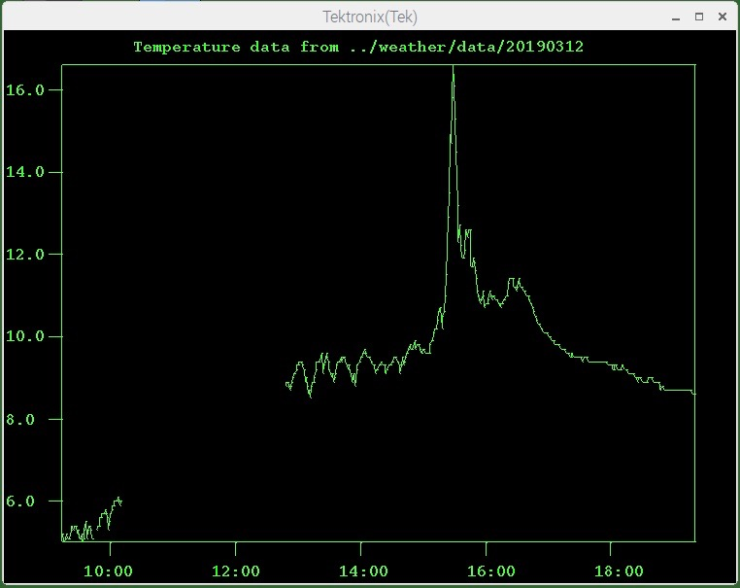
The Tektronix 4014 had a write-through mode, which allowed to animate a rather small number of vectors and characters. These were not stored in the display tube and had to be rewritten by the host computer in short intervals to avoid flickering. This mode is not supported by the xterm emulation (see man xterm).

