Freight Rate Prediction
Machine Learning Engineer Assessment — Report

Introduction
I'm coming into this assessment from a bootcamp background rather than a traditional software or data science role, so I want to be upfront about how I approached this: methodically, one decision at a time, and with a habit of checking my assumptions against the actual data rather than trusting my first instinct. This report walks through how I explored the data, the data-quality issues I found and fixed, how I engineered features, how I split the data for validation, and why I ended up choosing the model I did — including a mistake I almost made along the way, and what caught it.

1. Key Findings from Exploring the Data
The labeled dataset (train-test.csv) contains 48,000 freight loads spanning January 1 through October 31, 2025, with the target variable posted_rate ranging from about $57 to $25,533. A few things stood out during exploration:
- Distance is the dominant driver of price. It correlates with posted_rate at roughly 0.91 — by far the strongest single relationship in the dataset.
- market_index moves with the calendar, not with equipment type. Its monthly average swings from around 0.93 in slower months up to roughly 1.30 mid-year. This mattered later when I decided how to impute missing values for it.
- quote_signal showed almost no correlation with price (around 0.03–0.04), despite its name suggesting it should be informative. I kept it as a feature but didn't lean on it.
- Rate per mile itself has real seasonality — it drifted from about $2.10/mile in January up toward $2.33/mile by June, before easing back down toward $2.24/mile by October.
- Most importantly: the file I actually need to generate predictions for, validation.csv, covers November and December 2025 — entirely outside the date range of the training data. That single fact ended up shaping almost every modeling decision that followed.

2. Data-Quality Issues Identified and How I Addressed Them

2.1 Negative and missing weight values
About 292 rows had negative weight values, and roughly 300 rows had weight missing entirely. Before deciding how to handle the negatives, I compared the distribution of the negative values against the positive ones. They mirrored each other almost exactly in range and shape (both spanning roughly 5,000–47,500 in magnitude, with nearly identical medians). That told me this was very likely a sign-flip bug somewhere upstream, not corrupted or nonsensical data, so I applied an absolute value transformation rather than dropping or imputing those rows. Missing weight values were filled using the overall training mean, since weight didn't vary meaningfully by equipment type.

2.2 Missing market_index values
Around 374 rows were missing market_index. My first instinct was to impute using the group mean by equipment type, the same way I handled weight. But checking the actual numbers first showed equipment-level averages for market_index were nearly identical across Dry Van, Reefer, and Flatbed — while the monthly averages varied by as much as 40% across the year. That confirmed market_index is a time-driven signal, not an equipment-driven one, so I imputed missing values using the average for that row's specific month instead.

2.3 Outliers in posted_rate
I initially considered an IQR filter directly on posted_rate. But since price is so strongly tied to distance, that approach risked flagging genuinely long, expensive loads as "outliers" simply because they cost more in total dollars. Instead, I ran the IQR check on rate-per-mile (posted_rate divided by distance), which isolates loads that are unusually priced for their length rather than just long. I used the standard 1.5× IQR multiplier and applied this filter only to the training data — never to validation.csv or december-chart-inputs.csv, since every load in those files still needs a prediction, outlier-looking or not.

2.4 Cities in validation.csv that never appear in training
This was one I didn't expect to find. Comparing the unique pickup/delivery cities across files, train-test.csv contains 64 cities, but validation.csv contains 72 — eight of them (Jackson, Charlotte, Laredo, Norfolk, Allentown, Knoxville, San Diego, and Chicago) never appear anywhere in the training data. If I'd built my city encoding purely from training data without accounting for this, the pipeline would have broken — or silently mishandled — any load involving those eight cities. I addressed this by building my encoding vocabulary from training data but reserving an explicit "unknown" category, so any unseen city falls into a defined fallback bucket instead of causing an error.

2.5 december-chart-inputs.csv has a narrower set of columns
The December diagnostic file only includes pickup, delivery, distance, equipment, weight, date, and predicted_rate — it doesn't include market_index, quote_signal, or the latitude/longitude columns present in the other two files. Since a trained model needs the same input columns every time it's used, I made the deliberate choice to build my model using only the feature columns common to every file I'd need to predict on. This meant dropping market_index, quote_signal, and the coordinate columns, even though they were available in training. Given their weak correlation with the target during exploration, this cost very little in predictive power while keeping one single, consistent pipeline across all three files.

3. Feature Engineering
- pickup_encoded / delivery_encoded: cities converted to integer codes from a single shared vocabulary (built from training data, combining both pickup and delivery values), with a reserved "unknown" code for cities not seen in training.
- day_of_year: extracted from the date column. I considered a cyclical (sin/cos) encoding, but since this task only extrapolates forward (never wraps back around from December into January), a simple ordinal day-of-year was sufficient and easier to justify.
- equipment: one-hot encoded, since there are only three categories with no natural order between them, and all three files share the same equipment types.
I deliberately avoided engineering any feature derived from posted_rate itself (such as rate-per-mile as a lasting column). Since validation.csv and december-chart-inputs.csv don't contain posted_rate at all, any feature built from it could never be computed on those files — and would leak the answer into the input during training regardless. Rate-per-mile was used only as a temporary, in-memory calculation for the outlier check, never saved as a column.

4. Training and Validation Approach
Because the real prediction targets are entirely future, unseen dates, I avoided a random train/validation split — a random split would let the model validate on data very similar in time to what it trained on, which doesn't reflect the actual task. Instead, I used a time-based split: training on earlier months and validating on the most recent held-out period, to better simulate forecasting into a genuinely unseen future window, closer to what predicting November and December actually requires.

5. Reasoning Behind the Chosen Model
I benchmarked a simple Linear Regression against a Random Forest. Random Forest was clearly the stronger model on in-range data — roughly $67 mean absolute error and 2.9% MAPE, compared to about $120 and 7.6% for Linear Regression.
Before settling on Random Forest, though, I tested both models specifically on the December diagnostic file. The result surprised me: Random Forest predicted the exact same rate — down to the cent — for all 31 days of December. Investigating why, I learned this is a structural property of tree-based models: they make predictions by sorting each row through learned split points, and none of those splits go beyond the last date seen in training. Every December date fell into the same terminal leaf and received the same stored value. Linear Regression, by contrast, produced a smooth, gradually increasing trend across the same 31 days, because a straight line can keep extending past its training range.
This mattered a lot more than a single diagnostic chart, because validation.csv — the actual file I need to submit predictions for — is entirely November and December dates, with no overlap with the training period at all. A meaningful portion of my real submission would have relied on exactly the kind of extrapolation Random Forest cannot do.
To resolve this, I built a hybrid model: a linear regression component fit on day_of_year alone captures the overall seasonal trend and can extrapolate safely into new dates, while a Random Forest, trained on the remaining residual error, captures load-specific pricing patterns from route, distance, equipment, and weight. The final prediction is the sum of both components. I also tested a quadratic (degree-2) trend to better fit the mid-year peak I'd found during exploration, but it extrapolated into an unrealistic downward slope for December, so I reverted to the simpler linear trend, which extrapolates more conservatively and predictably.
The table below summarizes validation performance across all three approaches:
Metric | Linear Regression | Random Forest | Hybrid (Final Model)
MAE | $120.41 | $67.05 | $110.78
RMSE | $153.12 | $93.77 | $128.86
MAPE | 7.59% | 2.88% | 6.67%

The hybrid model's validation error is higher than Random Forest's on this in-range test — but that comparison undersells what actually matters here. The held-out validation period is still relatively close, in time, to the training data, so Random Forest hasn't yet failed the way it demonstrably does past the edge of its training range. I chose the hybrid model as my final approach because it is the only one of the three that produces sound, trending predictions across the entire real submission window, not just the portion closest to what it was trained on.

6. December Prediction Chart
The chart below, generated during model comparison, shows the core issue and the fix side by side: Random Forest's flat, unchanging prediction across every December date, against the hybrid model's smooth upward trend that reflects genuine seasonal movement.
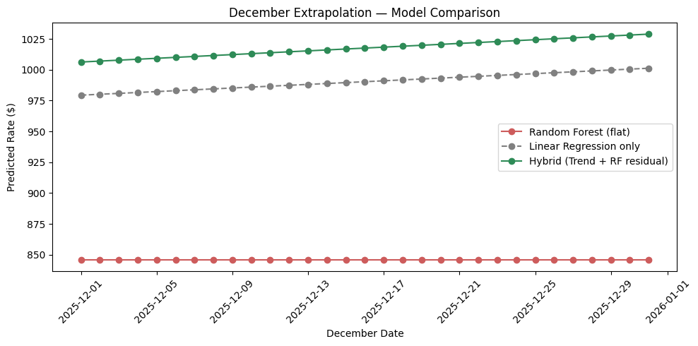
December extrapolation comparison — Random Forest (flat) vs. Linear Regression vs. the final Hybrid model.
Note: this chart illustrates the diagnostic comparison used to select the final model. The candidate_december.png chart generated directly by the provided score.py, using the final validation_predictions.csv and december_chart_inputs.csv outputs, is included alongside this report as a separate file.

7. Closing Notes
The biggest lesson from this project, for me, was that a model's validation score doesn't automatically tell the whole story — I only caught the Random Forest extrapolation issue because I went and specifically tested it against the actual shape of the real prediction task, rather than trusting the headline accuracy number. That habit of double-checking assumptions against the real data, even after a model already looks like it's performing well, is the biggest thing I'm taking away from this assessment and into how I'd approach modeling work going forward.
