Assessment M4-A1 - Data Science: Task Report
Date: 24 October 2026

Section A - Concept Application

A1: Missing Values and Data Types (Pandas)
With 14% missing values (about 7,000 of 50,000 rows), dropping rows would throw away a large part of the data, shrink the sample and could bias the results if delivery times are not missing completely at random. I would therefore impute instead of drop. Delivery times are usually right-skewed: a few very long deliveries (traffic, bad weather) pull the mean upwards, so the mean would give an unrealistically high "typical" time. The median is robust to such extreme values, so I would fill the gaps with the median, ideally group-wise (for example the median per city or restaurant category), and add a flag column such as delivery_time_missing so that the information about imputation is not lost. Before deciding I would check the skewness and the missing share:
df['delivery_time_mins'].isna().mean() # share of missing values
df['delivery_time_mins'].skew() # > 0 means right-skewed
df['delivery_time_mins'] = df['delivery_time_mins'].fillna(df['delivery_time_mins'].median())

Fixing customer_rating: (1) inspect the problem with df['customer_rating'].dtype and df['customer_rating'].map(type).value_counts(); (2) convert with pd.to_numeric(..., errors='coerce'), which turns '4.5' into 4.5 and any invalid text into NaN instead of raising an error; (3) cast with .astype('float64'); (4) check how many NaN values the conversion created with df['customer_rating'].isna().sum() and handle them (fill with mean/median or drop); (5) confirm the result with df.dtypes or df.info().
df['customer_rating'] = pd.to_numeric(df['customer_rating'], errors='coerce').astype('float64')

A2: Surge Days with NumPy Boolean Indexing
A boolean mask is an array of True/False values with the same shape as the data, created by a comparison such as order_counts > threshold. First np.mean() and np.std() give the mean and standard deviation of the 30 daily order counts, which define the threshold mean + 1.5 * std. The comparison order_counts > threshold produces a mask in which every surge day is True. Boolean indexing then uses this mask to pick the matching elements from any array of the same length, so revenue[surge_mask].sum() gives the total revenue of the surge days only, with no loop and no if-statement.
threshold = order_counts.mean() + 1.5 * order_counts.std()
surge_mask = order_counts > threshold
surge_revenue = revenue[surge_mask].sum()

This is much faster than a Python loop because a NumPy array is stored as one contiguous block of same-typed values and the comparison, masking and summing run in compiled C code over the whole array at once (vectorisation). A Python loop pays interpreter overhead for every element: bytecode execution, type checks and creation of Python objects.

A3: Choosing the Right Analysis and Chart (EDA)
(a) Delivery time vs customer rating involves two numeric variables, so it needs bivariate analysis. The best chart is a Seaborn scatterplot (or regplot with a trend line) with delivery_time_mins on the x-axis and customer_rating on the y-axis; the strength of the relationship can be backed with df.corr().
(b) The distribution of average order value across restaurant categories compares one numeric variable across the groups of a categorical variable, so it is also bivariate analysis. The best chart is a Seaborn boxplot (a violinplot also works), which shows median, spread and outliers for every category. For comparison, univariate analysis would look at one variable alone (for example a histogram of average_order_value) and multivariate analysis would add a third variable (for example colouring the scatterplot by restaurant_category with hue).
A simple line plot is not appropriate because it joins points in order and implies a continuous, ordered x-axis such as time. Delivery time and rating have no such order, so the connecting lines would be meaningless zig-zags, and restaurant categories are unordered labels. A scatterplot shows every individual point and the overall pattern, and a boxplot summarises the whole distribution of each category.

A4: JOIN Type for Restaurants with Zero Orders (SQL)
A LEFT JOIN with restaurants as the left table must be used. It keeps every row of the left table and fills the columns of the right table with NULL when there is no matching order, so restaurants without orders still appear in the report. Because SUM() of NULL is NULL, COALESCE converts it to 0.
SELECT r.name, COALESCE(SUM(o.order_value), 0) AS total_revenue
FROM restaurants r
LEFT JOIN orders o ON r.restaurant_id = o.restaurant_id
GROUP BY r.restaurant_id, r.name;

An INNER JOIN returns only rows that have a match in both tables. Restaurants with no orders have no match, so they would be silently dropped and the report would be incomplete, hiding exactly the restaurants the business wants to see.

A5: Ranking Delivery Agents with Window Functions (SQL)
I would use RANK() (or DENSE_RANK()) for the ranking and LAG() to fetch the previous row's value:
SELECT city, agent_id, completed_deliveries,
RANK() OVER (PARTITION BY city ORDER BY completed_deliveries DESC) AS city_rank,
LAG(completed_deliveries) OVER (PARTITION BY city
ORDER BY completed_deliveries DESC) AS deliveries_of_agent_above
FROM agent_monthly_deliveries;

PARTITION BY restarts the ranking and the LAG lookup for every city in a single pass over the data and keeps every agent as its own row (the top agent in each city simply gets NULL from LAG). A GROUP BY with a self-join or correlated subquery has to scan the table again for every row, for example to count agents with a higher total or to find the next higher value; it is slower, long, hard to read and easy to get wrong with ties, whereas RANK() handles ties explicitly. Window functions are declarative and short, and changing the ordering or the partition column is a one-word edit, which makes them far easier to maintain.

A6: CTE vs Nested Subquery (SQL)
For this two-step requirement the CTE version would be:
WITH top_categories AS (
SELECT r.category FROM orders o
JOIN restaurants r ON o.restaurant_id = r.restaurant_id
GROUP BY r.category ORDER BY COUNT(*) DESC LIMIT 5)
SELECT o.* FROM orders o JOIN restaurants r ON o.restaurant_id = r.restaurant_id
WHERE r.category IN (SELECT category FROM top_categories);

Readability: a CTE gives the first step a name and the query reads top to bottom, while a deeply nested subquery must be read inside-out. Reuse: a CTE can be referenced several times in the same statement (the logic is written once), whereas a nested subquery has to be copied each time it is needed. Debuggability: the CTE's SELECT can be run alone, or the final query can temporarily be changed to SELECT * FROM top_categories, whereas a subquery buried in a WHERE clause has to be cut out before it can be tested.
I would prefer a nested subquery when the inner query is small, simple and used only once, for example WHERE order_value > (SELECT AVG(order_value) FROM orders), where naming it adds clutter. It is also the choice when the database does not support WITH (such as MySQL before 8.0) or when a correlated subquery that refers to columns of the outer row is needed, which a CTE cannot do.

Section B - Practical Coding Tasks

Task 1: Daily Order Analysis with NumPy
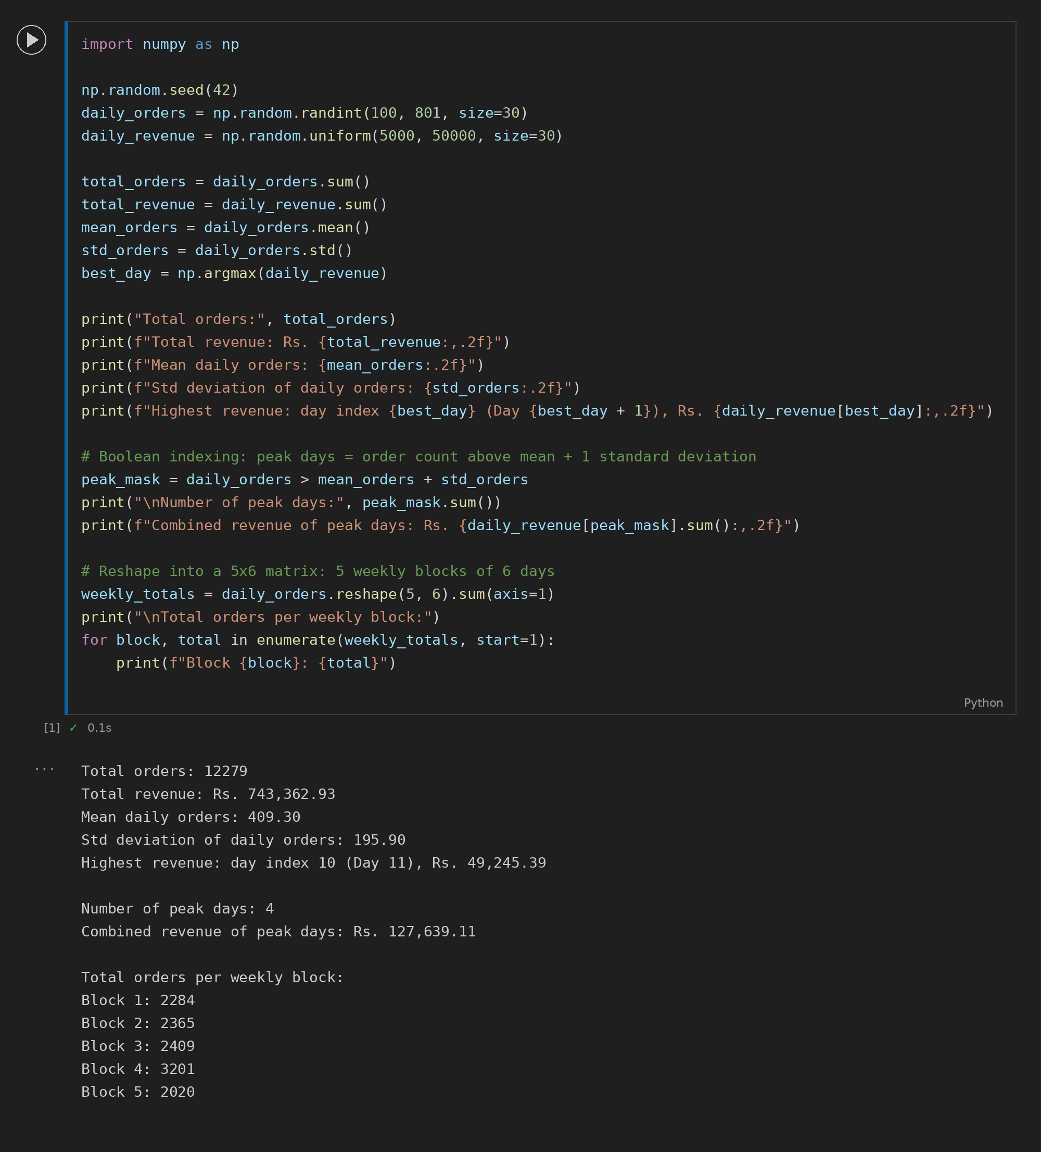

Task 2: Food Delivery Orders Data Cleaning Pipeline
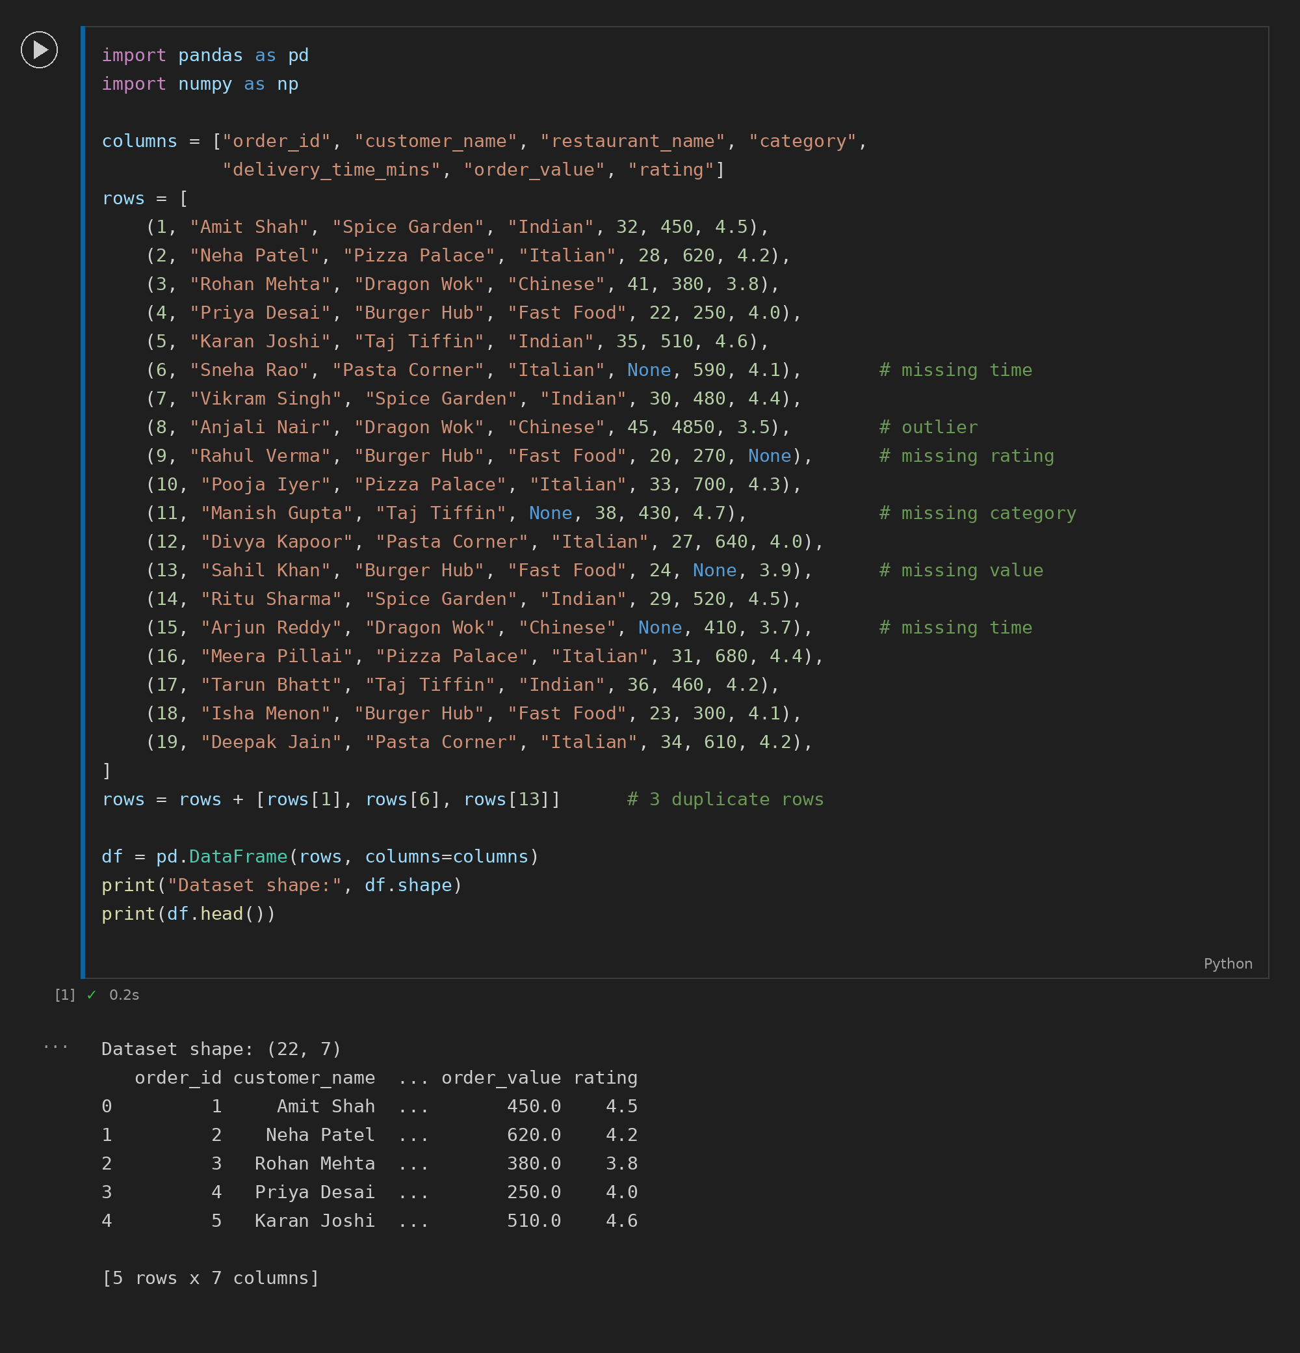
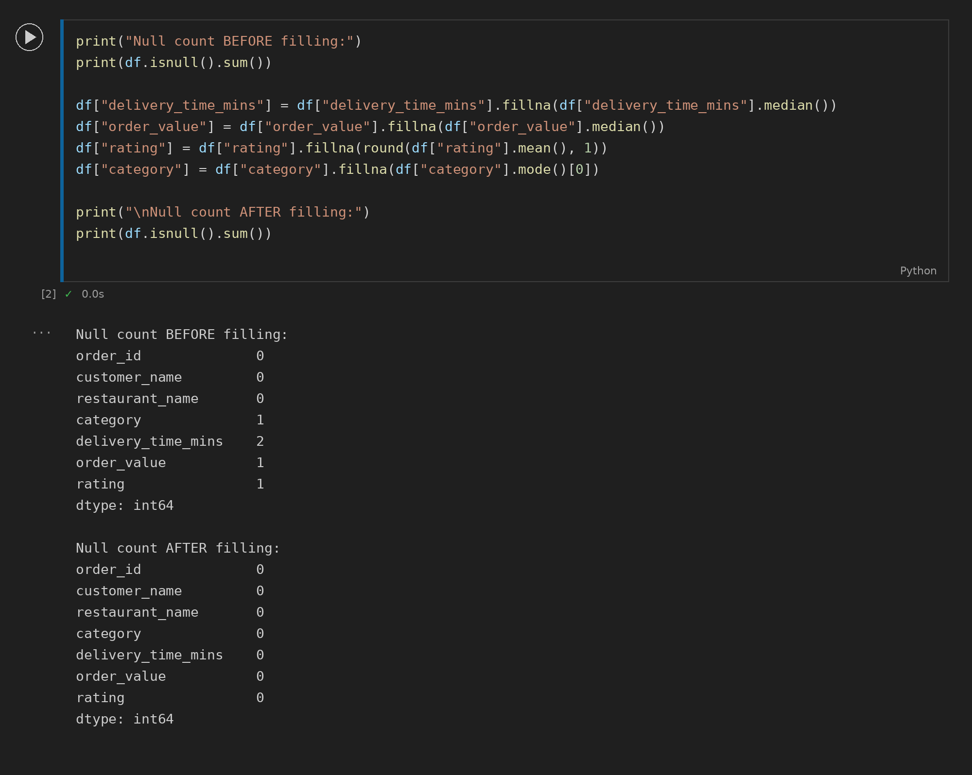
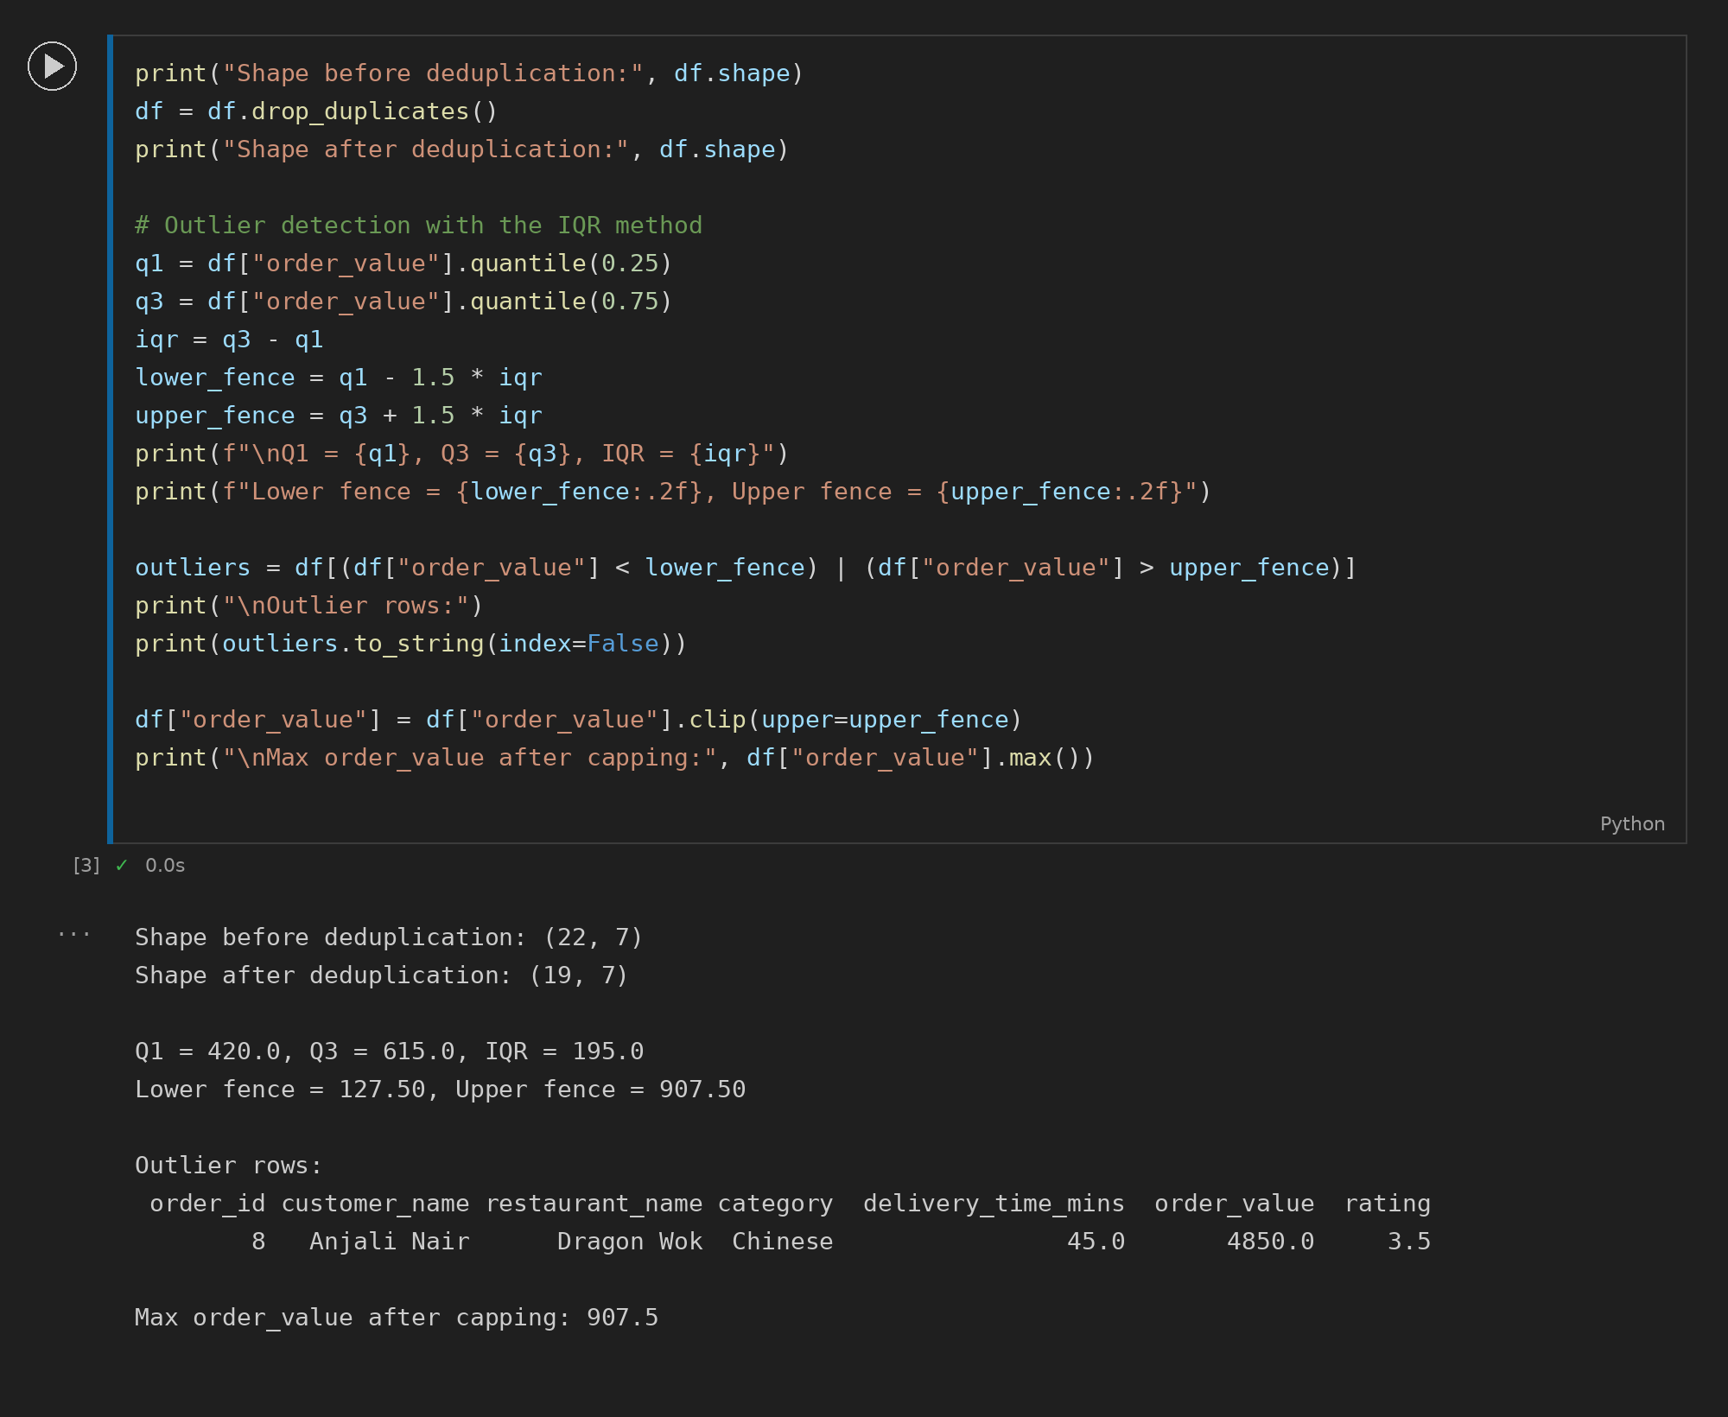

Task 3: Food Delivery Visualisation Dashboard
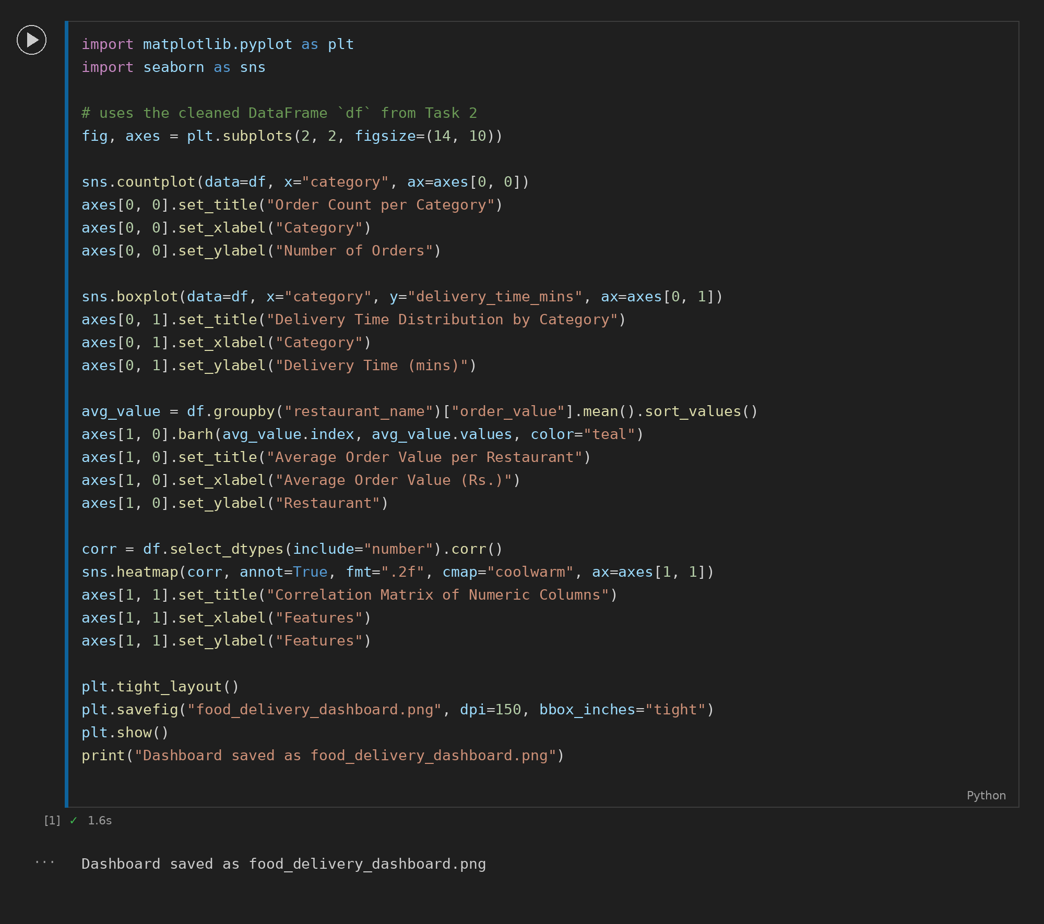
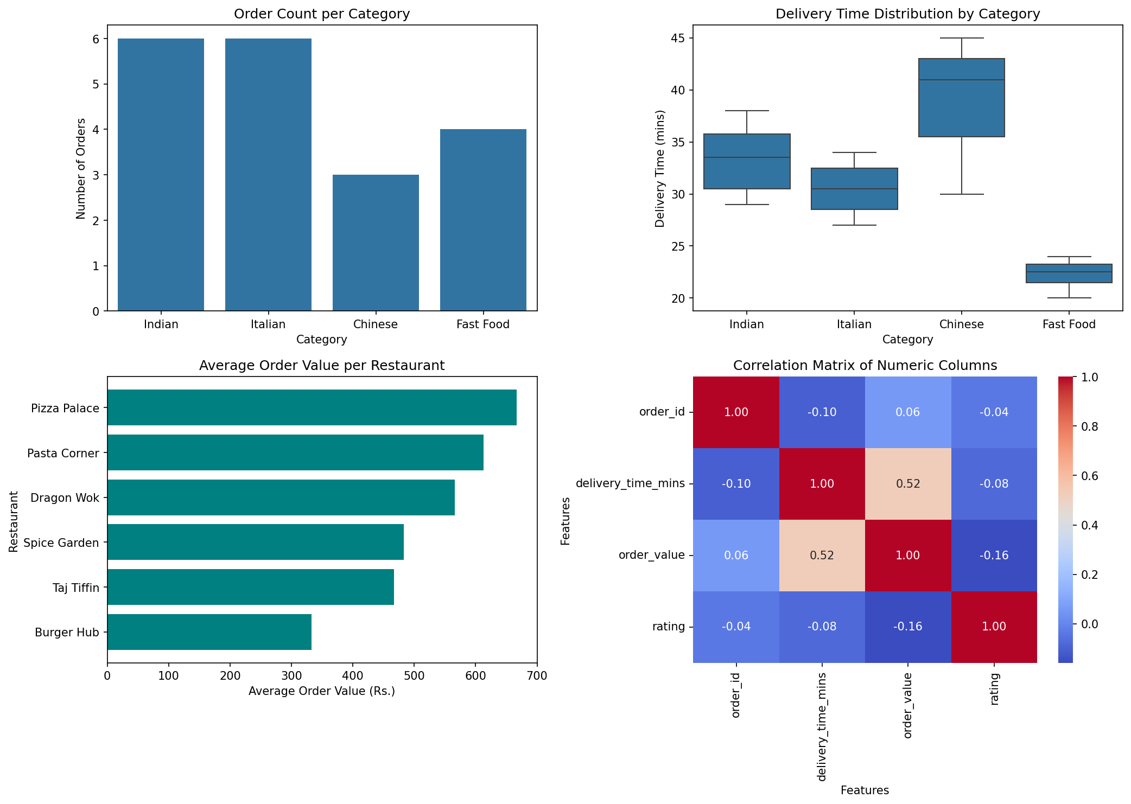

Task 4: SQL + Python Restaurant Performance Report
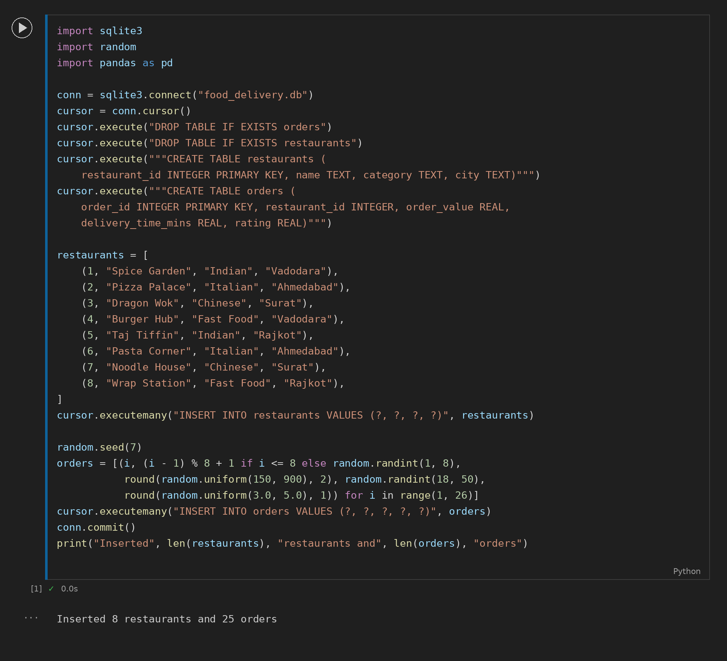
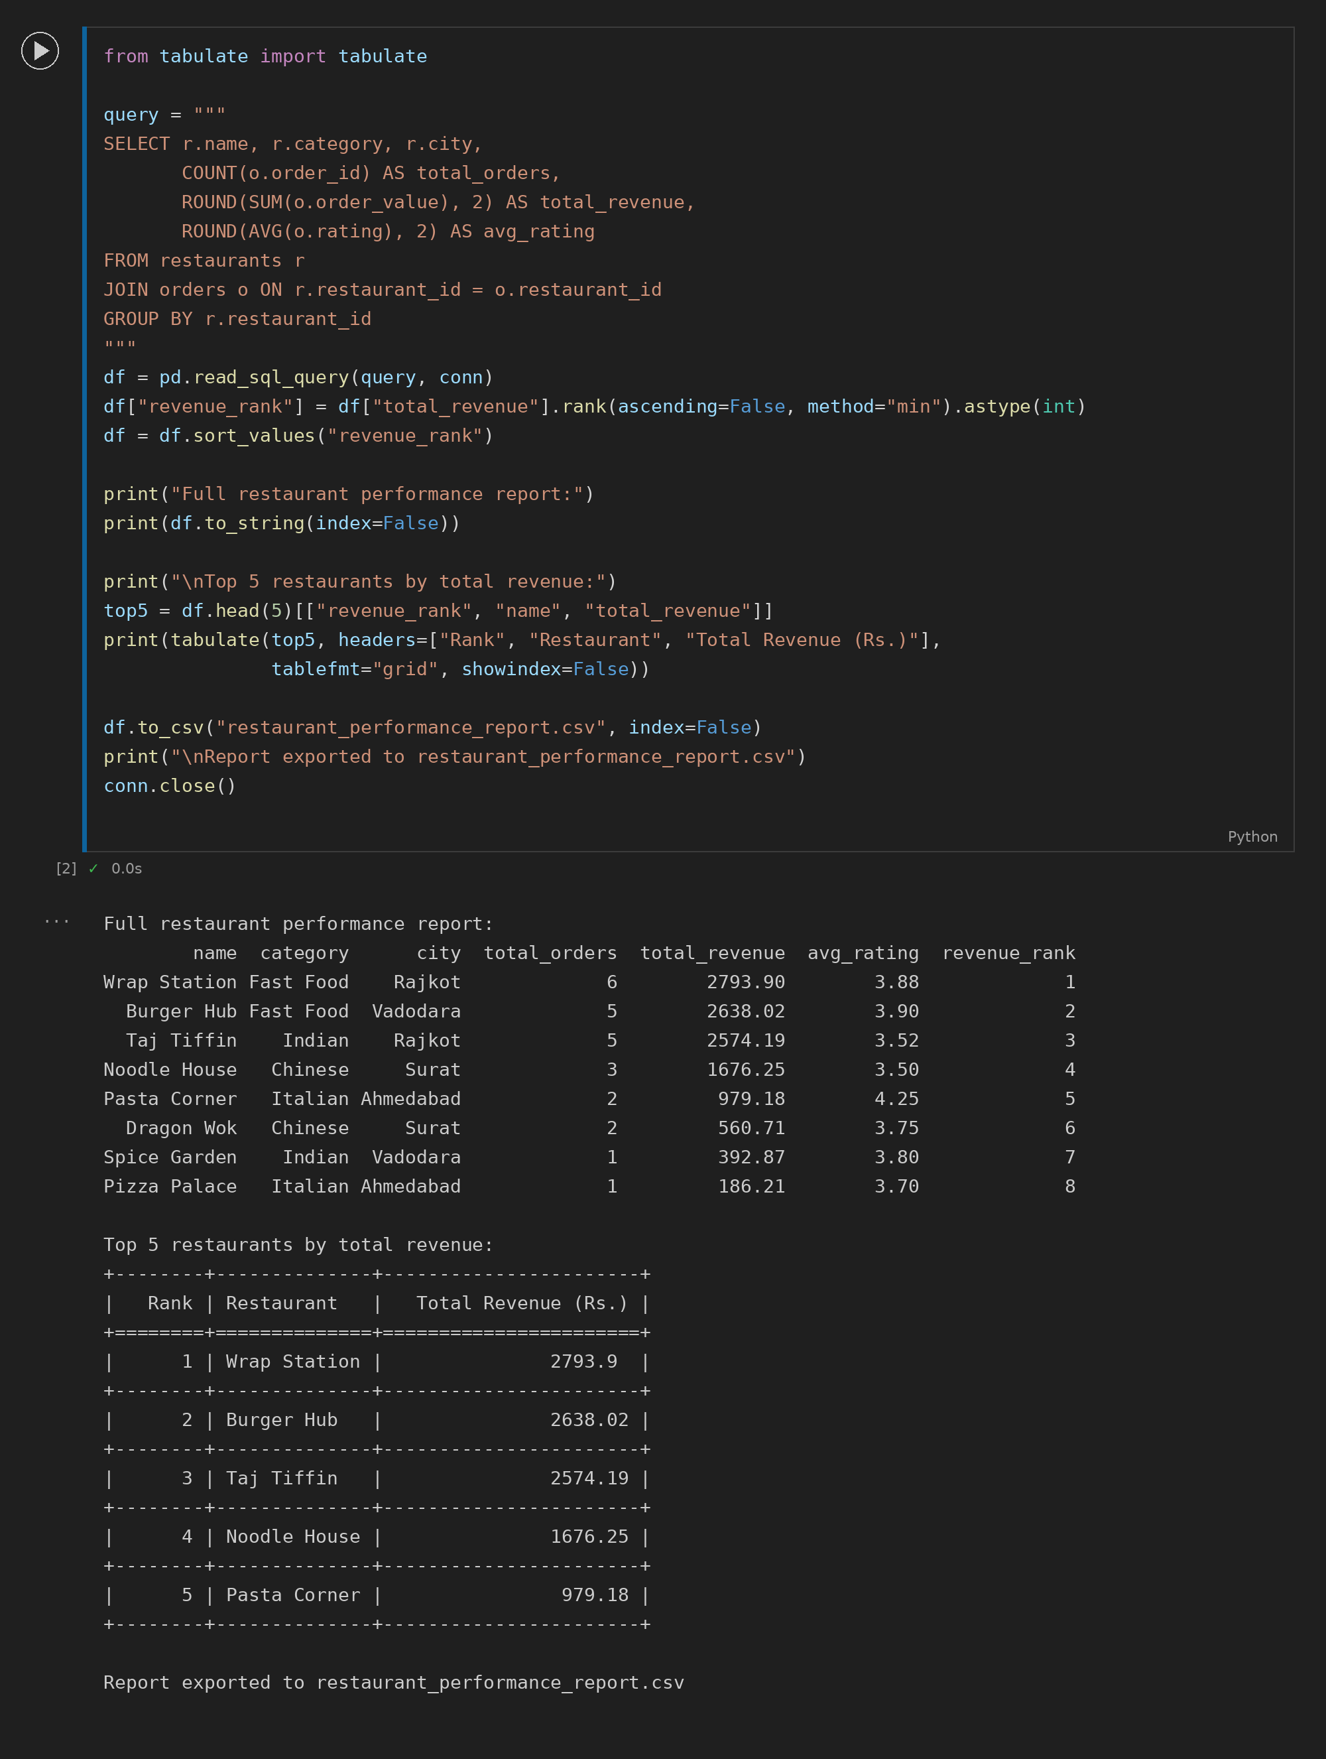

Section C - Mini Capstone Project

Food Delivery Analytics Console Application
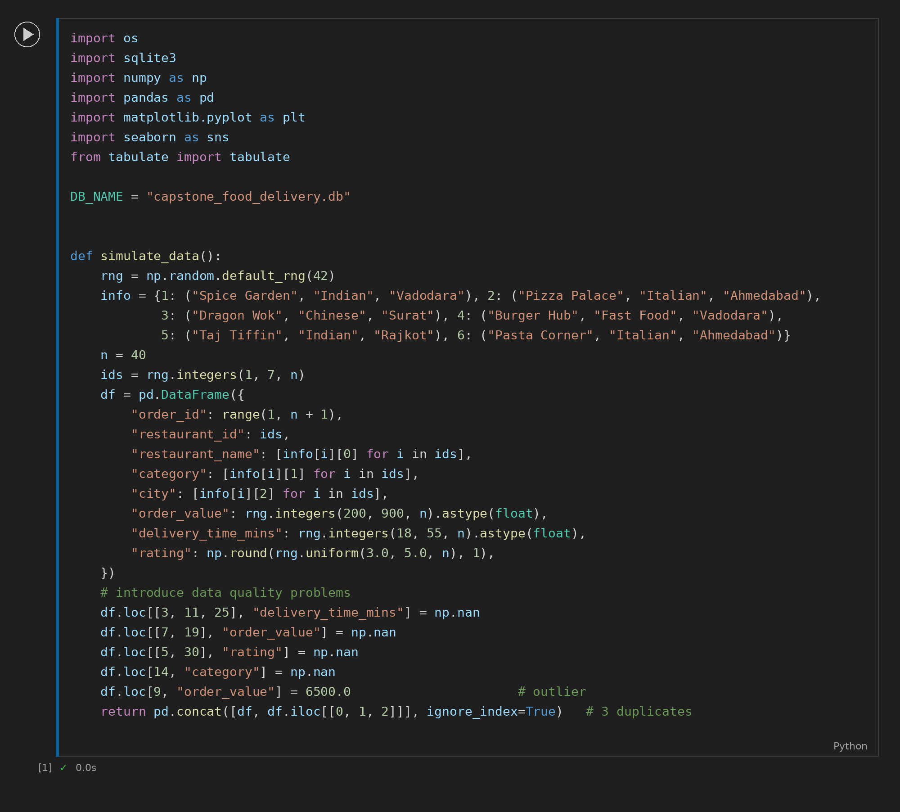
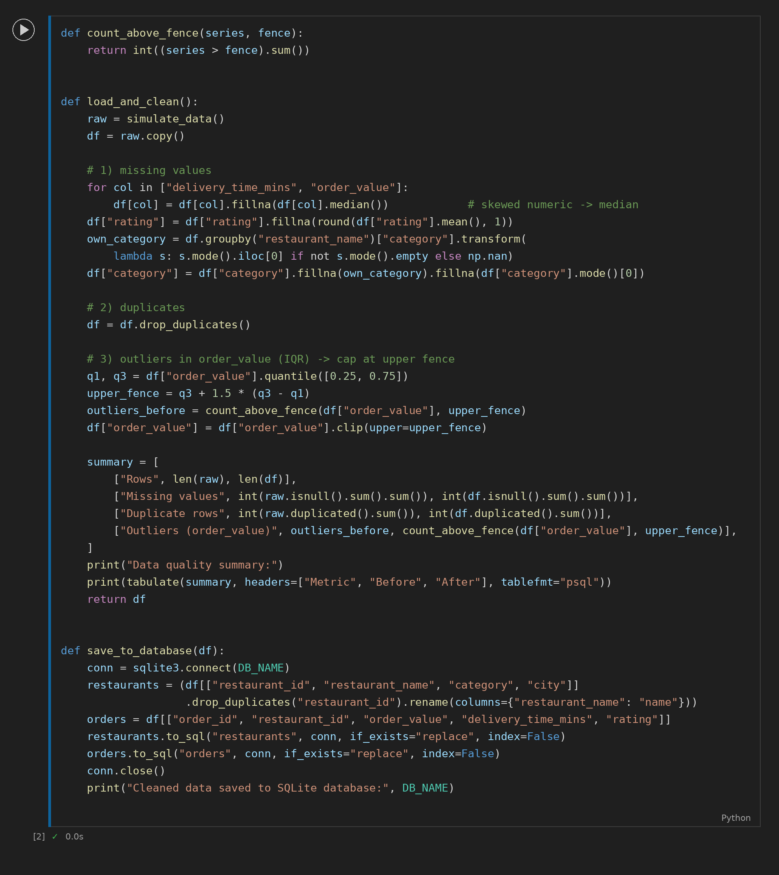
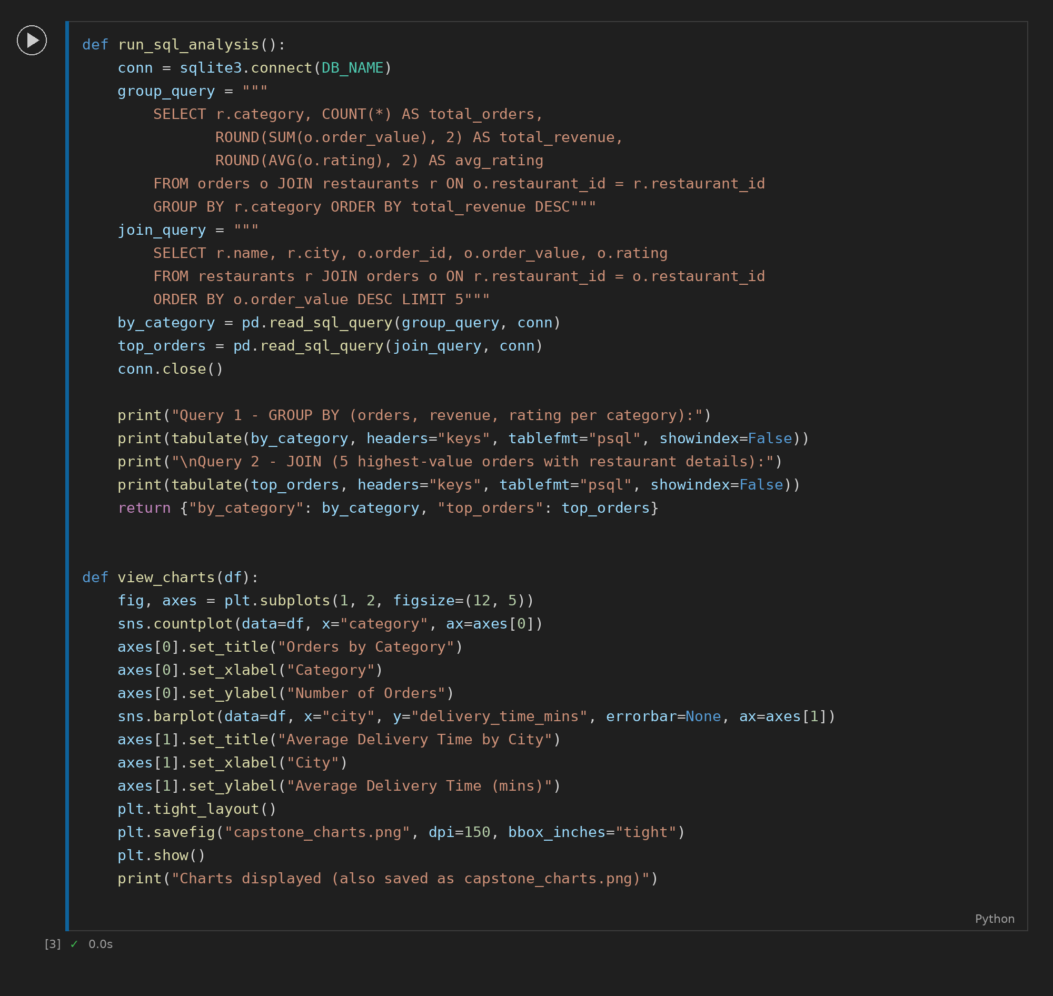
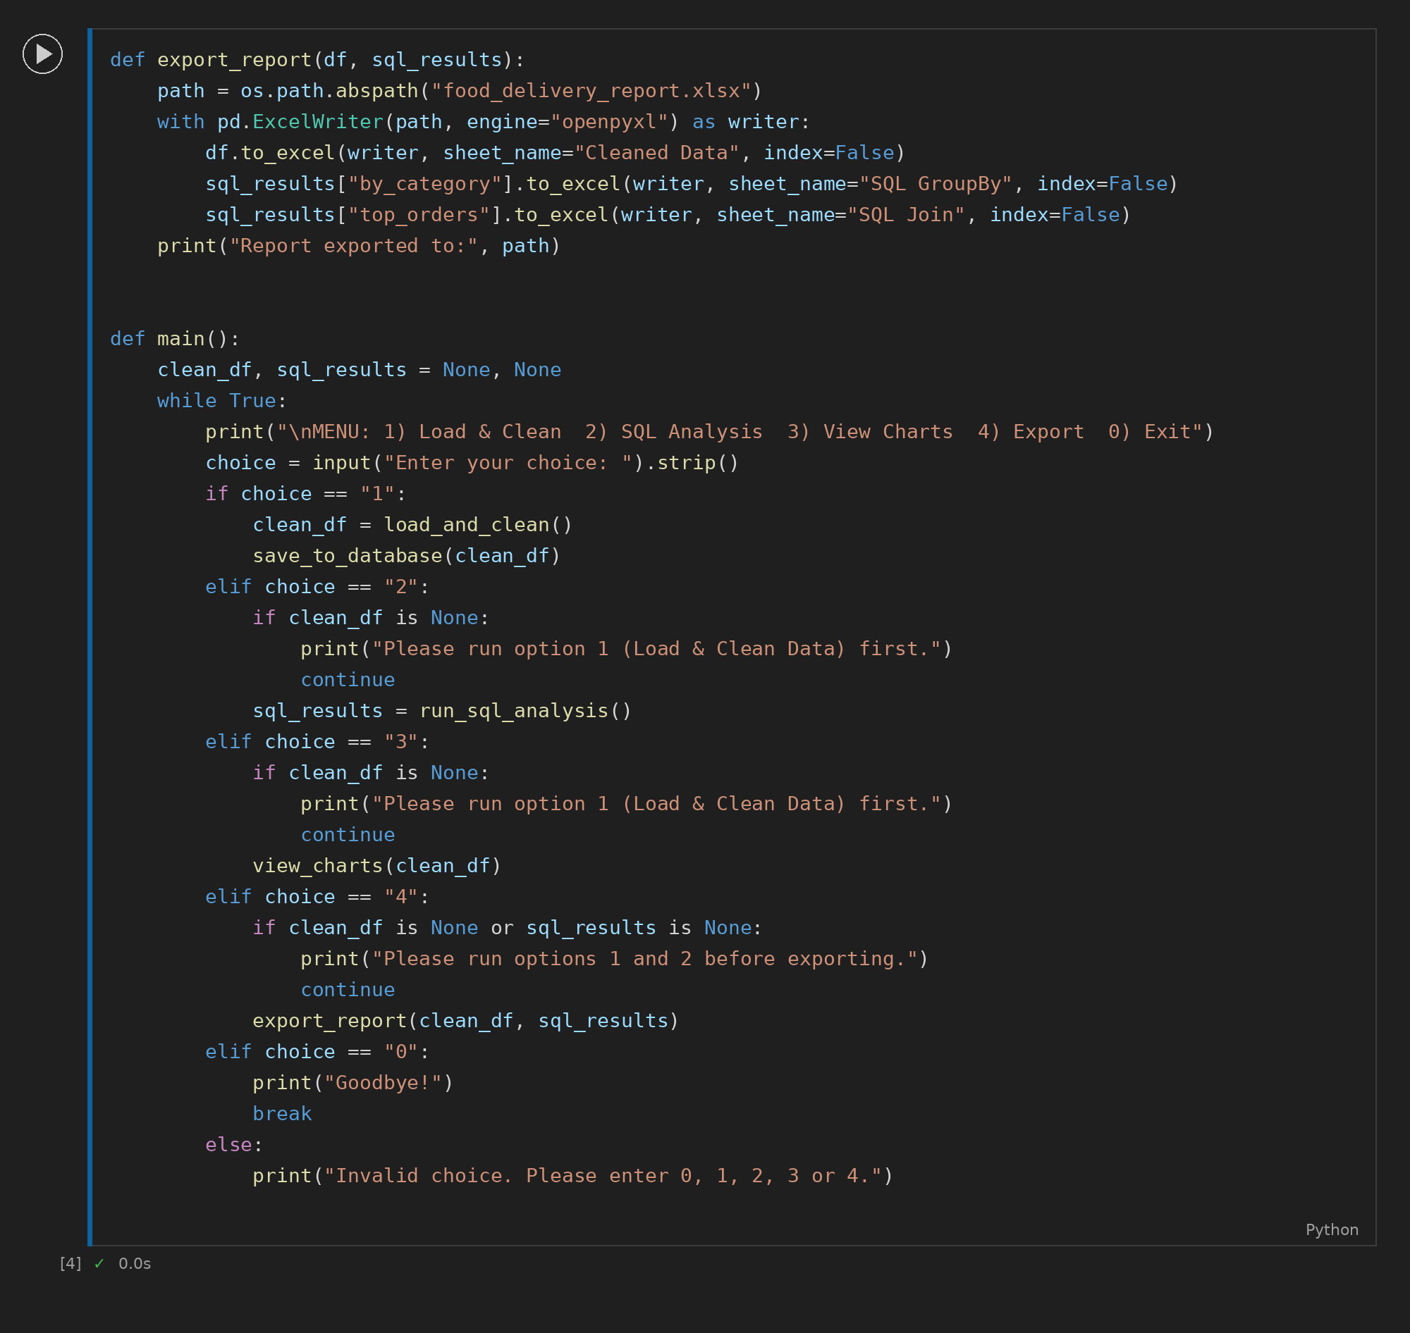
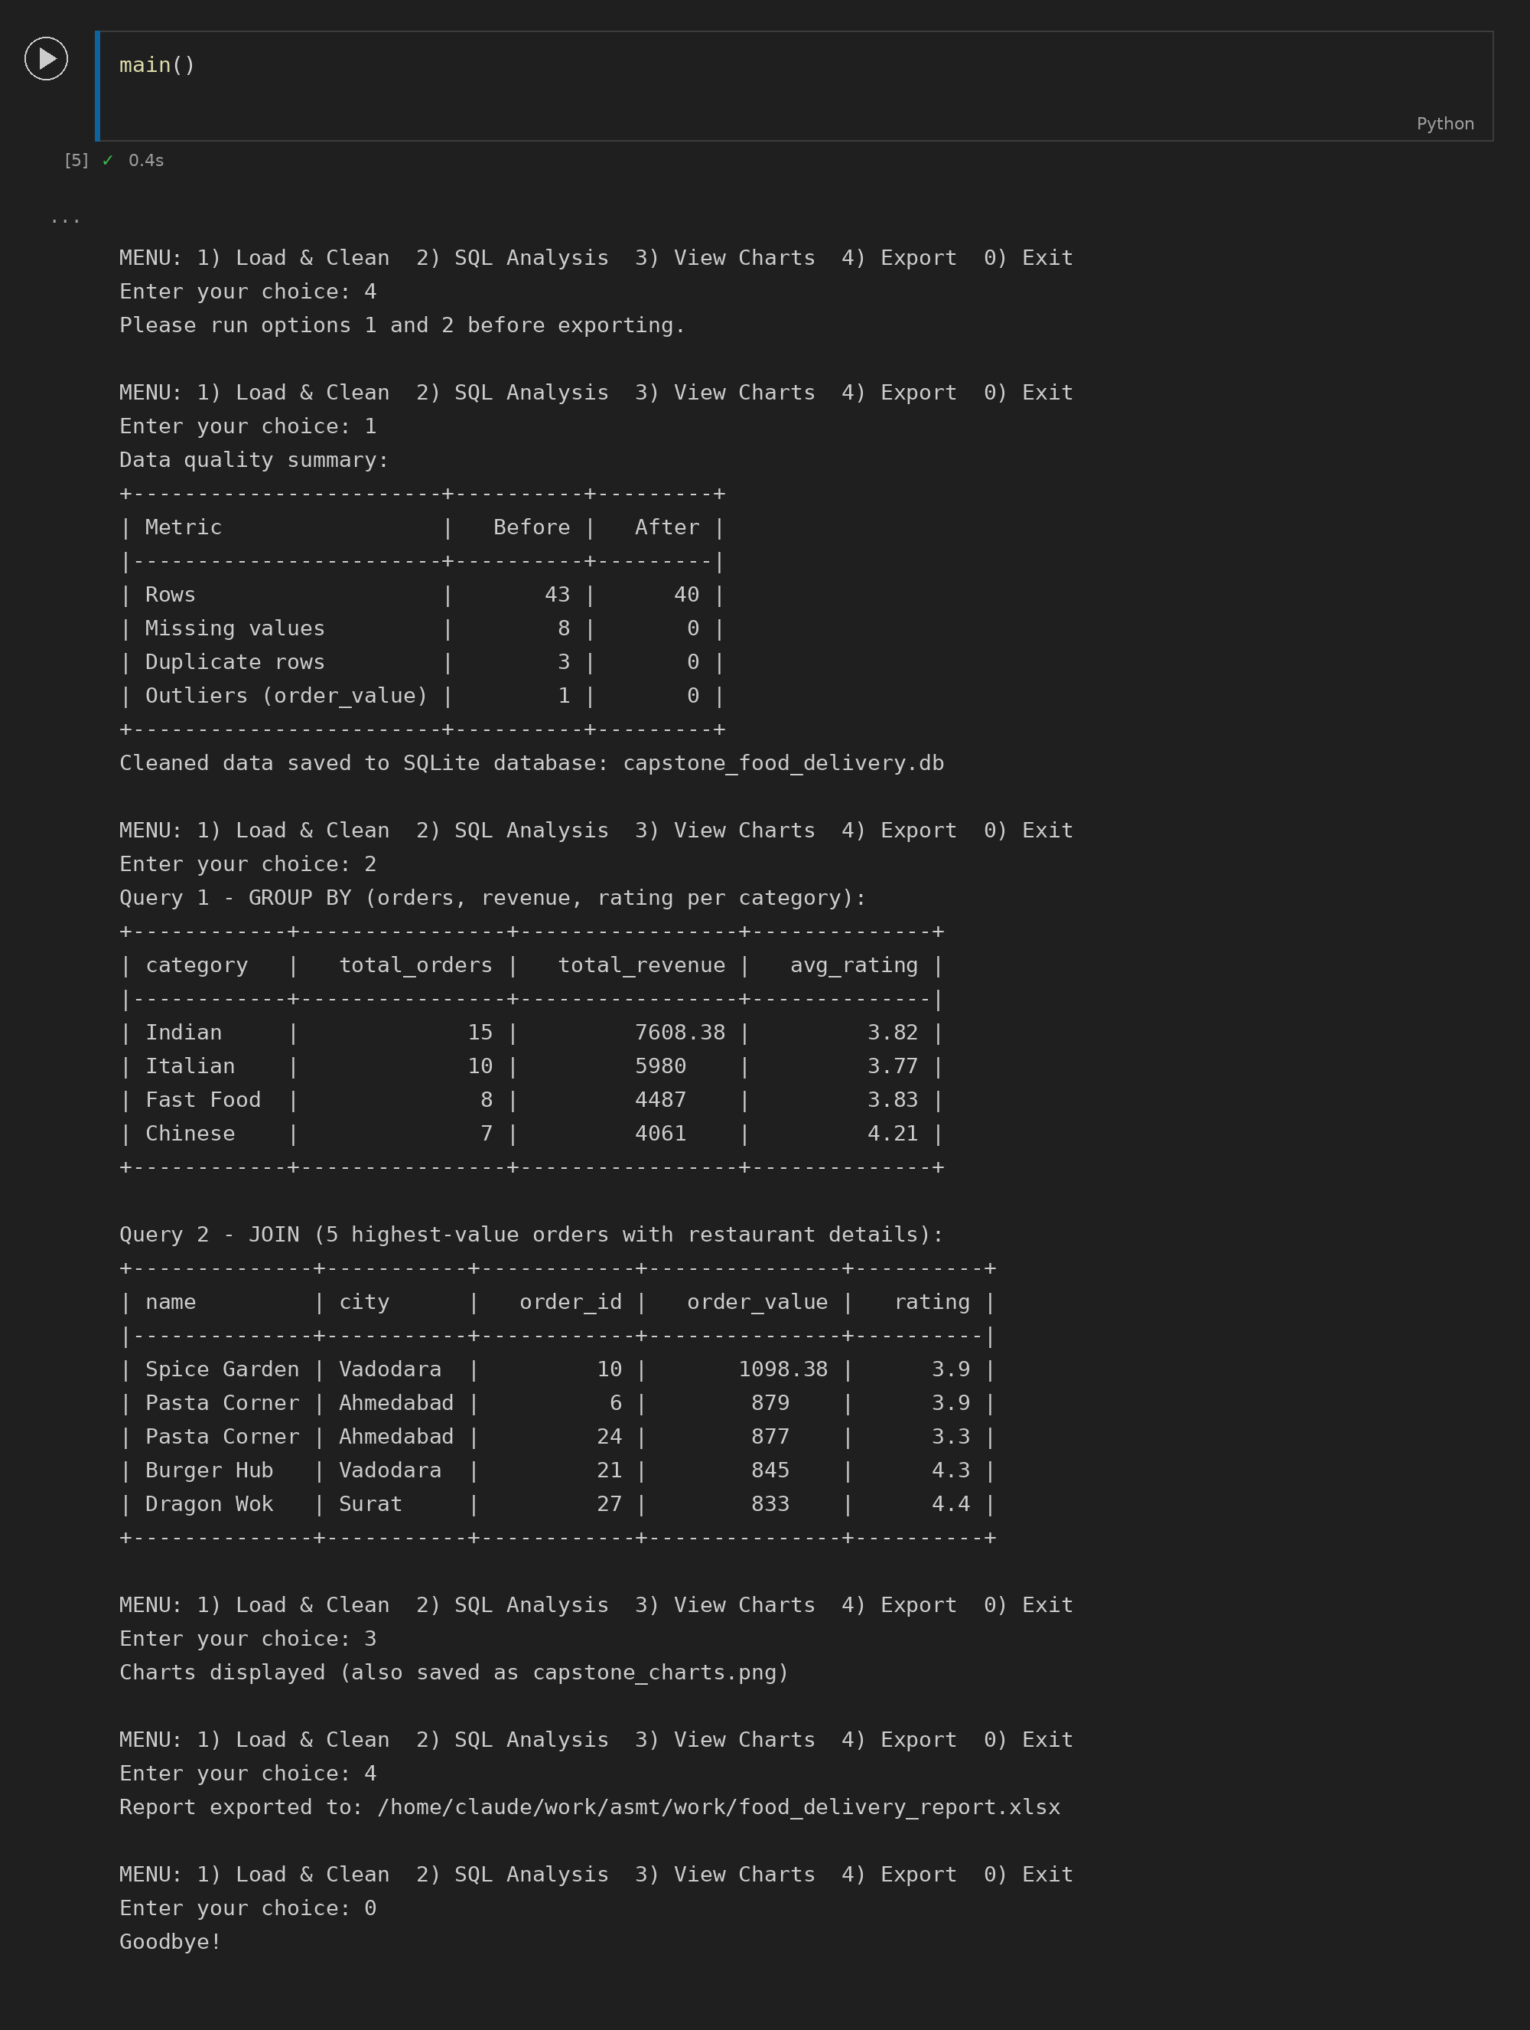
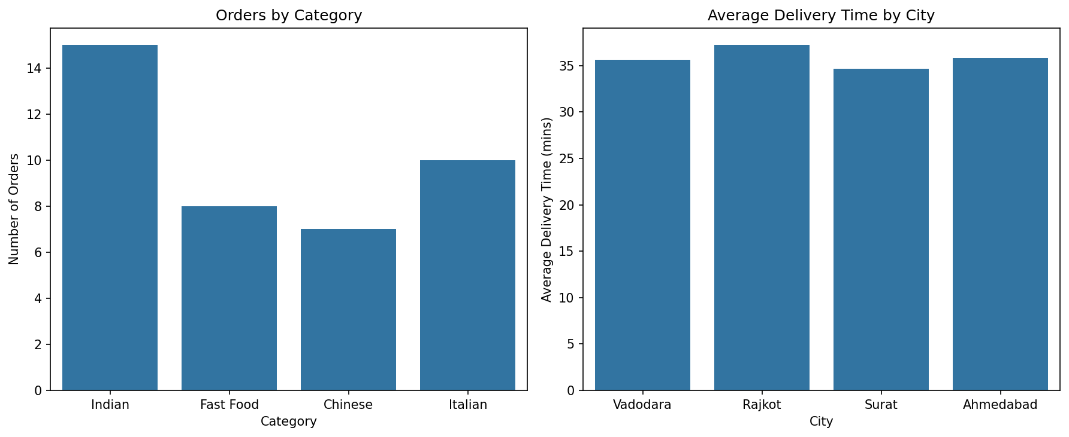

Section D - AI-Augmented Learning

1. Prompt given to the AI tool
Write a Python 3 program that connects to a SQLite database containing a food delivery orders table with the columns order_id, restaurant_name, category, order_value, rating and delivery_time_mins. The program should: (1) query the top 3 restaurants by average customer rating, filtering out any restaurant with fewer than 5 orders; (2) load the SQL result into a Pandas DataFrame and add a new column showing each restaurant's revenue share as a percentage of the total revenue across the top 3 restaurants combined; (3) plot a horizontal bar chart of the top 3 restaurants by average rating, with the revenue share percentage displayed as a bar label on each bar; (4) handle the case where the database file does not exist or the query returns no rows by printing a clear, user-friendly error message rather than crashing.

2a. AI's original code (with test runs)
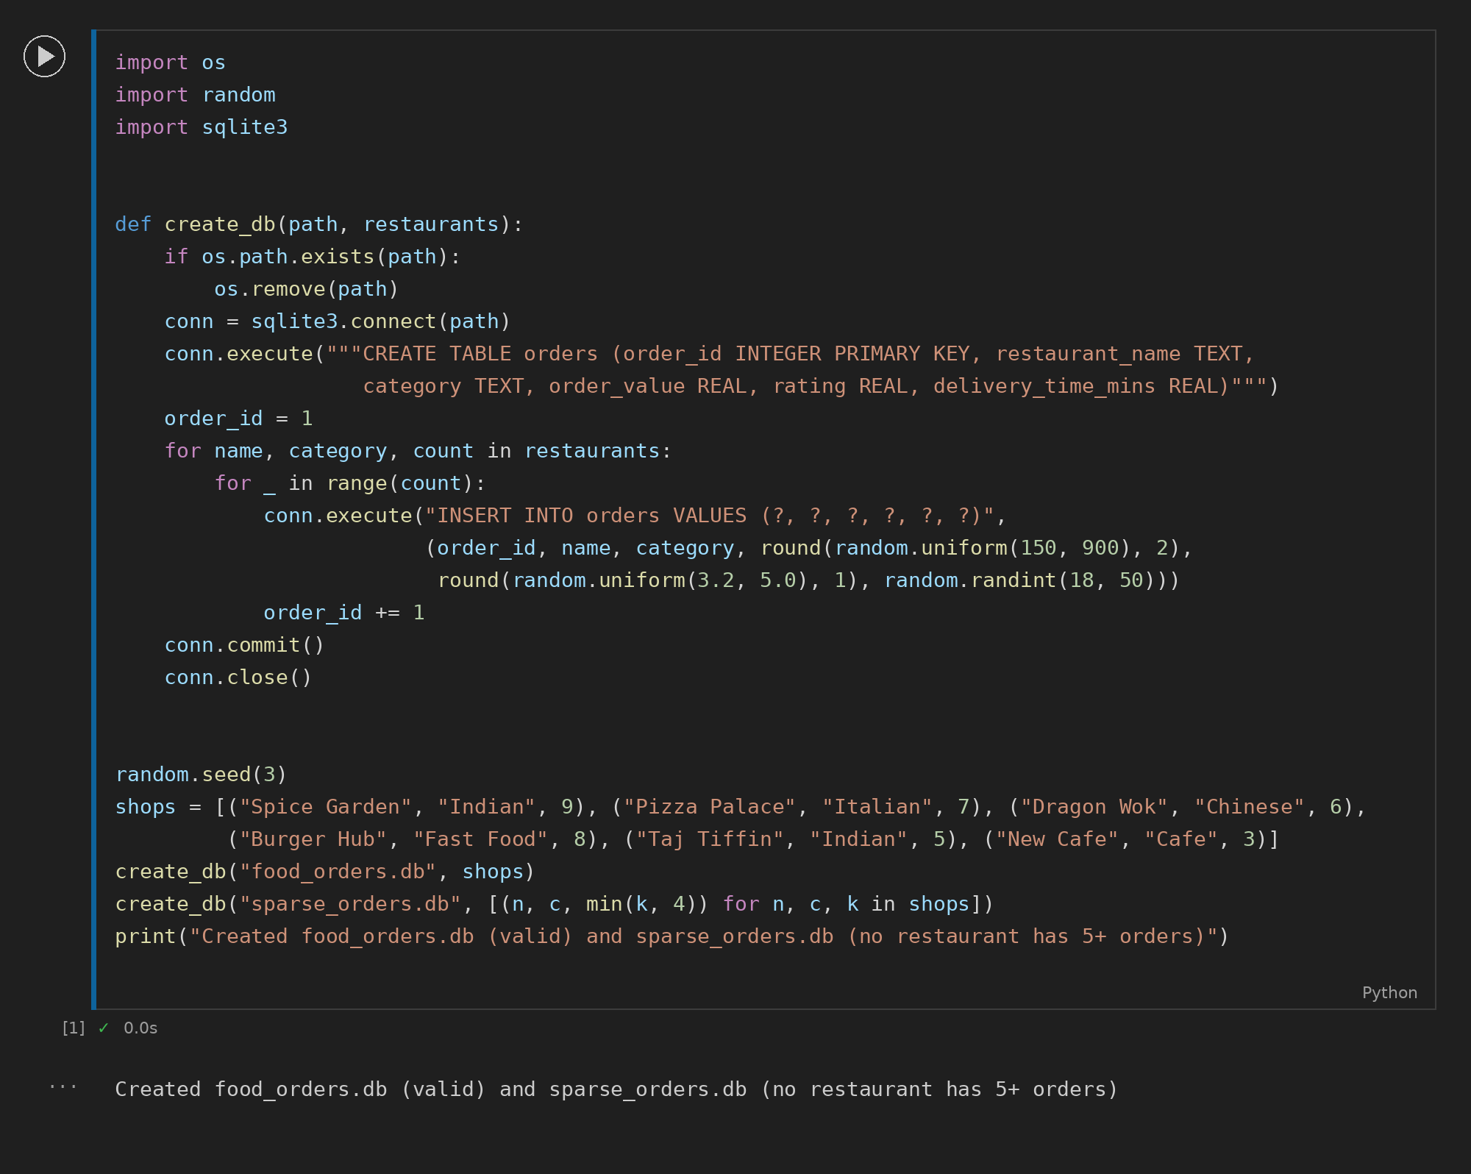
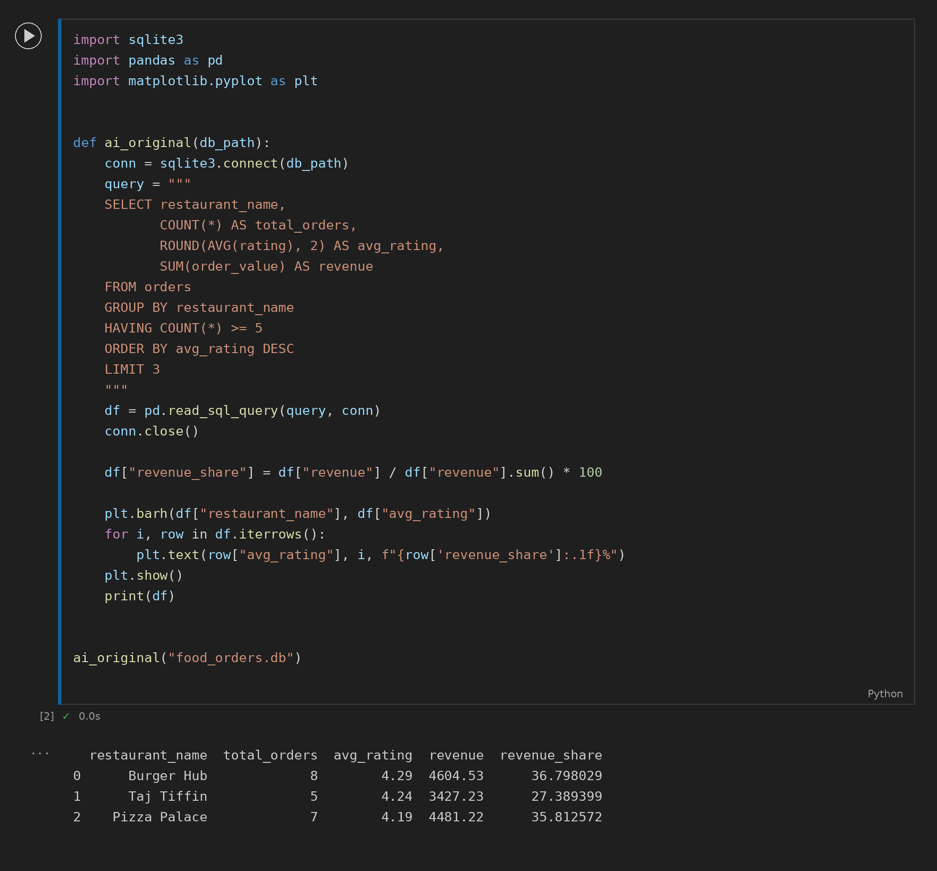
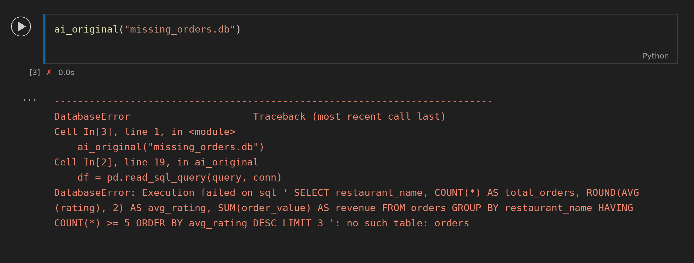
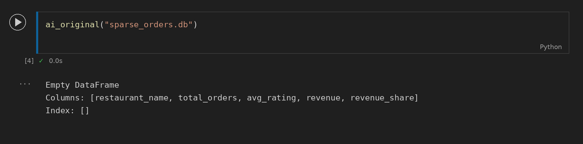
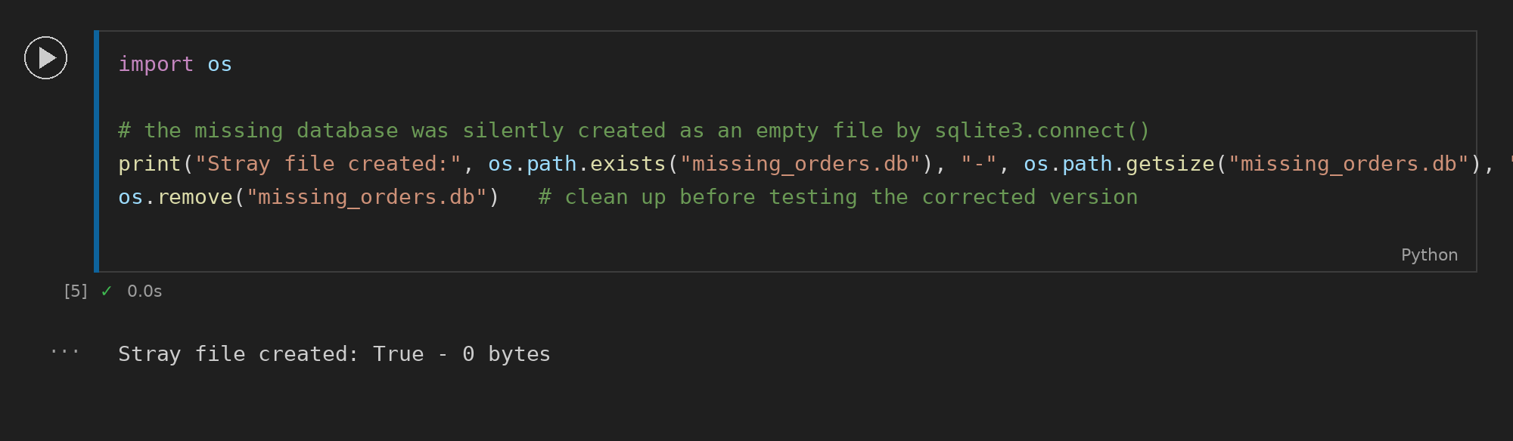

2b. Corrected version (with test runs)
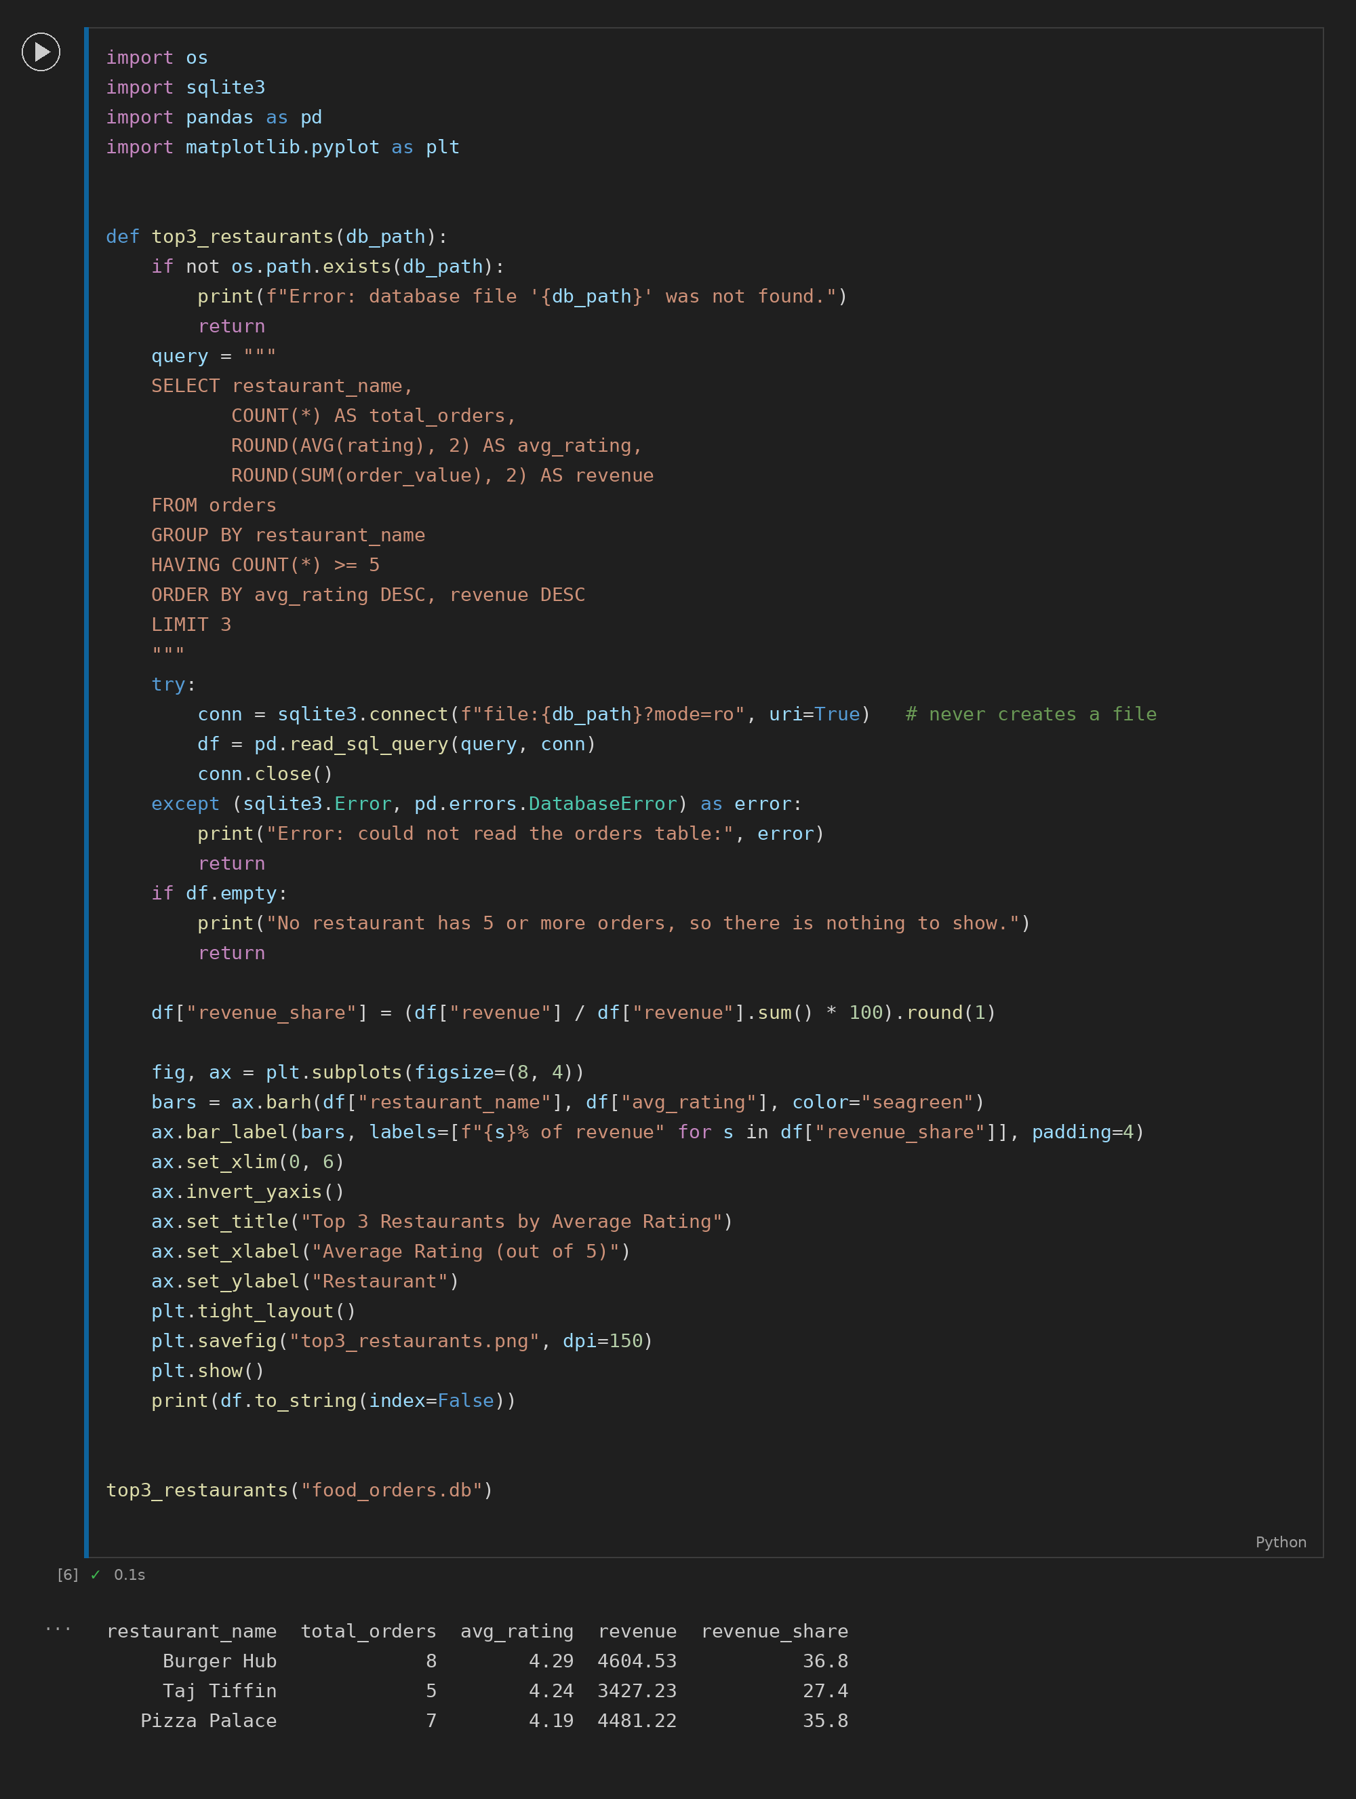
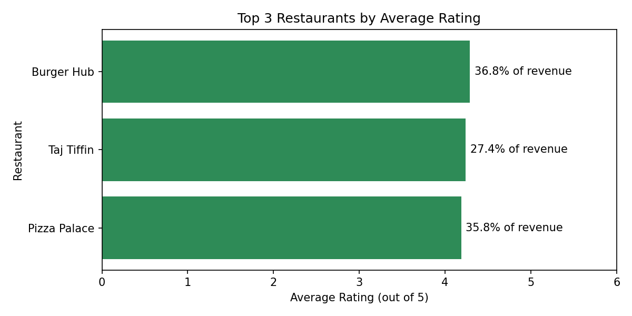
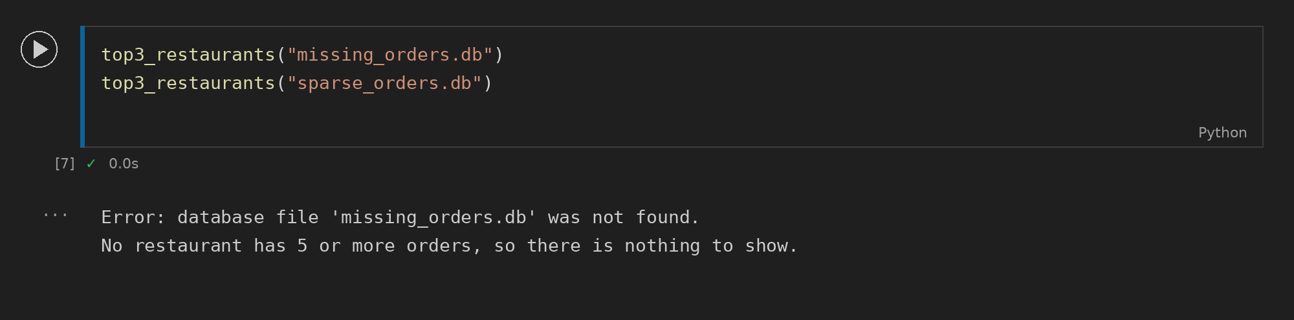

3. What I changed and why
Testing the AI's version on a missing database showed that sqlite3.connect() silently creates an empty file and pandas then crashes with "no such table: orders"; I added an os.path.exists() check, opened the database read-only (mode=ro) and caught sqlite3.Error and DatabaseError so the user sees a friendly message. When no restaurant had 5 or more orders, the AI's code printed an empty DataFrame and drew a blank chart, so I added an empty-DataFrame check before plotting. The chart also had no title or axis labels, and the revenue share was unrounded, so I added labels, rounded the share to 1 decimal and showed it as a proper bar label. Finally I added revenue as a tie-breaker in ORDER BY so that restaurants with equal ratings always give the same top 3.

