Session 15 - SQL + Python Integration

Task 1: Create foodie.db and the Restaurants table
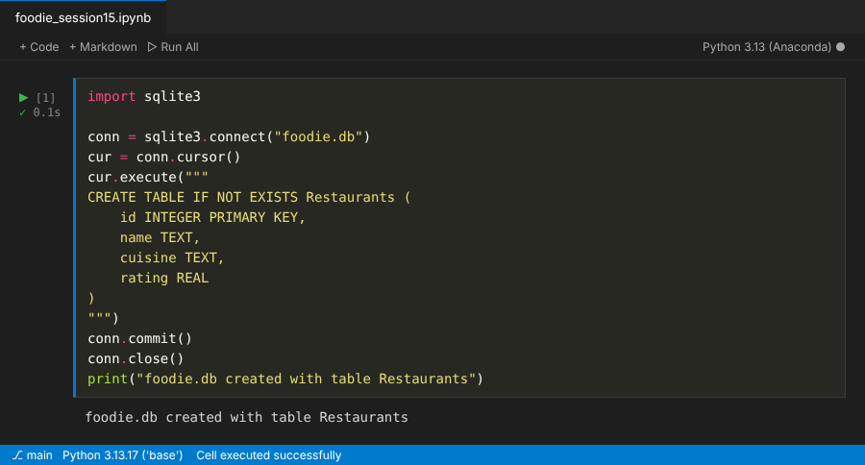

Task 2: Insert three restaurants and query rating above 4.0
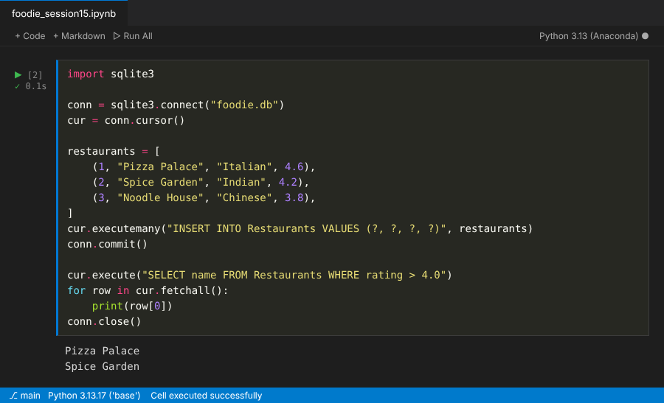

Task 3: Load into a Pandas DataFrame and show head(2)
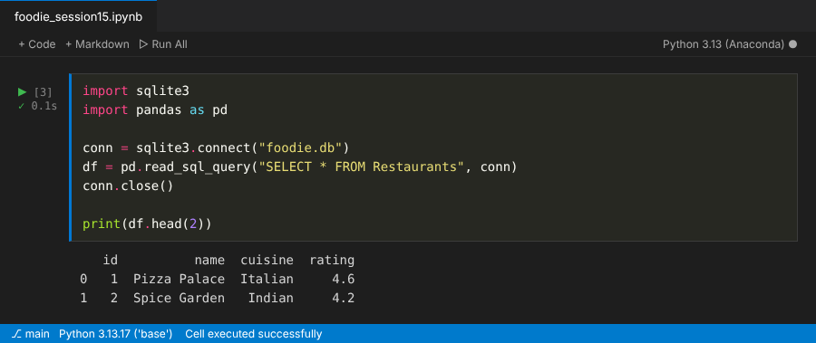

Task 4: delivery_charge and final_rating columns
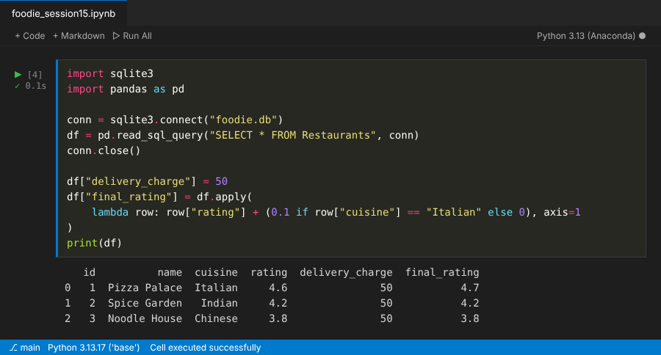

Task 5: Daily summary of top-rated restaurants
