Software Engineering
M5 Database Management
M5-A1 –
Section A — Concept Application
Q1. Food Delivery Database – Constraints
Question: Justify your constraint choices for at least three columns across two tables. What data integrity problems would arise if these constraints were not applied?
Answer:
In a food delivery database, constraints help maintain accurate and consistent data.

1. restaurant_id – PRIMARY KEY: It uniquely identifies each restaurant. Without it, duplicate or ambiguous restaurant records could occur.
2. restaurant_name – NOT NULL: Every restaurant should have a name. Without NOT NULL, incomplete restaurant records could be stored.
3. restaurant_id in menu_items – FOREIGN KEY: It connects each menu item with an existing restaurant. Without it, menu items could reference restaurants that do not exist, creating invalid or orphan records.
4. item_id – PRIMARY KEY: It uniquely identifies each menu item. Without it, menu items could be duplicated or difficult to identify.

Therefore, PRIMARY KEY prevents duplicate identification, NOT NULL prevents missing important data, and FOREIGN KEY maintains valid relationships between tables.
Q2. UPDATE and DELETE – WHERE Clause
Question: Explain why the WHERE clause is essential in each DML statement. What could go wrong with an UPDATE or DELETE executed without a proper WHERE condition?
Answer:
The WHERE clause specifies which records should be updated or deleted.
For example, an UPDATE with WHERE status = 'Pending' changes only pending orders. Similarly, a DELETE with a condition such as availability = 'Unavailable' removes only the required menu items.
Without a proper WHERE clause, an UPDATE could change all records, and a DELETE could permanently remove all records from the table. Therefore, WHERE prevents accidental data modification and data loss.
Q3. Aggregate Functions and HAVING
Question: Which SQL clauses and aggregate functions would you use to produce the report? Explain why HAVING must be used instead of WHERE to filter by aggregate results.
Answer:
We would use SUM() to calculate total revenue, AVG() to calculate average order value, COUNT() to calculate the number of orders, WHERE to filter orders for the current month, GROUP BY to group orders by restaurant, and HAVING to filter restaurants having more than 20 orders.
WHERE filters individual records before grouping, while HAVING filters groups after aggregate functions are calculated.
Therefore, since COUNT(order_id) > 20 is an aggregate condition, HAVING must be used.
Q4. INNER JOIN and LEFT JOIN
Question: Compare INNER JOIN and LEFT JOIN for this query. Which would you use and why? Describe what each join type does to records that have no match in the other table.
Answer:
INNER JOIN returns only records that have a matching record in both tables. If an order refers to a restaurant that no longer exists, that order will not appear.

LEFT JOIN returns all records from the left table, even when there is no matching record in the right table. Missing restaurant information will appear as NULL.

For this requirement, LEFT JOIN should be used because the page must display every order, including orders whose restaurant no longer exists.
Q5. VIEW
Question: Justify why a VIEW is preferred over direct table access here. What are two limitations the front-end developer should be aware of when working with this VIEW?
Answer:
A VIEW is preferred because it provides the front-end developer with only the required information, such as restaurant name, total orders, and average rating, without exposing unnecessary raw table columns.

Advantages:
1. It improves security by hiding unnecessary columns.
2. It makes queries simpler because the front-end can directly query the view.

Two limitations:
1. A view generally does not store separate data; its results depend on the underlying tables.
2. Views containing GROUP BY, aggregate functions, or complex joins may not be directly updatable.
Q6. Transactions – COMMIT, ROLLBACK and SAVEPOINT
Question: Which database mechanism should have prevented this inconsistency? Explain how COMMIT, ROLLBACK, and SAVEPOINT work together to ensure both operations succeed or neither takes effect.
Answer:
A transaction should be used to prevent inconsistency between the wallet deduction and payment record.

COMMIT: Permanently saves all successful operations.
ROLLBACK: Cancels the transaction and restores the previous state if an operation fails.
SAVEPOINT: Creates a point within a transaction to which we can roll back if required.

When placing an order, the wallet deduction and payment insertion should occur in the same transaction. If both operations succeed, COMMIT saves them. If the payment insertion fails, ROLLBACK cancels the wallet deduction as well.

Thus, either both operations succeed or neither operation takes effect, keeping the database consistent.

Section B — Practical Coding Tasks
Task-1
Design and Populate a Restaurant Database
-- Step 1: Create Database
CREATE DATABASE foodapp_db;
-- Step 2: Create Restaurants Table
CREATE TABLE restaurants (
restaurant_id INT AUTO_INCREMENT PRIMARY KEY,
name VARCHAR(100) NOT NULL,
city VARCHAR(100),
cuisine_type VARCHAR(100),
rating DECIMAL(3,1)
);

-- Step 3: Insert 6 Restaurants
INSERT INTO restaurants
(name, city, cuisine_type, rating)
VALUES
('Spice Garden', 'Ahmedabad', 'Indian', 4.5),
('Pizza Hub', 'Ahmedabad', 'Italian', 4.2),
('Tasty Bites', 'Mumbai', 'Fast Food', 4.1),
('Royal Dine', 'Mumbai', 'North Indian', 4.7),
('Food Palace', 'Delhi', 'Indian', 4.3),
('Urban Kitchen', 'Delhi', 'Chinese', 4.0);
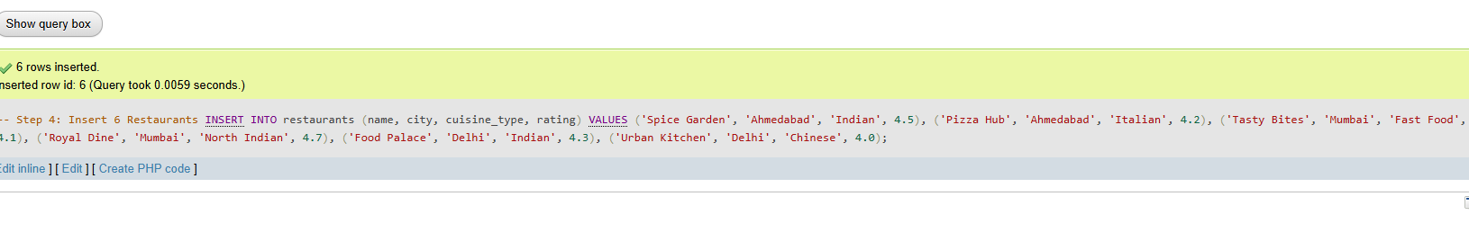
-- Step 4: Display All Restaurants
SELECT * FROM restaurants;

-- Step 5: Update One Restaurant Rating
UPDATE restaurants SET rating = 4.8 WHERE restaurant_id = 4;
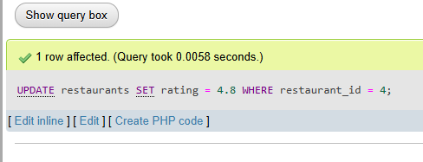
Step 6: Delete One Restaurant
DELETE FROM restaurants WHERE restaurant_id = 6;
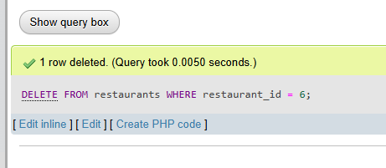
Step 7: Display Restaurants by Rating
SELECT *FROM restaurants ORDER BY rating DESC;
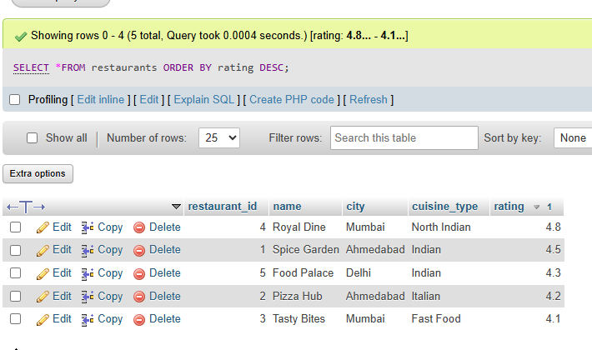
Task 2: Aggregate Revenue Reporting on Orders

CREATE TABLE orders (
order_id INT AUTO_INCREMENT PRIMARY KEY,
restaurant_id INT,
customer_name VARCHAR(100),
total_amount DECIMAL(10,2),
order_date DATE
);
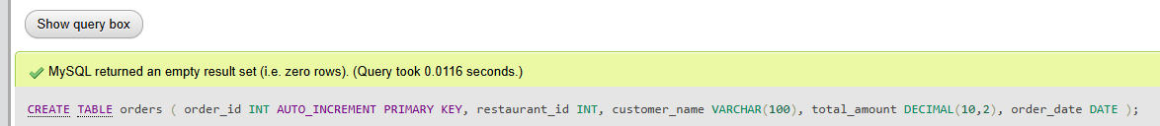
INSERT INTO orders
(restaurant_id, customer_name, total_amount, order_date)
VALUES
(1, 'Ritu', 650, '2026-09-01'),
(1, 'Amit', 800, '2026-09-03'),
(1, 'Neha', 450, '2026-09-05'),

(2, 'Rahul', 1200, '2026-09-06'),
(2, 'Priya', 900, '2026-09-07'),
(2, 'Karan', 750, '2026-09-08'),

(3, 'Meena', 1500, '2026-09-10'),
(3, 'Jay', 1300, '2026-09-11'),
(3, 'Pooja', 850, '2026-09-12'),

(4, 'Vivek', 2000, '2026-09-14'),
(4, 'Anjali', 1800, '2026-09-15'),
(4, 'Raj', 1600, '2026-09-16');
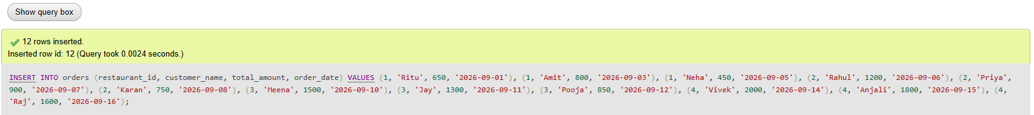
SELECT * FROM orders;
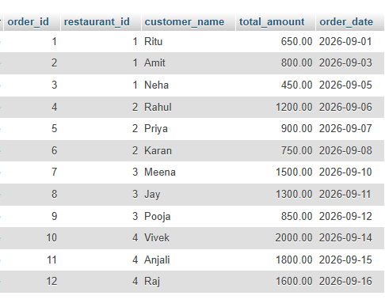
SELECT
restaurant_id,
SUM(total_amount) AS total_revenue,
AVG(total_amount) AS average_order_value
FROM orders
GROUP BY restaurant_id;
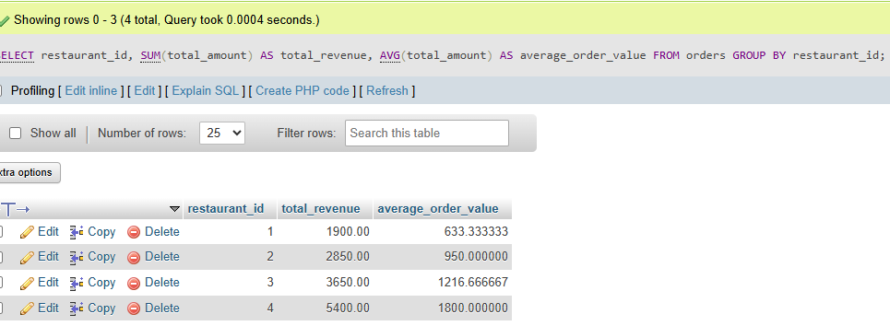
SELECT restaurant_id, SUM(total_amount) AS total_revenue FROM orders GROUP BY restaurant_id
HAVING SUM(total_amount) > 5000;

SELECT *FROM orders ORDER BY order_date DESC LIMIT 5;
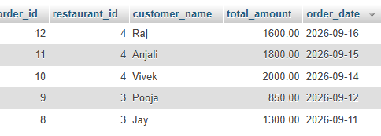
Task 3: Multi-Table JOINs and Menu Summary View

CREATE TABLE menu_items (
item_id INT AUTO_INCREMENT PRIMARY KEY,
restaurant_id INT NOT NULL,
item_name VARCHAR(100) NOT NULL,
price DECIMAL(10,2) NOT NULL,
category VARCHAR(50),

FOREIGN KEY (restaurant_id)
REFERENCES restaurants(restaurant_id)
);

INSERT INTO restaurants
(name, city)
VALUES
('Spice Garden', 'Ahmedabad'),
('Pizza Hub', 'Ahmedabad'),
('Tasty Bites', 'Mumbai'),
('Royal Dine', 'Mumbai'),
('Food Palace', 'Delhi');
SELECT * FROM restaurants;
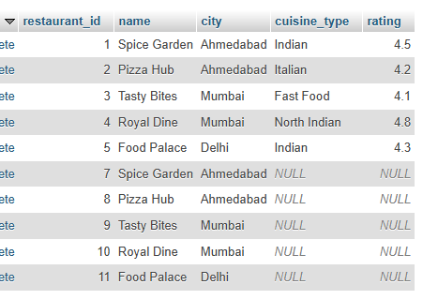

INSERT INTO menu_items
(restaurant_id, item_name, price, category)
VALUES
(1, 'Paneer Tikka', 250, 'Starter'),
(1, 'Butter Naan', 80, 'Bread'),
(1, 'Dal Makhani', 220, 'Main Course'),

(2, 'Margherita Pizza', 350, 'Pizza'),
(2, 'Farmhouse Pizza', 450, 'Pizza'),
(2, 'Garlic Bread', 180, 'Starter'),

(3, 'Veg Burger', 180, 'Burger'),
(3, 'French Fries', 120, 'Side Dish'),

(4, 'Paneer Butter Masala', 280, 'Main Course'),
(4, 'Butter Naan', 80, 'Bread'),
(4, 'Biryani', 300, 'Rice'),
(4, 'Lassi', 100, 'Beverage');
SELECT
r.name AS restaurant_name,
m.item_name,
m.price
FROM restaurants r
INNER JOIN menu_items m
ON r.restaurant_id = m.restaurant_id;
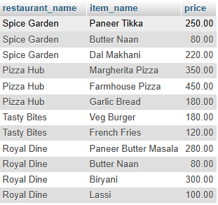
SELECT
r.name AS restaurant_name,
m.item_name,
m.price
FROM restaurants r
LEFT JOIN menu_items m
ON r.restaurant_id = m.restaurant_id;
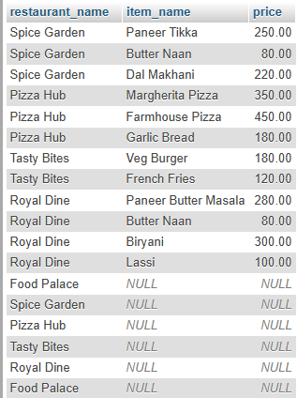
CREATE VIEW restaurant_menu_summary AS
SELECT
r.name AS restaurant_name,
COUNT(m.item_id) AS total_menu_items,
AVG(m.price) AS average_item_price
FROM restaurants r
LEFT JOIN menu_items m
ON r.restaurant_id = m.restaurant_id
GROUP BY r.restaurant_id, r.name;

SELECT * FROM restaurant_menu_summary;
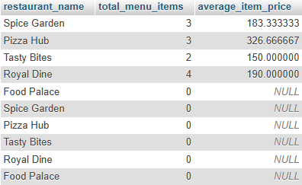

Task 4: PL/SQL Order Placement Procedure

CREATE TABLE customers (
customer_id INT AUTO_INCREMENT PRIMARY KEY,
customer_name VARCHAR(100) NOT NULL,
wallet_balance DECIMAL(10,2) NOT NULL
);

INSERT INTO customers
(customer_name, wallet_balance)
VALUES
('Ritu', 5000.00);
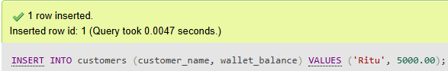

SELECT * FROM customers;
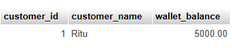
ALTER TABLE orders
ADD COLUMN customer_id INT;
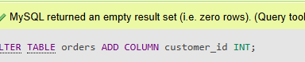
DELIMITER //

CREATE PROCEDURE place_order(
IN p_customer_id INT,
IN p_restaurant_id INT,
IN p_amount DECIMAL(10,2)
)
BEGIN

DECLARE v_balance DECIMAL(10,2);

START TRANSACTION;

SELECT wallet_balance
INTO v_balance
FROM customers
WHERE customer_id = p_customer_id
FOR UPDATE;

IF v_balance < p_amount THEN

ROLLBACK;

SELECT 'Insufficient wallet balance' AS message;

ELSE

UPDATE customers
SET wallet_balance = wallet_balance - p_amount
WHERE customer_id = p_customer_id;
INSERT INTO orders
(customer_id, restaurant_id, total_amount, order_date)
VALUES
(p_customer_id, p_restaurant_id, p_amount, NOW());
COMMIT;
SELECT 'Order placed successfully' AS message;
END IF;
END //
DELIMITER ;
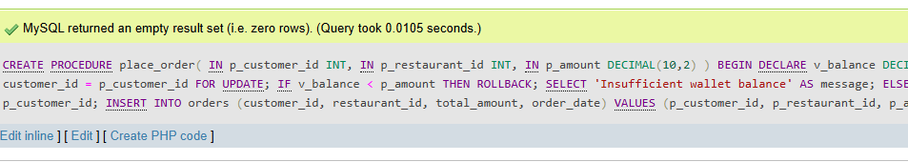

CALL place_order(1, 2, 500);


SELECT * FROM customers;


SELECT * FROM orders;
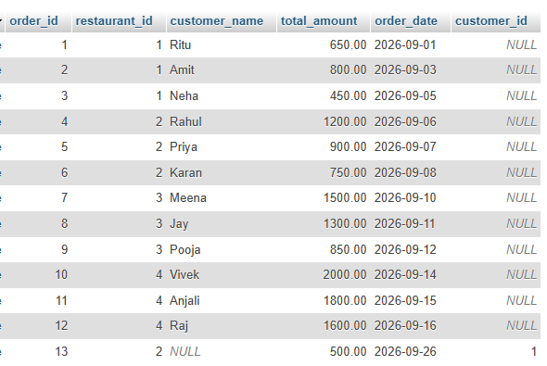
CALL place_order(1, 2, 999999);


C Section C — Mini Capstone Project
Mini Project: Food Delivery Platform — Backend Database

CREATE TABLE cap_restaurants (
restaurant_id INT AUTO_INCREMENT PRIMARY KEY,
name VARCHAR(100) NOT NULL,
city VARCHAR(100)
);

CREATE TABLE cap_menu_items (
item_id INT AUTO_INCREMENT PRIMARY KEY,
restaurant_id INT NOT NULL,
item_name VARCHAR(100) NOT NULL,
category VARCHAR(50) NOT NULL,
price DECIMAL(10,2) NOT NULL,

FOREIGN KEY (restaurant_id)
REFERENCES cap_restaurants(restaurant_id)
);

CREATE TABLE cap_orders (
order_id INT AUTO_INCREMENT PRIMARY KEY,
customer_name VARCHAR(100) NOT NULL,
restaurant_id INT NOT NULL,
item_id INT NOT NULL,
quantity INT NOT NULL,
total_amount DECIMAL(10,2) NOT NULL,

FOREIGN KEY (restaurant_id)
REFERENCES cap_restaurants(restaurant_id),

FOREIGN KEY (item_id)
REFERENCES cap_menu_items(item_id)
);

INSERT INTO cap_restaurants
(name, city)
VALUES
('Spice Garden', 'Ahmedabad'),
('Pizza Hub', 'Mumbai'),
('Royal Dine', 'Delhi');
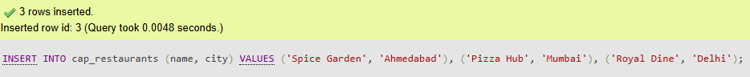

INSERT INTO cap_menu_items
(restaurant_id, item_name, category, price)
VALUES
(1, 'Paneer Tikka', 'Starter', 250),
(1, 'Veg Biryani', 'Main Course', 220),
(1, 'Dal Makhani', 'Main Course', 200),
(1, 'Butter Naan', 'Main Course', 80),
(1, 'Lassi', 'Beverage', 100),

(2, 'Margherita Pizza', 'Pizza', 350),
(2, 'Farmhouse Pizza', 'Pizza', 450),
(2, 'Garlic Bread', 'Starter', 180),
(2, 'Cold Coffee', 'Beverage', 150),
(2, 'Veg Pasta', 'Main Course', 280),

(3, 'Paneer Tikka', 'Starter', 270),
(3, 'Paneer Butter Masala', 'Main Course', 300),
(3, 'Veg Biryani', 'Main Course', 250),
(3, 'Masala Lassi', 'Beverage', 120),
(3, 'Spring Roll', 'Starter', 180);

CREATE VIEW restaurant_sales_summary AS
SELECT
r.name AS restaurant_name,
COUNT(o.order_id) AS total_orders,
COALESCE(SUM(o.total_amount), 0) AS total_revenue
FROM cap_restaurants r
LEFT JOIN cap_orders o
ON r.restaurant_id = o.restaurant_id
GROUP BY r.restaurant_id, r.name;

CREATE TABLE order_audit (
audit_id INT AUTO_INCREMENT PRIMARY KEY,
order_id INT,
restaurant_id INT,
action VARCHAR(20),
log_time DATETIME
);

DELIMITER //

CREATE PROCEDURE add_order(
IN p_customer_name VARCHAR(100),
IN p_restaurant_id INT,
IN p_item_id INT,
IN p_quantity INT
)
BEGIN

DECLARE v_price DECIMAL(10,2);
DECLARE v_total DECIMAL(10,2);
DECLARE v_count INT;

START TRANSACTION;

SELECT COUNT(*)
INTO v_count
FROM cap_restaurants
WHERE restaurant_id = p_restaurant_id;

IF v_count = 0 THEN

ROLLBACK;

SELECT 'Restaurant does not exist. Order cancelled.' AS message;

ELSE

SELECT price
INTO v_price
FROM cap_menu_items
WHERE item_id = p_item_id
AND restaurant_id = p_restaurant_id;

SET v_total = v_price * p_quantity;

INSERT INTO cap_orders
(customer_name, restaurant_id, item_id, quantity, total_amount)
VALUES
(p_customer_name, p_restaurant_id, p_item_id, p_quantity, v_total);

COMMIT;

SELECT 'Order added successfully.' AS message;

END IF;

END //

DELIMITER ;

DELIMITER //

CREATE TRIGGER after_order_insert
AFTER INSERT ON cap_orders
FOR EACH ROW
BEGIN

INSERT INTO order_audit
(order_id, restaurant_id, action, log_time)
VALUES
(NEW.order_id, NEW.restaurant_id, 'INSERT', NOW());

END //

DELIMITER ;

CALL add_order('Ritu', 1, 1, 2);

SELECT * FROM cap_orders;
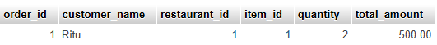

SELECT * FROM order_audit;


CALL add_order('Ritu', 99, 1, 2);
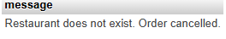
SELECT * FROM restaurant_sales_summary;
