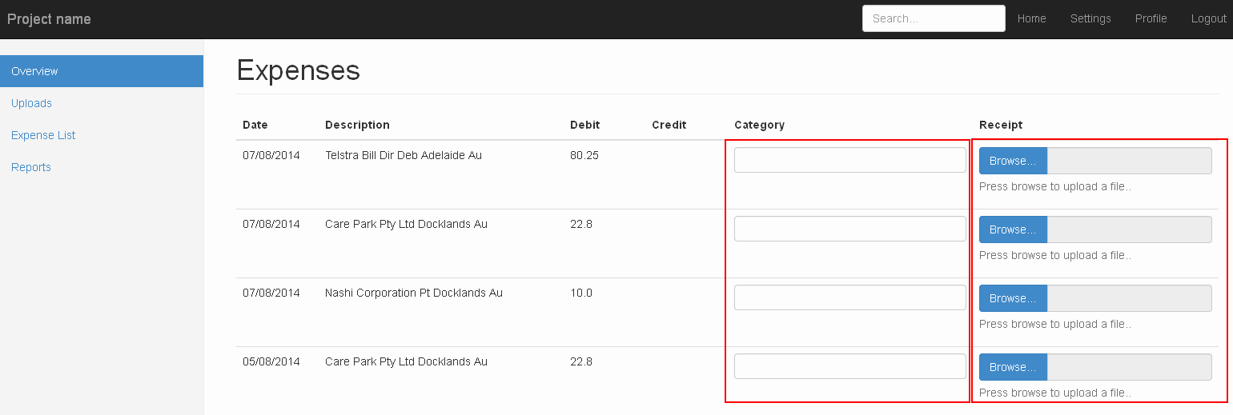

This is how the page looks like on load.

Objective 1.

When the page first appears I would like all “Category” inputs to have some text “Loading...”. As soon as the page loads I would like an Ajax request fired for every “Category” input. The Ajax request should call TransactionCategoryController > getTransactionCategoryByKeyword with the request parameter “phrase” being equal to the “Description” column in the table on the page. I have already written the data access code to retrieve the Transaction Category however it has not been tested so modify if you need to.

When the Ajax request comes back I would like the “Loading...” text to disappear and the input populated with the tag returned from the controller.

Objective 2.

I would like a “Save” button added to the bottom of the page. When the user hits the “Save” button I would like you to submit a POST request to ExpenseListController > saveExpenses and then save all the expenses to the mmdb.transaction table. I have already written the data access code to save the Transactions however it has not been tested so modify if you need to. The controller is set up to accept a json request.

After the POST request to save the Transactions reload the same page and show a simple confirmation of save showing somewhere on the page.

This save will not include a Receipt for the Transaction. See below for more details.

Objective 3.

Before saving the Transactions the input fields in the “Receipt” column should be disabled. But after the save (Objective 2) the inputs in the “Receipt” column should be enabled and the user should be able to browse and upload a file.

I need you to implement using jquery and a new method in a controller. There should be an indicator showing the progress of the upload when the upload is in progress.

After the save of a receipt has been successful the text “Browse” on the browser button should be changed to “View”, the colour of the button should be changed to Red, the text “Press browse to upload a file” should change to “Click here to see Receipt” and the right hand side of the input should show the file name.

The data access code for the save of the receipt has not been written so I need you to do that however you do not need to implement the view function or the delete function on the server side. I will do that at a later stage.

For your reference the example I have been following for the file upload is at <http://codepen.io/claviska/pen/vAgmd>. I have outlined in Red the method I am using.

