<https://realpython.com/python-dash/>

1. For development purposes, it’s useful to think of the process of building a Dash application in three steps:
   1. Define the **content** of your application using the app’s layout.
   2. Style the **looks** of your app with CSS or styled components.
   3. Use callbacks to determine which parts of your app are **interactive** and what they react to.
2. Creating a dash instance:

In flask too we initialize WSGI application using flash(__init__)

1. Dash app layout:

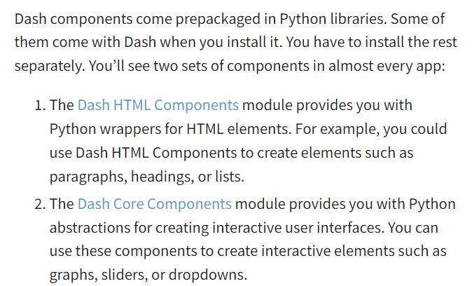

1. Note: You start by defining the parent component, html.Div. Then you add two more elements, a heading (html.H1) and a paragraph (html.P), as its children. These components are equivalent to the <div>, <h1>, and <p> HTML tags.

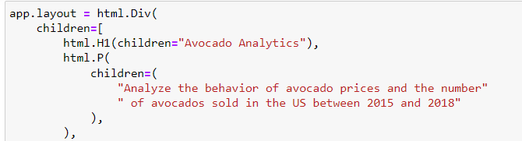

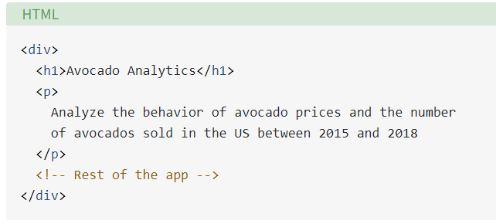

1. to specify what goes inside the <div> tag, you use the children argument in html.Div.
2. Note: important information for plotly and dash from documentation:

1. A white background with black text

   Description automatically generated with low confidenceAdding CSS: