<https://realpython.com/python-dash/>

1. For development purposes, it’s useful to think of the process of building a Dash application in three steps:
   1. Define the **content** of your application using the app’s layout.
   2. Style the **looks** of your app with CSS or styled components.
   3. Use callbacks to determine which parts of your app are **interactive** and what they react to.
2. Creating a dash instance:

In flask too we initialize WSGI application using flash(__init__)

1. Dash app layout:

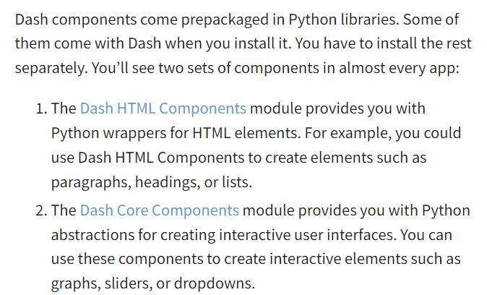

1. Note: You start by defining the parent component, html.Div. Then you add two more elements, a heading (html.H1) and a paragraph (html.P), as its children. These components are equivalent to the <div>, <h1>, and <p> HTML tags.

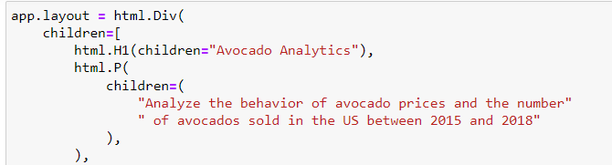

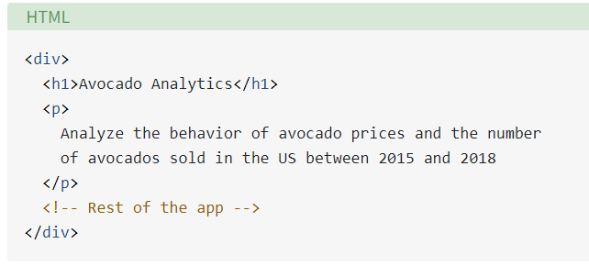

1. to specify what goes inside the <div> tag, you use the children argument in html.Div.
2. Note: important information for plotly and dash from documentation:

1. Adding CSS:

1. Callbacks will be used to define the input that comes from the webpage, do preprocessing on that input and return the output to an HTML component.

The linking of the input and outputs to specific HTML component is done by “id” and an argument of that component which will be affected.