2520090063
R.Radhakrishna
OSSP: Commands:
Uname : It displays the System information
Lscpu : It displays the complete CPU information
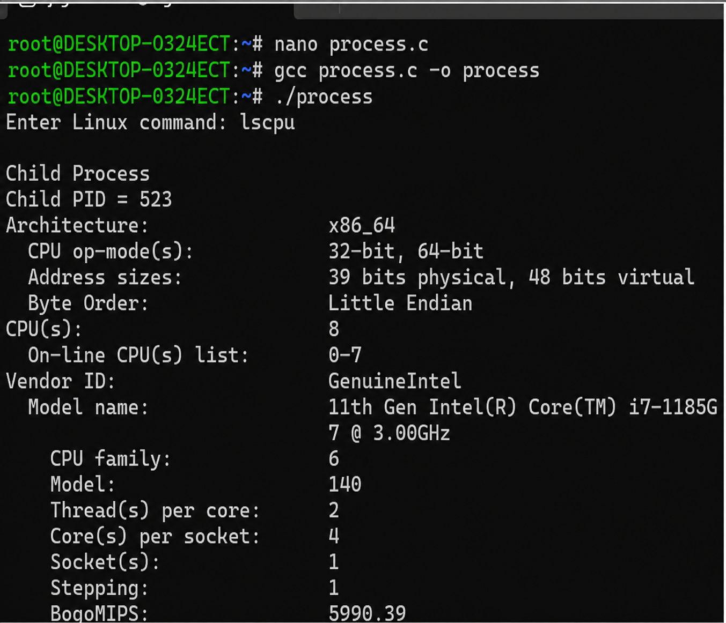
Ps : It displays the running process of our file
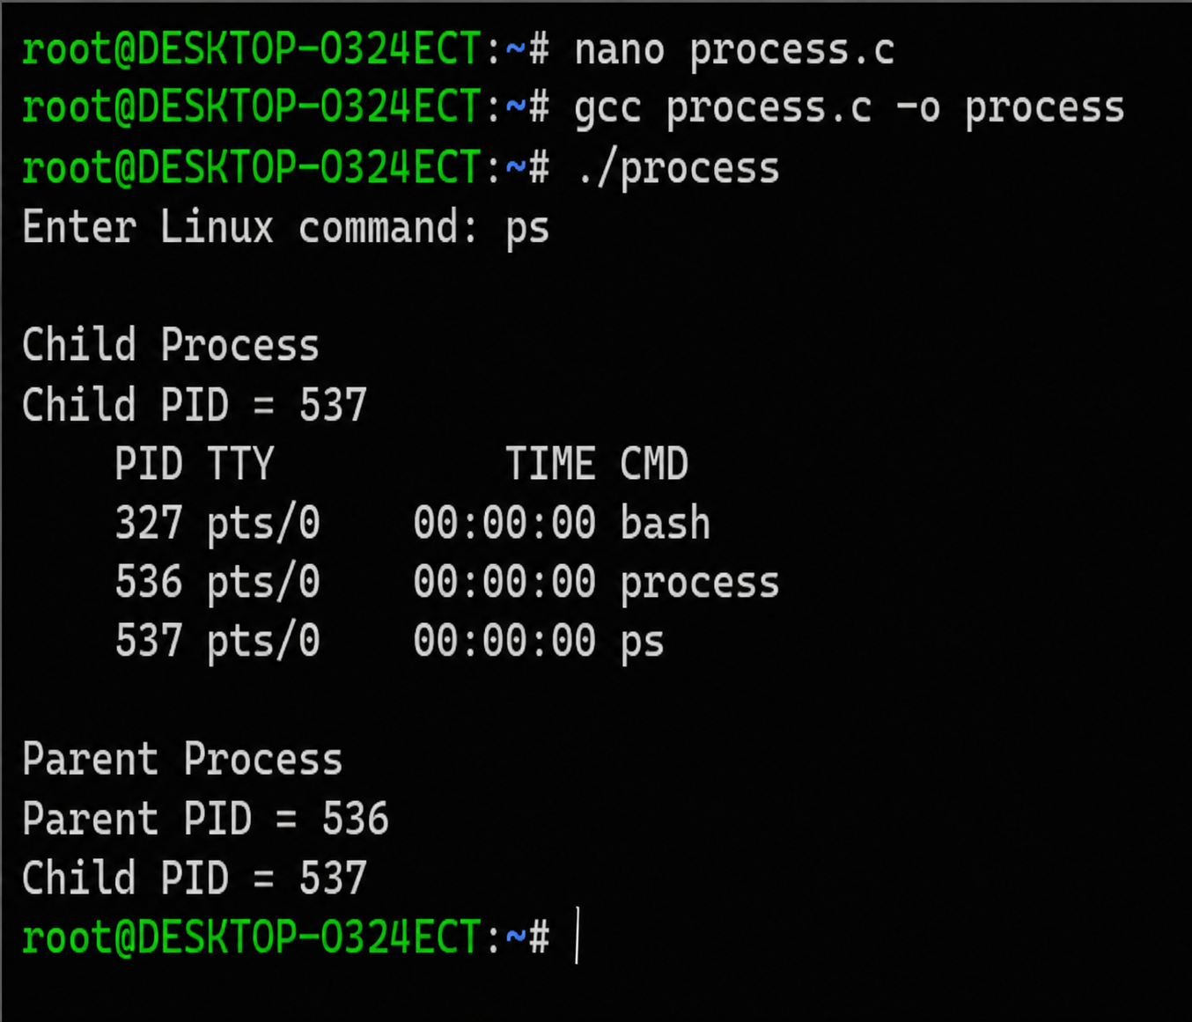
Relation Between Hardware Resources and Operating System Services:
1. CPU
The operating system shares the CPU among multiple programs by giving each one a turn to execute.
Example: When we open Chrome and a music player together, the OS schedules CPU time for both.It Process Both Chrome And music player

2. Memory (RAM) -> Memory Management
The operating system gives memory to each program that is running
It makes sure one program does not use another program's memory.
Example: Chrome and VS Code each get their own memory space while running.

3. Storage (SSD) → File System Management
The operating system storesand organizes files on the storage device.
Example: Saving a document in the Documents folder on our computer.

4. I/O Devices → Device Management
The operating system uses device drivers to control input and output devices.

