Supplementary Materials
Manuscript games-4365462
“Engineered Misunderstanding under Psychological Warfare: A Bayesian Signaling Game of Felt-Understanding Collapse in the German Atomausstieg”
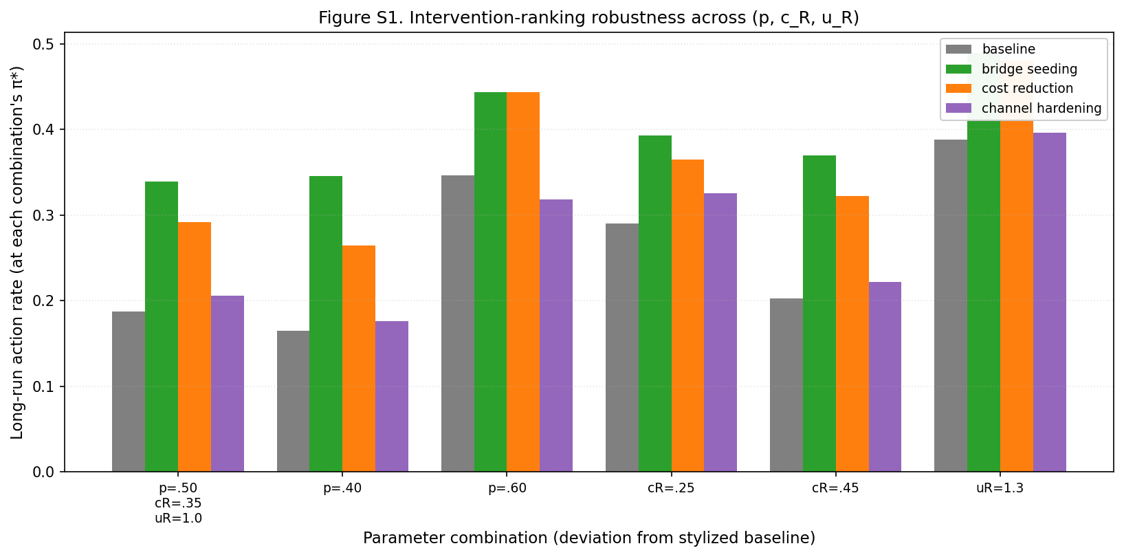
Figure S1. Sensitivity of intervention effectiveness to the stylized parameterization. Long-run action rate under bridge seeding, cost reduction, channel hardening, and the no-intervention baseline, recomputed across six combinations of the prior p, the recognition cost cR, and the recognition payoff uR. The intervention ranking is substantively preserved across the tested combinations: bridge seeding is the strongest intervention or numerically tied with cost reduction, while channel hardening remains the weakest active intervention.
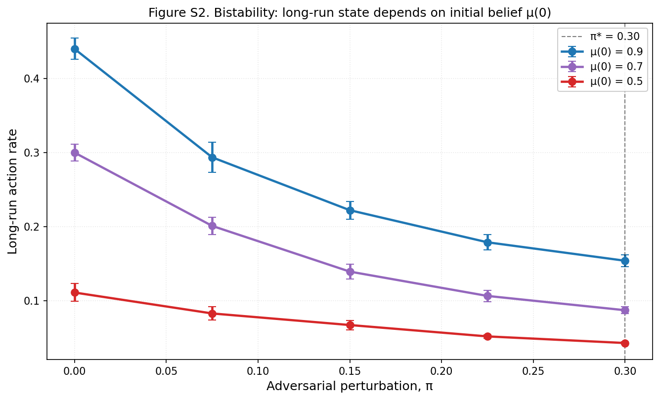
Figure S2. Robustness of the collapse dynamics to the initial belief μ(0). Long-run action rate as a function of μ(0) at π = 0, showing that the system is bistable: trajectories initialized near the cooperative basin (μ(0) = 0.9) remain cooperative, whereas trajectories initialized at the uninformative prior (μ(0) = 0.5) settle into the collapsed basin.

