*SOFTWARE ENGINEERING & CONCEPTS – LAB MANUAL*

BUS MANAGEMENT SYSTEM

*Someshwar K M 220701283*

*B.E. CSE – E : II Year*

**Contents**

Project Overview 2

Business Architecture 4

Requirements as User Stories - Poker Planning Method 8

Architecture Diagram 12

Test Strategy 18

# Project Overview

* **The Problem**

The survey conducted by our team involving the management of college buses revealed a significant amount fo problems with numerous people, especially students coming up with a variety of stories such as missing buses in a very short interval of time, overflowing buses due to the crowd, especially on the weekends, poor infrastructure and much more.

The question that we felt should be raised was when private travel agencies, like **redbus, goibibo, yatra.com**, etc. who are popular among the public, can provide a good service for quite a reasonable price, why can’t **private instituitions**, who charge a large amount of money separately to provide buses to students and give them a good service and experience. Hence, we have taken up this project, or lets say, this problem and strive towards providing solutions.

* **The Data**

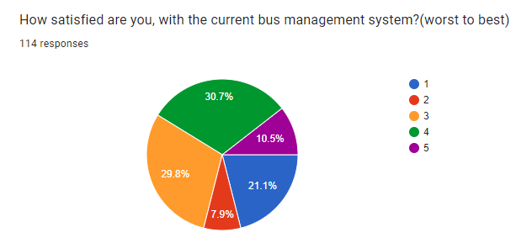

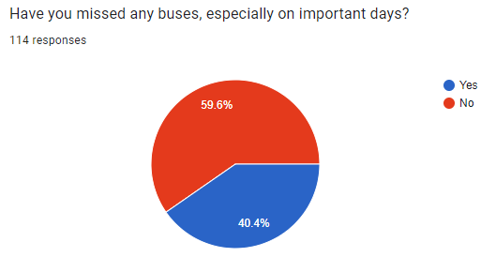

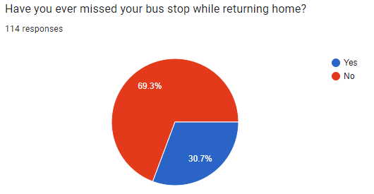

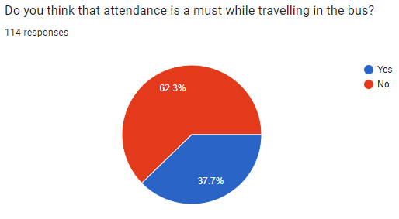

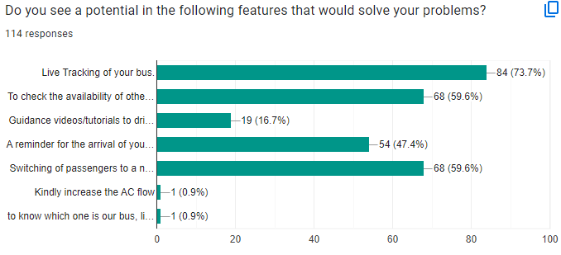

* **The Benefits**

Users, especially the students and the faculties using this system can be benefitted by the various features that we provide to solve the problems being faced so far. First things first that the people need is a **Live Tracking System**, for them to view the location of the buses in real time. This feature, when implemented can turn into a very useful thing. Then we have and **Attendance Automation System** for the attendance taken in the bus, because the manual entries include a lot of proxies. Another feature that’d potentially end the issue of crowded buses is our **Bus Switching Feature**, that would transfer the crowd, i.e., the people who are standing to a nearby bus in the vicinity. There are more of such benefits solving problems whose magnitude ranges from small to critical.

Business Architecture

* **Business need of the project**

Implementing a Bus Management System for a college addresses several critical needs related to transportation efficiency, safety, and user convenience. The goal is to streamline bus operations, enhance safety, and provide real-time information to students, faculty, and staff.

* **The current process (Manual) : How it works**
* **Route Planning :** College administration manually plans and updates bus routes and schedules based on historical data and static assumptions.
* **Tracking :** There is no real-time tracking; students and staff rely on fixed schedules, often leading to uncertainty about bus arrival times.
* **Attendance :** Attendance is recorded manually in a book, opening gates for a lot of proxies and misinformation.
* **Communication :** Notifications about delays or route changes are communicated through bulletin boards, emails, or phone calls, often leading to delays in information dissemination
* **Emergency Management :** In emergencies, bus drivers or students must manually contact the college administration, which can delay response times.

* **Personas and their current experiences**

**1. Students**

**Current Experience:**

**Uncertainty:** Students often wait at bus stops without knowing the exact arrival time of the bus.

**Missed Buses:** Due to lack of real-time updates, students may miss the bus or arrive late to classes.

**Manual Attendance:** Participation in manual attendance processes, which are time-consuming and intrusive.

**Desired Improvements:**

**Real-Time Tracking:** Ability to track bus location and receive timely notifications.

**Automated Attendance:** Streamlined attendance process without manual intervention.

**2. Faculty and Staff**

**Current Experience:**

**Inconsistent Information:** Similar to students, they face uncertainty regarding bus schedules and arrivals.

**Communication Issues:** Inadequate communication about delays or changes affects their planning and punctuality.

**Desired Improvements:**

**Reliable Information:** Access to reliable and real-time bus schedules and notifications.

**Efficient Commuting:** More predictable and efficient commuting experience.

**3. College Administration**

**Current Experience:**

**Resource Intensive:** Significant time and resources spent on managing transportation manually.

**Inaccurate Data:** Errors in manual data entry for attendance and route management.

**Emergency Response:** Delayed response times in case of emergencies due to lack of integrated communication systems.

**Desired Improvements:**

**Operational Efficiency:** Automated and integrated system to reduce manual workload.

**Accurate Data:** Reliable and real-time data for better decision-making.

**Improved Safety:** Faster and more effective emergency response capabilities.

**4. Bus Drivers**

**Current Experience:**

**Communication Gaps:** Inefficient communication with administration and students regarding schedule changes and emergencies.

**Desired Improvements:**

**Effective Communication:** Better tools for communicating with the administration and handling route changes or emergencies.

- **Overall business problems**

**1. Inefficiency**

**Manual Processes:** Time-consuming and error-prone manual processes for route planning, attendance, and communication.

**Resource Allocation:** Inefficient allocation of resources due to lack of real- time data and automation.

**2. Lack of Real-Time Information**

**Uncertainty:** Students and staff face uncertainty regarding bus arrival times, leading to inconvenience and missed classes.

**Delayed Responses:** Delays in communication and emergency response due to the lack of integrated, real-time systems.

**3. Communication Challenges**

**Fragmented Systems:** Inefficient communication channels resulting in delayed or missed notifications.

**Emergency Management:** Slow and ineffective emergency management processes, compromising safety.

**4. Data Accuracy and Security**

**Manual Errors:** High potential for errors in manual data entry for attendance and route management.

**Data Privacy:** Challenges in ensuring data privacy and security with manual and fragmented systems.

- **Business Architecture Diagram**

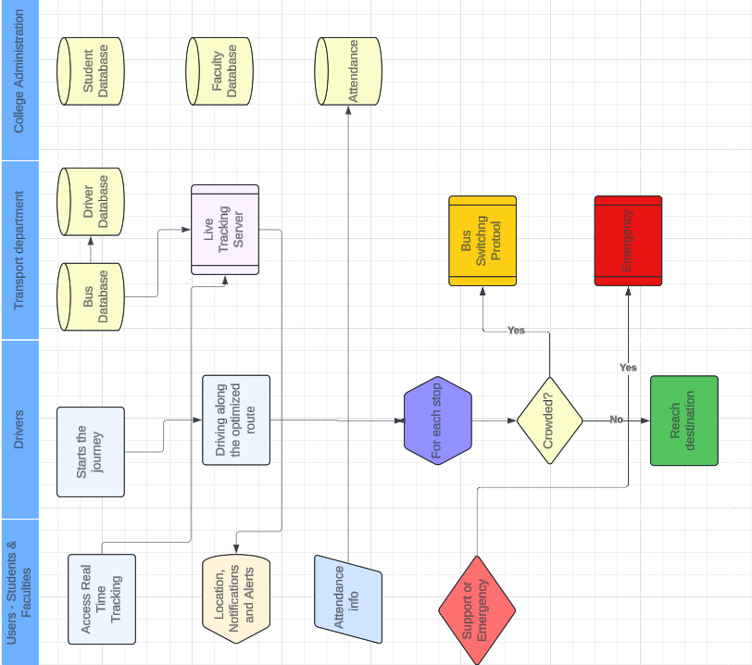

Requirements as User Stories and Estimating Story Points using the “Poker Planning Methodology”

* **Epic -1 : Bus Tracking System**
  + **Feature - 1 : Pin point tracking system( low internet)**
    - **USER STORY 1 :** My internet is slow and live tracking is more delayed than.

**Acceptance Criteria :** Prediction of buses’ possible location with the help of past data.

**Estimated Story Points :** **8** (Requires integration with historical data and predictive algorithms)

* + - **USER STORY 2 :** Management prefers to have a server-light system for increased throughput in all conditions.

**Acceptance Criteria :** Cost efficiency.

**Estimated Story Points : 5** (Focuses on optimizing server usage and performance, which can be complex but is not as data-intensive as the first story)

* + **Feature - 2 : Live tracking system ( high interent )**
    - **USER STORY 3 :** I need to know where my bus at any given moment, with the most accurate ETA.

**Acceptance Criteria :** GPS should be turned on.

**Estimated Story Points : 3** (Relatively straightforward integration with GPS data, assuming infrastructure exists)

* + - **USER STORY 4 :** As a user I want to know where the next closest bus is, incase I miss mine.

**Acceptance Criteria :** Buses in the vicinty should be in under a common network to form a link.

**Estimated Story Points : 8** (Requires real-time data sharing between buses and the central system, potentially complex)

* **Epic -2 : Attendance System**
  + **Feature - 3 : Manual Entry**
    - **USER STORY 5 :** The management needs a manual system to prevent false entries.

**Acceptance Criteria :** Proper maintenance of records.

**Estimated Story Points : 3** (Straightforward, involves creating a simple manual input system)

* + - **USER STORY 6 :** Students wish to digitalize the existing pen-paper system.

**Acceptance Criteria :** Unique identification of students is required.

**Estimated Story Points : 5** (Involves digitizing records and integrating unique IDs for students)

* + **Feature - 4 : Automated entry**
    - **USER STORY 7 :** Students and faculty need a fully automated system for a care - free journey

**Acceptance Criteria :** Real - time updation of the attendance fo the attendance details.

**Estimated Story Points : 8** (Requires real-time data processing and potentially new hardware integration)

* + - **USER STORY 8 :** Students wish to digitalize the existing pen-paper system.

**Acceptance Criteria :** Proper maintenance of records.

**Estimated Story Points : 5** (Similar to User Story 6 but with an emphasis on digitization)

* **Epic -3 : Support and Emergency**
  + **Feature - 5 : SOS Button**
    - **USER STORY 9 :** As the driver of the bus, I wish to swiftly inform the transport dept. regarding help or resources like about a flat tyre, inadequate fuel, brake failure, etc.

**Acceptance Criteria :** Timely response of the transport dept. to avoid mishappenings.

**Estimated Story Points : 5** (Requires a reliable communication system and potentially new processes)

* + - **USER STORY 10 :** As the driver, I need to contact the closest bus or any idle bus in case my bus breaks down.

**Acceptance Criteria :** Alternative buses should be in the vicinity and not too far.

**Estimated Story Points : 8** (Involves real-time data sharing and coordination among buses)

**Summary of the Story Points estimated using Poker Planning :**

|  |  |
| --- | --- |
| **User Story** | **Story Points** |
| **1** | **8** |
| **2** | **5** |
| **3** | **3** |
| **4** | **8** |
| **5** | **3** |
| **6** | **5** |
| **7** | **8** |
| **8** | **5** |
| **9** | **5** |
| **10** | **8** |

**Total story points : 58**

**Analysis:**

**High-Complexity Stories: User Stories 1, 4, 7, and 10 (8 points each) –** These involve significant integration and real-time data processing challenges.

**Medium-Complexity Stories: User Stories 2, 6, 8, and 9 (5 points each) –** These have moderate complexity, often involving optimization and digitization tasks.

**Low-Complexity Stories: User Stories 3 and 5 (3 points each)**

**–** These are relatively straightforward, focusing on basic integration and manual systems.

**Non - Functional Requirements**

**1. Performance**

**Description :** The system must maintain high performance levels to ensure timely and accurate bus tracking and attendance management.

**Requirement :** The system should be able to handle at least 10,000 concurrent users with a maximum response time of 2 seconds for all user interactions.

**Justification :** Ensuring quick response times is essential for features like live tracking and emergency alerts, where delays can significantly impact user experience and safety.

**2. Reliability and Availability**

**Description :** The system must be reliable and available at all times, especially during peak hours when students and staff are using bus services.

**Requirement :** The system must have an uptime of 99.9% and be resilient to handle network outages and hardware failures without significant service disruption.

**Justification :** High availability is crucial for real-time features such as the live tracking system and SOS button, where system downtime can lead to severe inconveniences and safety risks.

**3. Security and Data Privacy**

**Description:** The system must ensure the security and privacy of user data, including personal information and real-time location data.

**Requirement:** All user data must be encrypted both in transit and at rest. The system should comply with relevant data protection regulations (e.g., GDPR, FERPA).

**Justification:** Protecting sensitive information is vital to maintaining trust and compliance with legal standards. Features like unique student identification and real-time tracking require robust security measures to prevent unauthorized access and data breaches.

# Architecture Diagram

# 

Fig : MVC Architectural Design Pattern

# **Model**

# **Function :** Manages data and business logic. Represents the data structure and directly manages the data, logic, and rules of the application.

# **Components :**

# **Tracking Model :** Manages the data and business rules for bus tracking.

# **Attendance Model:** Manages the data and business rules for attendance management.

# **Emergency Model :** Manages the data related to emergencies and alerts.

# **Notification Model :** Manages notification data and logic.

# **Auth Model :** Manages user authentication and authorization data.

# **Route Management Model :** Manages data and logic for bus route management.

# **View**

# **Function :** Displays data to the user and sends user commands to the controller.

# **Components :**

# **Mobile Application :** User interface for mobile users.

# **Web Application :** User interface for web users.

# **Controller**

# **Function :** Acts as an intermediary between Model and View. It listens to the input from the View, processes it with the help of the Model, and returns the output display to the View.

# **Components :**

# **Bus Tracking Controller :** Handles user requests related to bus tracking.

# **Attendance Controller :** Manages requests related to attendance.

# **Emergency Controller :** Manages emergency alerts and notifications.

# **Notification Controller :** Handles notification-related requests.

# **Auth Controller :** Manages authentication and authorization processes.

# **Route Management Controller :** Handles bus route creation, modification, and management requests.

# **Error Handling and Logging**

# **Error Handling :** Integrated within the Controllers to manage exceptions and errors gracefully.

# **Logging :** Integrated within the Controllers to log important events and errors for monitoring and debugging purposes.

# **Data Storage**

# **Relational Database :** Stores structured data such as student, staff, and route information.

# **NoSQL Database :** Stores unstructured data such as real-time tracking data and logs, providing flexibility and scalability.

# **Architecture Pattern Used: MVC (Model-View-Controller)**

# **Why MVC?**

# **Separation of Concerns :** Clearly separates data (Model), user interface (View), and business logic (Controller), improving maintainability and scalability.

# **Reusability :** Components (Models, Views, Controllers) can be reused across different parts of the application.

# **Testability:** Each component can be tested independently, improving the overall quality of the system.

# **Design Principles Used**

# **Single Responsibility Principle (SRP) :** Each component (Model, View, Controller) has a single responsibility, ensuring high cohesion and low coupling.

# **Separation of Concerns (SoC) :** Divides the application into three main components, each handling distinct aspects of the application.

# **Encapsulation :** Each component encapsulates its data and behavior, exposing only necessary interfaces for interaction.

# **Modularity :** Each part of the application (Model, View, Controller) is a module that can be developed, tested, and maintained independently.

# **Implementation Strategy**

# **Develop Models :** Define the data structure and business logic for each component (Tracking, Attendance, Emergency, Notification, Auth, Route Management).

# **Implement Controllers :** Develop controllers to handle user inputs, interact with models, and update views accordingly.

# **Create Views :** Design the user interface for both mobile and web applications to interact with the controllers.

# **Integrate Error Handling and Logging :** Implement error handling within controllers to manage exceptions and ensure graceful degradation.

# Integrate logging within controllers to record important events and errors.

# Bus Management System Class Diagram

**CLASS DIAGRAM**

**SEQUENCE DIAGRAM**

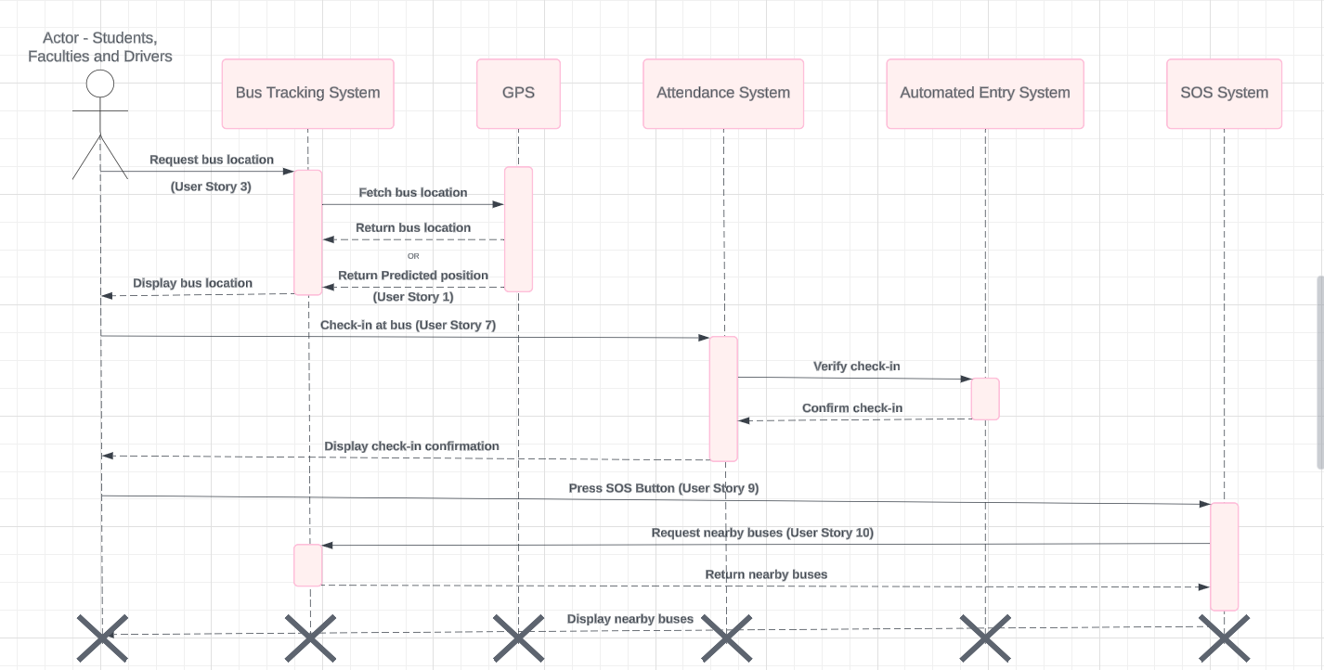

Test Strategy - Test Plans and Test Cases for user stories showcasing Happy Paths(HP) and Error Scenarios(ES)

The test strategy for the Bus Management System aims to ensure that all functionalities meet the specified requirements and perform reliably. This document outlines the test plans and test cases for five selected user stories, showcasing both happy paths and error scenarios.

**Test Plans**

**Test Plan for User Story 1: Slow Internet and Delayed Live Tracking**

**Objective :** Verify that the system predicts the bus location accurately using past data under low internet conditions.

**Test Cases**

**Test Case ID : TC1-HP**

**Description:** Validate bus location prediction using past data when internet is slow.

**Preconditions: Simulate slow internet connection.**

**Steps:**

1. Launch the bus tracking feature.
2. Check the predicted location displayed on the map.

**Expected Results:** The system should display the bus's possible location based on past data.

**Test Case ID : TC1-ES**

**Description :** Validate system behavior when past data is unavailable.

**Preconditions :** No past data available for the bus.

**Steps:**

1. Launch the bus tracking feature.
2. Check the predicted location displayed on the map.

**Expected Results :** The system should show a message indicating the unavailability of location prediction due to lack of past data.

**Test Plan for User Story 3 : Accurate ETA with GPS**

**Objective :** Ensure the GPS is on and the system provides the most accurate ETA.

**Test Cases**

**Test Case ID : TC3-HP**

**Description :** Validate accurate ETA when GPS is on.

**Preconditions :** GPS enabled on the device.

**Steps:**

1. Launch the bus tracking feature.
2. Check the current bus location and ETA.

**Expected Results :** The system should display the current bus location and an accurate ETA.

**Test Case ID: TC3-ES**

**Description :** Validate system behavior when GPS is off.

**Preconditions :** GPS disabled on the device.

**Steps :**

1. Launch the bus tracking feature.
2. Check the current bus location and ETA.

**Expected Results :** The system should prompt the user to enable GPS for accurate tracking.

**Test Plan for User Story 5 :** Manual System to Prevent False Entries

**Objective :** Ensure that manual entries are correctly recorded and false entries are prevented.

**Test Cases**

**Test Case ID : TC5-HP**

**Description :** Validate proper maintenance of records with manual entry.

**Preconditions :** System is set to manual entry mode.

**Steps :**

1. Manually enter attendance for a student.
2. Check the attendance records.

**Expected Results :** The entered attendance should be correctly recorded.

**Test Case ID : TC5-ES**

**Description :** Validate system behavior when a duplicate entry is made.

**Preconditions :** System is set to manual entry mode.

**Steps :**

1. Manually enter attendance for a student.
2. Attempt to enter attendance for the same student again.
3. Check the attendance records.

**Expected Results :** The system should prevent the duplicate entry and show an error message.

**Test Plan for User Story 7 : Fully Automated Attendance System**

**Objective :** Ensure that the automated system updates attendance details in real-time.

**Test Cases**

**Test Case ID : TC7-HP**

**Description :** Validate real-time updating of attendance details.

**Preconditions :** Automated attendance system is enabled.

**Steps :**

1. A student boards the bus.
2. Check the attendance records.

**Expected Results :** The system should automatically update the attendance records in real-time.

**Test Case ID : TC7-ES**

**Description :** Validate system behavior when there is a network issue.

**Preconditions :** Simulate network outage.

**Steps :**

1. A student boards the bus.
2. Check the attendance records.

**Expected Results :** The system should queue the attendance data and update records once the network is restored.

**Test Plan for User Story 9 :** Emergency Alerts by Driver

**Objective :** Ensure that the driver can send emergency alerts and receive a timely response.

**Test Cases**

**Test Case ID : TC9-HP**

**Description :** Validate the timely response to an emergency alert.

**Preconditions :** System is operational, and transport department is responsive.

**Steps :**

1. Driver presses the SOS button.
2. Check if the transport department receives the alert.
3. Verify the response time.

**Expected Results :** The transport department should receive the alert, and a response should be sent within the expected time frame.

**Test Case ID : TC9-ES**

**Description :** Validate system behavior when the transport department does not respond.

**Preconditions :** Simulate non-responsiveness from the transport department.

**Steps :**

1. Driver presses the SOS button.
2. Check if the system retries or escalates the alert.

**Expected Results :** The system should retry sending the alert and escalate the issue if no response is received within a specific time frame.

**Azure DevOps**

