**Guided Capstone - Step Six – Big Mountain Resort Price Model Report**

Rebeca Mahr

Nov 29, 2020

**Introduction & Background**

Big Mountain Resort (BMR) in Montana which has 105 trails attracts about 350,000 people for five days on average to ski or snowboard each season. To increase the distribution of visitors across the mountain, the resort added a chairlift which increased seasonal operating costs by $1.54 million. In order to afford the extra operating costs, BMR needs to increase annual revenue by increasing lift ticket prices and/or modifying existing facilities.

The data science team was tasked with developing a pricing model to predict the ideal chair lift ticket price for the next season based on BMR’s most competitive offerings in comparison to market competitors. A data source[1] including several resort offerings and lift ticket prices across 330 ski resorts was used for analysis. Prior to model development, the data underwent a thorough data wrangling process, exploratory data analysis, and preprocessing and training[2].

**How does BMR Compare?**

Exploratory data analysis and modeling found that key resort features driving lift ticket prices include number of fast quad chairlifts (r=.73), number of runs (r=.76), total snow making acreage (r=.7), and max vertical drop (r=.71).

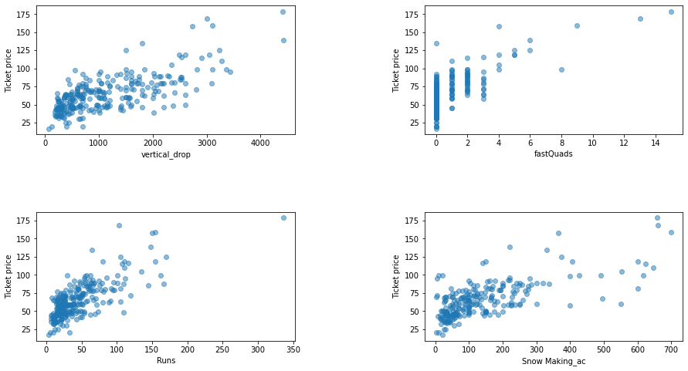

BMR has more competitive facilities on each of these key driver features than a majority of other ski resorts as shown in the dotted red line in the plot below.

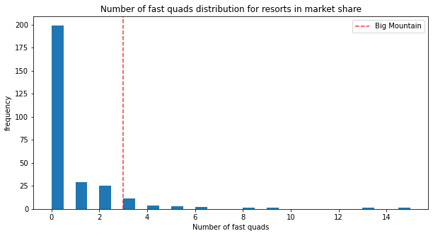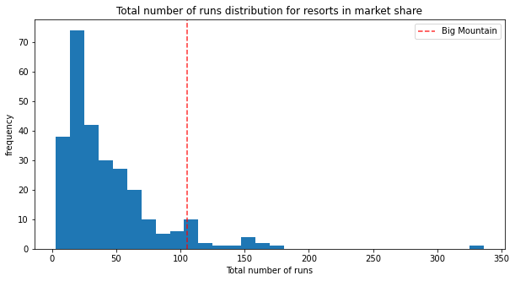

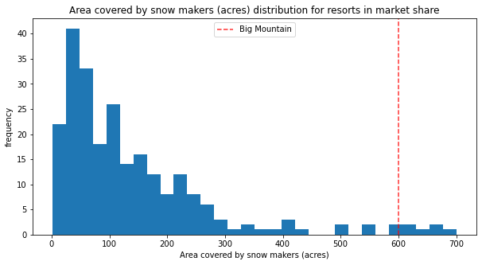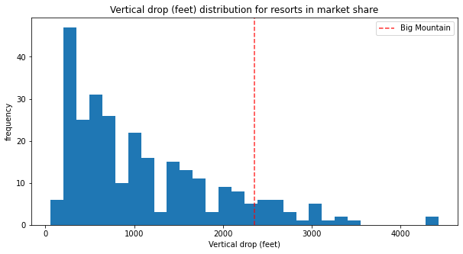

**Target Lift Ticket Price**

Several models were tested for predicting lift ticket prices for MDR including predicting based on the mean, linear regression and random forest regression models. A random forest model with the least error and variability across tested model variations was ultimately selected. Applying the model to the entire dataset resulted in a target lift ticket price of **$95.87** with an expected mean absolute error (MAE) of $10.39. Assuming approximately 1.75 million tickets are sold in the season, this price increase would result in **an annual revenue increase of about $26 million**, far more than is needed to cover the additional $1.54 million in operational costs. Considering BMR’s current ticket price is $81.00, such a drastic price increase does pose the risk of discouraging regular customers from returning. **A less volatile alternative based on this model would be to increase the lift ticket price to $85.48** (modeled ticket price – MAE) which would result in an **annual revenue increase of about $7.83 million**.

**Additional Scenarios for Consideration**

Two scenarios BMR leadership may consider in order to capitalize on their facilities are closing down 5 runs and increasing the max vertical drop by adding a run to a point 150 feet lower. Closing 5 of the existing runs could decrease operational costs for run maintenance and snow making and would only require lowering the modeled ticket price by about $.66. which would decrease annual revenue (post price increase) by $1.17 million. Additional information regarding the operational costs for maintaining 5 runs is necessary to determine whether closing the runs would be worthwhile. See these price changes plotted below.

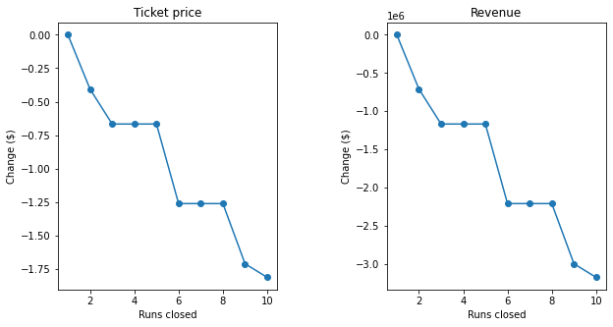

Increasing the max vertical drop by adding a run to a point 150 feet lower would allow MDR to increase the modeled ticket price by $1.99 which would result in an additional $3.5 million in annual revenue. This would require installation of another chair lift, which we will assume would cost the same as the previously added chair lift ($1.54 million), so net revenue would still be worth the added costs. Additional costs to consider in this scenario include run maintenance and snow making costs.

1. Big Mountain Resort CSV file. Available from https://github.com/rrmahr/DataScienceGuidedCapstone/blob/master/raw_data/ski_resort_data.csv
2. Notebooks using for data procession. Available from https://github.com/rrmahr/DataScienceGuidedCapstone/tree/6d99d5dce4c5d2e9804bc34a70898e5058cd6811/Notebooks